**Programming Fundamentals**

**Lab # 2**

# **Task No 1:**

## **Solution:**

1. Start
2. Declare num
3. Input num
4. Print num
5. End

# **FLOWCHART**

# C:\Users\F233029\Downloads\WhatsApp Image 2023-08-31 at 11.04.24 AM.jpeg

# **Task No 2:**

## **Solution:**

1. Start
2. Declare num1,num2,num3,Sum
3. Input num1,num2,num3
4. Sum =num1+num2+num3
5. Print sum
6. End

# **FLOWCHART**

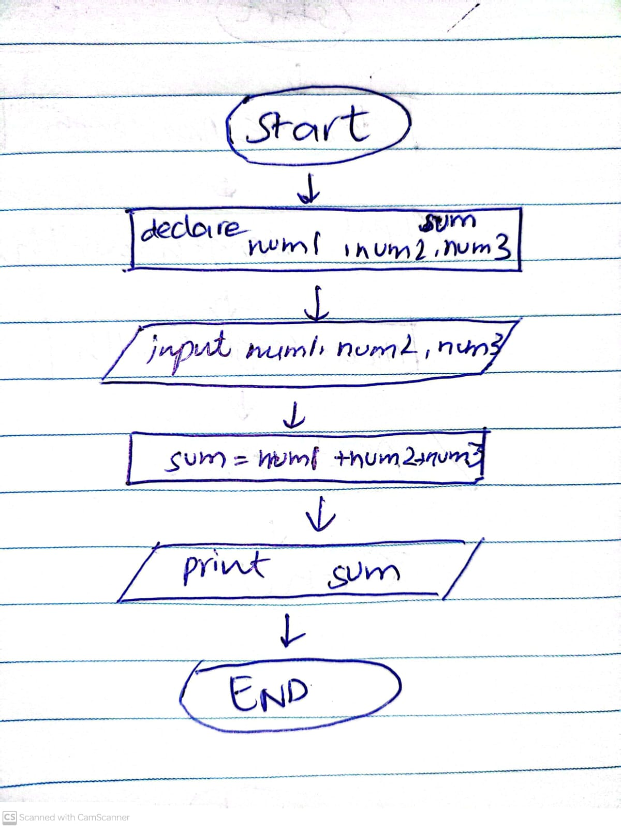

# **Task No 3:**

## **Solution:**

1. Start
2. Declare num1,num2,num3,Sum,Avg
3. Input num1,num2,num3
4. Sum =num1+num2+num3
5. Avg=Sum/3
6. Print Avg
7. End

# **FLOWCHART**

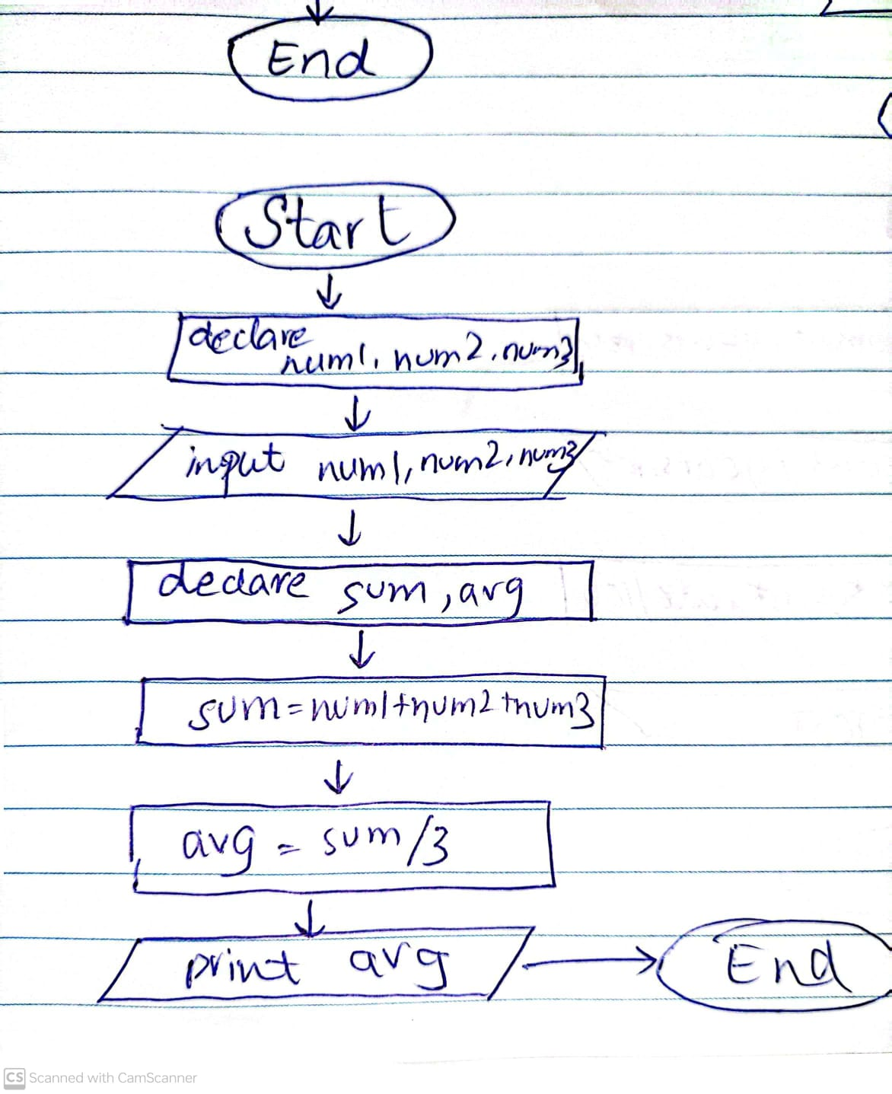

# **Task No 4:**

## **Solution:**

1. Start
2. Declare Area ,Length ,width
3. Input Length , Width
4. Area=Length*width
5. Print Area
6. End

# **FLOWCHART**

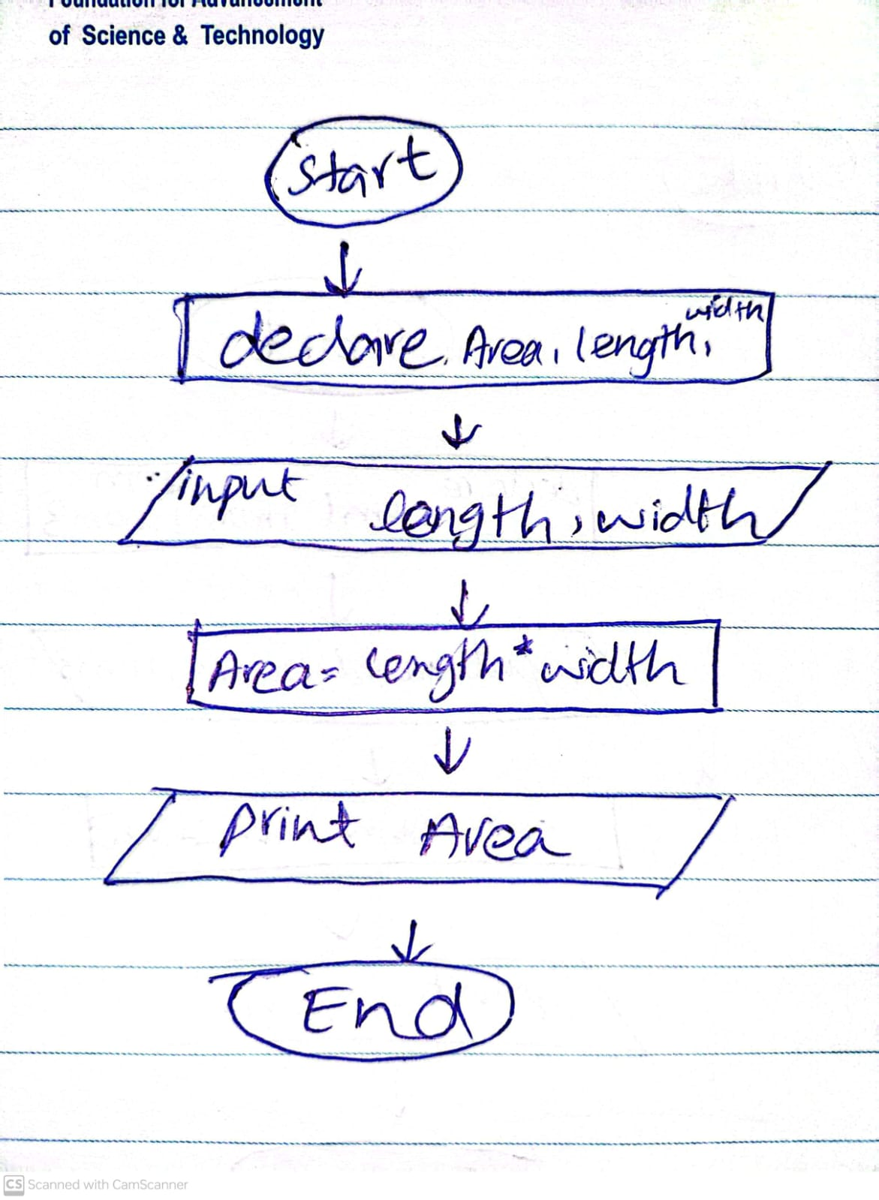

# **Task No 5:**

## **Solution:**

1. Start
2. Declare interest , amount, years, rate
3. Input amount ,years ,rate
4. Interest=amount*years*rate/100
5. Print interest
6. End

# **FLOWCHART**

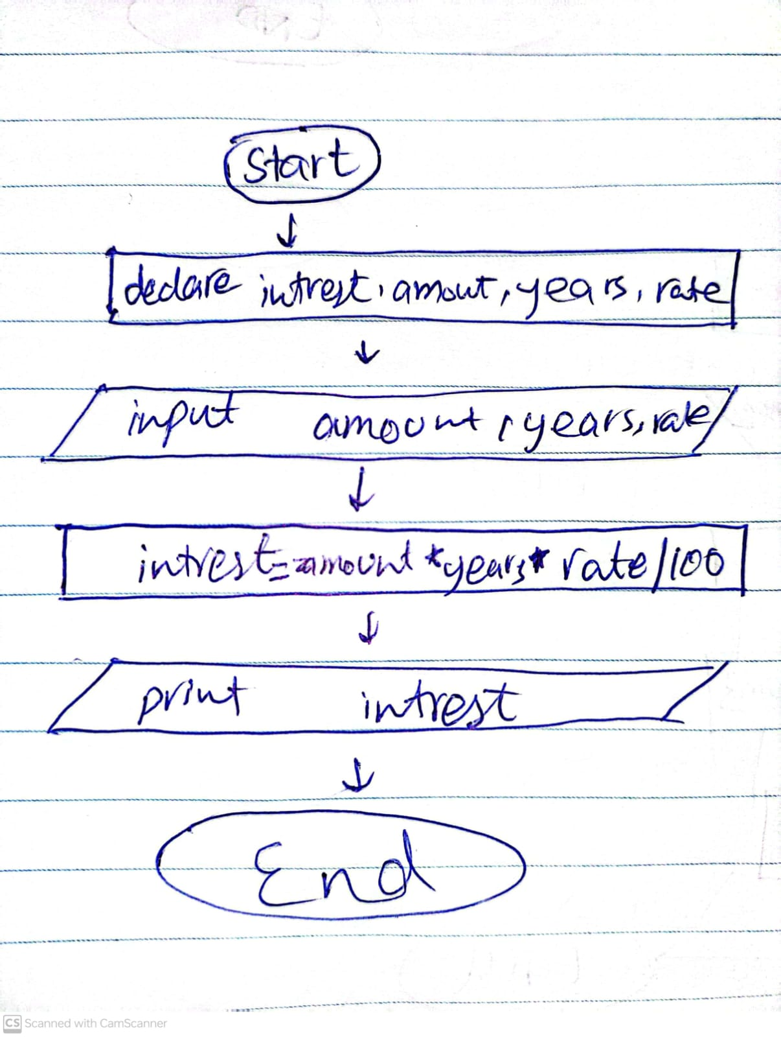

# **Task No 6:**

## **Solution:**

1. Start
2. Declare Far , cel
3. Input Far
4. Cel=5/9*(far-32)
5. Print cel
6. End

# **FLOWCHART**

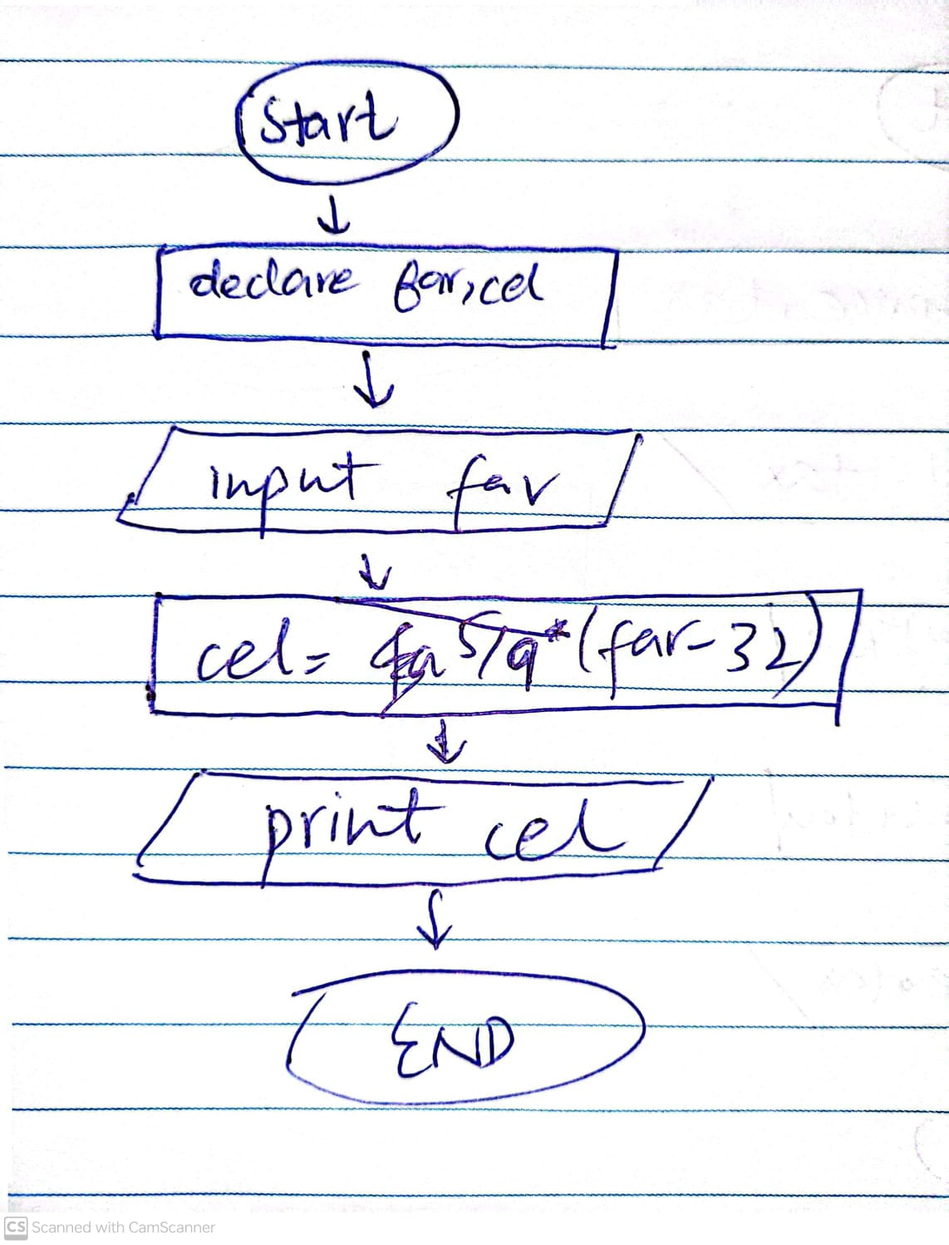

# **Task No 7:**

## **Solution:**

1. Start
2. Declare len , wid , perimeter
3. Input len , wid
4. Perimeter=2(len+wid)
5. Print perimeter
6. End

# **FLOWCHART**

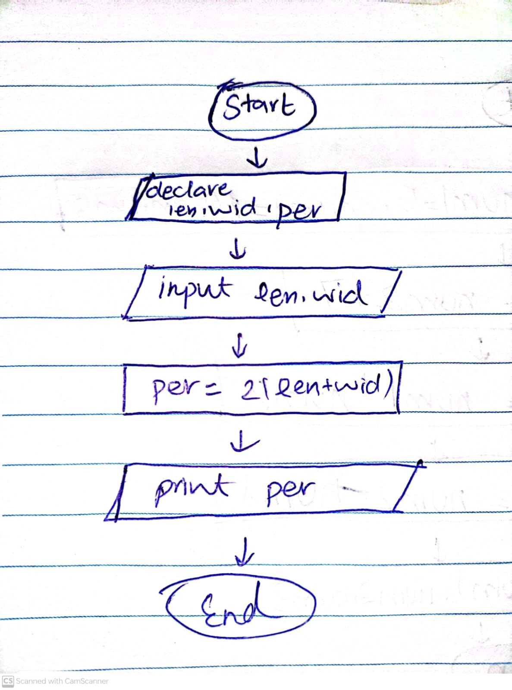

# **Task No 8:**

## **Solution:**

1. Start
2. Declare Total , r_price , tax
3. Input total,tax
4. Tax=(tax/total)*100
5. r_price= total+tax
6. print r_price , tax
7. end

# **FLOWCHART**

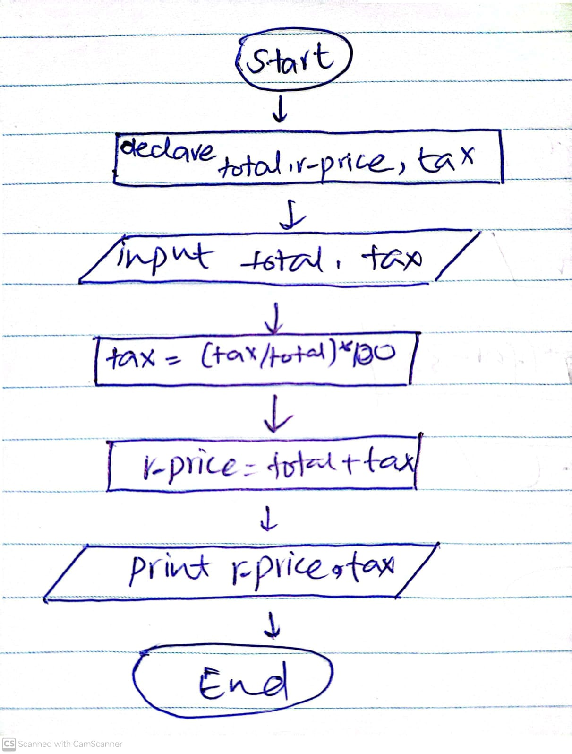

# **Task No 9:**

## **Solution:**

1. Start
2. Declare C_balance ,S_balance , Deposits , withdrawls
3. Input s_balance , deposits , withdrawls
4. C_balance=(S_balace+deposits)-withdrawls
5. Print c_balance
6. End

# **FLOWCHART**

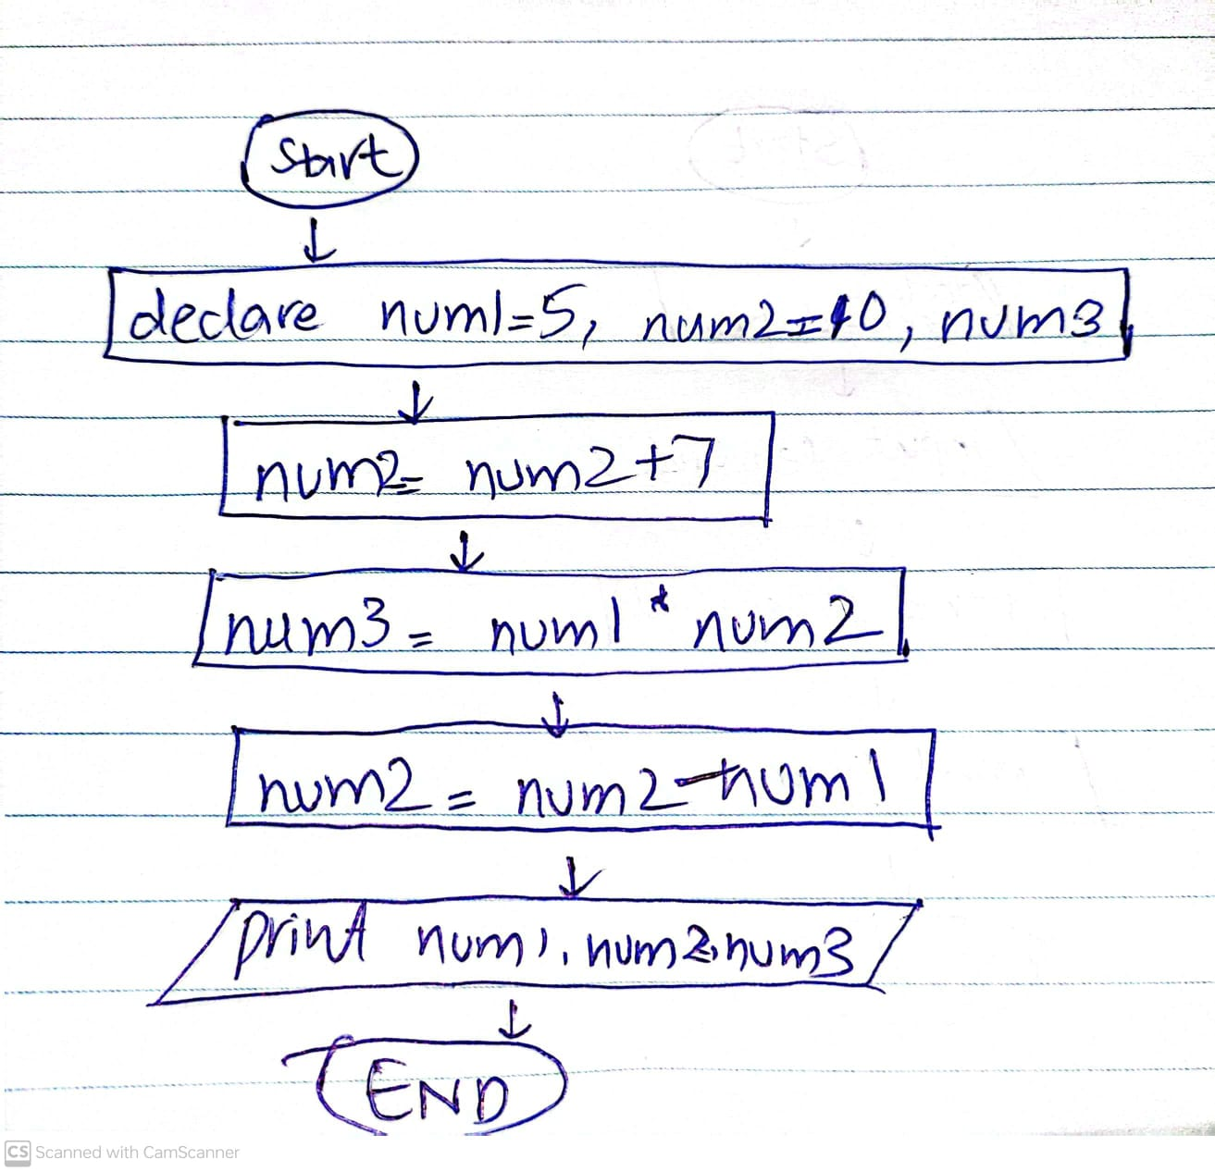

# **Task No 10:**

## **Solution:**

1. Start
2. Declare num1=5 , num2=10 , num3
3. num2=num2+7
4. num3=num1*num2
5. num2=num2-num1
6. print num1 , num2 , num3
7. End

# **FLOWCHART**

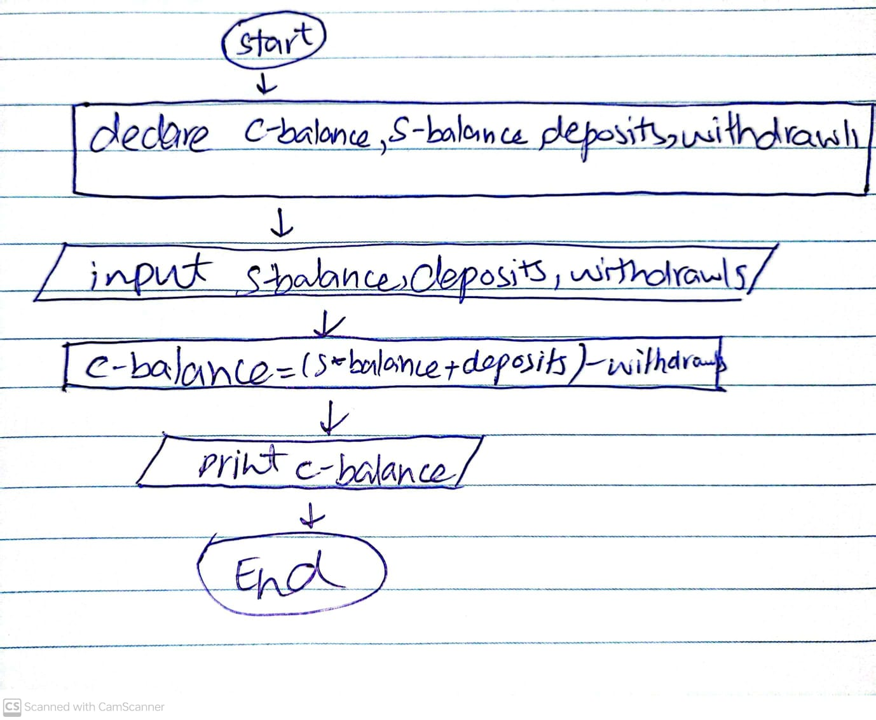

# **Task No 11:**

## **Solution:**

1. Start
2. Declare H_pay , hours , pay
3. Input H_pay , hours
4. Pay= H_pay*hours
5. Print pay
6. End

# **FLOWCHART**

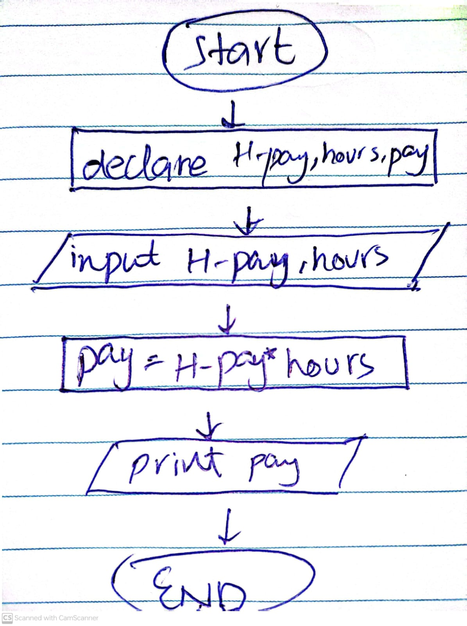

# **Question No 2**

# **Task No 1:**

## **Solution:**

1. Start
2. Declare Area ,Length ,width
3. Input Length , Width
4. Area=Length*width
5. Print Area
6. If Length == width
   1. print “This is a square”
7. End If
8. End

## Flowchart :

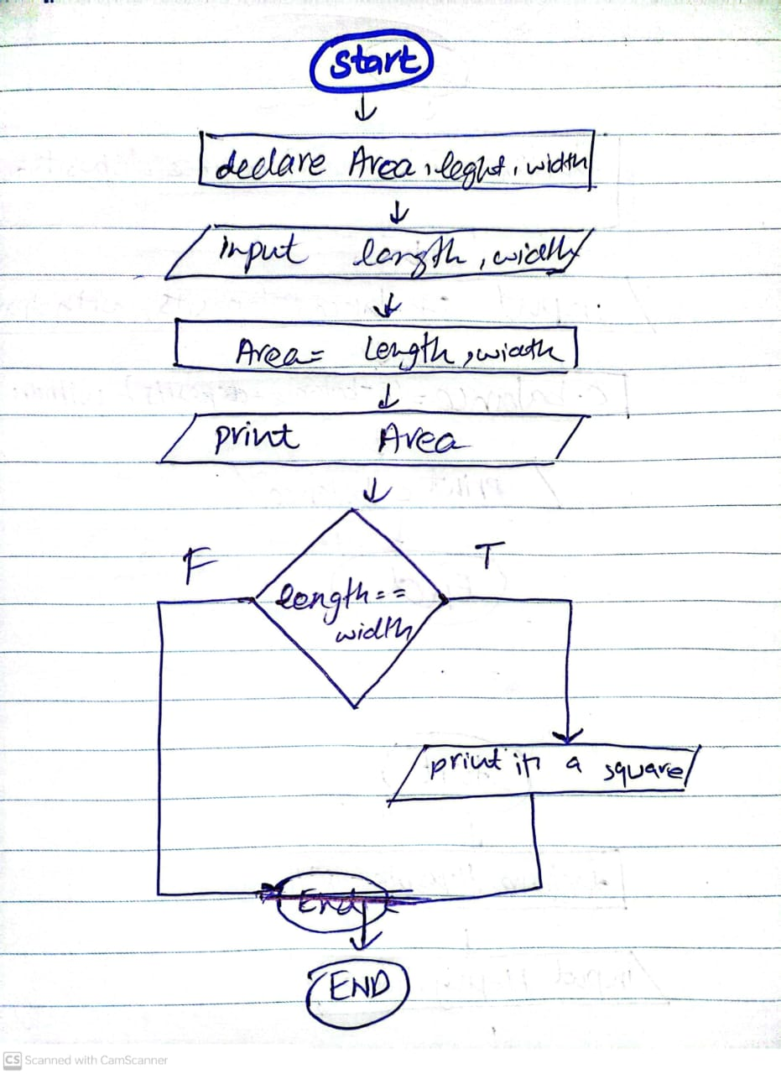

# **Task No 2:**

## **Solution:**

1. Start
2. Declare comp, eng , math , avg , sum
3. Input comp, eng , math
4. Sum = eng+math+comp
5. Avg = sum/3
6. Print avg
7. If avg >=75
   1. Print you proceed to next class
8. End if
9. End

## Flowchart :

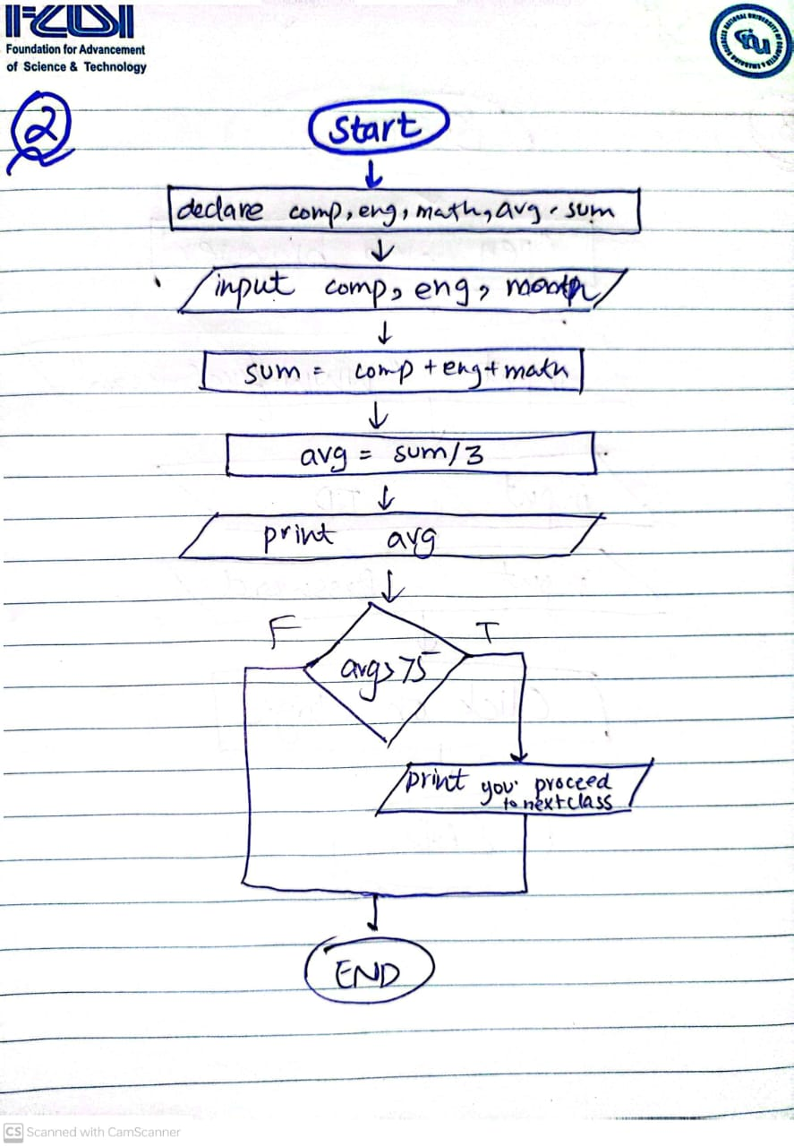

# **Task No 3:**

## **Solution:**

1. Start
2. Open web browser
3. Search for [www.facebook.com](http://www.facebook.com)
4. input ID
5. input Password
6. End

## Flowchart :

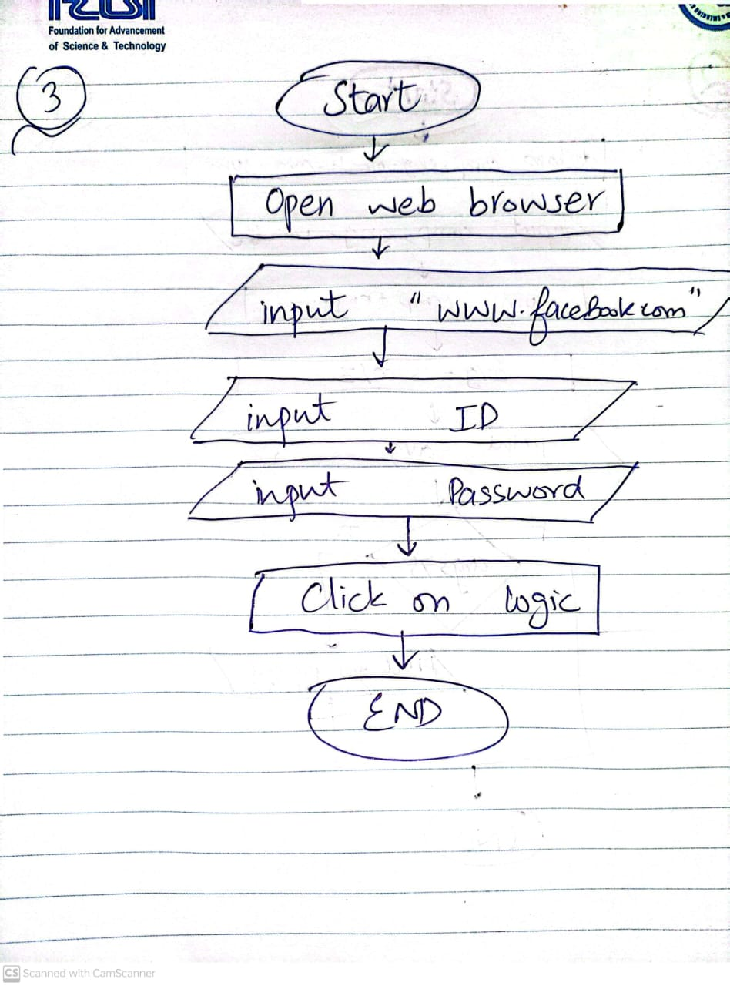

# **Task No 4:**

## **Solution:**

1. Start
2. Declare name, age, x
3. Input name , age
4. If age >=18
   1. Print you are old enough to drive
5. Else
   1. X = 18-age
   2. Print you have to wait x years to drive
6. End if
7. End

## Flowchart :

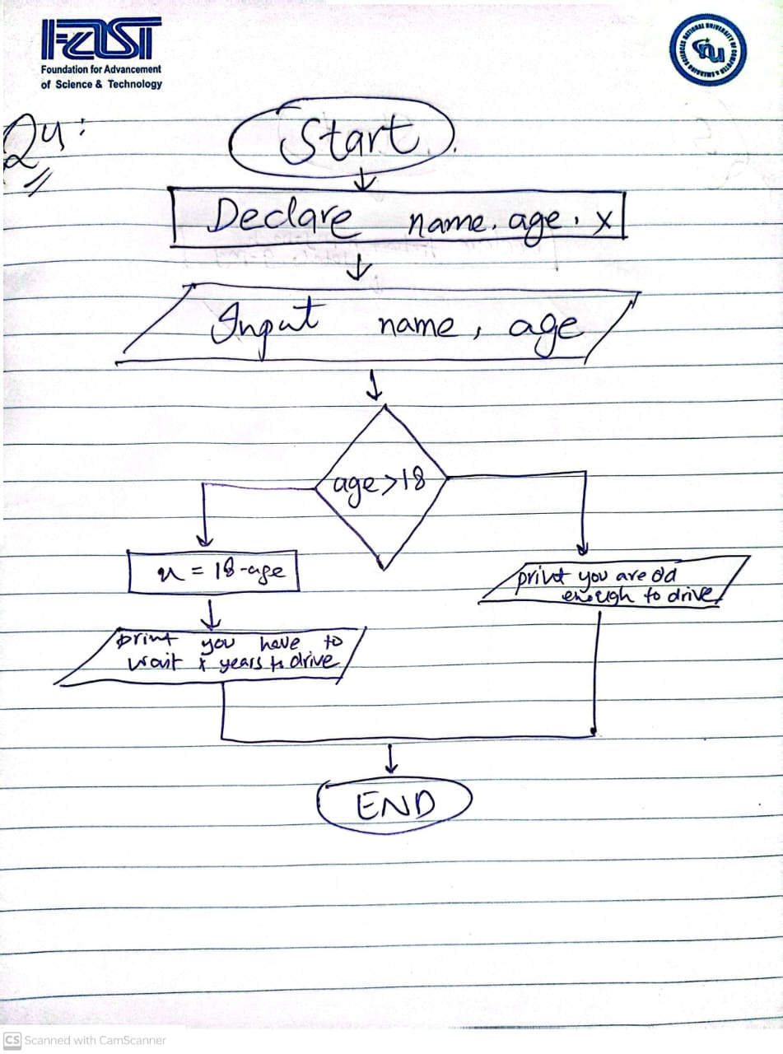

# **Task No 5:**

## **Solution:**

1. Start
2. Declare h_pay, no_h , total, g_pay
3. Input h_pay, no_h
4. Total = h_pay*no_h
5. Print total
6. If h_times>40
   1. G_Total= total*1.5
7. Else
   1. G_pay=total
8. End if
9. Print g_pay
10. End

## Flowchart :

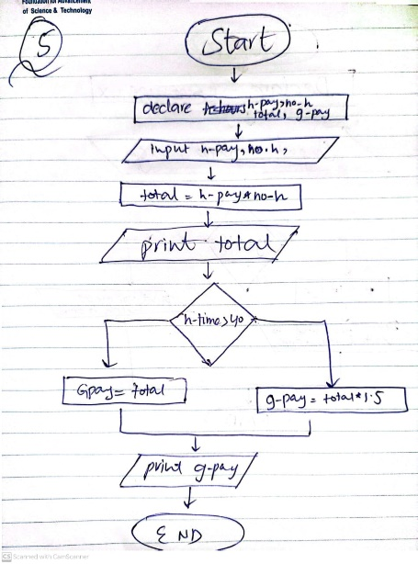

# **Task No 6:**

## **Solution:**

1. Start
2. Declare temp
3. Input temp
4. If temp>=80
   1. Print " weather is perfect for playing cricket "
5. Else
   1. Print "Don’t go outside, weather is too cold”.
6. End if
7. End

## Flowchart :

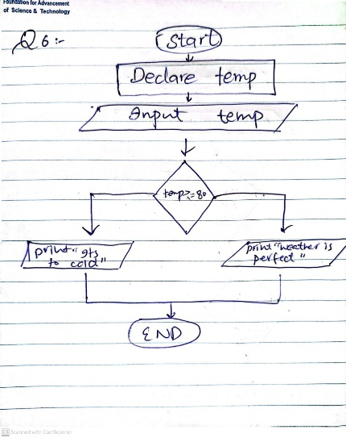

# **Task No 7:**

## **Solution:**

1. Start
2. Declare num1,num2,num3
3. Input num1,num2,num3
4. If num1 > num2 && num1>num3
   1. Print num1 is greater
5. Else if num2>num1 && num2>num3
   1. Print Num2 is greater
6. Else
   1. Print num3 is greater
7. End if
8. End

## Flowchart :

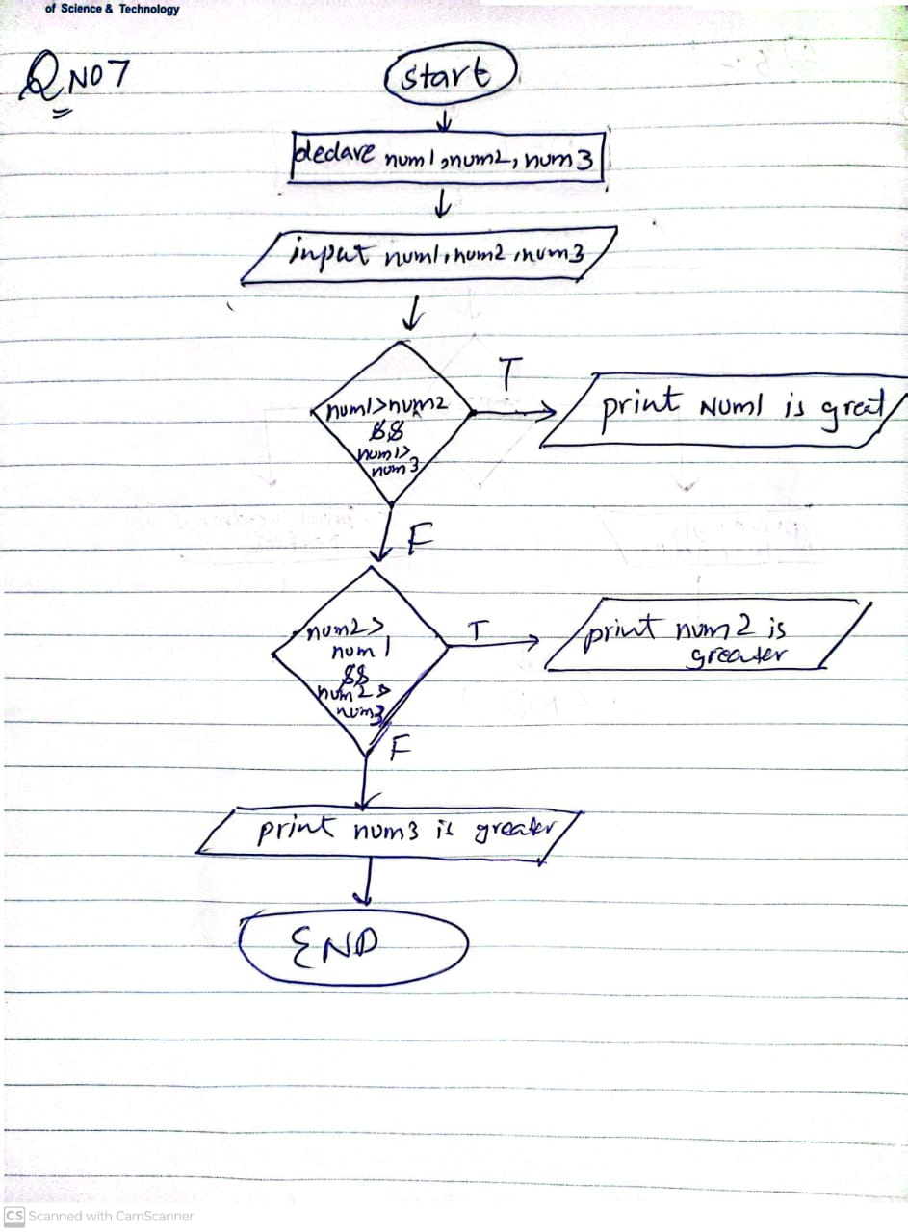

# **Task No 8:**

## **Solution:**

1. Start
2. Declare math , phy , chem , total , MP_total
3. Input math , phy , chem
4. Total= math + phy + chem
5. Mp_total= math+phy
6. If math>=65 && phy>=55 && chem>=50 && total>=180 && mp_total>=140
   1. Print “ you are eligibility of admission “
7. Else
   1. Print “you are not eligible”
8. End if
9. End

## Flowchart :

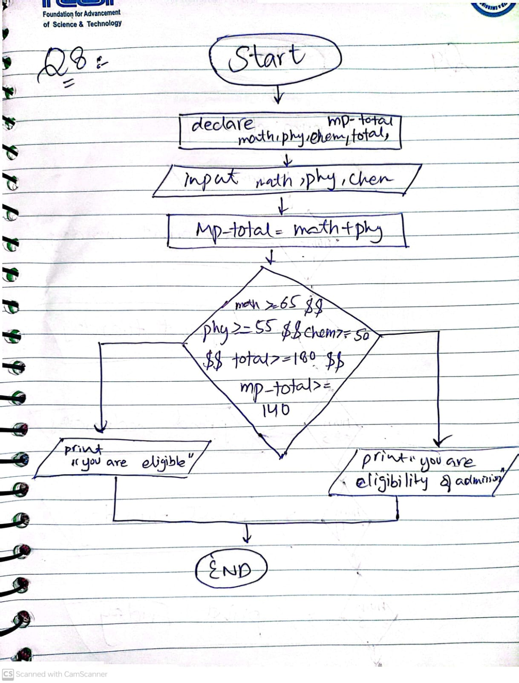

# **Task No 9:**

## **Solution:**

1. Start
2. Declare num
3. Input num
4. If num ==1
   1. Print Monday
5. Else if num==2
   1. Print Tuesday
6. Else if num==3
   1. Print Wednesday
7. Else if num==4
   1. Print thursday
8. Else if num==5
   1. Print friday
9. Else if num==6
   1. Print Saturday
10. Else if num==7
    1. Print sunday
11. Else
    1. Print Entered wrong number
12. End if
13. End

## Flowchart :

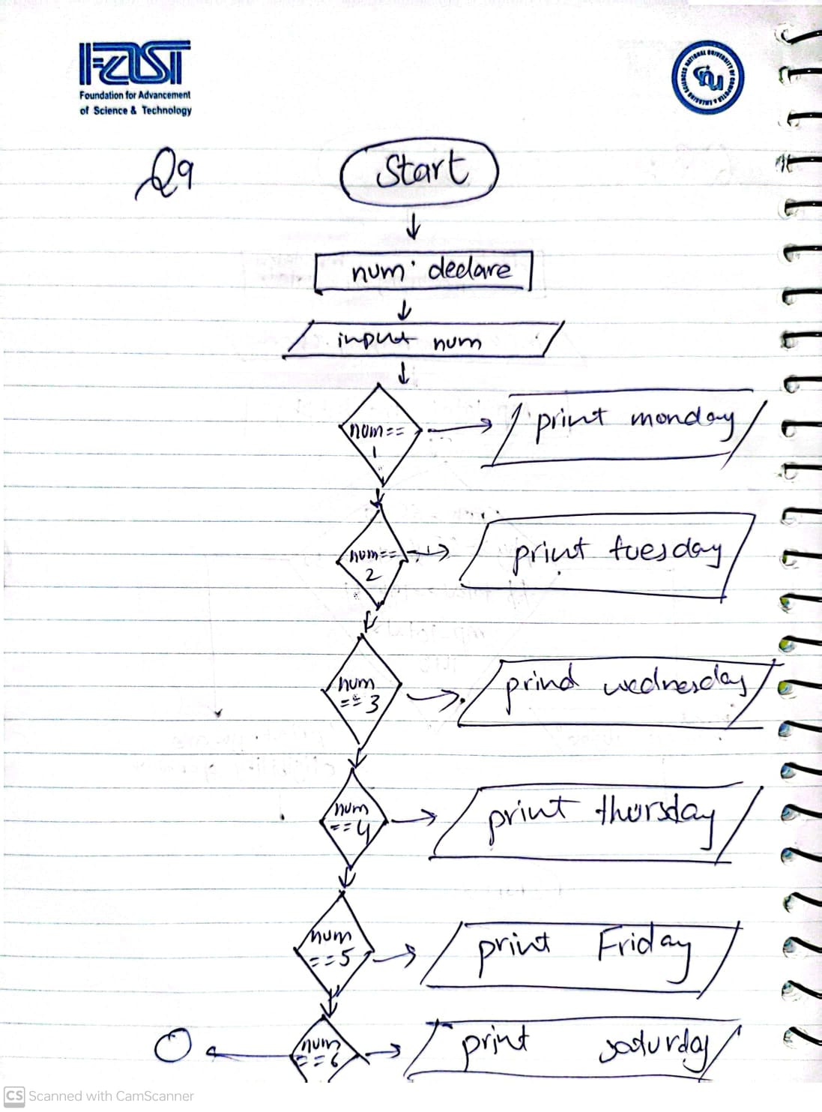

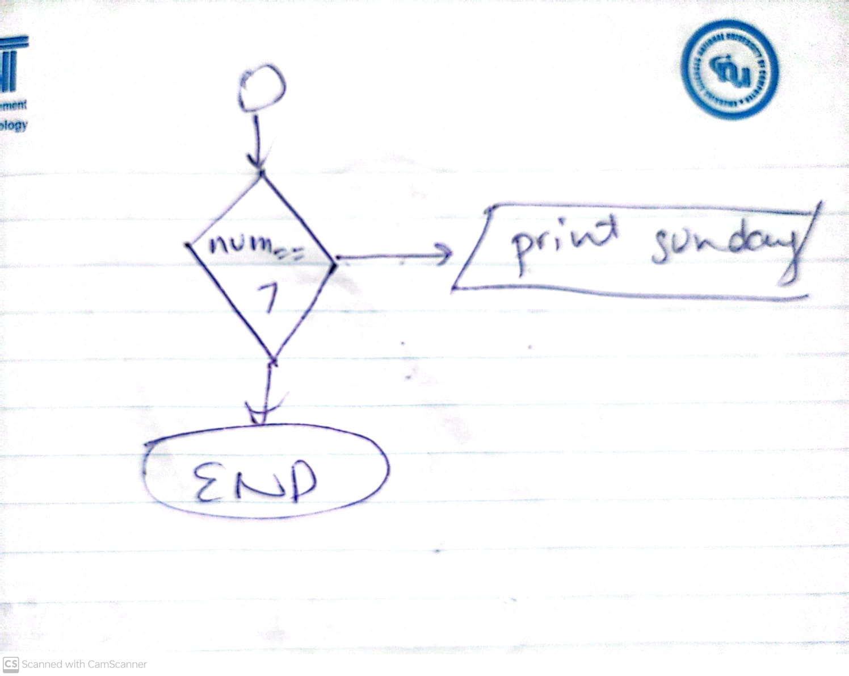

# **Task No 10:**

## **Solution:**

1. Start
2. Declare salary, gross, house_rent, dearness, i, x.
3. Input salary, house_rent, dearness.
4. IF (salary <= 10000) then
   1. i=house_rent*0.2
   2. x = dareness*0.8
   3. Gross=i+x
   4. Print Gross.
5. ELSE IF (salary >= 20000) then
   1. I=house_rent*0.3
   2. X=dareness*0.95
   3. Gross=i+x
   4. Print gross
6. Else
   1. i= house_rent*0.25
   2. x=dareness*0.9
   3. gross=i+x
   4. print gross
7. end if
8. end

## Flowchart :

ssssss