**Programming Fundamentals**

Lab # 5

# Problem # 1

**Solution**

1. Start
2. declare num , count=1 , nth , table
3. input num , nth
4. while count <= nth
   1. table= count * num
   2. count = count + 1
   3. print table
5. end while
6. end

**Flowchart :**

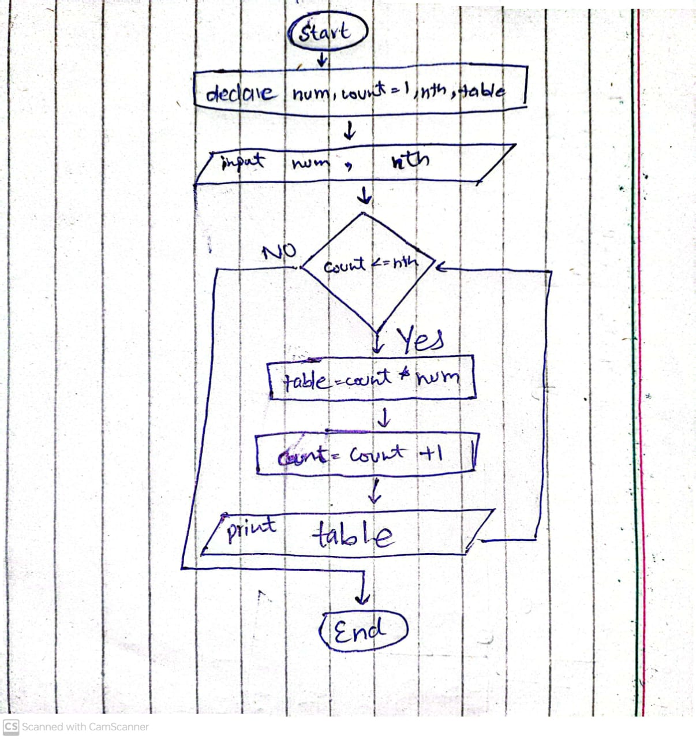

# Problem # 2

**Solution**

* + - 1. start
      2. declare num , count =1 , sum=0 , average , limit
      3. input limit
      4. while count <= limit
         1. 4.1. input num
         2. 4.2. sum = sum + num
         3. 4.3. count = count + 1
      5. End while
      6. average = sum / limit
      7. print average
      8. end

**Flowchart :**

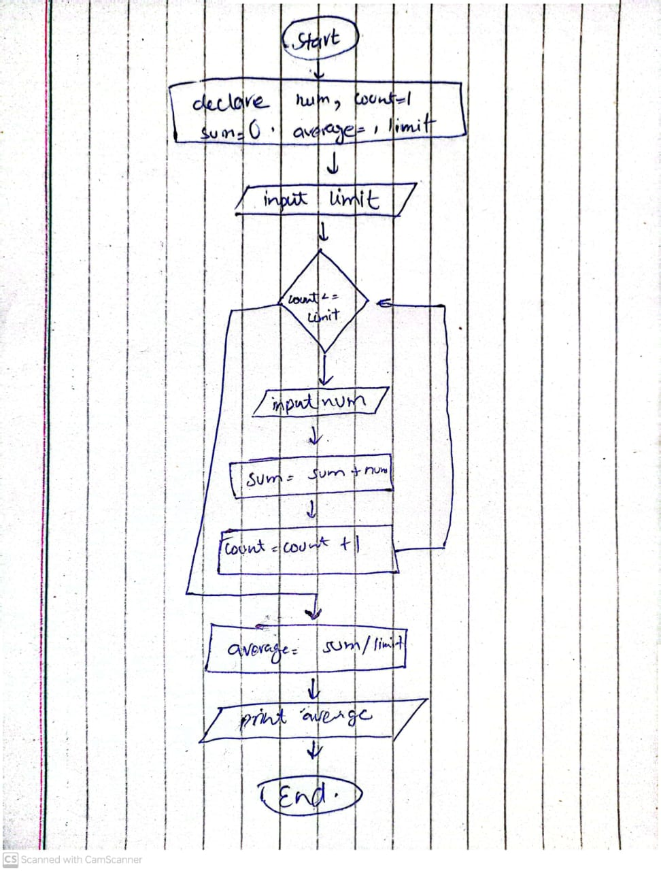

# Problem # 3

Solution

1. start
2. declare choice , price =0 , coke, fanta , sprite , pepsi , water
3. input coke, fanta , sprite , pepsi , water
4. if ( coke ==fanta || coke == sprite || coke == pepsi || coke == water ||fanta ==sprite || fanta == pepsi || fanta == water ||sprite == pepsi || sprite == water || pepsi == water )
   1. print error , you entered same price , please try again
5. else
6. input amount
7. while amount >= water
8. print Welcome .. Drinks available are …

1#Coke =coke Rs 2#Fanta=fanta RS 3# Sprite =sprite RS

4#Pepsi= pepsi RS 5#mineral water =water RS

1. input choice
2. if choice ==1
   1. price =coke
3. else if choice ==2
   1. price =fanta
4. else if choice ==3
   1. price =sprite
5. else if choice ==4
   1. price =pepsi
6. else if choice ==5
   1. price =water
7. else
   1. print wrong input
8. end if
9. if amount >= price
   1. print have!! your drink .
   2. amount = amount – price
10. else
    1. you have run out of money
11. end if
12. end while
13. end if
14. end

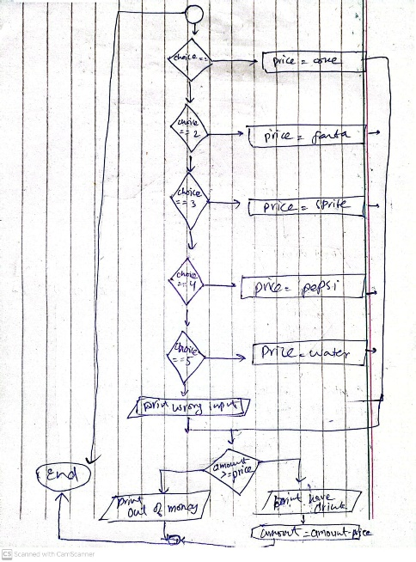Flowchart :

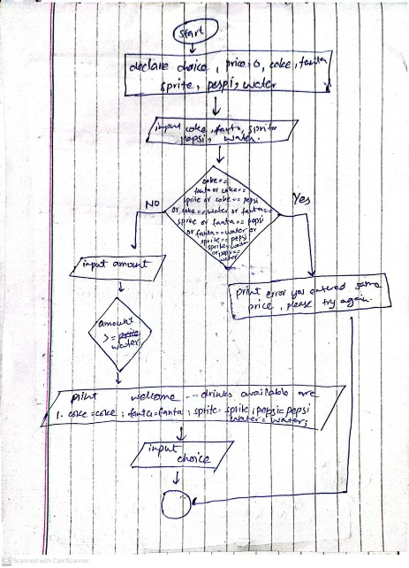

# Problem # 4

Solution

1. start
2. declare num , count = 1 , remain , Armstrong
3. input num
4. number = num
5. while count <= 3
   1. remain = num % 10
   2. num = num / 10
   3. armstrong = armstrong + (remain ^3)
   4. count = count +1
6. end while
7. if number == armstrong
   1. print number is Armstrong
8. else
   1. print number is not Armstrong
9. end if
10. print Armstrong
11. end

**Flowchart**

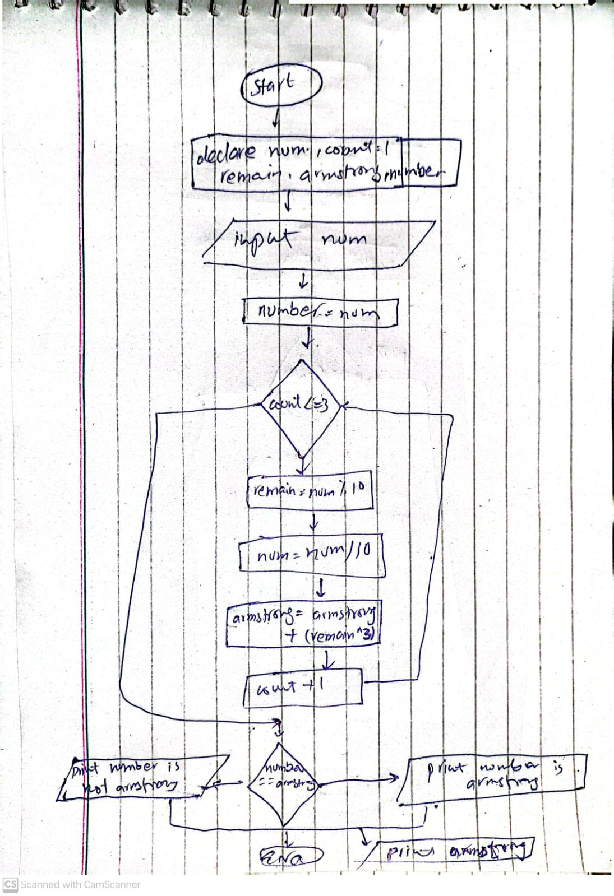

# Problem # 5

Solution

1. start
2. declare first=0 , second=1 , num, nth
3. input nth
4. while num <= nth
   1. num = first + second
   2. print num
   3. first=second
   4. second = num
5. end while
6. end

**Flowchart**

