**Lab 11**

Task 1

#include <iostream>

int main()

{

int num, limit, choice, square, i;

std::cout << "Enter 1 for Square without asterisk \n\n Enter 2 for squares in increasing order \n\n Enter 3 for squares in reverse order ";

std::cin >> choice;

switch (choice)

{

case 1:

std::cout << "Enter a number \n";

std::cin >> limit;

for (num = 1; num <= limit; num++)

{

for (int j = num; j > 0; j--)

{

for (i = num; i > 0; i--)

{

std::cout << "*";

}

std::cout << std::endl;

}

}

break;

case 2 :

std::cout << "Enter the limit : ";

std::cin >> limit;

std::cout << "Series of Square in increasing order ";

for ( i = 1; i <= limit; i++)

{

std::cout << i*i << " ,";

}

break;

case 3:

std::cout << "Enter the limit : ";

std::cin >> limit;

std::cout << "Series of Square in decreasing order ";

for (i = limit; i >=1 ; i--)

{

std::cout << i*i << " ,";

}

break;

default:

std::cout << "Wrong input ";

}

system("pause");

}

Output

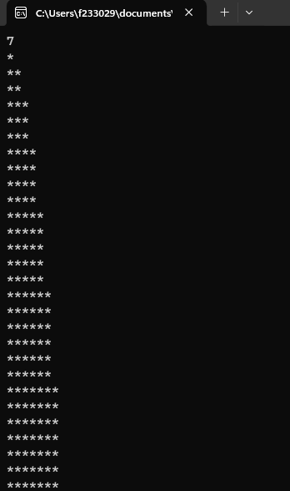

Task 2

#include <iostream>

int main()

{

int choice;

std::cout << "Pattren 1 :\n\n11111\n22222\n33333\n44444\n55555 \n\nPattren 2 :\n\n12345\n12345\n12345\n12345\n12345 \n\nPattren 3: \n55555\n44444\n33333\n22222\n11111 \n\n Pattren 4 : \n54321\n54321\n54321\n54321\n54321 \n\n";

std::cout << "Enter pattren you want : ";

std::cin >> choice;

switch (choice)

{

case 1:

for (int i = 1; i <= 5; i++)

{

for (int j = 1; j <= 5; j++)

{

std::cout << i;

}

std::cout << "\n";

}

std::cout << "\n\n";

break;

case 2 :

for (int i = 1; i <= 5; i++)

{

for (int k = 1; k <= 5; k++)

{

std::cout << k;

}

std::cout << std::endl;

}

break;

case 3 :

for (int l = 5; l >= 1; l--)

{

for (int n = 1; n <= 5; n++)

{

std::cout << l;

}

std::cout << std::endl;

}

break;

case 4:

for (int m = 1; m <= 5; m++)

{

for (int n = 5; n >= 1; n--)

{

std::cout << n;

}

std::cout << std::endl;

}

break;

default :

std::cout << "wrong input ";

}

system("pause");

}

Output

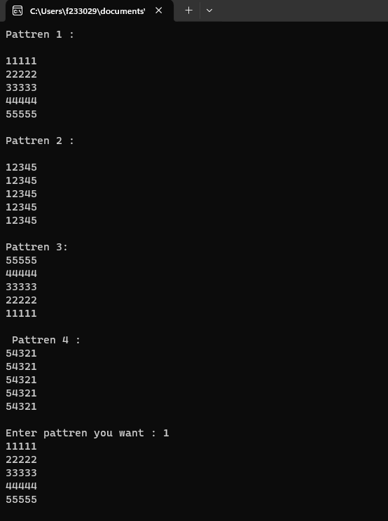

Task 3

#include<iostream>

int main()

{

int n=3, k = 1 , h=1;

for (int i = 1; i <= 7; i=i+2)

{

for (; k <= 3;k++ )

{

std::cout << " ";

}

for (int j = i; j >= 1; j--)

{

std::cout << "*";

}

h++;

k = h;

std::cout << "\n";

}

std::cout << "\nIn Inverse order \n";

n = 3, k = 4, h = 4;

for (int i = 7; i >= 1; i = i - 2)

{

for (; k <= 3; k++)

{

std::cout << " ";

}

for (int j = i; j >= 1; j--)

{

std::cout << "*";

}

h--;

k = h;

std::cout << "\n";

}

system("pause");

}

Output

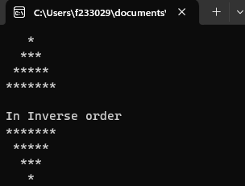

Task 4

#include<iostream>

int main()

{

int size;

std::cout << "Enter size of Diamond ";

std::cin >> size;

if (size % 2 == 0)

{

std::cout << "Enter an odd number please ";

}

else

{

int z=1 , oddcount=1;

while (z < size)

{

if (z % 2 != 0)

{

oddcount++;

}

z++;

}

oddcount--;

int n = 3, k = 1, h = 1;

for (int i = 1; i < size ; i = i + 2)

{

for (; k <= oddcount; k++)

{

std::cout << " ";

}

for (int j = i; j >= 1; j--)

{

std::cout << "*";

}

h++;

k = h;

std::cout << "\n";

}

n = 3, k = oddcount+1, h = oddcount+1;

for (int i = size ; i >= 1; i = i - 2)

{

for (; k <= oddcount; k++)

{

std::cout << " ";

}

for (int j = i; j >= 1; j--)

{

std::cout << "*";

}

h--;

k = h;

std::cout << "\n";

}

}

system("pause");

}

Output

