**Lab-6**

# **Task # 1**

#include <iostream.h>

using namespace std ;

int main()

{

cout<<"Hello World!!"<<;

# }

## **Output**

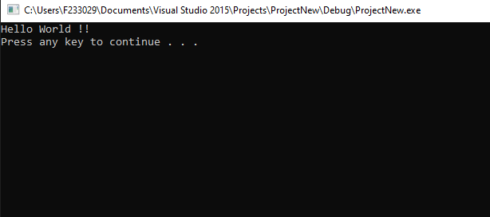

# **Task # 2**

#include <iostream>

int main()

{

std::cout << "5.0 + 3.5=" << 5.0 + 3.5<<std::endl;

std::cout << " 3.0 + 9.4=" << 3.0 + 9.4 << std::endl;

std::cout << " 16.3 - 5.2=" << 16.3 - 5.2 << std::endl;

std::cout << " 4.2 * 2.5=" << 4.2 * 2.5 << std::endl;

std::cout << " 5.0 / 2.0=" << 5.0 / 2.0 << std::endl;

std::cout << " 34.5 / 6.0=" << 34.5 / 6.0 << std::endl;

std::cout << " 34.5 / 6.5=" << 34.5 / 6.5 << std::endl;

system("pause");

}

## Output

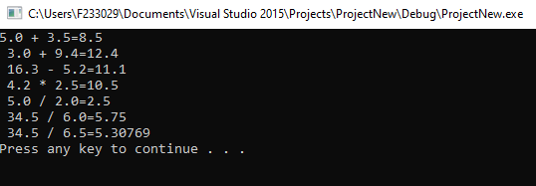

# **Task # 3**

#include <iostream>

int main()

{

std::cout << "Hello it's Daniyal Hiader \n I am student of BS \"SE\" batch 23 . Following are the List of subjects that I studied in this semester \n PF \t English Physics \n I am from \"Renala Khurd\". \n "; // \n - Represents a newline character and \" - Represents a double quote character. \t - Represents a tab character and \" - Represents a double quote character.

system("pause");

}

## Output

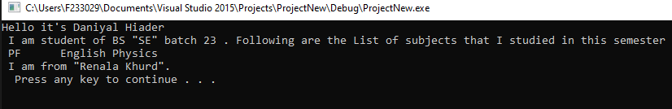

# Task # 4

#include <iostream>

#include <iomanip>

int main()

{

std::cout << std::setprecision(4)<< 1.235362563546754 << "\n" ;//used to set precision of the number

std::cout << std::setw(10) << std::left << 176 << "\n";//used to set width of number

std::cout << std::setw(10) << 176;//by default it is right

std::cout << std::setfill('#') << std::setw(6) << 234 << "\n";//used to fill blank spaces with any character

std::cout << std::hex << 5644 << "\n";//to convert in hexa decimal

std::cout << std::oct << 5644 << "\n";//to convert in octal

std::cout << std::setbase(5) << 5644 << "\n";// to set nbasae of any number

system("pause");

}

## Output

