Lab 14

Task 1

#include<iostream>

int main()

{

int a[2][2][2] = { {{1,2},{1,2}}, {{1,2},{1,2} } };

for (int i = 0; i < 2; i++)

{

for (int j = 0; j < 2; j++)

{

for (int k = -0; k < 2; k++)

{

std::cout << a[i][j][k]<< " ";

}

std::cout << std::endl;

}

}

}

Output

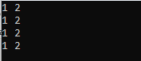

Task 2

#include<iostream>

#include <ctime>

int main()

{

int marks[20][2];

srand(time(0));

int HMM, HME; //Variables for highest marks

int mathaverage = 0, englishaverage = 0;

int maxmath = 0, maxenglish = 0;

for (int i = 0; i < 20; i++)

{

for (int j = 0; j < 2; j++)

{

marks[i][j] = (rand() % 100) + 1;

}

}

for (int i = 0; i < 20; i++)

{

if (marks[i][0] > maxmath)

{

maxmath = marks[i][0];

HMM = i;

}

mathaverage = marks[i][0] + mathaverage;

}

mathaverage = mathaverage / 20;

for (int i = 0; i < 20; i++)

{

if (marks[i][1] > maxenglish)

{

maxenglish = marks[i][1];

HME = i;

}

englishaverage = marks[i][1] + englishaverage;

}

englishaverage = englishaverage / 20;

std::cout << "Average of Math marks of Class is " << mathaverage<< "\n";

std::cout << "Average of English marks of Class is " << englishaverage<< "\n";

std::cout <<"The Roll number "<<HMM+1 << " Maximum marks in maths are " << maxmath << "\n";

std::cout << "The Roll number " << HME+1<<" Maximum marks in english is " << maxenglish << "\n";

}

Output

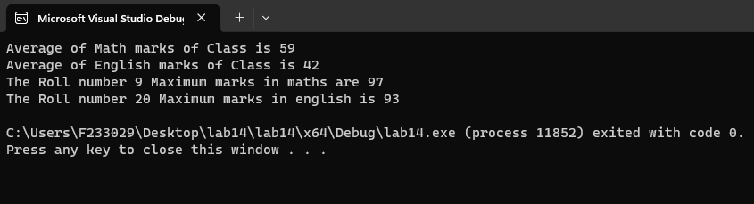

Task 3

#include<iostream>

int main()

{

int game[3][3] = { 0 };

int p1, p2, in1R , in1C , in2R ,in2C ;

bool gamestatus = true;

for (int i = 0; i < 3; i++)

{

for (int j = 0; j < 3; j++)

{

std::cout << game[i][j]<< " ";

}

std::cout << "\n";

}

while (gamestatus == true)

{

while (1)

{

std::cout << "Player 1 turn \n";

std::cout << "Enter Row and Colunm Number you want to Enter ";

std::cin >> in1R;

std::cin >> in1C;

if (in1R > 3 && in1C > 3)

{

std::cout << "\nwrong input";

std::cout << "\nEnter again ";

continue;

}

else

{

break;

}

}

game[in1R][in1C] = 1;

std::cout << "\n";

for (int i = 0; i < 3; i++)

{

for (int j = 0; j < 3; j++)

{

std::cout << game[i][j] << " ";

}

std::cout << "\n";

}

while (1)

{

std::cout << "Player 2 turn \n";

std::cout << "Enter Row and Colunm Number you want to Enter ";

std::cin >> in2R;

std::cin >> in2C;

if (in2R > 3 && in2C > 3)

{

std::cout << "\nWrong input";

std::cout << "\nEnter again ";

continue;

}

else

{

break;

}

}

game[in2R][in2C] = 2;

std::cout << "\n";

for (int i = 0; i < 3; i++)

{

for (int j = 0; j < 3; j++)

{

std::cout << game[i][j] << " ";

}

std::cout << "\n";

}

//checkin rows

for (int i = 0; i < 3; i++)

{

if (game[i][0] == game[i][1] && game[i][1] == game[i][2])

{

gamestatus = false;

break;

}

}

//colunms

for (int i = 0; i < 3; i++)

{

if (game[0][i] == game[1][i] && game[1][i] == game[2][i])

{

gamestatus = false;

break;

}

}

//diagonal

if (game[0][0] == game[1][1] && game[1][1] == game[2][2]) {

gamestatus = false;

}

else if (game[0][2] == game[1][1] && game[1][1] == game[2][0]) {

gamestatus = false;

}

else if (game[0][0] != '1' && game[0][1] != '2' && game[0][2] != '3' && game[1][0] != '4' && game[1][1] != '5' && game[1][2] != '6' && game[2][0] != '7' && game[2][1] != '8' && game[2][2] != '9') {

gamestatus= true;

}

else {

gamestatus= false;

}

}

}

Output

