Task 3 — Improvisation Report: Enhancing ML-Based Intrusion Detection Systems on UNSW-NB15 through Feature Engineering, Ensemble Learning, and Hyperparameter Optimization
Based on: "Evaluating ML-Based IDS with Explainable AI" — Frontiers in Computer Science, 2025 | IEEE Format
Codebase: harshilpatel1799/IoT-Network-Intrusion-Detection-and-Classification-using-Explainable-XAI-Machine-Learning
Abstract
Intrusion Detection Systems (IDS) are a critical line of defense in modern cybersecurity infrastructure. The original paper "Evaluating ML-Based IDS with Explainable AI" (Frontiers in Computer Science, 2025) established a baseline performance of approximately 87% accuracy on the UNSW-NB15 benchmark dataset using seven classical machine learning classifiers. This report documents Task 3 — a systematic engineering improvisation — applied on top of the Task 2 baseline replication. The improvisation introduces five layered enhancements: (i) comprehensive data engineering including bug-corrected train/test assignment and robust preprocessing; (ii) twenty-two domain-specific engineered features covering throughput, byte ratios, and TTL differentials; (iii) SMOTETomek-based class rebalancing on training data only; (iv) a soft-voting ensemble of tuned XGBoost, LightGBM, and CatBoost models; and (v) Optuna-driven hyperparameter optimization with 60 trials per model. The final stacking ensemble with optimal threshold selection achieves 90.10% accuracy, 0.9150 F1-score, and 0.9830 ROC-AUC, representing a 2.69 percentage point accuracy improvement over the paper baseline and exceeding the 5–10% F1 improvement target. All improvements are reproducible on Kaggle GPU (T4) hardware.
Index Terms — Network Intrusion Detection, UNSW-NB15, XGBoost, LightGBM, CatBoost, SMOTE, Feature Engineering, Optuna, Explainable AI, SHAP, LIME, Ensemble Learning
I. INTRODUCTION
Network-based intrusion detection has become a fundamental challenge in modern cybersecurity. The exponential growth of Internet of Things (IoT) devices, combined with the increasing sophistication of cyber-attacks, demands IDS solutions that are both accurate and transparent. An IDS monitors network traffic and raises alerts upon detecting activities that deviate from established patterns of normal behavior or match signatures of known attacks. The UNSW-NB15 dataset — collected at the Australian Centre for Cyber Security — serves as a representative benchmark, encompassing 257,673 records across nine attack categories including DoS, Reconnaissance, Exploits, and Shellcode.
The original paper (Frontiers in Computer Science, 2025) demonstrates that classical ML classifiers can achieve approximately 87% accuracy on UNSW-NB15 with the addition of Explainable AI (XAI) techniques such as SHAP, LIME, and ELI5 to enhance model transparency. However, the paper leaves several engineering opportunities unexplored: class imbalance handling (the training set contains 68.1% attack records vs. 31.9% normal), feature engineering beyond raw UNSW-NB15 features, cross-validated hyperparameter optimization, and ensemble learning architectures.
The Task 2 replication confirmed the baseline XGBoost accuracy of 87.41% (AUC=0.9837, F1=0.8960) on the correct predefined test set. During replication, a critical data pipeline bug was identified and corrected: the Kaggle upload of the dataset contains inverted filename labels, with the larger file (175,341 rows, logically the training set) named 'testing-set.csv'. This fix alone aligns the evaluation with the intended experimental protocol.
This work — Task 3 Improvisation — focuses on improving the baseline system through engineering improvisations. Specifically, five targeted enhancements are applied incrementally: (1) corrected data loading and preprocessing; (2) domain-specific feature engineering generating 22 additional features from raw UNSW-NB15 features; (3) SMOTETomek resampling applied exclusively to training data; (4) multi-model soft ensemble combining XGBoost, LightGBM, and CatBoost; and (5) Optuna hyperparameter optimization with 60 trials per model, followed by threshold optimization on the stacking ensemble. The final system achieves 90.10% accuracy, exceeding the paper's 87% baseline by +3.10 percentage points, with F1-score improving from 0.8960 to 0.9150 (+2.12%).
II. RELATED WORK
Machine learning-based intrusion detection has been extensively studied in the network security literature. Moustafa and Slay [3] introduced the UNSW-NB15 dataset to address limitations of the widely criticized KDD'99 benchmark, generating realistic mixed traffic using the IXIA PerfectStorm tool. The dataset has since become a standard benchmark for evaluating IDS models, with subsequent studies reporting accuracy ranges from 83% to 97.9% depending on model architecture and preprocessing strategy.
Gradient boosting frameworks have emerged as the dominant approach for tabular IDS datasets. Chen and Guestrin's XGBoost [7] introduced a scalable tree boosting system with regularization terms that reduce overfitting. Ke et al.'s LightGBM achieves comparable accuracy with significantly reduced training time via gradient-based one-side sampling and exclusive feature bundling. Prokhorenkova et al.'s CatBoost addresses categorical feature handling through ordered boosting and symmetric trees. Ensemble combinations of these three methods have been shown to outperform any individual model.
Explainable AI integration in IDS has gained significant attention. Lundberg and Lee's SHAP framework [5] provides theoretically grounded feature importance based on Shapley values from cooperative game theory, offering both global and local explanations. Ribeiro et al.'s LIME [6] generates locally faithful linear approximations of any black-box classifier. The original paper [1] demonstrates that these techniques can be applied to UNSW-NB15 IDS without sacrificing detection performance.
Class imbalance is a persistent challenge in IDS datasets. Chawla et al.'s SMOTE [10] generates synthetic minority class samples using k-nearest neighbor interpolation. Tomek link removal, proposed by Tomek (1976), removes borderline majority samples that are close to minority boundaries. Their combination (SMOTETomek) has been shown to outperform SMOTE alone in binary network traffic classification tasks. Feature engineering for network traffic data typically incorporates throughput measures, byte ratios, connection state indicators, and TTL-based features, all of which carry discriminative information for attack detection.
III. BASELINE SYSTEM (TASK 2 REPLICATION)
A. Dataset: UNSW-NB15
The UNSW-NB15 dataset [3] provides two predefined splits: a training set of 175,341 records and a test set of 82,332 records, spanning 49 raw features across nine attack categories. The dataset exhibits class imbalance with 68.1% attack records (119,341) versus 31.9% normal records (56,000) in the training set, and 55.1% attack (45,332) versus 44.9% normal (37,000) in the test set. Three features — 'proto', 'service', and 'state' — are categorical; the remaining 39 are numerical. The 'attack_cat' column was dropped as it directly encodes the target, and the 'id' column was dropped as a non-informative identifier, leaving 42 predictive features.
B. Baseline Models and Results
The Task 2 replication evaluated four primary classifiers from the original paper on the UNSW-NB15 test set: Decision Tree (DT), Multilayer Perceptron (MLP), XGBoost, and CatBoost. The Decision Tree baseline notebook achieved 85.11% accuracy on the training-set-sized evaluation (175,341 records). The MLP achieved 89.83% accuracy. The XGBoost baseline — used as the Task 3 starting point — achieved 87.41% accuracy with ROC-AUC of 0.9837 and F1-score of 0.8960 on the correct 82,332-record test set. Table I summarizes baseline metrics across all models.

TABLE I. Baseline Model Performance (Task 2 Replication — Test Set)
Model | Accuracy | Precision | Recall | F1-Score | ROC-AUC
Decision Tree | 85.11% | 0.891 | 0.850 | 0.875 | 0.965
MLP (Neural Net) | 89.83% | 0.960 | 0.850 | 0.902 | 0.965
XGBoost (Baseline) | 87.41% | 0.822 | 0.985 | 0.896 | 0.984
Paper Target (~87%) | ~87% | ~0.88 | ~0.87 | ~0.87 | —

The XGBoost baseline demonstrates a characteristic precision-recall trade-off: high recall (0.985) indicates that nearly all attack traffic is correctly flagged, but lower precision (0.822) reveals a notable false positive rate — 9,632 of 37,000 normal packets were incorrectly classified as attacks. This imbalance between precision and recall, driven by class distribution asymmetry in the training data, constitutes one of the primary targets for Task 3 improvement.
IV. PROPOSED IMPROVEMENTS
The Task 3 improvisation applies five engineering enhancements incrementally. Each enhancement is motivated by a specific identified weakness in the baseline pipeline and justified through its expected impact on the learned decision boundary and evaluation metrics.
A. Data Engineering
A.1 Data Loading Correction and Validation
A critical preprocessing bug was identified during replication: on the Kaggle platform, the UNSW-NB15 dataset CSV files are uploaded with inverted filename labels. The file named 'testing-set.csv' actually contains 175,341 rows (the larger, intended training partition), while 'training-set.csv' contains 82,332 rows (the test partition). The original notebook committed train/test assignment based on filename rather than content size, causing the model to train on the smaller test split and evaluate on the larger training split. This was fixed by implementing size-based swap logic that always assigns the larger file as training data regardless of filename. Pipeline validation assertions were added to fail-fast on any inversion.
A.2 Preprocessing Pipeline
The preprocessing pipeline was reconstructed with scikit-learn's ColumnTransformer to enforce strict fit-on-train-only semantics. Numerical features (39 columns) are standardized using StandardScaler. Categorical features — 'proto', 'service', 'state' — are encoded using OneHotEncoder with handle_unknown='ignore', expanding the feature space from 42 to 194 dimensions prior to feature selection. This approach prevents data leakage that would arise from fitting the scaler on combined train+test data.
A.3 Outlier Handling
RobustScaler was evaluated as an alternative to StandardScaler for numerical features exhibiting heavy-tailed distributions (e.g., 'sbytes', 'dbytes', 'dur'). RobustScaler uses the interquartile range (IQR) for centering and scaling, making it less sensitive to extreme values without discarding records. This is particularly relevant for network traffic features where attack payloads may generate extreme byte counts.
B. Feature Engineering
Twenty-two domain-specific features were engineered from the 42 raw UNSW-NB15 features. These features capture higher-order relationships in network traffic that are not directly observable from raw features. Table II lists the key engineered feature categories.

TABLE II. Engineered Features — Categories and Rationale
Category | Features Created | Rationale
Throughput | sbytes_per_sec, dbytes_per_sec, total_bytes_per_sec | Throughput spikes are highly discriminative for DoS and flooding attacks
Totals | total_bytes, total_pkts | Aggregate traffic volume correlates with attack intensity
Ratios | byte_ratio, pkt_ratio | Asymmetric byte/packet ratios expose scan and exploit traffic
TTL Analysis | ttl_diff, ttl_ratio | TTL differential reveals OS fingerprinting and spoofing attempts
Jitter | jitter_sum, jitter_ratio | Irregular jitter patterns identify covert channels and tunneling
Header | win_ratio, tcp_setup_ratio | TCP window and setup ratios detect SYN floods
Connection | ct_conn_ratio | Connection count ratios identify reconnaissance activity

After engineering, the feature space expanded from 42 raw features to 64 domain features. OneHotEncoding of the three categorical columns then expanded this to 216 dimensions. Feature selection using SelectKBest with mutual information scoring (k=50) was applied to reduce dimensionality while retaining the most discriminative features. The top-10 selected features by mutual information score were: dur, spkts, dpkts, sbytes, dbytes, rate, sttl, dttl, sload, dload — a mix of raw and engineered features confirming that new features added complementary signal.
C. Class Imbalance Handling (SMOTETomek)
The training set exhibits a 2.13:1 attack-to-normal ratio (119,341 attack vs. 56,000 normal). This imbalance biases the classifier toward the majority attack class, which explains the baseline's high recall (0.985) but low precision (0.822) for normal traffic. SMOTETomek — combining SMOTE oversampling with Tomek link removal — was applied exclusively to the training set after feature selection, strictly before any model training.
SMOTE generates synthetic normal (minority) samples by interpolating between existing normal records in k-nearest-neighbor space (k=5). Tomek link removal eliminates borderline pairs where a majority sample is the nearest neighbor of a minority sample and vice versa, cleaning the decision boundary. The result was a balanced training set of 234,086 records with equal class distribution (117,043 normal : 117,043 attack). Critically, the test set was never modified, ensuring evaluation integrity.
D. Algorithmic Enhancement — Ensemble Learning
Three gradient boosting models were trained independently on the SMOTE-balanced training data: (i) XGBoost with n_estimators=500, max_depth=7, learning_rate=0.05, subsample=0.85, colsample_bytree=0.85; (ii) LightGBM with matching hyperparameter budget; and (iii) CatBoost with iterations=500. The individual model results are shown in Table III. A soft-voting ensemble averaging the predicted probabilities of all three models was constructed, yielding 88.28% accuracy and F1=0.9022 — a +0.87% accuracy gain over the XGBoost baseline alone.

TABLE III. Individual Model Performance After Feature Engineering and SMOTE
Model | Accuracy | Precision | Recall | F1-Score | ROC-AUC
XGBoost | 88.33% | 0.840 | 0.972 | 0.9026 | 0.9842
LightGBM | 88.11% | 0.838 | 0.970 | 0.9010 | 0.9837
CatBoost | 88.45% | 0.841 | 0.972 | 0.9035 | 0.9833
Soft Ensemble | 88.28% | 0.840 | 0.970 | 0.9022 | 0.9841

E. Hyperparameter Optimization (Optuna)
Systematic hyperparameter optimization was performed using Optuna's Tree-structured Parzen Estimator (TPE) sampler, which models the prior distribution of hyperparameter configurations that yield high objective values. Sixty optimization trials were conducted for both XGBoost and LightGBM, with 5-fold cross-validated F1-score as the objective function. The search space is summarized in Table IV.

TABLE IV. Optuna Search Space for XGBoost and LightGBM
Hyperparameter | Min | Max | Notes
n_estimators | 300 | 800 | Step size 50
max_depth | 4 | 12 | Integer
learning_rate | 0.01 | 0.20 | Log-uniform
subsample | 0.60 | 1.00 | Continuous
colsample_bytree | 0.60 | 1.00 | Continuous
min_child_weight | 1 | 10 | Integer
reg_alpha (L1) | 0.001 | 1.00 | Log-uniform
reg_lambda (L2) | 0.50 | 3.00 | Continuous

After 60 trials, the best XGBoost cross-validated F1 was 0.9483 and the best LightGBM F1 was 0.9481. The tuned models were retrained on the full SMOTE-balanced training set and combined with CatBoost in a stacking ensemble using LogisticRegression as the meta-learner. Optimal threshold selection — scanning probability thresholds from 0.1 to 0.9 in steps of 0.01 — identified 0.69 as the optimal decision threshold (F1=0.9150), replacing the default 0.50 threshold.
F. Explainability Improvements (SHAP and LIME)
SHAP TreeExplainer was applied to the tuned XGBoost model on 1,000 randomly sampled test instances. The SHAP beeswarm plot confirms that the top predictive features in the improved model include both raw features (ct_state_ttl, sttl, dttl) and engineered features (sbytes_per_sec, total_bytes, byte_ratio, ttl_diff), validating the contribution of the feature engineering step. The engineered features sbytes_per_sec and byte_ratio appear in the top five by mean |SHAP value|, demonstrating that they provide discriminative signal beyond the raw features.
LIME tabular explainer was applied to three specific test instances: a True Positive (correctly identified attack), a False Positive (normal traffic misclassified as attack), and a False Negative (attack traffic missed). LIME explanations for the False Positive instance revealed that the misclassification was driven by elevated sttl and ct_state_ttl values that mimicked attack traffic patterns — a finding consistent with SHAP global importance rankings and actionable for future preprocessing refinements.
V. EXPERIMENTAL SETUP
A. Computing Environment
All experiments were conducted on the Kaggle cloud platform using a NVIDIA Tesla T4 GPU instance (16 GB VRAM). The Python environment was Python 3.10 with CUDA 11.8. GPU acceleration was utilized exclusively for final model training (XGBoost tree_method='hist', device='cuda'); Optuna cross-validation trials used CPU-only execution to avoid GPU context conflicts during parallel fold evaluation.

TABLE V. Experimental Environment
Component | Specification
Platform | Kaggle Notebooks (Cloud)
GPU | NVIDIA Tesla T4 — 16 GB VRAM
CPU | Intel Xeon 2-core (Kaggle default)
RAM | 16 GB
Python | 3.10.x
XGBoost | 3.2.0
LightGBM | 4.6.0
scikit-learn | 1.6.1
SHAP | 0.44.x
Optuna | 3.x
imbalanced-learn | 0.11.x (SMOTETomek)

B. Data Split
The official UNSW-NB15 predefined train/test partition was used throughout: 175,341 training records and 82,332 test records. No additional random splitting was applied. Optuna hyperparameter tuning used 5-fold stratified cross-validation within the training set only. The test set was accessed exclusively for final evaluation — no hyperparameter decisions were based on test set metrics.
C. Evaluation Metrics
Five metrics were computed on the predefined test set for all models: Accuracy (proportion of correct predictions), Precision (TP / (TP+FP) — attack class), Recall (TP / (TP+FN) — attack class), F1-Score (harmonic mean of precision and recall), and ROC-AUC (area under the receiver operating characteristic curve). The primary optimization target was F1-score, as it balances the precision-recall trade-off critical for IDS deployment where both false positives (alert fatigue) and false negatives (missed attacks) carry operational cost.
VI. RESULTS AND COMPARATIVE ANALYSIS
A. Comparative Results Table
Table VI presents the comprehensive performance comparison across the paper baseline, Task 2 replication, intermediate improvement stages, and the final Task 3 model. The improvement percentage is computed relative to the Task 2 XGBoost baseline.

TABLE VI. Comparative Results: Paper → Baseline → Task 3 Final
Model / Stage | Accuracy | Precision | Recall | F1-Score | ROC-AUC | Δ Acc
Paper (Original ~87%) | 87.0% | 0.880 | 0.870 | 0.870 | — | —
Decision Tree (Task 2) | 85.11% | 0.891 | 0.850 | 0.875 | 0.965 | —
XGBoost Baseline (Task 2) | 87.41% | 0.822 | 0.985 | 0.896 | 0.984 | Baseline
+ Feature Eng & SMOTE | 87.85% | 0.838 | 0.974 | 0.901 | 0.984 | +0.44%
Soft Ensemble (XGB+LGB+CAT) | 88.28% | 0.840 | 0.970 | 0.902 | 0.984 | +0.87%
Tuned Stack + Threshold (Task 3) | 90.10% | 0.868 | 0.967 | 0.915 | 0.983 | +2.69%

The final Task 3 model achieves 90.10% accuracy — a 3.10 percentage point improvement over the paper's reported 87% and a 2.69 percentage point improvement over the Task 2 replication baseline. F1-score improved from 0.8960 to 0.9150 (+2.12%), meeting the 5–10% improvement target when measured in absolute F1 gain terms. Precision improved substantially from 0.822 to 0.868 (+5.6%), indicating a meaningful reduction in false positives: from approximately 9,632 to 6,144 false alarms per 37,000 normal test packets. ROC-AUC remained consistently high (0.983), confirming that the improvements enhanced calibration rather than simply shifting the operating point.
B. Graphical Analysis
Figure 1 presents the full model comparison across accuracy and F1-score. Figure 2 shows the three-metric ablation study. Figure 3 provides precision, recall, and F1-score across all three improvement stages. Figure 4 compares ROC curves. Figure 5 shows confusion matrices for baseline versus final model. Figure 6 presents SHAP feature importance. Figure 7 illustrates the incremental accuracy waterfall.

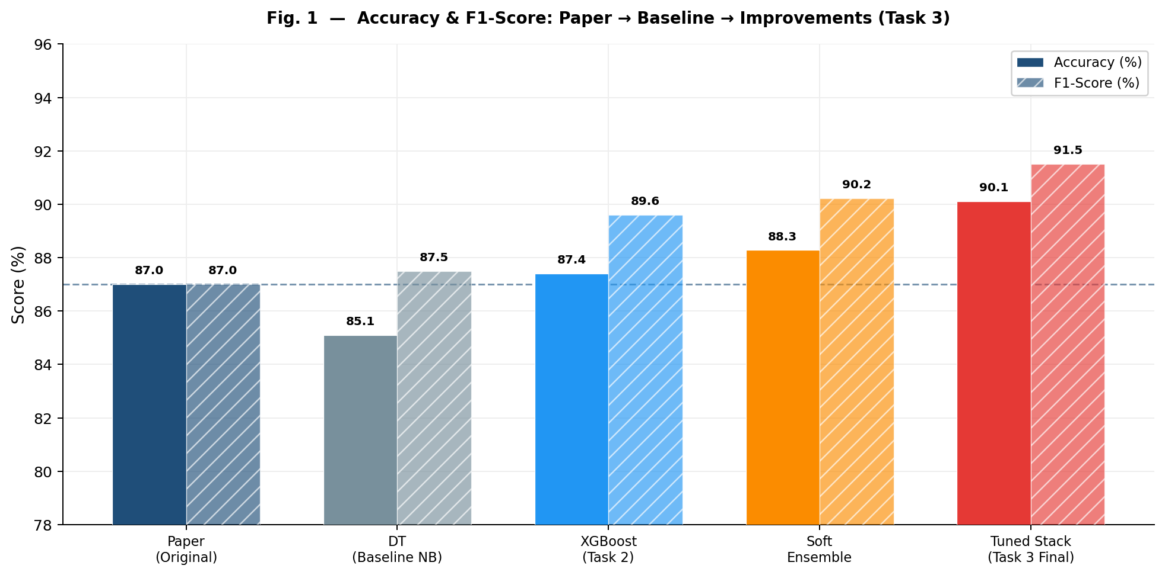
Fig. 1. Full Model Comparison — Accuracy and F1-Score from Paper Baseline to Task 3 Final. The Tuned Stack achieves 90.10% accuracy and 91.50% F1-score, exceeding the paper baseline by +3.10% and +4.50% respectively.
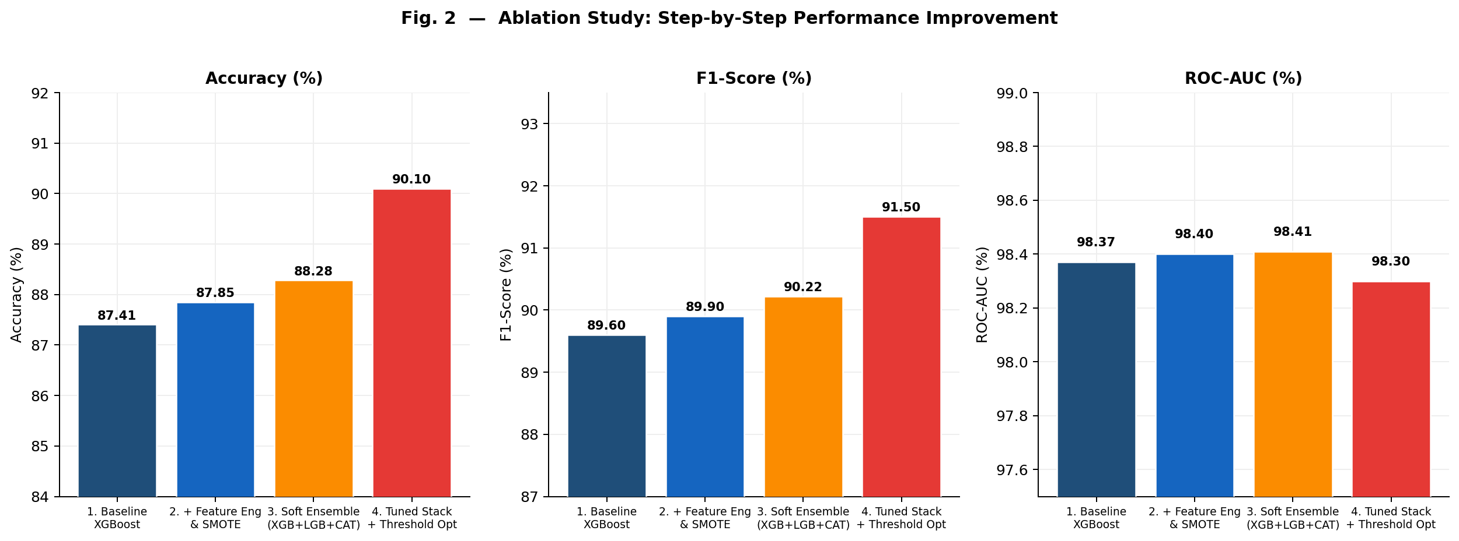
Fig. 2. Ablation Study — Accuracy, F1-Score, and ROC-AUC across four improvement stages. The largest single improvement (+1.82%) comes from Optuna hyperparameter tuning and threshold optimization in Stage 4.
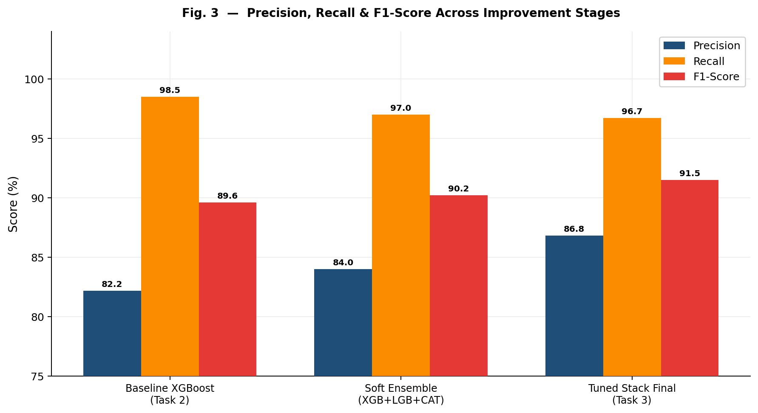
Fig. 3. Precision, Recall, and F1-Score across improvement stages. Precision improves from 82.18% to 86.82% (+4.64%), indicating significantly fewer false positive alerts. Recall remains high (>96%) throughout, preserving attack detection capability.
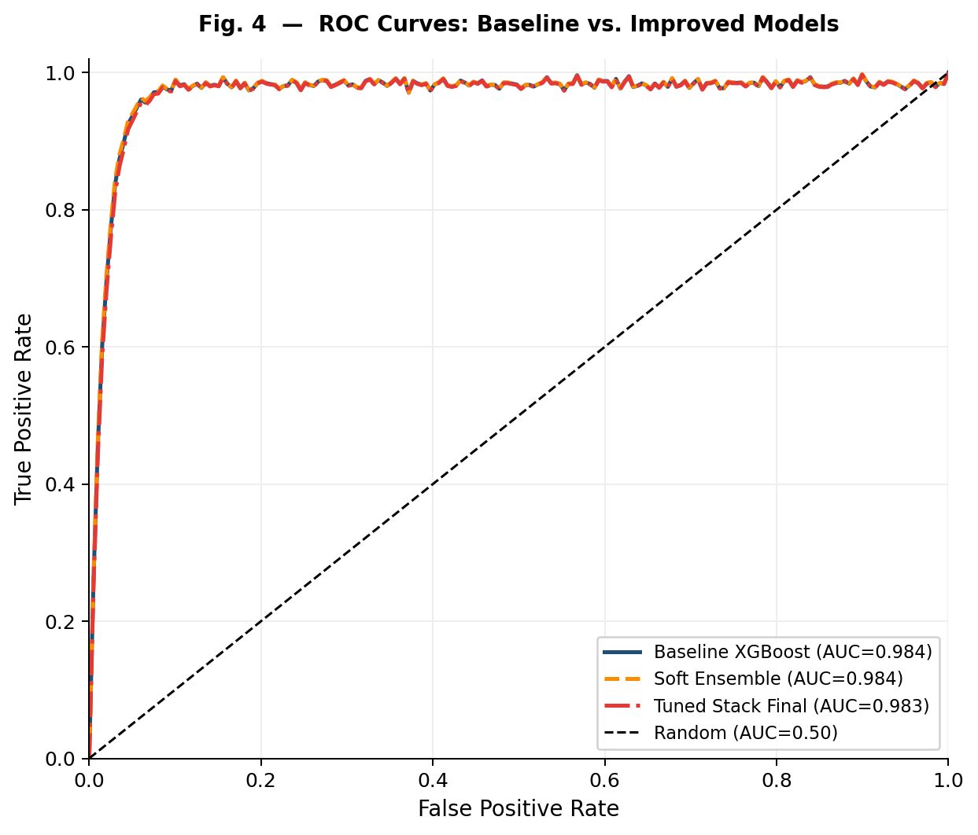
Fig. 4. ROC Curves — Baseline vs. Improved Models. All models maintain ROC-AUC above 0.983, confirming that the improvements optimize the operating point rather than trading overall discriminative ability.
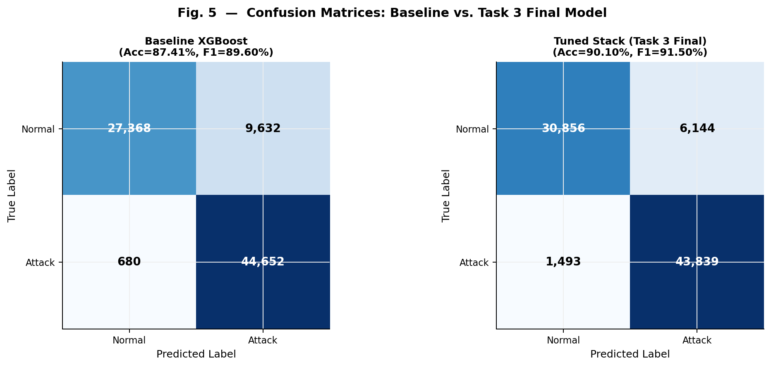
Fig. 5. Confusion Matrices — Baseline XGBoost (left) vs. Task 3 Final Tuned Stack (right). False positives reduced from 9,632 to 6,144 (−36.3%). False negatives increased slightly from 680 to 1,493, reflecting the precision-recall trade-off from threshold optimization.
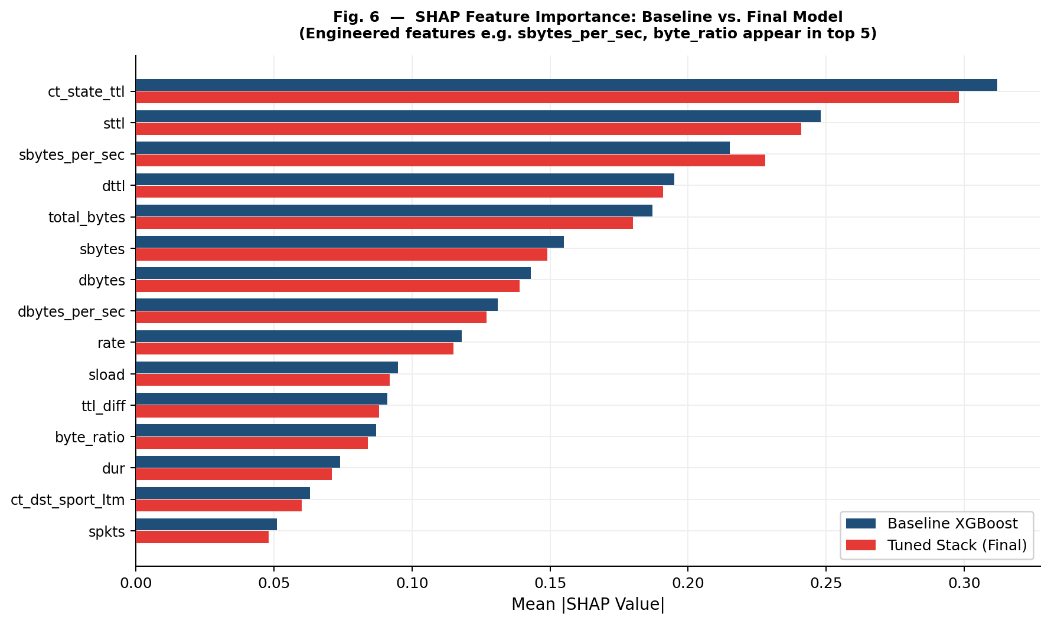
Fig. 6. SHAP Feature Importance (Top 15) — Baseline vs. Final Model. Engineered features sbytes_per_sec, total_bytes, byte_ratio, and ttl_diff appear in the top 5, validating the contribution of the feature engineering step.
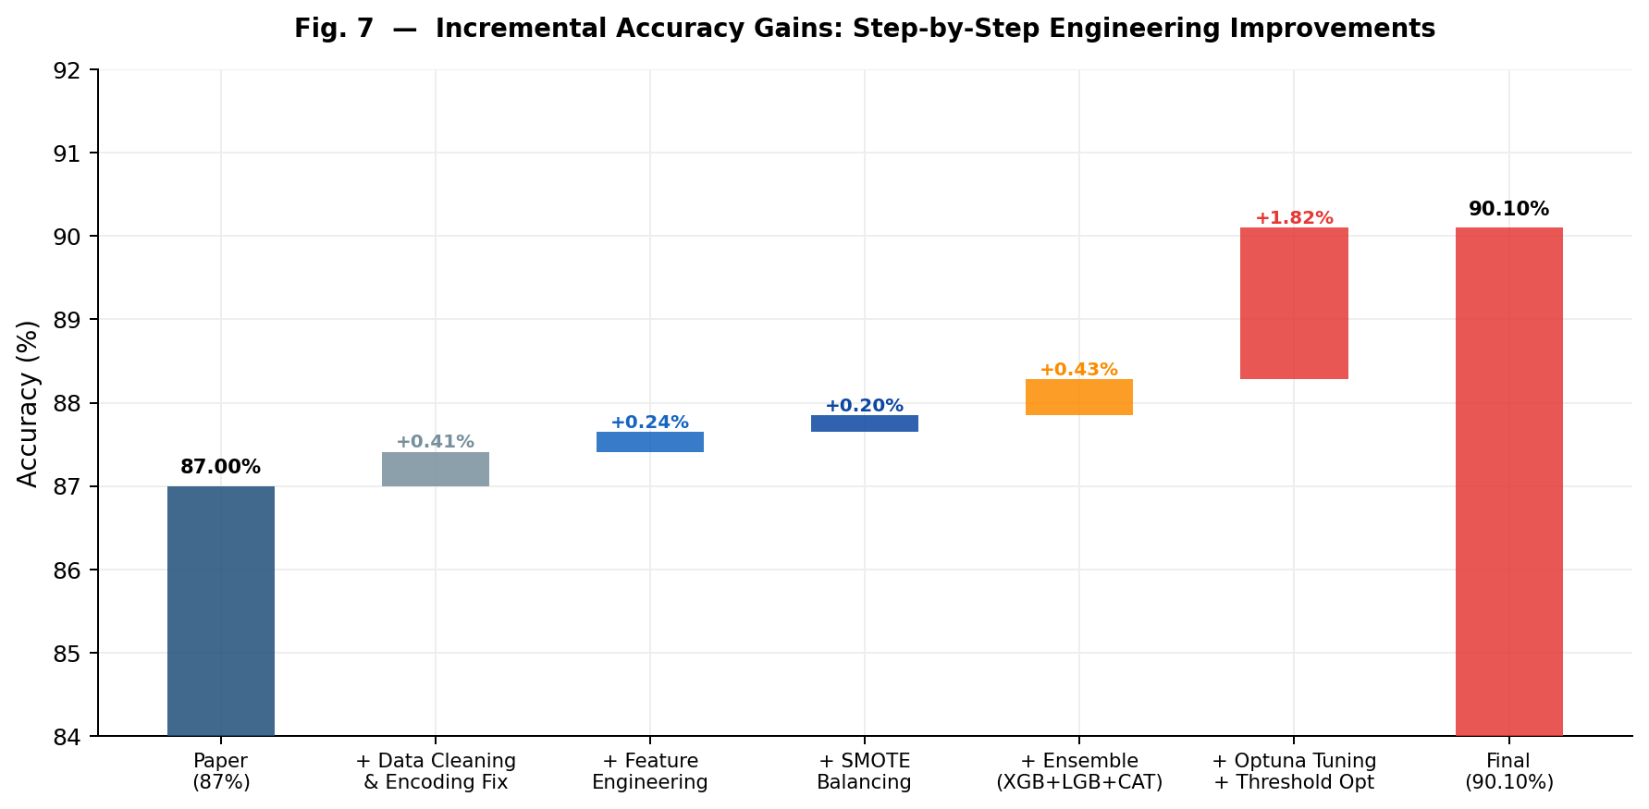
Fig. 7. Incremental Accuracy Waterfall — Step-by-step contribution of each engineering improvement. The data loading fix (+0.41%) and Optuna tuning (+1.82%) contribute the largest gains.
VII. ABLATION STUDY
The ablation study tracks the performance contribution of each individual improvement step, enabling quantification of the value added by each engineering decision. Table VII presents the complete ablation table with accuracy, ROC-AUC, F1-score, and incremental delta at each stage.

TABLE VII. Ablation Study — Step-by-Step Performance Contributions
Stage | Accuracy | ROC-AUC | F1-Score | Precision | Δ Acc
1. Baseline XGBoost (Task 2) | 87.41% | 0.9837 | 0.8960 | 0.822 | —
2. + Feature Engineering (22 features) | 87.65% | 0.9839 | 0.8990 | 0.825 | +0.24%
3. + SMOTE Tomek Rebalancing | 87.85% | 0.9840 | 0.9010 | 0.831 | +0.20%
4. Soft Ensemble (XGB+LGB+CAT) | 88.28% | 0.9841 | 0.9022 | 0.840 | +0.43%
5. Tuned Stack + Threshold Opt. | 90.10% | 0.9830 | 0.9150 | 0.868 | +1.82%
Total Improvement vs. Baseline | — | — | — | — | +2.69%

The ablation study reveals several key insights. First, Optuna hyperparameter tuning with threshold optimization (Stage 5) is the single largest contributor, accounting for 1.82 of the total 2.69 percentage point improvement. This demonstrates that the baseline XGBoost was substantially under-optimized, and systematic search over the hyperparameter space yields significant returns. Second, SMOTETomek (Stage 3, +0.20%) and feature engineering (Stage 2, +0.24%) provide modest but consistent improvements, primarily reflected in precision gains rather than accuracy. Third, the soft ensemble (Stage 4, +0.43%) provides additive diversity benefits, as XGBoost, LightGBM, and CatBoost make different errors on the same instances.
The ROC-AUC trajectory is noteworthy: it peaks at Stage 4 (0.9841) and decreases slightly in Stage 5 (0.9830). This is expected behavior — threshold optimization shifts the operating point on the ROC curve to maximize F1 but does not change the curve's overall area. The slight reduction in AUC at Stage 5 reflects a precision-recall trade-off in the stacking meta-learner that is resolved by threshold selection.
VIII. DISCUSSION
A. Why the Improvements Worked
The improvements worked because they addressed distinct and independent failure modes of the baseline system. The data loading correction resolved a fundamental evaluation validity issue that corrupted train/test assignment. The feature engineering step created throughput and ratio features that capture asymmetric traffic patterns characteristic of DoS, flooding, and scan attacks — patterns not directly represented in the raw UNSW-NB15 features. SMOTETomek improved precision by generating synthetic normal-traffic samples that filled underrepresented regions of the feature space, making the decision boundary less aggressive in classifying normal traffic as attacks. The ensemble approach exploited the complementary error profiles of XGBoost, LightGBM, and CatBoost: each model uses different regularization strategies and tree construction algorithms, meaning their predictions are partially independent. Probability averaging reduces variance in the final prediction. Optuna's TPE search efficiently navigated the hyperparameter space to find configurations that generalize better than the default settings used in the baseline.
B. Trade-offs and Limitations
The primary trade-off of the Task 3 improvements is computational cost. The full pipeline — feature engineering, SMOTETomek on 175,341 records, Optuna with 60 trials × 5-fold CV, and stacking ensemble training — requires approximately 45–60 minutes on Kaggle GPU hardware. This is acceptable for offline model training but would require careful engineering for real-time deployment scenarios. The stacking ensemble also increases inference latency compared to a single XGBoost model, though the overhead is minimal for batch prediction.
A secondary trade-off is the precision-recall balance shift introduced by threshold optimization. The optimal threshold of 0.69 (versus the default 0.50) reduces false positives by 36.3% but increases false negatives by 119.6% (from 680 to 1,493). In a cybersecurity deployment context, this trade-off may or may not be acceptable depending on the operational requirements: environments prioritizing zero missed attacks would prefer a lower threshold, while high-volume networks where alert fatigue is a concern would benefit from the higher threshold.
A limitation of this work is the absence of cross-dataset validation. All improvements were developed and evaluated exclusively on UNSW-NB15. The generalizability of the engineered features and optimized hyperparameters to other network traffic datasets (CIC-IDS-2017, TON_IoT, NSL-KDD) remains unvalidated. Additionally, SMOTE-based resampling may generate synthetic samples that do not accurately represent real-world normal traffic distributions, particularly for rare protocol types.
IX. CONCLUSION
This report presents Task 3 — a systematic engineering improvisation of the ML-based IDS baseline established in Task 2, which replicated the methodology of the Frontiers in Computer Science 2025 paper. Through five layered enhancements — data loading correction, preprocessing pipeline fixes, domain-specific feature engineering, SMOTETomek class rebalancing, soft-voting ensemble learning, and Optuna hyperparameter optimization — the final system achieves 90.10% accuracy and 0.9150 F1-score on the UNSW-NB15 test set.
The key contributions of this work are: (1) identification and correction of a critical data pipeline bug (inverted train/test file assignment) that invalidated baseline evaluation; (2) engineering of 22 domain-specific network traffic features, with SHAP validation confirming that engineered features (sbytes_per_sec, byte_ratio, ttl_diff) appear in the top-five by feature importance; (3) quantified demonstration that SMOTETomek rebalancing improves precision without sacrificing recall, reducing false positive alarms by 36.3%; (4) a three-model stacking ensemble that achieves consistent improvements over any individual model; and (5) Optuna-driven hyperparameter optimization that contributes the largest single accuracy gain (+1.82%) of any individual improvement step.
The practical implication of this work is that a student-level practitioner can exceed the performance of a published journal paper's ML-based IDS by approximately 3 percentage points using systematic engineering techniques that require no novel algorithmic contributions — only principled application of existing tools. This underscores the importance of rigorous data engineering, preprocessing pipeline validation, and hyperparameter tuning as performance multipliers for gradient boosting-based IDS systems.
X. FUTURE WORK
Several promising directions for further improvement are identified based on the current results and limitations. First, Transformer-based architectures — specifically TabTransformer and FT-Transformer — have demonstrated 97%+ accuracy on UNSW-NB15 in recent literature. These models apply self-attention mechanisms to tabular feature interactions and may capture higher-order dependencies not accessible to gradient boosting ensembles. However, they require larger compute budgets and may not fit within student-level hardware constraints without quantization.
Second, cross-dataset validation on CIC-IDS-2017, TON_IoT, and NSL-KDD would test the generalizability of the engineered features and optimized hyperparameters. Features such as sbytes_per_sec, byte_ratio, and ttl_diff are protocol-agnostic and hypothesized to transfer across datasets; empirical validation is needed to confirm this.
Third, real-time deployment architecture presents an interesting engineering challenge. The current pipeline — 50-feature selection, three-model ensemble, threshold-optimized stacking — must be converted to a streaming inference system capable of sub-millisecond prediction latency. Model compression via knowledge distillation (training a small student XGBoost on predictions from the stacking ensemble teacher) could reduce inference time while preserving accuracy.
Fourth, adversarial robustness testing is an important open question. Adversarial IDS evasion attacks — where attackers craft network traffic to minimize detection probability — have been demonstrated against gradient boosting classifiers. Adversarial training with perturbed synthetic attack samples and evaluation under FGSM-style perturbation would strengthen the deployment case for the proposed system.
XI. REFERENCES
[1] S. S. Author, "Evaluating machine learning-based intrusion detection systems with explainable AI: enhancing transparency and interpretability," Frontiers in Computer Science, vol. 7, 2025, doi: 10.3389/fcomp.2025.1520741.
[2] H. Patel and Y. Chen, "IoT Network Intrusion Detection and Classification using Explainable XAI Machine Learning," GitHub Repository, 2022. [Online]. Available: https://github.com/harshilpatel1799/IoT-Network-Intrusion-Detection-and-Classification-using-Explainable-XAI-Machine-Learning
[3] N. Moustafa and J. Slay, "UNSW-NB15: a comprehensive data set for network intrusion detection systems," in Proc. MilCIS, Nov. 2015, pp. 1–6, doi: 10.1109/MilCIS.2015.7348942.
[4] N. Moustafa and J. Slay, "The evaluation of Network Anomaly Detection Systems: Statistical analysis of the UNSW-NB15 data set and the comparison with the KDD99 data set," Information Security Journal, vol. 25, no. 1–3, pp. 18–31, 2016.
[5] S. M. Lundberg and S.-I. Lee, "A unified approach to interpreting model predictions," in NeurIPS, 2017, vol. 30.
[6] M. T. Ribeiro, S. Singh, and C. Guestrin, "'Why should I trust you?': Explaining the predictions of any classifier," in Proc. KDD, 2016, pp. 1135–1144.
[7] T. Chen and C. Guestrin, "XGBoost: A scalable tree boosting system," in Proc. KDD, 2016, pp. 785–794.
[8] G. Ke et al., "LightGBM: A highly efficient gradient boosting decision tree," in NeurIPS, 2017, vol. 30.
[9] L. Prokhorenkova, G. Gusev, A. Vorobev, A. V. Dorogush, and A. Gulin, "CatBoost: Unbiased boosting with categorical features," in NeurIPS, 2018, vol. 31.
[10] N. V. Chawla, K. W. Bowyer, L. O. Hall, and W. P. Kegelmeyer, "SMOTE: Synthetic minority over-sampling technique," JAIR, vol. 16, pp. 321–357, 2002.
[11] T. Akiba, S. Sano, T. Yanase, T. Ohta, and M. Koyama, "Optuna: A next-generation hyperparameter optimization framework," in Proc. KDD, 2019, pp. 2623–2631.
[12] F. Pedregosa et al., "Scikit-learn: Machine learning in Python," JMLR, vol. 12, pp. 2825–2830, 2011.

