TeleAfya

Software Architecture Document

Version 1.0

Revision History

|  |  |  |  |
| --- | --- | --- | --- |
| **Date** | **Version** | **Description** | **Author** |
| 03/10/2017 | 1.1 | Initial Draft | Vincent Ch |
|  |  |  |  |
|  |  |  |  |
|  |  |  |  |

Table of Contents

1. Introduction 3

1.1 Purpose 3

1.2 Scope 3

1.3 Team Members and Roles 3

1.4 Definitions, Acronyms, and Abbreviations 3

2. High-level Architectural Overview 4

2.1 TeleAfya System 4

2.2 Live video doctor visits 4

2.3 Patient registration Page 4

2.4 Consult online 5

2.5 Ability for the patient To Order Lab Tests 6

2.6 Dispatch Module 6

2.7 Offline/Online Status 6

2.8 Mapping System/Real Time Tracking of the Doctor/Patient Appointment 6

3. System Architecture Descriptions 6

3.1 Proposed Technical Tools/Vendor Also allowed to suggest other tools 6

3.2 General System Features 7

3.3 Database Entities 7

3.4 Admin Panel 8

3.5 Doctor Panel 8

3.6 Nurse Panel 8

3.7 Medical Assistant Panel 9

3.8 Mid Wife 9

3.9 Patients 9

4. Samples Web Application To Base the Design On. 10

Software Architecture Document

# Introduction

## Purpose

This document provides a comprehensive architectural overview of the system, using a number of different architectural views to depict different aspects of the system. It is intended to capture and convey the significant architectural decisions that have been made on the system. This document may be used to communicate significant architectural decisions to the technical leads to ensure that design is consistent throughout the project. The architectural views will stabilize very early in Elaboration, but the patterns and guidelines sections of the document will continue to evolve through early Construction.

## Scope

This document describes high level views of the architecture to indicate the overall structure of the project and its relationship to the enterprise architecture. In addition, the document will include patterns and guidelines created by the architect for the design teams to use. These patterns and guidelines will ensure consistency in the design of the project. Reasons for significant architectural decisions will be included along with alternates considered. This will provide a record in case questions arise later in the project or during maintenance of the system. If the reasons for the decisions change, this documentation will provide a basis for revisiting those architectural decisions.

## Team Members and Roles

|  |  |
| --- | --- |
| **Team Member** | **Role** |
|  |  |
|  |  |
|  |  |
|  |  |

## Definitions, Acronyms, and Abbreviations

This subsection provides the definitions of all terms, acronyms, and abbreviations required to properly interpret the SAD.

|  |  |
| --- | --- |
| **Acronyms and Abbreviation** | **Definitions** |
| SAD | Software Architecture Document |
| CCMS | Catalog Category Management System |
|  |  |
|  |  |

# High-level Architectural Overview

## TeleAfya System

TeleAfya is a system that connect patients to board-certified doctors, Nurses, Nurse Assistants, and Mid-Wives 24 hours a day using your computer, tablet or mobile phone. And the underlying goal is to leverage Technology to strengthened local health systems and reached at-risk patients and children with lifesaving treatment for acute under nutrition.

Last but not least, it bring quality care directly to communities and mobilized professional health care professionals to deliver needed care to these underserved communities.

## Live video doctor visits

The system shall allow the patient to see schedule a Live video doctor visits which includes assessment, diagnosis and prescriptions when necessary. Example: <https://youtu.be/S-e4PnE3eM0>

## Patient registration Page

The system shall allow a patient to register in order to see medical Professional such as doctor, Nurse and midwives.

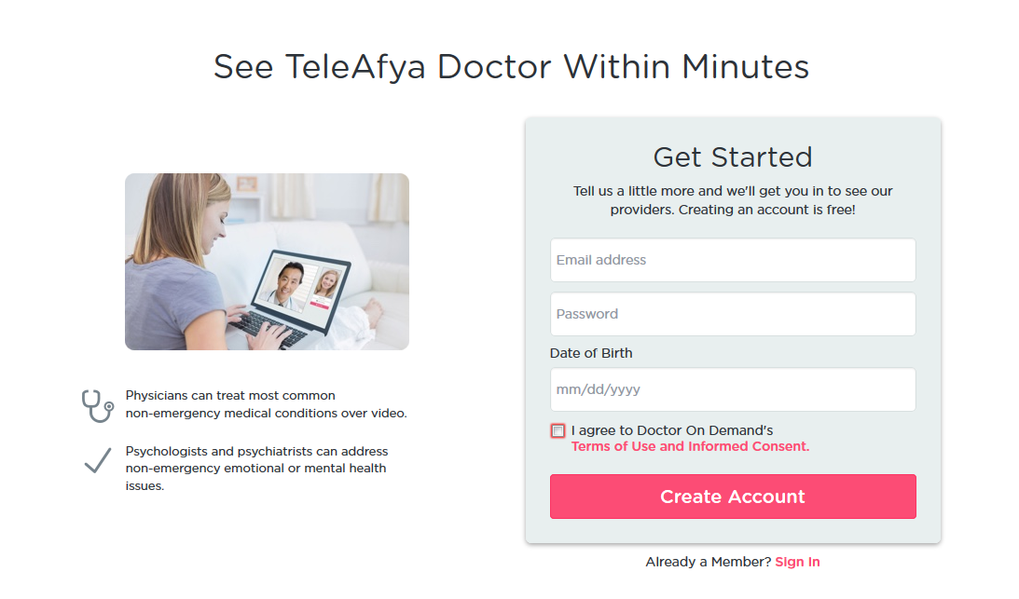

## Consult online

The system shall allow a patient to seek medical advice online from any medical Professional such as doctor, Nurse and midwives by typing in the issue such as “Sore Throat” and a list of specialized professional would show up and from there the patient can either consult online now or schedule appointment.



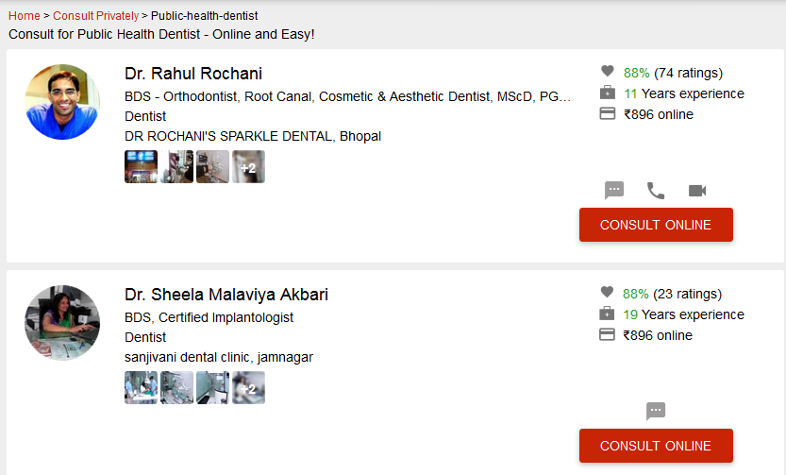

## Ability for the patient To Order Lab Tests

The system shall allow a patient to order Lab Tests

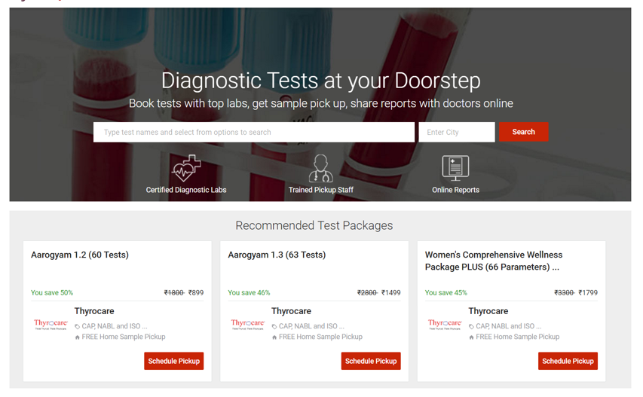

## Dispatch Module

The system will be deployed to rural and urban areas and for those patients without access to internet the system shall have a built in Dispatch Module or Call Center Module where by a dedicated dispatcher will receive calls from the patient and registered them to them system. The Dispatcher shall also be able to connect those patients with medical professionals around the community.

## Offline/Online Status

The system shall allow Medical professionals to set status either online to accept patients or offline not to accept patients.

## Mapping System/Real Time Tracking of the Doctor/Patient Appointment

The system shall allow Patient to track when the Doctor is heading to the patient Location for treatment.

## Home Page-Our Doctors, Our Nurses, Our Midwives Profiles

The system shall allow Patient to see Our Doctors Full Profiles with ratings. Same as Our Nurses with full profiles and etc.

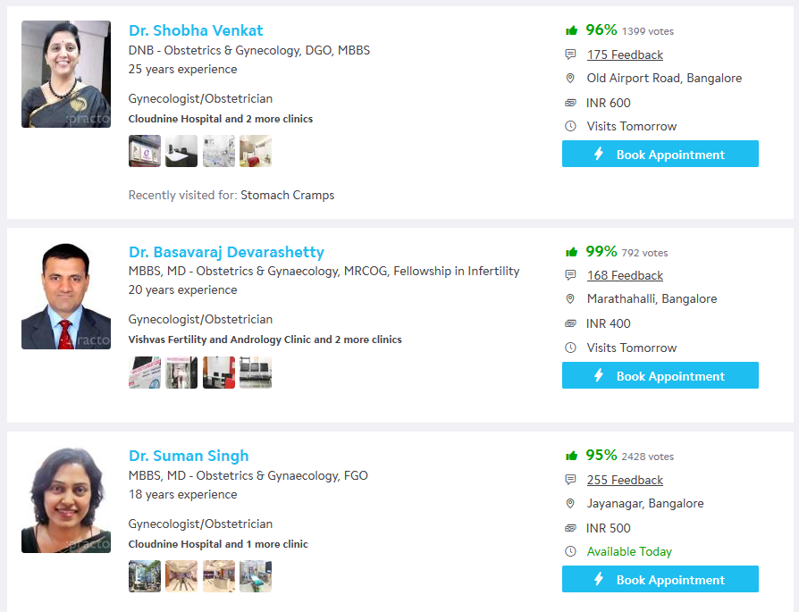

## Affiliate Hospitals and other Health Centers

The system shall allow adding and listing Affiliate Hospitals and Health Centers and shall allow the ratings for those Health centers to be seen by doctors and Patients.

# System Architecture Descriptions

## Proposed Technical Tools/Vendor Also allowed to suggest other tools

1. Android and IOS Native Apps
2. ASP.NET MVC 4 or 5-Web Front End and Admin Panels
3. C#
4. Twitter Bootstrap
5. CSS
6. JQuery/JavaScript where Necessary
7. SQL Server Database
8. Entity Frameworks
9. ASP.NET Web Api
10. HTML

## General System Features

1. Home page
2. About us page
3. FAQs
4. Patient
5. Apply To Become Health care Professionals for TeleAfya
6. Booking Appointment Page
7. Login Page
8. Patient Signup page
9. Search page (Landing Page)
10. Press Release Page

## Database Entities

1. Patients
2. Doctors
3. Mid-Wives
4. Nurses
5. Appointments
6. Reviews
7. Ratings
8. Services
9. Pricing Table

## Admin Panel

|  |
| --- |
| 1. Add Create Location Radius |
| 1. Choose Health care (Add Update, Delete, Show) |
| 1. Country(Add,Update,Delete,Show) |
| 1. State (Add, Update,Delete,Show) |
| 1. City (Add, Update, Delete, Show) |
| 1. Location Wise Booing Health Care (Add, Update, Delete, Show) |
| 1. Add Doctors |
| 1. Add Nurses |
| 1. Add Medical Assistant |
| 1. Add Mid Wife |
| 1. FAQ Report |
| 1. Reports |
| 1. Review Show |

## Doctor Panel

|  |  |
| --- | --- |
| Upcoming Appointment | Show,Delete,Update,Approved |
| Past Appointment | Show,Delete,Update,Approved |
| Review Report |  |

The Frond Facing Doctor page must also shows:

1. Doctor Licensing Board
2. Community Ratings e.g. Gold Star, Silver Star,
3. Reviews.

## Nurse Panel

|  |  |
| --- | --- |
| Upcoming Appointment | Show,Delete,Update,Approved |
| Past Appointment | Show,Delete,Update,Approved |
| Review Report |  |

## Medical Assistant Panel

|  |  |
| --- | --- |
| Upcoming Appointment | Show,Delete,Update,Approved |
| Past Appointment | Show,Delete,Update,Approved |
| Review Report |  |
| Appointment Status | Show, Delete |

The Frond Facing Medical page must also shows:

1. Medical Assistant Licensing Board
2. Community Ratings e.g. Gold Star, Silver Star,
3. Reviews.

## Mid Wife

|  |  |
| --- | --- |
| Upcoming Appointment | Show,Delete,Update,Approved |
| Past Appointment | Show,Delete,Update,Approved |
| Review Report |  |
| Appointment Status | Show, Delete |

The Frond Facing Mid Wife page must also shows:

1. Mid Wife Licensing Board
2. Community Ratings e.g. Gold Star, Silver Star,
3. Reviews.

## Patients

|  |  |
| --- | --- |
| Upcoming Appointment | Show,Delete,Update,Approved |
| Past Appointment | Show,Delete,Update,Approved |
| Show Booking Message |  |
| Appointment Status | Show, Delete |

# Samples Web Application To Base the Design On.

1. **Soothe**-This is Massage web and Mobile Application that I would like TeleAfya to be based on.
2. **Practo**- This is Doctors on Demand Application. I would like Teleafya to have the same search Feature Page like this: So when Health care Professional name is clicked it show page like this with rating and reviews.

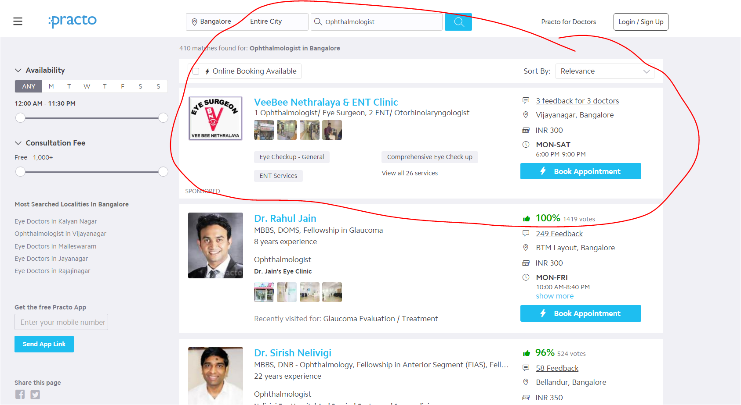

1. **Lybrate.com** .TeleAfya should also have the ability to order Lab Test and ability to have a page for wellness Lab Test just like Lybrate:



