Final Project

Showcasing Pulse Width Modulation (PWM) on ARM and HCS12

By: Mohamed Halane, Muhammad Ali Kermali, Muhammad Basit, Daniyal Asim

LE/EECS 3215 A - Embedded Systems

December 2nd, 2025

Overview Of The Project

For the final project, we decided to go with demonstrating PWM on ARM and HCS12. For ARM, we would showcase our demonstration of PWM through the BeagleBone AI. For HCS12, we would use the older Dragon boards used in Lab 4 and 5. For the demonstration, we would show a servo’s (HS-422) movement with pulse width modulation on the 2 systems. For the HCS12 part, our code would showcase the ability to change the direction and speed of the servo with both 8 bit and 16 channels, along with the ability to shift the servo to specific positions, using the 4x4 keypad. For the showcase on the Beaglebone AI, we would show PWM functionality through the keyboard. The reason why we chose this project is because we wanted to understand the difference in process when implementing PWM on the two different systems and the difference in the two systems overall.

Deliverables
When the HCS12 program is run, the user should be able to control the servo’s movement, direction and speed, as well as the ability to change its bit functionality and the ability to send the servo to specific positions (0, 90, 180). The legend to what the user can do with the keypad is below.
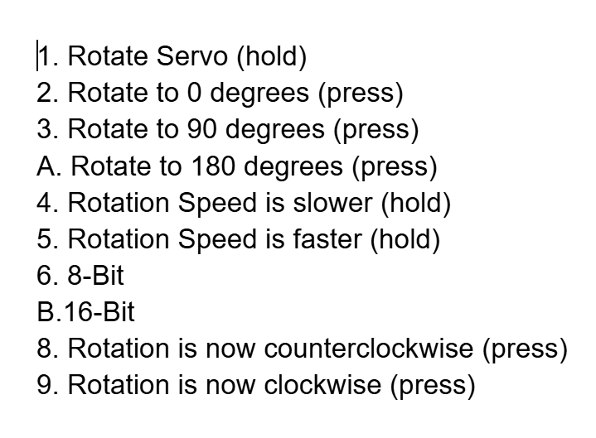
When the ARM program is run on the BeagleBone AI, the user should be able to toggle between manual movement of the servo and automatic movement. They should also be able to control the speed of the servo (step), along with how fast each of its adjustments is (ms). Other things the user can do is send the servo to specific positions (0, 90, 180) and change its direction. This is shown in the legend below, as the user is able to use their keyboard to control the servo.
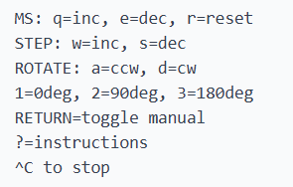

Servo PWM
Servo PWM is based on the period and duty cycle. Depending on the values of the period and duty cycle, the position of the servo will change. If set at a period of 20ms, the servo will go to the “neutral position” or 90 degrees if the duty cycle is set to 1.5 ms. It will go to 0 degrees if the duty cycle is set at 0.5 ms and 180 degrees if set at 2.5ms. Since the servo can only go from 0 to 180 and back, going outside the 0.5-2.5 ms range will cause the servo’s motor to produce unpredictable results. By continuously increasing and decreasing the duty cycle within this range, we can showcase 180 degree movement on the servo.

Part 1: HCS12

Introduction
Since we have focused on using HCS12 through the labs, we wanted this part of the project to showcase our understanding of the labs along with the combination of the various features we used on the HCS12 Dragon boards throughout the labs. The goal of the program was to allow the user to completely control the servo’s movement, along with using all the features available to us to make the process as user friendly as possible. This involved using the seven segment display available on the board to showcase what the user is currently changing, using the 4x4 keypad to allow the user control of the servo and using the LCD display to show messages relating to the program. This code is run on CodeWarrior and we use the older HCS12 Dragon Board with the serial monitor.

Setup
For the HCS12 part of this project, the code is run on CodeWarrior and we use the older HCS12 Dragon Board with the serial monitor. The servo is plugged into the PP5 slot on the Dragon Board.
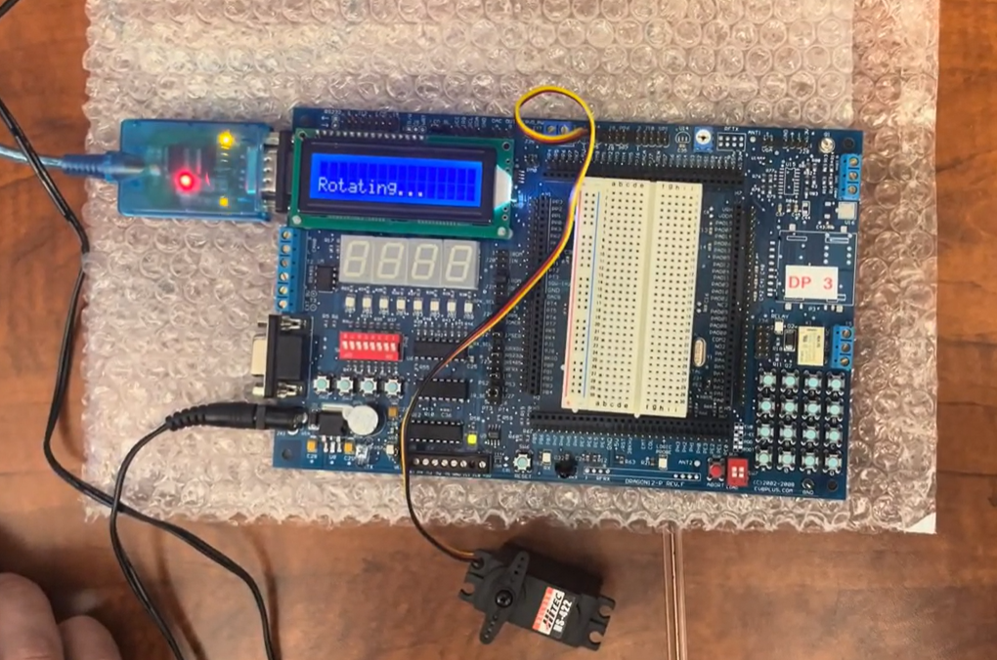

Implementation

For HCS12, pulse width modulation is controlled through the PWM commands. These commands include PWMCLK, PWMPRCLK and PWMSCL* (involved in setting the clock for the program, * can be A or B), PWMPOL (turning on/off the polarity for PWM), PWMCTL (setting 8 bit and 16 bit channels) and PWME (turning on a PWM channel). The 2 most important PWM commands are PWMPER* and PWMDTY* (where * can be a number). PWMPER* sets the period and PWMDTY* sets the duty cycle. Depending on these values, the position of the servo (when all others are set) will be moved. For the 16 bit functionality, we use PWMPER45 and PWMDTY45, while for the 8 bit functionality we use PWMPER5 and PWMDTY5.
In our program, there are a few other custom variables that help control the movement of the servo. In our code, the servo movement is handled by constantly adding and subtracting the PWMDTY* value (within the range). The “sign” variable is always set at -1 or 1, and depending on its value, the PWMDTY* value will be subtracted or added from. This allows you to easily change the direction of the servo by simply changing this shift value, as seen below.
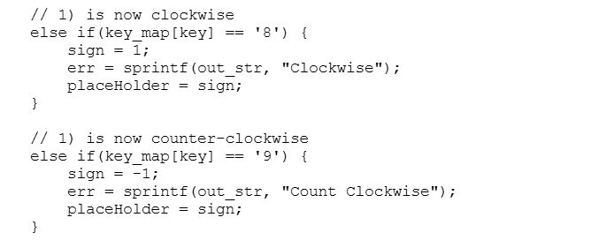
If the user clicks 8 or 9 on the 4x4 keypad, the rotation direction will be changed (8 for clockwise, 9 for counterclockwise).

The “shift” variable controls how much PWMDTY* will be subtracted or added from. Increasing and decreasing this value will cause the servo to go to other positions faster or slower, which allows us to control speed, as seen below.
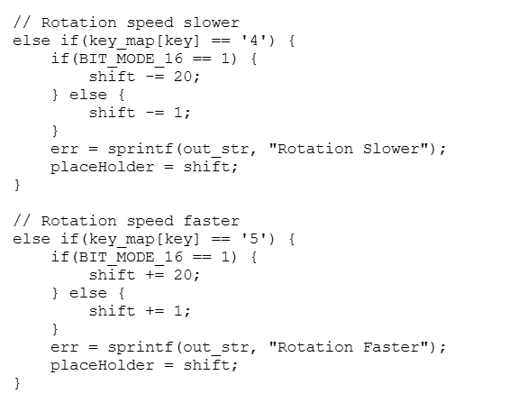

If the user clicks 4 or 5 on the 4x4 keypad, the rotation speed can be changed.

The user is able to send to the specific positions 0 degrees, 90 degrees and 180 degrees through the buttons 2, 3 and A. This is done by setting the PWMDUTY* value as the value that corresponds to that servo position. MIN_DUTY is 0 degrees, MAX_DUTY is 90 degrees and 90 degrees is found through the average of the min and max values (0 + 180 = 180 / 2 = 90).
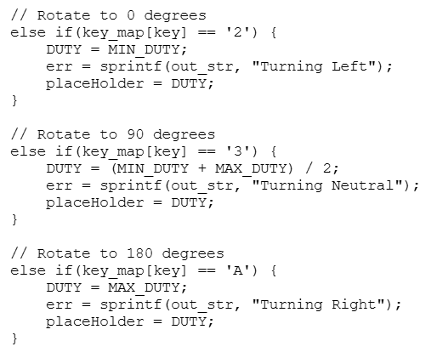
In this program, the user is able to change the current PWM channel being used from a 16 bit channel into a 8 bit channel, and vice versa. This allows the user to choose if they want smoother transitions that require more power and memory (16-bit channel), or if they want a servo that uses less power at the cost of rougher transitions. At default, the channel is set as a 16-bit channel. However, the user can switch it to an 8 bit channel by pressing “6”, or switch it back to a 16 bit channel by pressing “B”, as seen below.
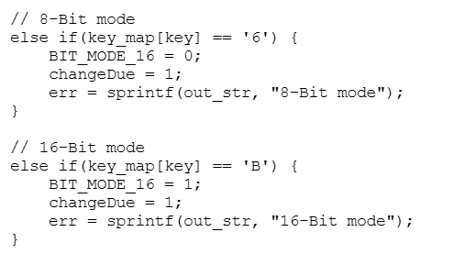

The user is able to manually move the servo by holding down the button “1”. The servo will move the current direction that’s set by sign, at the current speed that’s set by shift. There is also an if condition after each position shift to make sure that the servo has not left the acceptable range. If it has, it will set the current position to 0 or 180 degrees (depending if it went over or under the range).

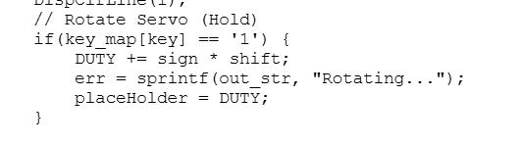

For the HCS12 part of this project, we use μC/OS-II in order to integrate a task into the program in order to make the process of running the servo easier. One of the responsibilities of this task is making sure that the preset PWM commands are set correctly depending on the current PWM channel the user has selected. Based on whether it's 8 bit or 16 bit, the task will update these preset values to accommodate the change.
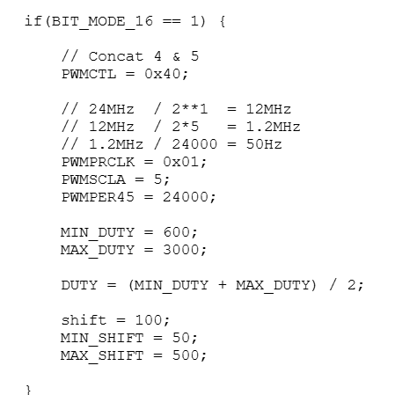
Up above are the preset values if 16-bit is selected. Through the clock commands, we are able to set a frequency of 50hz (which is the best frequency to use for servos). Since 16 bit allows for values from 0-65,535, the period is set at 24,000 and the duty cycle range is set as 600-3000. This matches up with the 0.5-2.5ms range of a 20ms period, while allowing for the servo’s positions and movements to be even more precise and smooth.

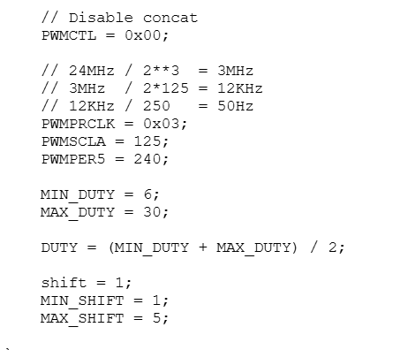
Up above are the presets of an 8 bit PWM channel. Since values are only able to be set from 0-256, the amount of positions the servo can reach in 8 bit is limited compared to using 16 bit. With a frequency of 50Hz, the period is set as 240 and the duty cycle range is set as 6-30 in order to match up with the 20ms period.

Another responsibility of this task is to make sure that the servo does not leave the duty cycle range and rotation speed range. This is done through an if condition in the task that sets the duty cycle/rotation speed as the minimum or maximum if they go under or over the range. This is shown down below.

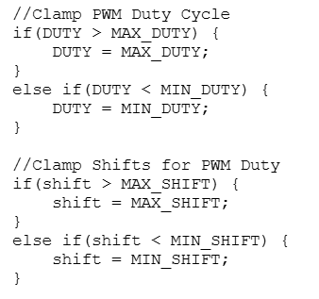

Part 2: BeagleBone AI

Introduction
Setting up the PWM on BeagleBone AI first involved connecting the board to a computer, then SSH-ing into it using its local networking capabilities. This gave us access to the full Debian Linux operating system that was pre-installed on it. The version of the OS was from 2019, but worked for our purposes. We did install a newer version of the system on a different BeagleBone AI, however since it did not provide much benefit to us, the board we tested and demoed on ran with the version it came with out of the box. There were also some issues connecting the board to campus Wi-Fi, so anything involving an internet connection was done through the host computer.

Setup
Our BeagleBones were not initially set up to work with PWM, which required some research and tinkering on our end. Eventually we came across a solution called pinmuxing (pin multiplexing), which requires a custom device tree source. A device tree source is essentially a text file that describes how the hardware is configured. To achieve this, we cloned the BeagleBoard-DeviceTrees repo, and created a dts file, the contents of which we found on an Element14 forum. We then transferred the repo using scp to the BeagleBone AI, built the .dts file, and edited the uEnv.txt file so that it would use the custom DTS after rebooting. This gave us access to the pwm on P9_14.

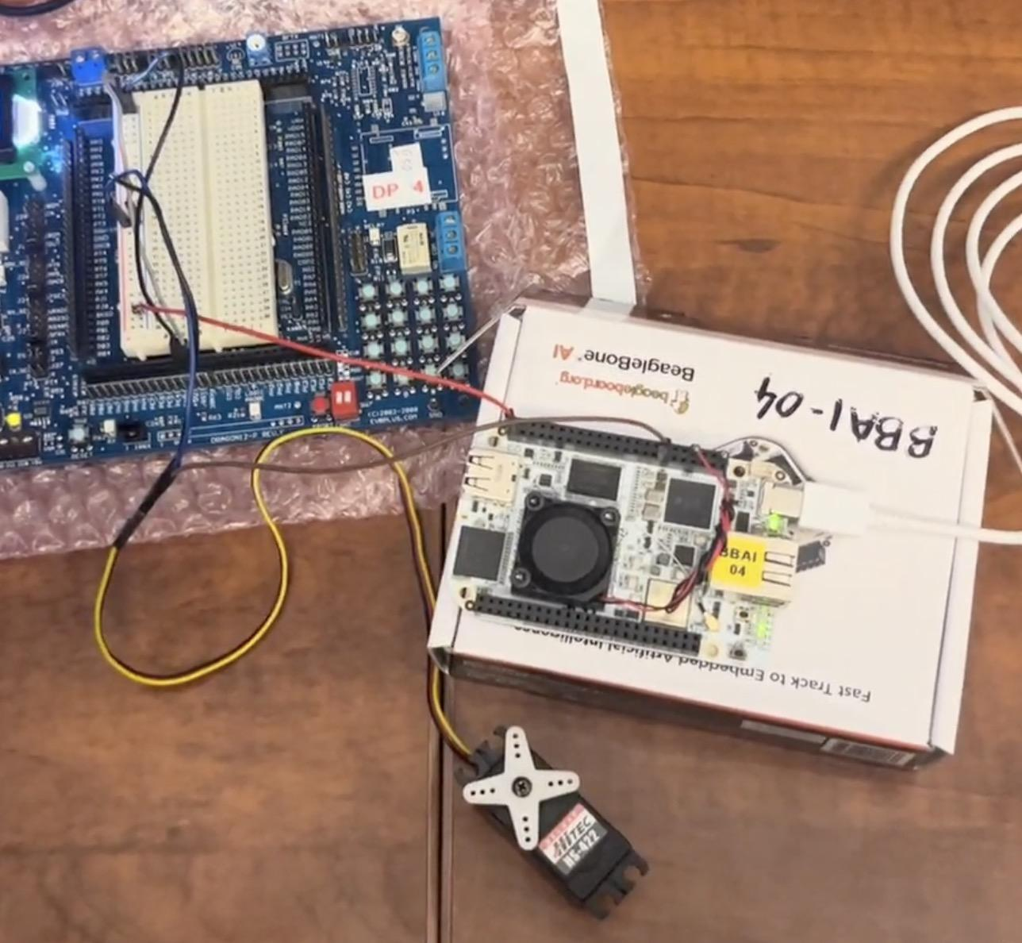
Once the BeagleBone AI was set up to work with PWM, we needed to connect it to the servo. The servo we had required 4.8V, however the board could only output 5V. To avoid stressing the BeagleBoard AI, we opted to connect both the servo and the BBAI to the integrated breadboard on an older HCS12 board (serial monitor version). Using jumper wires, we connected the grounds of the BBAI and servo to the HCS12, the power (red wire) of the servo to the HCS12, and the yellow wire (signal) of the servo was connected to pin P9_14 of the BeagleBone AI.

Implementation
The way PWM is handled by the BeagleBone AI is through files. We found the PWM folder at /sys/class/pwm/pwm-0:0, which contains the files we needed to manipulate the servo. This is referred to as the PWMPATH in our code.

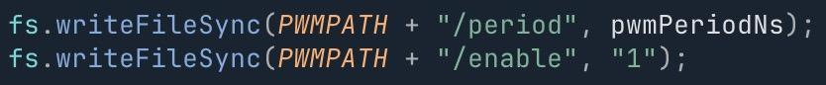
We set the period to 20,000,000 ns (20ms) by writing to the PWMPATH/period file, then enabled PWM by writing 1 to the PWMPATH/enable file. We found that a period of 0.8ms represented an angle of 0deg and 2.4ms represented 180deg, so these were set as our boundaries, and the initial position of the servo was set to 1.6ms, used when starting the program.

To adjust the rotation of the servo, we took our position in milliseconds, converted it to nanoseconds (ms • 10^6), then wrote the result to PWMPATH/duty_cycle.

We used the preinstalled Node package to run the program, as it was the most convenient option, however the BeagleBone AI also supports programs written in C or Python 2. No external libraries were used, beyond the built in node modules fs and readline for filesystem and stdin.

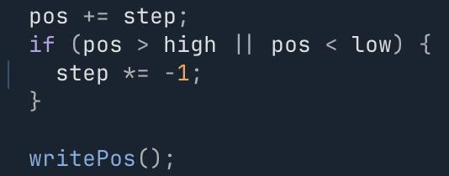
Once called, the program starts by setting the servo to the center (1.6ms), then begins rotating by approximately 11.25 degrees clockwise (step = 0.1ms) every 250ms (controlled by a NodeJS.Timeout), until it reaches the maximum angle, after which it begins rotating 11.25 degrees counterclockwise (step = -0.1ms).

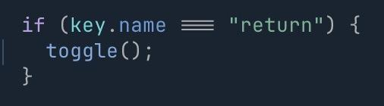
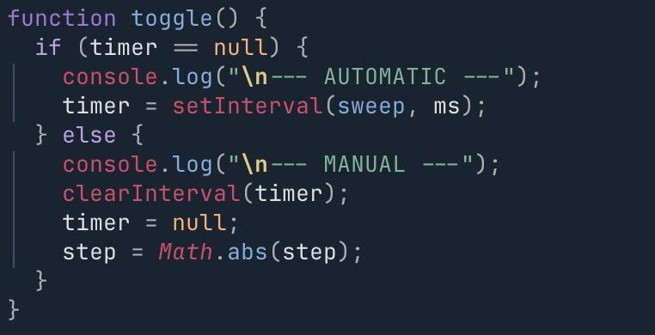
The program can be controlled by the host computer’s keyboard, for example, toggling between automatic and manual modes by pressing the return key. Distinguishing between automatic and manual modes is done by checking the timer used to periodically call the rotation function when in automatic mode. If it is null, then the program is in manual mode, otherwise it is in automatic mode.

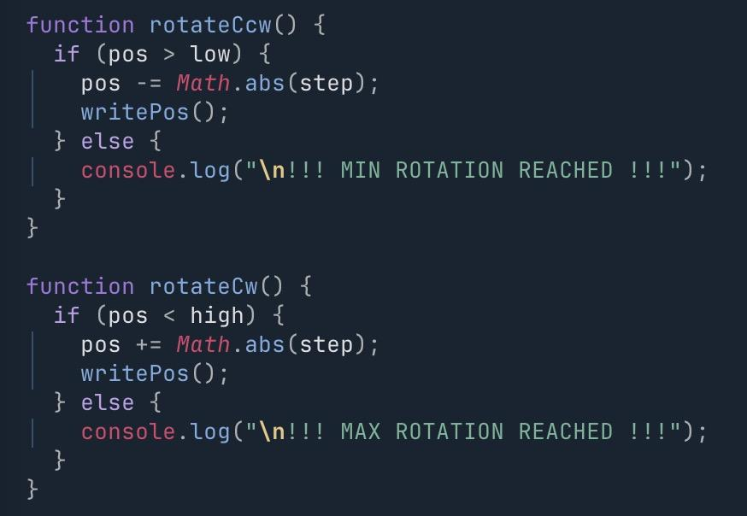
When in manual mode, the servo can be controlled using the keyboard, rotating in either direction by step (e.g clockwise by 0.1ms) via the ‘a’ (ccw) and ‘d’ (cw) keys, or by jumping to a predetermined position (1 = 0 degrees, 2 = 90 degrees, 3 = 180 degrees). These are limited, preventing the user from over rotating the servo and causing damage to it.

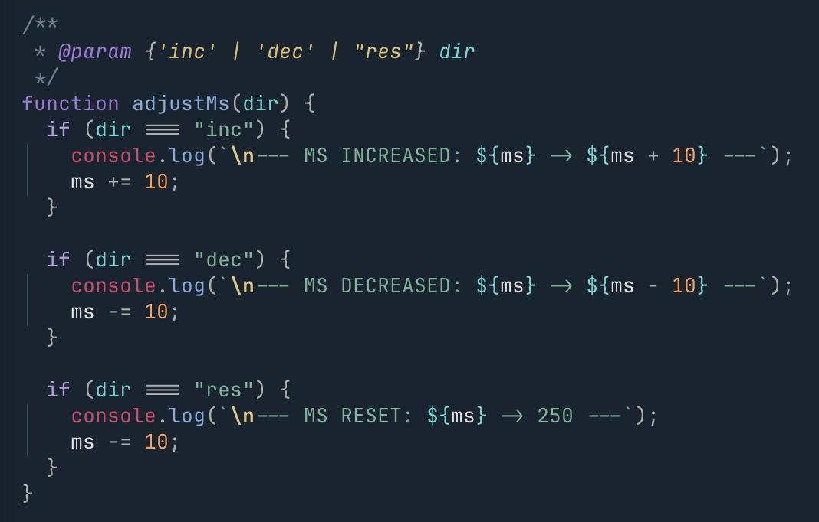
Users can also make adjustments to the step using the ‘w’ and ‘s’ keys, from 0.1ms up to 1.6ms, and the time between automatic rotations (‘q’ to increase by 10ms, ‘e’ to decrease by 10ms, and ‘r’ to reset to 250ms). Above is the adjustMs function, which controls the rotation interval in automatic mode, the implementation for adjustStep is similar.

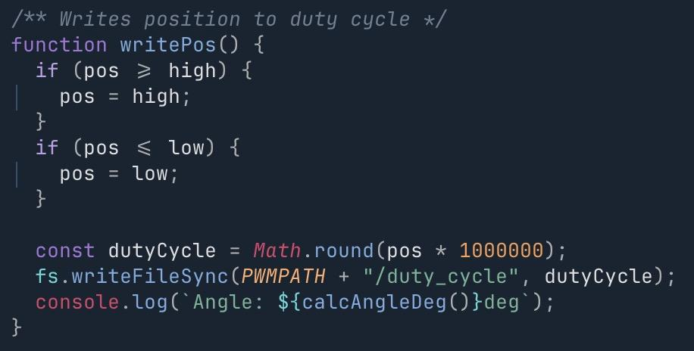
There is another protection feature in the writePos function, that prevents the program from writing a position that is too high or too low for the servo to handle. This is especially useful when adjusting the step, as it will prevent the servo from over rotating in cases where pos + step or pos - step passes the boundaries (e.g pos = 2, step = 1 -> pos = 3).

All keypresses are handled by listening to stdin, and then matching the key name to the appropriate action.

Comparing HCS12 and ARM
Going through this project idea has allowed us to better understand the differences between ARM and HCS12.

After using both BeagleBone AI and Dragon Board, we noticed that there were many more freedoms on the BeagleBone AI compared to the HCS12 Dragon board. One key example is the difference in languages available to be used from the HCS12 and BeagleBone AI. The BeagleBone AI was able to handle a much larger amount of languages, while the HCS12 Dragon Board forced us to use C or Assembly in order to use the microcontrollers. We felt that using JavaScript as the language on the BeagleBone AI made it easier for us to use PWM compared to C, a choice that would not have been possible on the HCS12 Dragon Board. Similarly, the Dragon Board forced us to use the CodeWarrior IDE (as it is the only IDE that works with it) while the BeagleBone AI board allowed us the flexibility to code where we wanted.

Another key difference was the access to Internet on the BeagleBone compared to the HCS12. With access to the internet, the BeagleBone was able to access updates in images, available and easy to find on the BeagleBone website. This allows the BeagleBone to keep up with the quick evolution of programming, compared to the Dragon Board and its lack of internet access. One example of this is the board’s access to Git, allowing users to clone and build projects with ease. This is especially useful in cases where a custom device tree is needed, such as to enable PWM. A developer can clone the BeagleBoard-DeviceTrees repo, create a custom DTS file, and build it all from the BBAI itself. This is one of the major reasons for why the BeagleBone AI gives much more freedom to the programmer compared to the Dragon Board.

Because of the BeagleBone AI being newer (2019) and more available, the BeagleBone AI has much more resources available online talking about it compared to the Dragon Board, which uses older microcontrollers. This made it easier for us to understand how to set up the BeagleBone AI when we first started on the ARM part of this project, since there were pretty recent references to this board across the internet. For example, when trying to understand how to set up PWM for the BeagleBone AI, we were able to find official resources on how to use it and how to connect to a servo. However, when we were unable to access the PWM pins on our board, due to them not being set up by default, we were eventually able to find a post that explained how to enable it using pin multiplexing via a custom DTS. Comparing this to the HCS12, the resources we could find were very old, the documentation was relatively harder to understand, and very few websites and forums would discuss this board.

PWM signals are generated differently between the boards. The BeagleBone AI uses a file system to control the PWM, writing numerical values to text files in order to enable/disable, set the period, and to update the duty cycle. On the other hand, the HCS12 board generated the signals directly from the board, using the dedicated PWM registers. Values were controlled by writing integers to the variables provided by the header file. Configuration also differed, where the BeagleBone AI required us to compile a custom device tree system to set up the pins, the HCS12 only required the specific registers to be written to, a simple task to complete in C.

Hardware differences required us to implement our program interfaces differently. The HCS12 has a 4x4 grid of buttons to control the servo, and a 7 segment display to communicate with the user. The BeagleBone AI had no buttons nor display, and thus required us to connect to a computer in order to present the user with information (via logging), as well as using the computer’s keyboard and stdin in order to read and process user inputs. Another hardware difference was the difference in power between the 2 boards. The HCS12 Dragon Board was able to handle the 4.8V the servo required, allowing us to use the board directly as a power source when running the program. In comparison, the BeagleBone was not powerful enough to be used as a power source, as the 4.8V could end up damaging the board. As a result, the setup for the BeagleBone was more complicated due to having to use the HCS12 board as a power source while running the code on the BeagleBone.

Overall, the differences between these two systems gives them strengths and weaknesses that could lead to different types of programmers using them. For a programmer who is newer to using microcontrollers/microprocessors and wants to learn more about them, the HCS12 Dragon Board with its simpler setup, simpler programming, and larger power supply would be a good recommendation. In comparison, the BeagleBone AI with how much freedom it provides the programmer, along with its internet access, would be better for a more experienced programmer who already understands the basics and wants to take on more.

Concluding Thoughts
We were able to successfully implement PWM generation programs for both the HCS12 and BeagleBone AI, allowing users to control a servo using either one of the boards. The BeagleBone AI, running Debian Linux on a relatively modern chip, allowed us to take advantage of the additional power and flexibility by using Node to control the servo, and provided a convenient SSH connection that made development, debugging, and testing much easier. However, getting the PWM pins set up, and connecting to the servo was more challenging, requiring a custom DTS, and additional hardware in order to power the servo. In contrast, the HCS12 was relatively simple to set up in terms of hardware, providing the servo enough power on its own, and setting up the PWM connection was as simple as setting a few variables. However, it is less advanced than the BBAI, and its simplicity meant that we required CodeWarrior to develop and test our program, which was more cumbersome than our setup for the BBAI. Interface differences also changed the way users interact with the different programs, one with buttons, the other with SSH and a keyboard. In the end, we were able to create two separate programs, each allowing users to generate arbitrary PWM signals to control a servo.

