**Daniyal**

**18P-0043**

**Computer Networks Lab**

**Task#1**

Perform communication of four devices using switch

• Use the IP Address of Class C

• Simulate transfer of packet between two PCs

• Write a brief and concise description of the whole process.

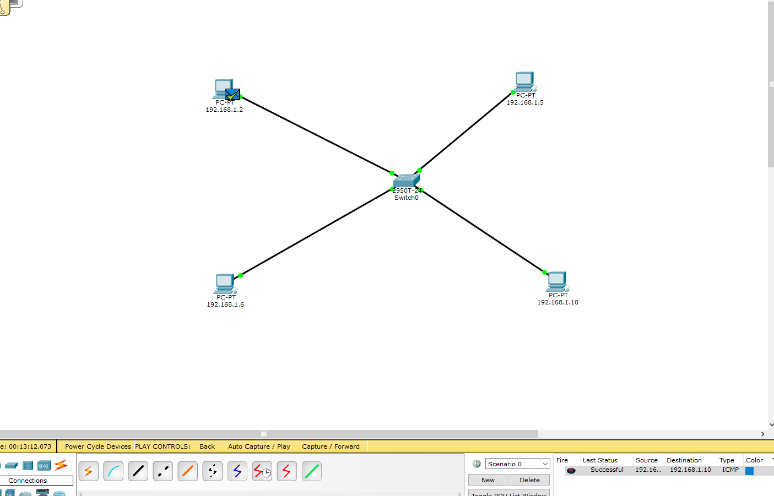

When sending packets through switches to different devices. When you send a packet to another pc, the switch reads the header of the packet and matches with the destination and sends the packet through the appropriate port which reaches the destination.

**Task#2**

Perform communication through multiple switches

• Use the IP Address of Class C

• Simulate transfer of packet between PC0 and PC3

• Write a brief and concise description of the whole process.

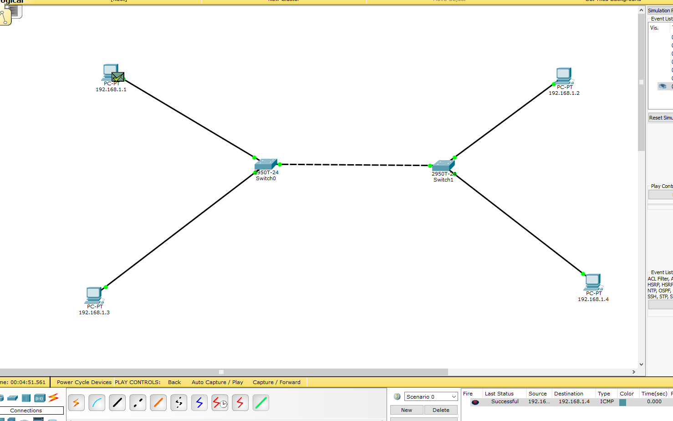

When sending packets through switches to different devices. When you send a packet to another pc, the switch reads the header of the packet and matches with the destination and sends the packet through the appropriate port which reaches the destination.

**Task#3**

Perform communication through Router

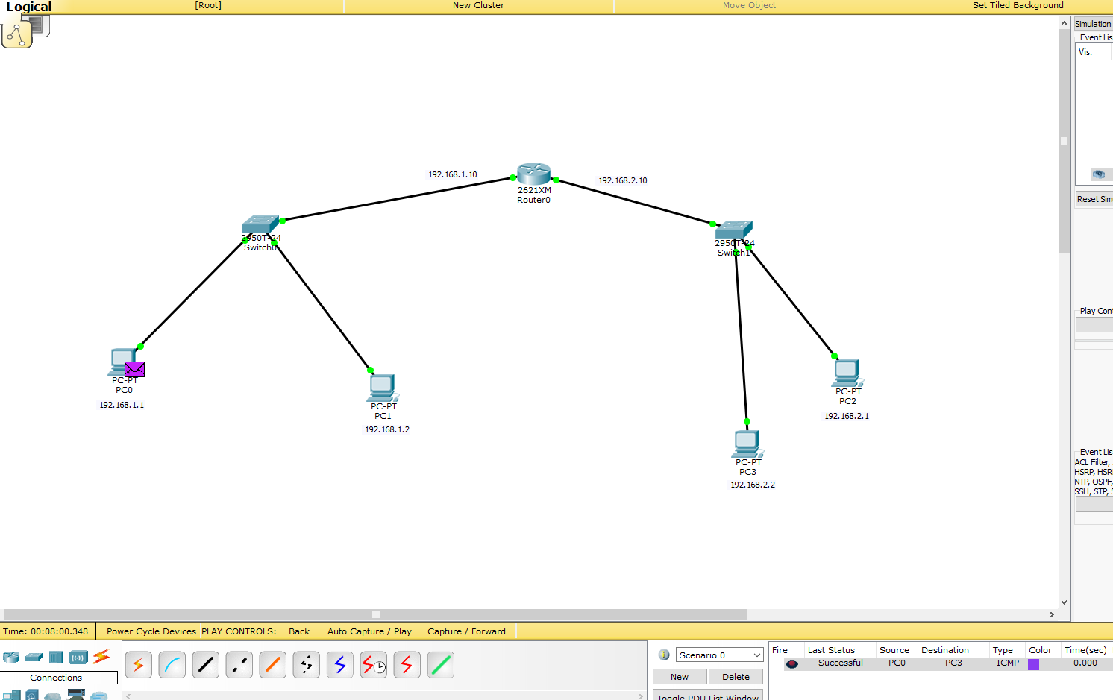

In the switch we send packets to different devices but the router is used to send packets on different networks.

**Task#4**

**Perform communication through two routers**

