SEARCH QUERY
- ("Course Learning Outcomes" OR "CLOs" OR "Learning Outcomes" OR "LOs") AND ("Bloom's Taxonomy" OR "Bloom Taxonomy" OR "Cognitive Levels") AND ("classification" OR "taxonomy level classification") AND ("large language models" OR "LLMs" OR "Generative AI")

ID | Title | Authors | Year | Focus | Method | Key Findings | Possible Future Work
1 | Leveraging generative AI for course learning outcome categorization using Bloom’s taxonomy | Omaima Almatrafi, Aditya Johri | 2025 | Course Learning Outcomes (CLOs) | GPT-4 (Zero-shot, Few-shot, Chain-of-Thought, Rhetorical Situation, Multiple Binary Questions) and BERT fine-tuning. | Prompts with rhetorical context and domain knowledge achieved the highest performance; fine-tuned BERT showed superior performance; multiple binary questions underperformed. | - Investigate GPT laziness with long context  - Improve Chain-of-Thought transparency  - Verify generalizability of fine-tuned BERT across different institutions.
2 | Automated Analysis of Learning Outcomes and Exam Questions Based on Bloom’s Taxonomy | Ramya Kumar, Dhruv Gulwani, Sonit Singh | 2025 | Exam questions and learning outcomes (600 sentences) | SVM, NB, Logistic Regression, LSTM, BERT, RoBERTa, and LLMs (GPT-4o-mini, Gemini-1.5-Pro, Llama 3.1, Claude 3.5). | SVM with data augmentation reached 94% accuracy; RNN and BERT suffered from severe overfitting on small data; Gemini and GPT-4o-mini performed best among LLMs (0.72-0.73 accuracy). | - Small dataset size;  - Need for more complex augmentation (back-translation);  - Parameter-efficient fine-tuning (lora).
3 | Investigating Methods for Mapping Learning Objectives to Bloom’s Revised Taxonomy in Course Descriptions for Higher Education | Zahra Kolagar, Frank Zalkow, Alessandra Zarcone | 2025 | Learning Objectives (LOs) from university course descriptions | LLM-based (GPT-4 via MCS, PWC, BWS, BCA, RCA) vs. Non-LLM based (Regex, Fuzzy Matching, SpaCy, Semantic Similarity). | LLM-based methods (specifically Best-Worst Scaling) consistently outperform non-LLM methods; GPT-4 shows minimal evidence of prompt-induced bias (positional or verbosity). | - Limited to a single LLM (GPT-4); small dataset size (35 los)  - Future work should include larger datasets and other languages like German.
4 | LLMs meet Bloom’s Taxonomy: A Cognitive View on Large Language Model Evaluations | Thomas Huber, Christina Niklaus | 2025 | LLM Benchmarks (AGIEval, BIG-Bench Hard, etc.) | Mapping 43 benchmark tasks to Bloom’s Taxonomy using human annotation, LLM annotation (GPT-4, Claude 3, Llama 3), and RoBERTa. | Current benchmarks focus on lower-order thinking (Understand, Apply, Analyze) and lack coverage of 'Evaluate', 'Create', and 'Metacognitive' levels. | - Need for benchmarks with absolute performance metrics for 'Create' and 'Evaluate'  - Human performance comparisons needed for gap identification.
5 | Revolutionizing Educational Assessment Using Bloom’s Taxonomy Bot | Minakshi Atre, Sarthak Karandikar, Kabeer Ahmed Merchant, Abhijeet Suryawanshi, Heramb Patil | 2025 | Engineering question papers (SPPU) | Mistral 7B fine-tuned using Quantized Low-Rank Adapters (QLoRA). | Bloomify bot achieved Mean Opinion Scores (MoS) of 8 to 9.5 for classification, suggestion, and generation; successfully automated BS (Bloom's Score) calculation. | - Current implementation struggles with mathematical formulae and coding questions;  - Future work to integrate RAG and Stable Diffusion for diagrams.
6 | Learning Analytics with Scalable Bloom’s Taxonomy Labeling of Socratic Chatbot Dialogues | Kok Wai Lee, Yee Sin Ang, Joel Weijia Lai | 2025 | Socratic student–chatbot exchanges (Statistics course) | SentenceTransformer (all-MiniLM-L6-v2) with Logistic Regression, SVM, XGBoost, and MLP; vs. Fine-tuned GPT-4o-mini. | Fine-tuned GPT-4o-mini had best micro-F1 (0.814); calibrated Linear SVM had best macro-F1 (0.630) for preserving rare higher-order labels. | - Limited gold labeling (3 students/8.8% cohort)  - Model-based labeling for the rest may contain bias  - Need for hybrid ensembles and student-level splits.

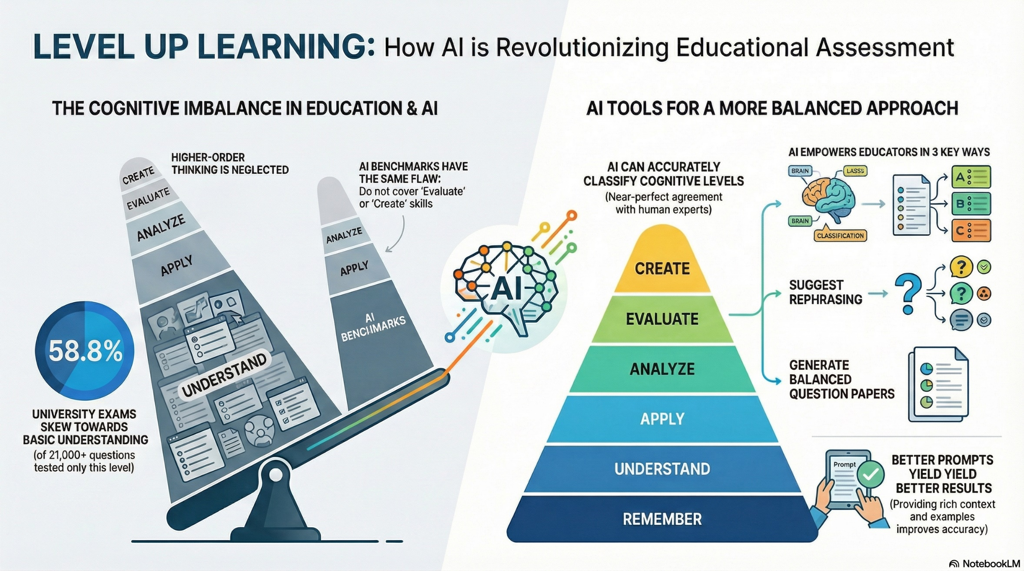
Topic Selection:
'Comparative Approaches To Automating Bloom’s Taxonomy Classification: Large Language Models (Llms) Vs. Traditional Machine Learning In Educational Assessment.'

Findings: The field is currently debating the trade-offs between using prompt-engineered LLMs (like GPT-4), fine-tuned models (like BERT or Mistral), and traditional machine learning (like SVM) for classifying educational content.

Here are the specific insights I have gathered from these papers to support this topic:

1. The "Prompt Engineering vs. Fine-Tuning" Trade-off
I found conflicting evidence regarding the most effective method, largely dependent on dataset size and specific metrics (like macro-F1 vs. micro-F1).
- Findings: In the paper "[1]," Almatrafi and Johri found that a fine-tuned BERT model achieved near-perfect agreement with experts, outperforming prompt-based GPT-4 methods, However, they noted that using "Rhetorical Situation" prompts (incorporating audience and context) achieved the highest performance among prompting strategies,
- Gap/Insight: Almatrafi and Johri also observed that while "Chain-of-Thought" prompting offers transparency, it did not improve classification accuracy and led the model to "over-analyze" inputs.

2. LLMs vs. Traditional & Non-LLM Methods I found a distinct split in the literature regarding whether "bigger is better."
- LLM Superiority: In [3] Kolagar et al. found that LLM-based methods (specifically GPT-4) consistently outperformed non-LLM methods (like Regex, fuzzy matching, or SpaCy) and showed resilience against common biases like verbosity or position bias,
- Traditional Model Resilience: Conversely, Kumar et al., in [2] found that on small datasets (600 sentences), a traditional Support Vector Machine (SVM) with synonym augmentation achieved 94% accuracy, outperforming both BERT (which overfit) and zero-shot LLMs like GPT-4o-mini and Gemini (which scored roughly 72–73%).
- Nuance in Dialogues: In [6], Lee [The one of the authors] found that while a fine-tuned GPT-4o-mini achieved the best weighted performance (micro-F1), a classical linear SVM was actually superior at balancing performance across categories (macro-F1), making it better for detecting rare, higher-order thinking skills.
3. Practical Applications & Tools I found that current research is moving beyond static text analysis into dynamic applications like chatbots and question generation.
- Bloomify: In "[5]," Atre [The one of the authors] developed "Bloomify," a chatbot fine-tuned on Mistral 7B using QLoRA, designed to classify, suggest, and generate exam questions aligned with Bloom's Taxonomy,
- Socratic Dialogue: Lee [The one of the authors] applied Bloom's taxonomy to dynamic student-chatbot interactions to tag conversational turns in real-time, moving beyond static learning outcomes to analyze Socratic dialogue.
4. Critique of Current LLM Benchmarks I also found a critical perspective on how LLMs themselves are evaluated.
- Findings: In "[4]," Huber and Niklaus analyzed popular benchmarks (like MMLU and AGIEval) and found they heavily overrepresent lower-order thinking skills (Remember/Understand),
- They argue that current benchmarks lack sufficient coverage of "Evaluate" and "Create" levels, meaning our current metrics may not accurately reflect an LLM's ability to perform complex cognitive tasks.
- Conclusion/Next Steps: "My proposed next step is to synthesize these comparative methodologies. I aim to explore when it is appropriate to use resource-heavy LLMs versus efficient traditional models, particularly for identifying higher-order cognitive skills which remain a challenge for current automated systems."

