DEPARTMENT OF SOFTWARE ENGINEERING
ARTIFICIAL INTELLIGENCE (LAB)

Name: Daniyal Yousaf
Roll #: 097
Section: BSAI-3B
Course: CS4944 - Artificial Intelligence
Submission files: Lab2_Report.docx

Intelligent Agents & the PEAS Framework
1. Executive Summary & Objective
This report analyzes intelligent agent architectures using the PEAS framework (Performance, Environment, Actuators, Sensors) and environment taxonomy. It evaluates two autonomous agent implementations—a campus delivery robot and an LLM-based student-support assistant—and examines a smart classroom energy controller to contrast simple reflex agents with model-based stateful systems.
Deliverables Summary: Key Deliverables & Investigation Scope:
• PEAS Formal Specifications: Detailed operational definitions for physical (delivery robot) and software (LLM assistant) agents.
• Environment Classification: Rigorous evaluation of observability and determinism boundaries for physical vs digital domains.
• Reflex vs Stateful Architecture: Practical implementation of memory mechanisms to eliminate redundant control signals.
• Failure Mode & Hysteresis Analysis: Evaluation of edge cases in stateful controllers operating under noisy sensor inputs.
2. PEAS Specifications for Target Agents (Task 1)
The PEAS framework establishes the task environment boundaries necessary to evaluate agent rationality. Below are the complete specifications and tool accessibility assumptions for the two target systems.
A. Autonomous Campus Delivery Robot
The delivery robot navigates outdoor pathways and campus building corridors to deliver physical packages to designated drop-off points.

PEAS Element | Concrete System Specification
Performance Measure | 1. High delivery completion rate and punctual delivery times.  2. Zero collisions with pedestrians, obstacles, or vehicles, plus low battery consumption.
Environment | 1. Campus sidewalks, building entrance ramps, elevators, and corridors.  2. Dynamic weather conditions (rain, fog) and pedestrian/cyclist traffic.
Actuators | 1. Electric wheel drive motors (steering and velocity control).  2. Electronic cargo compartment lock/unlock mechanism and audio/visual status indicators.
Sensors | 1. 3D LiDAR sensors, optical cameras, and ultrasonic proximity arrays.  2. Wheel encoders, internal IMU (gyro/accelerometer), and GPS receiver.

Performance Trade-off Analysis: A primary tension exists between delivery speed and operational safety. Optimizing strictly for rapid delivery times encourages aggressive navigation around pedestrians, increasing collision risk. Conversely, over-prioritizing safety can cause freezing behavior in dense crowds. Rationality requires balancing transit speed against collision avoidance.
B. LLM-Based Student-Support Agent
The student-support agent is a conversational software system designed to resolve academic inquiries, course registration requirements, and campus policy questions.

PEAS Element | Concrete System Specification
Performance Measure | 1. High accuracy of academic information and policy compliance.  2. Low response latency and high user satisfaction scores.
Environment | 1. Web chat interface and student portal infrastructure.  2. Dynamic university course databases, prerequisite charts, and academic calendar rules.
Actuators | 1. Natural language text generator and structured UI response builder.  2. API function calls (e.g., fetch_student_record, query_course_prereqs).
Sensors | 1. User text query prompt receiver and input context parser.  2. Database API response payloads and session state trackers.
Performance Trade-off Analysis: The system faces a conflict between reply latency and factual precision. Maximizing response speed by generating text without verifying database records increases the risk of hallucinations. Conversely, executing exhaustive retrieval queries delays responses. A rational agent must prioritize verified factual accuracy for official academic policies.
Operational Assumptions & Tool Access: The LLM agent operates under explicit tool boundaries. It possesses access to a read-only Student Information System (SIS) API, course catalog vector index, and enrollment status checker. It lacks administrative access to modify grades or alter course prerequisites.
3. Environment Taxonomy & Justification (Task 2)
Evaluating task environments along the dimensions of observability and determinism determines the required agent architecture.

Target System | Observability | Determinism | Observable vs Hidden Variable | Predictable vs Uncertain Outcome
Delivery Robot | Partially Observable | Stochastic | Observable: Wheel speed, front obstacle distance.  Hidden: Pedestrian intent behind corners. | Predictable: Motor brake command stops wheels.  Uncertain: Sudden pedestrian movement on wet tiles.
Student Support LLM | Partially Observable | Stochastic | Observable: User query text, SIS records.  Hidden: True user intent, unwritten policy norms. | Predictable: Database SQL lookup return.  Uncertain: LLM non-deterministic token sampling.
Simulator vs. Real Environment Boundary: Real physical environments are partially observable and stochastic due to sensor noise, blind spots, and unpredictable human behaviors. A simplified simulator converts this domain into a fully observable, deterministic matrix by supplying exact position vectors and fixed state transition rules.
4. Implementation & Action Trace Comparison (Task 3)
To evaluate agent memory mechanisms, the simple reflex agent in lab2_percepts.py was extended into a model-based stateful agent in lab2_model.py. The stateful agent maintains internal storage (self.previous_mode) and compares target calculations against its current state to suppress duplicate hardware commands.
A. Reflex Agent Execution Trace (lab2_percepts.py)
The reflex agent maps percepts directly to target modes without tracking past history. Output from running the script:

Step | Percept (Temp °C, Occupied) | Target Mode Output
1 | (29.0°C, True) | COOL
2 | (29.0°C, True) | COOL (Redundant Command)
3 | (20.0°C, True) | IDLE
4 | (26.0°C, True) | IDLE
5 | (19.0°C, True) | WARM
6 | (29.0°C, False) | ECO

OUTPUT

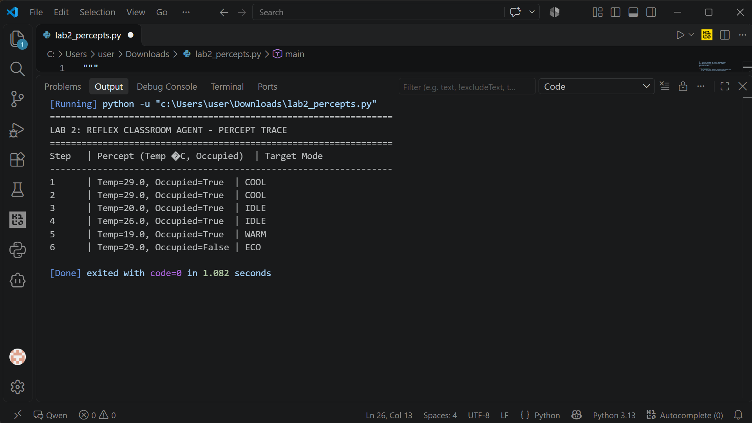B. Stateful Model-Based Agent Execution Trace (lab2_model.py)

The stateful agent evaluates identical threshold logic but tracks previous state to prevent redundant transmissions:

Step | Prev Mode | Percept (Temp, Occ) | Target | Command Action | Scenario Note
1 | IDLE | (29.0°C, True) | COOL | SEND_COMMAND | Initial cooling command sent.
2 | COOL | (29.0°C, True) | COOL | NO_COMMAND | Redundant command suppressed.
3 | COOL | (26.0°C, True) | IDLE | SEND_COMMAND | Upper boundary met (26°C -> IDLE).
4 | IDLE | (20.0°C, True) | IDLE | NO_COMMAND | Lower boundary met (20°C -> IDLE).
5 | IDLE | (19.0°C, True) | WARM | SEND_COMMAND | Heating mode transition.
6 | WARM | (29.0°C, False) | ECO | SEND_COMMAND | Empty room override priority.

OUTPUT model

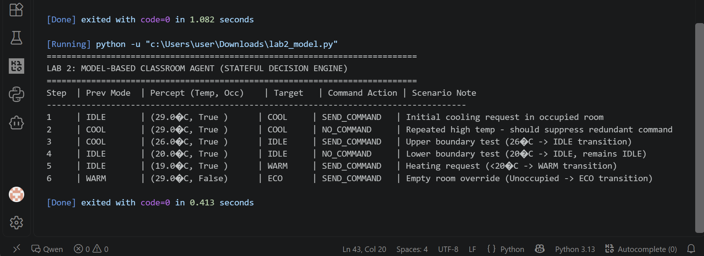

5. Failure Mode & Edge-Case Analysis (lab2_check.py)

While the stateful model-based agent successfully eliminates duplicate control commands, maintaining state alone does not resolve control instability caused by sensor noise near threshold boundaries.

Observed Failure Behavior: Rapid Actuator Chatter

In lab2_check.py, a sequence of fluctuating temperature readings around the 26.0°C boundary was tested: 26.5°C -> 25.9°C -> 26.2°C -> 25.8°C.

1. Observed Output: At 26.5°C, the system switches to COOL (SEND_COMMAND). At 25.9°C, it switches to IDLE (SEND_COMMAND). At 26.2°C, it flips back to COOL (SEND_COMMAND). At 25.8°C, it flips back to IDLE (SEND_COMMAND).
2. Root Cause: Because the decision logic uses sharp inequality thresholds (temp > 26.0), minor noise causes the target mode to oscillate rapidly between COOL and IDLE across consecutive cycles. Storing the previous mode does not prevent mode flipping when target state changes on every reading.
3. Proposed System Improvement (Hysteresis / Deadband Integration): To fix this, a deadband margin (e.g., ±0.5°C) must be introduced. Once in COOL mode, the system should remain in COOL until temperature drops below 25.5°C, suppressing rapid actuator wear.
OUTPUT

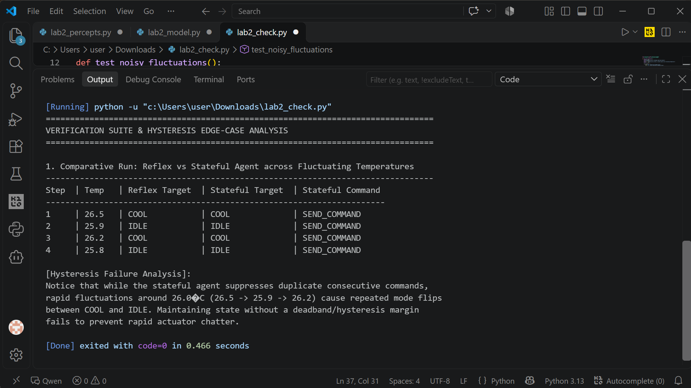6. Reflection & Responsible AI Practice
Learning Outcomes: • Key Learnings: Understood how PEAS specifications define agent rationality boundaries. Observed how reflex agents waste communications through repeated commands, while stateful agents require hysteresis to handle noisy environments.
Practical Application: • Real-World Application: In commercial HVAC or robotic systems, hybrid architectures combining internal state tracking with hysteresis control are essential for operational safety and equipment longevity.
Surprises & Failure Analysis: • Failures and Surprises: Discovered that state preservation alone does not guarantee stability; noisy inputs near sharp decision boundaries cause rapid actuator chatter unless deadband thresholds are applied.
Ethical & Responsible AI: • Responsible AI Practice: Performance measures must account for secondary impacts—such as physical wear, energy waste, and user safety—rather than focusing solely on primary operational metrics.
Ethical & Responsible AI: • Responsible AI Practice: Demonstrated systems must not be confused with marketing claims. Probabilistic flags require strict policy ownership and human-in-the-loop oversight to ensure fair and accurate evaluation.

