DEPARTMENT OF SOFTWARE ENGINEERING
ARTIFICIAL INTELLIGENCE (LAB)

Name: Daniyal Yousaf
Roll #: 097
Section: BSAI-3B
Course: CS4944 - Artificial Intelligence
Submission files: Lab3_Report.docx

Uninformed Search Algorithms
1. Executive Summary & Problem Formulation
This report presents an algorithmic evaluation of uninformed search strategies across problem graphs representing emergency exit navigation for a campus rescue robot. Without domain-specific heuristics, the agent relies on state-space structure, frontier management, and path costs to locate an exit node.
Formalization: State-Space Formulation Parameters:
• States (S): Set of graph vertices {A, B, C, D, E, F, G}.
• Initial State (s0): Node A (emergency robot starting position).
• Goal Test: Check if current expanded node == G (emergency exit).
• Action Schema: Transition along connected corridor edges to child nodes according to fixed successor-list order.
• Path Cost Function (g(n)): Unweighted edge hop count for BFS/DFS/DLS/IDDFS; accumulated travel cost sum for UCS.
2. Algorithmic Complexity Comparison Matrix
The standard theoretical performance properties of the evaluated uninformed search strategies are summarized below:
Search Strategy | Completeness | Optimality | Key Resource & Memory Behavior
BFS | Yes (if b is finite) | Yes (for step cost = 1) | High memory requirement O(b^d); keeps all frontier nodes in queue.
DFS | No (fails in infinite paths) | No | Low memory requirement O(b*m); vulnerable to deep unhelpful paths.
DLS | If limit L >= goal depth d | No | Bounded memory O(b*L); fails to find goals deeper than limit L.
IDDFS | Yes (if b is finite) | Yes (for step cost = 1) | Optimal memory O(b*d); incurs minor overhead from re-expanding shallow nodes.
UCS | Yes (for edge costs >= e > 0) | Yes (optimal cost) | Memory bounded by total cost O(b^(1 + floor(C*/e))); uses min-priority queue.
3. Manual vs Automated Traces: BFS and DFS (Task 1)
The search trace experiment was conducted on the unweighted emergency exit graph starting at A and searching for goal G. Left-to-right successor ordering was maintained across all algorithms.
A. Breadth-First Search (BFS) Step-by-Step Expansion
BFS expands nodes layer-by-layer using a FIFO queue. Goal G is processed at Step 7.
Step | Expanded Node | Frontier Queue State (FIFO) | Current Path Traversed
1 | A | ['B', 'C'] | A
2 | B | ['C', 'D', 'E'] | A -> B
3 | C | ['D', 'E', 'F'] | A -> C
4 | D | ['E', 'F'] | A -> B -> D
5 | E | ['F', 'G'] | A -> B -> E
6 | F | ['G'] | A -> C -> F
7 | G | [] (Goal Found) | A -> B -> E -> G
BFS Visit Order: A -> B -> C -> D -> E -> F -> G
BFS Final Returned Path: A -> B -> E -> G (3 Hops)
B. Depth-First Search (DFS) Step-by-Step Expansion
DFS explores deeply along each branch using a LIFO stack. Reversing successor insertion onto the stack ensures left-to-right branch exploration. Goal G is processed at Step 5.
Step | Expanded Node | Frontier Stack State (LIFO) | Current Path Traversed
1 | A | ['C', 'B'] | A
2 | B | ['C', 'E', 'D'] | A -> B
3 | D | ['C', 'E'] | A -> B -> D
4 | E | ['C', 'G'] | A -> B -> E
5 | G | ['C'] (Goal Found) | A -> B -> E -> G
DFS Visit Order: A -> B -> D -> E -> G
DFS Final Returned Path: A -> B -> E -> G (3 Hops)
OUTPUT

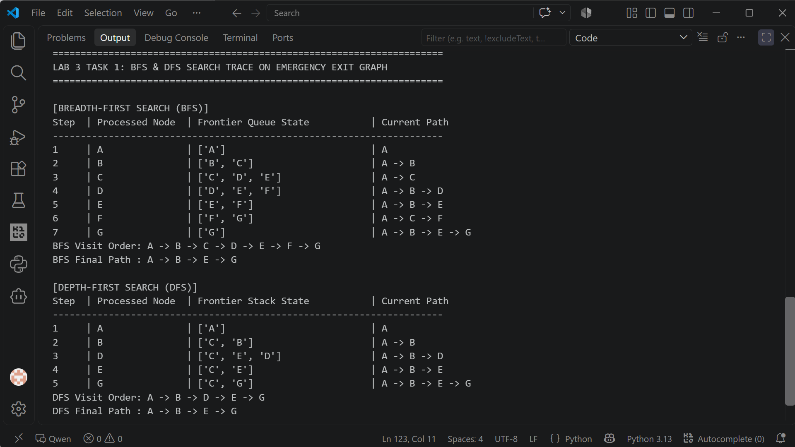4. Depth-Limited (DLS) & Iterative Deepening (IDDFS) Analysis (Task 2)

DLS restricts depth to prevent infinite loops. In this experiment, the root node A resides at depth 0. Exit node G resides at depth 3 along the valid route A -> B -> E -> G.

A. Individual Depth-Limited Search (DLS) Runs (Limits 1 to 4)

Testing depth limits 1, 2, 3, and 4 illustrates how bounding depth impacts search outcome:

Limit | Status Outcome | Visited Nodes Expansion Sequence | Returned Path Result
1 | CUTOFF | A -> B -> C | None (Depth limit reached prior to G)
2 | CUTOFF | A -> B -> D -> E -> C -> F | None (Depth limit reached prior to G)
3 | FOUND | A -> B -> D -> E -> G | A -> B -> E -> G
4 | FOUND | A -> B -> D -> E -> G | A -> B -> E -> G
Status Distinction Analysis: At depth limits 1 and 2, the algorithm returns CUTOFF because valid unexplored branches extend beyond the cutoff limit. A result of CUTOFF differs from FAILURE; CUTOFF indicates that the search was terminated artificially by the depth boundary, whereas FAILURE means the entire reachable state space was explored without locating the goal.
B. Iterative Deepening DFS (IDDFS) Trace
IDDFS combines the memory efficiency of DFS with the completeness of BFS by systematically incrementing the depth limit from 0 up to max_limit:

Limit Iteration | Outcome Status | Node Expansion Trace during Iteration
Limit 0 | CUTOFF | A
Limit 1 | CUTOFF | A -> B -> C
Limit 2 | CUTOFF | A -> B -> D -> E -> C -> F
Limit 3 | FOUND | A -> B -> D -> E -> G (Exit Found)
Repeated Overhead Evaluation: IDDFS re-expands shallow nodes across iterations (e.g., node A is processed in all four passes). However, because the number of nodes in a tree grows exponentially with depth (b^d), the overhead of re-expanding upper levels is minimal compared to the size of the bottom level. IDDFS maintains path-local cycle tracking per iteration without preserving a global visited set across limits.

OUTPUT

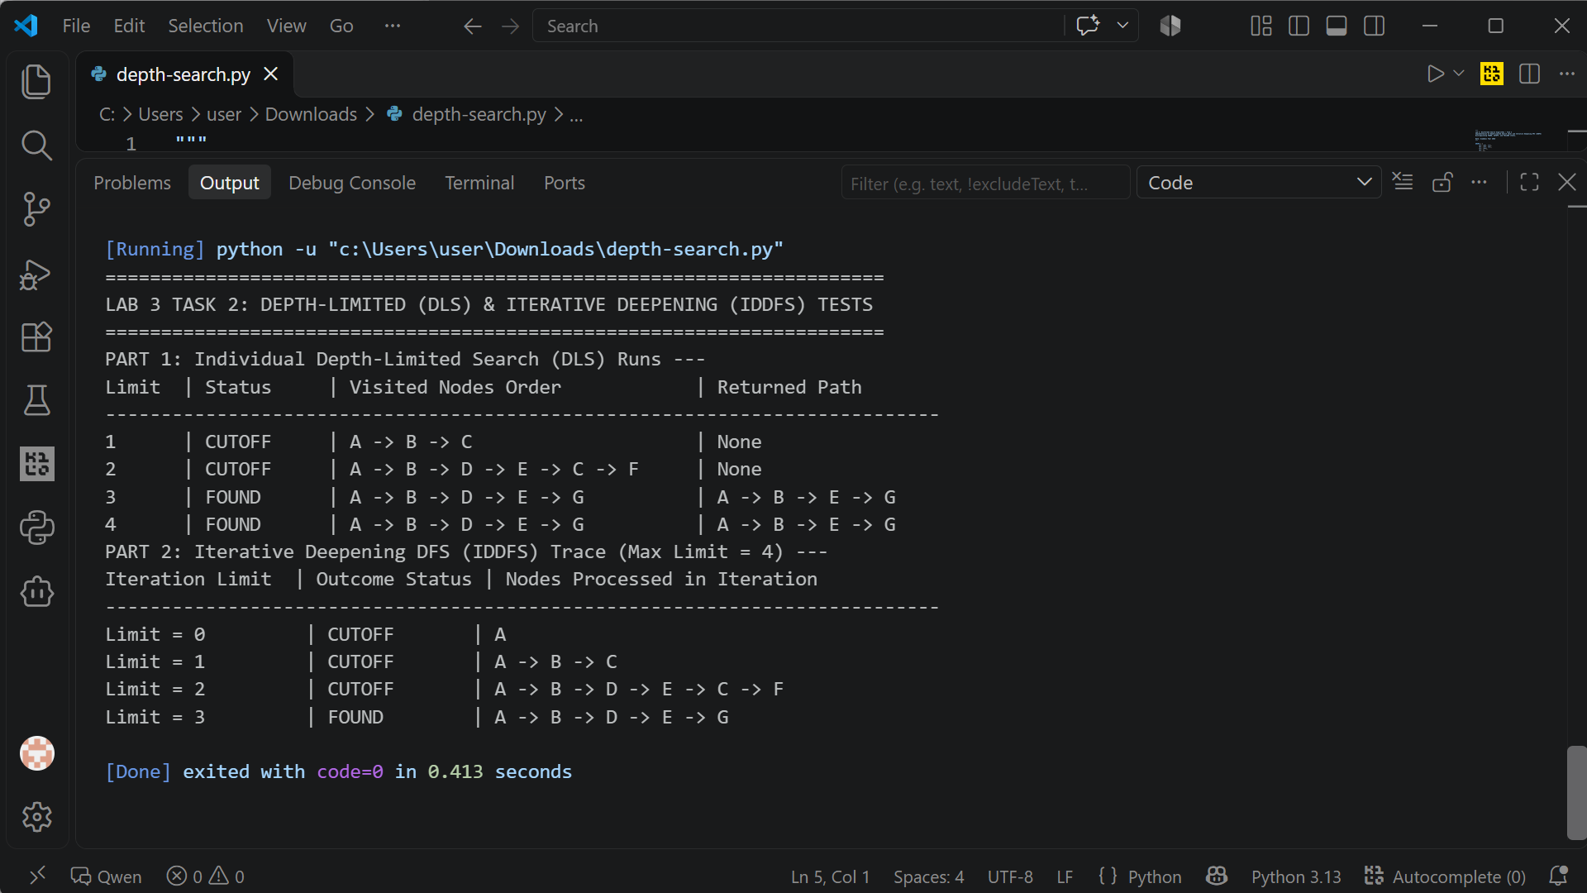5. Weighted Corridor Experiment & UCS Comparison (Task 3)

To evaluate cost-sensitive navigation, the emergency exit graph was extended into a weighted topology by assigning travel costs to corridors and adding a direct shortcut corridor C -> G with cost 10.

Weighted Graph Architecture Definition

• Edges & Costs: (A,B)=1, (A,C)=2, (B,D)=4, (B,E)=1, (C,F)=3, (C,G)=10 [Shortcut], (E,G)=1.
• Initial Node: A | Goal Node: G.

A. Uniform-Cost Search (UCS) Trace

UCS expands the node with the lowest path cost g(n) using a priority queue. Output trace:

Step | Expanded Node | Accumulated Path Cost g(n) | Current Path Traversed
1 | A | 0 | A
2 | B | 1 | A -> B
3 | C | 2 | A -> C
4 | E | 2 (1 + 1) | A -> B -> E
5 | G | 3 (1 + 1 + 1) | A -> B -> E -> G (Cost Optimal Goal Found)
B. Comparative Analysis: UCS vs BFS on Weighted Graph
Running BFS and UCS on the weighted graph highlights the difference between hop count and path cost:
Algorithm | Returned Path | Total Travel Cost | Hop Count
BFS (Hop Optimal) | A -> C -> G | 12 Units (Cost: 2 + 10) | 2 Hops
UCS (Cost Optimal) | A -> B -> E -> G | 3 Units (Cost: 1 + 1 + 1) | 3 Hops
Key Finding: BFS optimizes strictly for hop count, selecting route A -> C -> G (2 hops). However, because corridor C -> G has a high cost (10), the total path cost is 12. UCS evaluates accumulated edge costs, selecting A -> B -> E -> G (3 hops, cost 3). This confirms that a path with fewer hops can have a significantly higher travel cost.

OUTPUT

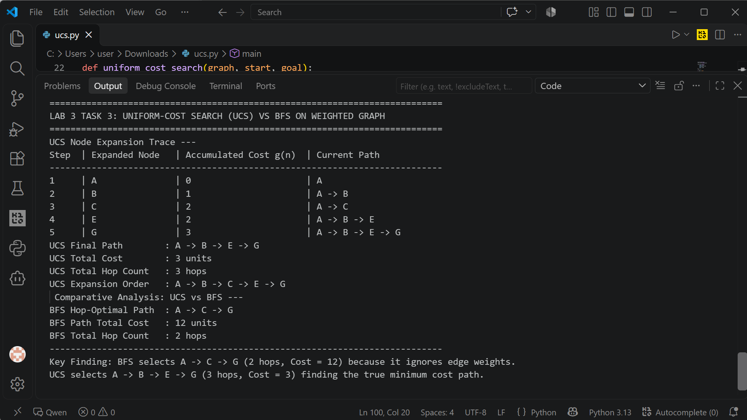6. Failure & Edge Case Analysis

To evaluate algorithm stability, two potential edge-case scenarios were analyzed:

Scenario 1: Cyclic Graphs & Global Visited Sets in IDDFS

• Input / Setup: A graph containing cyclic loops (e.g., A -> B -> A) tested under IDDFS.
• Observed Risk: If IDDFS uses a single global visited set that persists across iterations, nodes expanded in early iterations (e.g., limit 1) are marked as visited and suppressed during subsequent deeper iterations (e.g., limit 3).
• Likely Cause & Resolution: Persisting a global visited set across depth iterations incorrectly blocks valid paths. The fix is to use path-local cycle tracking (checking `if neighbor not in current_path`), ensuring each depth iteration starts with a clean state while preventing cycles within a single branch.

Scenario 2: Unreachable Goal State & Depth Bounded Misinterpretation

• Input / Setup: Searching for an isolated node H not connected to starting node A.
• Observed Output: DLS returns FAILURE (or CUTOFF if depth bounded), and BFS/DFS return None after exhausting the frontier.
• Critical Interpretation: Obtaining CUTOFF at limit 2 does not prove that goal G is unreachable; it only indicates that G is not present within 2 hops. Only a full traversal resulting in FAILURE confirms unreachability.

7. Reflection & Responsible AI Practice

Learning Outcomes: • Key Learnings: Understood how choice of search algorithm impacts memory usage, path optimality, and execution time. Observed how BFS and UCS diverge when edge costs vary.

Practical Application: • Real-World Application: In emergency rescue systems, algorithm choice depends on operational constraints: BFS/IDDFS for unweighted topological maps, and UCS for real-world terrain where travel distance or hazards vary.

Surprises & Debugging: • Surprises & Failure Analysis: Surprised by how easily a global visited set in IDDFS silently breaks path discovery, illustrating the importance of path-local cycle tracking.

Ethical & Responsible AI: • Responsible AI Practice: Emergency navigation agents must report actual expansion traces honestly. Substituting theoretical paths for actual search outputs can conceal dangerous failure modes.

