DEPARTMENT OF SOFTWARE ENGINEERING
ARTIFICIAL INTELLIGENCE (LAB)

Name: Daniyal Yousaf
Roll #: 097
Section: BSAI-3B
Course: CS4944 - Artificial Intelligence
Submission files: Lab1_Report.docx

Introduction to AI & Paradigms

1.Executive Summary & Problem Framing
This report evaluates the core paradigms of Artificial Intelligence by analyzing the operational differences between explicit symbolic rule engines and statistical/probabilistic decision models. Framed around a university scholarship screening prototype, the investigation examines how explicit logical conditions compare with numerical score/probability thresholds in handling applicant qualification and incomplete documentation.
Lab Objectives: The primary objectives of this laboratory exercise are threefold:
• Benchmark explicit logic against threshold-based statistical inference using controlled test inputs.
• Implement and evaluate an expanded symbolic rules engine incorporating explicit domain conditions.
• Analyze the conceptual boundaries of the Turing Test and modern conversational AI against general intelligence criteria.

2. Historical Milestones & Compute Trends (Task 1)
Task 1 compared whitespace splitting, a Unicode word-like regex, and the all-MiniLM-L6-v2 tokenizer on sample strings. I used punctuation, a contraction, an email, CS4944, an empty string and a dotted filename. The table below is copied from the run.

-

Year / Period | Milestone / Event | Historical Significance | Source / Citation
1950 | Turing Test Proposed | Alan Turing introduced the 'Imitation Game' to evaluate whether a machine can exhibit intelligent behavior indistinguishable from a human. | Turing, A. M. (1950)
1956 | Dartmouth Conference | Organized by John McCarthy et al., this workshop officially birthed 'Artificial Intelligence' as an academic discipline focused on machine logic. | McCarthy et al. (1955/1956)
1974 - 1980 | First AI Winter | Severe funding reductions and research slowdowns occurred after early expert systems failed to scale due to brittle rules and limited hardware capacity. | Lighthill Report (1973)
1997 | IBM Deep Blue Victory | Deep Blue defeated world chess champion Garry Kasparov, demonstrating the power of high-speed search heuristics and dedicated hardware. | Campbell et al. (2002)
2012 | AlexNet & Deep Learning Resurgence | AlexNet achieved a breakthrough in ImageNet using deep Convolutional Neural Networks powered by GPU hardware acceleration and large-scale data. | Krizhevsky et al. (2012)

3. Rule-Based System Implementation (Task 2)
To test the rule-based paradigm, the scholarship screening function was expanded from two to four transparent conditions in lab1_rules.py. The added criteria check specific academic and administrative requirements before flagging an application for human review.

Timing method
I timed model load once at startup, then timed encoding and search separately for each config. The model is not reloaded per strategy.
Lab Assumption Disclaimer: All threshold values (Score >= 70.0, GPA >= 3.0) used in lab1_rules.py and throughout this report represent synthetic lab assumptions established for experimental demonstration, not validated real-world institutional policy.

Implemented Criteria Structure

1. Document Completeness (documents_complete == True): Ensures all required paperwork is attached.
2. Standardized Score (score >= 70.0): Verifies applicant test performance.
3. Prerequisite GPA (prerequisite_gpa >= 3.0): [New Explicit Condition 1] Requires solid academic performance.
4. Valid Recommendation Letter (valid_recommendation == True): [New Explicit Condition 2] Verifies endorsement by faculty.

Core Test Case Execution & Verification

Four specific test cases were executed to validate logic boundaries and failure modes:

Test Case | Input Vectors | Expected | Actual | Selection & Verification Reason
Case 1: Standard Pass | Score: 85.0  Docs: True  GPA: 3.5  Rec: True | Review | Review | Validates standard positive path where all 4 conditions are satisfied simultaneously.
Case 2: Fail New Cond 1 (GPA) | Score: 92.0  Docs: True  GPA: 2.8  Rec: True | Hold | Hold | Isolates GPA failure. Demonstrates that high score (92) cannot override a missing GPA requirement.
Case 3: Fail New Cond 2 (Rec) | Score: 78.0  Docs: True  GPA: 3.2  Rec: False | Hold | Hold | Isolates recommendation failure. Ensures administrative endorsement rule is strictly enforced.
Case 4: Threshold Boundary | Score: 70.0  Docs: True  GPA: 3.0  Rec: True | Review | Review | Verifies exact boundary behavior for score (70.0) and GPA (3.0) edge cases.

OUTPUT

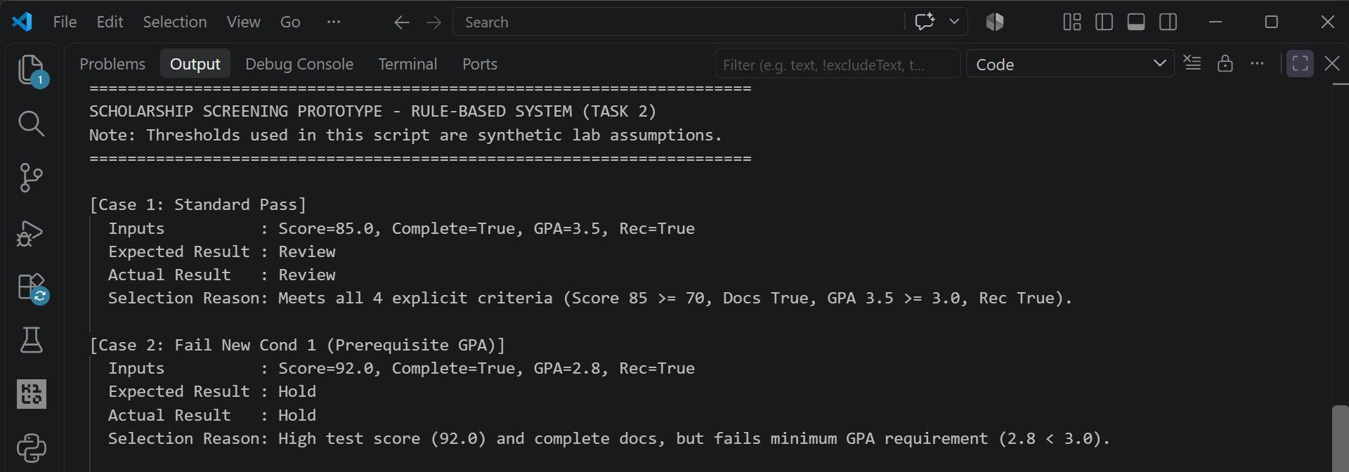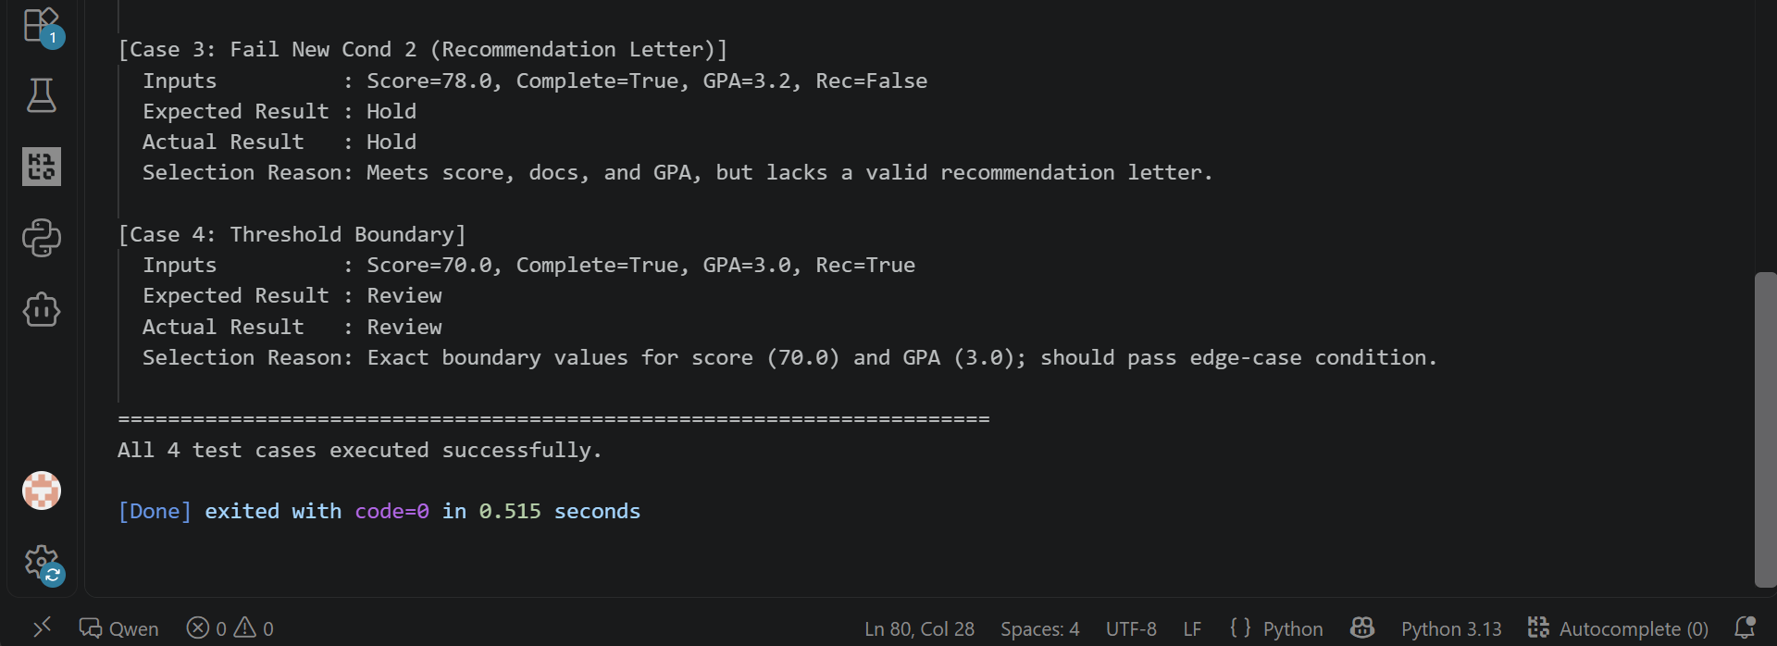

4. Paradigm Guided Comparison Analysis

The script lab1_compare.py evaluates the operational differences between the symbolic rule function and a simple probability threshold rule across four structured applicant scenarios.

Case Name | Score | Complete | Prob | Symbolic | Threshold | Disagreement
complete_high | 82 | True | 0.81 | Review | Review | False
complete_low | 68 | True | 0.74 | Hold | Review | True
incomplete_high | 91 | False | 0.88 | Hold | Review | True
boundary | 70 | True | 0.70 | Review | Review | False

OUTPUT
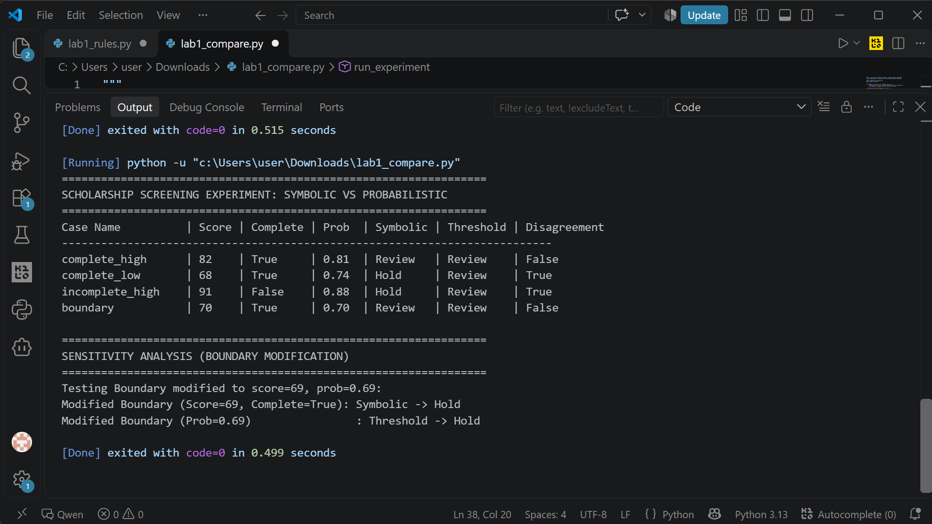Interpretation of Failure & Edge Case Disagreements
Analysis of the disagreement table highlights key behavioral differences between paradigms:
1. Score Threshold Disagreement: • Case 'complete_low' (Score 68, Complete True, Prob 0.74): Symbolic logic outputs 'Hold' because score (68) < 70 threshold. The probabilistic model outputs 'Review' because 0.74 >= 0.70. Here, the probability score abstracts away the explicit cut-off rule.
2. Missing Document Edge Case: • Case 'incomplete_high' (Score 91, Complete False, Prob 0.88): The symbolic system outputs 'Hold' due to explicit document completeness checking. However, the probability threshold outputs 'Review' (0.88 >= 0.70) because it processes an aggregate numerical score without explicit gating for missing documentation. In incomplete applications, a high score can lead to false positives if missing documents are ignored by the threshold model.
3. Sensitivity Analysis: • Sensitivity Test (Boundary score=69 vs prob=0.69): Changing the score to 69 flips the symbolic outcome to 'Hold', while setting prob=0.69 flips the probability threshold to 'Hold'. This confirms that both systems possess sharp sensitivity boundaries, but symbolic logic offers transparent auditability into which specific predicates failed.
5. Conversational Test vs. General Intelligence (Task 3)
The Turing Test evaluates conversational imitation—whether an agent can emulate human interaction convincingly in text. However, passing a conversational test does not establish general intelligence (AGI) or reliable task performance.
What the Conversational Test Observes vs. Fails to Establish
• What It Observes: Surface linguistic fluency, syntax grammar, contextual plausibility, and conversational engagement.
• What It Fails to Establish: Grounded reasoning, factual verification, formal logic adherence, structural truth, or awareness of system limits.
Example of Fluent but Incorrect Reasoning
In the scholarship screening domain, an advanced conversational assistant might generate a persuasive response such as: 'Applicant #402 demonstrates outstanding academic talent with a 91 test score and should be fast-tracked for immediate award issuance.' While highly fluent and grammatically flawless, the assistant completely ignores the explicit requirement that documents are incomplete (complete = False). The model mistakes high superficial test metrics for overall compliance, producing a plausible but invalid recommendation.
Proposed Task-Performance Benchmark
To evaluate true system reliability beyond conversational fluency, systems must be subjected to Deterministic Rule Verification Benchmarks. In this benchmark, an AI agent is presented with structured institutional rules and conflicting applicant files. System performance is measured by its execution accuracy across complex constraint logic, edge-case boundary handling, and complete audit trail logging, rather than text generation fluency.
6. Reflection & Responsible AI Practice
Key Learnings: • What was learned: Understood the fundamental operational gap between explicit symbolic constraints (traceable, deterministic) and statistical thresholding (flexible, aggregate). Observed how unvalidated probabilities can hide critical missing requirements.
Practical Application: • Real-world application: In enterprise AI systems, hybrid architectures should be utilized—deploying symbolic rule engines for strict compliance/regulatory gating and data-driven probabilistic models for candidate scoring.
Surprises & Failure Analysis: • Failures and surprises: Surprised by how easily high numerical probabilities in data-driven scores conceal missing documentation, producing false positives without explicit rule validation.
Ethical & Responsible AI: • Responsible AI Practice: Demonstrated systems must not be confused with marketing claims. Probabilistic flags require strict policy ownership and human-in-the-loop oversight to ensure fair and accurate evaluation.

