DEPARTMENT OF SOFTWARE ENGINEERING
ARTIFICIAL INTELLIGENCE (LAB)

Name: Daniyal Yousaf
Roll #: 097
Section: BSAI-3B
Course: CS4944 - Artificial Intelligence
Submission files: Lab4_Report.docx

Informed Search: Heuristics & A* Search
1. Problem Formulation & Campus Graph Setup
This report evaluates informed pathfinding using the A* search algorithm applied to a campus navigation scenario. The agent plans a path from start building S to destination building G across travel-time weighted edges using heuristic estimates of remaining travel time.
Graph Specification: Campus Graph Structure & Heuristic Definitions:
• Directed Weighted Edges: (S,A)=1, (S,B)=4, (A,C)=2, (B,G)=5, (C,G)=3.
• Heuristic Values h(n): h(S)=5, h(A)=4, h(B)=4, h(C)=2, h(G)=0.
• Start State: S | Destination State: G.
• Evaluation Function: f(n) = g(n) + h(n), combining accumulated path cost g(n) with estimated remaining cost h(n).
2. Manual Heuristic Audit & First Three Expansions (Task 1)
Prior to running the implementation, an explicit audit of the heuristic function and step-by-step arithmetic calculations for the first three A* expansions were performed by hand.
A. Heuristic Admissibility & Consistency Audit
1. Admissibility Verification (h(n) <= h*(n)): The true minimum remaining cost h*(n) to goal G for each node is h*(S)=6, h*(A)=5, h*(B)=5, h*(C)=3, and h*(G)=0. Comparing supplied estimates: h(S)=5 <= 6, h(A)=4 <= 5, h(B)=4 <= 5, h(C)=2 <= 3, and h(G)=0 <= 0. Thus, h(n) never overestimates the true remaining cost, satisfying admissibility.
2. Consistency Verification (h(u) <= cost(u,v) + h(v)): Every directed edge satisfies triangle inequality:
• Edge S -> A: h(S)=5 <= 1 + h(A)=5 (5 <= 5) [Valid]
• Edge S -> B: h(S)=5 <= 4 + h(B)=8 (5 <= 8) [Valid]
• Edge A -> C: h(A)=4 <= 2 + h(C)=4 (4 <= 4) [Valid]
• Edge B -> G: h(B)=4 <= 5 + h(G)=5 (4 <= 5) [Valid]
• Edge C -> G: h(C)=2 <= 3 + h(G)=3 (2 <= 3) [Valid]
B. Manual Step-by-Step Calculation of First Three Expansions
The min-priority queue orders nodes by f(n) = g(n) + h(n). Successors are added in graph declaration order (A before B).

Expansion | Selected Node | g(n) + h(n) = f(n) Calculation | Remaining Priority Queue Frontier | Selection Justification
Step 1 | S | g(S)=0, h(S)=5 -> f(S) = 0 + 5 = 5 | [(5, 1, 'A'), (8, 4, 'B')] | Initial node S is popped. Successors A (g=1, f=1+4=5) and B (g=4, f=4+4=8) are pushed.
Step 2 | A | g(A)=1, h(A)=4 -> f(A) = 1 + 4 = 5 | [(5, 3, 'C'), (8, 4, 'B')] | A is selected (f=5 < f(B)=8). Successor C (g=1+2=3, f=3+2=5) is pushed.
Step 3 | C | g(C)=3, h(C)=2 -> f(C) = 3 + 2 = 5 | [(6, 6, 'G'), (8, 4, 'B')] | C is selected (f=5 < f(B)=8). Successor G (g=3+3=6, f=6+0=6) is pushed.
Next Node Selection Reasoning: After expanding C at Step 3, the priority queue contains G with f(G)=6 and B with f(B)=8. Since f(G)=6 < f(B)=8, node G is popped next. Goal G is recognized, returning the optimal path S -> A -> C -> G with cost 6.
3. Controlled Comparison: A* Search vs UCS (Task 2)
To benchmark search efficiency, A* with the supplied heuristic was compared against Uniform-Cost Search (UCS), implemented by setting h(n)=0 for all nodes on the exact same priority-queue engine.
Standard Expansion Counting Convention: Counting Convention: A node is counted as expanded only when its outgoing edges/successors are examined. Goal node processing is logged upon popping but excluded from the expansion count, per lab guidelines. Stale queue entries are ignored.

Algorithm | Heuristic Used | Returned Path | Independently Summed Cost | Node Visit Order | Expansion Count
Standard A* | Supplied h(n) (S:5,A:4,B:4,C:2,G:0) | S -> A -> C -> G | 6 (1 + 2 + 3) | S -> A -> C -> G | 3 Nodes (S, A, C)
UCS (Control) | Zero Heuristic h(n)=0 | S -> A -> C -> G | 6 (1 + 2 + 3) | S -> A -> C -> B -> G | 4 Nodes (S, A, C, B)
Efficiency Empirical Finding: Both A* and UCS finds the optimal path S -> A -> C -> G with cost 6. However, A* expands only 3 nodes (S, A, C), whereas UCS expands 4 nodes (S, A, C, B). A* uses heuristic estimates to prune node B from expansion, demonstrating higher search efficiency.

OUTPUT

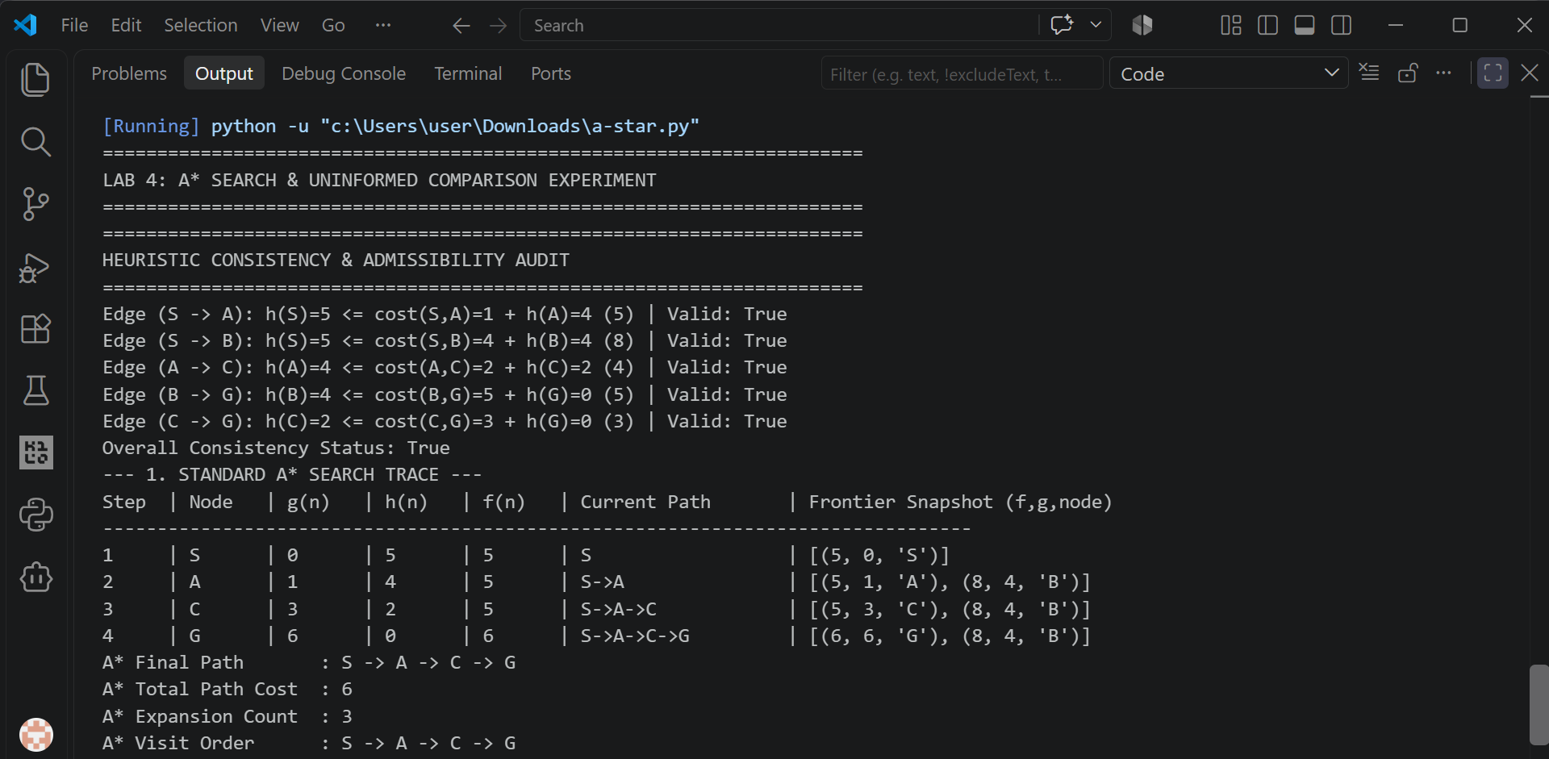4. Inadmissible Overestimate Failure Experiment (Task 3)

To investigate the loss of optimality guarantees when admissibility is violated, a single heuristic value was deliberately modified to overestimate remaining cost.

A. Experimental Setup & Modifications

• Modified Value: Node C's heuristic was changed from h(C)=2 to h(C)=10.
• True Remaining Cost h*(C): 3 units (C -> G = 3).
• Admissibility Violation: h(C)=10 > h*(C)=3 (Severe Overestimate). All other heuristic values were kept identical.

B. Empirical Execution Results & Comparative Impact

Running A* with the modified inadmissible heuristic produced the following trace:
Search Configuration | h(C) Value | Returned Path Result | Total Path Cost | Optimality Status
Admissible A* | h(C) = 2 (Valid) | S -> A -> C -> G | 6 | Optimal
Inadmissible A* | h(C) = 10 (Overestimate) | S -> B -> G | 9 | SUBOPTIMAL (Failed)
Failure Mechanism Analysis: When h(C)=10, expanding A adds C to the frontier with f(C) = g(C) + h(C) = 3 + 10 = 13. Meanwhile, node B sits in the priority queue with f(B) = g(B) + h(B) = 4 + 4 = 8. Because f(B)=8 < f(C)=13, the algorithm pops B and explores path B -> G (cost 9), terminating at goal G before ever popping C. Overestimating h(C) hides the optimal route behind an artificially inflated f-value.
Theoretical Discussion on Optimality Guarantees: An overestimate breaks the theoretical proof of optimality. Even if a specific trial run with an overestimating heuristic happens to return an optimal path (e.g., if the bad node is never near the search frontier), optimality is no longer guaranteed. A single successful run under an overestimating heuristic is an empirical coincidence, not proof of system correctness.
OUTPUT

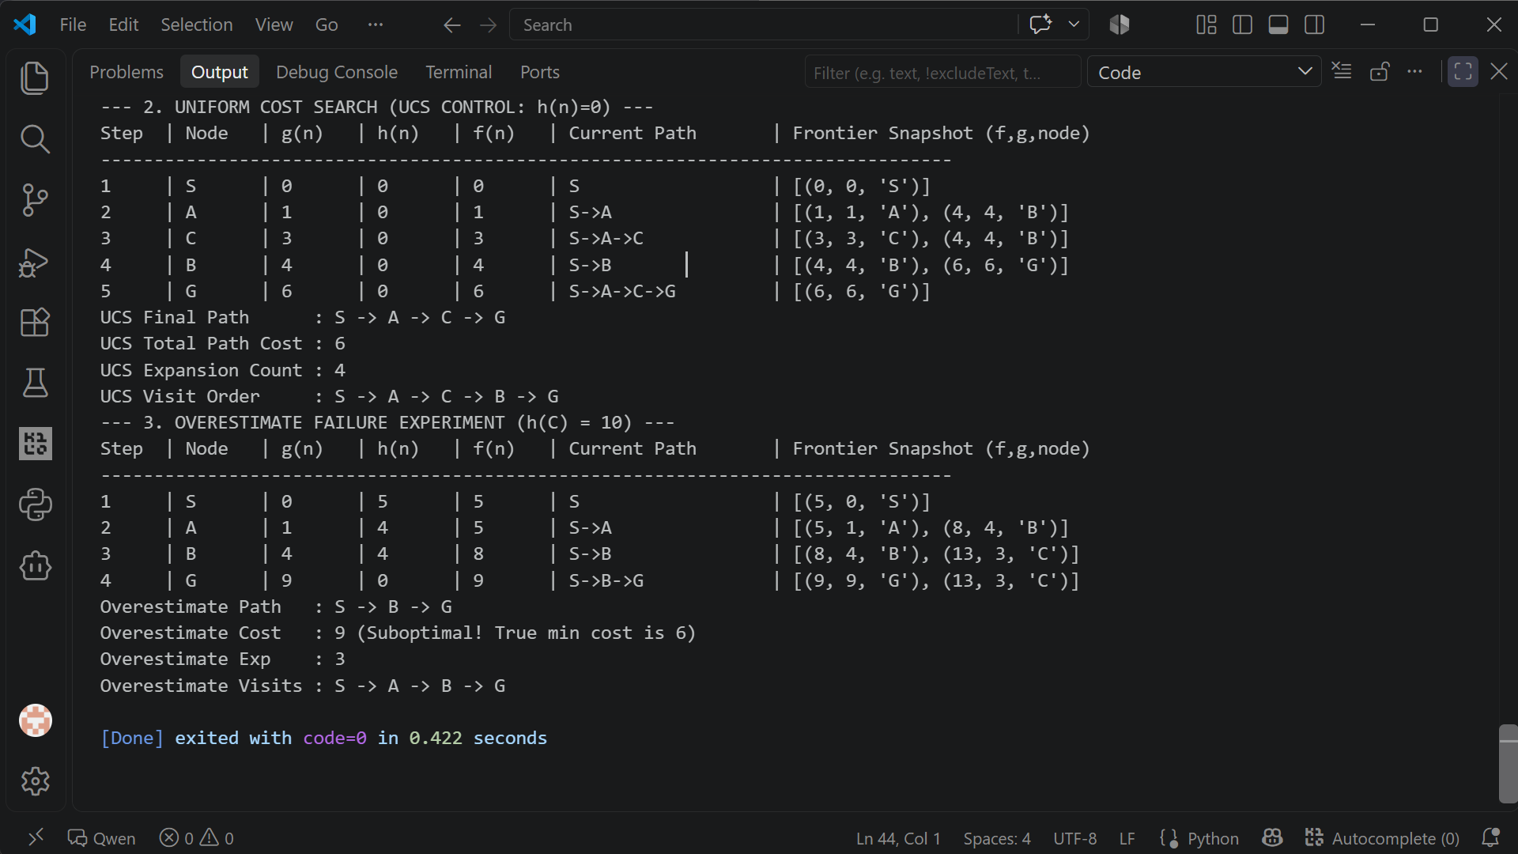
5. Reflection & Responsible AI Practice
Learning Outcomes: • Key Learnings: Understood how f(n) = g(n) + h(n) balances past cost with future estimates to guide pathfinding efficiently. Verified that admissibility (h <= h*) and consistency ensure optimal path discovery.
Practical Application: • Real-World Application: In real-world campus navigation or autonomous vehicle routing, heuristic functions (such as Euclidean or Manhattan distance) must use units compatible with edge travel costs to prevent suboptimal routing.I
Surprises & Failure Analysis: • Surprises & Debugging: Observed how easily an overestimated heuristic value distorts priority queue ordering, leading A* to choose a significantly worse path (cost 9 vs cost 6).
Ethical & Responsible AI: • Responsible AI Practice: Claims regarding search efficiency must be backed by empirical expansion counts on identical benchmarks rather than assumed superiority. Navigation systems in safety-critical domains must strictly guarantee heuristic admissibility to prevent guiding users along dangerous or inefficient routes.

