**Manual**

Requirements:

1. JDK 1.6 or higher
2. Eclipse

Used technologies: Swing

**Import project “ftp”**

1. Open Eclipse
2. Then import project “ftp” using File->Import->General->Existing Project into Workspace

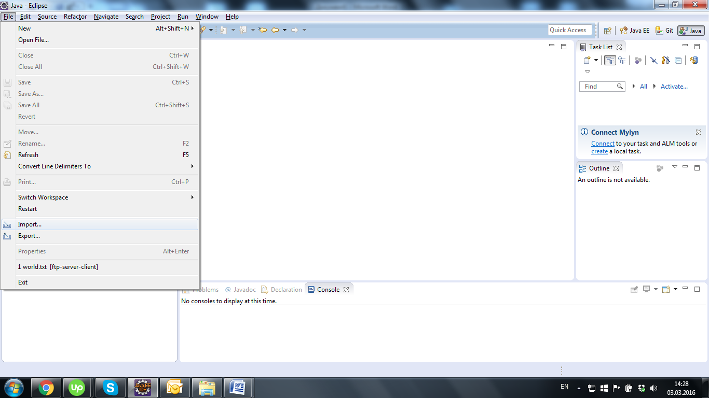

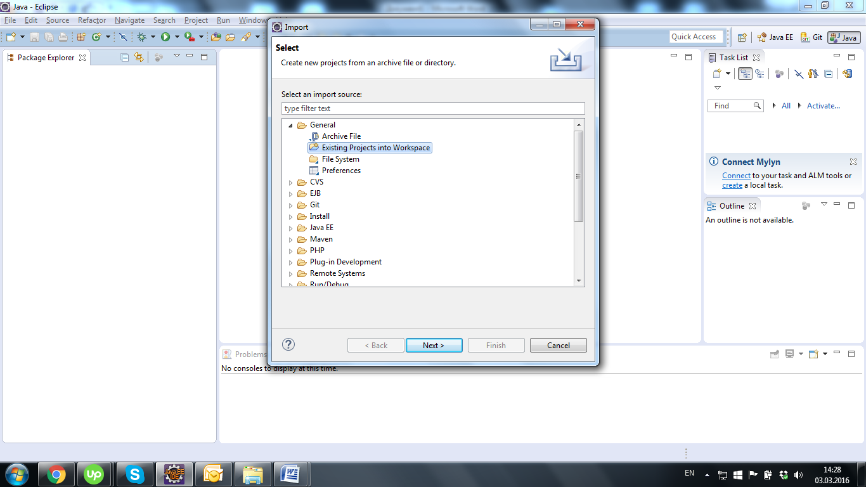

1. After click to “Browse…”

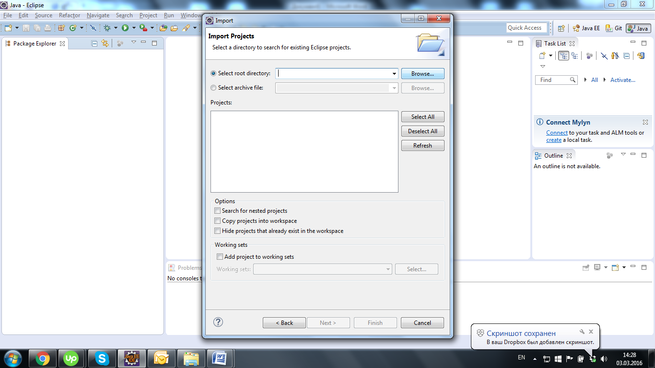

1. Then select project “ftp” and click to button “OK”

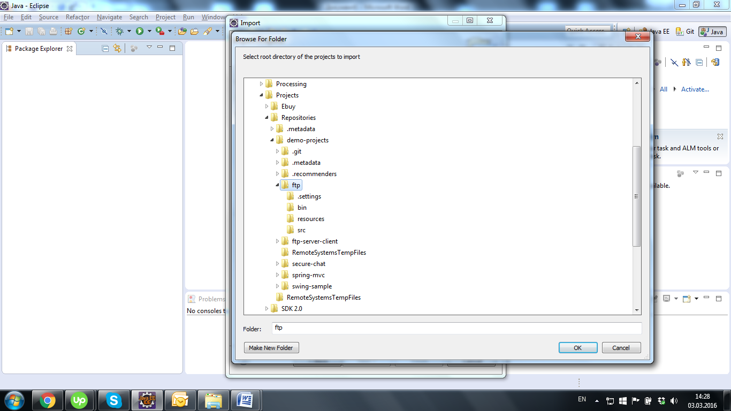

1. After that click to “Finish” button

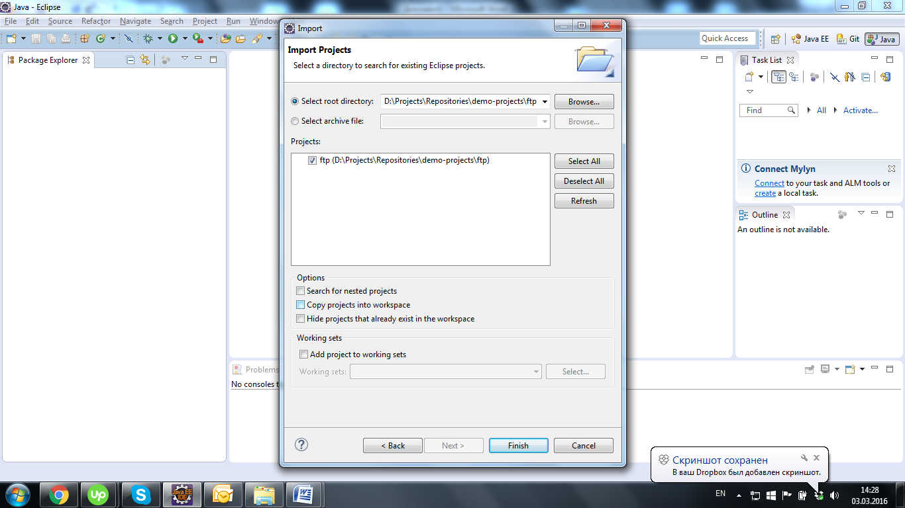

1. Opened project should look like next prt screen:

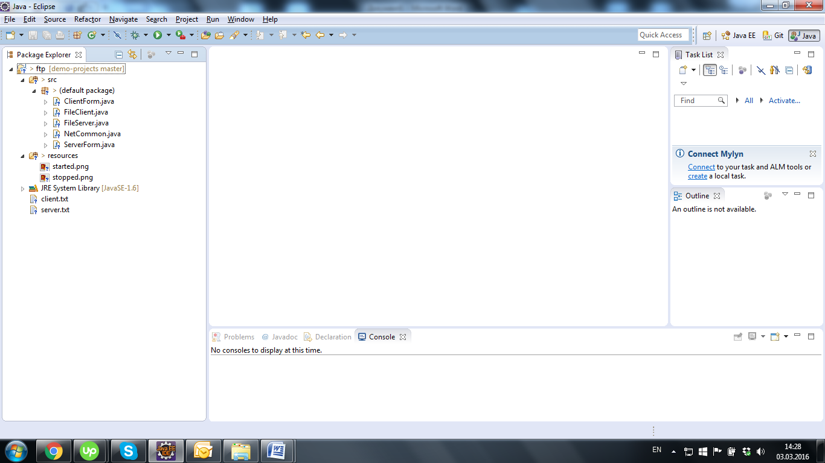

**Run Server/Client**

1. Server GUI class is called *ServerForm* and Client GUI class is *ClientForm*
2. Open ServerForm.java file in Eclipse and click to Run  (or Ctrl+F11) button on the Eclipse toolbar. If there is no errors it will open next window:

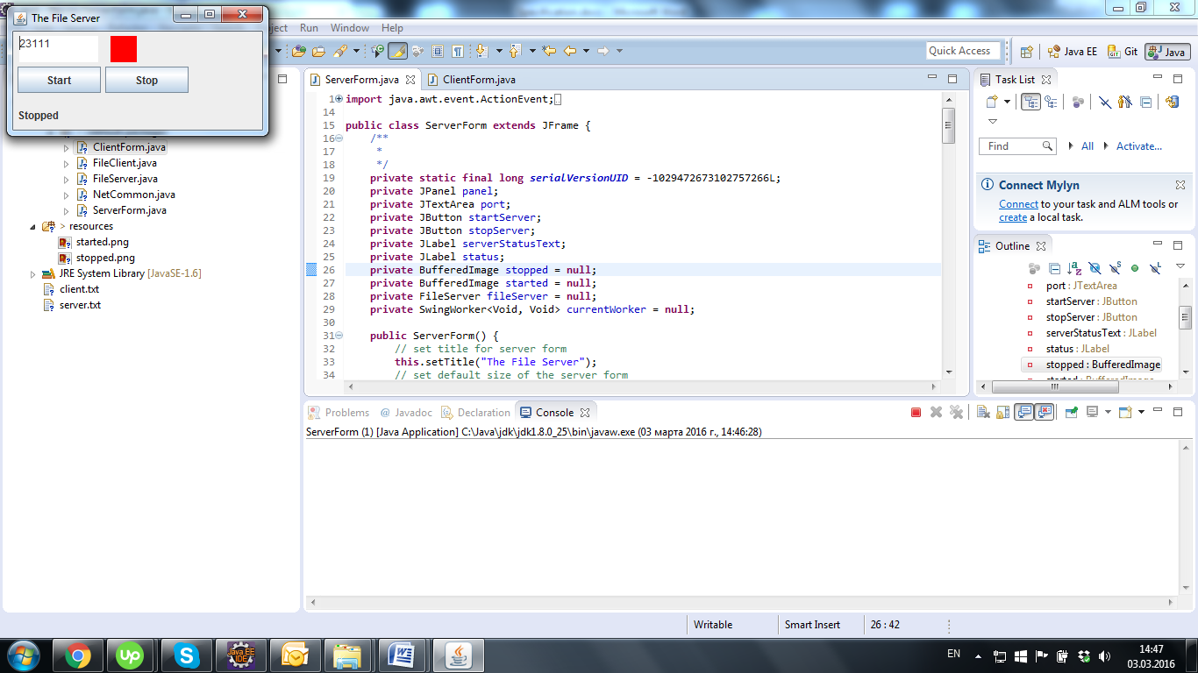

1. Click to Start button, if the file server started successfully it will look like this:

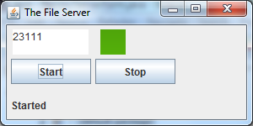

1. Then open ClientForm.java and Run it too:

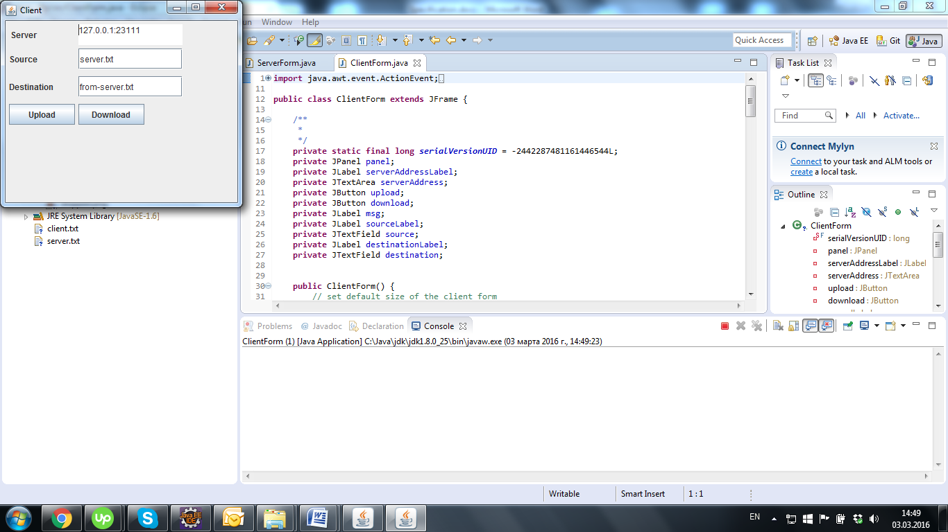

1. Click to Download button:

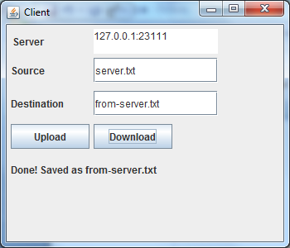

1. Change Source to client.txt and Destination to from-client.txt and click to Upload button:

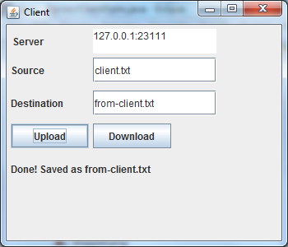

1. To check results click to “ftp” project in Eclipse and press F5 to refresh, after that there are you can find 2 new files from-server.txt and from-client.txt:

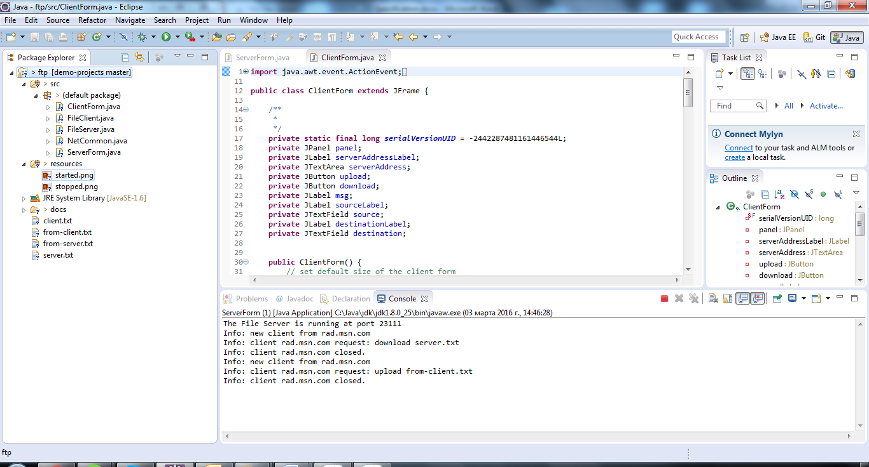

1. from-server.txt should be identically to server.txt and from-client.txt should be identically to client.txt

NOTE! If server and client run in different machines need to be changed ip and port!