To fix broken.db, I did the following steps:

1. I opened broken.db in SQLiteBrowser and executed: *pragma integrity_check*
2. it shows in broken.db 2 erros, as shown on the next picture

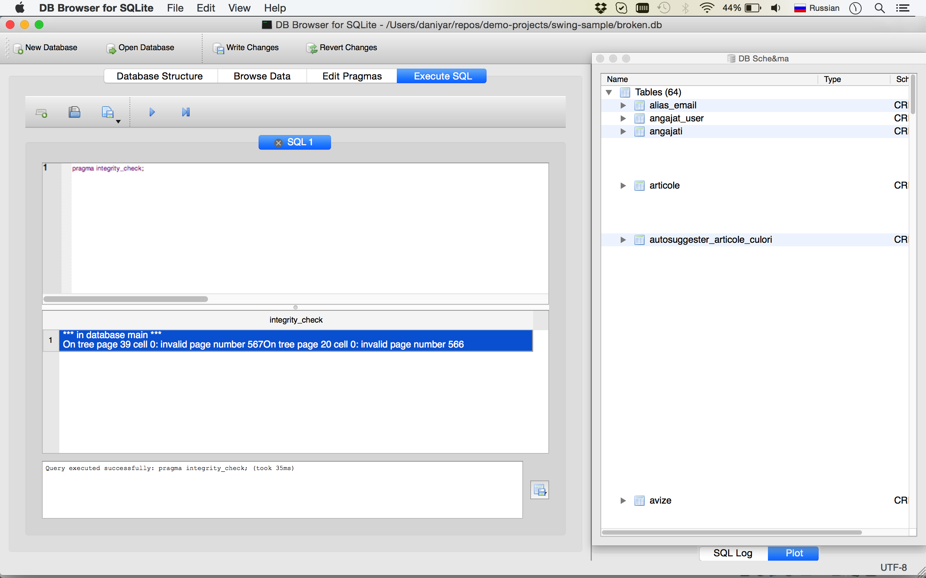

3. After that, I opened terminal and create dump file of the broken.db using next command to recovery: *sqlite3 broken.db .dump > recovery.sql*

4. Then I created new file notbroken.db from dump file recovery.sql using next command: *sqlite3 notbroken.db < recovery.sql*

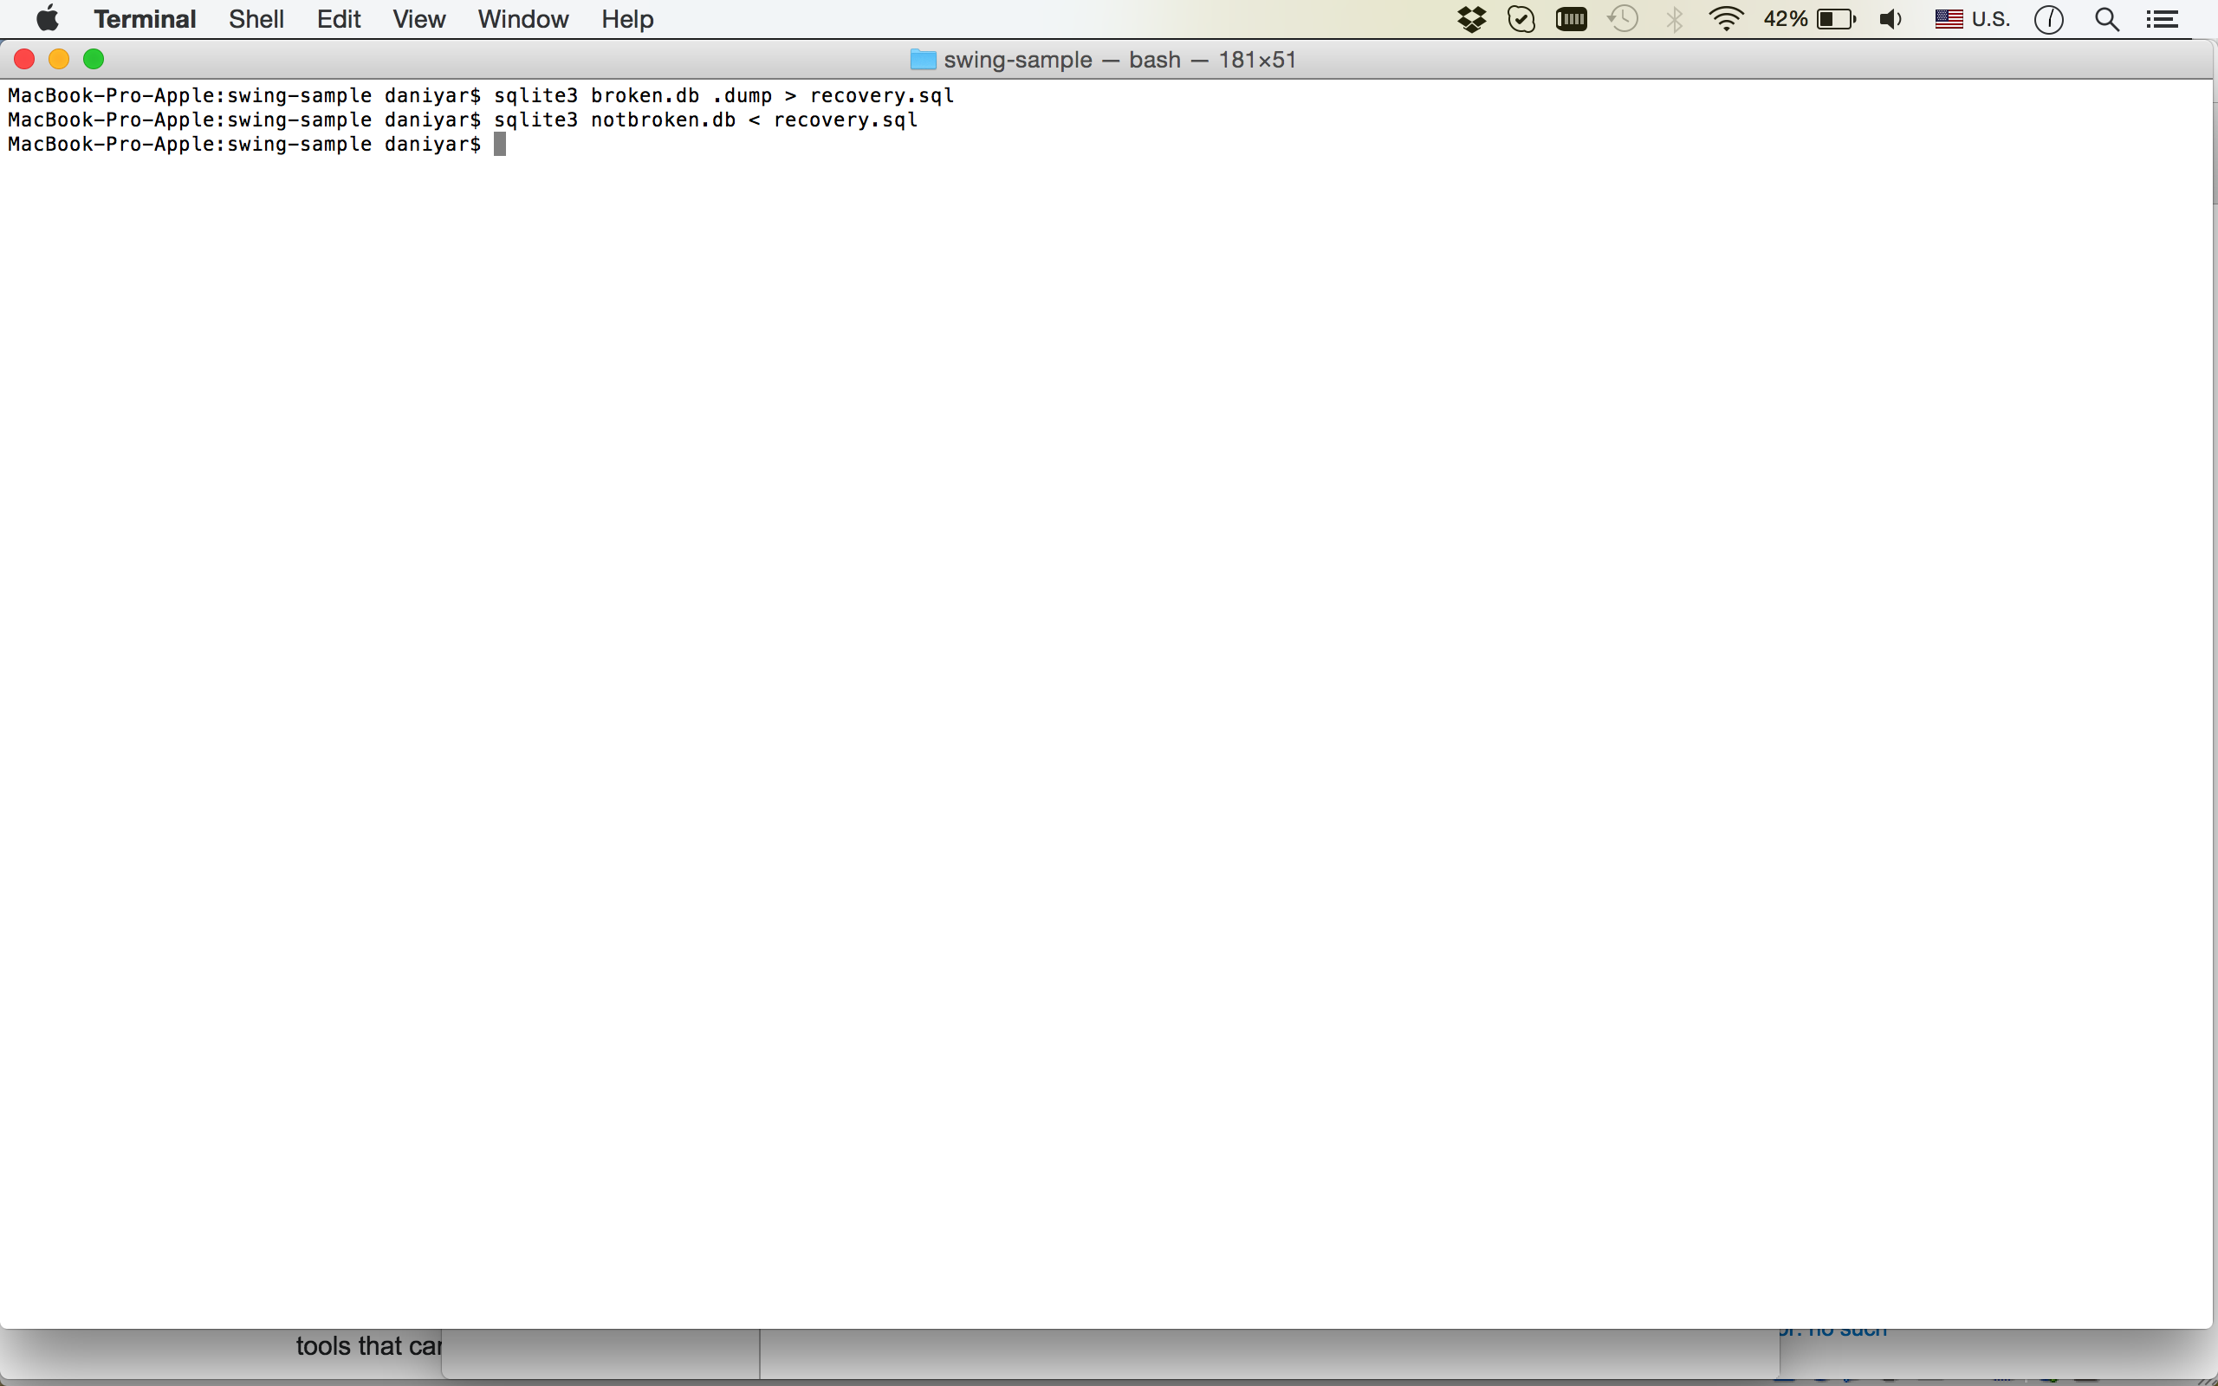

5. Then I opened file notbroken.db in SQLiteBrowser, and second time executed query: *pragma integrity_check*, in this time it return «ok»

6. Then I executed query: *select * from factori* and it returned data from table as shown on the next picture

