Detecting and Correcting Kazakh Spelling Errors, with a Focus on the "ka2ru" Cyrillic Look-Alike Phenomenon

Authors List
Abstract
A pervasive but under-studied source of Kazakh spelling errors arises when the nine Kazakh-specific Cyrillic letters are typed as visually similar standard-Russian letters by writers lacking the Kazakh keyboard layout. We term this the ka2ru class; as the corrupted text stays Cyrillic and resembles Russian, it also defeats naive language identification. We address it with a two-stage pipeline: a fine-tuned KazRoBERTa encoder labels each token KEEP or ERROR, and a lexicon- and edit-distance-based corrector resolves flagged tokens. Injecting six error types into cleaned Kazakh text yields a corpus of 2,615,771 pairs, ka2ru dominant (30.5% of edits). On the full 25,000-sentence test split the detector attains token-level F1 97.4% and the pipeline corrects 80.2% of sentences (95% CI [79.8, 80.7]) near an 83.2% oracle ceiling, so detection is essentially solved and the corrector is the bottleneck; an ablation shows the two candidate generators are complementary while a morphological guard hurts. The CPU-only system was validated in a live pilot. Errors are injected into authentic human-written Kazakh and follow a documented real-world mechanism; validating this synthetic error distribution against organically typed text, and adding learned baselines, remain future work.
Keywords: Kazakh spelling correction; ka2ru look-alike errors; KazRoBERTa; token classification; synthetic error generation; language identification; agglutinative morphology
Turan: Detecting and Correcting Kazakh Spelling Errors, with a Focus on the "ka2ru" Cyrillic Look-Alike Phenomenon
1. Introduction
Kazakh is a Turkic language written in Cyrillic and, by contemporary NLP standards, low-resource: large annotated corpora, gold error-correction datasets, and mature tooling remain scarce. It is also strongly agglutinative, concatenating long suffix sequences for number, possession, and case onto a stem under vowel harmony, so the effective vocabulary is enormous and fixed lexicons cover only a fraction of inflected forms. Subword tokenization mitigates this explosion (Sennrich et al., 2016), and Transformer encoders pretrained with masked language modelling are the standard backbone for sequence labelling (Devlin et al., 2019; Liu et al., 2019; Vaswani et al., 2017). Because monolingual models tend to outperform multilingual ones (Pires et al., 2019), we use the Kazakh-specific encoder KazRoBERTa (kz-transformers, 2023; Sagyndyk et al., 2025).
A specific, widespread source of noise motivates this work. The Kazakh Cyrillic alphabet extends the Russian one with nine letters that have no Russian counterpart: қ, ә, ң, ұ, ү, ғ, і, ө, һ. Users who lack or ignore the Kazakh keyboard layout substitute visually similar standard-Russian letters (қ→к, ә→а, ң→н, ұ→у, ү→у, ғ→г, і→и, ө→о, һ→х); we call this the ka2ru class. The result is still Cyrillic but no longer correct Kazakh: the special letters are systematically lost and the surface form resembles broken Russian. This harms downstream NLP twice over: the corrupted words degrade any task depending on correct orthography, and, more insidiously, it breaks language identification, since the discriminative Kazakh letters are exactly the ones removed, so a ka2ru-corrupted sentence can be misclassified as Russian and routed to the wrong processing path.
Despite its prevalence, this phenomenon has received little focused attention at scale. Prior Kazakh language technology has emphasised foundational resources — corpora (Makhambetov et al., 2013), named-entity datasets (Yeshpanov et al., 2022), finite-state morphological analysers (Kessikbayeva & Cicekli, 2014; Washington et al., 2014), machine translation (Salimzyanov et al., 2013), and treebanks (Tyers & Washington, 2015) — while recent hybrid systems combine finite-state methods, conditional random fields, and Transformer encoders for Kazakh correction (Baitenova et al., 2025). General spelling correction has a long history of nonword detection and isolated correction (Kukich, 1992) with edit-distance candidate ranking (Damerau, 1964; Levenshtein, 1966), and modern grammatical error correction increasingly frames the task as edit tagging over a pretrained encoder (Awasthi et al., 2019; Omelianchuk et al., 2020), often trained on synthetic error pairs (Grundkiewicz et al., 2019). What is largely missing is a system targeting ka2ru specifically, at corpus scale, addressing both its orthographic and language-routing consequences.
This paper presents Turan Text Corrector, an automatic Kazakh spelling-correction system built around ka2ru. We are explicit about scope: all reported numbers are computed on a synthetic test set whose errors were generated by the same confusion maps the corrector partially inverts, so the figures are in-distribution and upper-leaning estimates of organic performance. The principal contributions are:
- A reproducible cleaning and synthetic-error-generation methodology for Kazakh, yielding a large parallel dataset (training split 2,565,771; 2,615,771 pairs total) centred on the ka2ru phenomenon, with explicit edit metadata and a 10.86% identity-pair fraction to suppress over-correction.
- A two-stage detection-then-correction pipeline pairing a KazRoBERTa token-classification detector (test F1 97.4%) with a lexicon and edit-distance corrector, reaching 80.2% end-to-end sentence correction within about three points of the 83.2% oracle ceiling, with a component ablation isolating each part's contribution.
- A deployable, CPU-only system whose "russified-lexicon" routing signal recovers special-letter-stripped Kazakh otherwise misread as Russian (routing recall 31.5% → 99.4% on ka2ru-corrupted input), sustaining roughly 200 requests per second on about 373 MB of RAM in a 2.84 GB image, validated in an accepted live pilot.
2. Related Work
2.1 Transformer Encoders, Kazakh, and Morphology
The Transformer (Vaswani et al., 2017) introduced attention-based sequence modelling; BERT (Devlin et al., 2019) established masked-language-modelling pretraining with fine-tuning for per-token labelling; and RoBERTa (Liu et al., 2019) refined the recipe with longer training, larger batches, and dynamic masking. For morphologically rich languages, subword tokenization is a prerequisite: byte-pair encoding (Sennrich et al., 2016) segments words into reusable units, mitigating Kazakh's out-of-vocabulary problem. Our detector fine-tunes KazRoBERTa (kz-transformers, 2023; Sagyndyk et al., 2025), a RoBERTa-style encoder pretrained with MLM on Kazakh using byte-level BPE, as a binary KEEP/ERROR token classifier.
Kazakh inflection is governed by vowel harmony (сингармонизм), making morphological well-formedness a useful signal for separating genuine from corrupted words. Foundational resources include the Kazakh Language Corpus (Makhambetov et al., 2013) and the Universal Dependencies treebank (Tyers & Washington, 2015), while token-level tasks such as KazNERD (Yeshpanov et al., 2022) establish sequence labelling as viable. Rule-based morphological processing for Kazakh and related Kypchak languages has a substantial open-source tradition: finite-state analysers (Kessikbayeva & Cicekli, 2014; Washington et al., 2014) segment a surface form into a stem and ordered NUMBER/POSS/CASE suffixes and verify harmony, with broader pipelines built for Kazakh–Tatar machine translation (Salimzyanov et al., 2013). Because monolingual encoders tend to outperform multilingual ones (Pires et al., 2019), we adopt a Kazakh-specific encoder and evaluate morphological analysis as a candidate guard for well-formed inflected forms (ablated in Section 6.4).
2.2 Error Correction, Synthetic Data, and Edit Distance
Kukich (1992) surveys the classical decomposition of correction into non-word detection and candidate ranking. Recent grammatical error correction (GEC) has converged on neural sequence labelling rather than full rewriting: Parallel Iterative Edit models (Awasthi et al., 2019) predict local edit tags over a BERT encoder, and GECToR (Omelianchuk et al., 2020) showed a Transformer tagger ("tag, not rewrite") to be fast and accurate. We share this philosophy but separate the sub-problems: a learned detector finds where errors occur, a deterministic corrector decides how to fix them. The most directly comparable Kazakh work is the hybrid architecture of Baitenova et al. (2025), combining finite-state transducers, conditional random fields, and KazRoBERTa/mBERT; we differ in emphasis, targeting ka2ru and pairing the detector with a transparent lexicon- and edit-distance-based corrector.
A persistent obstacle for GEC is the scarcity of annotated parallel data, acute for Kazakh. Grundkiewicz et al. (2019) showed that confusion-set-based synthetic corruption followed by training on the generated pairs substantially improves neural GEC; we adapt this to Kazakh by corrupting clean sentences with six operations. For candidate ranking, Levenshtein distance (Levenshtein, 1966) counts minimal insertions, deletions, and substitutions, while Damerau (1964) additionally models adjacent-character transposition. Our fallback uses Optimal String Alignment — a restricted Damerau–Levenshtein metric with transposition cost 1 — over a frequency-weighted lexicon; combining edit-distance ranking with language-specific confusion sets and morphological guarding is what differentiates it from generic spellcheckers.
3. Data and Error Modeling
Because no gold-standard, human-annotated corpus of Kazakh spelling errors exists at the scale needed for supervised training, we follow standard practice and programmatically inject errors into clean reference text (Grundkiewicz et al., 2019), with the central decision being an error distribution dominated by the ka2ru look-alike phenomenon that prior Kazakh correction work has not modelled explicitly (Baitenova et al., 2025). Two properties make this construction stronger than generic noise injection. First, every reference (target) sentence is authentic, published human-written Kazakh from a real corpus, so the system is trained and evaluated against genuine in-domain language — real vocabulary, morphology, and register — rather than templated or machine-generated text. Second, the dominant operation is not arbitrary noise but the ka2ru mechanism, which models a documented real-world cause (writers substituting Russian look-alike letters for absent Kazakh-keyboard characters), while the remaining operations are standard human typing-error classes (Damerau, 1964; Kukich, 1992). The injected errors are thus realistic in kind, though their exact rate and mix are design choices rather than measurements of human typing.
3.1 Source Corpus and Cleaning
The raw material is a merged JSON file of Kazakh-language historical articles harvested from the ehistory domain. The corpus is descriptive rather than prescriptive, so attested non-normative forms are treated as valid by the lexicon and not auto-corrected. A deterministic pipeline applied uniformly to every article converts raw text to clean ground truth: NFC normalisation; rewriting two encoding-level confusables to their intended code points (Latin schwa ə→ә, Serbian/Cyrillic tshe ћ→һ), distinct from the injected ka2ru errors; stripping invisible characters (soft hyphens, zero-width and bidirectional controls, Private Use Area code points, byte-order mark); splitting run-on text at terminal punctuation requiring at least two preceding lowercase letters so initials survive (cutting the run-on rate from approximately 9% to 0.04%); and removing non-Cyrillic tokens. After cleaning, approximately 92% of sentences satisfy Kazakh vowel harmony, and after segmentation and exact-duplicate removal the corpus contains 922,798 unique clean sentences, the pool from which all pairs are drawn.
3.2 Error Taxonomy
Corruption is a composition of six elementary edit operations; realized frequencies (Table 1, Figure 2) differ from sampling weights because operations apply to differing fractions of tokens.
- ka2ru (30.5%). The flagship class: Kazakh-specific letters replaced by visually similar standard-Russian ones via the map {ә→а, ө→о, ұ→у, ү→у, қ→к, ғ→г, ң→н, і→и, һ→х}; e.g. қазақ → казак. The output remains Cyrillic and resembles broken Russian, so it also disrupts language identification.
- harmony (21.3%). A vowel-harmony violation replacing a vowel by its non-harmonic counterpart (а↔ә, о↔ө); e.g. өте → оте.
- swap (17.9%). Transposition of two adjacent characters, e.g. мектеп → мекетп — motivating transposition-aware edit distance (Damerau, 1964).
- drop (11.9%). Deletion of a single character, e.g. маңызды → маңзды.
- dup (9.6%). Duplication of a character, e.g. болып → боллып.
- sub (8.7%). Substitution by an arbitrary other character, e.g. тұр → тыр.
These cover the principal classes in the literature — insertion, deletion, substitution, transposition (Damerau, 1964; Kukich, 1992) — augmented by two Kazakh-specific phenomena, ka2ru layout substitution and vowel-harmony violation, whose 30.5% ka2ru emphasis distinguishes this dataset from generic confusion sets.
3.3 Synthetic Pair Generation
Errors are injected at a per-character rate of 0.12, with at most 3 per sentence and a fixed random seed (42); the training split uses ×3 augmentation. To suppress over-correction, a substantial fraction of pairs are identity (clean→clean): the realized clean ratio is 0.1086 (284,038 pairs), teaching the detector to emit KEEP and the corrector to leave valid input unchanged. Each pair stores explicit metadata so every corrupted sentence can be reconstructed by replaying the recorded edits. Splits are disjoint with no cross-split leakage, and before augmentation 50,000 of the 922,798 sentences are held out (25,000 validation, 25,000 test), leaving 872,798 for training; the realized sizes are 2,565,771 training pairs and 25,000 each for validation and test, totalling 2,615,771 (per-sentence error histogram and mean 1.451 in Table 1). These injected errors approximate but do not equal human typing; with no gold Kazakh test set, all metrics are computed against this synthetic distribution.
Table 1
Dataset statistics for the synthetic Kazakh spelling-correction corpus.
Item | Value
Unique cleaned sentences | 922,798
Total parallel pairs (train + val + test) | 2,615,771
Train pairs (from 872,798 sentences, ×3 variants) | 2,565,771
Validation / test pairs | 25,000 / 25,000
Clean (identity) pairs | 284,038 (10.86%)
Error rate / max errors / mean errors per pair | 0.12 / 3 / 1.451
Errors-per-sentence histogram (0/1/2/3) | 284,038 / 1,336,004 / 528,027 / 467,702
Random seed | 42
Error mix: ka2ru / harmony / swap | 30.5% (1,157,438) / 21.34% (809,903) / 17.93% (680,471)
Error mix: drop / dup / sub | 11.91% (451,816) / 9.64% (366,027) / 8.68% (329,509)
Note. Error-operation shares are computed over all injected edits (counts in parentheses) and differ from the sampling weights.
Figure 2
Realized error-type distribution.
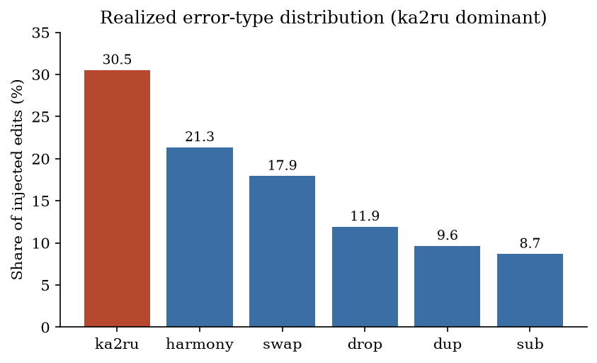
Note. A vertical bar chart of the six injected error operations across all edits, ordered by descending share (ka2ru 30.5%, harmony 21.34%, swap 17.93%, drop 11.91%, dup 9.64%, sub 8.68%); the ka2ru bar is highlighted. Percentages are of all injected edits and sum to 100%.
4. Method
4.1 Overview
The system uses a two-stage pipeline separating where an error occurs from what the corrected form should be. A neural error detector — a KazRoBERTa (Liu et al., 2019; Sagyndyk et al., 2025) token-classification model — emits a per-token KEEP/ERROR judgement, and a corrector resolves each flagged token from a frequency lexicon via inverse look-alike substitutions and an optimal-string-alignment edit-distance fallback; the stages communicate only through the flagged positions. This factorisation is deliberate: correction is precision-sensitive, so restricting generation to flagged positions and in-lexicon candidates yields a conservative failure mode — when no confident candidate exists, the word is left unchanged.
Figure 1
System architecture.
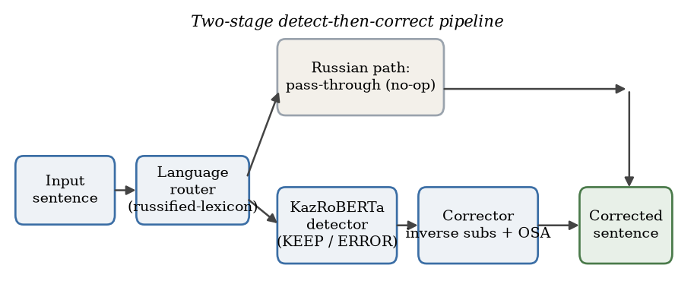
Note. A language router sends Kazakh input (including special-letter-stripped Kazakh recovered by the russified-lexicon signal) to a two-stage pipeline where a KazRoBERTa detector labels each token KEEP/ERROR, a corrector resolves flagged tokens by inverse look-alike substitution and Optimal String Alignment (OSA) search over the lexicon, while Russian input passes through unchanged.
4.2 Error Detector: KazRoBERTa Token Classification
The detector fine-tunes kz-transformers/kaz-roberta-conversational (kz-transformers, 2023; Sagyndyk et al., 2025), a RoBERTa-style encoder (Liu et al., 2019; Vaswani et al., 2017) pretrained with MLM on Kazakh using a byte-level BPE vocabulary (Sennrich et al., 2016) of 52,000 subwords (6 layers, 12 heads, hidden size 768), with a two-label token-classification head, id2label = {0: KEEP, 1: ERROR} (Devlin et al., 2019). Training labels come from whitespace alignment: corrupted and reference sentences are split on whitespace and each word labelled 𝟙[corrupted ≠ reference]; corruption preserves token counts, so after subword tokenisation only the first subword of each word carries the label, with continuation and special tokens set to the ignore index −100.
We adopt token classification rather than sequence-to-sequence because the targeted errors are local edits fitting a non-autoregressive edit-tagging view (Awasthi et al., 2019; Omelianchuk et al., 2020), because a tagger factorises detection from generation (letting a lexicon-constrained corrector rewrite deterministically rather than risk hallucinated substitutions), and because it is cheaper to serve. The model is fine-tuned for 2 epochs (≈ 80,182 steps) on a Colab T4 GPU using AdamW with learning rate 2×10⁻⁵, batch size 64, weight decay 0.01, maximum sequence length 128, and mixed precision (fp16, seed 42); the best checkpoint by ERROR F1 occupies 316.1 MiB in safetensors. On the full test set it attains F1 97.4% (precision 97.3%, recall 97.4%), versus F1 86.5% for a heuristic baseline flagging any word absent from the lexicon (Table 2).
4.3 Corrector
Given the flagged positions, the corrector replaces each flagged word's Cyrillic substring while preserving surrounding punctuation, hyphenation, and casing, using two complementary candidate generators. The first applies inverse look-alike substitutions: a bidirectional map encodes the visually similar Russian↔Kazakh and vowel-harmony pairs (e.g. а↔ә, о↔ө, у→{ұ, ү}, к↔қ, г↔ғ, н↔ң, х↔һ), directly inverting the two dominant error classes; substitutions are enumerated over at most six positions, only in-lexicon candidates retained, and the most frequent chosen. The second is an edit-distance fallback for the remaining swap, drop, duplication, and substitution errors, searching the lexicon with Optimal String Alignment — a restricted Damerau–Levenshtein metric with unit transposition cost (Damerau, 1964; Kukich, 1992; Levenshtein, 1966) — at a cutoff of 2 edits, selecting the minimum-distance form with a frequency tie-break.
When the detector flags a word that is itself a valid lexicon entry but wrong in context (e.g. казак, intended қазақ), the corrector runs in force-correct mode, accepting a candidate only if at least as frequent as the original to avoid replacements toward rarer words. The lexicon contains 339,717 surface forms; the valid subset used for filtering retains the 174,100 forms with frequency ≥ 2, derived from the cleaned ehistory corpus rather than an external dictionary. The fallback runs only when an invalid flagged word yields no in-lexicon inverse candidate, so valid input is left unchanged. At oracle detection the corrector fixes 87.5% of erroneous words at 91.5% precision of changes, with a per-type profile analysed in Section 6.3 (Table 4).
4.4 Language Routing
Because ka2ru strips the Kazakh-specific letters, corrupted Kazakh resembles broken Russian and misleads conventional language identification (Pires et al., 2019). The router adds a russified-lexicon coverage signal: the valid lexicon is mapped through the ka2ru substitution into a set of russified-Kazakh forms, and the fraction of input tokens in this set that are not Russian stopwords feeds a length-aware, nonlinear score combined with character- and token-level cues; the Russian branch is a deliberate no-op. A controlled ablation (Section 6.5) shows this signal raises routing recall on ka2ru-corrupted Kazakh from 31.5% to 99.4% with no observed Russian false positives. The threshold and weight constants are hand-set, so tuning them against a large Russian corpus and standard language-ID baselines remains future work.
We additionally implemented a morphological guard intended to shield valid inflected forms from the edit-distance fallback, segmenting a surface form as STEM (+NUMBER) (+POSSESSIVE) (+CASE) (Kessikbayeva & Cicekli, 2014; Washington et al., 2014) and accepting it only under a harmony-consistent analysis whose stem is in the lexicon (e.g. мектептердің as мектеп-PL-GEN). An ablation (Section 6.4), however, shows this guard reduces accuracy — its permissive segmenter also shields genuinely corrupted tokens that coincidentally parse as valid inflections — so the final system excludes it; we retain it here as a negative result.
5. Experimental Setup
The detection stage fine-tunes the pretrained KazRoBERTa encoder (kz-transformers, 2023; Sagyndyk et al., 2025) for token classification via AutoModelForTokenClassification, with all hyperparameters from the final Colab run in Table 5. The detector is a single training run with one seed; we report all metrics on the full 25,000-pair test split with 95% bootstrap confidence intervals over test sentences (1,000 resamples). Multiple-seed retraining remains future work.
We evaluate on the full held-out test split (25,000 pairs, disjoint from train and validation; no sentences are dropped, as the error model preserves token counts). At the token level, the detector is a binary classifier reporting precision, recall, and F1 on the positive (ERROR) class. At the sentence level, we report an end-to-end "fully corrected" metric — the fraction of sentences the pipeline reproduces exactly, penalising both missed corrections and over-corrections — both including and excluding the trivially-correct identity (clean) pairs. Under oracle detection we additionally report, by error type, the proportion of erroneous words corrected and the precision of changes, and we ablate the corrector's components (Section 6.4) and the routing signal (Section 6.5). We compare the trained pipeline against a heuristic out-of-lexicon detector (a weak baseline isolating the learned detector's contribution) and an oracle upper bound with perfect detection (F1 = 100% by construction); stronger learned comparisons are future work (Section 7).
Table 5
Training hyperparameters for the final detector (Colab run).
Hyperparameter | Value
Base checkpoint | kz-transformers/kaz-roberta-conversational
Head | num_labels=2, id2label={0:KEEP, 1:ERROR}
Learning rate / weight decay | 2×10⁻⁵ / 0.01
Train / eval batch size | 64 / 128
Epochs / total steps | 2 / 80,182
Max sequence length / mixed precision | 128 / fp16
Optimizer / LR scheduler / warmup | AdamW / linear / none
Seed / hardware | 42 / Colab T4 GPU
Note. Values not set fall back to Hugging Face Trainer defaults.
6. Results and Analysis
We evaluate detection quality, end-to-end correction, a per-error-type decomposition under oracle detection, a corrector component ablation, the language-routing signal, qualitative behaviour, and efficiency. All results are on the full held-out test split (25,000 pairs) of synthetically injected errors, with 95% bootstrap confidence intervals over test sentences.
6.1 Detection
The KazRoBERTa detector attains token-level F1 97.4% (precision 97.3%, recall 97.4%); the lexicon heuristic, flagging any token absent from the corrector lexicon, reaches F1 86.5% (precision 85.1%, recall 87.9%) but at roughly six times the false positives (5,434 vs 943; Table 2). The eleven-point gap shows why a contextual encoder beats a membership test: the heuristic cannot distinguish a genuinely misspelled token from a valid but rare or out-of-vocabulary form (a proper noun, neologism, or legitimate inflection), so it over-flags. The fine-tuned detector, building on KazRoBERTa's MLM pretraining (Liu et al., 2019; Sagyndyk et al., 2025) and byte-level subword tokenization (Sennrich et al., 2016), conditions each decision on context — consistent with the long-standing observation that dictionary-lookup detection needs context to separate true errors from rare valid words (Kukich, 1992).
Table 2
Token-level error-detection results on the 8,000-sentence test subset.
Detector | F1 | Precision | Recall | False positives
KazRoBERTa token classifier (trained) | 97.4% | 97.3% | 97.4% | 943
Heuristic baseline (word ∉ lexicon) | 86.5% | 85.1% | 87.9% | 5,434
Note. The trained KazRoBERTa classifier is compared with a heuristic baseline that flags any word absent from the lexicon.
Figure 3
Detection: trained vs. baseline.
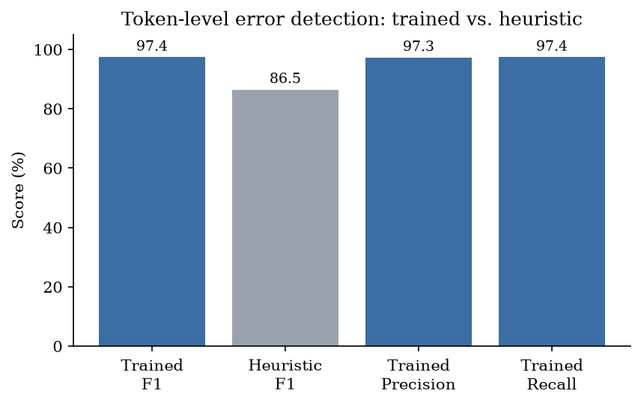
Note. Token-level error detection: the fine-tuned KazRoBERTa detector achieves F1 = 97.4% (P = 97.3%, R = 97.4%), substantially exceeding the lexicon-membership heuristic (F1 = 86.5%) at a sixth of its false positives.
6.2 End-to-End Correction
At the sentence level, the full pipeline corrects 80.2% of sentences (95% CI [79.8, 80.7]), versus 64.3% for the non-learned baseline (heuristic detection plus the same corrector) and 83.2% for an oracle with perfect detection (Table 3). Replacing the heuristic with the trained detector improves full-sentence correction by 15.9 points (64.3% → 80.2%), confirming detection quality as the dominant lever once the corrector is fixed. The trained pipeline then sits within 3.0 points of the 83.2% oracle ceiling, so on this synthetic distribution detection is essentially solved and the residual gap is attributable to the corrector; on organic text the detector's behaviour is unknown. Excluding the trivially-correct identity pairs lowers the absolute figures but preserves the ordering (trained 77.7%, baseline 61.3%, oracle 80.8%).
Table 3
End-to-end sentence-level correction on the full 25,000-pair test split,
Configuration | Fully corrected, all (95% CI) | Excl. identity | Detection F1
Heuristic baseline | 64.3% [63.8, 64.9] | 61.3% | 86.5%
Trained pipeline | 80.2% [79.8, 80.7] | 77.7% | 97.4%
Oracle ceiling (perfect detection) | 83.2% [82.7, 83.6] | 80.8% | 100%
Note. measured as the fraction of sentences fully corrected. The oracle ceiling assumes perfect detection. The "all" column includes identity pairs in the denominator; "excl. identity" removes them.
Figure 4
End-to-end vs. oracle ceiling.
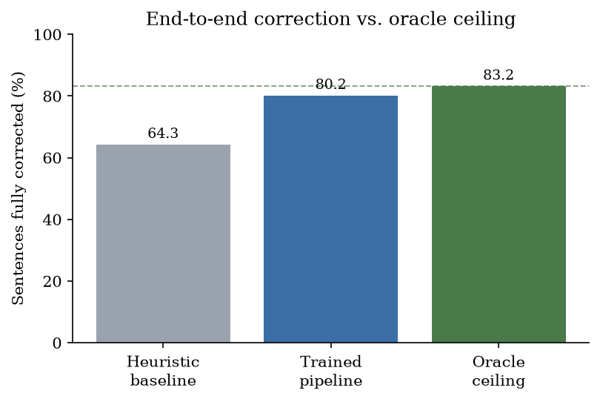
Note. Sentence-level performance (fraction fully corrected): the trained pipeline corrects 80.2%, the heuristic baseline 64.3%, and the oracle 83.2%, so the trained pipeline lies within ≈ 3 points of the ceiling and the corrector is the remaining bottleneck on this synthetic distribution.
6.3 Per-Error-Type Corrector Analysis (Oracle)
Under oracle detection the corrector fixes 87.5% of flagged words at 91.5% precision-of-changes, with a strongly bimodal profile (Table 4): near-perfect on the substitution-based classes — ka2ru 97.2%, harmony 97.4% — strong on duplication (92.1%) and swap (82.9%), but markedly weaker on substitution (70.6%) and drop (60.8%). The ka2ru and harmony classes are deterministic, reversible substitutions over a small confusion set that destroy no surface information, so the lexicon-filtered inverse-substitution generator recovers the intended word almost unambiguously — partly an artefact of the evaluation, since the corrector inverts exactly the injection maps, making the 97.2%/97.4% figures in-distribution. Duplication is similarly low-entropy and easily removed by the OSA fallback (Damerau, 1964; Levenshtein, 1966), and a swap is one OSA operation, though its 82.9% rate already strains when more than one valid form lies within the radius.
Drop and sub are hardest because each destroys information unrecoverable from form alone: a deletion leaves multiple lexicon entries equidistant, and a substitution replaces a character with an arbitrary letter, breaking the inverse path and forcing the generic edit-distance search. Crucially, the corrector ranks by lexicon frequency, not sentential plausibility, so when the surface form underdetermines the answer accuracy falls — the observation motivating context-dependent correction (Kukich, 1992) and neural re-ranking in modern GEC (Awasthi et al., 2019; Omelianchuk et al., 2020), whose addition is the clearest path to closing the drop/sub gap.
Table 4
Per-error-type corrector accuracy under oracle detection on the test set.
Error type | Fixed (95% CI) | n
ka2ru | 97.2% [96.9, 97.5] | 10,680
harmony | 97.4% [97.0, 97.7] | 7,561
dup | 92.1% [91.2, 92.9] | 3,539
swap | 82.9% [82.0, 83.8] | 6,439
sub | 70.6% [69.0, 72.2] | 3,045
drop | 60.8% [59.4, 62.2] | 4,207
Overall | 87.5% fixed; 91.5% precision-of-changes | 35,471
Note. "Fixed" denotes recovery of the gold word form.
Figure 5
Per-error-type corrector accuracy.
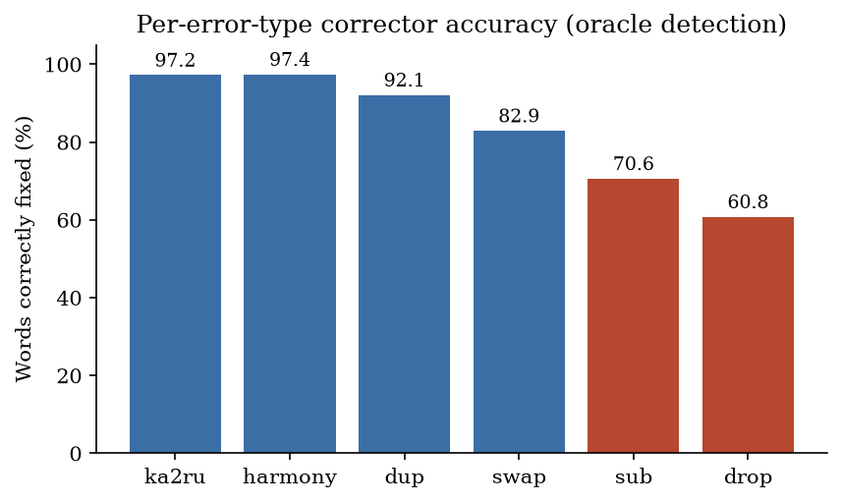
Note. Corrector accuracy by error type under oracle detection: strongest on systematic substitution errors — ka2ru (97.2%) and vowel-harmony (97.4%) — and weakest on information-losing drop (60.8%) and generic sub (70.6%), which lack a deterministic inverse, for an overall 87.5% fixed at 91.5% precision-of-changes.
6.4 Component Ablation
Table 6 ablates the corrector. Removing either candidate generator is costly. Inverse substitutions alone fix only the structured classes — ka2ru 94.9% and harmony 96.4% — but cannot touch swap, drop, duplication, or substitution (≈ 0%), which have no deterministic inverse. OSA edit distance alone covers those four but mishandles ka2ru (72.6% vs 97.2%), because for a look-alike error the nearest lexicon form by edit distance is often the wrong word, whereas the inverse map is exact. The two generators are thus complementary and together reach 80.2% end-to-end. Adding the morphological guard reduces end-to-end accuracy by 5.9 points (80.2% → 74.3%): its permissive segmenter accepts many genuinely corrupted tokens as valid inflections and shields them from correction. We therefore exclude the guard from the final system and report it as a negative result; a stricter analyser (full verbal morphology and tighter harmony constraints) is left to future work.
Table 6
Corrector component ablation on the full 25,000-pair test set
Corrector configuration | E2E (model det.) | E2E (oracle det.)
Full (inverse subs + OSA) — proposed | 80.2% | 83.1%
+ morphological guard | 74.3% | 76.7%
Inverse substitutions only | 43.6% | 44.1%
OSA edit-distance only | 70.2% | 72.5%
Note. (% sentences fully corrected, at model and oracle detection).
6.5 Language-Routing Ablation
To quantify the russified-lexicon routing signal (Section 4.4), we compare the full router against an ablation with the russified set emptied, on 3,000 real Kazakh test sentences, their ka2ru-corrupted variants, and a small indicative Russian negative set. Both variants route clean Kazakh correctly (100%), but on ka2ru-corrupted Kazakh — which superficially resembles Russian — the russified signal raises routing recall from 31.5% to 99.4%, while no Russian sentence is misrouted to Kazakh in either variant (Table 7). A larger Russian-corpus precision study against fastText/CLD3 remains future work.
Table 7
Language-routing ablation
Input set | Full router | Naive (no russified signal)
Clean Kazakh (n = 3,000) | 100.0% | 100.0%
ka2ru-Kazakh (n = 3,000) | 99.4% | 31.5%
Russian (n = 20, indicative) | 0.0% | 0.0%
Note. (% of inputs routed to the Kazakh correction path; higher is better for the Kazakh sets, lower for Russian).
6.6 Qualitative Example and Efficiency
The flagship behaviour is recovering ka2ru-corrupted Kazakh that superficially resembles Russian. The input «Бул маселе оте манызды болып тур» is routed to the Kazakh path by the russified-lexicon signal and restored to «Бұл мәселе өте маңызды болып тұр», each edit a ka2ru inverse substitution — exactly the low-entropy regime in which the corrector excels. In the underdetermined cases behind the 60.8% drop rate, the safe failure mode is to leave the token unchanged.
The system is designed for CPU-only serving. A warm request completes in roughly 9 ms, sustaining throughput on the order of 200 requests per second. The deployed container occupies approximately 373 MB of resident memory in a 2.84 GB image, with the fine-tuned checkpoint at 316.1 MiB; the system was validated in an accepted live pilot.
7. Discussion and Limitations
The evaluation supports the central design hypothesis for this synthetic setting: detection is essentially solved by a fine-tuned KazRoBERTa token classifier (F1 97.4%) while correction is the bottleneck, so the small gap between the trained pipeline (80.2%) and the oracle (83.2%) means further gains will come predominantly from the corrector. Notably, ka2ru is both the dominant error class (30.5% of edits) and among the most tractable, resolved at 97.2% under oracle detection — second only to harmony at 97.4% — because both are structured, low-entropy substitutions the generator recovers almost deterministically. The most frequent real-world Kazakh typing error is thus the one the system handles best.
We are candid about the limitations. The evaluation pairs authentic human text with synthetic errors. The reference side of every pair is genuine published Kazakh and the error model targets a documented real-world phenomenon rather than arbitrary noise (Section 3), which makes the setup more realistic than generic corruption; what remains synthetic is the error distribution on the input side — its rate, mix, and clustering are design choices, not measured from human typing — and the corrector inverts exactly the maps used to inject the ka2ru and harmony classes, so those per-type figures are partly in-distribution. The reported numbers are therefore upper-leaning estimates of organic performance: a few hundred manually annotated organic sentences (e.g. from live-pilot traffic) are still needed to validate the error distribution, though the reference text, being already human, needs no such validation. The "detection is essentially solved" claim rests on the ~3-point synthetic gap at a fixed error rate. Competitive learned baselines are missing — the only comparison is KazRoBERTa versus a dictionary-lookup heuristic. We ablate the corrector's candidate generators, the morphological guard, and the routing signal (Sections 6.4–6.5), but the identity-pair fraction and augmentation ratio are not ablated (these require retraining), and all results come from a single training seed. The corrector is weakest on drop (60.8%) and sub (70.6%), which admit several valid candidates with no contextual re-ranking. A descriptive-versus-normative tension surfaces: built from attested usage, the lexicon treats non-standard but commonly written forms (e.g. салем, рахмет) as valid, requiring an explicit normative layer rather than more data. The approach is plausibly generalizable to other Cyrillic-script Turkic languages (Tatar, Bashkir, Kyrgyz) sharing the agglutinative morphology and look-alike-substitution cause, since only the confusion maps, lexicon, and morphological rules are language-specific. Ethically, the system is a suggestion engine that inherits a historical-register bias from its corpus and fails conservatively by leaving uncertain words unchanged.
8. Conclusion and Future Work
We presented Turan Text Corrector, a two-stage Kazakh spelling-correction system pairing a KazRoBERTa token-classification detector (test F1 97.4%) with a lexicon and edit-distance corrector, reaching 80.2% sentence-level correction near an 83.2% oracle ceiling on the full 25,000-pair synthetic test set and validated in an accepted live pilot. It centres on the under-studied ka2ru look-alike error class — the dominant error type (30.5% of edits) and the one corrected most reliably (97.2%) — and contributes a lightweight "russified-lexicon" routing signal that recovers special-letter-stripped Kazakh otherwise misread as Russian. The empirical results are synthetic and in-distribution; the durable contributions are the problem framing, the data-construction methodology, and a deployable system. Future work follows from the limitations:
- A human-annotated benchmark of a few hundred organically typed Kazakh sentences (e.g. from pilot traffic) to measure performance against the real error distribution — the first priority.
- Competitive baselines: a seq2seq GEC model, a multilingual encoder (XLM-R), an off-the-shelf spellchecker, and Baitenova et al. (2025), with standard GEC metrics (M2/ERRANT, GLEU) alongside the fully-corrected metric.
- Remaining statistical rigor: train multiple seeds; ablate the identity-pair fraction and augmentation ratio (which require retraining); and evaluate routing precision on a large Russian corpus against fastText/CLD3/langid with tuned constants.
- A contextual re-ranker and a normative layer to close the drop/sub gaps and the descriptive-versus-normative tension, plus extended verbal-morphology coverage and transfer to other Cyrillic-script Turkic languages.
References
Awasthi, A., Sarawagi, S., Goyal, R., Ghosh, S., & Piratla, V. (2019). Parallel Iterative Edit Models for Local Sequence Transduction. In Proceedings of EMNLP-IJCNLP 2019. https://doi.org/10.18653/v1/D19-1435
Baitenova, L., Tussupova, S., Mambetov, S., Munaitbas, G., & Mukhamejanova, G. (2025). Hybrid artificial intelligence architectures for automatic text correction in the Kazakh language. Frontiers in Artificial Intelligence, vol. 8. https://doi.org/10.3389/frai.2025.1708566
Damerau, F. J. (1964). A Technique for Computer Detection and Correction of Spelling Errors. Communications of the ACM, vol. 7, no. 3, pp. 171-176. https://doi.org/10.1145/363958.363994
Devlin, J., Chang, M.-W., Lee, K., & Toutanova, K. (2019). BERT: Pre-training of Deep Bidirectional Transformers for Language Understanding. In Proceedings of NAACL-HLT 2019. https://doi.org/10.18653/v1/N19-1423
Grundkiewicz, R., Junczys-Dowmunt, M., & Heafield, K. (2019). Neural Grammatical Error Correction Systems with Unsupervised Pre-training on Synthetic Data. In Proceedings of the Fourteenth Workshop on Innovative Use of NLP for Building Educational Applications (BEA 2019). https://doi.org/10.18653/v1/W19-4427
Kessikbayeva, G., & Cicekli, I. (2014). Rule Based Morphological Analyzer of Kazakh Language. In Proceedings of the 2014 Joint Meeting of SIGMORPHON and SIGFSM. https://doi.org/10.3115/v1/W14-2806
Kukich, K. (1992). Techniques for Automatically Correcting Words in Text. ACM Computing Surveys, vol. 24, no. 4, pp. 377-439. https://doi.org/10.1145/146370.146380
kz-transformers (2023). kaz-roberta-conversational (Hugging Face model card). Hugging Face Model Hub. https://huggingface.co/kz-transformers/kaz-roberta-conversational
Levenshtein, V. I. (1966). Binary Codes Capable of Correcting Deletions, Insertions and Reversals. Soviet Physics Doklady, vol. 10, no. 8, pp. 707-710. https://nymity.ch/sybilhunting/pdf/Levenshtein1966a.pdf
Liu, Y., Ott, M., Goyal, N., Du, J., Joshi, M., Chen, D., Levy, O., Lewis, M., Zettlemoyer, L., & Stoyanov, V. (2019). RoBERTa: A Robustly Optimized BERT Pretraining Approach. arXiv preprint arXiv:1907.11692. https://arxiv.org/abs/1907.11692
Makhambetov, O., Makazhanov, A., Yessenbayev, Z., Matkarimov, B., Sabyrgaliyev, I., & Sharafudinov, A. (2013). Assembling the Kazakh Language Corpus. In Proceedings of the 2013 Conference on Empirical Methods in Natural Language Processing (EMNLP 2013). https://aclanthology.org/D13-1104/
Omelianchuk, K., Atrasevych, V., Chernodub, A., & Skurzhanskyi, O. (2020). GECToR -- Grammatical Error Correction: Tag, Not Rewrite. In Proceedings of the Fifteenth Workshop on Innovative Use of NLP for Building Educational Applications (BEA 2020). https://doi.org/10.18653/v1/2020.bea-1.16
Pires, T., Schlinger, E., & Garrette, D. (2019). How Multilingual is Multilingual BERT?. In Proceedings of the 57th Annual Meeting of the Association for Computational Linguistics (ACL 2019). https://doi.org/10.18653/v1/P19-1493
Sagyndyk, B., Murzakhmetov, S., & Yakunin, K. (2025). Kaz-RoBERTa Conversational Technical Report. TechRxiv preprint. https://doi.org/10.36227/techrxiv.175942902.25827042
Salimzyanov, I., Washington, J., & Tyers, F. (2013). A Free/Open-source Kazakh-Tatar Machine Translation System. In Proceedings of Machine Translation Summit XIV. https://aclanthology.org/2013.mtsummit-papers.22/
Sennrich, R., Haddow, B., & Birch, A. (2016). Neural Machine Translation of Rare Words with Subword Units. In Proceedings of the 54th Annual Meeting of the Association for Computational Linguistics (ACL 2016). https://doi.org/10.18653/v1/P16-1162
Tyers, F. M., & Washington, J. N. (2015). Towards a Free/Open-source Universal-dependencies Treebank for Kazakh. In Proceedings of the 3rd International Conference on Turkic Languages Processing (TurkLang 2015). https://aclanthology.org/2017.turklang-1.0/
Vaswani, A., Shazeer, N., Parmar, N., Uszkoreit, J., Jones, L., Gomez, A. N., Kaiser, L., & Polosukhin, I. (2017). Attention Is All You Need. In Advances in Neural Information Processing Systems 30 (NeurIPS 2017). https://arxiv.org/abs/1706.03762
Washington, J. N., Salimzyanov, I., & Tyers, F. M. (2014). Finite-state Morphological Transducers for Three Kypchak Languages. In Proceedings of the Ninth International Conference on Language Resources and Evaluation (LREC 2014). https://aclanthology.org/L14-1143/
Yeshpanov, R., Khassanov, Y., & Varol, H. A. (2022). KazNERD: Kazakh Named Entity Recognition Dataset. In Proceedings of the Thirteenth Language Resources and Evaluation Conference (LREC 2022). https://aclanthology.org/2022.lrec-1.44/

