**About “My Beeline”**

The free mobile application "My Beeline" is a personal account that is always at hand.

The application allows the Subscriber to connect/disconnect the Operator's services, as well as pay for these services using a Bank card and/or funds on a personal account (balance). It is also possible to manage services using the login and password of the System.

Information about the balance, tariff and connected services is always available here. You can top up your account in one click or transfer money to another subscriber.

**Components**

The mobile application combines many different technologies and features:

1. Artificial Intelligence: chatbot Dana, a showcase based on Big Data & Machine Learning, and biometrics.
2. Finance: online payments, transfers by phone number, QR code transactions, installments, and loans.
3. Aggregators: games, movies, TV series, news, and music.
4. Online gadget store: purchase of smartphones, and routers.
5. Telecom services: tariff constructor, mobile communication, tariff change, detailing, and family packages.

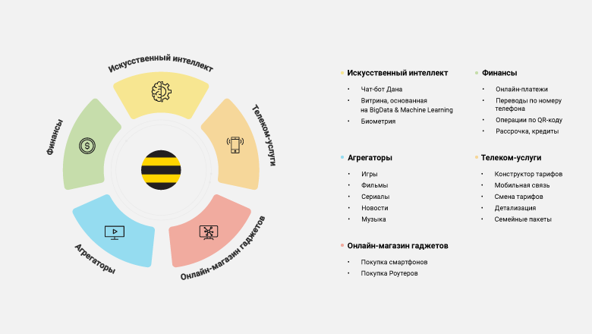

**Functionality**

Authorization/registration:

* Login by phone number or login “Internet at Home”
* Login by fingerprint or Face ID
* Registration in 1 minute

Beeline Product Management:

* View the remnants of the Internet service package/calls/messages
* Change of the tariff plan
* Enabling/disabling additional services
* Exchange minutes for gigabytes
* Replenishment of the balance from the card

Making payments and transfers:

* Transfer from balance to balance
* Transfer from balance to bank card
* Transfer from balance to account
* Transfer from the balance to withdraw at an ATM
* Payment via QR in transport
* Payment for services from the balance (utilities, online games, bookmakers, etc.)
* Payment history

Additionally:

* Details of expenses and deposits
* The "Internet at Home" service: checking the balance, replenishing the account, payment of the subscription fee
* Managing additional numbers
* Activation of special offers
* Search for answers to questions in the HELP section
* Addresses of Beeline offices and service points

**Use Case Diagram**

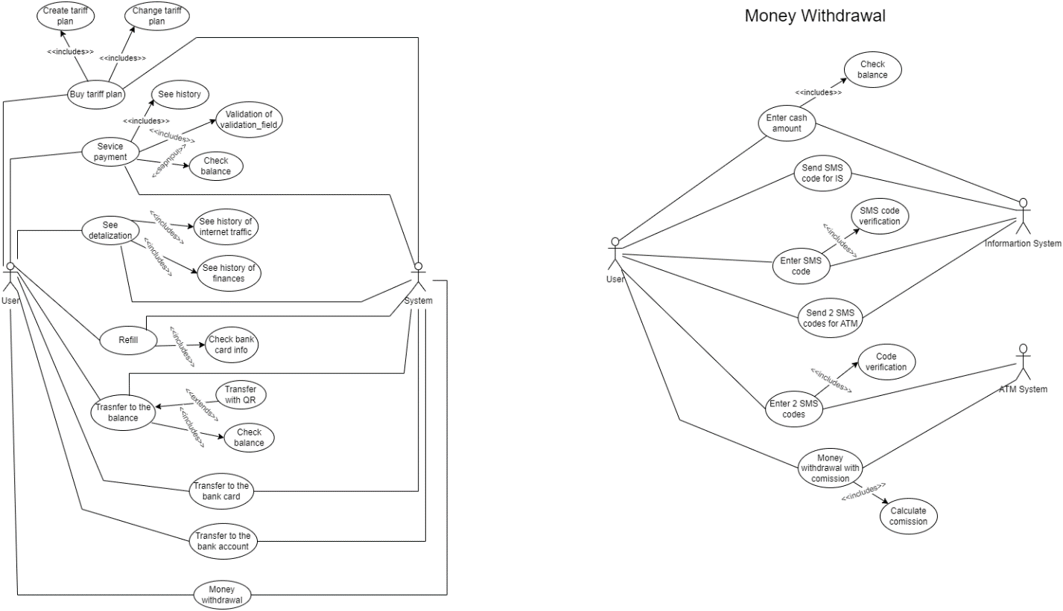

This diagram shows two actors (the user and the system) and what use cases exist for telecom services. Use case diagram well represents the goals of system-user interactions, defines and organizes functional requirements in a system, and models the basic flow of events in a use case.

In this case, the user interacts with the system through such use cases as buying a tariff plan, service payment, seeing detail, refilling, transferring to the balance, transferring to the bank card, transferring to the bank account, and money withdrawal. When buying a tariff plan, the user must either change the tariff plan or create a new one. To pay for services, you first need to pass validation and check for the necessary balance. Viewing details allows you to view the history of Internet traffic usage and financial history. To top up your balance, you need to check the information on your bank card.

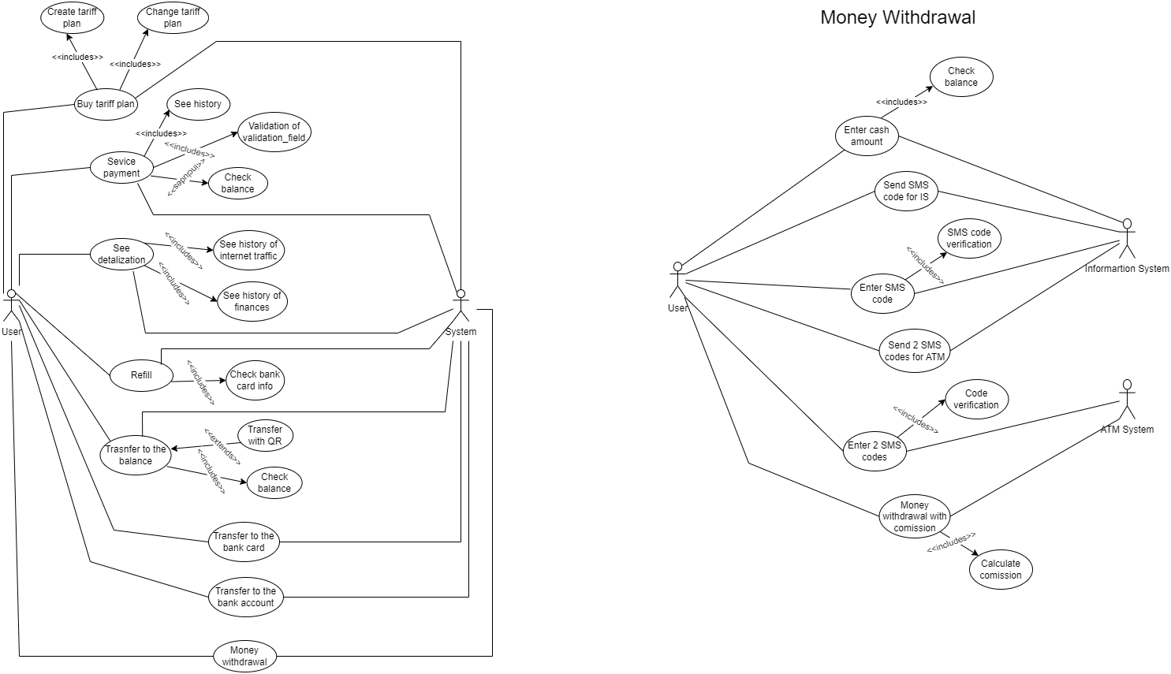

The second use case diagram reveals in more detail how the interaction between the user, the system, and the ATM system is going on. The money withdrawal process is taking place. To do this, first, the user enters the amount of money to withdraw. The system checks his balance and, when passing, sends him an SMS with a code to the number. After entering this code into the application, it now sends another code in two parts so that the user enters it into the ATM. After confirming the code, the user receives money with a commission.

**DFD Diagram**

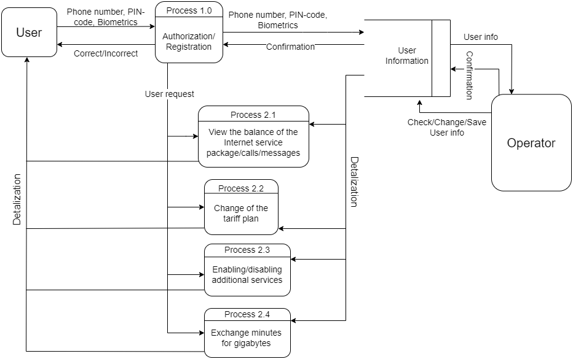

In order to open the application and use its services, the user must first log in or register. To do this, he enters either his phone number, PIN code, or biometrics. This data is sent to the database from where the system receives either a response about correct or incorrect data entry. After authorization, the user can already use such services as viewing their own balance, the remaining data package, time for calls and messages, changing the tariff plan, connecting or disabling additional services, as well as replacing minutes with Gigabytes. All the processes used will be displayed through the details of the mobile application in the user account.

**Class Diagram**

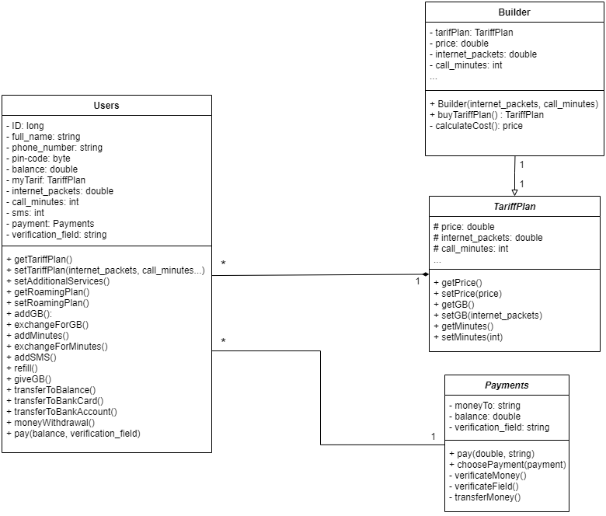

This class diagram shows the relationship between classes existing in the application regarding telecom services. The main class is the users since it stores personal information about users and most of the main functions of the application are available. In addition, there are also TariffPlan, Payments, and Builder classes. The TariffPlan class is used so that the user can choose an existing tariff for himself or construct a new tariff through the Builder class. The Builder class is inherited from the Tariff Plan class, and it, in turn, is connected to the Users class through a compositional connection in the form of one-to-many. The Payments class makes it possible to pay for various services that exist in the mobile application. The relationship between the Payments class and Users is associative, one to many.

**BPMN Diagram**

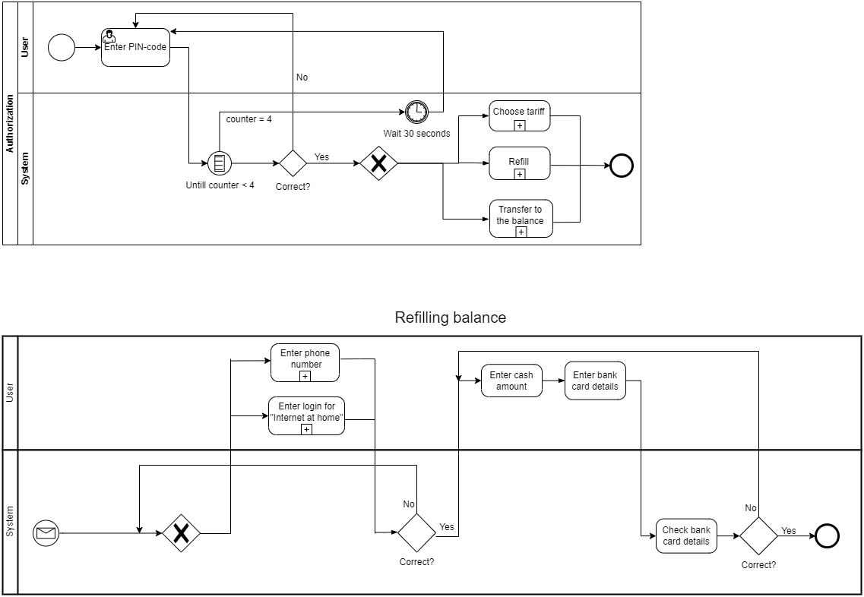

The first BPMN diagram shows the user authorization process, in which the user and the system participate. The process begins with the user entering the PIN code and can be repeated 4 times if entered incorrectly. If all 4 attempts were wrong, then a timer is triggered, where you need to wait 30 seconds, after which you can repeat the process. If the entered PIN code was correct, then the user can either choose a tariff, top up the balance, or transfer money to another balance.



The second BPMN diagram shows the process of replenishment of the balance, in which the user and the system participate. From the very beginning, the user can choose what he wants to top up, the balance of his phone number or the balance of his account in the "Internet at Home". After that, a check is carried out and if an error has occurred, the data entered can be repeated again. If everything was entered correctly, the user enters the amount of money and the details of the bank card. After that, the system checks these very details. If there is an error, you can repeat the input process again.