Machine Learning tools to assist the analysis of complex rotational spectra of chemical mixtures
D. Yélamos, Z. Wang, C. Calabrese, C. Bermúdez
Departamento de Química Física y Química Inorgánica, Facultad de Ciencias — I.U. CINQUIMA. Paseo de Belén 7, 47011 Valladolid, Spain

Broadband chirped pulse Fourier Transform microwave spectroscopy enables the collection of large bandwidth spectrum in a single shot [1], increasing the speed of the spectral accumulation and allowing the study of more complex species and chemical mixtures. However, the possibility of averaging millions of spectra makes rotational analysis challenging, even with precise quantum chemical predictions. To address this, different approaches appeared to assist the spectral analysis: AUTOFIT algorithm relies on transition frequencies and Hamiltonian fitting [2], pump-probe methods like Double-Resonance [3], or intensity-based methods [4].
Across this study, we consider intensity-based methods for spectral analysis by applying it to mixtures of small gases like SO₂-H₂O. Our experimental approach consists of taking different spectra of the mixture, changing the conditions or the proportion of the gases by adding deuterated water. The spectral processing carries an initial data filtering; grouping transitions that remain unperturbed when adding some components, or the ones that increase/decrease with the changes and selecting the ones of interest. The second step of the filtering follows the intensity-based methods: to filter the transitions in function of the number of water molecules that complexes have in their structure (n in the complexes like [SO₂]_{m}[H₂O]_{n}). On top of that, we propose to go further and to implement Machine Learning tools to cluster transitions into different groups and separate them in function of how they react with the experimental conditions.
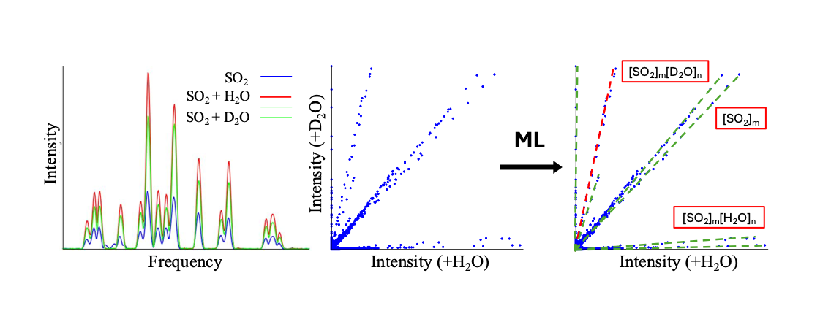
REFERENCES
[1] G. B. Park, R. W. Field, Perspective: The first ten years of broadband chirped pulse Fourier transform microwave spectroscopy, J. Chem. Phys. 144 (20), 200901 (2016).
[2] N. A. Seifert, I. A. Finneran, C. Perez, D. P. Zaleski, J. L. Neill, A. L. Steber, R. D. Suenram, A. Lesarri, S. T. Shipman, B. H. Pate; AUTOFIT, an automated fitting tool for broadband rotational spectra, and applications to 1-hexanal, J. Mol. Spectrosc. 321, 13-21 (2015).
[3] M. Martin-Drumel, M. C. McCarthy, D. Patterson, B. A. McGuire, K. N. Crabtree; Automated microwave double resonance spectroscopy: A tool to identify and characterize chemical compounds. J. Chem. Phys. 144 (12): 124202 (2016).
[4] K. C. Gilbert, S. A. Peebles, B. H. Pate, R. A. Peebles, Application of Intensity Ratios to Disentangle Rotational Spectra of Large Molecular Clusters: Trifluoroethylene with up to 6 CO₂ Molecules, J. Phys. Chem. A. 129 (45), 10393-10403 (2025).

