**CS1073  
FR03B**

**Assignment #6**

**Daniyal Khan  
3765942**

**Part I:**  
import javafx.application.Application;

import javafx.stage.Stage;

import javafx.scene.Scene;

import javafx.scene.layout.FlowPane;

import javafx.scene.text.Text;

import javafx.scene.control.Label;

import javafx.scene.control.TextField;

import javafx.scene.control.Button;

import javafx.event.ActionEvent;

import javafx.geometry.Pos;

import java.text.NumberFormat;

/**

This class represents a javadoc application for Character Counting

@author Daniyal Khan 3765942

*/

public class CharacterCounting extends Application {

TextField inputField;

Text instruct;

public static void main(String[] args) {

launch(args);

}

public void start(Stage Stage) {

Stage.setTitle("Character Counting");

Text heading = new Text("Enter a word or phrase:");

inputField = new TextField();

inputField.setPrefWidth(210);

Button countLetters = new Button("Count Letters");

Button countDigits = new Button("Count Digits");

countLetters.setOnAction(this::letterCounter);

countDigits.setOnAction(this::digitCounter);

instruct = new Text("Count digits or letters!");

FlowPane pane = new FlowPane(heading, inputField, countLetters, countDigits, instruct);

pane.setAlignment(Pos.CENTER);

pane.setVgap(20);

pane.setHgap(20);

Scene scene = new Scene(pane, 260, 300);

Stage.setScene(scene);

Stage.show();

}

public void letterCounter(ActionEvent event) {

String inputStr = inputField.getText();

int numLetters = 0;

for (int i = 0, len = inputStr.length(); i < len; i++) {

if(Character.isLetter(inputStr.charAt(i))) {

numLetters++;

}

}

instruct.setText("The numbers of letters is: " + numLetters);

}

public void digitCounter(ActionEvent event) {

String inputStr = inputField.getText();

int numDigits = 0;

for (int i = 0, len = inputStr.length(); i < len; i++) {

if(Character.isDigit(inputStr.charAt(i))) {

numDigits++;

}

}

instruct.setText("The numbers of digits is: " + numDigits);

}

}

**Output:**

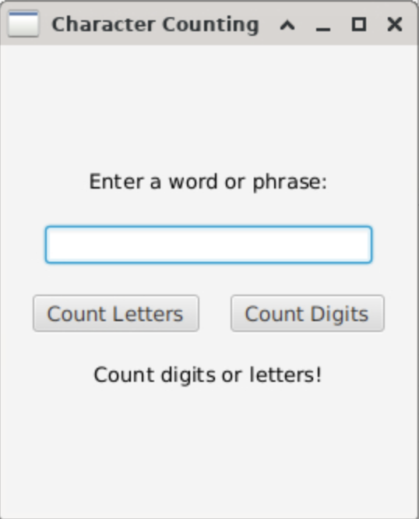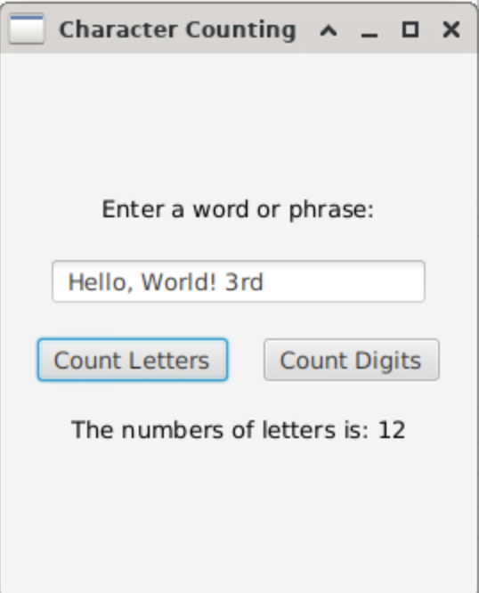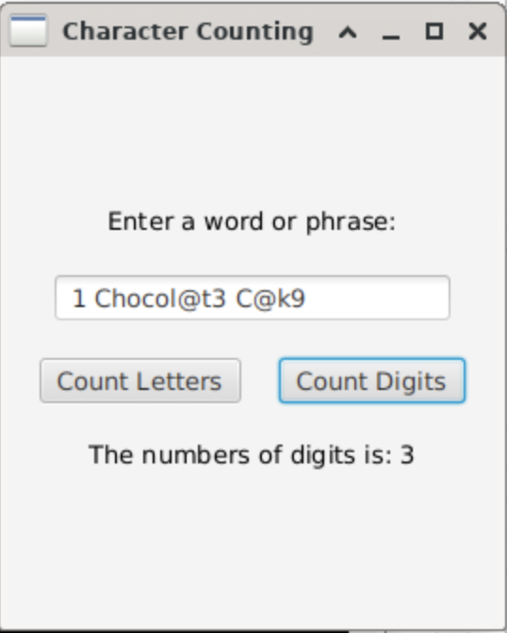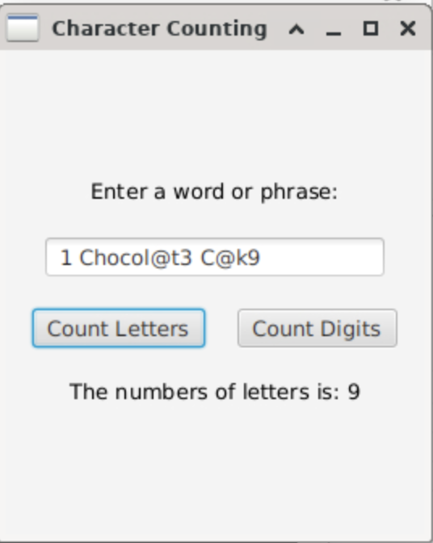

**Part 2:**

**HotelRoomBooking.java**

import javafx.application.Application;

import javafx.stage.Stage;

import javafx.scene.Scene;

import javafx.scene.layout.FlowPane;

import javafx.scene.text.Text;

import javafx.scene.control.Label;

import javafx.scene.control.TextField;

import javafx.scene.control.Button;

import javafx.event.ActionEvent;

import javafx.geometry.Pos;

import java.text.NumberFormat;

/**

This class represents a javadoc application for Character Counting

@author Daniyal Khan 3765942

*/

public class HotelRoomBooking extends Application {

private TextField nameField;

private TextField guestField;

private TextField bedField;

private TextField nightField;

private NumberFormat currency;

private Text intro;

private Text checkOut;

private Text display;

public static void main(String[] args) {

launch(args);

}

public void start(Stage Stage) {

Stage.setTitle("Hotel Room Booking");

Text name = new Text("Name:");

nameField = new TextField();

nameField.setPrefWidth(100);

Text numGuests = new Text("Number of Guests:");

guestField = new TextField();

guestField.setPrefWidth(60);

Text numBeds = new Text("Number of Beds:");

bedField = new TextField();

bedField.setPrefWidth(60);

Text numNights = new Text("Number of Nights:");

nightField = new TextField();

nightField.setPrefWidth(60);

Button suite = new Button("Suite");

Button standard = new Button("Standard");

Button reset = new Button("Reset");

reset.setOnAction(this::resetFields);

suite.setOnAction(this::suiteRoom);

standard.setOnAction(this::standardRoom);

intro = new Text("Welcome to Hotels R Us");

checkOut = new Text("Take note of your check-out time.");

display = new Text("Enter your information");

FlowPane pane = new FlowPane(name, nameField, numGuests, guestField, numBeds, bedField, numNights, nightField, suite, standard, reset, intro, checkOut, display);

pane.setAlignment(Pos.CENTER);

pane.setVgap(20);

pane.setHgap(15);

Scene scene = new Scene(pane, 260, 370);

Stage.setScene(scene);

Stage.show();

}

public void suiteRoom(ActionEvent event) {

currency = NumberFormat.getCurrencyInstance();

String nameStr = nameField.getText();

String guestStr = guestField.getText();

String bedStr = bedField.getText();

String nightStr = nightField.getText();

int numGuests = Integer.parseInt(guestStr);

int numBeds = Integer.parseInt(bedStr);

int numNights = Integer.parseInt(nightStr);

Suite suite = new Suite(nameStr, numNights, numGuests, numBeds);

intro.setText("Your room perk is: " + suite.randPerk());

checkOut.setText("Please check-out by: " + suite.checkOutTime());

display.setText("Total Cost: " + currency.format(suite.getRate()));

}

public void standardRoom(ActionEvent event) {

currency = NumberFormat.getCurrencyInstance();

String nameStr = nameField.getText();

String guestStr = guestField.getText();

String bedStr = bedField.getText();

String nightStr = nightField.getText();

int numGuests = Integer.parseInt(guestStr);

int numBeds = Integer.parseInt(bedStr);

int numNights = Integer.parseInt(nightStr);

Standard standard = new Standard(nameStr, numNights, numGuests, numBeds);

intro.setText("Breakfast included in room cost.");

checkOut.setText("Please check-out by: " + standard.checkOutTime());

display.setText("Total Cost: " + currency.format(standard.getRate()));

}

public void resetFields(ActionEvent event) {

nameField.clear();

guestField.clear();

bedField.clear();

nightField.clear();

}

}

**Room.java**

/**

This class represents a room in Hotel R Us

@author Daniyal Khan 3765942

*/

public class Room {

/**

Name of the person booking

*/

private String name;

/**

Number of nights staying

*/

private int numNights;

/**

Number of guests

*/

private int numGuests;

/**

Number of beds

*/

private int numBeds;

/**

Contructs a object of type Room given the name, number of nights, number of guests and

@param name Name of the person booking

@param numNights Number of nights

@param numGuests Number of guests

@param numBeds Number of beds

*/

public Room(String name, int numNights, int numGuests, int numBeds) {

this.name = name;

this.numNights = numNights;

this.numGuests = numGuests;

this.numBeds = numBeds;

}

/**

@return Name of the person who booked

*/

public String name() {

return name;

}

/**

@return Number of nights staying

*/

public int numNights() {

return numNights;

}

/**

@return Number of guests

*/

public int numGuests() {

return numGuests;

}

/**

@return Number of beds

*/

public int numBeds() {

return numBeds;

}

}

**Suite.java**

import java.util.Random;

/**

This class represents a Suite in Hotel R Us

@author Daniyal Khan 3765942

*/

public class Suite extends Room {

/**

Base rate of the suite

*/

private final double BASE_RATE;

/**

Contructs a object of type Suite given the name, number of nights, number of guests and

@param name Name of the person booking

@param numNights Number of nights

@param numGuests Number of guests

@param numBeds Number of beds

*/

public Suite(String name, int numNights, int numGuests, int numBeds) {

super(name, numNights, numGuests, numBeds);

BASE_RATE = 380;

}

/**

@return Total cost of the suite

*/

public double getRate() {

double total = 0;

int numExtraBed = super.numBeds() - 3;

double additionalBedCharge = 15.00;

total = super.numNights()*BASE_RATE;

if (numExtraBed >= 1) {

total += super.numNights()*(numExtraBed*additionalBedCharge);

}

return total;

}

/**

@return Random perk (Champagne, Chocolates, Fruit basket)

*/

public String randPerk() {

String perk = "";

Random rand = new Random();

int random = rand.nextInt(3)+1;

switch (random) {

case 1:

perk = "Champagne";

break;

case 2:

perk = "Chocolates";

break;

case 3:

perk = "Fruit basket";

break;

}

return perk;

}

/**

@return Checkout time

*/

public String checkOutTime() {

return "12 noon";

}

}

**Standard.java**

import java.util.Random;

/**

This class represents a Standard room in Hotel R Us

@author Daniyal Khan 3765942

*/

public class Standard extends Room {

/**

Base rate for a standard room

*/

private final double BASE_RATE;

/**

Contructs a object of type Standard given the name, number of nights, number of guests and

@param name Name of the person booking

@param numNights Number of nights

@param numGuests Number of guests

@param numBeds Number of beds

*/

public Standard(String name, int numNights, int numGuests, int numBeds) {

super(name, numNights, numGuests, numBeds);

BASE_RATE = 225;

}

/**

@return Total cost of the suite

*/

public double getRate() {

double total = 0;

int numExtraBed = super.numBeds() - 2;

double additionalBedCharge = 20.00;

double breakFastCharge = 9.75;

total = super.numNights()*BASE_RATE + super.numNights()*(breakFastCharge*super.numGuests());

if (numExtraBed >= 1) {

total += super.numNights()*(additionalBedCharge*numExtraBed);

}

return total;

}

/**

@return Random checkout time (either 10am or 11am)

*/

public String checkOutTime() {

String time = "";

Random rand = new Random();

int random = rand.nextInt(2) + 1;

switch (random) {

case 1:

time = "11am";

break;

case 2:

time = "10am";

break;

}

return time;

}

}

**Output:  
  
