**CS1083**

**Assignment #0**

**Daniyal Khan**

**3765942**

**Source Code For Attendee Class:**  
  
/**

*This is class represents a Attendee*

@author *Daniyal Khan 3765942*

*/

*public* *class* Attendee {

*private* int daysAttended;

*private* int numOfEventsVisited;

*private* Event[] events;

*private* int eventsAttended; // *companion variable*

*public* *Attendee*(int daysAttended) {

events = *new* Event[5];

eventsAttended = 0;

numOfEventsVisited = 0;

this.*daysAttended* = daysAttended;

}

*public* void *addEvent*(Event event) {

*if*(eventsAttended >= 5) {

Event[] moreEvents = *new* Event[events.*length*+1];

System.*arraycopy*(events, 0, moreEvents, 0, events.*length*);

events = moreEvents;

}

events[eventsAttended] = event;

numOfEventsVisited++;

eventsAttended++;

}

*public* boolean *removeEvent*(Event eventToBeRemoved) {

boolean removed = false;

*for* (int i = 0; i < eventsAttended; i++) {

*if* (events[i].*getID*() == eventToBeRemoved.*getID*()) {

*for* (int j = i; j < eventsAttended-1; j++) {

events[j] = events[j+1];

}

events[eventsAttended-1] = null;

eventsAttended--;

removed = true;

}

}

*return* removed;

}

*public* Event[] *listOfEvents*() {

*return* events;

}

*public* double *costOfTicket*() {

double cost = 189.99;

*if* (eventsAttended > 4) {

cost = 279.99;

}

*return* cost;

}

*public* String *textuallistOfEvents*() {

String allEvents = "";

*for* (int i = 0; i < eventsAttended; i++) {

allEvents += events[i].*getID*() + " " + events[i].*getArtistName*() + "\n";

}

*return* allEvents;

}

}

**Source code for Event:**  
  
*public* *class* Event{

*private* String artistName;

*private* int id;

*private* *static* int nextID = 6000;

*public* *Event*(String nameIn){

artistName = nameIn;

id = nextID;

nextID++;

}

*public* String *getArtistName*(){

*return* artistName;

}

*public* int *getID*(){

*return* id; }

}

**Source Code for VIP attendee:**

/**

*This is class represents a VIP attendee which is a subclass of Attendee*

@author *Daniyal Khan 3765942*

*/

*public* *class* VIPAttendee *extends* Attendee {

*private* boolean group;

*private* *final* double DEFAULTFEE;

*public* *VIPAttendee*(boolean group) {

super(4); // *VIPAttendee attend all 4 days*

this.*group* = group;

DEFAULTFEE = 209.99;

}

*public* boolean *attendingWithGroup*() {

*return* group;

}

*public* void *updateGroup*() {

group = !group;

}

*public* double *costOfTicket*() {

double cost = DEFAULTFEE;

Event events[] = super.*listOfEvents*();

String[] artists = *new* String[events.*length*];

int uniqueArtistCount = 0;

*for* (int i = 0; i < events.*length*; i++) {

artists[i] = events[i].*getArtistName*();

}

*for* (int j = 0; j < artists.*length*-1; j++) {

*if* (artists[j] != artists[j+1]) {

uniqueArtistCount++;

}

}

*if*(uniqueArtistCount >= 1) { // *if attendee is attending different artist events*

cost = super.*costOfTicket*();

}

*return* cost;

}

}

**Source Code for Driver:**  
  
/**

*This is a driver class for Attendee and VIPAttendee*

@author *Daniyal Khan 3765942*

*/

*public* *class* Driver {

*public* *static* void *main*(String[] args) {

// *ALL EVENTS*

Event event1 = *new* *Event*("Billy Currington");

Event event2 = *new* *Event*("Luke Bryan");

Event event3 = *new* *Event*("High Valley");

Event event4 = *new* *Event*("Connor Price");

Event event5 = *new* *Event*("Timberlake");

Event event6 = *new* *Event*("Marianas Trench");

Event event7 = *new* *Event*("Tim McGraw");

Event event8 = *new* *Event*("Deric Ruttan");

Event event9 = *new* *Event*("Billy Currington");

Event event10 = *new* *Event*("High Valley");

Attendee attendee1 = *new* *Attendee*(2);

Attendee attendee2 = *new* *Attendee*(3);

VIPAttendee VIPattendee1 = *new* *VIPAttendee*(false);

VIPAttendee VIPattendee2 = *new* *VIPAttendee*(true);

// *TEST CASE 1*

System.*out*.*println*("");

System.*out*.*println*("--------------------");

System.*out*.*println*("Test Case 1");

System.*out*.*println*("");

attendee1.*addEvent*(event1); // *adding events*

attendee1.*addEvent*(event5);

attendee1.*addEvent*(event4);

attendee1.*addEvent*(event3);

attendee1.*addEvent*(event2);

attendee1.*addEvent*(event7);

attendee1.*addEvent*(event6); // *adding move than 5 events sequentially causing creation of a new array*

attendee1.*removeEvent*(event7); // *removing an event*

attendee1.*removeEvent*(event8); // *removing an event that does not exist*

System.*out*.*println*(attendee1.*textuallistOfEvents*());

System.*out*.*println*("Total Price: " + attendee1.*costOfTicket*());

// *TEST CASE 2*

System.*out*.*println*("");

System.*out*.*println*("--------------------");

System.*out*.*println*("Test Case 2");

System.*out*.*println*("");

attendee2.*addEvent*(event1); // *Events added and dropped, where the current number of events attended*

attendee2.*addEvent*(event5); // *never exceeds 5, but the total added + dropped exceeds 5.*

attendee2.*addEvent*(event4);

attendee2.*addEvent*(event3);

attendee2.*addEvent*(event2);

attendee2.*removeEvent*(event5);

attendee2.*addEvent*(event7);

attendee2.*removeEvent*(event2);

attendee2.*addEvent*(event6);

attendee2.*removeEvent*(event1);

System.*out*.*println*(attendee2.*textuallistOfEvents*());

System.*out*.*println*("Total Price: " + attendee2.*costOfTicket*());

// *TEST CASE 3*

System.*out*.*println*("");

System.*out*.*println*("--------------------");

System.*out*.*println*("Test Case 3");

System.*out*.*println*("");

VIPattendee1.*addEvent*(event9);

VIPattendee1.*addEvent*(event1);

VIPattendee1.*addEvent*(event9);

VIPattendee1.*addEvent*(event1);

VIPattendee1.*addEvent*(event9);

System.*out*.*println*(VIPattendee1.*textuallistOfEvents*()); // *VIP Attendee attending same artist events*

System.*out*.*println*("Joining with group? " + VIPattendee2.*attendingWithGroup*());

System.*out*.*println*("Total Price: " + VIPattendee1.*costOfTicket*());

// *TEST CASE 4*

System.*out*.*println*("");

System.*out*.*println*("--------------------");

System.*out*.*println*("Test Case 4");

System.*out*.*println*("");

VIPattendee2.*addEvent*(event8);

VIPattendee2.*addEvent*(event2);

VIPattendee2.*addEvent*(event8);

VIPattendee2.*addEvent*(event5);

VIPattendee2.*addEvent*(event4);

System.*out*.*println*(VIPattendee2.*textuallistOfEvents*()); // *VIP Attendee attending different artist events*

System.*out*.*println*("Joining with group? " + VIPattendee2.*attendingWithGroup*());

System.*out*.*println*("Total Price: " + VIPattendee2.*costOfTicket*());

}

}

**Output:**

**Test case 1** demonstrates the **adding of events** to an attendee object, **adding more than 5 events sequentially** causing creation of a new array, **removing an event** and removing an **event that does not exist.**

In **Test case 2** the Events are added and dropped, where the current number of events attended never exceeds 5, but the total added + dropped exceeds 5.

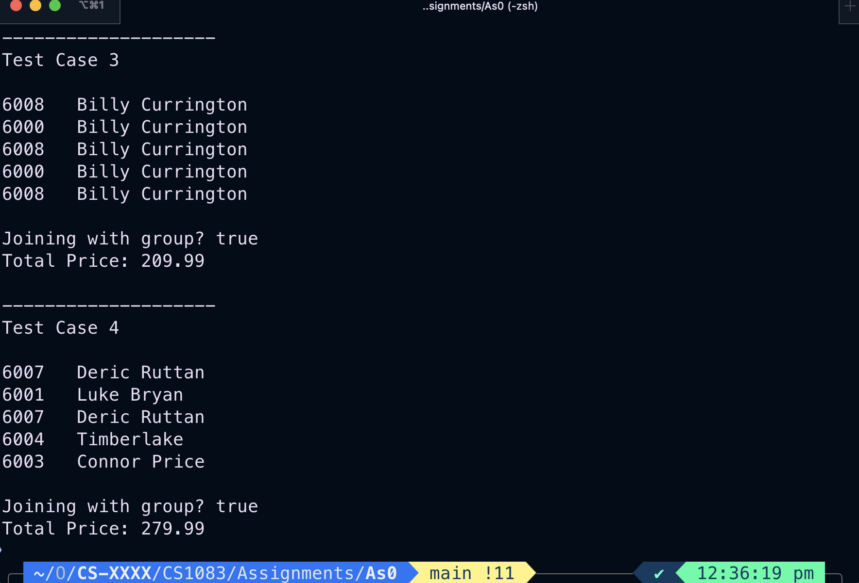

**Test case 3** demonstrates the adding of events by the same artists only and checking the VIP price for it. Also checks if they are coming with a group.

**Test case 4** demonstrates the VIP attendee attending events with different artists. Also checks if they are coming with a group.