**CS1083**

**Assignment #6**

**Daniyal Khan**

**3765942**

**File1.java**  
  
import *java*.*io*.*\**;

*public* *class* file1 {

*public* *static* void *main* (String[] args) {

*try* {

FileInputStream f1 = *new* *FileInputStream*("File1.bin"); // *reads raw byte data from file (serialized)*

ObjectInputStream inStream = *new* *ObjectInputStream*(f1); // *deserializes object or primitive data*

*while* (true) {

*try* {

char c = inStream.*readChar*(); // *reads enough data to make a char*

System.*out*.*print*(c);

}

*catch* (EOFException eofe) {

*break*;

}

}

inStream.*close*();

} *catch* (FileNotFoundException fnfe) {

System.*out*.*println*(fnfe.*getMessage*());

} *catch* (IOException ioe) {

System.*out*.*println*(ioe.*getMessage*());

}

}

}

**File2.java:**  
  
import *java*.*io*.*\**;

*public* *class* file2 {

*public* *static* void *main* (String[] args) {

*try* {

FileInputStream f2 = *new* *FileInputStream*("File2.bin");

ObjectInputStream inStream = *new* *ObjectInputStream*(f2);

*while* (true) {

*try* {

char c = inStream.*readChar*();

*if* (c == 'G') {

c = '7';

}

System.*out*.*print*(c);

} *catch* (EOFException eofe) {

*break*;

}

}

inStream.*close*();

} *catch* (FileNotFoundException fnfe) {

System.*out*.*println*(fnfe.*getMessage*());

} *catch* (IOException ioe) {

System.*out*.*println*(ioe.*getMessage*());

}

}

}

**File3.java:**  
  
import *java*.*io*.*\**;

*public* *class* file3 {

*public* *static* void *main*(String[] args) {

*try* {

FileInputStream f3 = *new* *FileInputStream*("File3.bin");

ObjectInputStream inStream = *new* *ObjectInputStream*(f3);

double latitude = inStream.*readDouble*();

double longitude = inStream.*readDouble*();

System.*out*.*println*("Longitude: " + latitude);

System.*out*.*println*("Latitude: " + longitude);

inStream.*close*();

} *catch* (FileNotFoundException fnfe) {

System.*out*.*println*(fnfe.*getMessage*());

} *catch* (IOException ioe) {

System.*out*.*println*(ioe.*getMessage*());

}

}

}

**Result:**

The meeting will be on *10:00am on Thursday at*

*Longitude: 45.950102*

*Latitude: -66.642087*

**Part 2:**

**Iteration.java:**

import *java*.*util*.*Scanner*;

*public* *class* Iteration {

*public* *static* void *main* (String[] args) {

*try* {

Scanner scan = *new* *Scanner*(System.*in*);

System.*out*.*println*("Enter a integer: ");

int userInput = Integer.*parseInt*(scan.*nextLine*());

long startTime = System.*nanoTime*();

// *System.out.println(loop(userInput));*

System.*out*.*println*(*Recursion*(userInput));

double elapsedSeconds = (double) (System.*nanoTime*() - startTime) / 1000_000_000; // *converting from nanoseconds to seconds*

System.*out*.*println*("Runtime:" + elapsedSeconds);

} *catch* (Exception e) {

System.*out*.*println*(e.*getMessage*());

}

}

*public* *static* int *loop*(int userInput) {

*if* (userInput <= 3) {

*return* userInput;

}

int cs1 = 1;

int cs2 = 2;

int cs3 = 3;

int csn = 0;

*for* (int i = 4; i <= userInput; i++) {

csn = cs3 + cs2 - cs1 + 1;

cs1 = cs2;

cs2 = cs3;

cs3 = csn;

}

*return* csn;

}

/* *Different approach*

*public static int loop2(int n) {*

*int CS[] = new int[n+1];*

*CS[3] = 3;*

*CS[2] = 2;*

*CS[1] = 1;*

*for (int i = 4; i <= n; i++) {*

*CS[i] = CS[i-1] + CS[i-2] - CS[i-3] + 1;*

*}*

*return CS[n];*

*}*

*/

*public* *static* int *Recursion*(int n) {

*if* (n <= 3) {

*return* n;

}

*return* *Recursion*(n-1) + *Recursion*(n-2) - *Recursion*(n-3) + 1;

}

}

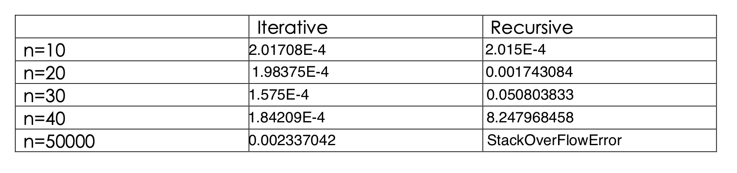

1. With smaller values of n the time difference between the two approaches is negligible.

1. As the value of n increases the time difference increases between the two with Recursive approach being slower. This happens because of all the recursive calls that take up memory in the stack.