**Daniyal Khan  
  
3765942  
  
CS-2263  
  
Assignment 4**

**Source code:**

#*include* <stdio.h>

#*include* <string.h>

#*include* <stdlib.h>

#*include* <math.h>

float ** *dataReadIn*(char *fileName, int *numRows);

float *euclideanDist*(float * row1, float * row2, int length);

#*define* *NUM_OF_MEASUREMENTS* 4

int *main*(int argc, char **argv) {

*if* (argc < 2) {

*printf*("Usage: %s <filename>.txt\n", argv[0]);

*return* 1;

}

int numRows = 0;

float **patientData = *dataReadIn*(argv[1], &numRows);

*if* (patientData == *NULL*) {

*return* 1;

}

float p1, m1, m2, m3, m4;

*printf*("Input patient data: ");

*scanf*("%f, %f, %f, %f, %f", &p1, &m1, &m2, &m3, &m4);

float patientToBeDiagnosed*[]* = {p1, m1, m2, m3, m4};

float dist;

int closetPatientNum = 0;

float smallestDist = *euclideanDist*(patientData[0], patientToBeDiagnosed, *NUM_OF_MEASUREMENTS*);

*for* (int i = 0; i < numRows; i++) {

dist = *euclideanDist*(patientData[i], patientToBeDiagnosed, *NUM_OF_MEASUREMENTS*);

*if* (dist < smallestDist) {

closetPatientNum = i;

smallestDist = dist;

}

}

*printf*("Diagnosis of the closest previous patient: %.0f \n", patientData[closetPatientNum][5]);

*for* (int i = 0; i < numRows; i++) {

*free*(patientData[i]);

}

*free*(patientData);

*return* 0;

}

float *euclideanDist*(float * row1, float * row2, int length) {

float sum = 0.0;

*for* (int i = 1; i <= length; i++) { *// skip the patient number*

float diff = row1[i] - row2[i];

sum += diff * diff;

}

*return* *sqrt*(sum);

}

float ** *dataReadIn*(char * fileName, int * numRows) {

FILE *fptr = *fopen*(fileName, "r");

*if* (fptr == *NULL*) {

*printf*("File not found!\n");

*return* *NULL*;

}

int ch;

*while* ((ch = *fgetc*(fptr)) != *EOF*) { *// count the number of rows*

*if* (ch == '\n') {

(*numRows)++;

}

}

*if* (*numRows == 0) {

*printf*("Not enough data in file!\n");

*return* *NULL*;

}

float ** data = *malloc*((*numRows) * sizeof(float*)); *// allocate space of the heap for the 2D Array*

*if* (data == *NULL*) {

*printf*("Error allocating space!\n");

*return* *NULL*;

}

*for* (int i = 0; i < *numRows; i++) {

data[i] = *malloc*(6 * sizeof(float));

*if* (data[i] == *NULL*) {

*printf*("Error allocating space!\n");

*// freee all previously allocated rows*

*for* (int j = 0; j < i; j++) {

*free*(data[j]);

}

*free*(data);

*return* *NULL*;

}

}

*rewind*(fptr); *// reset file pointer to the beginning*

*for* (int i = 0; i < *numRows; i++) {

*fscanf*(fptr, "%f,%f,%f,%f,%f,%f", &data[i][0], &data[i][1], &data[i][2], &data[i][3], &data[i][4], &data[i][5]);

}

*fclose*(fptr);

*return* data;

}

Makefile:

GCC = gcc

CFLAGS = -g -Wall -Wshadow -lm

*all*: patient_predict

*patient_predict*: patient_predict.o

$(GCC) $(CFLAGS) patient_predict.o -o patient_predict

*patient_predict.o*: patient_predict.c

$(GCC) $(CFLAGS) -c patient_predict.c

*test0*: patient_predict

./patient_predict MedData.txt < Test/input0.txt > Test/output0.txt

*test1*: patient_predict

./patient_predict MedData.txt < Test/input1.txt > Test/output1.txt

*test2*: patient_predict

./patient_predict MedData.txt < Test/input2.txt > Test/output2.txt

*tests*: test0 test1 test2

*check0*: test0

grep "Diagnosis of the closest previous patient: 0" Test/output0.txt

*check1*: test1

grep "Diagnosis of the closest previous patient: 1" Test/output1.txt

*check2*: test2

grep "Diagnosis of the closest previous patient: 2" Test/output2.txt

*check*: check0 check1 check2

*@*echo "All tests passed!"

*clean*:

rm -f *.o patient_predict

**Testing:**

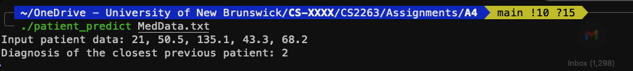

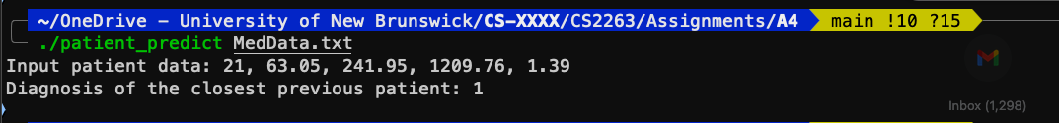

Testing with MakeFile:  
  
Inputs used:

1. 21, 58.01695695, 237.026522, 1185.13261, 1.706318785
2. 22, 63.04762625, 241.9527672, 1209.763836, 1.394672244
3. 23, 85.3639715, 190.24415, 951.2207501, 0.411893893