Daniyal Khan
3765942
CS2263
Lab 1

Exercise 1:
class Exercise1 {
public static void main (String[] args) {
System.out.println("Hello World\n");
}
}

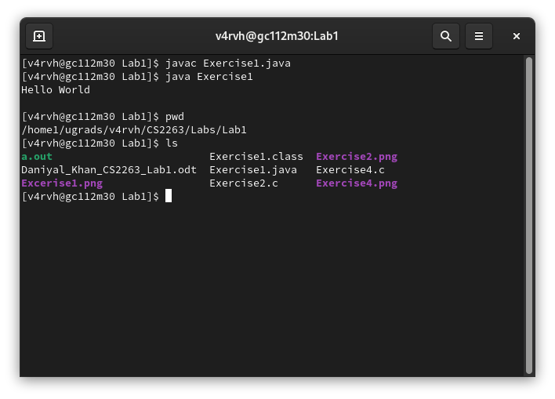

Exercise 2:
#include <stdio.h>

int main() {
printf("Hello World\n");
return 0;
}

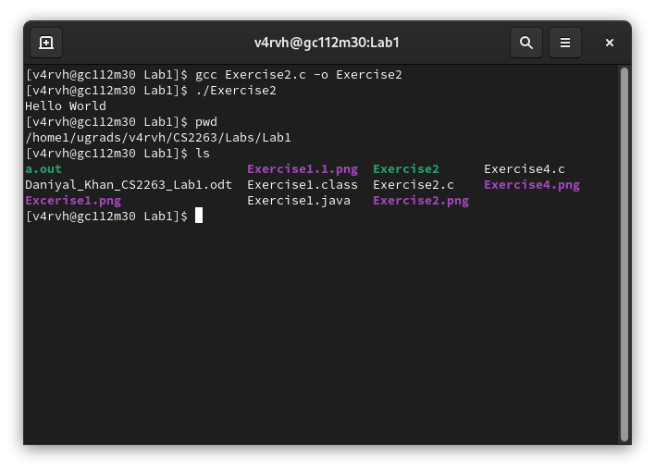

Exercise 3:
The java compilation model takes human written source code as input and emits not machine code but something called “byte code”. Byte code cannot be directly executed on a machine. Instead, it needs to be translated once again by another compiler to machine code. Byte code can run on any platform that has either a byte code compiler or virtual machine written for it. While in C language there is not such protability implied by the machine code.

To answer the question, javac compiles the code similar to the gcc command for c and c++. But the difference is that gcc produces an executable file whereas javac produces a bytecode which we run by the java command.

Referenced from this question on stackOverFlow:
https://stackoverflow.com/questions/8297832/how-does-c-differ-from-javas-compilation-model

Exercise 4:
#include <stdio.h>
#include <stdlib.h>

void printFib(int n);

int main() {
printFib(10);
putchar('\n');
return EXIT_SUCCESS;
}

void printFib(int n) {
int a = 0, b = 1, temp;
if (n <= 0) {
return;
}
printf("%d ", a);
for (int i = 1; i < n; i++) {
printf("%d ", b);
temp = a + b;
a = b;
b = temp;
}
}

