Daniyal Khan

3765942
CS2263
Lab 5

Exercise 1:
1.1:

#include <stdio.h>
#include <stdlib.h>

void dummy_frame()
{
return;
}

int main(int argc, char **argv)
{
int i;
int a[] = {1, 2, 3, 4, 5};

for (i = 0; i < 5; i++)
printf("main: a[%d] = %d, address = %p\n", i, a[i], (void *)&a[i]);

dummy_frame();
return EXIT_SUCCESS;
}

Backtrace:
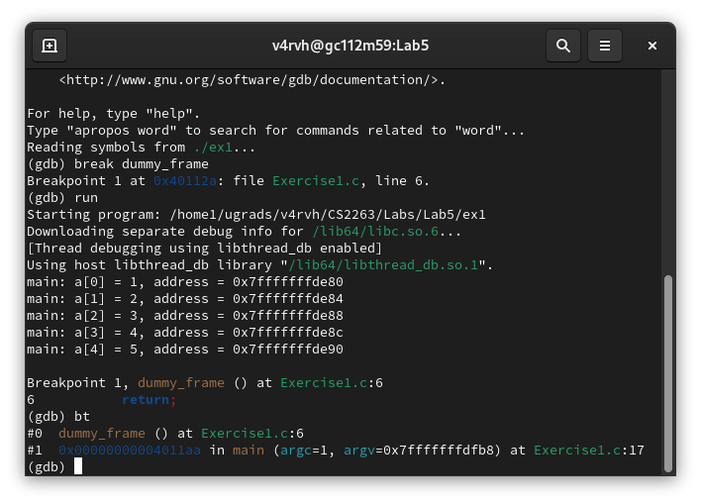

There are 2 frames on the memory stack.

Frame 0 info:
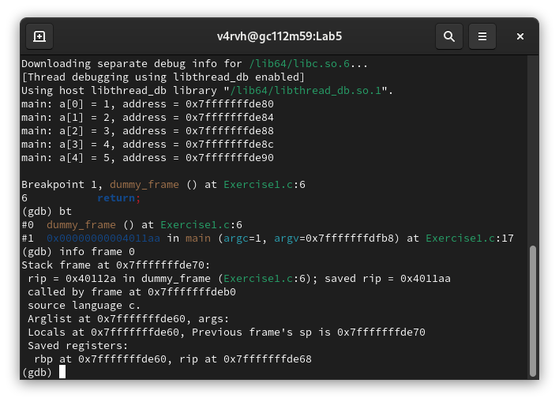

main()'s stack frame lies above dummy_frame()'s (since stack grows downward).
So the boundaries for main() are from:
0x7fffffffde70 (top of main frame)
up to the called by frame at (0x7fffffffdeb0)

Looking at the addresses of the array elements, they do fall inside the range of the main function frame as in the screenshot.

1.2:
#include <stdio.h>
#include <stdlib.h>

void dummy_frame()
{
return;
}

int main(int argc, char **argv)
{
int i;
int *a = (int *)malloc(5 * sizeof(int)); // Heap allocation

if (a == NULL) {
fprintf(stderr, "Memory allocation failed\n");
return EXIT_FAILURE;
}

for (i = 0; i < 5; i++) {
a[i] = i + 1;
printf("main: a[%d] = %d, address = %p\n", i, a[i], (void *)&a[i]);
}

dummy_frame();

free(a); // Clean up
return EXIT_SUCCESS;
}

Backtrace:
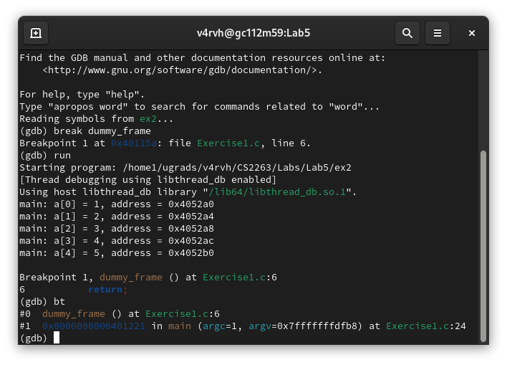

There are 2 frames on the memory stack.

Info of frame 0:
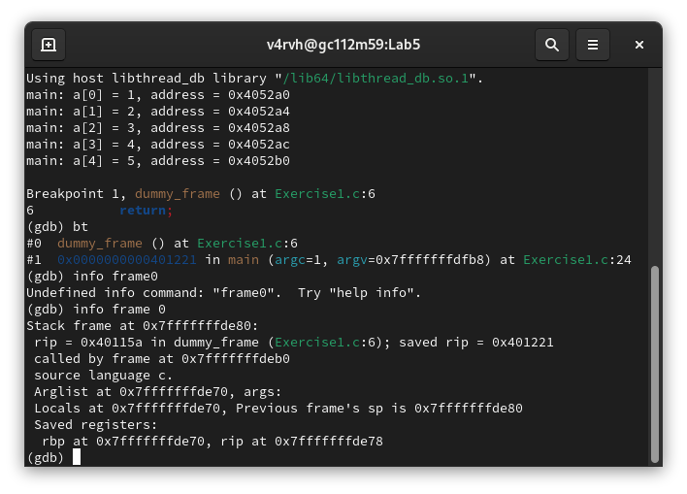
This means main()’s frame lies between 0x7fffffffde80 and 0x7ffffffffdeb0.

No the addresses of the array elements are not within the stack frame of main(). They are located in the heap, as they were allocated using malloc().

Exercise 2:
2.1:
#include <stdio.h>
#include <stdlib.h>

void dummy_frame() {
return;
}

int main(int argc, char **argv) {
int i;
int *a;

a = (int *)malloc(5 * sizeof(int));
if (a == NULL) {
fprintf(stderr, "Initial malloc failed.\n");
return EXIT_FAILURE;
}

printf("Original array (5 elements):\n");
for (i = 0; i < 5; i++) {
a[i] = i + 1;
printf("a[%d] = %d, address = %p\n", i, a[i], (void *)&a[i]);
}

int *temp = (int *)realloc(a, 8 * sizeof(int));
if (temp == NULL) {
fprintf(stderr, "Realloc failed.\n");
free(a); // Free original memory if realloc fails
return EXIT_FAILURE;
}
a = temp;

for (i = 5; i < 8; i++) {
a[i] = (i + 1) * 10;
}

printf("Original array (5 elements):\n");
for (i = 0; i < 8; i++) {
printf("a[%d] = %d, address = %p\n", i, a[i], (void *)&a[i]);
}

dummy_frame();
free(a);
return EXIT_SUCCESS;
}

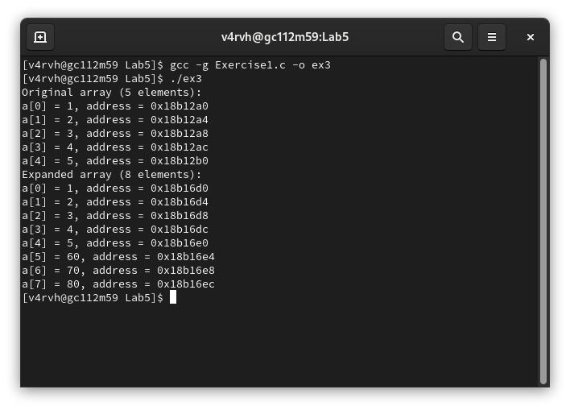

As in the terminal screenshot the address changed, the array was moved in memory

Exercise 3:

3.1:

#include <stdio.h>
#include <stdlib.h>

void dummy_frame() {
return;
}

int main(int argc, char **argv) {
int i;
int *a;

a = (int *)malloc(5 * sizeof(int));
if (a == NULL) {
fprintf(stderr, "Initial malloc failed.\n");
return EXIT_FAILURE;
}

printf("Original array (5 elements):\n");
for (i = 0; i < 5; i++) {
a[i] = i + 1;
printf("a[%d] = %d, address = %p\n", i, a[i], (void *)&a[i]);
}

int *temp = (int *)realloc(a, 8 * sizeof(int));
if (temp == NULL) {
fprintf(stderr, "Realloc failed.\n");
free(a); // Free original memory if realloc fails
return EXIT_FAILURE;
}
a = temp;

for (i = 5; i < 8; i++) {
a[i] = (i + 1) * 10;
}

printf("Expanded array (8 elements):\n");
for (i = 0; i < 8; i++) {
printf("a[%d] = %d, address = %p\n", i, a[i], (void *)&a[i]);
}

dummy_frame();
return EXIT_SUCCESS;
}

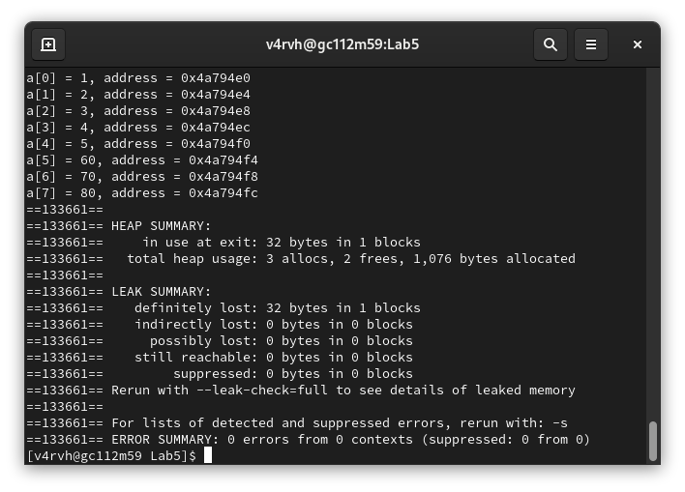

There is a memory leak as in the screenshot.

3.2:

#include <stdio.h>
#include <stdlib.h>

void dummy_frame() {
return;
}

int main(int argc, char **argv) {
int i;
int *a;

a = (int *)malloc(5 * sizeof(int));
if (a == NULL) {
fprintf(stderr, "Initial malloc failed.\n");
return EXIT_FAILURE;
}

printf("Original array (5 elements):\n");
for (i = 0; i < 5; i++) {
a[i] = i + 1;
printf("a[%d] = %d, address = %p\n", i, a[i], (void *)&a[i]);
}

int *temp = (int *)realloc(a, 8 * sizeof(int));
if (temp == NULL) {
fprintf(stderr, "Realloc failed.\n");
free(a); // Free original memory if realloc fails
return EXIT_FAILURE;
}
a = temp;

for (i = 5; i < 8; i++) {
a[i] = (i + 1) * 10;
}

printf("Expanded array (8 elements):\n");
for (i = 0; i < 8; i++) {
printf("a[%d] = %d, address = %p\n", i, a[i], (void *)&a[i]);
}

dummy_frame();
free(a);
return EXIT_SUCCESS;
}

