Pump - Platform Unlimited Media Player

A media player that will play/record sound and video.
Loop
Status Display

Volume

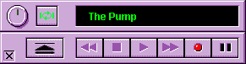

Exit
Load
Review
Play
Cue
Record
Pause
Stop

JMF must be installed.
It should load and play any media file supported by JMF (virtually anything).
It will record sound & video (if a card is installed) saving as .avi, otherwise sound only saving as .mp3.
The volume control works by clicking on it and moving mouse vertically up/down.

The app is built around 5 Java files :

Pump.java - main() method and main window
GUI.java - user interface
Knob.java - volume knob component
MediaBox.java - control class (has methods like loadFile(), rew() etc.)
StateMonitor.java - manages state changes of JMF Player/Processor

Button icons etc. are in IMAGES subdirectory.

