Distributing SPARQL Queries across remote stores using data exemplars

Context : a client on the Web, communicating with remote triplestore using SPARQL (over HTTP)

Purpose : to allow querying (and updates later) across multiple stores. (Scale is more of a priority than speed - later exploit caching somehow)

The Basic Problem : moving from A to B

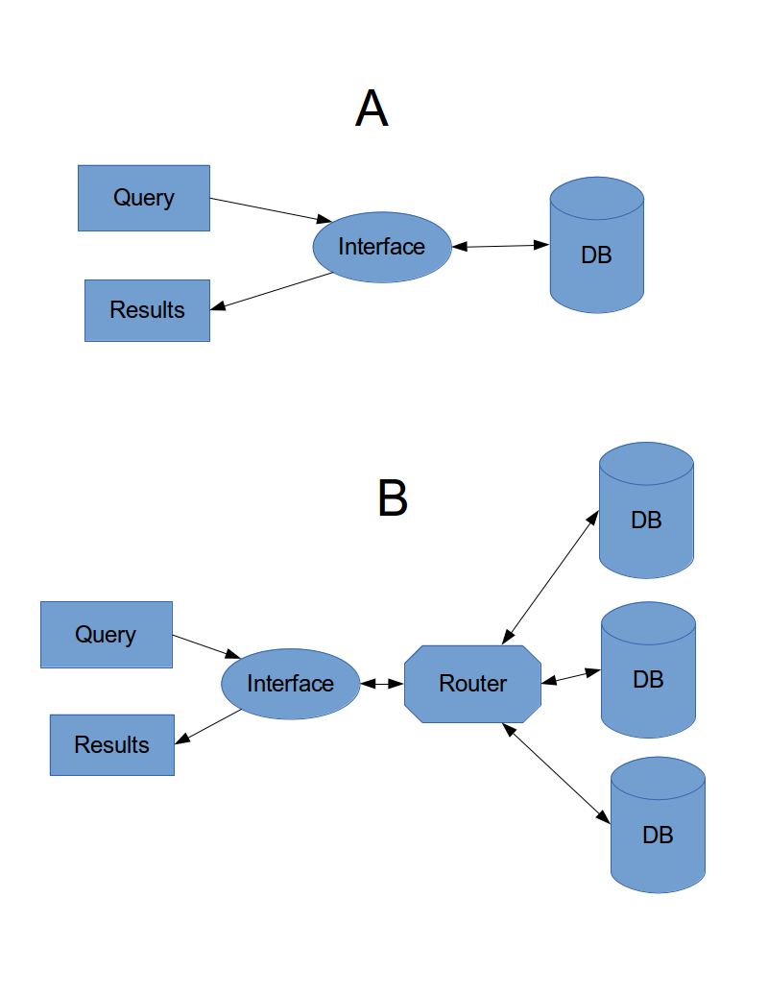

Proposed Solution :

Router contains two relatively small local stores:
- remote store examplars (in-memory, file-backed)
- results buffer (in-memory)

examplars store is initialized when a new remote store is linked into the system by adding a small graph containing one triple for each property (chain) used by the remote store

Runtime:
incoming query is rewritten to an ASK
applied to local store
for true results
original query is forwarded to remote stores as a CONSTRUCT
individual results merged in results buffer
original query reapplied to results buffer
final results returned

maybe hard bit:
query rewriting
especially when query can be fulfilled across multiple stores, but not individually

Related/Later
similar technique could be used as part of store distribution system. E.g. say a given (R/W) store contains datestamped news pieces. Periodically the pieces are moved to a second (R) store. Exemplar data contains first and last dated pieces, test ASK query is FILTERed per date

