Project 1 – Suicide Rates

Team: Daniel Ardoin, John Kozitza, and Mariko Falke

Our team’s focus was to identify suicide trends in California over time. We were also motivated to understand whether or not there were observable differences between demographics or region. Various data sources were reviewed before conducting cleanup and analysis. At least 15 data sets from Data.gov as well as other non-profit suicide organizations and specific California programs were encountered. Most of these did not represent complete data sets that would answer our questions or were not able to be merged because of the differing data sources and an inability to identify a common strata. Let’s Get Healthy California (LGHC), a task force spearheaded by the California Health and Human Services Agency and the California Department of Public Health, provided the most complete data set that would answer our questions with reasonably credible sourcing. This data set was jumbled with annual California data collection as well as year range data collection from separate counties intermingled with data collection based on sex. This mixed data set though complete, required heavy cleanup to identify the trends and answer our questions.

**Question 1: What are the common trends of suicide in California?**

Generally, California suicide rates increase over time. There was a slight dip from year ranges 2000-2002 to 2003-2005. The most dramatic increase was observed from year range 2006-2008 to 2009-2011. This information correlates to a time period of the post-2008 economic crash as well as the aftermath of a record-breaking election year.

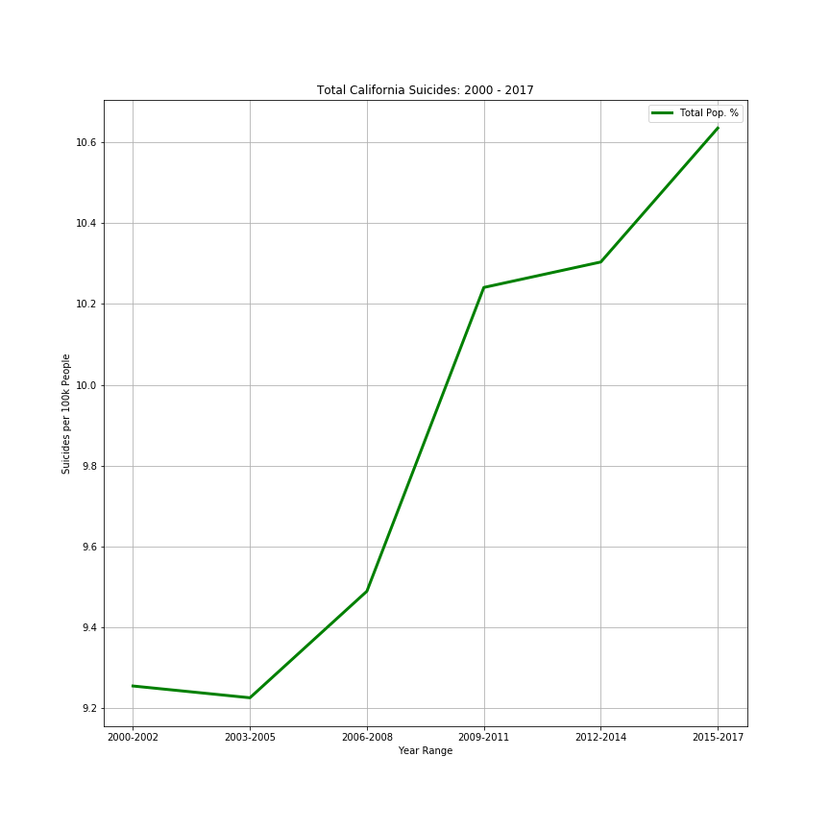

**Question 2: Do certain demographics exhibit higher rates?**

Yes, white males have significantly higher rates of suicide in comparison to any other demographic. Interestingly, the trend for females increased from year range 2000-2002 to 2003-2005 which counters the general California trend during this same time period. This period is also the only time in which the rates for males decrease. American Indian/Native Alaskans (AINA) have the second highest suicide rate and have increased over time. Hispanic, Black, and Asian groups are statistically very stable, with little variation over time.

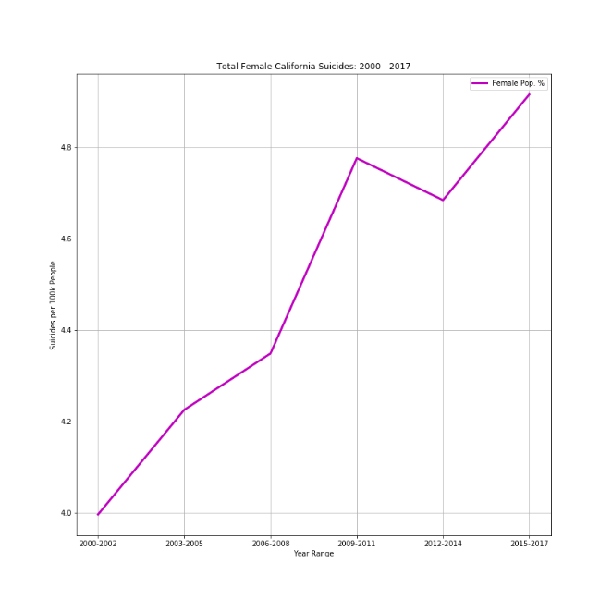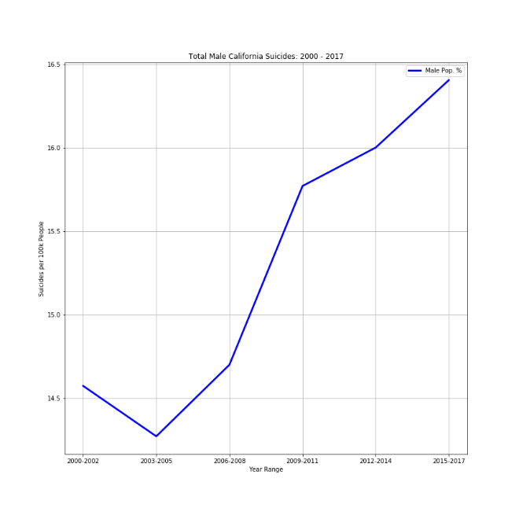

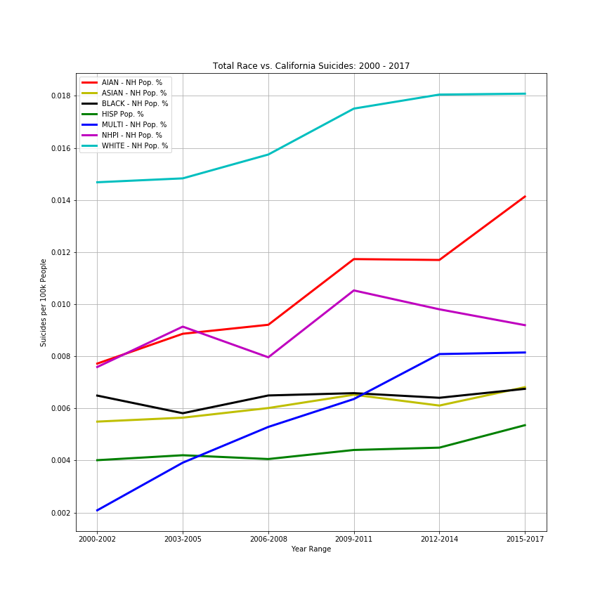

**Question 3: Do certain regional locations exhibit higher rates?**

Identifying trends in regional location was difficult to determine due to a lack of data sets in some year ranges. For example, Trinity county appears to set the bar for highest rates of suicide; however, in year ranges 2000-2002, 2009-2011, and 2012-2014 no data was reported for this county. This somewhat skews our dataset. Generally, we have determined that areas with high isolation and rurality have higher suicide rates. The area with the highest suicide rates seems to primarily focused in the northernmost portion of California.

