

Carl von Ossietzky Universität Oldenburg
Faculty V – Mathematics and Science
Institute for Chemistry and Biology of the Marine Environment (ICBM)
Master’s programme Microbiology (M.Sc.)
MASTER’S THESIS
Resolving Starvation Responses of Photosymbiotic Holobionts
submitted by
Danjel Kola
Matriculation number: 654901
First examiner: Dr. Nils Rädecker
Second examiner: Prof. Dr. Sarahi Garcia
Oldenburg, [DATE OF SUBMISSION]
Table of contents
Abstract i
1. Introduction 1
1.1 Photosymbiosis sustains animal life in nutrient-poor environments 1
1.2 The partnership is vulnerable, and its loss is costly 1
1.3 Nitrogen limitation as the control point 1
1.4 Feeding as the holobiont's nitrogen source 1
1.5 Exaiptasia as a model, and the limits of a single model 1
1.6 Waminoa as an independent comparison 1
1.7 Aims and hypotheses 1
2. Materials and Methods 1
2.1 Biological material and maintenance 1
2.2 Symbiont cell density 1
2.3 Photosynthetic Efficiency (Fv/Fm) 1
2.4 Net photosynthetic oxygen production 1
2.5 Host Protein Content 1
2.6 Ammonium Uptake 1
2.7 DNA Extraction 1
2.8 16S rRNA Amplicon Sequencing to Characterize the Bacterial Community 1
2.9 Statistical analysis 1
3. Results 1
3.1 Physiological responses to feeding treatment 1
3.2 Bacterial communities differed between the hosts; a starvation effect was detected only in Exaiptasia 1
4. Discussion 1
4.1 Feeding-dependent regulation is a property of the host 1
4.2 In Exaiptasia, carbon supply and nitrogen capture fail together 1
4.3 Nitrogen-based host control is not evident in Waminoa on this timescale 1
4.4 What might limit the Waminoa symbiosis instead? 1
4.5 Bacterial communities: tentative signals under severe technical limits 1
4.6 Future work 1
5. Conclusion 1
References 1
Appendix A. Details of the 16S rRNA amplicon analysis 1
Appendix C. Code, data and supplementary material 1
A.1 Primer coverage 1
A.2 Primer dimer 1
A.3 Contaminant removal 1
A.4 Sequencing depth 1
A.5 Sensitivity analyses 1

List of figures
Figure 1. BCA protein assay calibration curve. 1
Figure 2. Ammonium (NH₄⁺) calibration curve. 1
Figure 3. The two study hosts belong to distant branches of the animal tree. 1
Figure 4. Total host protein content declines under starvation in both hosts. 1
Figure 5. Symbiont number per animal declines under starvation in Exaiptasia but not in Waminoa sp. 1
Figure 6. Symbiont density normalized to host protein declines under starvation in Exaiptasia but not in Waminoa sp. 1
Figure 7. Net oxygen production declines in both hosts, more steeply in Exaiptasia. 1
Figure 8. Net oxygen production per unit host biomass declines only in Exaiptasia. 1
Figure 9. Photosynthetic efficiency declines in Exaiptasia only. 1
Figure 10. Ammonium uptake collapses in Exaiptasia but is maintained in Waminoa sp. 1
Figure 11. No change in oxygen production per symbiont cell was detected in either host. 1
Figure 12. Bacterial communities differed between the hosts; a starvation effect was detected only in Exaiptasia. 1
List of abbreviations
ANCOM-BC2 analysis of compositions of microbiomes with bias correction 2
ANOVA analysis of variance
ASV amplicon sequence variant
BCA bicinchoninic acid
BSA bovine serum albumin
Fv/Fm maximum quantum yield of photosystem II
H1, H2 hypotheses of conserved and lineage-specific regulation (Section 1.7)
NEGCON negative control (extraction blank)
PAM pulse-amplitude-modulated (fluorometry)
PCoA principal coordinates analysis
PCR polymerase chain reaction
PERMANOVA permutational multivariate analysis of variance
PSU practical salinity units
SD standard deviation

Abstract
Photosymbiosis between marine invertebrates and endosymbiotic microalgae underpins the productivity of nutrient-poor tropical waters. Such a partnership is stable only if the host animal keeps its algal partners in check: algae that multiply without restraint would draw on the host’s resources and the partnership would break down. The relationship is maintained by the host’s ability to regulate symbiont growth by restricting its access to limiting nutrients. In cnidarians this nutrient is nitrogen: the host uses algal-translocated photosynthetic carbon to assimilate ammonium, so that waste nitrogen released by heterotrophic feeding is withheld from the symbiont, holding the algal population in check. However, our understanding of this metabolic control is largely limited to this single phylum, and it remains unclear whether the mechanism is a general property of animal–algal symbiosis.
This thesis compared the starvation response of two phylogenetically distant photosymbiotic hosts, the sea anemone Exaiptasia diaphana (clonal line H2) and the acoel flatworm Waminoa sp., maintained under fed or starved conditions and assayed for symbiont density, net photosynthetic oxygen production, ammonium uptake, host protein content, photosynthetic efficiency (Fv/Fm) and bacterial community composition.
In two experiments, both host species were starved until a comparable biomass decline was observed: soluble host protein declined by 39.7 % in Exaiptasia over five months and by 45 % in Waminoa over five weeks. While starvation caused a pronounced symbiotic response in Exaiptasia, the symbiosis in Waminoa remained remarkably stable. Exaiptasia symbiont density declined by 69 %, while symbiont density in Waminoa was unchanged. In line with this, only starved Exaiptasia showed a pronounced decline in net photosynthesis and ammonium uptake respectively.
Taken together, our results point to contrasting starvation responses in distinct host-symbiont pairings. Cnidarian symbionts may be more reliant on host-derived metabolites for their nutrition. In contrast, high sustained ammonium uptake by starved Waminoa holobionts, indicates that algal symbionts were able to acquire sufficient nutrients to sustain stable symbiont densities. If the Waminoa symbiont population is not held in check through host nitrogen limitation, this raises the question which regulatory processes, e.g. phosphorous limitation or digestion, maintain this symbiosis.

1. Introduction
1.1 Photosymbiosis sustains animal life in nutrient-poor environments
Tropical surface waters are among the most oligotrophic environments in the ocean, yet the reefs found there are among the most productive ecosystems on Earth. This phenomenon is commonly referred to as Darwin’s coral reef paradox (de Goeij et al., 2013; Muscatine & Porter, 1977). Photosymbiosis, i.e., the symbiosis between heterotrophic host and photosynthetic microalgae, resolves this paradox through a simple nutritional exchange: the algal symbiont fixes carbon through photosynthesis and translocates a part of it to the host, while the host provides the symbiont with inorganic nutrients, most importantly carbon dioxide, and a stable, safe light exposed environment (Cui et al., 2023; Davy et al., 2012; Weis et al., 2008). One of these associations is the one between cnidarians and dinoflagellates of the family Symbiodiniaceae (LaJeunesse et al., 2018). They form the biological and structural foundation of coral reefs making these ecosystems thrive in nutrient-poor waters (Rädecker et al., 2015).
Not every member of either partner group takes part in this association. Cnidarians, which include corals, sea anemones, jellyfish and hydroids, are a large group of mainly predatory animals, and many species, among them the corals of deep and dark waters, carry no algae at all. Dinoflagellates are likewise a diverse group of mostly free-living protists, and only some lineages live in symbiosis with animals. The best known are the Symbiodiniaceae, which associate with reef-building corals and many other cnidarians (LaJeunesse et al., 2018), but other dinoflagellates, such as members of the genus Amphidinium, form symbioses with hosts outside the Cnidaria, including acoel flatworms (Barneah et al., 2007b).
1.2 The partnership is vulnerable, and its loss is costly
This remarkable, functional relationship is vulnerable to environmental stressors, for example heat. Today the breakdown of the symbiosis under warming, known as coral bleaching, is a big threat to reefs worldwide (Hughes et al., 2017). What is lost when this partnership fails can be stated concretely. Coral reefs scatter an average of 97% of incident wave energy, with reef crests alone accounting for 86% of that attenuation, and on this basis 100 million or more people receive coastal protection from reefs or would bear the cost of replacing it (Ferrario et al., 2014). Global coverage of living coral has declined by half since the 1950s, catch per unit effort in reef-associated fisheries has fallen by 60% since 1950, and at least 63% of coral-reef-associated biodiversity has declined alongside the loss of coral cover (Eddy et al., 2021). Understanding how the partnership is held together is therefore a prerequisite for understanding how it comes apart.
1.3 Nitrogen limitation as the control point
A photosymbiotic partnership is best described not as a fixed mutualistic arrangement but as a regulated nutrient economy in which the interests of host and symbiont are only partially aligned (Morris et al., 2019). Its stability depends on the host retaining control over symbiont proliferation, and in the cnidarian–dinoflagellate association nitrogen availability is the currency of that control (Rädecker et al., 2015). In a functional cnidarian–dinoflagellate symbiosis, the host restricts the nitrogen supply reaching its algae, which prevents the symbiont population from overgrowing the host (Xiang et al., 2020). Because host and symbiont draw on the same pool of assimilated nitrogen, the two compartments are in partial competition for it, and stable-isotope labelling combined with single-cell imaging has resolved that competition directly: the host assimilates ammonium using photosynthetically derived carbon and thereby withholds nitrogen from the symbiont (Rädecker et al., 2023). The resulting arrangement is particularly sensitive to environmental change, and heat stress destabilises it (Rädecker et al., 2021). When regulation fails under thermal stress or altered external nutrient supply, the interaction can shift from mutualism towards parasitism and end in symbiont loss, that is, in bleaching (Wiedenmann et al., 2013). Because the association is fundamentally a nutritional one, the feeding status of the host offers a direct and experimentally tractable means of disrupting it.
1.4 Feeding as the holobiont's nitrogen source
Symbiotic cnidarians are mixotrophs, obtaining energy and nutrients both from symbiont photosynthesis (autotrophy) and from the capture of prey (heterotrophy) (Houlbrèque & Ferrier-Pagès, 2009). Heterotrophic feeding supplies nitrogen and other nutrients that reduce the host’s dependence on translocated photosynthate, and increased heterotrophy has been linked to resilience and recovery following bleaching (Grottoli et al., 2006). Removing food removes this external nutrient supply and forces the holobiont to rely on its internal, symbiont-derived economy. The consequence of prolonged food deprivation in a cnidarian model has been documented directly: Rädecker and Meibom (2023) maintained Exaiptasia diaphana without heterotrophic food for approximately one year. The anemones remained viable, sustained by increased photosynthetic activity and more efficient carbon translocation, but lost about 85 % of their biomass. Heterotrophy is therefore not required for survival in this system but is required for growth; lacking an external nitrogen source, the holobiont settles into a reduced, nutrient-conserving state.
1.5 Exaiptasia as a model, and the limits of a single model
The sea anemone Exaiptasia diaphana — hereafter Exaiptasia — is one of the most widely used laboratory models for the mechanistic study of cnidarian photosymbiosis (Weis et al., 2008; Rädecker et al., 2018). It is small, clonal and fast-growing; it can be rendered symbiont-free (aposymbiotic) and re-infected at will (Xiang et al., 2013), and genome assemblies are available both for the host (Baumgarten et al., 2015) and for its symbionts (Aranda et al., 2016). Much of what is known about nutrient exchange, symbiont regulation, and the cellular basis of symbiosis breakdown in cnidarians has been established in this system (Rädecker et al., 2018).
The strategies uncovered in Exaiptasia may, however, be specific to cnidarian physiology and ecology, or they may reflect a general principle by which marine animals manage photosynthetic symbionts. Host regulation of symbiont density through nutrient limitation is not unique to the anthozoan model. Another cnidarian, the freshwater hydrozoan Hydra viridissima, shows a metabolic co-dependence between host and alga in which the host controls the nutrients reaching the symbiont (Hamada et al., 2018). Beyond the Cnidaria, the nitrogen supply to the endosymbiotic Chlorella of the ciliate Paramecium bursaria is host-mediated (Albers et al., 1982). In giant clams, experimental nutrient enrichment alters the growth of the symbiotic partners, indicating that the symbionts are nutrient-limited in hospite, i.e. while living within the host (Belda et al., 1993). What has not been done is a single experiment in which feeding-dependent regulation is compared across phyla under one design, with both hosts exposed to the same treatment and assayed with the same parameters. Such a comparison requires two phylogenetically distant hosts that both associate with dinoflagellate symbionts.
1.6 Waminoa as an independent comparison
Photosymbiosis with dinoflagellates is not a cnidarian invention. The acoel flatworm Waminoa sp. maintains such an association with an entirely different body plan: no gastric cavity, no gastrodermis, and an evolutionary origin of the symbiosis independent of the cnidarian one (Abalde & Jondelius, 2025; Barneah et al., 2007a). Waminoa are small, dorsoventrally flattened acoels that live as ectosymbionts on the surfaces of scleractinian corals and other anthozoans throughout the Indo-Pacific and the Red Sea (Haapkylä et al., 2009). Waminoa therefore represents an independent evolutionary solution to the problem Exaiptasia solves, and its physiology is almost entirely uncharacterised. Comparing the two brings a natural experiment: both hosts exchange shelter and inorganic nutrients for fixed carbon from dinoflagellate symbionts, but they do so with different body plans and in different ecological settings. The symbiont partners are not equivalent, however. Microscopy in our laboratory indicates that the Waminoa used here carry dinoflagellates of the genus Amphidinium, which is not a member of the Symbiodiniaceae, so the comparison is between two dinoflagellate-bearing hosts rather than between two hosts of the same symbiont lineage.
1.7 Aims and hypotheses
Almost everything known about host control of photosymbiosis is known from cnidarians. This thesis asks whether the nitrogen-limitation model built in that phylum describes animal–dinoflagellate photosymbiosis generally or describes one lineage’s solution to a problem that other lineages solve with a different limiting nutrient or with a different mechanism altogether. Two phylogenetically distant hosts, both carrying dinoflagellate symbionts, i.e. the sea anemone Exaiptasia diaphana (clonal line H2) and the acoel flatworm Waminoa sp., were held fed or starved under identical conditions and assayed with a single set of measurements. Food deprivation removes the heterotrophic arm of mixotrophic nutrition and forces the holobiont onto the autotrophic one; how far an association can be pushed in that direction before it is restructured is a direct measure of how tightly, and by which nutrient, the host holds it.
Two hypotheses were distinguished by whether that response is shared between the two associations. Under H1 (conserved regulation), feeding-dependent regulation is a general property of animal–dinoflagellate photosymbiosis: both holobionts should move in the same direction under starvation, and no organism × treatment interaction should be detected. Under H2 (lineage-specific regulation), regulation is a property of the host lineage and its physiology: the two associations should diverge, producing a significant organism × treatment interaction.
In parallel, the bacterial communities of both hosts were characterized as an exploratory question. Photosymbiotic animals also associate with bacteria that take part in holobiont nitrogen cycling (Rädecker et al., 2015), and in Exaiptasia the bacterial community differs between the symbiotic and the aposymbiotic state (Röthig et al., 2016). Whether food removal restructures these communities has not been tested in either host, so no directional prediction was made. Answering the question with 16S rRNA amplicon sequencing is technically demanding in small animals: DNA yields are low, organelle and chloroplast-like sequences can dominate amplicon libraries (Bodenhausen et al., 2013), and in low-biomass samples DNA from reagents and laboratory handling can account for a large share of the sequences (Eisenhofer et al., 2019; Salter et al., 2014). The choice of primers and the treatment of contaminants are therefore described in Section 2.8 and Appendix A and evaluated in Section 4.5.
2. Materials and Methods
2.1 Biological material and maintenance
Experiments were performed on two photosymbiotic model organisms: the sea anemone Exaiptasia diaphana, clonal line H2 (Xiang et al., 2013), and the acoel flatworm Waminoa sp. Waminoa were obtained from Aqua Design, Oldenburg, Germany, and identified to genus following Barneah et al. (2007a). The symbionts of this Waminoa culture were identified as Amphidinium by light microscopy and were not genotyped.
Both species were maintained in boxes containing approximately 500 mL of artificial seawater at a salinity of 35 PSU and 25 °C under a 12:12 h light:dark cycle at 70 µmol photons m⁻² s⁻¹. Each combination of host and treatment was kept in its own box, so that fed and starved animals of each species were housed separately (four boxes in total). Fed individuals were offered freshly hatched Artemia salina nauplii twice per week, the feeding protocol established for Exaiptasia and applied to Waminoa. Twice per week, the seawater was changed and accumulated biofilm was removed from all inner surfaces of the boxes.
To test the effect of food deprivation, starved individuals received no food at any point during the experimental period. Starved Exaiptasia had been kept without food for approximately five months at the time of sampling, which established a chronic starvation state; this duration was chosen on the basis of previous heat-stress experiments, in which Exaiptasia tolerated periods beyond five months without unacceptable mortality. Waminoa were starved for a total of five weeks and the measurements reported here were taken at the end of that period. This shorter duration was chosen because prior heat-stress trials in this laboratory indicated that Waminoa tolerates prolonged stress less well than Exaiptasia, and a starvation period comparable to that used for Exaiptasia was judged to carry an unacceptable risk of mortality. The two durations were therefore set by what each host tolerates and not by a common endpoint; the resulting loss of soluble protein was nevertheless similar in the two hosts. The experiment therefore comprised four treatment combinations: fed Exaiptasia, starved Exaiptasia, fed Waminoa and starved Waminoa. Because the two hosts were starved for different lengths of time, starvation duration is confounded with host identity; this constraint is returned to Section 4.1.
2.2 Symbiont cell density
To determine symbiont cell density, each individual of both species (n = 5 per treatment for Exaiptasia and n = 6 for Waminoa) was homogenized in 500 µL of sterile-filtered seawater with a Polytron PT 1200E homogenizer. A 200 µL aliquot of homogenate was reserved for DNA extraction and bacterial community analysis. The remaining homogenate was centrifuged at 3000 × g for 4 min to pellet symbiont cells and the supernatant retained for protein quantification (Section 2.5). Symbiont cells are pelleted at this speed, so the supernatant contains the soluble protein fraction of the host homogenate, which was used as a proxy for host biomass; insoluble and membrane-bound protein and the protein of the pelleted symbiont cells are not included. The pellet was resuspended in 500 µL of filtered seawater and symbiont cells were counted on a DeNovix CellDrop FLi dual-fluorescence automated cell counter (DeNovix Inc., Wilmington, DE, USA). Cells were detected by chlorophyll a autofluorescence in the red channel (~680 nm emission); no nucleic-acid stain was added. Counting parameters were held constant across all samples: chamber height 400 µm, dilution factor 1, size gating 10–30 µm, red fluorescence threshold 10, roundness 1, with small-cell and irregular-cell modes disabled. For each individual, three separate 40 µL aliquots of the resuspended pellet were counted and the values averaged, to account for variation in loading and in cell distribution within the counting chamber. Symbiont abundance is reported both per individual (cells animal⁻¹) and normalized to host soluble protein (cells µg⁻¹ protein), the latter to permit comparison between hosts of different body size.
2.3 Photosynthetic Efficiency (Fv/Fm)
The maximum quantum yield of photosystem II (Fv/Fm) was measured as an index of symbiont photosystem condition using pulse-amplitude-modulated (PAM) fluorometry (Junior-PAM, Walz GmbH, Effeltrich, Germany; Schreiber, 2004; Ralph & Gademann, 2005). Individuals were dark-adapted for 12 h before measurement to allow full oxidation of the photosynthetic reaction centres. A saturating light pulse was then applied and Fv/Fm was calculated as (Fm − F0)/Fm, where Fm is maximum and F0 minimum fluorescence. Measuring light intensity was set to 12 at a frequency of 3; the saturating pulse had intensity 8 and a duration of 0.6 s. Gain and damping were set to 2 and 3 respectively and held constant across all measurements. In cnidarian associations, Fv/Fm values in the region of 0.65 are typical of unstressed symbionts, whereas values declining below this range accompany photosystem II damage under stress (Warner et al., 1996). In both hosts, Fv/Fm was measured at the end of the starvation period (n = 5 per treatment for Exaiptasia and n = 6 per treatment for Waminoa).
2.4 Net photosynthetic oxygen production
Net photosynthetic oxygen production was measured as O₂ evolution during light incubations (Rädecker et al., 2018), in the same incubations used to determine ammonium uptake (Section 2.6). Incubation chambers were filled with sterile artificial seawater amended to a final concentration of 10 µM NH₄⁺ and held at 25 °C. Each individual was transferred to its own 10 mL chamber, which was sealed and held in a box containing the same enriched artificial seawater; each treatment group therefore comprised five chambers for Exaiptasia and six chambers for Waminoa, in addition to the blank chambers described below. Incubations were performed at the end of the respective starvation periods.
Dissolved oxygen concentration was recorded once at the onset of incubation (t₀) and again after a three-hour light incubation (t₁; ~70 µmol photons m⁻² s⁻¹, 25 °C) using a FireSting O₂ optical oxygen meter (PyroScience, Aachen, Germany). The sensor was inserted into the chamber and the water stirred briefly to obtain a stable reading. Two blank chambers containing enriched seawater without animals were incubated in parallel to quantify background planktonic oxygen flux, so that measured changes in O₂ could be attributed to the animals rather than to the incubation medium. Dissolved oxygen concentrations were recorded in mg L⁻¹. Oxygen flux was expressed as the change in dissolved oxygen concentration over the incubation (ΔO₂, mg L⁻¹) divided by incubation duration, to correct for variation in incubation length across experimental days. Rates were blank-corrected per replicate by subtracting the mean flux of the blank chambers run on the same day, giving net photosynthesis (ΔΔO₂/Δt) in mg O₂ L⁻¹ h⁻¹; all net photosynthesis values reported in this thesis are blank-corrected. Because respiration of the host, the symbionts and associated microbes continue in the light, the measured oxygen flux is net oxygen production (gross photosynthesis minus respiration) and not gross photosynthesis; it is referred to as net oxygen production throughout.
At the end of each incubation the seawater was collected, filtered through a 0.22 µm filter and stored at −20 °C for later ammonium analysis (Section 2.6). Individuals were then homogenized and total soluble protein content and symbiont cell number were quantified as described in Sections 2.5 and 2.2. For normalized rates, volumetric flux was converted to an absolute rate per individual using the chamber volume (10 mL) and the molar mass of O₂ (31.998 g mol⁻¹) and then divided by the total soluble protein content or the total symbiont number of that individual, giving mass-specific rates in nmol O₂ h⁻¹ µg protein⁻¹ and per-cell rates in pmol O₂ h⁻¹ cell⁻¹. Three quantities are therefore reported: net photosynthesis per individual, protein-normalized photosynthesis, and photosynthesis per symbiont cell.
2.5 Host Protein Content
Total host protein content in the post-centrifugation supernatant was determined with the BCA Protein Assay Kit (Thermo Scientific, USA) according to the manufacturer’s instructions (Thermo Fisher Scientific, 2014), following the method of Smith et al. (1985). Supernatant (20 µL) from each sample was added to a well of a 96-well plate and incubated with BCA working reagent at 37 °C for 30 min. Absorbance was read at 562 nm on a Vantastar plate reader (BMC Labtech, Germany). Protein concentrations were interpolated from a bovine serum albumin (BSA) standard curve spanning 0–2000 µg mL⁻¹ (Figure 1). All samples were measured in technical triplicates. Protein content was used as the primary normalisation factor for all physiological rates reported in this thesis.
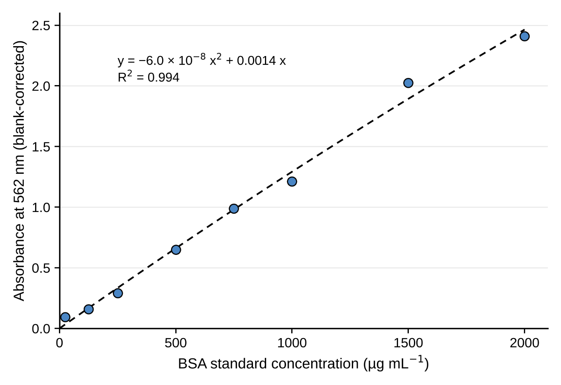
Figure 1. BCA protein assay calibration curve. Bovine serum albumin (BSA) standards (0–2000 µg mL⁻¹) were measured in technical triplicates at 562 nm following the manufacturer’s protocol (Thermo Fisher Scientific, 2014). Points show mean absorbance across replicates after blank correction; the second-order polynomial fit (y = −6 × 10⁻⁸x² + 0.0014x, R² = 0.9939) was used to interpolate host protein concentrations in experimental samples.

2.6 Ammonium Uptake
Net ammonium (NH₄⁺) uptake was measured as an index of the dissolved inorganic nitrogen demand of the holobiont. NH₄⁺ concentrations in water samples collected from each incubation chamber (Section 2.4) were determined colorimetrically by the indophenol blue method (Solórzano, 1969), in which ammonium reacts with hypochlorite to form monochloramine, which in turn reacts with phenol to form indophenol blue. Absorbance was measured at 690 nm on a Vantastar plate reader. Ammonium concentrations were calculated against a standard curve prepared from serial dilutions of an NH₄Cl stock solution in sterile artificial seawater spanning 0–10 µM. Net NH₄⁺ uptake per replicate was calculated as the difference between the initial concentration in the enriched seawater (10 µM) and the concentration measured at t₁, corrected for the mean flux recorded in paired blank chambers to account for abiotic and microbial contributions to ammonium depletion. Uptake was normalised to total soluble protein content (Section 2.5) to correct for inter-individual variation in biomass.

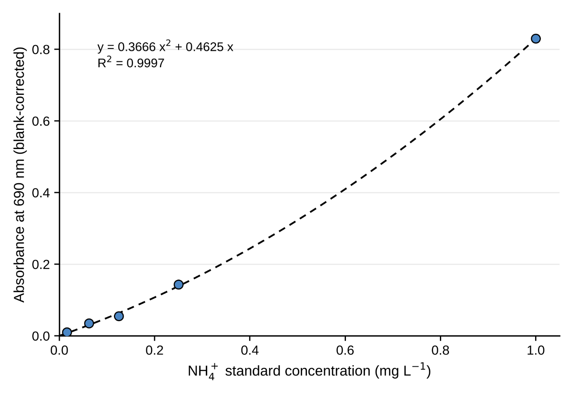
Figure 2. Ammonium (NH₄⁺) calibration curve. NH₄⁺ standards were measured in technical triplicates at 690 nm. Points show mean absorbance across replicates after blank correction; the second-order polynomial fit (y = 0.3666x² + 0.4625x, R² = 0.9997) was used to interpolate ammonium concentrations in experimental seawater samples.

2.7 DNA Extraction
Total genomic DNA was extracted from Exaiptasia individuals (n = 10) and Waminoa individuals (n = 12) using the DNeasy PowerSoil Kit (Qiagen, Hilden, Germany) following the manufacturer’s protocol. Two extraction blanks containing no biological material were processed alongside the samples and carried through extraction, amplification and sequencing as negative controls. In addition, one sample of the Artemia food suspension was extracted and sequenced as a food reference, to establish whether taxa recovered from the animals could be attributed to the food source.
2.8 16S rRNA Amplicon Sequencing to Characterize the Microbial Community
The V5–V7 region of the bacterial 16S rRNA gene was amplified with the primer pair 799F (5′-AACMGGATTAGATACCCKG-3′; Chelius & Triplett, 2001) and 1193R (5′-ACGTCATCCCCACCTTCC-3′; Bodenhausen et al., 2013). The forward primer carries mismatches to plastid 16S rRNA genes and was chosen to limit co-amplification of chloroplast sequences from the dinoflagellate symbionts (Chelius & Triplett, 2001; Beckers et al., 2016); host mitochondrial sequences are still amplified and were removed bioinformatically. The pair matches only 46 % of the bacterial sequences in the SILVA database (TestPrime; Klindworth et al., 2013), so the profiles describe the part of the community that these primers amplify (Appendix B). Each 20 µL reaction contained 10 µL Q5 Hot Start High-Fidelity 2× Master Mix (New England Biolabs), 0.5 µM of each primer and 1 µL template DNA. After initial denaturation at 98 °C for 30 s, reactions were cycled 35 times (98 °C for 10 s, 58 °C for 20 s, 72 °C for 15 s), followed by a final extension at 72 °C for 2 min. Products were checked on a 2 % agarose gel, and libraries were prepared and sequenced (2 × 250 bp) by Biomarker Technologies GmbH (BMK).
Reads were processed with DADA2 v1.34 (Callahan et al., 2016) in R v4.4.3 (R Core Team, 2025). Primers were removed by trimming the first 19 (forward) and 18 (reverse) bases, and reads were truncated at positions 240 (forward) and 200 (reverse) and filtered with a maximum expected error of 2 and 5. Error models were learned with a monotonic error function suited to binned quality scores, forward and reverse reads were merged (minimum overlap 12 nucleotides), merged sequences outside 350–400 nucleotides were discarded, and chimeras were removed by the consensus method. Sequencing artefacts consisting of Illumina adapter sequence with long homopolymer runs were removed, and taxonomy was assigned against SILVA v138.2 (Quast et al., 2013).
Most reads came from human handling and laboratory reagents rather than from the animals, as is typical of low-biomass samples (Salter et al., 2014; Eisenhofer et al., 2019). Prevalence-based decontamination (Davis et al., 2018) could not separate these taxa, because they occurred in samples and blank alike. Contaminants were therefore removed with a curated, logged procedure (Appendix B): non-bacterial, chloroplast and mitochondrial sequences; genera associated with human skin, mouth and gut; reagent genera that were also detected in the extraction blank NEGCON1; and amplicon sequence variants (ASVs) more abundant in that blank than in any animal. Cleaning removed 75.8 % of the reads from the analysed animals (65.8 % in Exaiptasia and 83.3 % in Waminoa). The five libraries with the fewest reads after cleaning (870–1,717 reads; AF5, AS1, AS2, WF2 and WS4), all of which consisted of 73–93 % primer-dimer reads, were excluded; the smallest retained library held 2,910 reads. The community analyses are therefore based on 17 animals: four fed and three starved Exaiptasia, and five fed and five starved Waminoa.
2.9 Statistical analysis
Statistical analysis of physiological data
All analyses were performed in R v4.4.1 (R Core Team, 2024). Values in the text and tables are means ± SD; figures show medians and interquartile ranges with individual animals. Fed and starved animals were independent individuals, and all comparisons were treated as unpaired. Sample sizes were n = 5 per treatment for Exaiptasia and n = 6 per treatment for Waminoa sp. Each parameter was analysed separately. Eight parameters were tested: total host protein content, symbiont number per animal, symbiont density per unit protein, net oxygen production, protein-normalised oxygen production, oxygen production per symbiont cell, Fv/Fm, and protein-normalised ammonium uptake.
To test whether the two hosts differed in their response to food deprivation, each parameter was fitted with a two-way analysis of variance including organism, treatment and their interaction, using Type III sums of squares with sum-to-zero contrasts (Fox & Weisberg, 2019).
Assumptions were checked before testing. Normality within each organism × treatment group was assessed with the Shapiro–Wilk test and homogeneity of variance across groups with Levene’s test. Variances differed between fed and starved animals for host protein content (Levene’s test, p = 0.008), and normality was not met for oxygen production per symbiont cell in fed animals of both hosts (Shapiro–Wilk, p = 0.006 and p = 0.036) or for ammonium uptake in starved Waminoa (p = 0.008). Within-host comparisons of fed against starved animals were therefore made with Welch’s two-sample t-test, which does not assume equal variances. For each parameter, the two within-host p-values were adjusted with the Holm method (Holm, 1979), and the adjusted values are reported (Appendix A, Table A1). The two-way ANOVA was retained for the interaction term despite these departures, since no non-parametric equivalent tests an interaction directly; the interaction p-values should be read with that caveat.
Statistical analysis of the bacterial community data
Community analyses were performed in R with phyloseq (McMurdie & Holmes, 2013), vegan (Oksanen et al., 2022) and ANCOMBC v2.8.0 (Lin & Peddada, 2024). Differences in community composition were tested by permutational multivariate analysis of variance (PERMANOVA; Anderson, 2001; 9,999 permutations) on Bray–Curtis dissimilarities of relative abundances and on Aitchison distances, i.e. Euclidean distances of centred log-ratio transformed counts with a pseudo-count of 0.5 (Gloor et al., 2017). Host, treatment and their interaction were fitted across all animals, and the fed-versus-starved contrast was tested separately within each host. Homogeneity of multivariate dispersion was checked with betadisper (Anderson, 2006), and community structure was visualised by principal coordinates analysis (PCoA). Alpha diversity (observed ASVs and Shannon index, rarefied to the smallest retained library) was compared between treatments within each host with Wilcoxon rank-sum tests. Differentially abundant genera and families were identified with ANCOM-BC2 for fed versus starved animals within each host and for the two hosts adjusted for treatment; taxa present in fewer than 30 % of samples were not tested, p-values were Holm-adjusted, and a difference was accepted only if it also passed the pseudo-count sensitivity analysis. Figures were produced with ggplot2 (Wickham et al., 2019). All analysis scripts, processed data and supplementary tables are available as described in Appendix C.
3. Results
3.1 Physiological responses to feeding treatment
Both hosts, which belong to distant branches of the animal tree (Figure 3), lost substantial biomass during starvation, but only Exaiptasia showed a pronounced response of its symbiosis. Host protein content declined to a similar extent in both hosts (Figure 4), whereas symbiont density, protein-normalised oxygen production, photosynthetic efficiency and ammonium uptake declined in Exaiptasia and remained unchanged in Waminoa. Net oxygen production fell in both hosts, but more steeply in Exaiptasia, and no change in oxygen production per symbiont cell was detected in either host. Two-way analyses of variance confirmed that the two hosts responded differently (organism × treatment interaction; Appendix A, Table A1) for six of the eight parameters; the exceptions were host protein content and oxygen production per symbiont cell, for which the two hosts behaved alike.
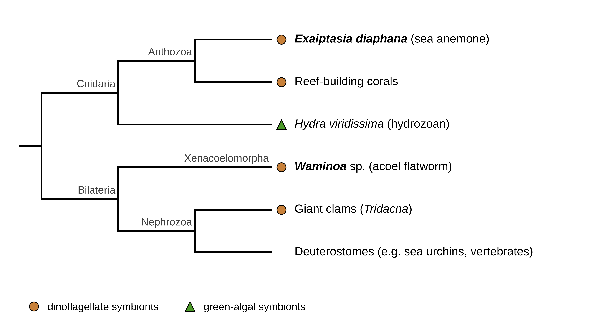Figure 3. The two study hosts belong to distant branches of the animal tree. Simplified cladogram (branch lengths not to scale) showing Exaiptasia diaphana (Cnidaria) and Waminoa sp. (Xenacoelomorpha) together with other photosymbiotic animals discussed in this thesis. Symbols mark hosts of dinoflagellate (circles) or green-algal (triangle) symbionts. Xenacoelomorpha is shown as the sister group of all other bilaterians (Cannon et al., 2016); an alternative analysis places it within the deuterostomes (Philippe et al., 2019).

In Exaiptasia, starvation took the symbiosis apart. Starved anemones contained fewer than a fifth of the symbionts of fed animals, and symbiont density was still about 70 % lower after correction for the smaller body (Figures 5 and 6). Net oxygen production per animal fell by 90 %, much more than host biomass, so oxygen production per unit of host protein also fell steeply (Figures 7 and 8). The remaining symbionts had lower photochemical efficiency: Fv/Fm fell from about 0.66 to 0.55, below the range typical of unstressed cnidarian symbionts (Figure 9). Ammonium uptake stopped altogether. On average, starved anemones took up no ammonium from the enriched medium, and two individuals released it (Figure 10).
In Waminoa, the symbiosis did not change. Symbiont number and density, photochemical efficiency and ammonium uptake did not differ between fed and starved worms (Figures 5, 6, 9 and 10). Net oxygen production per animal fell by 38 %, but only in proportion to the smaller body: per unit of host protein, it was unchanged (Figures 7 and 8).
Oxygen production per symbiont cell did not differ detectably between fed and starved animals in either host (Figure 11). Within each group, however, these per-cell estimates varied about as much as their means, so the tests had little power and a per-cell decline cannot be excluded.
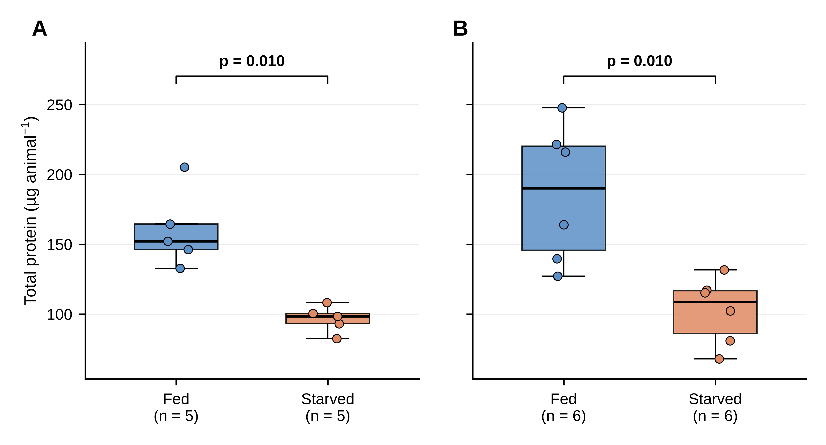
Figure 4. Total host protein content declines under starvation in both hosts. Soluble protein content per animal (µg animal⁻¹) in (A) Exaiptasia and (B) Waminoa under fed and starved conditions. In Figures 4–11, boxes show the median and interquartile range, points show individual animals, and p-values are from Welch’s t-tests, Holm-adjusted across the two hosts.

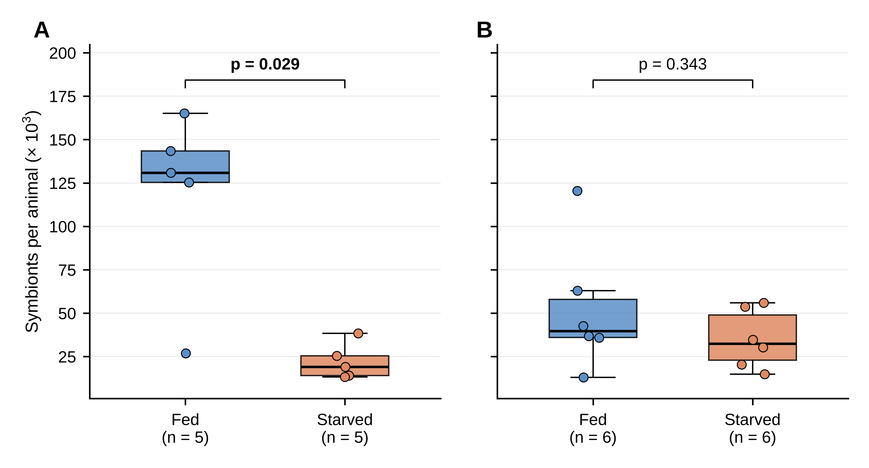
Figure 5. Symbiont number per animal declines under starvation in Exaiptasia but not in Waminoa sp. Total symbiont cells per individual in (A) Exaiptasia and (B) Waminoa under fed and starved conditions.

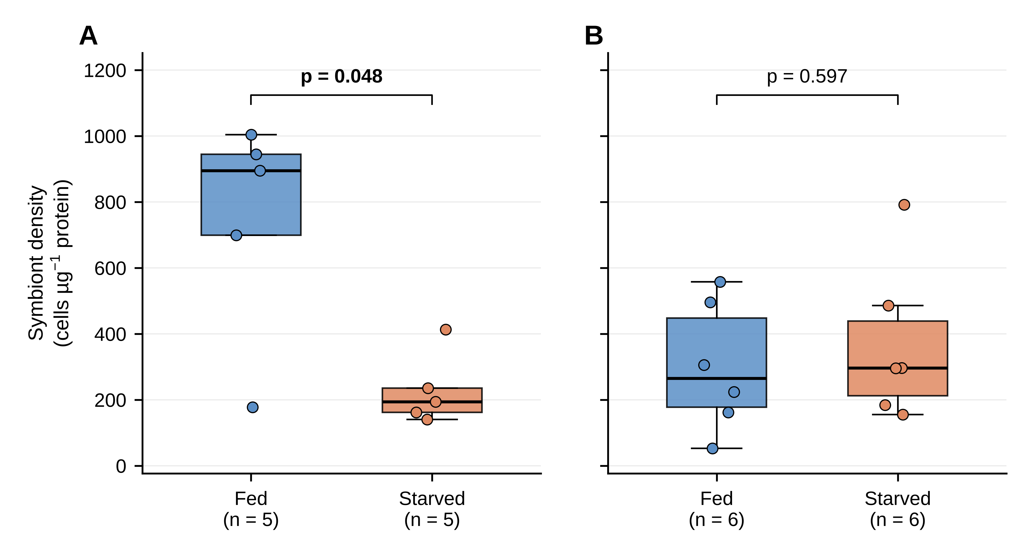
Figure 6. Symbiont density normalised to host protein declines under starvation in Exaiptasia but not in Waminoa sp. Symbiont cell density (cells µg⁻¹ host soluble protein) in (A) Exaiptasia and (B) Waminoa under fed and starved conditions.

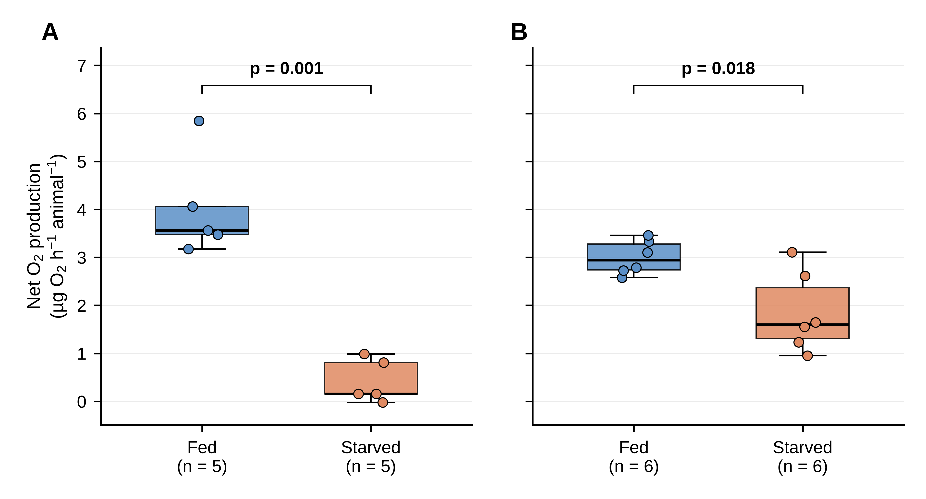
Figure 7. Net oxygen production declines in both hosts, more steeply in Exaiptasia. Blank-corrected net oxygen production per individual (µg O₂ h⁻¹ animal⁻¹) during three-hour light incubations in (A) Exaiptasia and (B) Waminoa under fed and starved conditions.

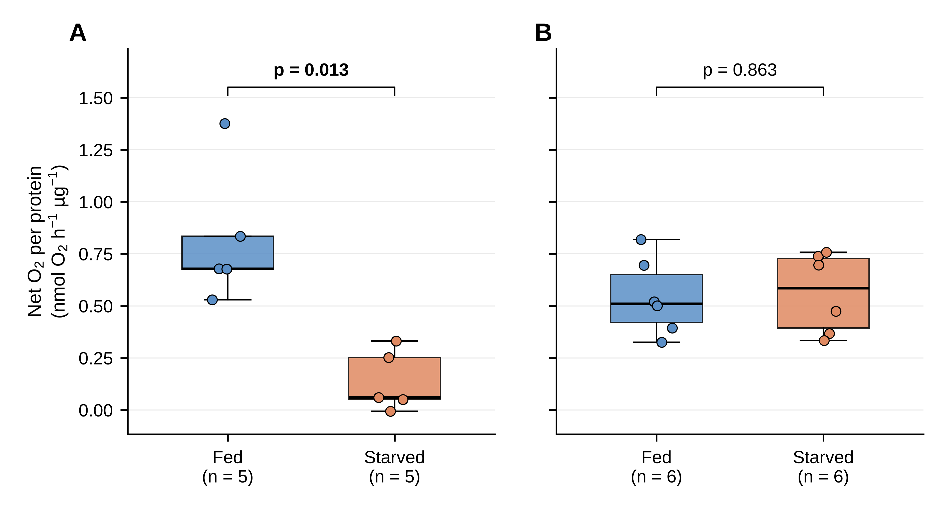
Figure 8. Net oxygen production per unit host biomass declines only in Exaiptasia. Net oxygen production normalised to host soluble protein (nmol O₂ h⁻¹ µg⁻¹ protein) in (A) Exaiptasia and (B) Waminoa under fed and starved conditions.

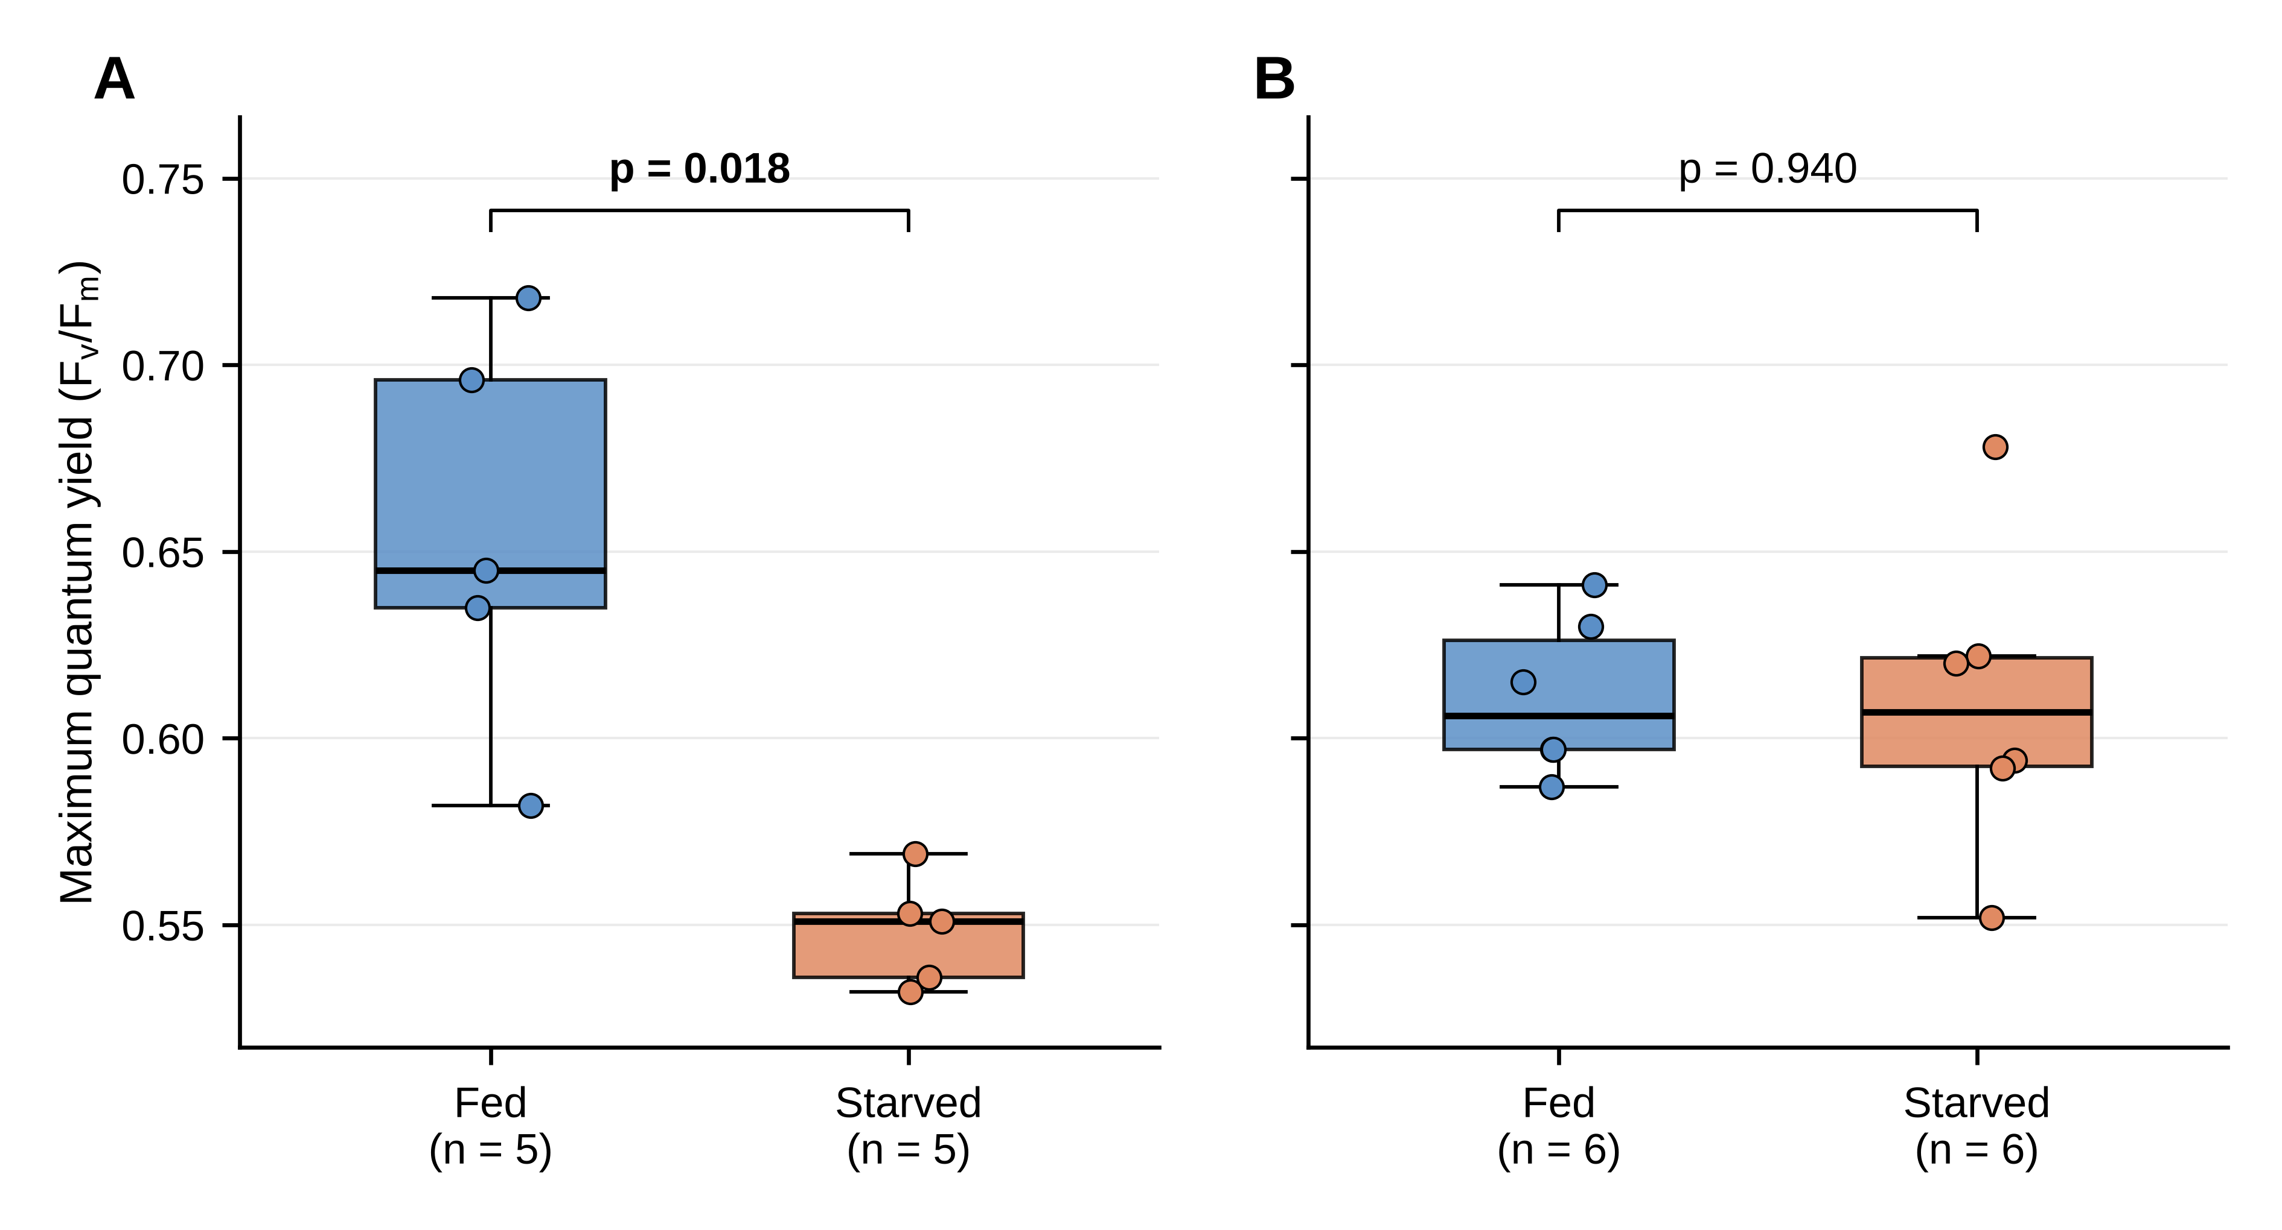
Figure 9. Photosynthetic efficiency declines in Exaiptasia only. Maximum quantum yield of photosystem II (Fv/Fm) measured after dark adaptation in (A) Exaiptasia and (B) Waminoa under fed and starved conditions. Values are endpoint measurements taken at the end of the starvation period.

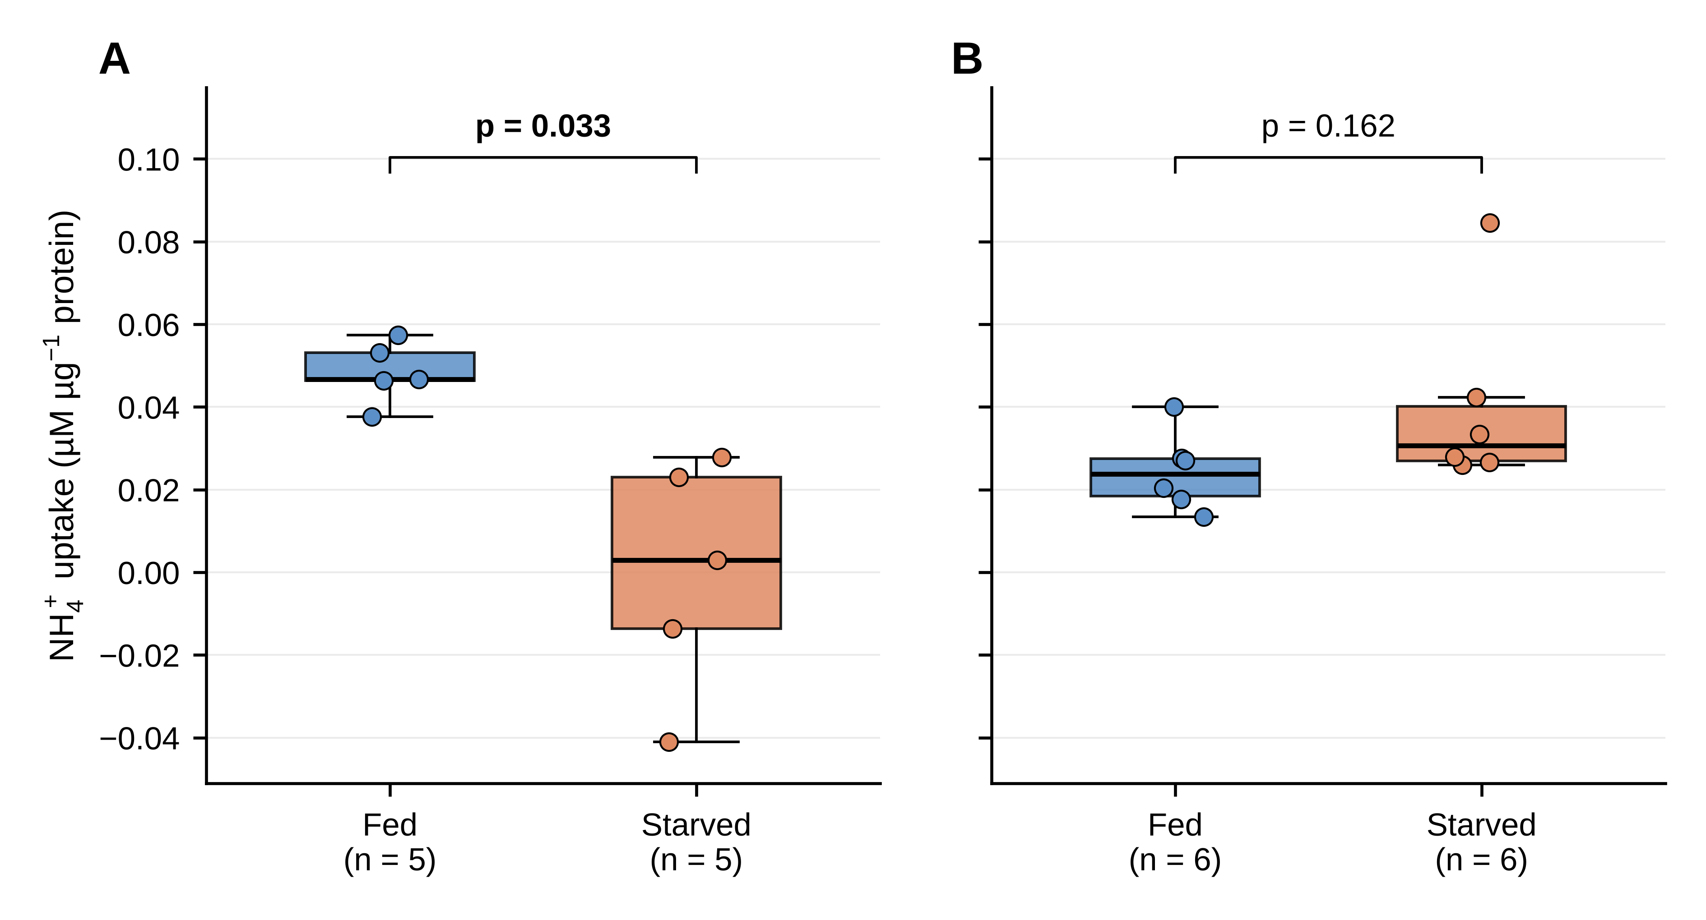
Figure 10. Ammonium uptake collapses in Exaiptasia but is maintained in Waminoa sp. Net ammonium uptake normalised to host soluble protein in (A) Exaiptasia and (B) Waminoa under fed and starved conditions. Positive values indicate net uptake from the incubation medium and negative values net release. Uptake was measured over three-hour light incubations in seawater enriched to 10 µM NH₄⁺ and corrected against organism-free blanks.
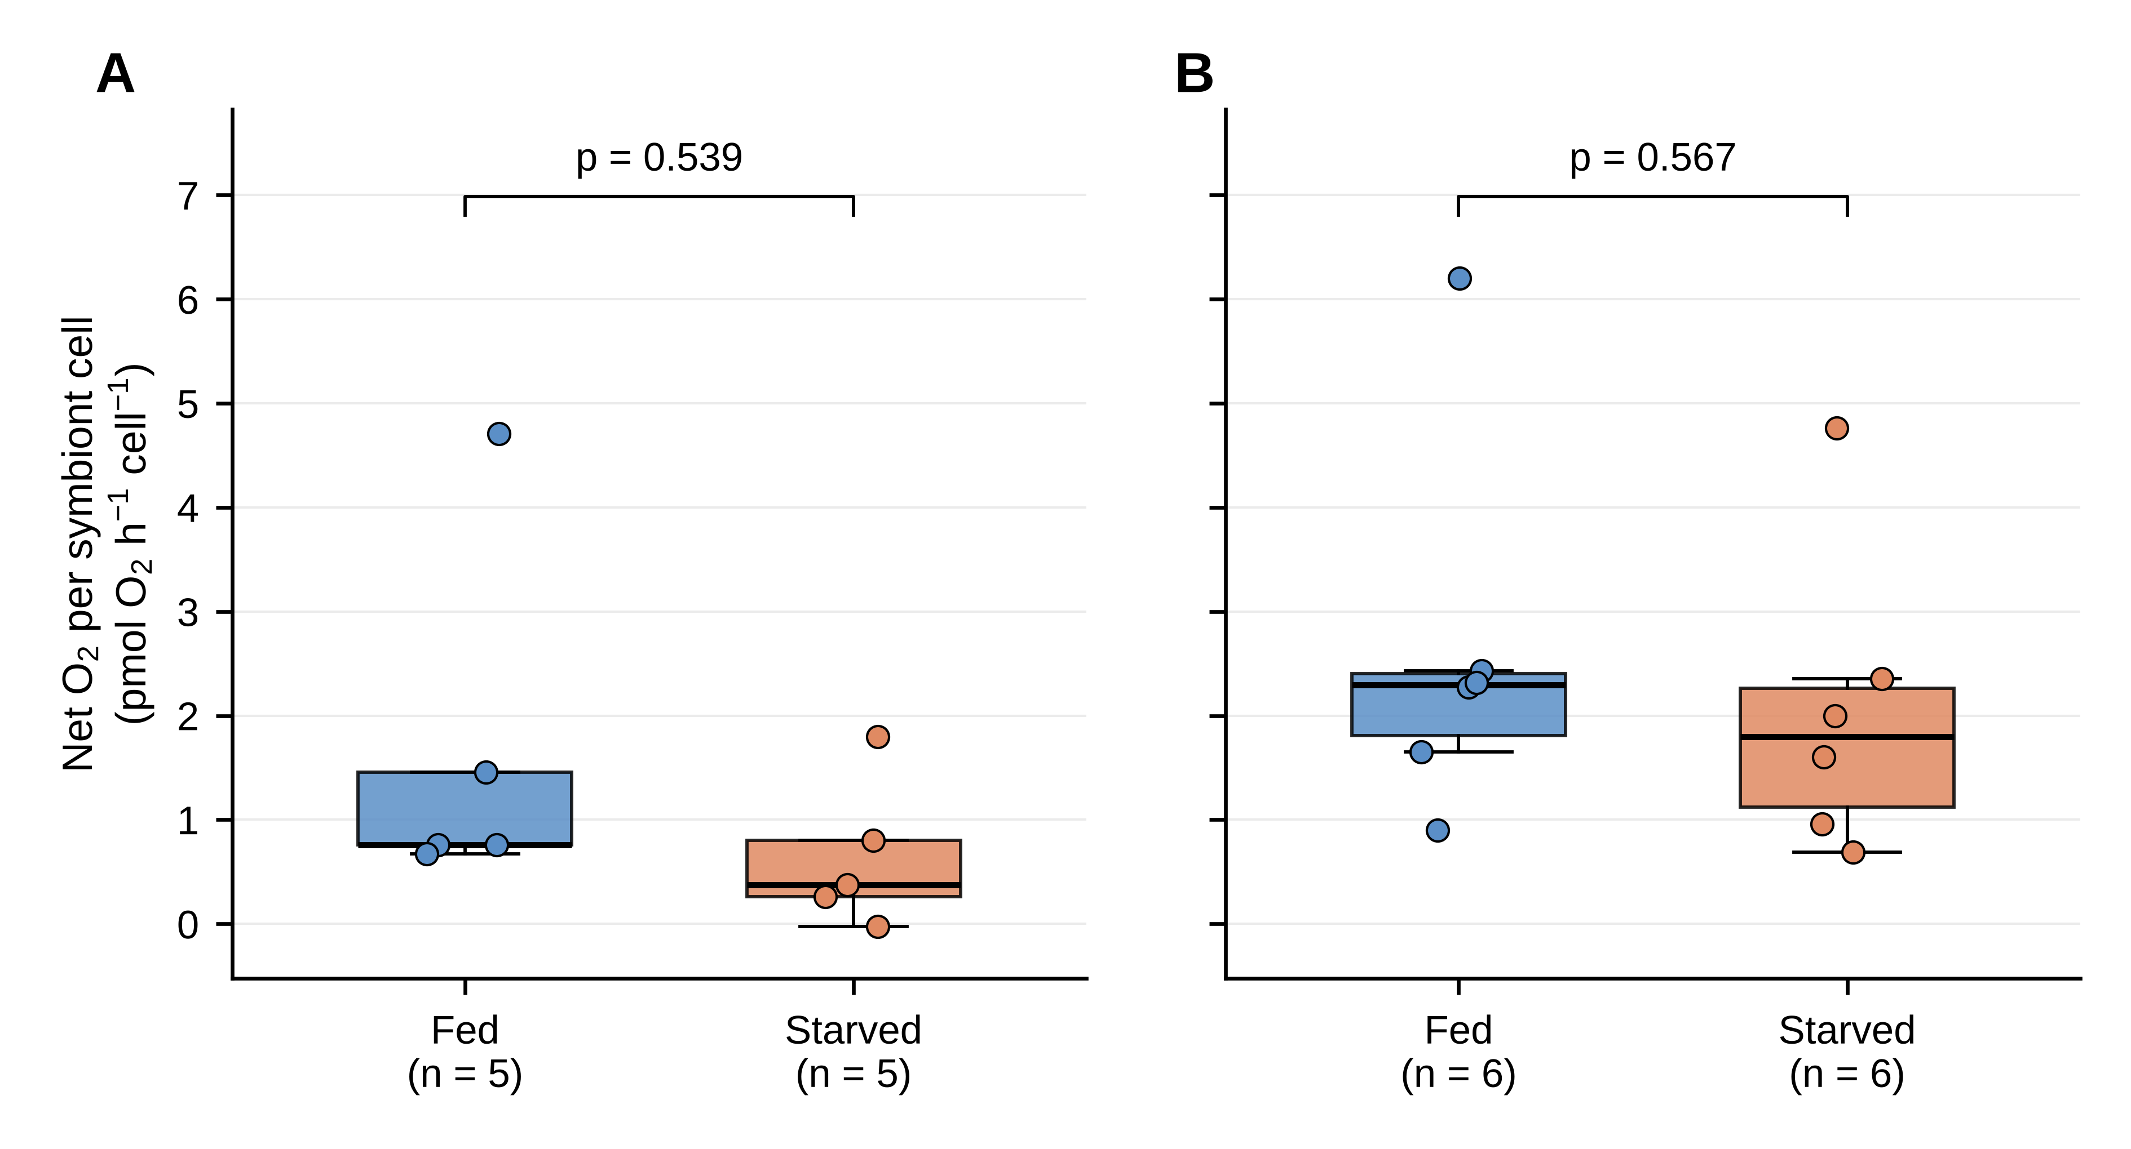
Figure 11. No change in oxygen production per symbiont cell was detected in either host. Net oxygen production normalised to symbiont cell number (pmol O₂ h⁻¹ cell⁻¹) in (A) Exaiptasia and (B) Waminoa under fed and starved conditions.

3.2 Bacterial communities differed between the hosts; a starvation effect was detected only in Exaiptasia
The bacterial communities of the two hosts differed, and starvation was associated with a difference in community composition in Exaiptasia but not in Waminoa. The most abundant families were Comamonadaceae, Alteromonadaceae, Bacillaceae and Prevotellaceae, whereas the Artemia food was dominated by Alteromonadaceae (Figure 12A); Comamonadaceae and Prevotellaceae consist largely of genera that appear on reagent-contaminant lists or are human-associated (Aquabacterium and Roseateles, formerly Pelomonas; Segatella and Hoylesella; Section 4.5). Host was the strongest term in the PERMANOVA (Bray–Curtis R² = 0.171, Aitchison R² = 0.123, both p < 0.001; Figure 12B; Table A1). Treatment was also significant across all animals (Bray–Curtis R² = 0.094, p = 0.031; Aitchison R² = 0.101, p < 0.001), but its effect depended on the host on Aitchison distances (host × treatment, R² = 0.104, p = 0.001; Bray–Curtis p = 0.067). Within hosts, fed and starved Exaiptasia differed (Bray–Curtis R² = 0.288, Aitchison R² = 0.326; both p = 0.029, the smallest p-value possible with four fed and three starved animals), whereas fed and starved Waminoa did not (R² = 0.148, p = 0.241; R² = 0.140, p = 0.200). The Exaiptasia result was also obtained when the three libraries excluded by choice were included (n = 20; Bray–Curtis R² = 0.196, p = 0.025) and after removal of renamed human-associated genera or of all reagent-list genera (Appendix A.5). No genus or family differed in abundance between fed and starved animals in either host (Figure 12C), and alpha diversity did not differ between treatments. Two families, Lachnospiraceae and Acetobacteraceae, were more abundant in Waminoa than in Exaiptasia (Figure 12C); both are likely to be partly contaminant-derived (Section 4.5).
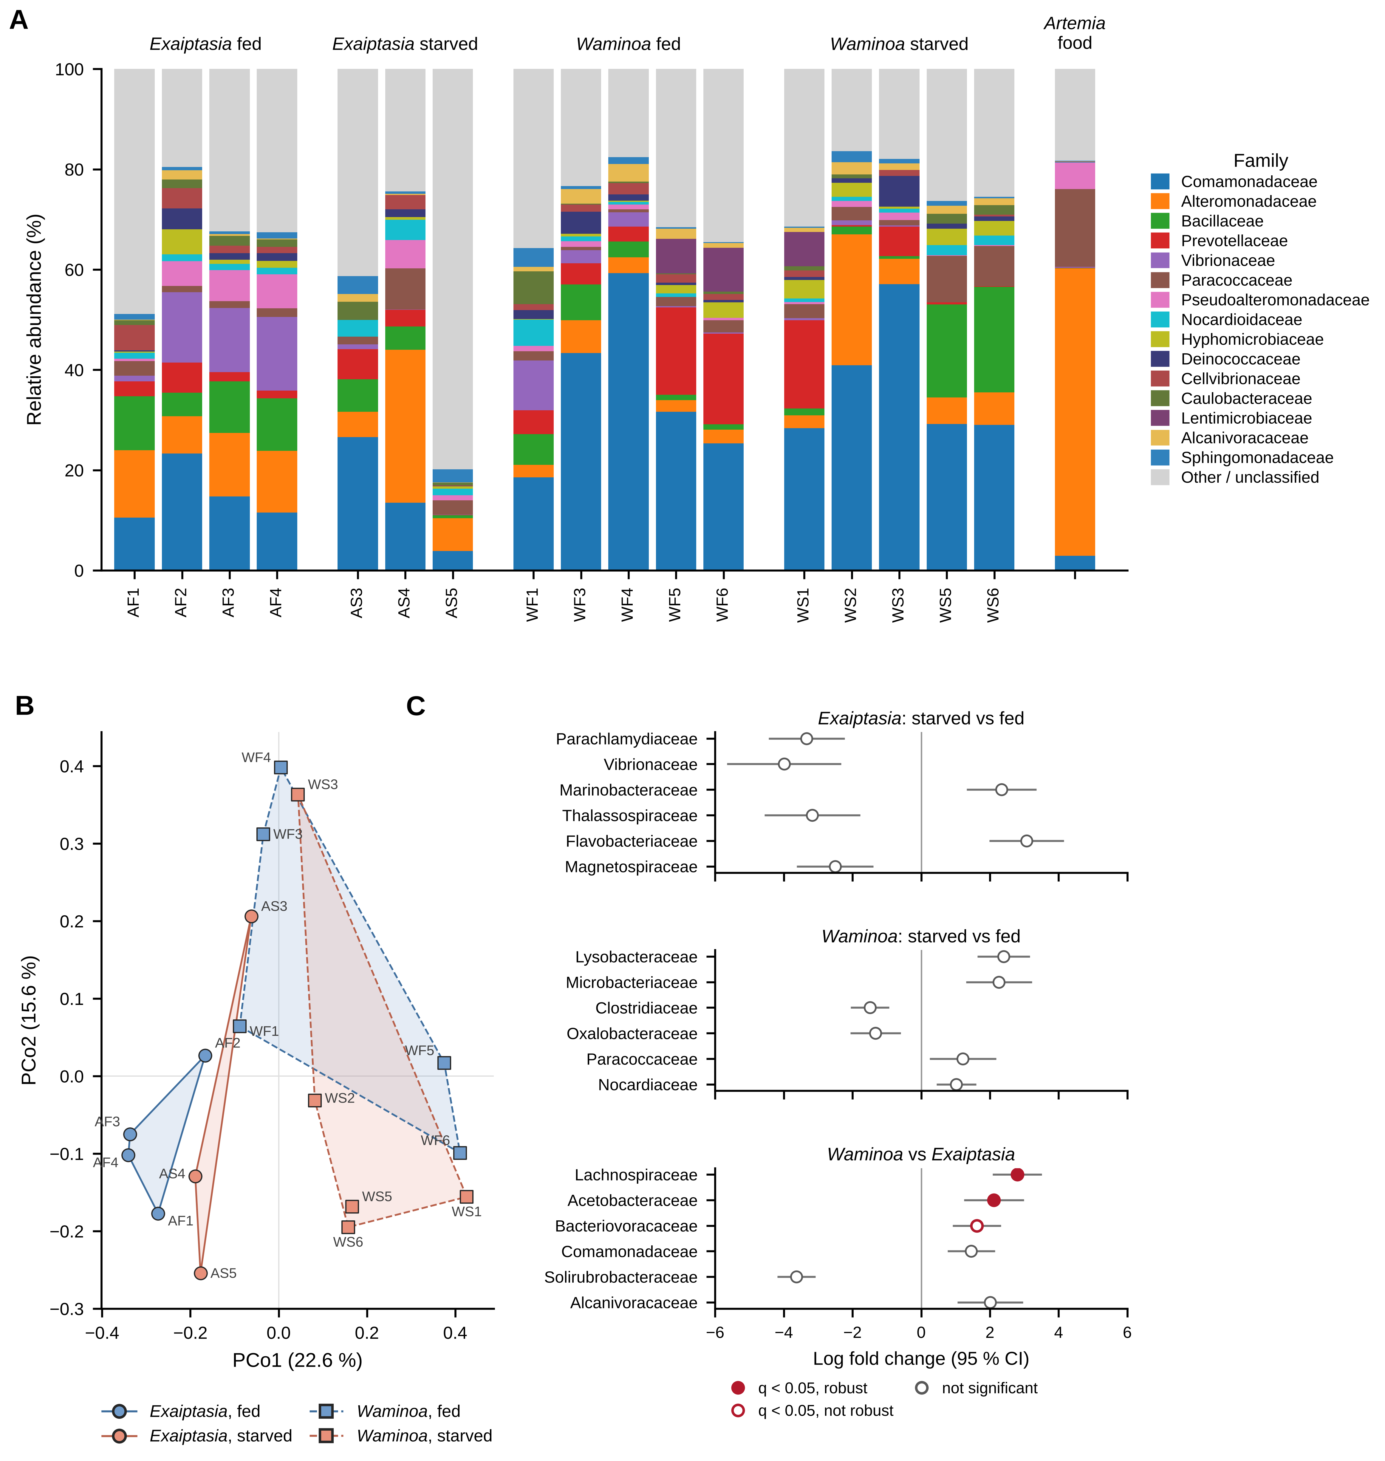
Figure 12. Bacterial communities differed between the hosts; a starvation effect was detected only in Exaiptasia. (A) Relative abundance of the 15 most abundant bacterial families in each animal and in the Artemia food after contaminant removal; all other families are pooled as Other / unclassified. (B) Principal coordinates analysis (PCoA) of Bray–Curtis dissimilarities between animals. Circles and solid lines, Exaiptasia; squares and dashed lines, Waminoa; blue, fed; orange, starved; lines enclose the animals of each group. (C) ANCOM-BC2 log fold changes (95 % confidence intervals) of the six classified families with the smallest p-values in each comparison; positive values indicate higher abundance in starved animals (upper two panels) or in Waminoa (lower panel).

4. Discussion

4.1 Feeding-dependent regulation is a property of the host
Two hosts drawn from distinct branches of the animal tree (Figure 3), both carrying dinoflagellate symbionts, were maintained under the same light, temperature, and salinity conditions, subjected to complete food withdrawal, and assayed with the same set of measurements. Their symbioses responded in different ways. Exaiptasia lost most of its symbionts, most of its photosynthetic output, and all its measurable ammonium uptake. Waminoa became smaller while leaving its symbiosis intact.
Under H1 (conserved regulation), both associations would have responded to starvation in the same way and no organism × treatment interaction would have been detected. Under H2 (lineage-specific regulation), the two associations would have diverged. Because an interaction was detected for six of the eight parameters, H1 is rejected and the data support H2: the response of the symbiosis to starvation differs between the two hosts and is set by the host, within the limits discussed below.
There are certain constraints to this hypothesis. The two hosts differ in starvation duration and identity. Exaiptasia was starved for approximately five months and Waminoa for five weeks. So, the possibility that Waminoa would eventually respond in the same way given longer deprivation cannot be excluded in the present design. Importantly, however, given the rapid shrinkage of Waminoa during starvation, survival for five months, as in Exaiptasia, may not be feasible. Moreover, the symbionts were not genotyped in the experiments reported here. Waminoa has been reported to host both Symbiodinium and Amphidinium in other populations (Barneah et al., 2007a, 2007b), whereas microscopy in our laboratory indicates that the animals in our culture host only Amphidinium, a dinoflagellate outside the Symbiodiniaceae. The two hosts therefore carry dinoflagellate partners that are not equivalent. What the interaction establishes is that carrying dinoflagellate symbionts is not sufficient to determine the response to host starvation. Finally, each combination of host and treatment was kept in a single box (Section 2.1). Treatment is therefore confounded with box, and the animals within a box are not fully independent replicates, so an effect of the box itself cannot be separated from the effect of starvation. Replicate boxes per treatment would remove this limitation in future experiments.

4.2 In Exaiptasia, carbon supply and nitrogen capture fail together
In the fed state of cnidarian hosts such as Exaiptasia, symbiont photosynthesis translocates fixed carbon to the host, and the host uses those carbon skeletons to assimilate ammonium, most of which is its own catabolic waste (Rädecker et al., 2023). Thus, the host captures the nitrogen before the symbiont can reach it and thereby holds the algal population in check (Rädecker et al., 2015, 2023). In summary, external feeding of the host produces ammonium, which can be assimilated only if the photosynthate supplies the system with organic carbon. Withdrawing food removes the nitrogen/ammonium input. The recycled ammonium on which the symbionts ultimately depend is no longer generated, and the symbiont population contracts. The loss of symbionts in starved Exaiptasia is what this model predicts.
What the model does not predict is that ammonium uptake should cease altogether. Since the symbionts are a major sink for ammonium, a smaller symbiont population should draw down proportionally less ammonium, not none. Starved animals still carried symbionts — 22.1 ± 10.3 × 10³ per animal — yet took up no ammonium on average, and two individuals released ammonium into a medium already enriched to 10 µM. The failure therefore lies in the machinery that assimilates ammonium rather than in the number of algae drawing on it. This is also the opposite of what a simple nitrogen shortage would predict: an animal depleted of nitrogen and then offered it should take it up rapidly, so the failure to do so points away from nitrogen supply as the immediate constraint. A shortage of carbon rather than nitrogen accounts for this result.
Assimilating ammonium costs carbon: the glutamine synthetase–glutamate synthase route builds amino acids from carbon skeletons (Rädecker et al., 2023). In starved animals both carbon inputs were failing simultaneously: heterotrophic carbon was absent by design, and autotrophic carbon collapsed with the symbiont population, as the 89.6 % reduction in net oxygen production shows. The holobiont was therefore not merely short of nitrogen; it had lost the carbon supply that funds the reaction by which nitrogen is captured. The animals that released ammonium make the same point from the other direction. An animal catabolizing its own protein liberates ammonium continuously, and with no carbon skeletons available to re-assimilate it, that nitrogen has nowhere to go but the medium. The holobiont converts from a net nitrogen sink into a net nitrogen source. This interpretation is consistent with the present data but is not established by them, since carbon availability was not manipulated here; the experiment that would test it directly is set out in Section 4.6.
The two observations are compatible if the two limitations followed each other in time: nitrogen limitation would have started the decline, and carbon limitation would then have set the state measured at the end of the experiment. The result is therefore a self-reinforcing sequence. The loss of food imposed a severe nitrogen limitation, which, under the cnidarian model, caused the symbiont population to crash to a point at which carbon may in turn have become limiting; the host, short of carbon, would then have had to catabolize its own protein, which fits the loss of host protein and the release of ammonium. From then on, fewer symbionts mean less translocated carbon, less carbon means less ammonium assimilation, and once assimilation has stopped, the route by which nitrogen would be recaptured and returned to the symbionts remains closed even if nitrogen becomes available again. This provides a concrete, measurable description of the reduced state that Rädecker and Meibom (2023) reported in anemones kept without food for approximately one year. The animals that survived settled into a smaller, nutritionally self-contained configuration, in which carbon supply and nitrogen capture are both held at a low level.
One caveat belongs to the assay rather than to the interpretation. The animals were not pre-conditioned with ammonium before the three-hour incubation in enriched artificial seawater. What was measured is therefore the standing assimilatory state, not the capacity that might be induced given time and a carbon source. A host whose transporter genes are switched off and a host that has lost the assimilatory machinery are indistinguishable in this assay. Separating them requires a factorial pre-incubation — glucose supplied or withheld, crossed with ammonium supplied or withheld — with transporter transcripts measured alongside flux: if the transporters are glucose-inducible in starved animals, the collapse reflects a regulatory state; if they are not, it reflects a loss of capacity.

4.3 Nitrogen-based host control is not evident in Waminoa on this timescale
Waminoa was not indifferent to starvation, and stating the response precisely is what makes the contrast with Exaiptasia informative. The worms lost soluble protein (44.9 %) and total photosynthetic output (38.3 %). What starvation produced in Waminoa was a smaller animal carrying a proportionally unaltered symbiosis. None of the regulatory variables moved — not symbiont density, not photosynthetic efficiency, not the capacity to take up ammonium. Two features of that outcome argue against nitrogen limitation, unlike what is known from the cnidarian literature.
The first feature is the symbiont population itself. In the cnidarian model the population is capped because the host intercepts the nitrogen passing through it, so removing the external nitrogen supply should tighten the cap and the population should contract, as it did in Exaiptasia. Under the same mechanism, starvation should have reduced symbiont density in Waminoa, but it did not. A population that does not respond when the supposedly limiting nutrient is withdrawn is unlikely to be limited by that nutrient.
The second feature is the ammonium flux. Starvation of Exaiptasia resulted in the shutdown of its nitrogen assimilatory route and a reduction of its symbiont population. In contrast, starvation of Waminoa affected neither nitrogen assimilation nor the symbiont population, an unexpected outcome for a nitrogen-limited holobiont.
Both arguments are, however, conditional on the five-week duration of the Waminoa treatment, and a more pronounced response on a longer timescale cannot be excluded. Because food withdrawal removed phosphorus as well as nitrogen, the absence of a response also argues against a limitation by food-derived phosphorus (Section 4.4).

4.4 What might limit the Waminoa symbiosis instead?
These data indicate that food withdrawal, which removes the external supply of nitrogen, phosphorus and carbon, does not disrupt the Waminoa symbiosis on the timescale tested, which raises the question of what limits it. Identifying the limiting factor matters because it would show whether different host lineages regulate their symbionts in different currencies or converge on the same nitrogen-based mechanism. The plausible alternatives are few enough to name, and each makes a testable hypothesis.
First, the population may be limited by a different element. In Exaiptasia, Faulstich et al. (2024) found evidence that phosphate availability controls symbiont cell division, which suggests that an element other than nitrogen can set the limit in a dinoflagellate photosymbiosis. In reef corals, a comparable mechanism has been demonstrated directly: nitrogen enrichment destabilizes the symbiosis specifically when phosphate is scarce, because the excess nitrogen drives the symbionts into phosphate starvation (Wiedenmann et al., 2013).
Waminoa may therefore be phosphorus-limited rather than nitrogen-limited. Because food withdrawal also removes phosphorus, such a limitation would have to operate through phosphorus that reaches the symbionts by another route, for example from the seawater, or the host would have to buffer the symbionts with internal phosphorus stores for the five weeks of the experiment. Testing this would require the design used here with phosphate in place of ammonium: if phosphorus caps the Waminoa symbiont population, phosphate enrichment should raise symbiont density in fed animals while ammonium enrichment should not.
A second alternative is that the population is limited physically rather than nutritionally. Waminoa is a small, dorsoventrally flattened acoel with a constrained body volume and no gastric cavity. A symbiont load already at a spatial ceiling would be insensitive to nutritional signals in either direction. This predicts that symbiont density should be insensitive to enrichment with any nutrient, while symbiont number per animal should scale with body size.
A third possibility is that the symbiont population is regulated by removal of algal cells rather than by nutrient supply. Cnidarian hosts can reduce their symbiont populations by digesting algal cells inside host cells or by expelling them, and digestion has been proposed as a regulatory mechanism that adjusts symbiont density without any need for nutrient limitation of symbiont growth (Davy et al., 2012; Titlyanov et al., 1996). A host that digests surplus symbionts could hold its symbiont population constant irrespective of the nitrogen that reaches it, which would explain why symbiont density in Waminoa did not change when food, and with it the external nutrient supply, was withdrawn. This hypothesis predicts that degraded algal cells should be detectable in host tissue, that the removal rate should follow the growth rate of the symbionts, and that symbiont density should stay stable under nutrient enrichment as well. It can be tested by histology or electron microscopy of host tissue and by counting algal cells released into the surrounding water.
What the present data establish is the narrower and firmer point: the mechanism that regulates symbiont density in Exaiptasia through host control of nitrogen does not operate detectably in Waminoa over five weeks of food withdrawal.

4.5 Bacterial communities: tentative signals under severe technical limits
The bacterial data support one robust and one tentative conclusion. The robust conclusion is that the two hosts carried different bacterial communities: the host term was significant on both distance measures, with the three low-read libraries included and with stricter contaminant filters (Appendix A.5). The tentative conclusion is that starved Exaiptasia carried communities different from those of fed anemones, whereas starvation did not change the communities of Waminoa. This parallels the host-specific physiological response (Section 4.1), but it rests on seven animals, reached the smallest p-value the design allows, and no single genus or family changed with feeding in either host. One starved anemone (AS5) also held 31 % of all retained reads and had a profile dominated by unclassified bacteria and soil-associated genera (Massilia, Gaiella). The two families that distinguished the hosts are not clear host associates: Lachnospiraceae are typical of the human gut, and Acetobacteraceae include Roseomonas, a genus listed among reagent contaminants (Salter et al., 2014). Even the host difference may therefore partly reflect differences in contamination rather than host biology, although it persisted after contaminant-associated genera were removed (Appendix A.5). The bacterial results are best read as hypothesis-generating: they neither establish nor exclude a feeding-dependent restructuring of the bacterial community, and they do not show whether bacteria involved in holobiont nitrogen cycling (Section 1.7) were affected.
Three technical limitations account for this uncertainty. First, the primer pair was chosen to avoid plastid sequences from the symbionts, and the same design makes it selective: it matches only about half of the known bacterial 16S rRNA sequences and covers several lineages poorly (Section 2.8; Appendix A), so the profiles describe only part of the community. Second, the animals yielded little bacterial template. The libraries were amplified for 35 cycles from low-input extracts, primer dimer made up a large share of many libraries, and five libraries with very few usable reads had to be excluded (Section 2.8). Dimer load also differed between groups (median 51 % in starved and 24 % in fed Exaiptasia), which suggests less bacterial template and therefore a larger relative share of contaminant sequences in starved anemones; when dimer load was entered into the model first, the treatment effect was no longer significant on Bray–Curtis dissimilarities, although it remained on Aitchison distances (Table A2). Third, about three quarters of all reads were removed as contaminants, and only one extraction blank was used to identify them. The genus lists also predate the SILVA 138.2 taxonomy, so renamed genera (Segatella, Hoylesella) and gut-associated Lachnospiraceae were retained (3.6 % of retained reads), and reagent-list genera that were absent from the single blank, such as Aquabacterium and Roseateles (together 15 % of retained reads), were kept by design. The main results did not change when these genera were removed (Appendix A.5). Relative abundances also cannot show whether the total bacterial load changed (Gloor et al., 2017).
A design that could resolve a feeding effect would need to address these limitations directly: quantification and normalization of the input DNA, fewer amplification cycles, a primer pair with broader coverage of marine bacteria (for example the 515F-Y/806R pair evaluated for marine samples; Apprill et al., 2015; Parada et al., 2016) combined with blocking oligonucleotides against host and plastid 16S rRNA (Lundberg et al., 2013), several extraction and PCR blanks and a mock community (Eisenhofer et al., 2019; Karstens et al., 2019), and spike-in standards for absolute quantification. Until then, the bacterial results should be treated as exploratory.

4.6 Future work
Two questions raised by these results cannot be answered with the present data. In Exaiptasia, the mechanism proposed in Section 4.2 was inferred from uptake and oxygen measurements rather than tested by manipulating carbon directly. In Waminoa, the finding is negative: these data indicate that food withdrawal does not perturb the symbiosis, but not what regulates it. The following experiments would address these questions.
The most informative experiment would identify which element, if there is one, limits the symbiont population in Waminoa. Phosphate and ammonium would be supplied to fed animals of both species, separately and in combination. Symbiont density and ammonium uptake should then be measured. Exaiptasia would serve as the positive reference knowing that nitrogen availability controls symbiont density and that phosphate may control symbiont cell division (Faulstich et al., 2024). A response in Exaiptasia would confirm that the enrichment was effective, but the informative comparison would be whether Waminoa responds to the same element, to the other, or to neither.
The next best experiment would be to follow the starvation response through time rather than until a single endpoint. Sampling both hosts at several intervals addresses two problems at once: it removes the concern that Waminoa was simply not starved long enough, and it resolves the shape of the response rather than its final state, so that a symbiosis which declines gradually can be distinguished from one that fails abruptly.
Two further experiments would test the carbon argument in Exaiptasia, both by manipulating the carbon supply rather than the nitrogen supply. In the first, starved animals would be given glucose before being offered ammonium, with transporter transcripts measured alongside uptake: if uptake returns, the assimilatory machinery was intact but switched off; if it remains at zero, the machinery has been lost. In the second, symbiotic and aposymbiotic animals would be compared when fed and when starved. A fed aposymbiotic animal has carbon from food but none from photosynthesis, which separates the presence of carbon from the presence of symbionts — a separation the present design cannot make. Aposymbiotic animals do not survive prolonged starvation, so this comparison is restricted to fed and briefly starved states.
A final experiment would test how far the Exaiptasia result generalizes. These data come from a single clonal line carrying a single symbiont assemblage, so they strictly describe that particular pairing rather than the species. Repeating the starvation in two or three host lines carrying different symbiont genotypes would establish whether the collapse is a property of the host species or of one specific host–symbiont combination.
Two further experiments would extend the interpretation of the Waminoa result. To test the digestion hypothesis of Section 4.4, symbiont degradation could be assessed by histology or electron microscopy of fed and starved animals, and algal cells released into the surrounding water could be counted. To resolve the bacterial question, the design outlined in Section 4.5 should be applied to both hosts, with quantified input DNA and a larger number of controls.

5. Conclusion
Feeding-dependent regulation of photosymbiosis was tested in both Exaiptasia and Waminoa sp. Both hosts were starved, yet their results diverged: Exaiptasia lost most of its symbionts, most of its photosynthetic output, and all its measurable ammonium uptake, while Waminoa became smaller without altering its symbiont population, its photochemistry, or its nitrogen handling.
In Exaiptasia, the collapse amounts to more than a shortage of nitrogen. Ammonium uptake stopped altogether rather than falling in step with the symbionts that remained, which places the failure at the assimilatory step itself. With both heterotrophic and autotrophic carbon inputs gone, the host no longer had the carbon skeletons that ammonium assimilation requires. Carbon supply and nitrogen capture failed together, and the animal settled into a reduced, nutritionally self-contained state.
In Waminoa, starvation produced no such reorganization. Its symbiont population did not respond to removal of the nutrient that is expected to limit it, and its capacity to assimilate ammonium remained intact. These two observations argue that nitrogen is not the currency in which this symbiosis is regulated on a five-week timescale. Retaining the symbionts while losing biomass may indicate that the host depends on both nutritional modes together and cannot readily relinquish either, though establishing this would require testing whether Waminoa can survive without its symbionts at all. Which element sets the limit here, or whether the algal population is regulated by removal of algal cells, for instance by digestion, rather than by nutrient limitation, remains open.
Bacterial communities were characterized in parallel as an exploratory question. After the exclusion of five libraries with very few usable reads (Section 2.8), 17 animals remained. Their communities differed between the hosts and, tentatively, between fed and starved Exaiptasia, but low template amounts, limited primer coverage and a high share of contaminant reads restrict these findings, which require confirmation with a quantitative design.
The wider implication is that the nitrogen-centered model of host control is built almost entirely on cnidarians. It may describe one case of a general principle. If the identity of the limiting element is set by resource competition between host and symbiont, two photosymbioses can be equally tightly regulated by different currencies — and the question to ask of a newly described photosymbiotic system is not only whether the host controls its symbionts, but with which element it does so.

References
Abalde, S., & Jondelius, U. (2025). A phylogenomic backbone for Acoelomorpha inferred from transcriptomic data. Systematic Biology, 74(1), 70–85. https://doi.org/10.1093/sysbio/syae057
Albers, D., Reisser, W., & Wiessner, W. (1982). Studies on the nitrogen supply of endosymbiotic chlorellae in green Paramecium bursaria. Plant Science Letters, 25(1), 85–90. https://doi.org/10.1016/0304-4211(82)90210-3
Anderson, M. J. (2001). A new method for non-parametric multivariate analysis of variance. Austral Ecology, 26(1), 32–46. https://doi.org/10.1111/j.1442-9993.2001.01070.pp.x
Anderson, M. J. (2006). Distance-based tests for homogeneity of multivariate dispersions. Biometrics, 62(1), 245–253. https://doi.org/10.1111/j.1541-0420.2005.00440.x
Apprill, A., McNally, S., Parsons, R., & Weber, L. (2015). Minor revision to V4 region SSU rRNA 806R gene primer greatly increases detection of SAR11 bacterioplankton. Aquatic Microbial Ecology, 75(2), 129–137. https://doi.org/10.3354/ame01753
Aranda, M., Li, Y., Liew, Y. J., Baumgarten, S., Simakov, O., Wilson, M. C., Piel, J., Ashoor, H., Bougouffa, S., Bajic, V. B., Ryu, T., Ravasi, T., Bayer, T., Micklem, G., Kim, H., Bhak, J., LaJeunesse, T. C., & Voolstra, C. R. (2016). Genomes of coral dinoflagellate symbionts highlight evolutionary adaptations conducive to a symbiotic lifestyle. Scientific Reports, 6, Article 39734. https://doi.org/10.1038/srep39734
Barneah, O., Brickner, I., Hooge, M., Weis, V. M., & Benayahu, Y. (2007a). First evidence of maternal transmission of algal endosymbionts at an oocyte stage in a triploblastic host, with observations on reproduction in Waminoa brickneri (Acoelomorpha). Invertebrate Biology, 126(2), 113–119. https://doi.org/10.1111/j.1744-7410.2007.00082.x
Barneah, O., Brickner, I., Hooge, M., Weis, V. M., LaJeunesse, T. C., & Benayahu, Y. (2007b). Three party symbiosis: Acoelomorph worms, corals and unicellular algal symbionts in Eilat (Red Sea). Marine Biology, 151(4), 1215–1223. https://doi.org/10.1007/s00227-006-0563-2
Baumgarten, S., Simakov, O., Esherick, L. Y., Liew, Y. J., Lehnert, E. M., Michell, C. T., Li, Y., Hambleton, E. A., Guse, A., Oates, M. E., Gough, J., Weis, V. M., Aranda, M., Pringle, J. R., & Voolstra, C. R. (2015). The genome of Aiptasia, a sea anemone model for coral symbiosis. Proceedings of the National Academy of Sciences, 112(38), 11893–11898. https://doi.org/10.1073/pnas.1513318112
Beckers, B., Op De Beeck, M., Thijs, S., Truyens, S., Weyens, N., Boerjan, W., & Vangronsveld, J. (2016). Performance of 16S rDNA primer pairs in the study of rhizosphere and endosphere bacterial microbiomes in metabarcoding studies. Frontiers in Microbiology, 7, Article 650. https://doi.org/10.3389/fmicb.2016.00650
Belda, C. A., Lucas, J. S., & Yellowlees, D. (1993). Nutrient limitation in the giant clam-zooxanthellae symbiosis: Effects of nutrient supplements on growth of the symbiotic partners. Marine Biology, 117(4), 655–664. https://doi.org/10.1007/BF00349778
Bodenhausen, N., Horton, M. W., & Bergelson, J. (2013). Bacterial communities associated with the leaves and the roots of Arabidopsis thaliana. PLoS ONE, 8(2), Article e56329. https://doi.org/10.1371/journal.pone.0056329
Callahan, B. J., McMurdie, P. J., Rosen, M. J., Han, A. W., Johnson, A. J. A., & Holmes, S. P. (2016). DADA2: High-resolution sample inference from Illumina amplicon data. Nature Methods, 13(7), 581–583. https://doi.org/10.1038/nmeth.3869
Cannon, J. T., Vellutini, B. C., Smith, J., Ronquist, F., Jondelius, U., & Hejnol, A. (2016). Xenacoelomorpha is the sister group to Nephrozoa. Nature, 530(7588), 89–93. https://doi.org/10.1038/nature16520
Chelius, M. K., & Triplett, E. W. (2001). The diversity of Archaea and Bacteria in association with the roots of Zea mays L. Microbial Ecology, 41(3), 252–263. https://doi.org/10.1007/s002480000087
Cui, G., Konciute, M. K., Ling, L., Esau, L., Raina, J. B., Han, B., Salazar, O. R., Presnell, J. S., Rädecker, N., Zhong, H., Menzies, J., Cleves, P. A., Liew, Y. J., Krediet, C. J., Sawiccy, V., Cziesielski, M. J., Guagliardo, P., Bougoure, J., Pernice, M., . . . Aranda, M. (2023). Molecular insights into the Darwin paradox of coral reefs from the sea anemone Aiptasia. Science Advances, 9(11), Article eadf7108. https://doi.org/10.1126/sciadv.adf7108
Davis, N. M., Proctor, D. M., Holmes, S. P., Relman, D. A., & Callahan, B. J. (2018). Simple statistical identification and removal of contaminant sequences in marker-gene and metagenomics data. Microbiome, 6, Article 226. https://doi.org/10.1186/s40168-018-0605-2
Davy, S. K., Allemand, D., & Weis, V. M. (2012). Cell biology of cnidarian-dinoflagellate symbiosis. Microbiology and Molecular Biology Reviews, 76(2), 229–261. https://doi.org/10.1128/mmbr.05014-11
de Goeij, J. M., van Oevelen, D., Vermeij, M. J. A., Osinga, R., Middelburg, J. J., de Goeij, A. F. P. M., & Admiraal, W. (2013). Surviving in a marine desert: The sponge loop retains resources within coral reefs. Science, 342(6154), 108–110. https://doi.org/10.1126/science.1241981
Eddy, T. D., Lam, V. W. Y., Reygondeau, G., Cisneros-Montemayor, A. M., Greer, K., Palomares, M. L. D., Bruno, J. F., Ota, Y., & Cheung, W. W. L. (2021). Global decline in capacity of coral reefs to provide ecosystem services. One Earth, 4(9), 1278–1285. https://doi.org/10.1016/j.oneear.2021.08.016
Eisenhofer, R., Minich, J. J., Marotz, C., Cooper, A., Knight, R., & Weyrich, L. S. (2019). Contamination in low microbial biomass microbiome studies: Issues and recommendations. Trends in Microbiology, 27(2), 105–117. https://doi.org/10.1016/j.tim.2018.11.003
Faulstich, N. G., Deloach, A. R., Ksor, Y. B., Mesa, G. H., Sharma, D. S., Sisk, S. L., & Mitchell, G. C. (2024). Evidence for phosphate-dependent control of symbiont cell division in the model anemone Exaiptasia diaphana. mBio, 15(9), Article e01059-24. https://doi.org/10.1128/mbio.01059-24
Ferrario, F., Beck, M. W., Storlazzi, C. D., Micheli, F., Shepard, C. C., & Airoldi, L. (2014). The effectiveness of coral reefs for coastal hazard risk reduction and adaptation. Nature Communications, 5, Article 3794. https://doi.org/10.1038/ncomms4794
Fox, J., & Weisberg, S. (2019). An R companion to applied regression (3rd ed.). Sage.
Gloor, G. B., Macklaim, J. M., Pawlowsky-Glahn, V., & Egozcue, J. J. (2017). Microbiome datasets are compositional: And this is not optional. Frontiers in Microbiology, 8, Article 2224. https://doi.org/10.3389/fmicb.2017.02224
Grottoli, A. G., Rodrigues, L. J., & Palardy, J. E. (2006). Heterotrophic plasticity and resilience in bleached corals. Nature, 440(7088), 1186–1189. https://doi.org/10.1038/nature04565
Haapkylä, J., Seymour, A. S., Barneah, O., Brickner, I., Hennige, S., Suggett, D., & Smith, D. (2009). Association of Waminoa sp. (Acoela) with corals in the Wakatobi Marine Park, South-East Sulawesi, Indonesia. Marine Biology, 156(5), 1021–1027. https://doi.org/10.1007/s00227-009-1145-x
Hamada, M., Schröder, K., Bathia, J., Kürn, U., Fraune, S., Khalturina, M., Khalturin, K., Shinzato, C., Satoh, N., & Bosch, T. C. G. (2018). Metabolic co-dependence drives the evolutionarily ancient Hydra–Chlorella symbiosis. eLife, 7, Article e35122. https://doi.org/10.7554/elife.35122
Holm, S. (1979). A simple sequentially rejective multiple test procedure. Scandinavian Journal of Statistics, 6(2), 65–70.
Houlbrèque, F., & Ferrier-Pagès, C. (2009). Heterotrophy in tropical scleractinian corals. Biological Reviews, 84(1), 1–17. https://doi.org/10.1111/j.1469-185X.2008.00058.x
Hughes, T. P., Barnes, M. L., Bellwood, D. R., Cinner, J. E., Cumming, G. S., Jackson, J. B. C., Kleypas, J., van de Leemput, I. A., Lough, J. M., Morrison, T. H., Palumbi, S. R., van Nes, E. H., & Scheffer, M. (2017). Coral reefs in the Anthropocene. Nature, 546(7656), 82–90. https://doi.org/10.1038/nature22901
Karstens, L., Asquith, M., Davin, S., Fair, D., Gregory, W. T., Wolfe, A. J., Braun, J., & McWeeney, S. (2019). Controlling for contaminants in low-biomass 16S rRNA gene sequencing experiments. mSystems, 4(4), Article e00290-19. https://doi.org/10.1128/msystems.00290-19
Klindworth, A., Pruesse, E., Schweer, T., Peplies, J., Quast, C., Horn, M., & Glöckner, F. O. (2013). Evaluation of general 16S ribosomal RNA gene PCR primers for classical and next-generation sequencing-based diversity studies. Nucleic Acids Research, 41(1), Article e1. https://doi.org/10.1093/nar/gks808
LaJeunesse, T. C., Parkinson, J. E., Gabrielson, P. W., Jeong, H. J., Reimer, J. D., Voolstra, C. R., & Santos, S. R. (2018). Systematic revision of Symbiodiniaceae highlights the antiquity and diversity of coral endosymbionts. Current Biology, 28(16), 2570–2580.e6. https://doi.org/10.1016/j.cub.2018.07.008
Lin, H., & Peddada, S. D. (2024). Multigroup analysis of compositions of microbiomes with covariate adjustments and repeated measures. Nature Methods, 21(1), 83–91. https://doi.org/10.1038/s41592-023-02092-7
Lundberg, D. S., Yourstone, S., Mieczkowski, P., Jones, C. D., & Dangl, J. L. (2013). Practical innovations for high-throughput amplicon sequencing. Nature Methods, 10(10), 999–1002. https://doi.org/10.1038/nmeth.2634
McMurdie, P. J., & Holmes, S. (2013). phyloseq: An R package for reproducible interactive analysis and graphics of microbiome census data. PLoS ONE, 8(4), Article e61217. https://doi.org/10.1371/journal.pone.0061217
Morris, L. A., Voolstra, C. R., Quigley, K. M., Bourne, D. G., & Bay, L. K. (2019). Nutrient availability and metabolism affect the stability of coral-Symbiodiniaceae symbioses. Trends in Microbiology, 27(8), 678–689. https://doi.org/10.1016/j.tim.2019.03.004
Muscatine, L., & Porter, J. W. (1977). Reef corals: Mutualistic symbioses adapted to nutrient-poor environments. BioScience, 27(7), 454–460. https://doi.org/10.2307/1297526
Oksanen, J., Simpson, G. L., Blanchet, F. G., Kindt, R., Legendre, P., Minchin, P. R., O'Hara, R. B., Solymos, P., Stevens, M. H. H., Szoecs, E., Wagner, H., Bedward, M., Bolker, B., Borcard, D., Carvalho, G., De Caceres, M., Durand, S., Evangelista, H. B. A., Hannigan, G., . . . Weedon, J. (2026). vegan: Community ecology package (R package version 2.7-5) [Computer software]. https://CRAN.R-project.org/package=vegan
Parada, A. E., Needham, D. M., & Fuhrman, J. A. (2016). Every base matters: Assessing small subunit rRNA primers for marine microbiomes with mock communities, time series and global field samples. Environmental Microbiology, 18(5), 1403–1414. https://doi.org/10.1111/1462-2920.13023
Philippe, H., Poustka, A. J., Chiodin, M., Hoff, K. J., Dessimoz, C., Tomiczek, B., Schiffer, P. H., Müller, S., Domman, D., Horn, M., Kuhl, H., Timmermann, B., Satoh, N., Hikosaka-Katayama, T., Nakano, H., Rowe, M. L., Elphick, M. R., Thomas-Chollier, M., Hankeln, T., . . . Telford, M. J. (2019). Mitigating anticipated effects of systematic errors supports sister-group relationship between Xenacoelomorpha and Ambulacraria. Current Biology, 29(11), 1818–1826.e6. https://doi.org/10.1016/j.cub.2019.04.009
Quast, C., Pruesse, E., Yilmaz, P., Gerken, J., Schweer, T., Yarza, P., Peplies, J., & Glöckner, F. O. (2013). The SILVA ribosomal RNA gene database project: Improved data processing and web-based tools. Nucleic Acids Research, 41(D1), D590–D596. https://doi.org/10.1093/nar/gks1219
Rädecker, N., Escrig, S., Spangenberg, J. E., Voolstra, C. R., & Meibom, A. (2023). Coupled carbon and nitrogen cycling regulates the cnidarian-algal symbiosis. Nature Communications, 14, Article 6948. https://doi.org/10.1038/s41467-023-42579-7
Rädecker, N., & Meibom, A. (2023). Symbiotic nutrient cycling enables the long-term survival of Aiptasia in the absence of heterotrophic food sources. Peer Community Journal, 3, Article e48. https://doi.org/10.24072/pcjournal.281
Rädecker, N., Pogoreutz, C., Gegner, H. M., Cárdenas, A., Roth, F., Bougoure, J., Guagliardo, P., Wild, C., Pernice, M., Raina, J. B., Meibom, A., & Voolstra, C. R. (2021). Heat stress destabilizes symbiotic nutrient cycling in corals. Proceedings of the National Academy of Sciences, 118(5), e2022653118. https://doi.org/10.1073/pnas.2022653118
Rädecker, N., Pogoreutz, C., Voolstra, C. R., Wiedenmann, J., & Wild, C. (2015). Nitrogen cycling in corals: The key to understanding holobiont functioning? Trends in Microbiology, 23(8), 490–497. https://doi.org/10.1016/j.tim.2015.03.008
Rädecker, N., Raina, J.-B., Pernice, M., Perna, G., Guagliardo, P., Kilburn, M. R., Aranda, M., & Voolstra, C. R. (2018). Using Aiptasia as a model to study metabolic interactions in cnidarian-Symbiodinium symbioses. Frontiers in Physiology, 9. https://doi.org/10.3389/fphys.2018.00214
R Core Team. (2024). R: A language and environment for statistical computing (Version 4.4.1) [Computer software]. R Foundation for Statistical Computing. https://www.R-project.org/
R Core Team. (2025). R: A language and environment for statistical computing (Version 4.4.3) [Computer software]. R Foundation for Statistical Computing. https://www.R-project.org/
Röthig, T., Costa, R. M., Simona, F., Baumgarten, S., Torres, A. F., Radhakrishnan, A., Aranda, M., & Voolstra, C. R. (2016). Distinct bacterial communities associated with the coral model Aiptasia in aposymbiotic and symbiotic states with Symbiodinium. Frontiers in Marine Science, 3, Article 234. https://doi.org/10.3389/fmars.2016.00234
Salter, S. J., Cox, M. J., Turek, E. M., Calus, S. T., Cookson, W. O., Moffatt, M. F., Turner, P., Parkhill, J., Loman, N. J., & Walker, A. W. (2014). Reagent and laboratory contamination can critically impact sequence-based microbiome analyses. BMC Biology, 12, Article 87. https://doi.org/10.1186/s12915-014-0087-z
Schreiber, U. (2004). Pulse-amplitude-modulation (PAM) fluorometry and saturation pulse method: An overview. In G. C. Papageorgiou & Govindjee (Eds.), Chlorophyll a fluorescence: A signature of photosynthesis (pp. 279–319). Springer. https://doi.org/10.1007/978-1-4020-3218-9_11
Smith, P. K., Krohn, R. I., Hermanson, G. T., Mallia, A. K., Gartner, F. H., Provenzano, M. D., Fujimoto, E. K., Goeke, N. M., Olson, B. J., & Klenk, D. C. (1985). Measurement of protein using bicinchoninic acid. Analytical Biochemistry, 150(1), 76–85. https://doi.org/10.1016/0003-2697(85)90442-7
Solórzano, L. (1969). Determination of ammonia in natural waters by the phenolhypochlorite method. Limnology and Oceanography, 14(5), 799–801. https://doi.org/10.4319/lo.1969.14.5.0799
Thermo Fisher Scientific. (2014). Pierce BCA protein assay kit: Instructions (Publication No. MAN0011430) [Product manual].
Titlyanov, E., Titlyanova, T., Leletkin, V., Tsukahara, J., van Woesik, R., & Yamazato, K. (1996). Degradation of zooxanthellae and regulation of their density in hermatypic corals. Marine Ecology Progress Series, 139, 167–178. https://doi.org/10.3354/meps139167
Warner, M. E., Fitt, W. K., & Schmidt, G. W. (1996). The effects of elevated temperature on the photosynthetic efficiency of zooxanthellae in hospite from four different species of reef coral: A novel approach. Plant, Cell & Environment, 19(3), 291–299. https://doi.org/10.1111/j.1365-3040.1996.tb00251.x
Weis, V. M., Davy, S. K., Hoegh-Guldberg, O., Rodriguez-Lanetty, M., & Pringle, J. R. (2008). Cell biology in model systems as the key to understanding corals. Trends in Ecology & Evolution, 23(7), 369–376. https://doi.org/10.1016/j.tree.2008.03.004
Wickham, H. (2016). ggplot2: Elegant graphics for data analysis. Springer. https://doi.org/10.1007/978-3-319-24277-4
Wiedenmann, J., D'Angelo, C., Smith, E. G., Hunt, A. N., Legiret, F. E., Postle, A. D., & Achterberg, E. P. (2013). Nutrient enrichment can increase the susceptibility of reef corals to bleaching. Nature Climate Change, 3(2), 160–164. https://doi.org/10.1038/nclimate1661
Xiang, T., Hambleton, E. A., DeNofrio, J. C., Pringle, J. R., & Grossman, A. R. (2013). Isolation of clonal axenic strains of the symbiotic dinoflagellate Symbiodinium and their growth and host specificity. Journal of Phycology, 49(3), 447–458. https://doi.org/10.1111/jpy.12055
Xiang, T., Lehnert, E., Jinkerson, R. E., Clowez, S., Kim, R. G., DeNofrio, J. C., Pringle, J. R., & Grossman, A. R. (2020). Symbiont population control by host-symbiont metabolic interaction in Symbiodiniaceae-cnidarian associations. Nature Communications, 11, Article 108. https://doi.org/10.1038/s41467-019-13963-z
Appendix A. Statistical summary of physiological parameters

Table A1. Starvation changed the symbiosis in Exaiptasia but not in Waminoa. Values are means ± SD (n = 5 per treatment for Exaiptasia, n = 6 for Waminoa). Change is the difference between the starved and fed means relative to the fed mean. p (fed vs starved): Welch’s t-test, Holm-adjusted across the two hosts. Organism × treatment: interaction term of the two-way ANOVA (Type III sums of squares; F with 1 and 18 degrees of freedom).
Parameter | Host | Fed | Starved | Change | p (fed vs starved) | Organism × treatment
Total protein (µg animal⁻¹) | Exaiptasia | 160.2 ± 27.7 | 96.5 ± 9.5 | −40 % | 0.010 | F = 0.52, p = 0.478
Total protein (µg animal⁻¹) | Waminoa | 186.0 ± 49.2 | 102.5 ± 24.1 | −45 % | 0.010 | F = 0.52, p = 0.478
Symbionts per animal (× 10³) | Exaiptasia | 118.4 ± 53.3 | 22.1 ± 10.3 | −81 % | 0.029 | F = 7.66, p = 0.013
Symbionts per animal (× 10³) | Waminoa | 52.0 ± 37.2 | 35.0 ± 16.9 | −33 % | 0.343 | F = 7.66, p = 0.013
Symbiont density (cells µg⁻¹ protein) | Exaiptasia | 743.9 ± 336.9 | 229.1 ± 109.0 | −69 % | 0.048 | F = 8.57, p = 0.009
Symbiont density (cells µg⁻¹ protein) | Waminoa | 299.5 ± 195.3 | 368.0 ± 237.7 | +23 % | 0.597 | F = 8.57, p = 0.009
Net O₂ production (µg O₂ h⁻¹ animal⁻¹) | Exaiptasia | 4.02 ± 1.07 | 0.42 ± 0.45 | −90 % | 0.001 | F = 15.62, p < 0.001
Net O₂ production (µg O₂ h⁻¹ animal⁻¹) | Waminoa | 3.00 ± 0.36 | 1.85 ± 0.84 | −38 % | 0.018 | F = 15.62, p < 0.001
Net O₂ per protein (nmol O₂ h⁻¹ µg⁻¹) | Exaiptasia | 0.82 ± 0.33 | 0.14 ± 0.15 | −83 % | 0.013 | F = 13.75, p = 0.002
Net O₂ per protein (nmol O₂ h⁻¹ µg⁻¹) | Waminoa | 0.54 ± 0.19 | 0.56 ± 0.19 | +4 % | 0.863 | F = 13.75, p = 0.002
Net O₂ per symbiont cell (pmol O₂ h⁻¹ cell⁻¹) | Exaiptasia | 1.7 ± 1.7 | 0.6 ± 0.7 | −62 % | 0.539 | F = 0.12, p = 0.728
Net O₂ per symbiont cell (pmol O₂ h⁻¹ cell⁻¹) | Waminoa | 2.6 ± 1.8 | 2.1 ± 1.5 | −22 % | 0.567 | F = 0.12, p = 0.728
Fv/Fm | Exaiptasia | 0.655 ± 0.054 | 0.548 ± 0.015 | −16 % | 0.018 | F = 11.67, p = 0.003
Fv/Fm | Waminoa | 0.611 ± 0.021 | 0.610 ± 0.042 | 0 % | 0.940 | F = 11.67, p = 0.003
NH₄⁺ uptake (µM µg⁻¹ protein) | Exaiptasia | 0.048 ± 0.007 | −0.000 ± 0.028 | −100 % | 0.033 | F = 15.78, p < 0.001
NH₄⁺ uptake (µM µg⁻¹ protein) | Waminoa | 0.024 ± 0.009 | 0.040 ± 0.023 | +65 % | 0.162 | F = 15.78, p < 0.001

Appendix B. Details of the 16S rRNA amplicon analysis

B.1 Primer coverage
The coverage of the primer pair was assessed in silico in two ways. First, a TestPrime search against the SILVA database (Klindworth et al., 2013) indicated that the pair matches only 46 % of the bacterial sequences in the database. Second, both primers were matched, with IUPAC ambiguity codes taken into account, to a random sample of 100,000 of the 431,575 bacterial sequences in the SILVA 138.1 non-redundant training set (Quast et al., 2013), requiring an amplicon length of 250–700 nucleotides and counting mismatches per primer. In this test, 51.8 % of the sequences matched both primers without a mismatch. Coverage was low for several lineages, among them Cyanobacteria, Patescibacteria, Campylobacterota, Planctomycetota and Chloroflexi. A single mismatch in the 5′ half of 1193R affects nearly all database sequences of Vibrio, Alteromonas and Deinococcus; such a mismatch is usually tolerated during PCR but can bias the relative abundances of the taxa concerned (Klindworth et al., 2013; Parada et al., 2016). None of the 69 sequences of the family Parachlamydiaceae in the SILVA training set matches both primers without a mismatch.
B.2 Primer dimer
Primer dimer, the direct joining of 799F to the reverse complement of 1193R, was quantified for every library from the raw forward reads as the proportion of reads that contain the reverse complement of 1193R (5′-GGAAGGTGGGGATGACGT-3′) within their first 70 nucleotides. In a true amplicon of about 400 bp this sequence lies beyond the end of the 250 bp read, so its presence near the read start identifies a dimer. Dimer reads made up 13–93 % of individual libraries (median 24 % in fed Exaiptasia and 42–51 % in the other three groups). Because dimer load differed between groups, the PERMANOVA was repeated with the proportion of dimer reads entered as the first term (Table B2).
B.3 Contaminant removal
Contaminants were removed in the following order, and every removed ASV was logged: (1) ASVs classified as non-bacterial, chloroplast or mitochondria; (2) genera and families associated with human handling, skin, oral cavity and gut, using a curated blocklist (including Cutibacterium, Staphylococcus, Corynebacterium, Lawsonella, Streptococcus and Micrococcus; Salter et al., 2014) and, for remaining genera, a habitat list of oral and gut taxa; (3) genera listed as reagent or water-system contaminants (Salter et al., 2014), removed only where they were also detected in the extraction blank NEGCON1; and (4) ASVs that were more abundant in NEGCON1 than in any animal. The blocklist steps removed 69.7 % of the reads of the analysed animals and the blank-based steps a further 6.1 %. The second extraction blank, NEGCON2, was not used for cleaning; using it as well would have flagged 31 further ASVs and removed a further 12.4 % of the retained animal reads.
B.4 Sequencing depth
Four libraries (WF3, WF4, WS2 and WS3) fell short of the contracted sequencing depth and were resequenced by the provider; the new delivery contained the original reads plus reads from an additional flowcell and replaced the original files. After cleaning, the 17 analysed libraries held a median of 3,817 reads (range 2,910–58,997), and a single library (AS5) held 31 % of all retained reads.

Table B1. Bacterial communities differed between the hosts; a treatment effect was detected only in Exaiptasia. PERMANOVA of bacterial community composition after contaminant removal. R² is the share of variation explained by each term; p-values are from 9,999 permutations. Multivariate dispersion did not differ between groups in any test (betadisper, p ≥ 0.14), and alpha diversity (observed ASVs, Shannon index) did not differ between fed and starved animals in either host (Wilcoxon rank-sum tests, p ≥ 0.22).
Animals | Term | Bray–Curtis | Aitchison
All animals (n = 17) | Host | R² = 0.171, p < 0.001 | R² = 0.123, p < 0.001
All animals (n = 17) | Treatment | R² = 0.094, p = 0.031 | R² = 0.101, p < 0.001
All animals (n = 17) | Host × treatment | R² = 0.082, p = 0.067 | R² = 0.104, p = 0.001
Exaiptasia (4 fed, 3 starved) | Treatment | R² = 0.288, p = 0.029ᵃ | R² = 0.326, p = 0.029ᵃ
Waminoa (5 fed, 5 starved) | Treatment | R² = 0.148, p = 0.241 | R² = 0.140, p = 0.200
ᵃ The smallest p-value possible with four fed and three starved animals (1/35).

Table B2. PERMANOVA with primer-dimer load entered as the first term (n = 17 animals). R² is the share of variation explained by each term; p-values are from 9,999 permutations.
Term |  | Bray–Curtis | Aitchison
Primer dimer (entered first) |  | R² = 0.110, p = 0.005 | R² = 0.084, p = 0.106
Host |  | R² = 0.153, p < 0.001 | R² = 0.098, p = 0.015
Treatment |  | R² = 0.077, p = 0.068 | R² = 0.124, p < 0.001
Host × treatment |  | R² = 0.092, p = 0.021 | R² = 0.117, p < 0.001

Appendix C. Code, data and supplementary material
C.1 Code and data availability
All code, processed data and tables needed to reproduce the results of this thesis are archived in a public repository, https://github.com/[GITHUB-USERNAME]/photosymbiosis-starvation-thesis (release v1.0; DOI [ZENODO DOI]). The repository contains two R scripts. physiology_analysis.R reads the physiology workbook and performs the assumption tests, the within-host Welch’s t-tests with Holm correction, the two-way ANOVA, Table A1 and Figures 4–11. 16S_amplicon_analysis.R runs the DADA2 pipeline (Callahan et al., 2016) with SILVA 138.2 taxonomy (Quast et al., 2013), the contaminant removal described in Appendix B.3, the diversity analyses, PERMANOVA and ANCOM-BC2, and produces Tables B1 and B2 and Figure 12. Both scripts run from the repository root. The 16S script starts from the supplied phyloseq object, and the 17-animal analysis of this thesis is its default setting (libraries AF5, AS1, AS2, WF2 and WS4 are excluded; setting EXCLUDE_ANIMALS to an empty string reproduces the 20-animal sensitivity analysis).
The raw 16S reads (25 libraries, 2 × 250 bp) are deposited at the European Nucleotide Archive under accession [ENA ACCESSION]. Software versions are recorded in the repository (R 4.4.3, DADA2 1.34, ANCOMBC 2.8.0).
C.2 Supplementary workbook
Tables that are too long to print, and the numerical data behind every figure, are collected in one Excel workbook, Supplementary_Tables_and_Figure_Data.xlsx, in the folder supplement of the repository. It has one sheet per table or figure (37 sheets including an index). A figure sheet shows the figure as printed together with its adjusted p-values and the per-animal values. Table C1 summarises the contents.
Table C1. Contents of the supplementary workbook. Sheet names are those of the file Supplementary_Tables_and_Figure_Data.xlsx; the README sheet of the workbook links to every sheet.
Sheets | Content | Used in
Table_A1, Phys_Contrasts, Phys_ANOVA, Phys_Assumptions, Phys_Descriptives | Table A1; fed vs. starved tests with exact permutation p-values and Hedges’ g; two-way ANOVA; Shapiro–Wilk and Levene tests; group means | Sections 2.9, 3.1; Appendix A
Phys_Data, Data_dictionary | Values for every animal and parameter; meaning of each column of the physiology workbook | Figures 4–11
Fig04_TotalProtein to Fig11_O2perCell (8 sheets) | Each figure as printed, with its adjusted p-values and the per-animal data | Figures 4–11
Fig12_16S, Fig12A_Family_bars, Fig12B_PCoA_BrayCurtis, Fig12C_ANCOMBC2_family | Figure 12 and the data behind panels A–C | Figure 12
Table_B1_PERMANOVA, Table_B1b_Pairwise, Table_B2_PERMANOVA_dimer | PERMANOVA of community composition; pairwise tests; model with primer-dimer load as first term | Section 3.2; Appendix B
16S_Samples, 16S_ReadTracking, 16S_Contam_per_sample, 16S_Cleaning_Steps, 16S_NEGCON1 | Reads per library through DADA2 and cleaning; primer-dimer load; reads removed per contaminant rule; role of the extraction blank | Section 2.8; Appendix B.2–B.4
16S_ASV_status_log, 16S_ASV_counts_clean | Status of every ASV (retained, or removed by which rule); decontaminated ASV count table with taxonomy | Appendix B.3
16S_Alpha_diversity, 16S_ANCOMBC2_all_levels, 16S_Phylum_percent, 16S_Family_percent, 16S_Genus_percent, 16S_Top15_… | Alpha diversity; complete ANCOM-BC2 results; taxonomic composition per animal | Sections 3.2, 4.5

Declaration of independent work
Eigenständigkeitserklärung
Hiermit versichere ich, dass ich diese Arbeit selbstständig verfasst habe und keine anderen als die angegebenen Quellen verwendet, sowie keine unzulässige fremde Hilfe in Anspruch genommen habe. Zudem wurde die Arbeit nicht unter unkenntlichem Einsatz generativer KI erbracht. Außerdem versichere ich, dass ich die allgemeinen Prinzipien wissenschaftlichen Arbeitens und Veröffentlichens, wie sie in den Leitlinien guter wissenschaftlicher Praxis der Carl von Ossietzky Universität Oldenburg festgelegt sind, befolgt habe. Weiterhin erkläre ich, dass die Arbeit in gleicher oder ähnlicher Form noch keiner Prüfungsbehörde vorgelegt wurde.
English translation for information only (the German text above is the declaration): I hereby declare that I have written this thesis independently, that I have used no sources other than those indicated, and that I have not made use of any impermissible outside help. Furthermore, the thesis was not produced with undisclosed use of generative AI. I also declare that I have followed the general principles of scientific work and publication as laid down in the guidelines of good scientific practice of the Carl von Ossietzky University of Oldenburg. I further declare that this thesis has not been submitted in the same or a similar form to any examination authority.
________________________________ ________________________________
Ort, Datum Danjel Kola (Vorname, Name)
handschriftliche Unterschrift
Use of generative AI tools

