Yoanna Borisova

Group 1

Yoanna Borisova, Dongdong Ke, Danas Jusys

common issues & troubleshooting

Document created for Testing & Continuous Integration (TCI) course

Table of Contents

INTRODUCTION 2

COMMON ISSUES 2

HOW TO SOLVE THEM 2

Solving Issue 1 2

Solving Issue 2 3

# INTRODUCTION

To get started with the project and check any prerequisites, please refer to the Readme.txt of the group project for Group 1. Common issues that may arise while opening/running tests will be mentioned here with a step by step guide on how to fix them.

# COMMON ISSUES

Issue 1: Build.gradle does not load all dependencies correctly

Issue 2: Not all tests are reachable

# HOW TO SOLVE THEM

## Solving Issue 1

To open the project correctly, from IntelliJ, select File -> Open

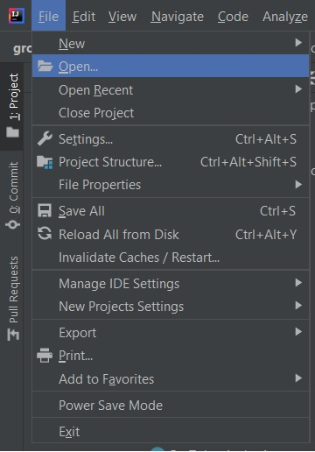

Navigate to the folder where the project is and select only groupAssignment20202021fall-startproject from within that folder (NOT THE PARENT FOLDER).

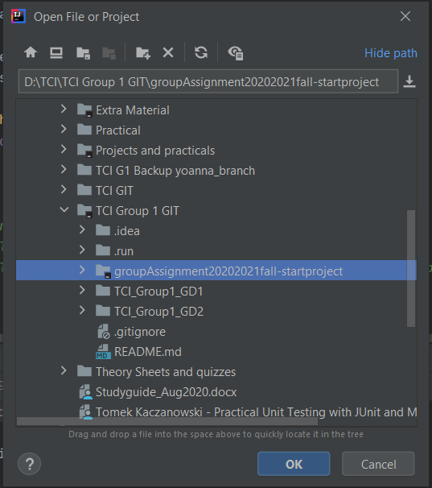

## Solving Issue 2

If by running the project not all tests are reachable then some configurations might be missing.

Step 1: In IntelliJ select Run -> Edit Configurations

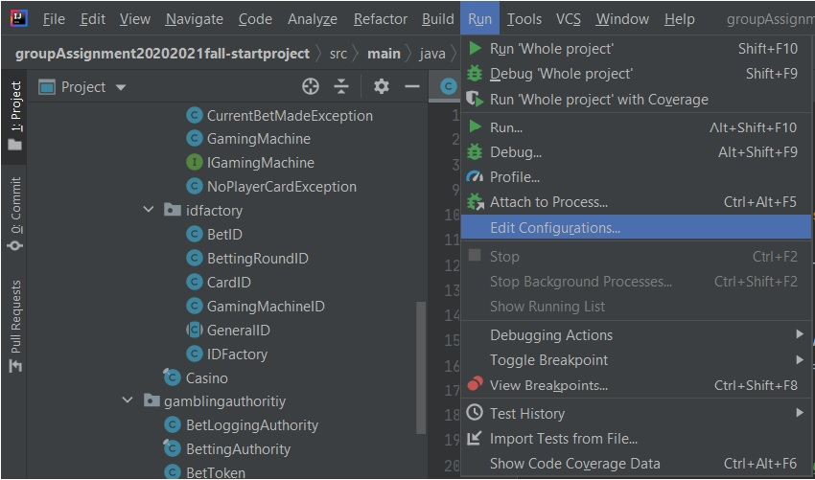

Afterwards, a pop-up window called Run/Debug Configurations will appear. Select the Plus sign to add a new configuration. From its drop-down menu select Junit.

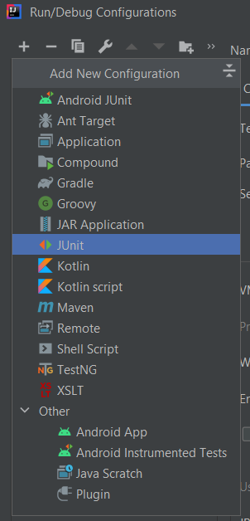

Give it a name, like Whole Project or Run All Tests etc. Let the test kind be All in package and let tests be searched in whole project.

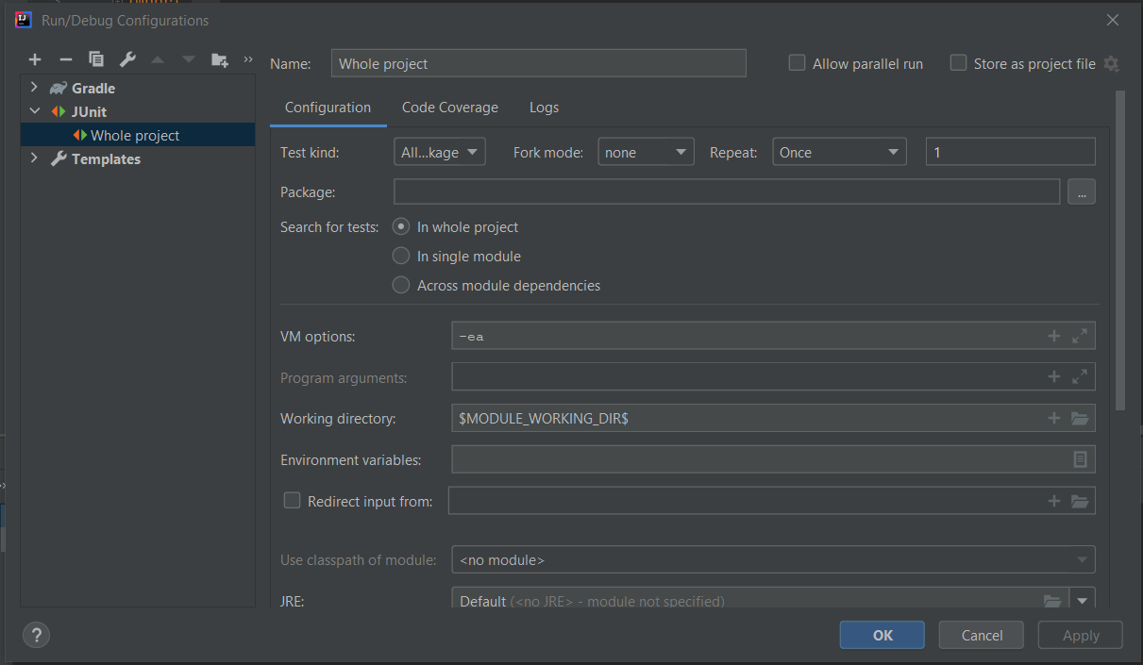

Apply the changes then select OK to close the window.

In ItelliJ select the newly created configuration to run from the drop-down menu. Now all test will run.

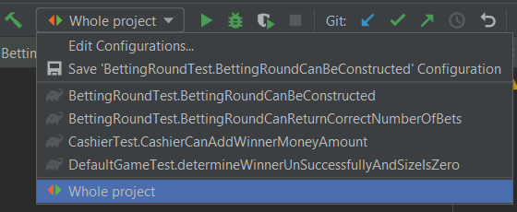

Run the configuration.