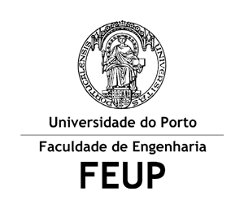

D5: Informações sobre Literatura em Linguagem Natural
Relatório Intercalar

Inteligência Artificial
3º ano do Mestrado Integrado em Engenharia Informática e Computação

Group Elements:
Daniela José Antão João – up201505982@fe.up.pt
João Miguel Matos Monteiro – up201506130@fe.up.pt
Nelson André Garrido da Costa – up201403128@fe.up.pt

7 de Abril de 2018

Goal:
The goal of this project is to implement a program that will help to obtain several information about writers and their literary works using Natural Language.

Description:
The program must interpret and answer to sentences written in Natural Language using DCGs. The program must include information about writers and their literary works.
The program must respect the following requirements:
- Acceptance of affirmative sentences.
- Acceptance of interrogative sentences.
- Verification of the sentence syntax
- Verification of sentence semantics.
- Inclusion of more than one commands. This inclusion means the use of the particle “and” in a sentence.
- Acceptance of sentences beginning with the particle “and”, by saving the context of the previous sentence to answer the new sentence.
- Use of adjectives and modifiers.

Work Done So Far:
We chose to do our program in English in order to simplify the gender and number agreement.

Grammatical Module:
sentence -->subject, verbComp, object.
verbComp --> verbAux, verb |verb.
subject -->noun | modifier, noun | verb, noun.
object -->noun | modifier, noun| modifier, modifier, noun | modifier, adjective, noun.

Knowledge base Module:

modifier --> [the].
modifier --> [in].
modifier --> [a].

noun -->[fernandoPessoa].
noun --> [osMaias].
noun --> [ecaDeQueiroz].
noun --> [writer].
noun --> [book].
noun --> [portugal].
noun --> [xviiiCentury].

verb -->[wrote].
verb --> [born].
verb -->[was].
verb --> [is].
verb -->[did].
verbAux-->[was].
verbAux --> [is].
verbAux -->[did].

born([ixxcentury], [ecaDeQueiroz]).
wrote([jamesjoyce], [ulysses]).
wrote([ecaDeQueiroz], [osMaias]).
born([portugal], [fernandoPessoa]).

Tests Module
The following tests test the syntax agreement between words:

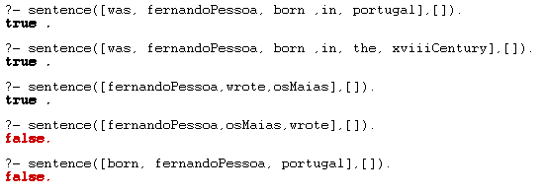

Expected interaction with the user:
This program must accept and answer to sentences like the following ones:

- Who has written Os Maias?
- Which are the most famous books from Fernando Pessoa?
- Who are the African writers?
- And Portuguese?
- Who are the Portuguese and Spanish writers from the XV century?
- How many books from African writers date from after the XVI century?
- Which one is the more recent?
- Alberto Caeiro is an heteronymuos of Fernado Pessoa.

Conclusion:
At the time of the elaboration of this report we’ve realized that there’s still a lot of work to do, but we think we have a good starting point that we can use to build a complex and robust program by adding increments to the modules already done.

Resources:

Software:
SWI-PROLOG
ATOM

Bibliography:
https://paginas.fe.up.pt/~eol/IA/

http://www.amzi.com/AdventureInProlog/a15nlang.php

