Waltham Forest International Site

A simple mobile website that can be viewed on full screen, ipad, android and mobile.

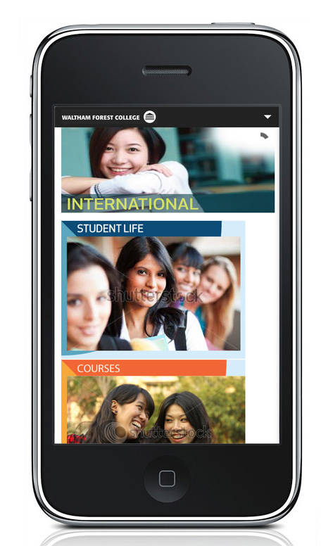

Contents

Admin

Editing existing Courses

Creating New Courses

Front Page Images

Creating New Main Page

Creating New Sub-Page

Change Password

Admin

To login and update the site, use the following address with your user-name and password:

http://www.waltham.ac.uk/international/login

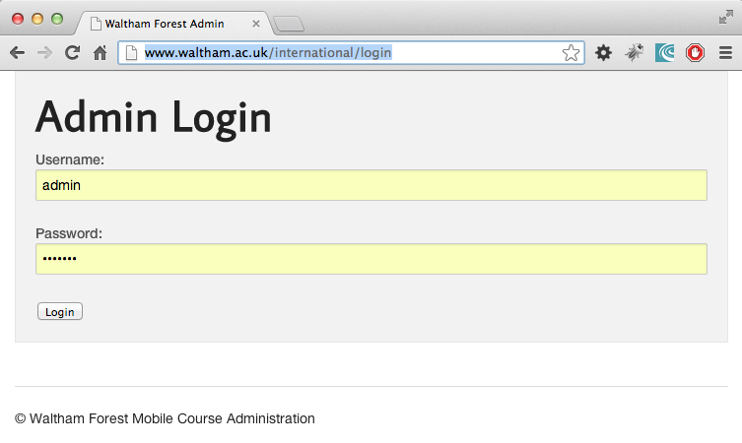

Editing Existing Courses

To access International Courses from the database, either:

1) On the admin home page, select International Course List button

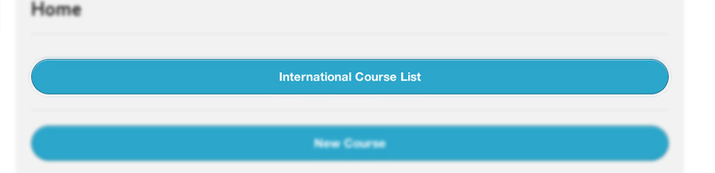

2) Or use the top menu to select Courses:

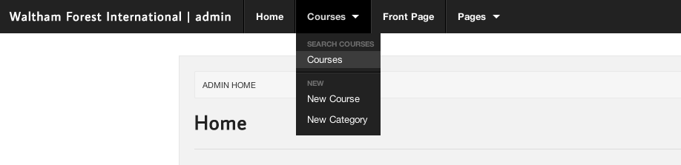

Once selected, you will see a list of the Course Categories:

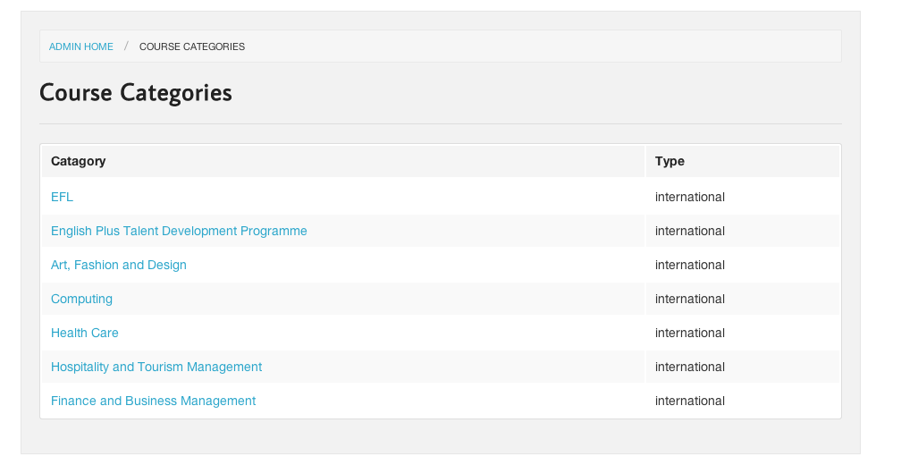

Selecting any of the blue category links will reveal courses within that category:

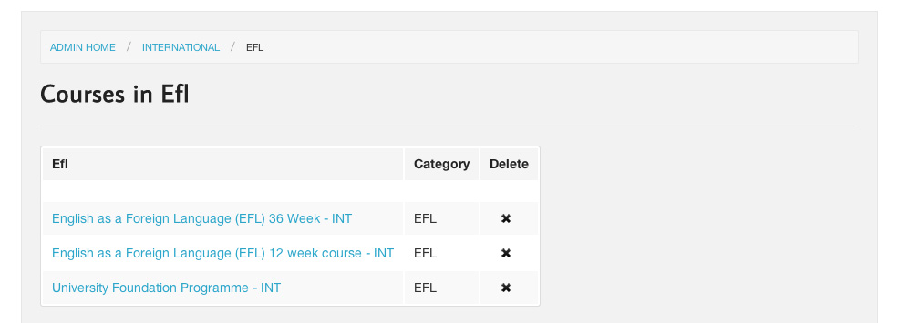

You can delete a course, by pressing the cross beside the course name.

To view or edit a course, select the course name in blue.

Update a Course

Edit any of text fields:

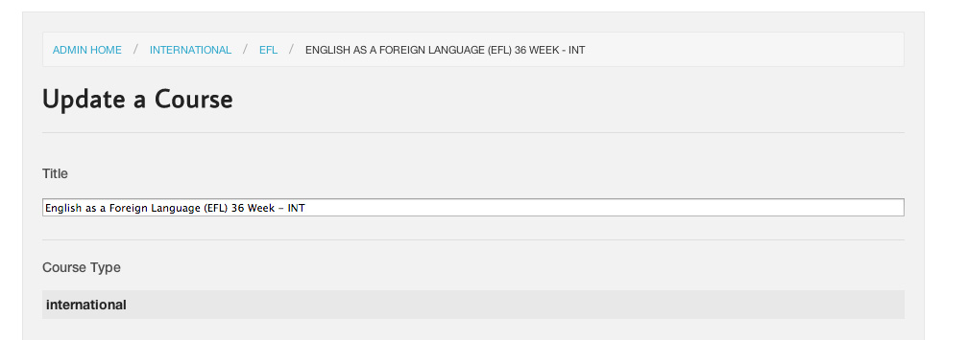

To save and update changes press the cyan button at the bottom of the page:

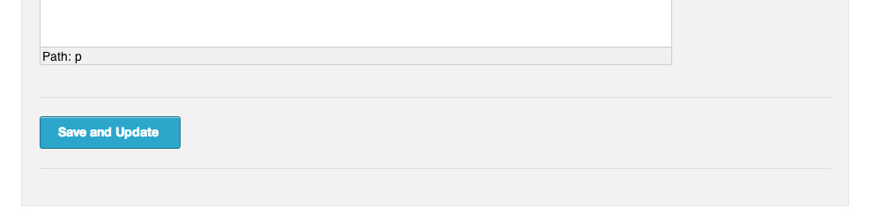

Insert New Course

To create a New Course, either:

1) On the admin home page, select New Course button



2) Or use the top menu to select New Course button:

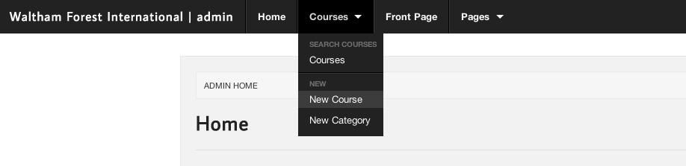

Add to any of text fields (the title field is required):

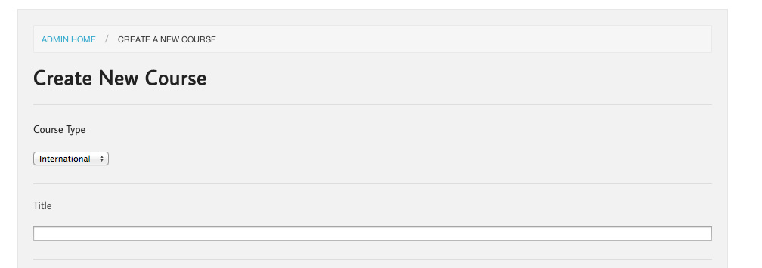

To save the course, press the cyan button at the bottom of the page:

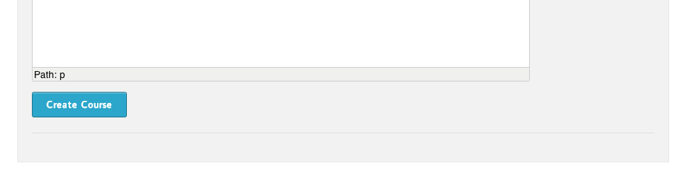

Front Page Image

This section refers to the un-blurred images below on the front of the public site:



To edit and re-arrange these images via the admin panel, find:

- The front-page button on the admin home page
- Or from the main menu at the top of all the admin pages.

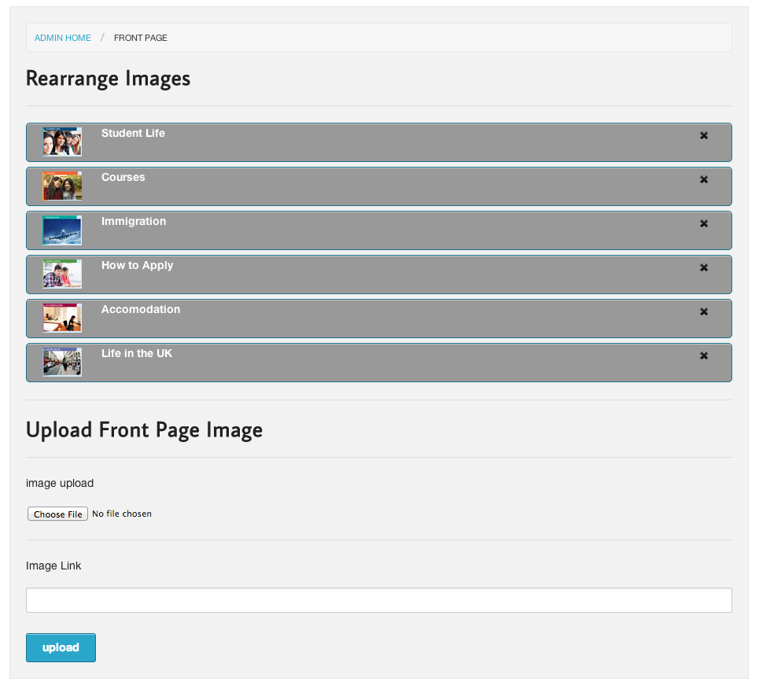

Re-arrange order of images
To re-arrange the order of existing images, move your curser over the grey bar until the curser changes to a cross. You can now click and drag to re-order, just let the curser go in the required position.

Delete an image
Click the cross within the grey box to delete the image, you will be prompted to confirm and the image will be deleted.

Upload Front Page Image
Press choose file and select an image from your computer, once ready, press the upload button

You can link to any other page or website via the Link field, paste a URL / Web address in the field and the image you have uploaded will link to that page or website. If you don’t want it to link to anything, just leave the hash #.

Edit image
Click on the text beside the image in the grey bar. This will open a new page to enable the replacement of the image and update the name, link and description of the image.

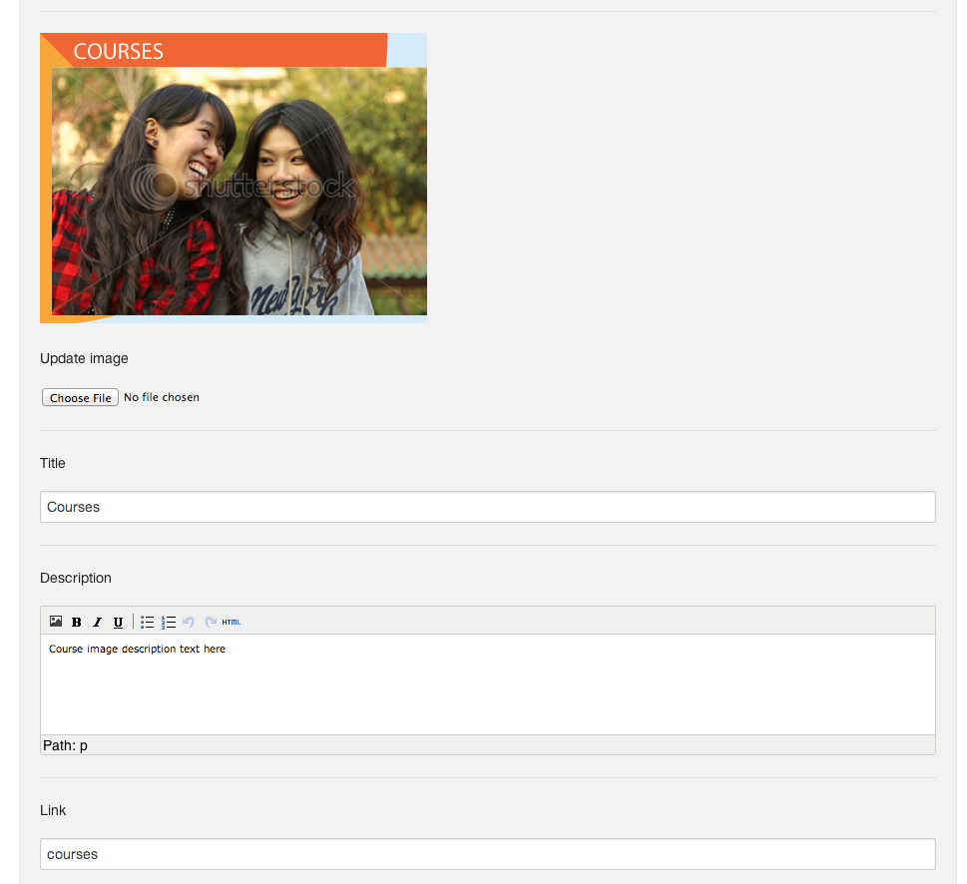

Create a New Main Page

To create a new main page, either:

1) On the admin home page, select New Main Page
2) Or use the top menu to select New Main Page

Add the title and content, (the title is a required field) and press the New Main Page button at the bottom. You will then be redirected to the Main Page List page.

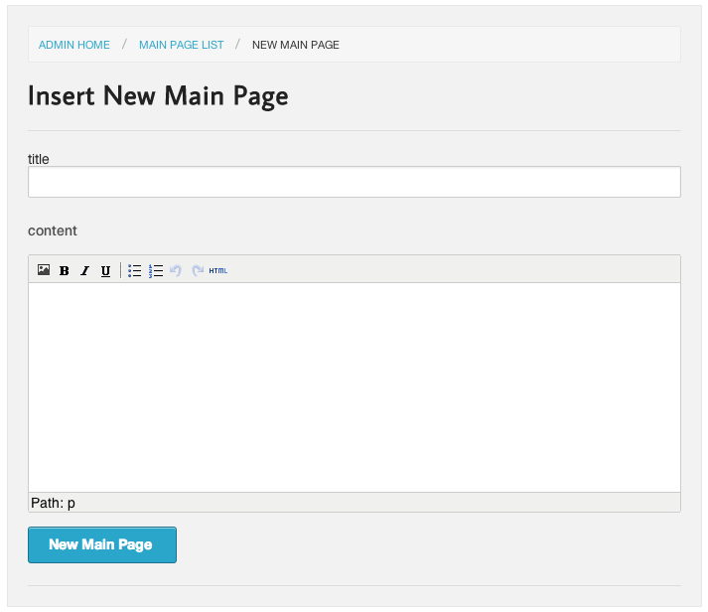

Main Page List

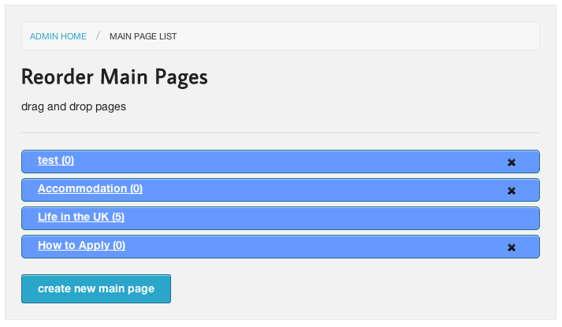

Re-arrange order of Main pages
To re-arrange the order of existing Main Pages, move your curser over the blue bar until the curser changes to a cross. You can now click and drag to re-order, just let the curser go in the required position. The re-ordering of the pages will also show on the main navigation of the public site:

Delete a Main Page
Click the cross within the blue bar to delete the Main page, you will be prompted to confirm and the page will be deleted.

If you don’t see a cross beside the text, it means that you have sub-pages assigned to the main page so it can’t be deleted.
Note. you can tell how many sub-pages assigned to a main pages by the number in brackets next to the name of the main page.

Edit Main Page
Click on the text in the blue bar. This will open a section to enable editing of the name and content of the Main page:
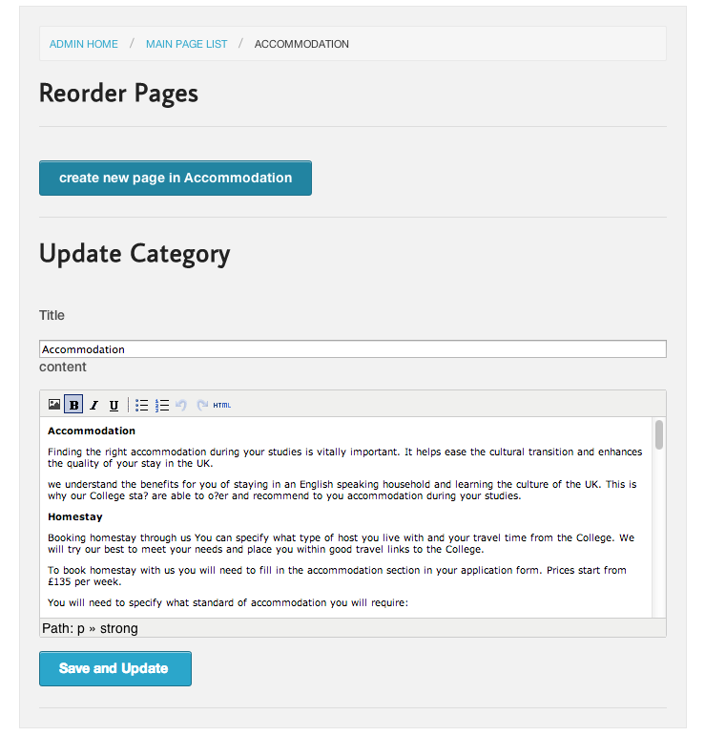

Creating New Sub-Page

There are two ways to create a sub-page select:

1) If you are in the Edit page of a Main Page, you can create new page by clicking on the blue button that says “Create new Sub-page in….” eg,

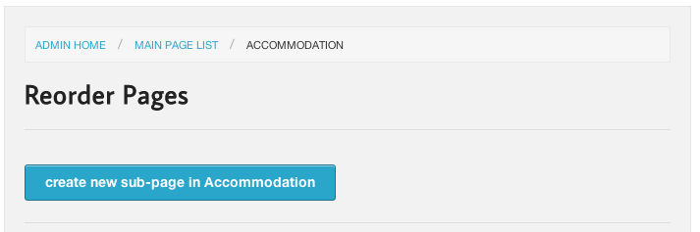

2) From the drop down menu “pages” in Admin, you can also create a new page:
By selecting “new sub-page.”

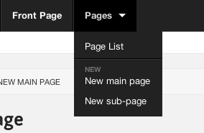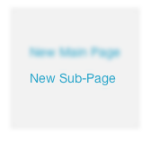

Then you can connect it to an existing main page, via the category section:

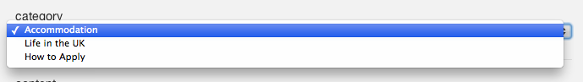

You can now add the title and content to the new sub-page.

You can save the page by pressing the following:

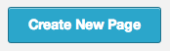

You will now be redirected to the Main Edit Page with new blue bars representing the pages within the main page, e.g.

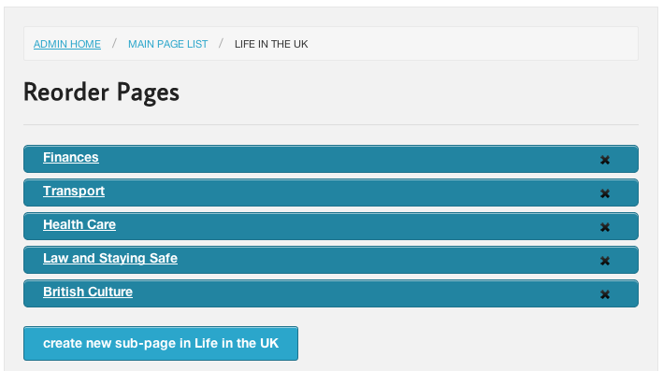

You can drag and drop these in any order and this will also be shown in the order on the main site and they will be seen as a drop down menu of Main pages:

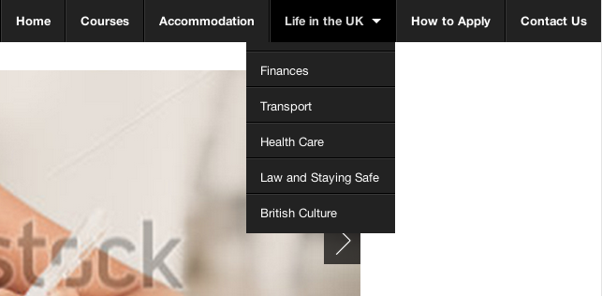

Please note, if a sub-page has been created within a main page, only the title of the Main page will remain in the public site as a button to reveal the sub-pages.

Change Password

You can change your assigned password by going to preferences from the top menu in the Admin panel:

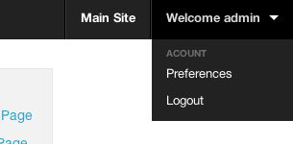

Once you have selected preferences, provide your current password and add a new one in each of the fields, the password field must be at least 6 characters in length.

