SQL Mini Project – Forero, Daniel

**Point Value:** 100

# Instructions

The SQL mini-project assignment is designed to test your skills acquired in Lessons 2 to 4. You will be required to create and submit SQL queries for various scenarios using the sample database.

Students will be submitting a word document along with *.sql file. You can submit the assignment multiple times before the submission deadline. I will be grading your latest submission.

## Database

For this project, you will be working with the sample **ScrubsHospital** database. You can access the database by logging into the Virtual Lab’s SQL server instance.

## tables

The **ScrubsHospital** database has the following tables-

***physician:***

* employeeid – this is a unique ID of a physician
* name – this is the name of a physician
* position – this is the designation of a physician
* ssn – this is a security number of a physician

***department:***

* departmentid – this is a unique ID for a department
* name – this is the name of a department
* head – this is the ID of the physician who is the head of a department, referencing to the column employeeid of the table physician

***affiliated_with:***

* physician – this is the ID of the physicians which is referencing to the column employeeid of the physician table
* department – this is the ID the department which is referencing to the column departmentid of the department table
* primaryaffiliation – this is a logical column which indicate that whether the physicians are yet to be affiliated or not
* *Note: The combination of physician, department will come once in that table.*

***MedProcedures:***

* code – this is the unique ID of a medical procedure
* name – the name of the medical procedure
* cost – the cost for the procedure

***trained_in:***

* physician – this is ID of the physicians which is referencing to the column employeeid of the physician table
* treatment – this is the ID of the medical procedure which is referencing to the column code of the procedure table
* certificationdate – this is the starting date of certification
* certificationexpires – this is the expiry date of certification
* *Note: The combination of physician and treatement will come once in that table.*

***patient:***

* ssn – this is a unique ID for each patient
* name – this is the name of the patient
* address – this is the address of the patient
* phone – this is the phone number of the patient
* insuranceid – this is the insurance id of the patient
* pcp – this is the ID of the physician who primarily checked up the patient which is referencing to the column employeeid of the physician table

***nurse:***

* employeeid – this is the unique ID for a nurse
* name – name of the nurses
* position – the designation of the nurses
* registered – this is a logical column which indicate that whether the nurses are registered for nursing or not
* ssn – this is the security number of a nurse

***appointment:***

* appointmentid – this is the unique ID for an appointment
* patient – this is the ID of each patient which is referencing to the ssn column of patient table
* prepnurse – the ID of the nurse who may attend the patient with the physician, which is referencing to the column employeeid of the nurse table
* physician – this is the ID the physicians which is referencing to the employeeid column of the physician table
* start_dt_time – this is the schedule date and approximate time to meet the physician
* end_dt_time – this is the schedule date and approximate time to end the meeting
* examinationroom – this the room where to meet a patient to the physician

***medication:***

* code – this is the unique ID for a medicine
* name – this is the name of the medicine
* brand – this is the brand of the medicine
* description – this is the description of the medicine

***prescribes:***

* physician – this is the ID of the physician referencing to the employeeid column of the physician table
* patient – this is the ID of the patient which is referencing to the ssn column of the patient table
* medication – the ID of the medicine which is referencing to the code of the medication table
* date – the date and time of the prescribed medication
* appointment – the prescription made by the physician to a patient who may taken an appointment which is referencing to column appointmentid of appointment table
* dose – the dose prescribed by the physician
* *Note: The combination of physician, patient, medication, date will come once in that table.*

***block:***

* blockfloor – ID of the floor
* blockcode - ID of the block
* *Note: The combination of blockfloor, blockcode will come once in that table.*

***room:***

* roomnumber – this is the unique ID of a room
* roomtype – this is type of room
* blockfloor - this is the floor ID where the room in
* blockcode – this is the ID of the block where the room in
* unavailable – this is the logical column which indicate that whether the room is available or not
* *Note: The of blockfloor, blockcode columns are refercing to the combination of blockfloor and blockcode columns of the table block.*

***on_call:***

* nurse – this is ID of the nurse which is referencing to the employeeid column of the table nurse
* blockfloor - this is the ID of the floor
* blockcode – this is the ID of block
* oncallstart - the starting date and time of on call duration
* oncallend – the ending date and time of on call duration
* *Note: The combination of nurse, blockfloor, blockcode, oncallstart, oncallend will come once in that table and the combination of blockfloor, blockcode columns are refercing to the combination of blockfloor and blockcode columns of the table block .*

***stay:***

* stayid - this is unique ID for the admission
* patient – this is the ID of the patient which is referencing the ssn column of patient table
* room - this is the ID of the room where the patient admitted and which is referencing to the roomnumber column of the room table
* start_time – this is the time when a patient admitted
* end_time – this is the time how long a patient is staying

***undergoes:***

* patient - this is ID of the patient which is referencing to the ssn column of the patient table
* procedure – this is ID of the procedure and referencing to the code column of the procedure table
* stay - this is the ID admission of a patient, which is referencing to the stayid column of the stay table
* date – this is the date when a patient undergoes for a medical procedure
* physician – this is the ID of a physician which is referencing to the column employeeid of the table physician
* assistingnurse – this is the ID of a nurse who will assists the physician, referencing to the column employeeid of the table nurse
* *Note: The combination ofpatient, procedure, stay, date will come once in that table.*

## Entity Relationship (ER) Diagram

Please refer to the Database Diagram “ERDiagramScrubs” in the database.



Tip: Below is a snapshot of the ER diagram. Please zoom in to see details in the picture below.



## **Project Questions**

For this project, you will be using the **ScrubsHospital** database to write the SQL queries for the following scenarios. You need to submit the SQL query for each question and a snapshot of the output (edited screenshot of the Result window in SSMS).

1. List the details of all nurses. In your output, generate an additional column called “Comment” and populate it with the text “Send registration reminder” if the nurse is not registered. [5pt]

SELECT N.EmployeeID, N.Name Nurse, N.Position, N.Registered, N.SSN,

case

when N.Registered = 0 then 'Send registration reminder'

end as Comment

FROM [ScrubsHospital].[dbo].[Nurse] as N;

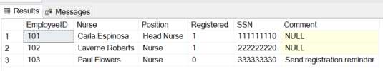

1. List all the departments and their head’s names along with the position of the head. [5pt]

Select D.Name Department, P.Name DeptHead, P.Position

from [ScrubsHospital].[dbo].[Department] as D, [ScrubsHospital].[dbo].Physician as P

where D.head = P.EmployeeID;

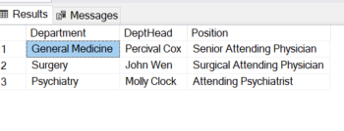

1. List the names of all patients and the number of appointments they have made where the examination room was “A”. [5pt]

select P.Name,count( case

when convert(varchar,A.ExaminationRoom) = 'A' then 1

end ) 'count appts in room A'

from [ScrubsHospital].[dbo].Patient as P, [ScrubsHospital].[dbo].Appointment as A

where P.SSN = A.Patient

group by P.Name;

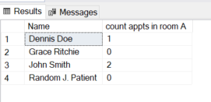

1. List all the unique patient names who got an appointment in room “B”. [5pt]

select distinct P.Name, convert(varchar(max),A.ExaminationRoom) ExamRoom

from [ScrubsHospital].[dbo].Patient as P, [ScrubsHospital].[dbo].Appointment as A

where P.SSN = A.Patient

and convert(varchar(max),A.ExaminationRoom) = 'B';

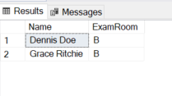

1. List the names of all physicians who are trained in a particular medical procedure along with the name of the procedure. Also list their certification expiration date. You should have the following columns in your output- Physician name, Med Procedure Name, Certificate expiration. [10pt]

Select P.Name Physician, MP.Name MedicalProcedure, T.CertificationExpires

from [ScrubsHospital].[dbo].Physician as P, [ScrubsHospital].[dbo].Trained_In as T, [ScrubsHospital].[dbo].MedProcedures as MP

where p.EmployeeID = T.Physician

and T.Treatment = MP.Code;

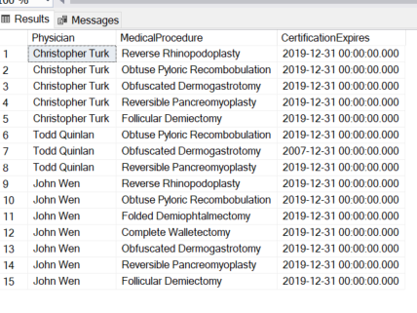

1. List all the physicians with department who are not affiliated. Your output should contain columns with the names – Physician name, Department Name, Physician Position. [10pt]

Select P.Name Physicians, D.Name Department, P.Position

from [ScrubsHospital].[dbo].Physician as P, [ScrubsHospital].[dbo].Department as D, [ScrubsHospital].[dbo].Affiliated_With as A

where A.PrimaryAffiliation = 0

and A.Physician = p.EmployeeID

and A.Department = D.DepartmentID;

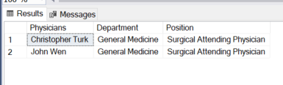

1. List the names of patients and their PCP only if their PCP is trained in a medical procedure. [10pt]

select distinct P.Name Patient, DR.Name PCP

from [ScrubsHospital].[dbo].Patient as P, [ScrubsHospital].[dbo].Trained_In as T, [ScrubsHospital].[dbo].Physician as DR

where P.PCP = T.Physician

and DR.EmployeeID = P.PCP;

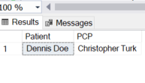

1. List the names of patients and the number of physicians they have taken appointments with only if the number of physicians is greater than 1. [10pt]

select P.Name Patient, COUNT( distinct A.Physician) PhysicianCount

from [ScrubsHospital].[dbo].Patient as P, [ScrubsHospital].[dbo].Appointment as A, [ScrubsHospital].[dbo].Physician as DR

where P.SSN = A.Patient

and A.Physician = DR.EmployeeID

group by P.Name

having COUNT( distinct A.Physician) > 1

order by P.Name;

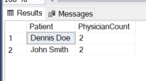

1. List all the patients along with their physician names, nurse names and room numbers when the patient has an appointment anytime between 4/21/2019 and 4/24/2019. [10pt]

select P.Name Patient, DR.Name Physician, N.Name Nurse, A.ExaminationRoom 'Room Number'

from [ScrubsHospital].[dbo].Appointment as A, [ScrubsHospital].[dbo].Patient as P, [ScrubsHospital].[dbo].Physician as DR, [ScrubsHospital].[dbo].Nurse as N

where A.Start > convert(date,'2019-04-20',102)

and A.[End] < convert(date,'2019-04-25',102)

and A.Patient = P.SSN

and A.Physician = DR.EmployeeID

and A.PrepNurse = N.EmployeeID;

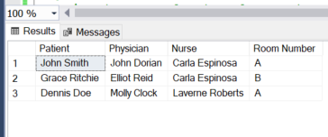

1. List all the patient names and their medications for patients who did not make an appointment. [10pt]

Select P.Name Patient, MED.Name Medication

from [ScrubsHospital].[dbo].Patient as P, [ScrubsHospital].[dbo].Prescribes as RX, [ScrubsHospital].[dbo].Medication as MED

where P.SSN = RX.Patient

and RX.Medication = MED.Code

and RX.Appointment is null;

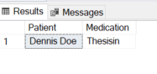

1. List the count of number of rooms that are unavailable on each block on each floor. Make sure to order the list by floor and block number. Your output should have the columns – “Floor”, “Block” and “# of unavailable rooms” [10pt]

select R.BlockFloor as Floor, R.BlockCode as Block, sum( ( case

when R.Unavailable = 1 then 1

else 0

end ) ) as '# of unavailable rooms'

from [ScrubsHospital].[dbo].Room as R

group by R.BlockFloor, R.BlockCode

order by R.BlockFloor, R.BlockCode;

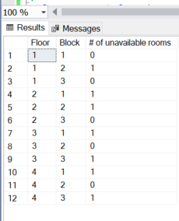

1. List the floor where there are minimum number of rooms unavailable. Your output should have the floor number, max number of rooms possible on the floor and the number of rooms unavailable. [10pt]

select top 1 * from (

select R.BlockFloor AS Floor, count( R.Unavailable ) as 'Max # of rooms on the floor',

sum( ( case

when R.Unavailable = 1 then 1

else 0

end ) ) as NumRoomsUnavail

from [ScrubsHospital].[dbo].Room as R

group by R.BlockFloor) as MinUnavail

order by NumRoomsUnavail;

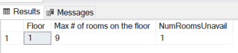

# What to submit

1. You will be uploading two file-
   * A word document (Lastname_Firstname.docx): showing the SQL queries along with output for each of the scenario questions.
   * A SQL file (Lastname_Firstname.sql): containing the SQL queries for all the questions along with question numbers in the comments for each scenario.
2. For each of the questions in the project, provide the SQL query and along with a snapshot of the output obtained from the query execution in SSMS.

Example:

Q. List all the physician names and their positions.

Answer:

SELECT [Name] as "Physician Name"

,[Position]

FROM [ScrubsHospital].[dbo].[Physician]

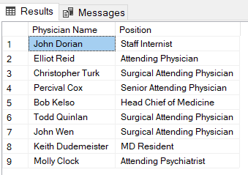

1. DO NOT insert a screenshot of the entire screen. You only need to provide the snapshot of Results window. Points will be deducted if the snapshot is not properly edited to display only the relevant information as shown in point #2 above.

Example: this is NOT acceptable

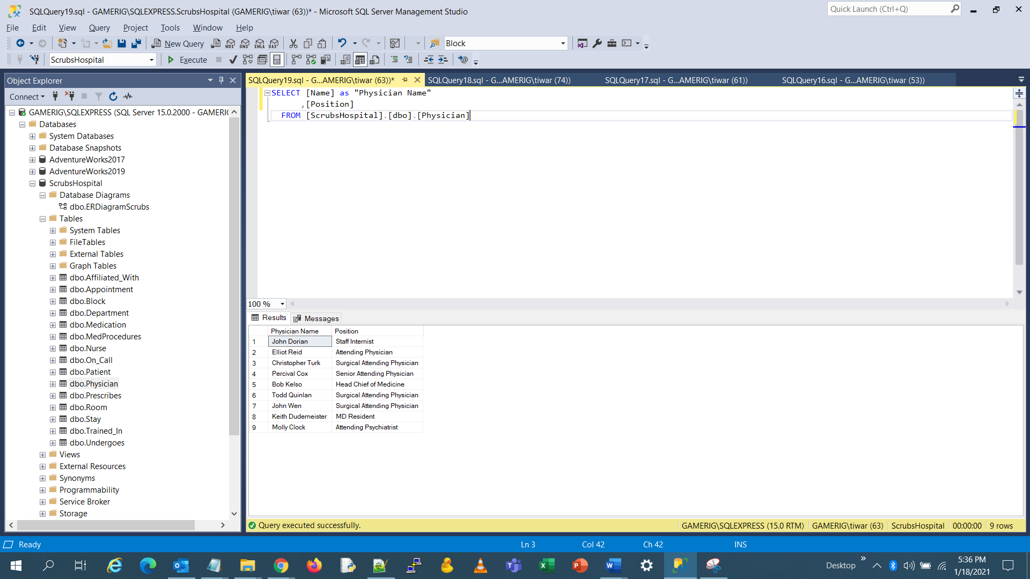

1. In your SQL file, you will put a comment corresponding to each question number and then the query below it. All queries need to be separated with semicolon and the entire sql file should be error free. I will execute all the queries at the same time from the file.

Example: You SQL file will look something like this-

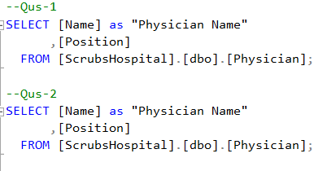

1. Name your word submission file “Lastname_Firstname.docx” and your SQL submission file “Lastname_Firstname.sql”. Upload both these files on the assignment page in Canvas for submission. Note: you need to submit both the files together in your submission.
2. Please note that the system might automatically append numbers to your file names after the submission. This is an acceptable behavior. As long as I can see your last name and first name, your submission will be valid. If the file name does not have your last name and first name, points will be deducted.
3. You can submit multiple times before the project deadline and your most recent version will be graded. But during each submission, both files (word and sql) need to be submitted together. Word file from one submission and sql file from another submission will not be graded. Both files need to be from the same submission attempt.