Implementing a Secure Network Architecture for a Large Enterprise

Prepared by:
Harsh Dankhra — Cybersecurity Intern

Table of Contents
1. Abstract 4
2. Introduction 5
2.1 Background 5
2.2 Problem Statement 6
2.3 Objectives of the Project 6
3. Current Network Security Assessment 8
3.1 Existing Network Architecture Risks 8
3.2 Identified Security Challenges 9
4. Proposed Secure Network Architecture 10
4.1 Secure Enterprise Network Architecture 10
4.2 Enterprise Perimeter Security Architecture 12
4.3 VLAN-Based Network Segmentation 14
4.4 Secure Remote Access via VPN 15
4.5 Security Monitoring and Logging Architecture 17
5. Implementation of Security Components 19
5.1 Firewall Implementation (pfSense) 19
5.2 Intrusion Detection System (Snort) 19
5.3 Network Segmentation using VLAN 20
5.4 Secure Remote Access using OpenVPN 20
5.5 Monitoring and Logging 20
6. Practical Demonstration (Proof of Concept) 22
6.1 Firewall Deployment Verification 22
6.2 Firewall Rule Configuration 23
6.3 Snort IDS Configuration 24
6.4 Snort Interface Monitoring 24
6.5 Attack Simulation using Kali Linux 25
6.6 Snort Attack Detection 26
6.7 OpenVPN Server Configuration 27
6.8 VPN Client Connection 28
6.9 Firewall Log Monitoring 29
7. Security Policies and Compliance 30
8. Incident Response Strategy 31
9. Results and Discussion 32
10. Conclusion 33
11. Future Improvements 34
12. References 35

1. Abstract
Modern enterprises rely heavily on interconnected networks to support business operations, communication, and data management. However, the increasing number of cyber threats such as unauthorized access, network attacks, and data breaches has made network security a critical requirement for organizations. A secure network architecture is essential to ensure the confidentiality, integrity, and availability of enterprise resources.
This project focuses on the design and implementation of a secure network architecture for a large enterprise environment. The proposed architecture integrates multiple security mechanisms including a firewall, intrusion detection system (IDS), network segmentation, secure remote access, and monitoring systems. The pfSense firewall is deployed to control network traffic and enforce security policies at the network perimeter. An intrusion detection system using Snort is implemented to detect suspicious activities and potential attacks within the network. Network segmentation is achieved using VLANs to separate different departments such as Human Resources (HR), Information Technology (IT), and Finance, thereby reducing the risk of lateral movement during cyber attacks.
In addition to internal network protection, secure remote access is implemented using OpenVPN to allow authorized employees to access enterprise resources securely over the internet. The architecture also incorporates monitoring and logging mechanisms to track network activities and detect anomalies in real time. To demonstrate the effectiveness of the proposed architecture, practical testing is performed using a simulated attack from Kali Linux, and the results are captured through proof-of-concept (PoC) demonstrations.
The implementation shows that combining firewall protection, intrusion detection, VPN-based secure access, and network monitoring significantly enhances enterprise network security. The proposed architecture provides a scalable and reliable framework that can be adapted by organizations to protect their network infrastructure from modern cyber threats.

2. Introduction
2.1 Background
In today’s digital era, enterprise organizations depend heavily on computer networks for communication, data sharing, and service delivery. As organizations grow and expand across multiple locations, their network infrastructure becomes increasingly complex. This complexity introduces numerous security challenges, including unauthorized access, malware attacks, data breaches, and network vulnerabilities.
Cyber attackers often target enterprise networks to gain access to sensitive information, disrupt operations, or exploit system weaknesses. Traditional network designs without proper security mechanisms are highly vulnerable to such threats. Therefore, organizations must implement a secure network architecture that integrates multiple layers of protection to safeguard their systems and data.
Modern enterprise security architectures rely on various security technologies such as firewalls, intrusion detection and prevention systems (IDS/IPS), secure remote access solutions, and network segmentation. Firewalls help filter and control incoming and outgoing traffic, while IDS/IPS systems monitor network activities to detect malicious behavior. Network segmentation divides the network into smaller segments to limit the impact of attacks, and VPN technologies enable secure communication for remote users.
This project focuses on implementing a secure enterprise network architecture using widely adopted security tools such as pfSense firewall, Snort intrusion detection system, VLAN segmentation, and OpenVPN remote access. By combining these technologies, the architecture provides multiple layers of security that protect enterprise networks from internal and external threats.

2.2 Problem Statement
Large enterprise networks often face multiple security challenges due to their distributed infrastructure and increasing number of connected devices. Without proper security mechanisms, organizations may experience unauthorized access, network intrusions, and data leaks. Traditional networks that lack firewall protection, intrusion detection systems, and proper segmentation are particularly vulnerable to cyber attacks.
Another major challenge is secure remote access. Many employees work remotely or access enterprise resources from different locations. If remote access is not properly secured, attackers can exploit these connections to gain unauthorized access to internal systems. Additionally, the absence of monitoring and logging mechanisms makes it difficult for administrators to detect and respond to security incidents.
Therefore, there is a need for a comprehensive network security architecture that integrates multiple security technologies to protect enterprise resources. The architecture must provide secure communication, monitor network activities, detect potential threats, and restrict unauthorized access across the network infrastructure.

2.3 Objectives of the Project
The primary objective of this project is to design and implement a secure network architecture suitable for a large enterprise environment. The project focuses on integrating multiple security mechanisms to protect enterprise systems and data from potential cyber threats.
The key objectives of this project include:
• Designing a secure enterprise network architecture that incorporates firewall protection, network segmentation, and monitoring mechanisms.
• Implementing a pfSense firewall to control network traffic and enforce security policies at the network perimeter.
• Deploying the Snort Intrusion Detection System (IDS) to monitor network activities and detect potential attacks.
• Implementing VLAN-based network segmentation to separate different departments and reduce the risk of lateral attacks.
• Establishing secure remote access using OpenVPN to allow employees to connect to the enterprise network securely from remote locations.
• Monitoring network traffic and security events through firewall logs and IDS alerts to ensure visibility and incident detection.
• Demonstrating the effectiveness of the proposed architecture through practical testing and proof-of-concept demonstrations.

3. Current Network Security Assessment
3.1 Existing Network Architecture Risks
In many enterprise environments, traditional network architectures were designed primarily for connectivity and operational efficiency rather than security. As organizations expanded their infrastructure and connected more devices, these networks became increasingly vulnerable to modern cyber threats. Without proper security mechanisms in place, attackers can exploit weaknesses in the network to gain unauthorized access, steal sensitive data, or disrupt services.
One of the major risks in traditional enterprise networks is the lack of strong perimeter security. Without a properly configured firewall, malicious traffic from external networks may enter the internal infrastructure. Attackers can exploit open ports or vulnerable services to launch attacks such as port scanning, brute-force attempts, or malware injection.
Another significant risk is the absence of intrusion detection systems. In many cases, network administrators are unaware of suspicious activities occurring within the network because there are no monitoring tools to analyze traffic patterns. Without intrusion detection capabilities, attacks such as network scanning, unauthorized access attempts, or exploitation of vulnerabilities may go unnoticed.
Additionally, enterprise networks that lack segmentation are more susceptible to lateral movement during cyber attacks. If an attacker gains access to one part of the network, they may be able to move freely across other systems and servers. This can lead to the compromise of multiple departments and sensitive information within the organization.
The increasing use of remote work also introduces security challenges. Employees often access enterprise resources from external networks, which may not be secure. If remote connections are not properly protected through secure technologies such as Virtual Private Networks (VPNs), attackers may intercept data or gain unauthorized access to internal systems.

3.2 Identified Security Challenges
During the assessment of a typical enterprise network environment, several security challenges are commonly identified. These challenges highlight the need for a more secure and structured network architecture.
One of the primary challenges is insufficient network visibility. Without proper monitoring tools, administrators may not be able to detect unusual network behavior or potential security incidents. This lack of visibility makes it difficult to respond quickly to threats and increases the risk of prolonged security breaches.
Another challenge is weak access control mechanisms. In some enterprise networks, users and devices are granted broad access privileges without proper restrictions. This increases the risk of unauthorized access and insider threats. Implementing role-based access control and network segmentation can help ensure that users only access resources relevant to their roles.
Network traffic filtering is another area where many organizations face challenges. Without advanced firewall configurations, it becomes difficult to control which types of traffic are allowed into or out of the network. As a result, malicious traffic may pass through the network perimeter without being detected.
The absence of intrusion detection and prevention systems also poses a significant risk. Attackers often use techniques such as port scanning, vulnerability exploitation, and malware propagation to compromise network systems. Without IDS or IPS mechanisms, these activities may remain undetected until significant damage has already occurred.
To address these challenges, organizations must adopt a comprehensive security architecture that combines multiple security layers. This approach improves threat detection, enhances network visibility, and provides stronger protection against unauthorized access and cyber attacks.

4. Proposed Secure Network Architecture
4.1 Secure Enterprise Network Architecture
To address the security challenges identified in the previous section, a secure enterprise network architecture was designed and implemented. The proposed architecture integrates multiple security layers to protect enterprise resources from both internal and external threats. The architecture includes firewall protection, intrusion detection systems, network segmentation, secure remote access, and centralized monitoring.
At the network perimeter, a firewall is deployed to control incoming and outgoing traffic and enforce security policies. The firewall acts as the first line of defense against malicious traffic originating from external networks. It filters traffic based on predefined rules and ensures that only authorized communication is allowed within the enterprise environment.
Behind the firewall, the network is divided into different segments to isolate sensitive resources and limit the impact of potential attacks. A demilitarized zone (DMZ) is created to host public-facing services such as web servers, while the internal network is used for employee systems and internal servers.
To further enhance security, monitoring systems are implemented to analyze network activity and detect potential threats. Intrusion detection systems continuously inspect network traffic and generate alerts when suspicious behavior is detected. This layered approach ensures that even if one security mechanism fails, additional security layers continue to protect the network infrastructure.

Figure 1: Secure Enterprise Network Architecture
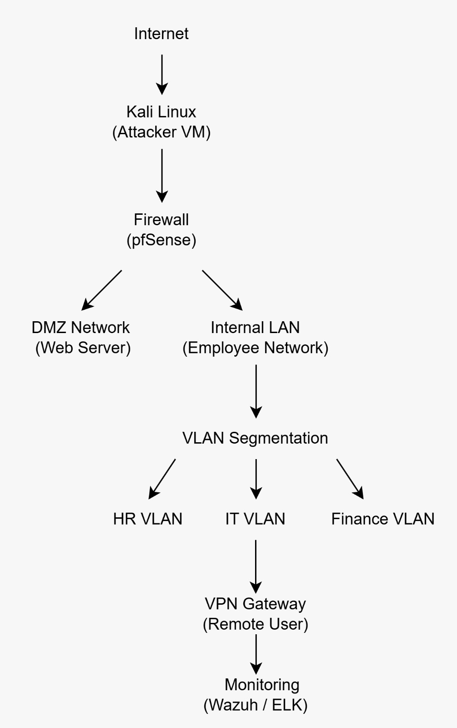

4.2 Enterprise Perimeter Security Architecture
Perimeter security is a critical component of enterprise network protection. The perimeter represents the boundary between the internal enterprise network and external networks such as the internet. Attackers often attempt to exploit vulnerabilities at this boundary to gain unauthorized access to internal systems.
In the proposed architecture, an edge router is connected to the internet and forwards traffic to the enterprise firewall. The firewall is implemented using the pfSense platform, which provides advanced traffic filtering, network address translation (NAT), and policy enforcement capabilities. The firewall ensures that only legitimate traffic is allowed to enter the internal network.
In addition to firewall protection, an intrusion detection and prevention system is deployed using Snort. The IDS monitors network traffic for known attack patterns and suspicious activities such as port scanning, brute force attacks, and abnormal traffic flows. When suspicious activity is detected, the system generates alerts that allow administrators to investigate potential threats.
By combining firewall protection with intrusion detection capabilities, the enterprise network achieves stronger perimeter defense and improved threat visibility.

Figure 2: Enterprise Perimeter Security Architecture
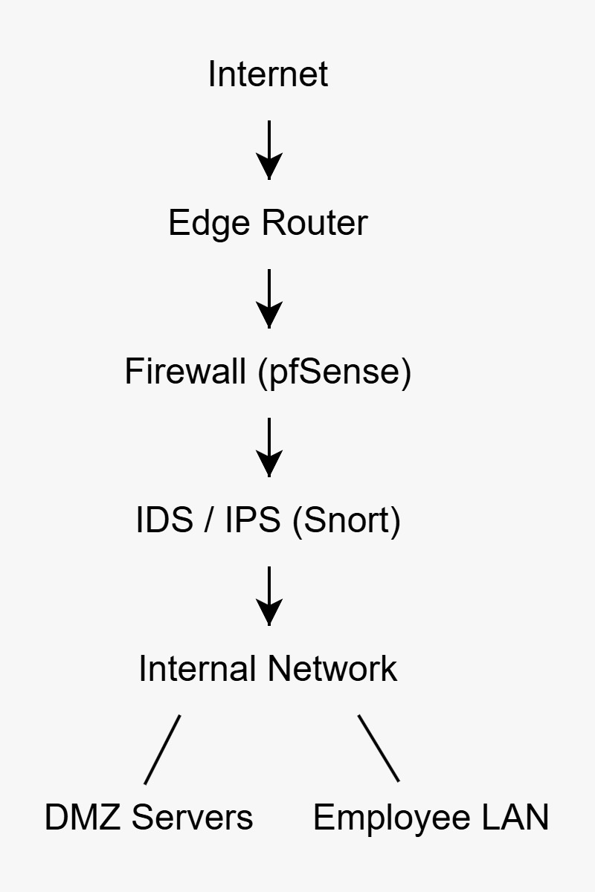

4.3 VLAN-Based Network Segmentation
Network segmentation is an important security strategy used to divide a large network into smaller and more manageable segments. This approach helps reduce the risk of lateral movement within the network in the event of a security breach. If an attacker gains access to one segment of the network, segmentation prevents them from easily accessing other parts of the infrastructure.
In the proposed architecture, Virtual Local Area Networks (VLANs) are used to separate different departments within the enterprise. Each department operates within its own isolated network segment, ensuring that traffic between departments is controlled and monitored.
This segmentation approach improves overall network security by limiting the impact of potential attacks and protecting sensitive departmental resources.

Figure 3: VLAN-Based Network Segmentation
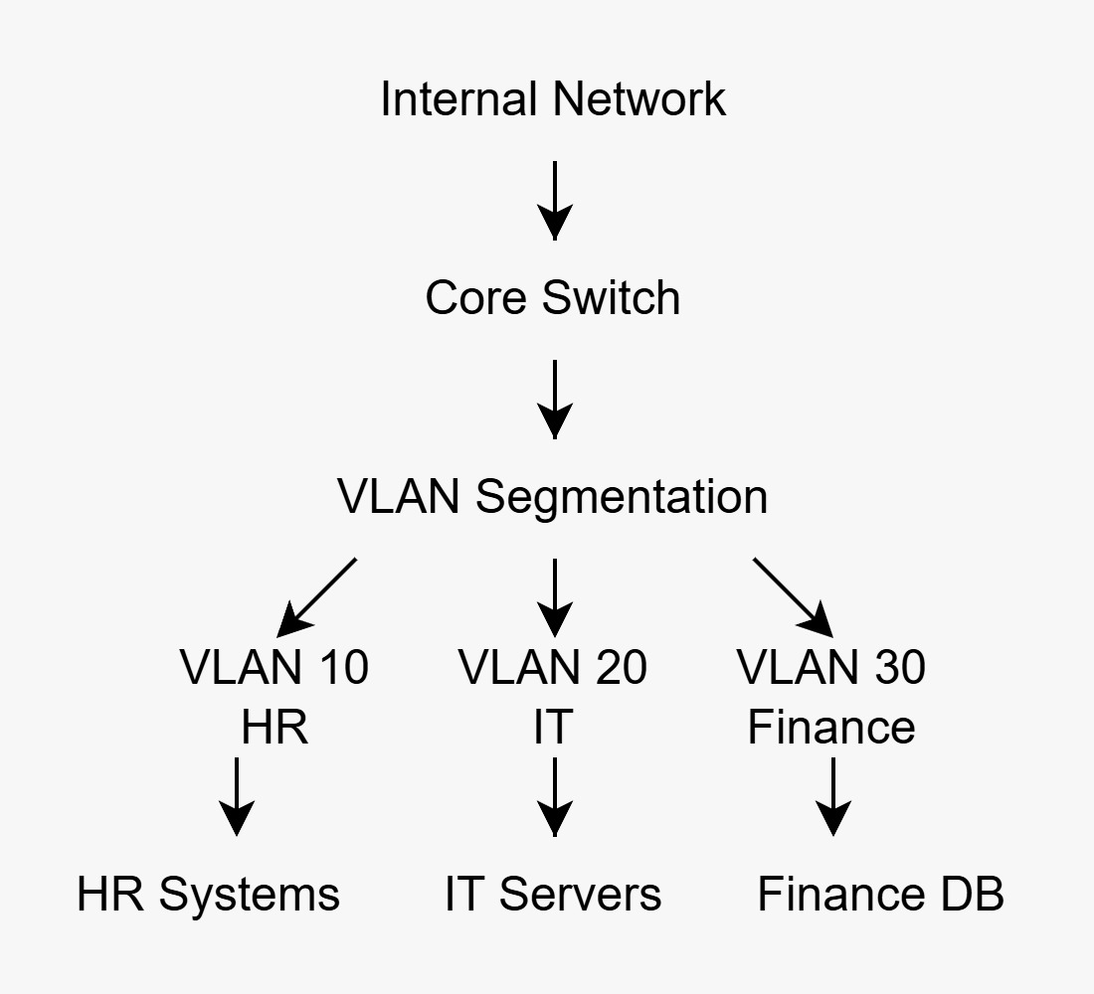

4.4 Secure Remote Access via VPN
Modern enterprises often require employees to access internal systems from remote locations. However, allowing remote access without proper security controls can expose enterprise networks to potential cyber threats. To address this challenge, the proposed architecture implements a Virtual Private Network (VPN) solution to provide secure remote connectivity.
The VPN gateway is implemented using OpenVPN integrated with the pfSense firewall. OpenVPN establishes an encrypted communication tunnel between remote users and the enterprise network. This ensures that sensitive data transmitted over the internet remains protected from interception or unauthorized access.
When remote employees connect to the VPN server, they are authenticated using secure credentials. Once authenticated, they are granted controlled access to the internal enterprise network. The firewall continues to enforce security policies for VPN traffic to ensure that remote users can only access authorized resources.
By implementing secure VPN access, the enterprise network can safely support remote work while maintaining strong security controls.

Figure 4: Secure Remote Access via VPN
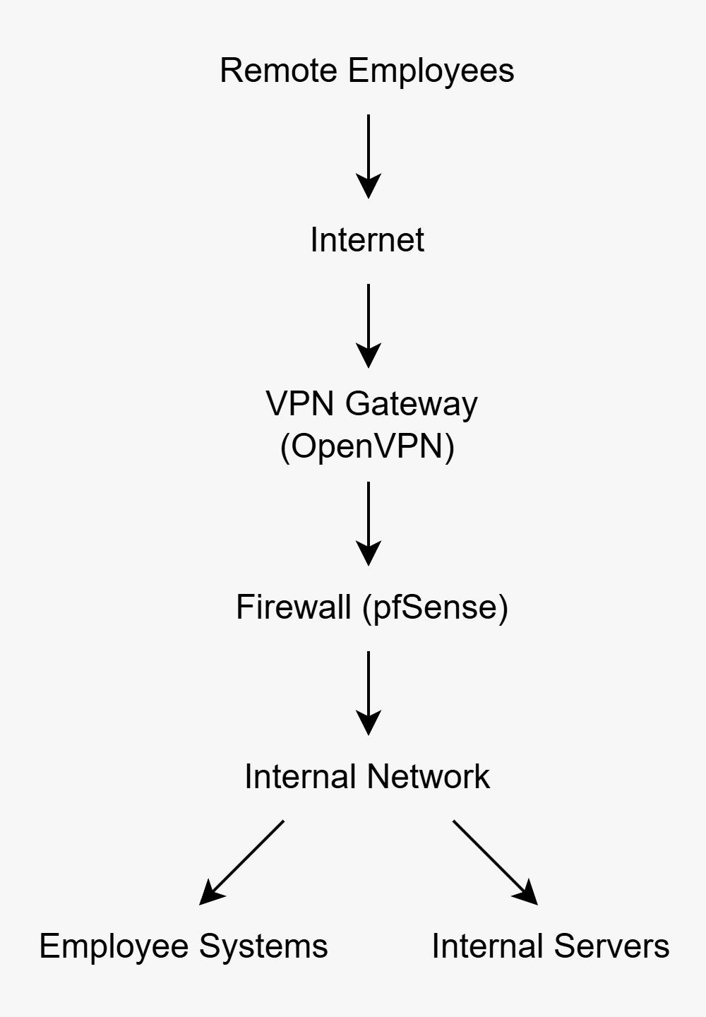

4.5 Security Monitoring and Logging Architecture
Continuous monitoring and logging are essential components of modern cybersecurity practices. Monitoring systems allow administrators to track network activities, detect anomalies, and respond quickly to potential security incidents.
In the proposed architecture, logs from multiple sources are collected and analyzed to provide comprehensive visibility into network operations. Firewall logs capture information about allowed and blocked traffic, while intrusion detection alerts provide details about suspicious activities detected within the network.
Endpoint systems also generate logs that record user activities and system events. These logs are forwarded to centralized monitoring platforms such as Wazuh and the Elastic Stack. The monitoring system aggregates and analyzes log data to identify potential security threats and provide real-time alerts to the security operations team.
This centralized monitoring architecture enables security teams to detect attacks more effectively, investigate incidents quickly, and maintain continuous oversight of the enterprise network environment.

Figure 5: Security Monitoring and Logging Architecture
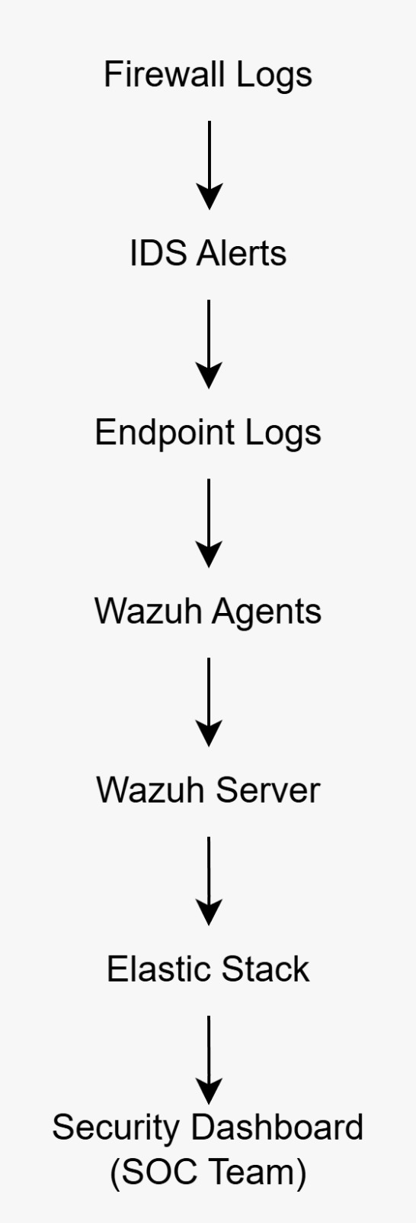

5. Implementation of Security Components

5.1 Firewall Implementation (pfSense)
The firewall is the first line of defense in the proposed enterprise network architecture. In this project, the pfSense firewall platform was deployed to control and monitor network traffic. pfSense provides advanced security features such as traffic filtering, network address translation (NAT), and firewall rule enforcement.
The firewall was configured to regulate incoming and outgoing network traffic based on predefined security rules. Only authorized traffic was allowed to pass through the network while suspicious or unauthorized traffic was blocked. This ensures that internal systems remain protected from potential external threats.
Additionally, pfSense provides real-time monitoring capabilities through its dashboard and logging features. These features allow administrators to observe network activity and identify potential security issues.

5.2 Intrusion Detection System (Snort)
An Intrusion Detection System (IDS) was implemented using Snort to monitor network traffic for malicious activity. Snort analyzes network packets and compares them against known attack signatures to identify suspicious behavior.
The IDS was configured on the pfSense firewall to monitor the internal network interface. During testing, a simulated attack using the Nmap scanning tool from the Kali Linux system was performed. Snort successfully detected the scanning activity and generated alerts in the system logs.
This demonstrates the ability of the IDS to detect abnormal network behavior and assist administrators in identifying potential cyber threats.

5.3 Network Segmentation using VLAN
Network segmentation was implemented to improve overall network security and limit the spread of potential attacks. Virtual Local Area Networks (VLANs) were used to divide the enterprise network into smaller segments representing different organizational departments.
Each department operates within its own isolated VLAN, such as Human Resources (HR), Information Technology (IT), and Finance. This segmentation ensures that network traffic between departments is controlled and monitored.
By separating network segments, the architecture reduces the risk of lateral movement within the network. If an attacker gains access to one segment, it becomes significantly more difficult to compromise other parts of the enterprise infrastructure.

5.4 Secure Remote Access using OpenVPN
Secure remote access was implemented using OpenVPN integrated with the pfSense firewall. OpenVPN creates an encrypted communication tunnel between remote users and the enterprise network, ensuring that data transmitted over the internet remains secure.
The VPN server was configured to authenticate users and assign them secure tunnel IP addresses upon successful connection. Remote employees can securely access internal resources while the firewall continues to enforce security policies for VPN traffic.
This secure remote access solution enables organizations to support remote work while maintaining strong network security controls.

5.5 Monitoring and Logging
Monitoring and logging mechanisms were implemented to provide visibility into network activities and detect potential security incidents. The pfSense firewall generates logs that record information about network traffic, firewall actions, and system events.
In addition to firewall logs, alerts generated by the Snort intrusion detection system are used to identify suspicious activities within the network. These monitoring capabilities help administrators quickly detect and respond to potential threats.
Regular monitoring of logs ensures that unusual traffic patterns or security events can be investigated promptly, improving the overall security posture of the enterprise network.

6. Practical Demonstration (Proof of Concept)
6.1 Firewall Deployment Verification

PoC 1: pfSense Firewall Dashboard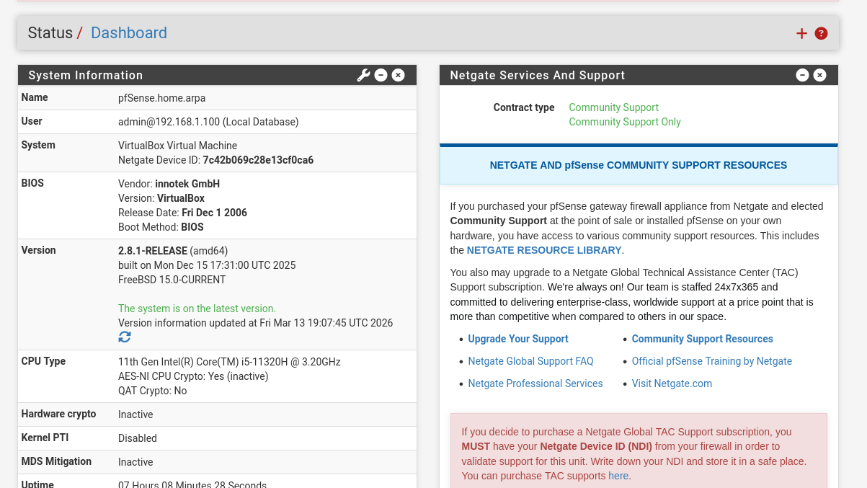
The pfSense firewall dashboard confirms that the firewall has been successfully deployed within the network environment. The dashboard displays system information, interface status, CPU usage, memory utilization, and network traffic statistics. This verifies that the firewall is actively managing and monitoring the enterprise network infrastructure.

6.2 Firewall Rule Configuration

PoC 2: pfSense Firewall Rules Configuration
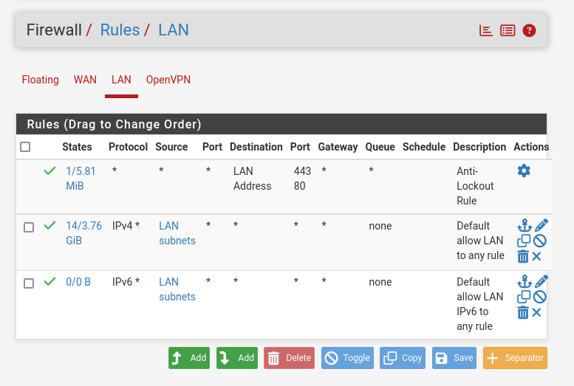
Firewall rules were configured to control traffic within the enterprise network. The rules determine which types of traffic are allowed or blocked based on predefined policies. This configuration ensures that only authorized communication is permitted while potentially harmful traffic is restricted.

6.3 Snort IDS Configuration

PoC 3: Snort Intrusion Detection System Configuration
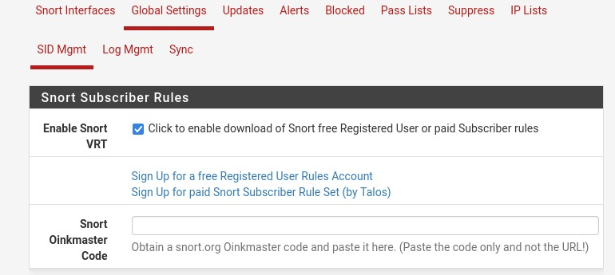
The Snort Intrusion Detection System was configured on the pfSense firewall to monitor network traffic and identify suspicious activities. Snort analyzes packets and compares them against predefined rules to detect potential attacks or abnormal traffic patterns.

6.4 Snort Interface Monitoring

PoC 4: Snort Interface Monitoring Configuration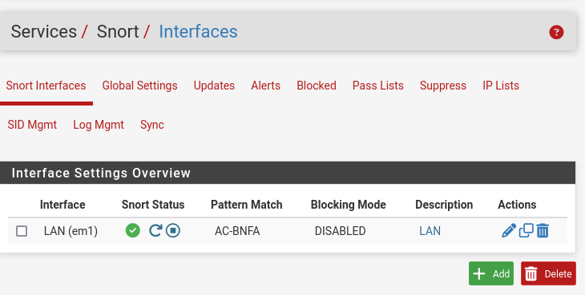
Snort was configured to monitor the LAN interface of the network. This enables the system to inspect traffic entering and leaving the internal network segment. By monitoring the interface, Snort can detect potential threats within the network environment.

6.5 Attack Simulation using Kali Linux

PoC 5: Nmap Port Scan Attack Simulation from Kali Linux
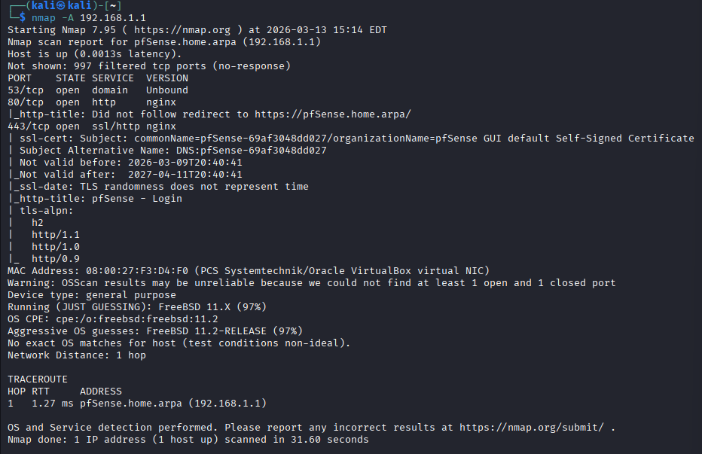
A simulated network attack was performed using the Nmap scanning tool from the Kali Linux attacker machine. The scan was conducted against the pfSense firewall to identify open ports and services. This simulation helps demonstrate how attackers may attempt to gather information about network systems.

6.6 Snort Attack Detection

PoC 6: Snort IDS Detecting Network Scan Activity
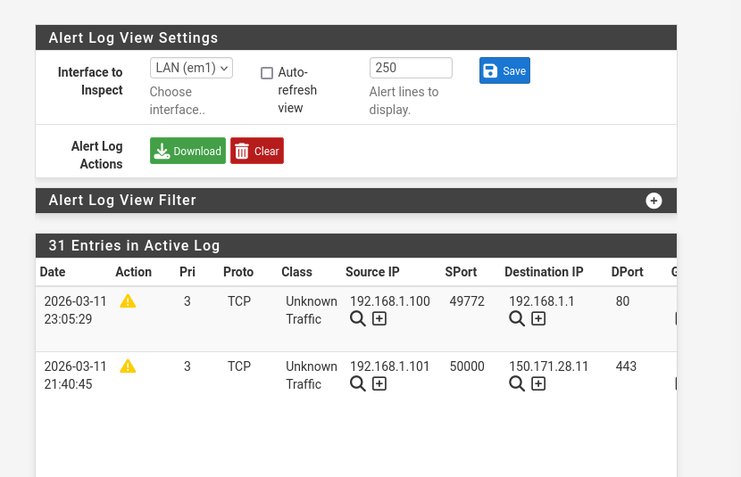
During the simulated attack, the Snort intrusion detection system successfully detected the scanning activity generated by the Nmap tool. The alert log displays information such as source IP address, destination IP address, and protocol details. This confirms that the IDS is capable of identifying suspicious activities within the network.

6.7 OpenVPN Server Configuration

PoC 7: OpenVPN Server Configuration on pfSense Firewall
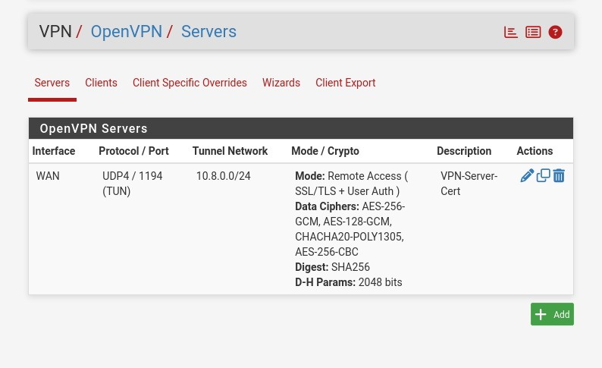
The OpenVPN server was configured on the pfSense firewall to enable secure remote access to the enterprise network. The VPN server operates using the UDP protocol on port 1194 and assigns secure tunnel IP addresses to authenticated users.

6.8 VPN Client Connection

PoC 8: Successful VPN Client Connection
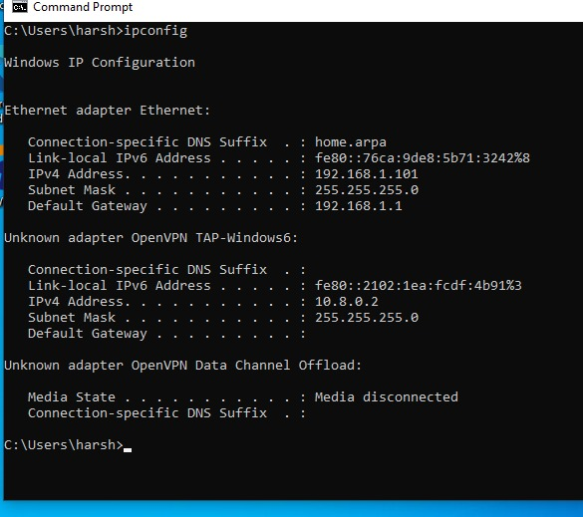
A successful VPN connection was established from the Windows client system. The VPN client received an IP address from the tunnel network (10.8.0.0/24), confirming that the encrypted communication tunnel between the remote client and the enterprise network was successfully created.

6.9 Firewall Log Monitoring

PoC 9: Firewall System Log Monitoring
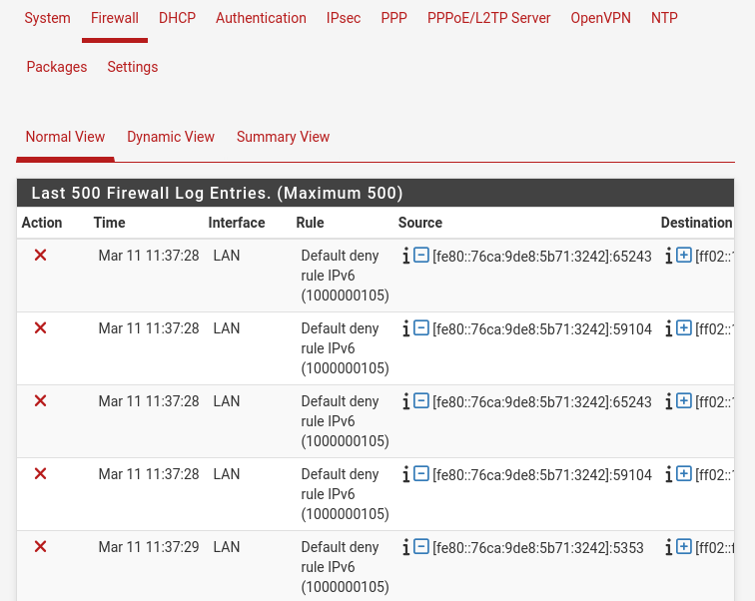
Firewall system logs were monitored to observe network traffic and security events. The logs provide detailed information about allowed and blocked connections, enabling administrators to analyze network behavior and detect potential security incidents.

7. Security Policies and Compliance
To ensure the effectiveness of the secure network architecture, several security policies must be implemented within the enterprise environment. These policies help regulate user behavior, enforce security practices, and maintain compliance with organizational security standards.

Strong password policies should be enforced to ensure that users create complex passwords and update them regularly. Access control policies must also be implemented to restrict user privileges based on their roles within the organization. This ensures that employees can only access resources necessary for their job functions.

Additionally, organizations should enforce regular monitoring of network logs and security alerts to detect suspicious activities. Security awareness training for employees is also important to reduce the risk of phishing attacks and social engineering threats. By following these policies, organizations can maintain a secure and controlled network environment.

8. Incident Response Strategy
Even with strong security mechanisms in place, security incidents may still occur. Therefore, an effective incident response strategy is necessary to minimize the impact of cyber attacks.

The incident response process typically involves several stages. The first stage is detection, where suspicious activities are identified through monitoring tools such as intrusion detection systems and firewall logs. Once a potential incident is detected, the security team analyzes the event to determine its severity and impact.

The next step is containment, where administrators take actions to prevent the attack from spreading across the network. After containment, the threat is removed from affected systems through remediation measures. Finally, systems are restored to normal operation and the incident is documented for future reference.

A well-defined incident response strategy ensures that organizations can quickly respond to security threats and minimize damage to their network infrastructure.

9. Results and Discussion
The implementation of the secure network architecture demonstrated significant improvements in enterprise network security. The pfSense firewall successfully controlled and filtered network traffic based on defined security rules. This ensured that unauthorized access attempts were restricted at the network perimeter.

The Snort intrusion detection system effectively monitored network activity and generated alerts when suspicious traffic was detected. During the simulated attack using the Nmap scanning tool from the Kali Linux system, Snort successfully identified the scanning activity and recorded the event in the alert logs.

Secure remote access was achieved using OpenVPN, allowing remote users to establish encrypted connections with the enterprise network. The VPN client successfully obtained a tunnel IP address, confirming that secure communication between remote users and internal resources was established.

Overall, the integration of firewall protection, intrusion detection, secure VPN access, and monitoring mechanisms significantly enhanced the security posture of the enterprise network.

10. Conclusion
This project successfully designed and implemented a secure network architecture for a large enterprise environment. The architecture integrates multiple security mechanisms including firewall protection, intrusion detection, network segmentation, and secure remote access.

The pfSense firewall provided strong perimeter security by filtering and controlling network traffic. The Snort intrusion detection system enhanced network visibility by identifying suspicious activities and generating alerts. Network segmentation using VLANs helped isolate different departments and reduced the risk of lateral attacks within the network.

Secure remote access was implemented using OpenVPN, enabling remote employees to connect safely to enterprise resources. Monitoring and logging mechanisms further improved the ability to detect and analyze potential security incidents.

The results demonstrate that implementing layered security controls significantly strengthens enterprise network protection and reduces the risk of cyber threats.

11. Future Improvements
Although the implemented architecture provides strong security features, additional improvements can further enhance enterprise network protection. One potential improvement is the integration of advanced Security Information and Event Management (SIEM) platforms for centralized monitoring and analysis of security events.
Organizations can also implement multi-factor authentication (MFA) to strengthen user authentication mechanisms and reduce the risk of credential-based attacks. Regular vulnerability assessments and penetration testing should be conducted to identify and address potential weaknesses within the network infrastructure.
Another improvement is the deployment of advanced endpoint detection and response (EDR) systems to monitor endpoint devices and detect malicious activities. By continuously enhancing security controls and adopting modern cybersecurity technologies, organizations can maintain a resilient and secure network environment.

12. References
• pfSense Documentation – https://www.pfsense.org
• Snort Intrusion Detection System – https://www.snort.org
• OpenVPN Official Website – https://openvpn.net
• Nmap Network Scanning Tool – https://nmap.org
• Wazuh Security Platform – https://wazuh.com

