Implementing a Robust Multi-Factor Authentication (MFA) System in an Enterprise Environment

Prepared by:
Harsh Dankhra — Cybersecurity Intern

Table of Contents
1. Abstract 4
2. Introduction 5
3. Objectives 6
4. Scope of the Project 7
5. Existing System (Without MFA) 8
6. Proposed System (With MFA) 9
7. MFA Methods Overview 10
7.1 Authenticator App 10
7.2 Email OTP 10
7.3 (Other methods – theoretical) 11
8. System Architecture 12
8.1 Authentication Flow Without MFA (Vulnerable) 13
8.2 Authentication Flow With MFA (Secure) 14
8.3 Login Flow with MFA 15
8.4 MFA System Architecture 16
8.5 Enterprise Network Architecture with MFA Integration 17
8.6 OTP Validation Process 18
8.7 Attack Scenarios and Security Analysis 19
8.8 Requirements Gathering and Analysis 21
8.9 Implementation Strategy (Pilot Testing and Rollout) 21
8.10 Security Policies and Compliance 22
8.11 Monitoring and Incident Response 22
8.12 User Awareness and Training 23
9. Working of the System 24
9.1 Login Flow without MFA 24
9.2 Login Flow with MFA 25
10. Proof of Concepts (PoCs) 26
PoC 1: Brute Force Attack on DVWA Login 26
PoC 2: Brute Force on Custom Login (No MFA) 27
PoC 3: Credential Compromise → OTP Trigger 27
PoC 4: MFA Enforcement (OTP Required) 28
PoC 5: Successful MFA Authentication 28
PoC 6: OTP Brute Force Attempt 29
PoC 7: MFA Bypass Attempt (Session Issue) 29
PoC 8: Server-Side MFA Enforcement 30
PoC 9: MFA Method Selection 30
PoC 10: Email OTP Authentication 31
PoC 11: Successful Login via Email OTP 31
11. Security Analysis 32
11.1 Attack Scenarios (Brute Force, Phishing, MFA Fatigue) 32
11.2 Mitigation using MFA 33
12. Results and Observations 35
13. Conclusion 36
14. Future Enhancements 37
15. References 38

1. Abstract

The ongoing research aims to implement a multi-factor authentication method that would safeguard the organization from any cyber-attack or other forms of breach.

Single-factor authentication is highly vulnerable to brute force attack, credential stuffing attack, and phishing attack. As a result, the project recommends implementing a dual-layer authentication process including OTP verification from authenticator app and email.

Accordingly, when the user logs into his account with the credentials, he will need to perform another layer of verification for the entry into the account by utilizing the OTP. In any case where there may be a breach, the attacker cannot gain access unless he can bypass the second layer of authentication. Examples of proof-of-concept are illustrated.

2. Introduction

Authenticating users has been one of the most essential requirements of any modern-day business organization because of the growing numbers and complexity of cyber-attacks on these entities. Classic single factor authentication schemes based on password-based login have ceased to be effective since they can be easily penetrated by various types of cyber-attacks like brute force attacks, credential stuffing attacks, and phishing attacks.

Multi-Factor Authentication (MFA) is a technique that involves verification of user's identity using not only one but several pieces of evidence. Typically, these consist of something the user has (password) and something he/she owns (OTP or the device used for generating them).

The purpose of this project is to illustrate implementation of an MFA-based scheme of authentication. Moreover, the proposed project will simulate certain attacks and evaluate how MFA counteracts them.

3. Objectives
The primary aim of this project is to develop a secure multi-factor authentication system that will enhance the entire authentication process within an organization.

The aims of this project are as follows:
- To examine traditional password authentication systems and their weaknesses.
- To develop and deploy a system for MFA through OTP authentication.
- To incorporate other types of authentications into the MFA, including authenticator-based OTPs and email-based OTPs.
- To perform simulations of different attacks, including brute-force attacks, in order to test the security of the system.
- To determine the potential weaknesses in the MFA system, especially MFA bypass techniques, and apply relevant solutions.
- To assess the ability of MFA to prevent any unauthorized access to accounts, even when the user's login details have been obtained.

4. Scope of the Project

The scope of this project revolves around developing, implementing, and testing a multifactor authentication scheme within a simulated enterprise network setting. The scope incorporates the usage of different methods of authentication to increase the security level and prevent any unauthorized access to the network.

This project includes developing a web-based authentication platform that employs OTP verification via authenticator apps and emails. Such an approach helps demonstrate how multifactor authentication is effective in securing user credentials and their sensitive information.

Furthermore, the scope of this project covers simulating attacks, such as brute-force attacks, brute-forcing the OTP, and attempting to circumvent the multifactor authentication process. Such tests allow evaluating whether security controls implemented are sufficient in preventing any threats.

Moreover, the scope of the project entails identifying possible security risks within the system and dealing with vulnerabilities, such as insecure sessions management, through implementing fixes and enhancements.

Nevertheless, the scope of this project does not involve a real-world application and testing of the developed components. Elements, like SMS gateway, biometric devices, and hardware tokens for authentication, are described in detail in the report, yet they are not deployed within the project.

5. Current System (Without MFA)

Many businesses implement authentication solutions that require only a username and password to authorize the user. Even though this is one of the most popular authentication techniques, it brings numerous risks for business security as it requires only one authentication factor.

First, password-based authentication solutions are very exposed to all kinds of cyber threats, including brute force attacks, credential stuffing using credentials stolen from other sites, and even phishing when victims are forced to reveal their credentials.

Secondly, one of the biggest limitations of the existing authentication technique is the lack of another layer of protection that could have helped to ensure the user's identity after successful authorization. Therefore, once someone has gained access to legitimate credentials, it is impossible to prevent them from entering the account.

Furthermore, security controls implemented at some organizations are not enough. For instance, there is no account lockout function or rate limiting and suspicious activities monitoring.

To sum up, the existing password authentication solution is obsolete today and should be improved with new approaches, like MFA.

6. Proposed System (With MFA)

As a solution to the shortcomings presented by conventional password-based authentication schemes, this project suggests implementing a multi-factor authentication system. The new system involves the inclusion of another authentication factor to enhance the authentication process.

First, users must input their usernames and passwords for authentication purposes. If these credentials pass the initial authentication process, another authentication phase involving OTP authentication must be done. This can be achieved using the app authenticator option or the email-based OTP method.

This proposed scheme gives users more options for securing their accounts. Moreover, this scheme employs best practices in terms of secure session management. Specifically, users' sessions will be created only after OTP authentication is successfully completed. In this way, this system will prevent MFA bypasses and allow strict controls when accessing any sensitive resource, such as user dashboards.

This proposed scheme was tested using multiple PoC scenarios, namely brute force attacks, OTP brute force attacks, and MFA bypasses. Vulnerabilities were identified and addressed accordingly.

In summary, the suggested scheme is an effective and scalable MFA framework for authentication security.

7. MFA Methods Overview

The Multi-factor authentication process improves security by enabling users to validate their identities based on more than one authentication factor. Various multi-factor authentication systems differ in levels of security, user-friendliness, and complexity. This chapter outlines some of the multi-factor authentication processes that have been reviewed in this research.

7.1 Authenticator Application

Another MFA technique widely employed is the use of an authenticator app which generates one-time passwords that change after a certain period, generally 30 seconds. The authenticator app-based MFA system is very secure since the one-time password is generated at the local level without being sent over any insecure channel.

The OTP MFA scheme based on the authenticator is employed in the current project for providing authentication.

7.2 Email-Based OTP

Email based OTP generation is defined by the creation of a one-time password at the server end and delivery of this password to the mail id of the user.

In the given project, the implementation of email based OTP is performed in a simulated way. That is, the one time password is created at the server end and shown on the console as an email delivery method.

7.3 Other MFA Techniques (Conceptual)

In addition to the implemented methods, several other MFA techniques are commonly used in enterprise environments:
- SMS-Based OTP:
OTP is sent to the user’s mobile phone via SMS. Although widely used, it is less secure due to risks such as SIM swapping and interception attacks.
- Biometric Authentication:
Uses physical characteristics such as fingerprint or facial recognition for identity verification. It provides high security along with user convenience.
- Hardware Tokens:
Devices such as RSA tokens generate secure authentication codes or use cryptographic mechanisms. These tokens offer strong protection against phishing and remote attacks.

These methods are not implemented in this project but are included for conceptual understanding and enterprise relevance.

8. System Architecture

The system architecture of the proposed solution is designed to implement a secure multi-factor authentication (MFA) mechanism within a web-based application. It ensures that user authentication is performed in a two-step process, involving both primary and secondary verification factors.

The architecture consists of the following key components:
- User Interface (Client):
Provides an interface through which users can enter their login credentials and OTP codes using a web browser.
- Web Application Server:
Handles authentication requests, processes user credentials, generates OTPs, and manages user sessions.
- Authentication Process:
involves a two-stage verification mechanism. The first stage validates the user’s username and password, while the second stage verifies the OTP using an authenticator application or email-based method.
- OTP Generation Component:
Responsible for generating time-based OTP (TOTP) for authenticator applications and random OTP codes for email-based authentication.
- Session Management System:
Ensures that user sessions are created only after successful OTP verification, thereby preventing unauthorized access and MFA bypass vulnerabilities.

8.1 Authentication Flow Without MFA (Vulnerable)

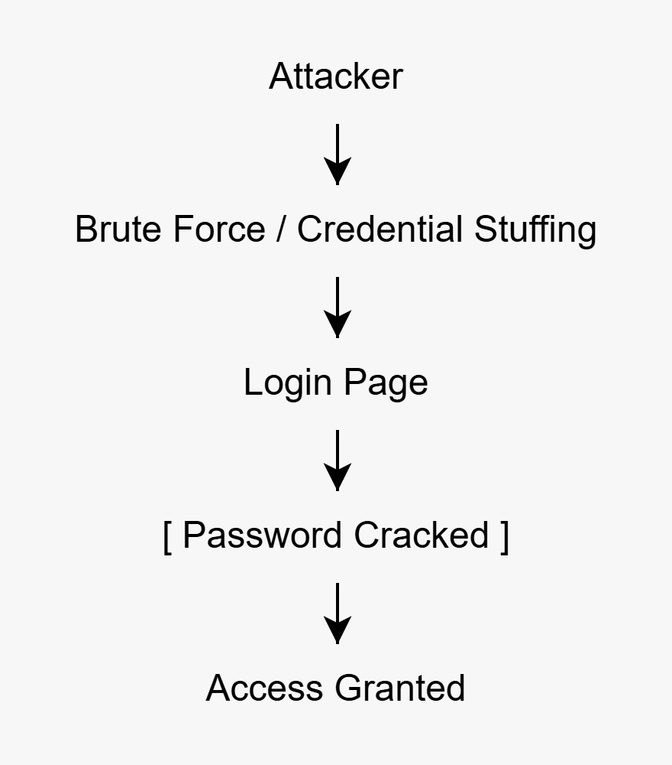
Figure 1: Authentication Without MFA (Vulnerable)

In a traditional authentication system, users are granted access after entering only their username and password. This approach is vulnerable to attacks such as brute force and credential theft. Once an attacker obtains valid credentials, they can easily gain unauthorized access to the system.

8.2 Authentication Flow With MFA (Secure)

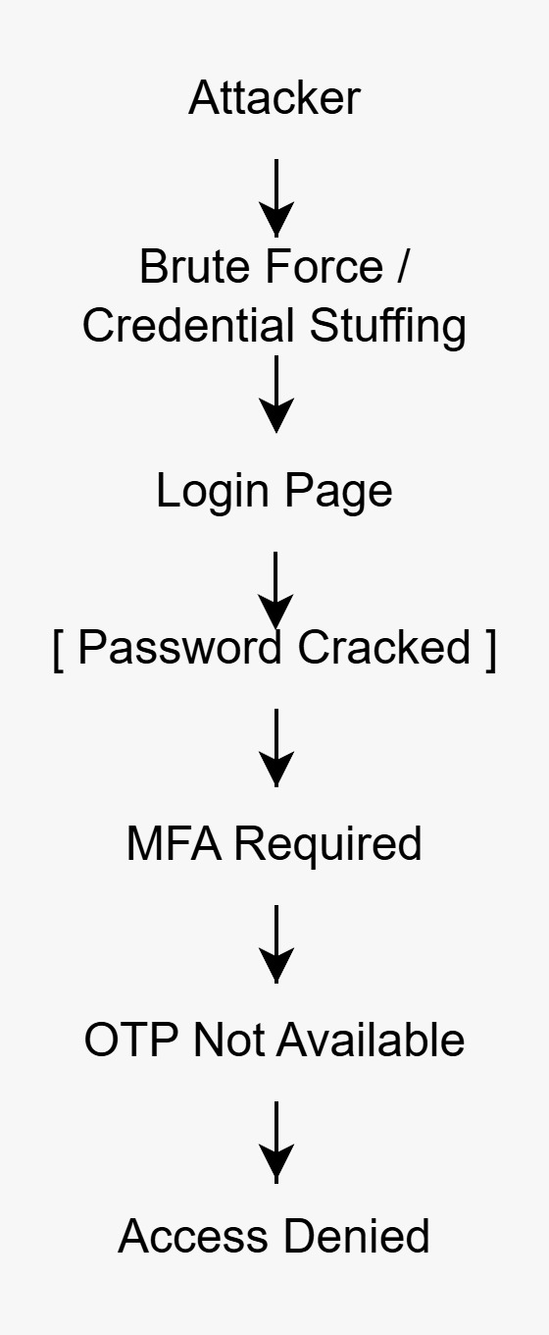
Figure 2: Authentication With MFA (Secure)

In the proposed MFA system, authentication is performed in two stages. After successful password verification, the user is required to complete OTP verification. This additional layer ensures that even if credentials are compromised, unauthorized access is prevented without successful OTP validation.

8.3 Login Flow with MFA

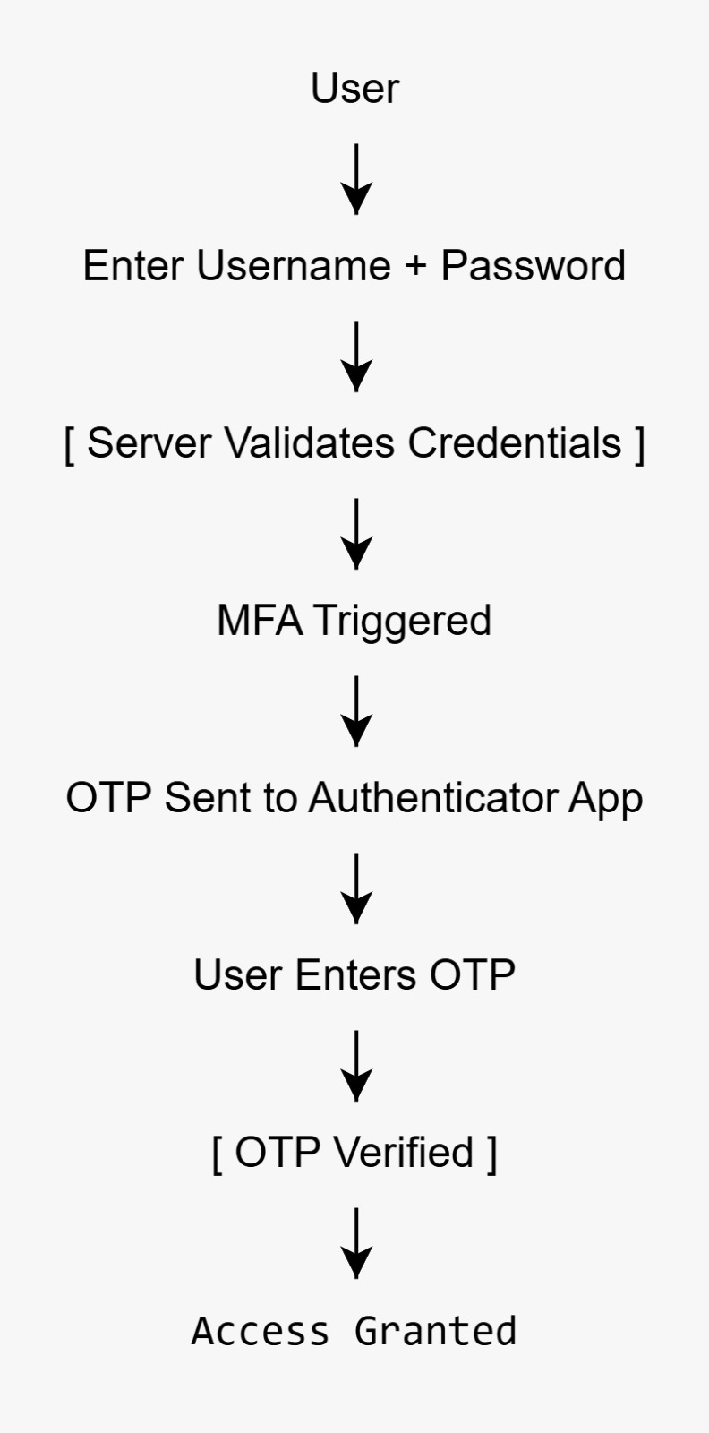
Figure 3: Login Flow with MFA

The login process follows a structured sequence:
- User enters username and password
- System validates credentials
- OTP is generated and sent (Authenticator or Email)
- User enters OTP
- System verifies OTP
- Access is granted upon successful verification

8.4 MFA System Architecture

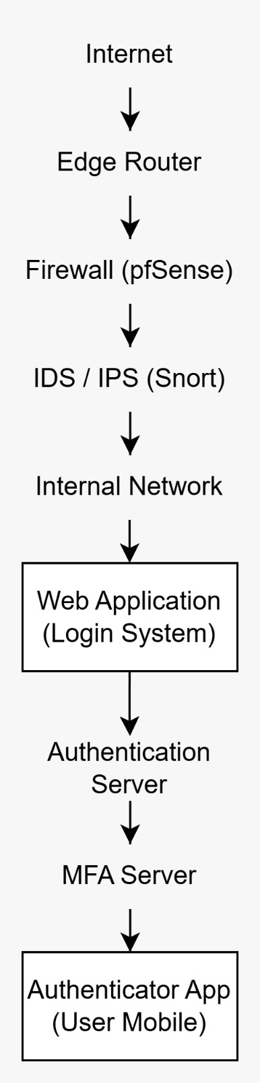
Figure 4: MFA Architecture Diagram

This diagram represents the overall system design, including user interaction, authentication layers, and backend processing. It shows how different components work together to ensure secure authentication.

8.5 Enterprise Network Architecture with MFA Integration

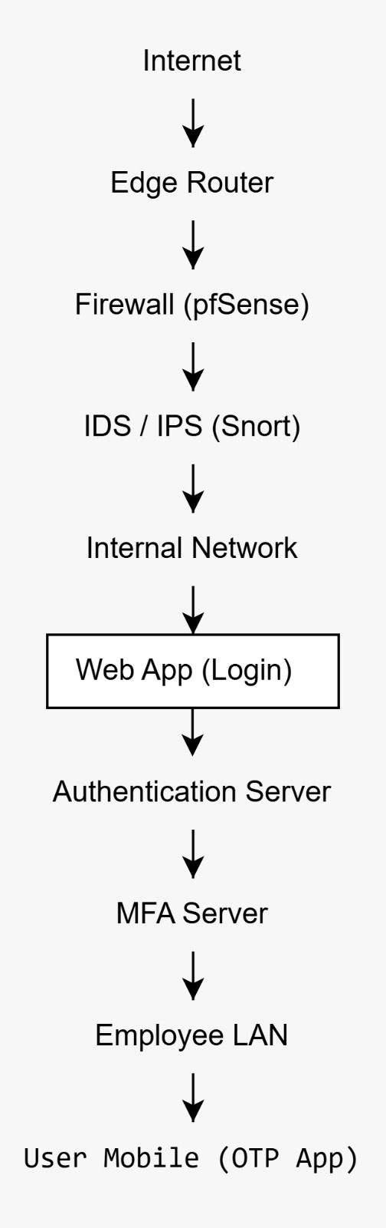
Figure 5: Enterprise Network Architecture with MFA Integration

This architecture demonstrates how MFA can be integrated into enterprise environments, including network security components such as firewalls, intrusion detection systems (IDS/IPS), and internal authentication servers.
Multi-Factor Authentication (MFA) can be incorporated into Enterprise Systems like SSO, Active Directory, and Virtual Private Network authentication for better access control.
8.6 OTP Validation Process

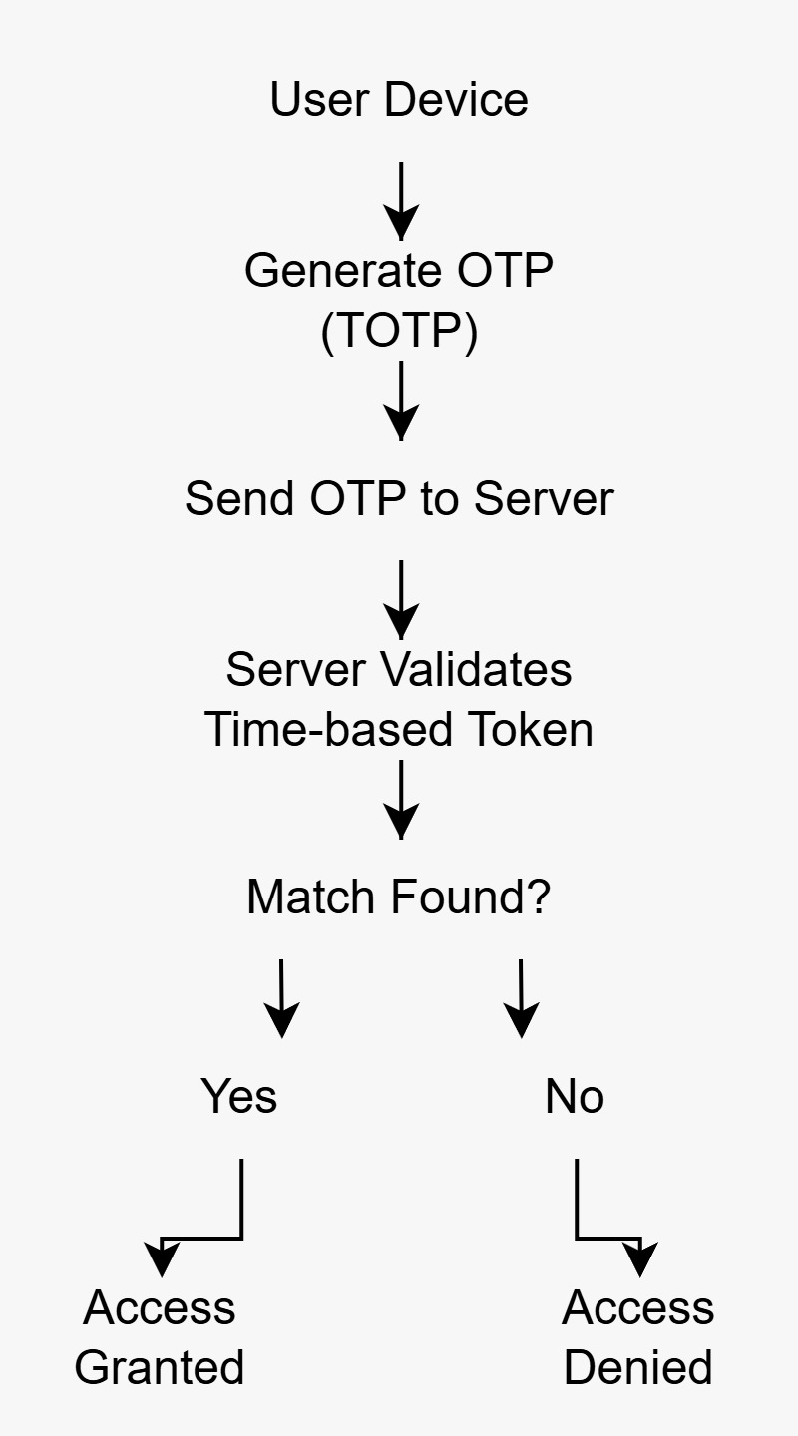
Figure 6: OTP Validation Process

This process illustrates how OTP is generated, validated, and verified by the system. The OTP must match within a specific time window to allow access, ensuring time-based security.

8.7 Attack Scenarios and Security Analysis

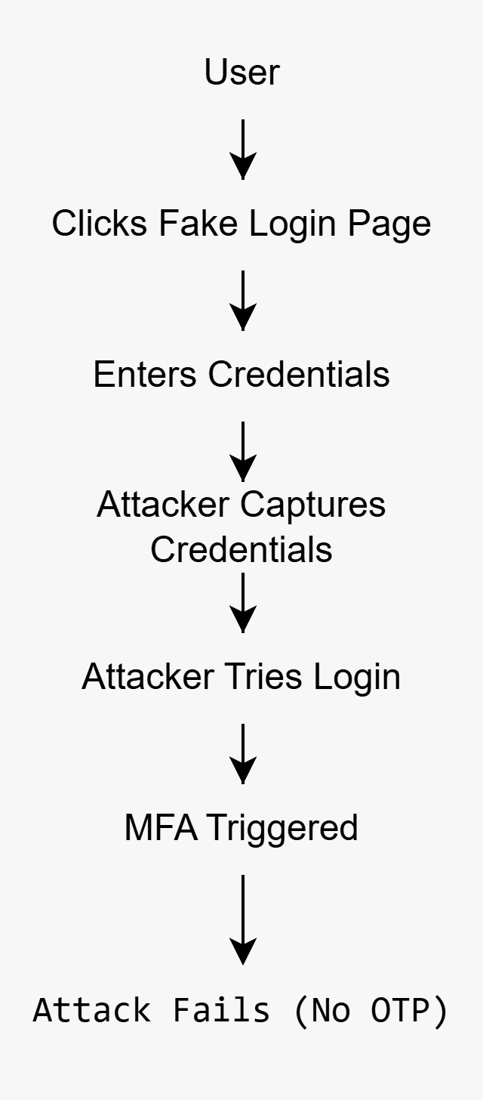
Figure 7: Phishing Attack Flow
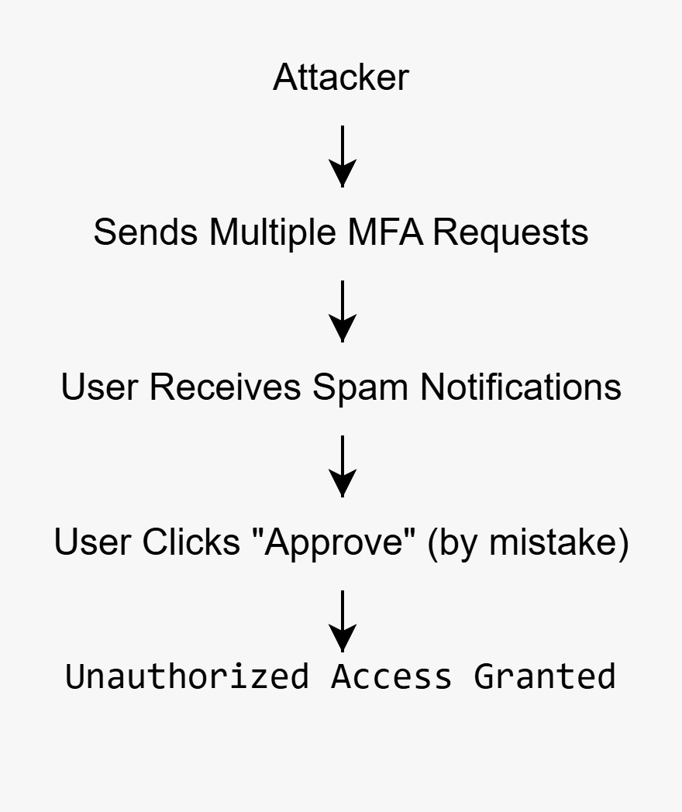
Figure 8: MFA Fatigue Attack Scenario

These diagrams represent potential attack scenarios targeting authentication systems. MFA significantly reduces the effectiveness of such attacks by introducing additional verification steps and improving overall security posture.

8.8 Requirements Gathering and Analysis

For the successful implementation of multi-factor authentication system, a thorough analysis of the requirement is essential. The requirements in the present project were gathered and analyzed considering the issues faced during the authentication processes in the organization.

Some of the major requirements taken into consideration in this project include:
- Requirement for secure authentication that would avoid any security breach due to unauthorized access
- Requirement for security from brute force attack, credential stuffing, and phishing
- Requirement for using multiple methods for multi-factor authentication
- Requirement for secure session management
- Requirement for user-friendly authentication without compromising usability

8.9 Implementation Strategy

A comprehensive implementation strategy is required to deploy the MFA solution effectively.

The MFA solution can first be rolled out in a pilot testing scenario that involves a few users. This will help identify any possible usability problems and other issues related to the functioning of the MFA solution. These can be taken into account in order to make required changes.

Once this stage is completed successfully, the next stage will be the rollout of the MFA solution using a gradual approach.
8.10 Security Policies & Compliance

The use of MFA is dependent on the establishment of clear security policies for the proper use of the system and management of the authentication methods.

The security policies that have been taken into consideration in this project include:
- Expiry Time Policy for OTPs: OTPs can be used only for a certain time limit.
- Restriction Due to Too Many Failed Login Attempts.
- Creation of User Session Only After Successful OTP Authentication.
- MFA Is Compulsory for Every User.

The above mentioned security policies will further enhance the security system.

8.11 Monitoring and Incident Response

Monitoring and incident response are vital in ensuring the security of the authentication system.

There could be an implementation of monitoring features to detect unusual events like multiple login failure attempts and irregular login access attempts.

In the event of any security breaches, the response will include the following:
- Account lock temporarily if there are numerous login failures.
- Creation of alert messages for any unusual login attempt activity.
- Password reset if any account is breached.

8.12 User Awareness and Training

User awareness is one of the vital elements for ensuring security in any authentication system. No matter how good the security measures employed may be, human errors are bound to create weak spots in the security system.

Some of the important guidelines users need to follow include:
- Do not share OTPs with anyone
- Watch out for phishing emails and spoof websites
- Use genuine authentication apps
- Practice good password hygiene

9. Working of the System

The working of the system is based on a multi-step verification process designed to ensure secure access to the application. The system verifies the user’s identity using both primary and secondary authentication factors. This section explains the operation of the system in two scenarios: without MFA and with MFA.

9.1 Login Process Without MFA

In a conventional authentication system without multi-factor authentication, the login process consists of a single verification step using a username and password.

The process can be described as follows:
- The user enters their username and password in the login interface.
- The system verifies the entered credentials against stored values.
- If the credentials are valid, access is granted.
- If the credentials are invalid, access is denied.

This approach is vulnerable to various security threats such as brute force attacks, credential stuffing, and phishing. Once an attacker obtains valid credentials, they can easily gain unauthorized access due to the absence of an additional verification layer.

9.2 Login Process with MFA

In the proposed system, the authentication process is enhanced by introducing an additional verification layer through multi-factor authentication.

The workflow is as follows:
- The user enters their username and password in the login form.
- The system validates the credentials.
- Upon successful validation, the user is redirected to the MFA stage.
- The user selects an MFA method, either an Authenticator App or Email OTP.
- The system generates an OTP based on the selected method.
- The user enters the OTP in the verification interface.
- The system verifies the OTP.
- A secure session is created only after successful OTP validation.
- Access is granted to the dashboard.

If the OTP is incorrect or not provided, access is denied. This multi-layer authentication process ensures that even if user credentials are compromised, unauthorized access is prevented without successful completion of the second authentication factor.

10. Proof of Concepts (PoCs)

This section presents the practical implementation and testing of the proposed multi-factor authentication system. Various proof-of-concept (PoC) scenarios were performed to demonstrate both vulnerabilities in traditional authentication systems and the effectiveness of MFA in mitigating these threats.

The PoCs include attack simulations, MFA enforcement validation, and security testing of the implemented system.

PoC 1: Brute Force Attack on DVWA Login
The PoC below shows how an authentication system based on a password scheme can be breached using brute force attacks. Using the Burp Suite Intruder tool, several password guesses were attempted to gain access by cracking the system's login until successful access was gained.
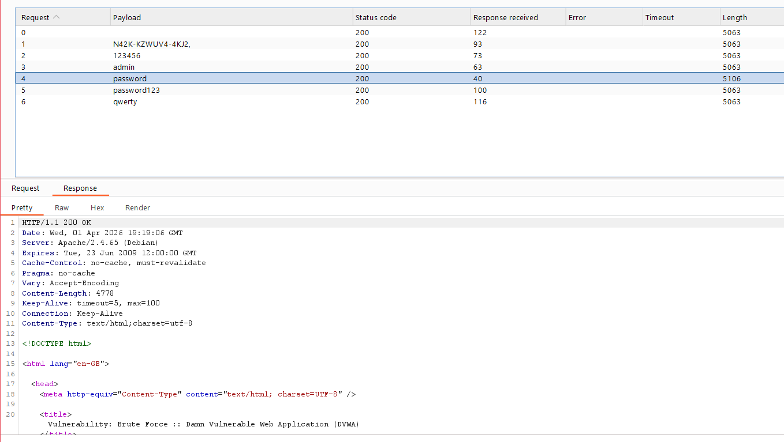

PoC 2: Brute Force Attack on Custom Login System (Without MFA)
This PoC indicates that even custom logins without MFA can be susceptible to brute-force attacks. This PoC proves that brute force can reveal valid usernames and passwords by trying out multiple combinations.
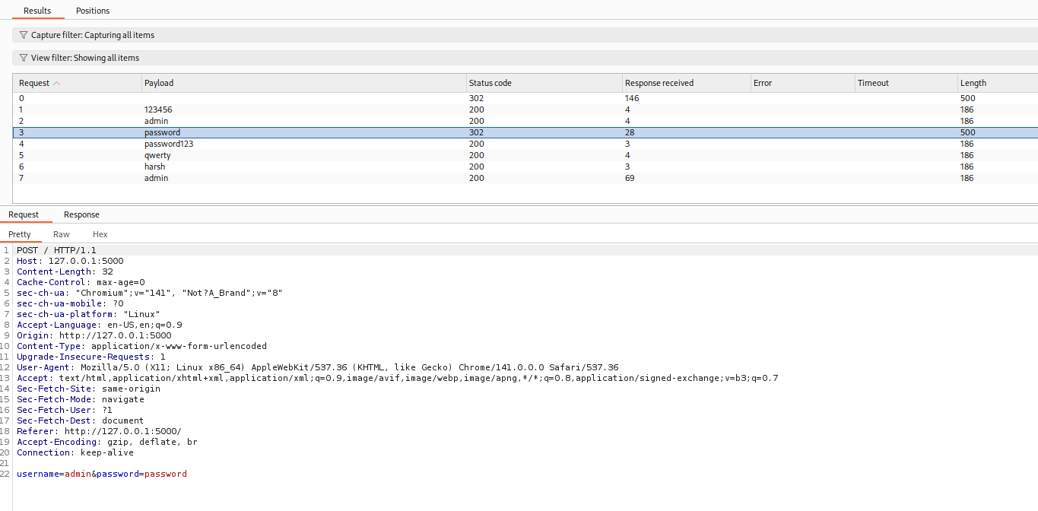

PoC 3: Credential Compromise Leading to OTP Verification
This PoC demonstrates that even after acquiring correct credentials, the system implements another level of security by requiring one-time password (OTP) authentication. Once the user logs in successfully, he/she will be automatically redirected to the OTP page
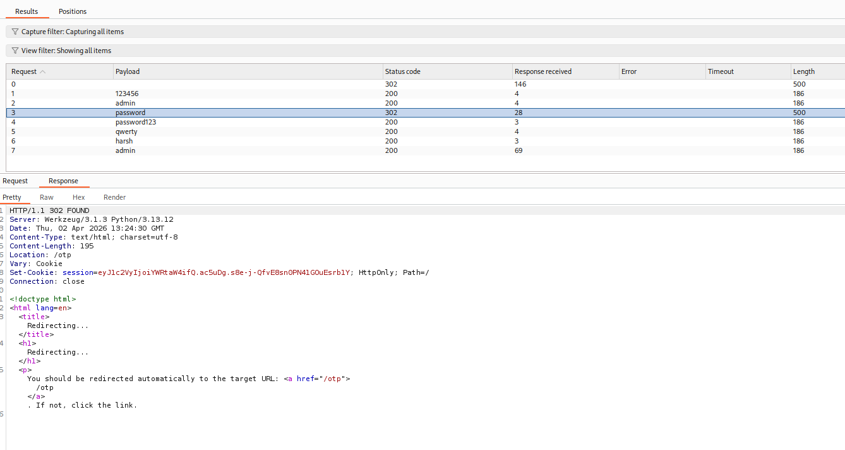
PoC 4: Enforcement of OTP-Based Multi-Factor Authentication (MFA)
PoC proves that users will only be able to access the system once the OTP authentication process is successfully completed. If users do not enter their OTP, they cannot navigate to the dashboard interface.
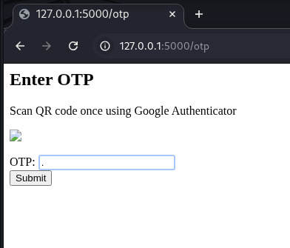

PoC 5: Successful MFA Authentication and Dashboard Access
This PoC shows that after successful OTP verification, the user is granted access to the dashboard. It confirms the correct implementation of the MFA process.
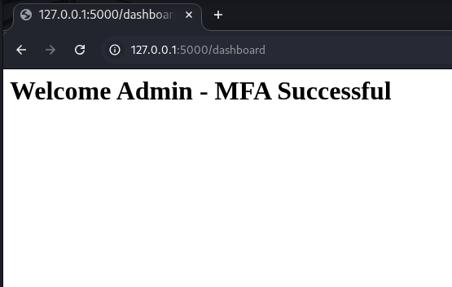
PoC 6: OTP Brute Force Attack Resistance
This is the PoC which tests the system's vulnerability to OTP bruteforce attacks. The test was conducted using several incorrect OTP codes, all of which failed to access the system.
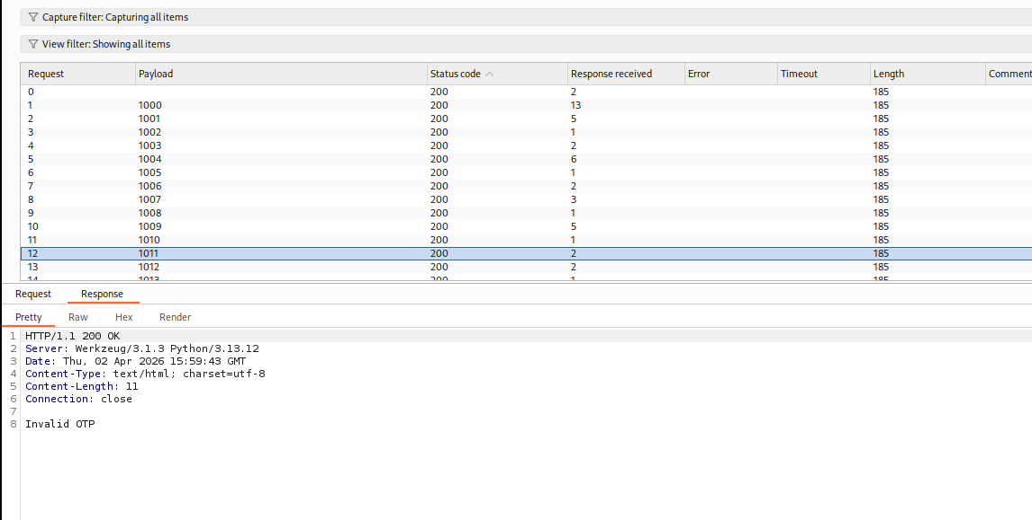

PoC 7: MFA Bypass via Improper Session Management
This PoC identifies a vulnerability where the system allowed access to protected resources without completing OTP verification due to improper session handling. This represents a critical MFA bypass issue.
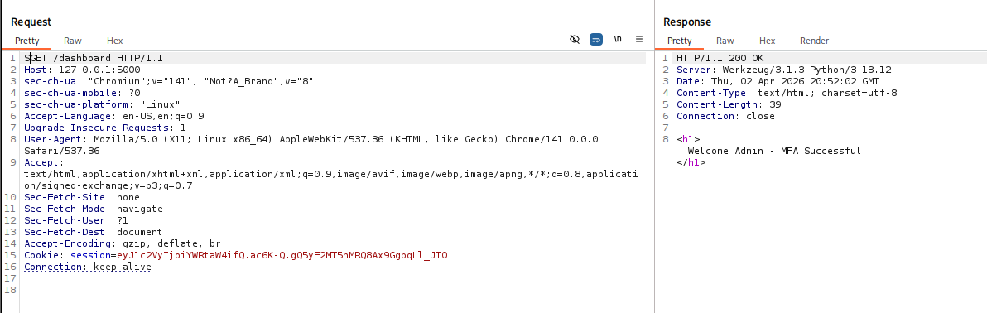

PoC 8: Server-Side Validation of MFA Enforcement
This PoC demonstrates that when the session management vulnerability is corrected, any unauthorized access attempts to restricted endpoints are prevented by the server. Logs verify effective enforcement of MFA.
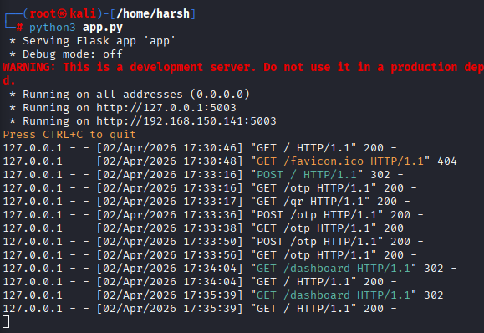

PoC 9: MFA Method Selection Interface
This PoC demonstrates the implementation of multiple MFA options, allowing users to choose between authenticator-based OTP and email-based OTP for authentication.
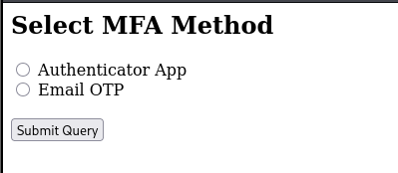

PoC 10: Email OTP Authentication (User Input Stage)
The PoC demonstrates the OTP authentication through the email, where the OTP is entered by the user using the simulated email.
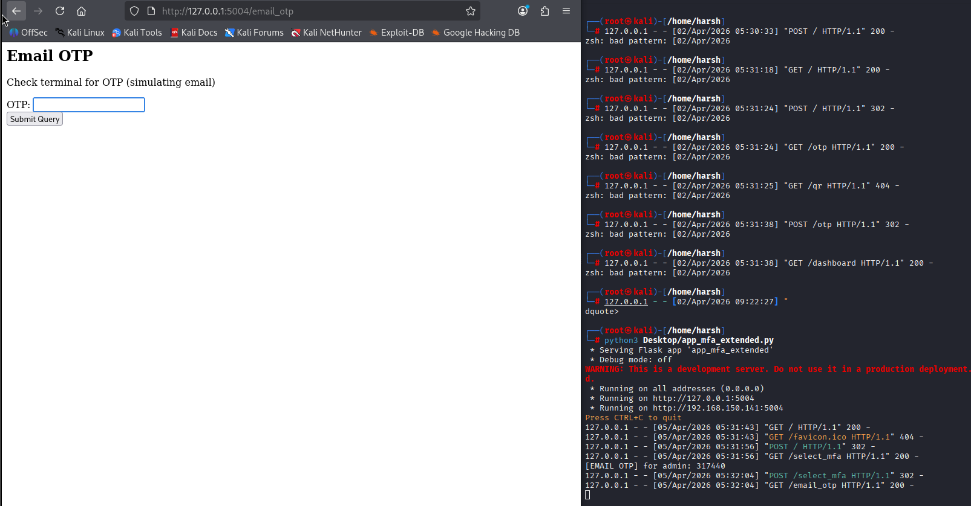

PoC 11: Successful MFA Login via Email OTP
The PoC highlights a successful login through OTP sent via email, thereby proving that the alternate form of MFA works.
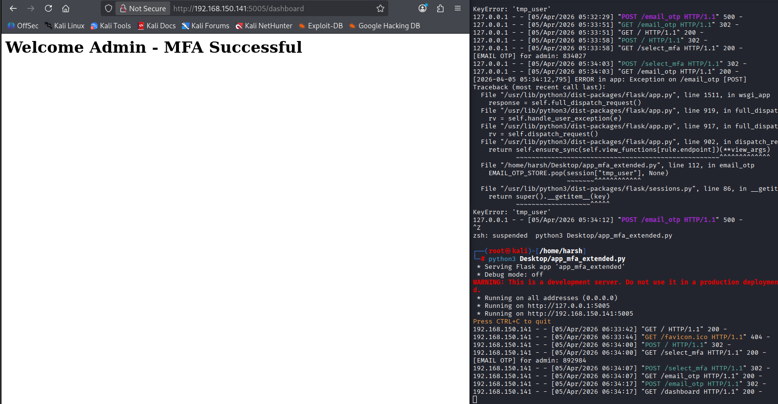

11. Security Analysis

The security aspect of the authentication process is investigated by considering different attack vectors as well as the impact MFA implementation has on them. The analysis is conducted using information collected from PoC scenarios that were implemented during research.

11.1 Attack Scenarios

The following attack scenarios were performed to assess the system’s level of security:

- Brute Force Attack:
The system was prone to being exposed to brute force attacks that involved guessing user credentials using numerous login attempts, especially in cases where there was no multi-factor authentication, as demonstrated in PoC 1-Brute Force Attack on DVWA Login and PoC 2-Brute Force Attack on Custom Login System (Without MFA).

- Credential Compromise:
Once attackers managed to get access to valid credentials, they were initially able to bypass the authentication procedure. Yet, thanks to MFA, they were not able to proceed without OTP code confirmation as illustrated in PoC 3-Credential Compromise Leading to OTP Verification Requirement and PoC 4-Enforcement of OTP-Based Multi-Factor Authentication (MFA).

- Brute Force Attack Against OTP:
The attackers attempted to crack the OTP by providing different values for it. Nonetheless, the system successfully resisted brute force attacks on account of the fact that OTP is time-sensitive, as illustrated in PoC 6-OTP Brute Force Attack Resistance.
- MFA Bypass Attempt:
A vulnerability that consisted in a flawed session handling process resulted in bypassing MFA authentication. This attack scenario was successfully tested in PoC 7-MFA Bypass Vulnerability via Improper Session Management, yet was fixed in PoC 8-Server-Side Validation of MFA Enforcement.

- Phishing and MFA Fatigue Attack:
Additional attack scenarios such as phishing attacks and MFA fatigue were analyzed conceptually. MFA significantly reduces the effectiveness of these attacks by requiring an additional verification factor.

11.2 Mitigation using MFA

The introduction of multi-factor authentication (MFA) plays a vital role in improving the security of the authentication system through adding another level of verification apart from conventional username and password authentication. This strategy addresses many of the common attack vectors seen during the initial phases of the project.

For starters, the MFA method ensures that the attacker is unable to gain access to the account even if the username and password are leaked. For instance, in cases where brute-force and credential stuffing attacks are carried out, the attacker obtains legitimate username and password combinations. Nevertheless, they cannot authenticate their identity without knowledge of the second factor, namely OTP.

Moreover, using TOTP helps secure the system against malicious attacks. The main advantage of TOTP is that each OTP generated can be used for a finite duration of time. Consequently, it makes brute-force attacks ineffective and impractical since they involve multiple guess-and-check attempts.

Lastly, the implementation of session management ensures that sessions are only created when the user passes the OTP validation step.

MFA can also help prevent attacks that use tactics such as phishing or credential harvesting. In cases where the user’s credentials have been compromised, the intruder still would not be able to breach the system without providing an additional authentication factor.

In summary, the adoption of MFA has greatly improved the authentication process by limiting the attack surface and implementing multiple layers of security.

12. Results and Observations

The deployment of the MFA system has led to noticeable improvement in the overall security associated with the authentication process. It can be noticed from the results of the PoC scenarios conducted that the difference between the conventional method of authentication and the MFA-based one is quite clear.

As seen in the first scenario, the system, not using MFA, is prone to brute force and other types of attacks where the attacker may gain access by using valid user credentials. After enabling MFA in the system, any unauthorized logins would have been impossible since the access to the system requires OTP verification.

The OTP-based authentication method turned out to be efficient and reliable since the attacker could not brute-force access through the use of OTP, due to its validity in terms of time period. Moreover, the discovery and elimination of MFA bypass vulnerability helped improve the system security further.

Multiple MFA mechanisms were used for increased security and convenience, including both OTP and email-based OTP.

13. Conclusion

In conclusion, this project has successfully implemented the process involved in designing a secure multi-factor authentication (MFA) system. This project illustrates some of the limitations associated with using password-based authentication systems, indicating the importance of additional levels of security measures to guard against attacks from contemporary cyber criminals.

Using authenticator and email-based One Time Password (OTP), the MFA system in question implements the required multi-layered authentication measures preventing any form of access to the system in case of compromised user login details. Through the various PoCs used, it becomes clear that there are various vulnerabilities that can arise in authentication systems lacking MFA and how MFA helps in overcoming these challenges.

Identifying and patching the vulnerability in the multi-factor authentication process has helped in improving the system's reliability in terms of session management and enforcing authentication.

Generally, this project proves that MFA is a viable security measure that should be implemented in modern enterprises.

14. Future Enhancements

Despite the fact that the proposed multi-factor authentication system offers a highly secure and reliable way for users' authentication process, some enhancements can be considered in order to improve its functionality and security further on.

As a first enhancement option, the system can be provided with the ability to utilize the real-time SMS-based delivery of one-time passwords using third-party services, for example, SMS gateways. This will help to implement additional authentication options during system deployment in real life.

As another enhancement, biometric authentication can be offered, which means that such authentication methods as fingerprint or facial scanning can be used instead of password-based verification.

Hardware authentication can also be implemented by using special tokens such as YubiKey which offers high levels of security against attacks like phishing or remote logins. Furthermore, it might also be beneficial to implement such advanced security options as account lockout procedures, rate limiting, and even anomaly detection.

Finally, one might consider implementing integration with other enterprise-level applications including Single Sign-On (SSO) solutions, Active Directory and Virtual Private Network (VPN) authentication services.

Thus, all those enhancements mentioned above will make it possible to develop the system further and convert it into a true enterprise-class authentication application.

15. References:

The following resources were referred to during the development and analysis of this project:
- OWASP – OWASP Top 10 Web Application Security Risks
- PortSwigger – Web Security Academy Labs and Documentation
- Flask Documentation – https://flask.palletsprojects.com/
- PyOTP Documentation – https://pyauth.github.io/pyotp/
- Google Authenticator – Time-based OTP implementation reference
- Burp Suite Documentation – https://portswigger.net/burp

