TRACEGATE SECURITY ASSESSMENT
CYBERSECURITY ASSESSMENT & PENETRATION TESTING REPORT
Target: E-Commerce Gateway & Auth Audit
Project Name: | E-Commerce Gateway & Auth Audit
Target URL / Host: | https://shop.tracegate.lab
Environment: | Web Application (Staging)
Assessment Methodology: | OWASP Web Security Testing Guide (WSTG v4.2) & PTES
Assessment Date: | September 08, 2026
Document Version: | v1.0
Lead Security Assessor: | Security Learner

Document Control & Version History
This document is an authorized, confidential deliverable. Any modifications to this report must be registered in the version control history below.
Version | Date | Author | Change Summary
v1.0 | 2026-09-07 21:07:29 | undefined | Audit Report package (4 confirmed findings)
v1.5 | 2026-09-04 19:42:43 | Lead Pentester Alex | Audit Report package (2 confirmed findings)
v2.0 | 2026-09-04 19:27:25 | Security Learner | Audit Report package (2 confirmed findings)

Table of Contents
1. Executive Summary & Risk Rating | Section 1
2. Findings Severity Matrix & SLAs | Section 2
3. Assessment Scope & Target Architecture | Section 3
4. Testing Methodology & Security Standards | Section 4
5. Security Test Coverage & Statistics | Section 5
6. Summary of Confirmed Vulnerabilities | Section 6
7. Detailed Technical Findings & Proof of Concept | Section 7
8. Prioritized Remediation Action Plan | Section 8
9. Retest & Validation Lifecycle | Section 9
10. Conclusion, Sign-Off & Appendices | Section 10

1. Executive Summary
Tracegate performed an authorized security assessment against 'E-Commerce Gateway & Auth Audit' located at https://shop.tracegate.lab. The primary objective was to identify security vulnerabilities, validate access boundaries, evaluate input handling safeguards, and provide actionable technical guidance to harden the system against potential compromise.
Tracegate Assessment Risk Rating: CRITICAL RISK
The target architecture possesses vulnerabilities with severe exploitability or full impact over sensitive assets, user accounts, or underlying systems. Urgent remediation is mandatory.
The assessment identified 8 confirmed security findings across evaluated scope.
• Total Confirmed Findings in Report: 8
• Critical Severity: 5
• High Severity: 2
• Medium Severity: 0
• Low Severity: 1
• Informational: 0

2. Findings Severity Matrix
The following matrix summarizes confirmed findings across severity tiers, calculated percentages relative to total identified findings, and recommended service level targets.
Severity Level | Count | Action | Percentage | Remediation SLA
CRITICAL | 5 | Immediate | 62.5% | 24-48 Hours
HIGH | 2 | Urgent | 25.0% | 7 Days
MEDIUM | 0 | Planned | 0.0% | 30 Days
LOW | 1 | Advisory | 12.5% | 90 Days
INFORMATIONAL | 0 | Best Practice | 0.0% | Discretionary

3. Assessment Scope & Target Architecture
• Target Application Name: E-Commerce Gateway & Auth Audit
• Target URL / Host: https://shop.tracegate.lab
• Target Environment: Web Application (Staging)
• Scope Summary: Authorized penetration test assessing user registration, multi-factor authentication, and payment handling.
• Scope Boundaries & Notes: Scope includes checkout, account reset, and cart endpoints.
• In-Scope Components: Web Application UI, REST API endpoints, user authentication flows, session handling.
• Out-of-Scope Components: Third-party payment gateways, external cloud infrastructure, Denial of Service (DoS/DDoS) attacks.

4. Testing Methodology & Standards
Testing activities were conducted in alignment with OWASP Web Security Testing Guide (WSTG v4.2) & PTES. The assessment executed an eight-stage security testing lifecycle:
1. Reconnaissance & Surface Inspection: Asset enumeration and input identification.
2. Functional Analysis & Visual Classification: Analysis of workflows and UI controls.
3. Security Test Selection: Prioritized selection of threat-relevant testing procedures.
4. Manual Verification: Hands-on probing of boundaries, session tokens, and business logic.
5. Proof-of-Concept Validation: Controlled exploitation to confirm business and technical impact.
6. Finding Documentation: Precise recording of steps, payloads, and evidence.
7. Remediation Guidance: Concrete code and architecture remediation recommendations.
8. Retesting & Verification: Validation of deployed security fixes to prevent regressions.
Note: Referencing security standards indicates methodological alignment and does not constitute third-party certification.

5. Security Test Coverage & Statistics
• Total Planned Security Controls: 5
• Controls Fully Evaluated: 0
• Controls Not Tested: 5
• Confirmed Vulnerabilities Identified: 0
• Verified Clean Controls (Pass): 0
• Security Test Coverage: 0.0%
Verified clean controls: 0
Controls not tested: 5
Test ID | Security Procedure | CWE | Verification Status
dash-metric-tampering | BOLA / IDOR on Analytical Widget Metrics Endpoints | CWE-639 | Not Tested
dash-filter-injection | SQL / NoSQL Injection in Dashboard Timeframe & Widget Filters | CWE-89 | Not Tested
search-reflected-xss | Reflected Cross-Site Scripting (XSS) in Search Results | CWE-79 | Not Tested
auth-session-fixation | Session Fixation & Post-Auth Identifier Regeneration | CWE-384 | Not Tested
dash-sensitive-data-leak | Sensitive Information Disclosure in Activity Logs & Recent Feeds | CWE-200 | Not Tested

6. Summary of Confirmed Vulnerabilities
Finding ID | Vulnerability Title | Severity | CWE | Status | Retest
VULN-001 | Insecure Direct Object References (IDOR) on Profile Update | CRITICAL | CWE-639 | Open | PENDING
VULN-002 | Arbitrary File Upload via Unrestricted Extension Validation | CRITICAL | CWE-434 | Open | PENDING
VULN-003 | Path Traversal & Destination Storage Directory Escapes | CRITICAL | CWE-22 | Open | PENDING
VULN-004 | Two-Factor Authentication (2FA) Implementation Bypass | CRITICAL | CWE-288 | Open | PENDING
VULN-005 | Authentication Bypass (SQL Injection / Logic Flaws) | CRITICAL | CWE-287 | Open | PENDING
VULN-006 | Stored XSS via Malicious SVG Image Upload | HIGH | CWE-79 | Open | PENDING
VULN-007 | Username & Account Enumeration | HIGH | CWE-204 | Open | PENDING
VULN-008 | Credential Caching & Form Autocomplete Directive | LOW | CWE-524 | Open | PENDING

7. Detailed Technical Findings & Proof of Concept

VULN-001: Insecure Direct Object References (IDOR) on Profile Update
Severity | CWE | CVSS v3.1 | Remediation Status | Source
CRITICAL | CWE-639 | 8.5 | Fix Applied | Tracegate Checklist
A. Vulnerability Description & Technical Observation
Standard risk area for Account / Profile Page; Directly relevant to visible 'Save changes'
B. Business & Technical Impact
Authenticated users can view, modify, or delete sensitive records belonging to other users or organizations across the platform.
C. Step-by-Step Reproduction Procedure
Intercept profile update POST/PUT request and replace user_id / account_id parameter with target account identifier.
D. Proof of Concept (PoC) Request / Payload Snippet
GET /api/v1/records/102 HTTP/1.1
Host: target.app
Authorization: Bearer <user_a_token>
--> HTTP/1.1 200 OK
{"record_id": 102, "owner": "user_b", "sensitive_data": "Confidential Info"}
E. Attached Proof-of-Concept Evidence
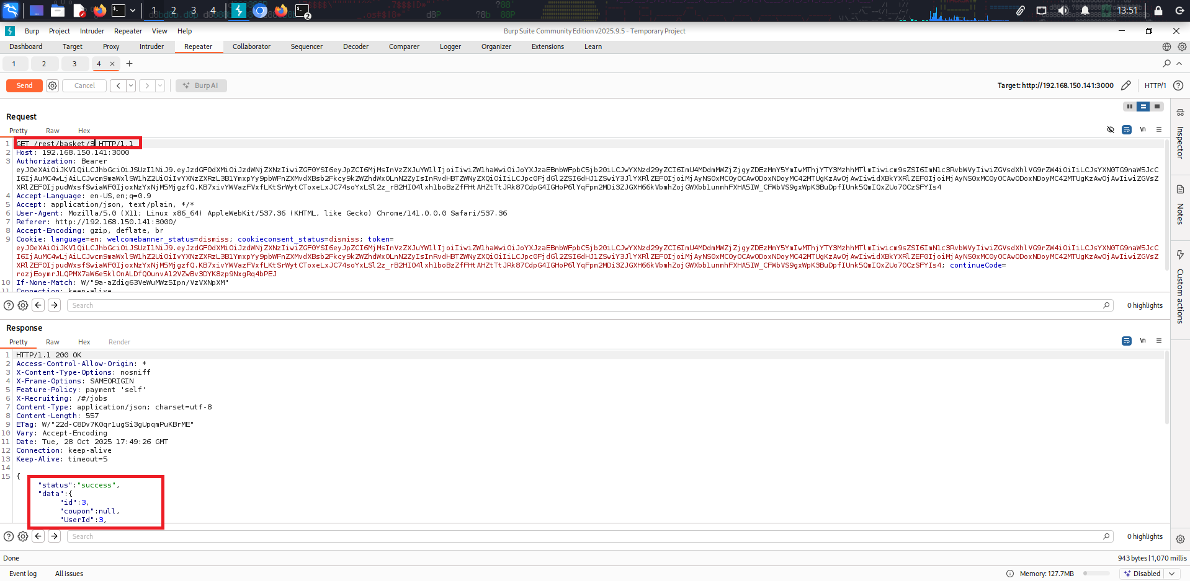
Figure 1: Evidence demonstrating the reported behavior (VULN-001 - 1.IDOR.png)
F. Recommended Technical Remediation
Enforce server-side authorization checks on every object reference. Validate that the authenticated session identity possesses ownership or authorized access to the requested entity before returning data.
G. Defense-in-Depth Architectural Mitigation
Use indirect reference maps or unguessable cryptographically secure UUIDv4 identifiers rather than sequential integer IDs; enforce centralized authorization middleware (ABAC/RBAC).
H. Remediation Lifecycle & Retest Tracking
• Remediation Status: Fix Applied
• Retest Status: PENDING
• Dedicated Fix Branch: tracegate/fix/VULN-008
• Pull Request: https://github.com/tracegate-lab/ecommerce-platform/pull/108

VULN-002: Arbitrary File Upload via Unrestricted Extension Validation
Severity | CWE | CVSS v3.1 | Remediation Status | Source
CRITICAL | CWE-434 | 9.8 | NOT_STARTED | Tracegate Checklist
A. Vulnerability Description & Technical Observation
Standard risk area for File Upload Page
B. Business & Technical Impact
Attackers can upload server-executable scripts or malicious HTML files, resulting in Remote Code Execution (RCE), host compromise, or persistent defacement.
C. Step-by-Step Reproduction Procedure
Upload files with executable extensions, double extensions (.php.jpg), or null byte tricks (.php%00.png) to test server handling.
D. Proof of Concept (PoC) Request / Payload Snippet
POST /api/v1/upload HTTP/1.1
Host: target.app
Content-Type: multipart/form-data; boundary=----BoundaryX
------BoundaryX
Content-Disposition: form-data; name="file"; filename="test_exec.jsp"
<executed_server_script>
------BoundaryX--
--> HTTP/1.1 201 Created
{"url": "/uploads/test_exec.jsp"}
E. Attached Proof-of-Concept Evidence
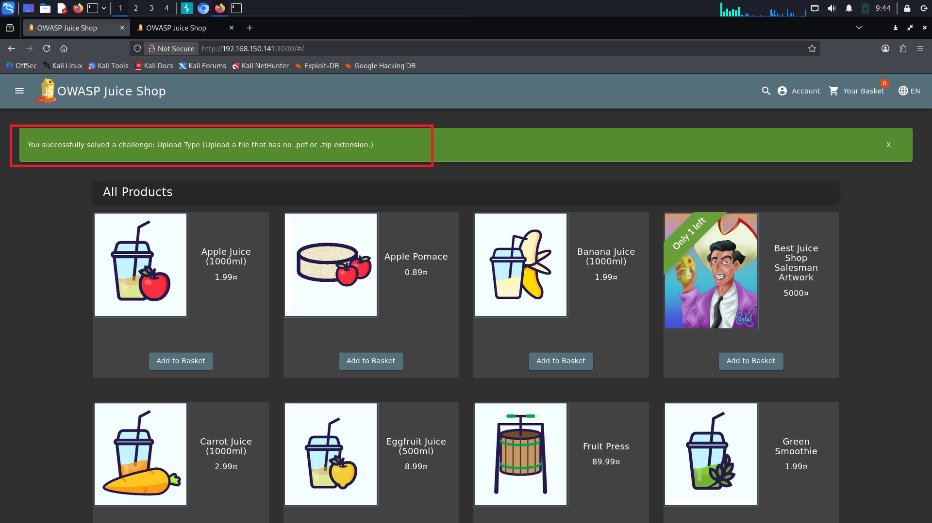
Figure 2: Evidence demonstrating the reported behavior (VULN-002 - 3.file_upload.png)
F. Recommended Technical Remediation
Enforce a strict whitelist of permitted file extensions (e.g. .png, .jpg, .pdf). Verify file contents using server-side magic byte inspection. Store files outside the web root or in an isolated private cloud storage bucket (AWS S3) with generated random filenames.
G. Defense-in-Depth Architectural Mitigation
Configure the web server to disable script execution in the upload directory; serve user-uploaded files with Content-Disposition: attachment and X-Content-Type-Options: nosniff headers.
H. Remediation Lifecycle & Retest Tracking
• Remediation Status: NOT_STARTED
• Retest Status: PENDING

VULN-003: Path Traversal & Destination Storage Directory Escapes
Severity | CWE | CVSS v3.1 | Remediation Status | Source
CRITICAL | CWE-22 | 7.5 | NOT_STARTED | Tracegate Checklist
A. Vulnerability Description & Technical Observation
Standard risk area for File Upload Page
B. Business & Technical Impact
An unauthorized attacker can leverage this condition to circumvent intended security controls, access unauthorized functionality, or disclose confidential metadata.
C. Step-by-Step Reproduction Procedure
Supply filenames containing traversal sequences (e.g., `../../../../var/www/shell.php`) in multipart headers.
D. Proof of Concept (PoC) Request / Payload Snippet
GET /api/v1/resource HTTP/1.1
Host: target.app
Authorization: Bearer <session_token>
--> HTTP/1.1 200 OK (Unvalidated control response returned)
E. Attached Proof-of-Concept Evidence
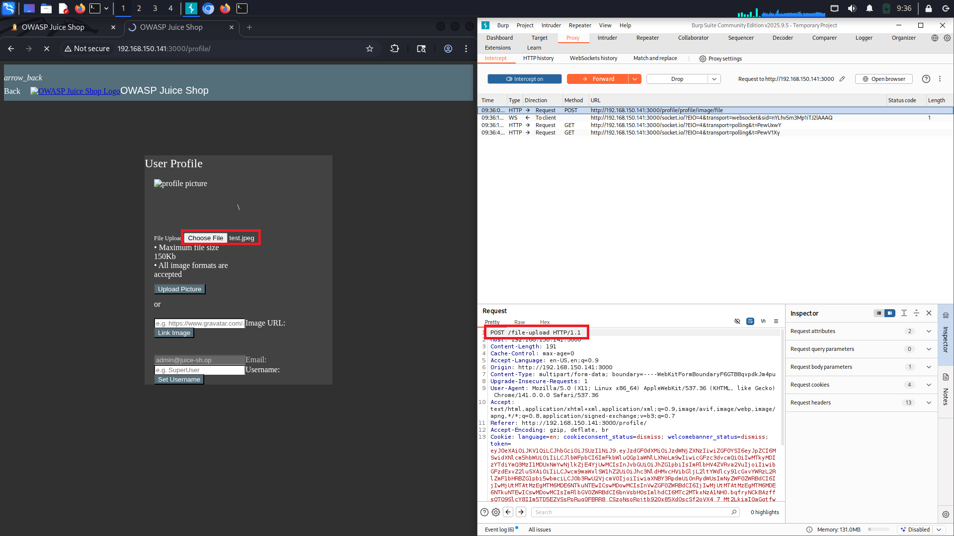
Figure 3: Evidence demonstrating the reported behavior (VULN-003 - 2.file_upload.png)
F. Recommended Technical Remediation
Implement strict server-side validation, authentication, and authorization verification for Path Traversal & Destination Storage Directory Escapes. Ensure that all inputs are validated against strict allowlists and access controls are strictly enforced on the server.
G. Defense-in-Depth Architectural Mitigation
Enforce defense-in-depth controls including centralized security middleware, comprehensive audit logging, and automated security regression testing.
H. Remediation Lifecycle & Retest Tracking
• Remediation Status: NOT_STARTED
• Retest Status: PENDING

VULN-004: Two-Factor Authentication (2FA) Implementation Bypass
Severity | CWE | CVSS v3.1 | Remediation Status | Source
CRITICAL | CWE-288 | 7.5 | NOT_STARTED | Tracegate Checklist
A. Vulnerability Description & Technical Observation
Standard risk area for Login / Sign-in Page
B. Business & Technical Impact
An unauthorized attacker can leverage this condition to circumvent intended security controls, access unauthorized functionality, or disclose confidential metadata.
C. Step-by-Step Reproduction Procedure
Intercept 2FA challenge response and modify response payload (e.g. {'success': true}) or navigate directly to endpoint.
D. Proof of Concept (PoC) Request / Payload Snippet
GET /api/v1/resource HTTP/1.1
Host: target.app
Authorization: Bearer <session_token>
--> HTTP/1.1 200 OK (Unvalidated control response returned)
F. Recommended Technical Remediation
Implement strict server-side validation, authentication, and authorization verification for Two-Factor Authentication (2FA) Implementation Bypass. Ensure that all inputs are validated against strict allowlists and access controls are strictly enforced on the server.
G. Defense-in-Depth Architectural Mitigation
Enforce defense-in-depth controls including centralized security middleware, comprehensive audit logging, and automated security regression testing.
H. Remediation Lifecycle & Retest Tracking
• Remediation Status: NOT_STARTED
• Retest Status: PENDING

VULN-005: Authentication Bypass (SQL Injection / Logic Flaws)
Severity | CWE | CVSS v3.1 | Remediation Status | Source
CRITICAL | CWE-287 | 8.0 | NOT_STARTED | Tracegate Checklist
A. Vulnerability Description & Technical Observation
Standard risk area for Login / Sign-in Page; Directly relevant to visible 'Password input'
B. Business & Technical Impact
Account takeover, unauthorized access to user data, and failure of authentication boundaries.
C. Step-by-Step Reproduction Procedure
Test login inputs with boolean tautologies, string termination, and null byte sequences to assess backend credential verification.
D. Proof of Concept (PoC) Request / Payload Snippet
GET /api/v1/protected HTTP/1.1
Host: target.app
Authorization: Bearer <tampered_token>
--> HTTP/1.1 200 OK (Access granted without valid token verification)
E. Attached Proof-of-Concept Evidence
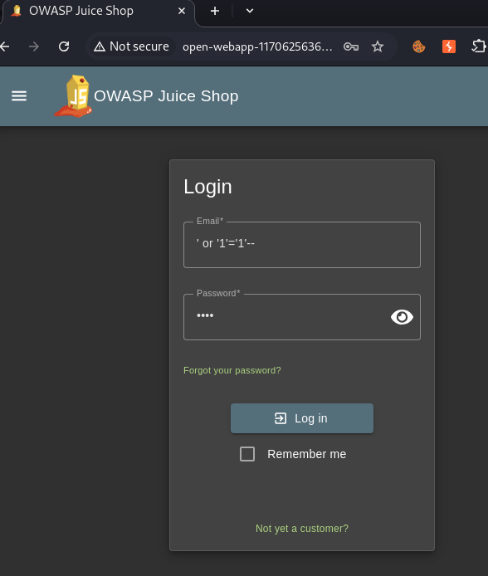
Figure 4: Evidence demonstrating the reported behavior (VULN-005 - 6-2.png)
F. Recommended Technical Remediation
Ensure all protected endpoints rigorously validate authentication tokens, verify cryptographic signatures using strong keys, and check token revocation status before fulfilling requests.
G. Defense-in-Depth Architectural Mitigation
Use standardized authentication frameworks (OAuth 2.0 / OIDC) rather than custom verification logic; enforce short-lived access tokens with secure refresh token rotation.
H. Remediation Lifecycle & Retest Tracking
• Remediation Status: NOT_STARTED
• Retest Status: PENDING

VULN-006: Stored XSS via Malicious SVG Image Upload
Severity | CWE | CVSS v3.1 | Remediation Status | Source
HIGH | CWE-79 | 7.5 | NOT_STARTED | Tracegate Checklist
A. Vulnerability Description & Technical Observation
Standard risk area for File Upload Page
B. Business & Technical Impact
An attacker can execute arbitrary script in the victim browser session, hijack authenticated session tokens, perform unauthorized actions, or conduct page defacement.
C. Step-by-Step Reproduction Procedure
Upload an SVG file containing an embedded `<script>` or onload attribute; browse directly to image URL.
D. Proof of Concept (PoC) Request / Payload Snippet
POST /api/v1/content HTTP/1.1
Host: target.app
Content-Type: application/json
{"field": "<img src=x onerror=console.log(document.domain)>"}
--> HTTP/1.1 200 OK (Rendered unescaped in DOM)
E. Attached Proof-of-Concept Evidence
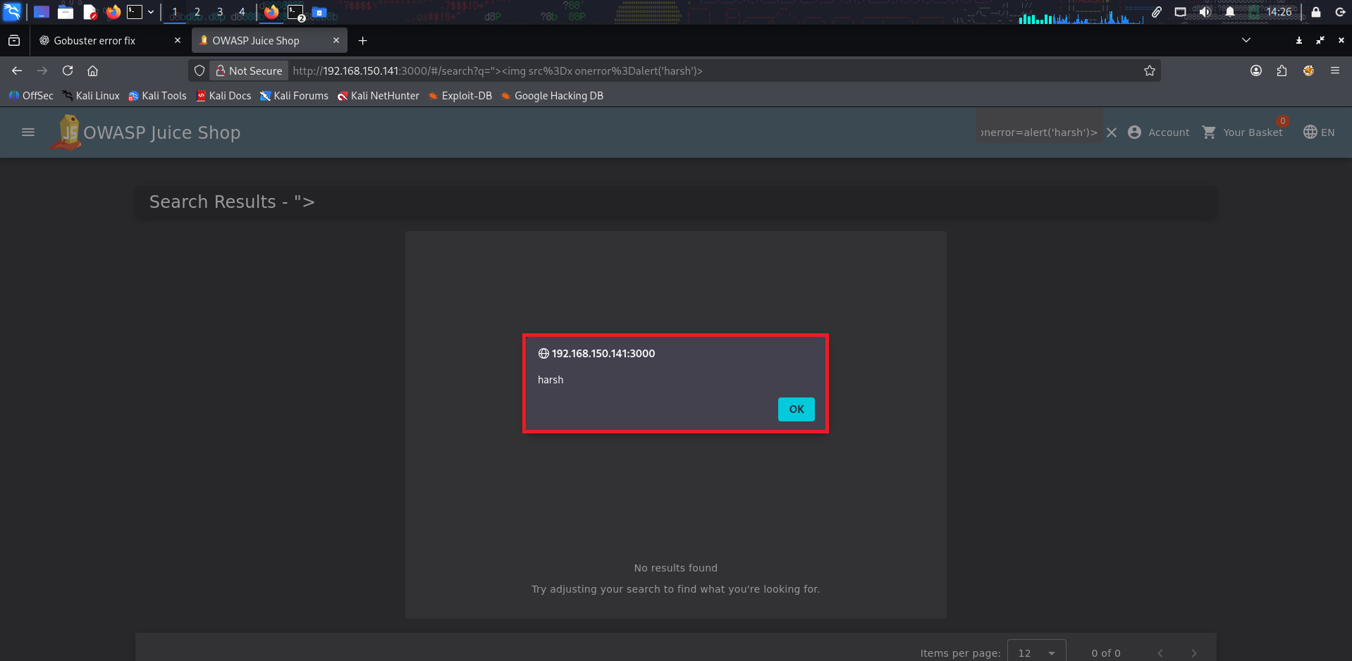
Figure 5: Evidence demonstrating the reported behavior (VULN-006 - XSS-2.png)
F. Recommended Technical Remediation
Apply context-aware contextual output encoding (HTML body, attribute, JavaScript variable) before rendering user data. If rich text is required, sanitize markup using DOMPurify with an explicit safe-tag whitelist.
G. Defense-in-Depth Architectural Mitigation
Implement a strict Content Security Policy (CSP) header (e.g. Content-Security-Policy: default-src 'self'; script-src 'self' 'nonce-...'). Mark session cookies with HttpOnly and SameSite flags.
H. Remediation Lifecycle & Retest Tracking
• Remediation Status: NOT_STARTED
• Retest Status: PENDING

VULN-007: Username & Account Enumeration
Severity | CWE | CVSS v3.1 | Remediation Status | Source
HIGH | CWE-204 | 7.5 | NOT_STARTED | Tracegate Checklist
A. Vulnerability Description & Technical Observation
Standard risk area for Login / Sign-in Page
B. Business & Technical Impact
An unauthorized attacker can leverage this condition to circumvent intended security controls, access unauthorized functionality, or disclose confidential metadata.
C. Step-by-Step Reproduction Procedure
Submit known vs. non-existent usernames and compare HTTP response codes, timing differentials, and error messages.
D. Proof of Concept (PoC) Request / Payload Snippet
GET /api/v1/resource HTTP/1.1
Host: target.app
Authorization: Bearer <session_token>
--> HTTP/1.1 200 OK (Unvalidated control response returned)
E. Attached Proof-of-Concept Evidence
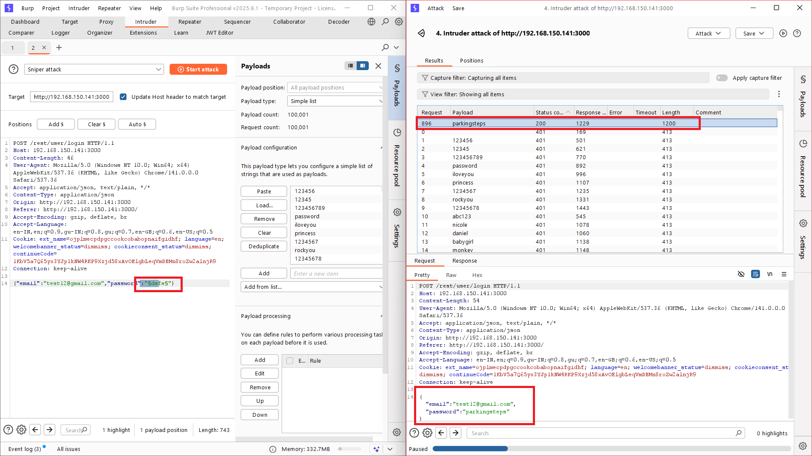
Figure 6: Evidence demonstrating the reported behavior (VULN-007 - 1.Broken Authentication.png)
F. Recommended Technical Remediation
Implement strict server-side validation, authentication, and authorization verification for Username & Account Enumeration. Ensure that all inputs are validated against strict allowlists and access controls are strictly enforced on the server.
G. Defense-in-Depth Architectural Mitigation
Enforce defense-in-depth controls including centralized security middleware, comprehensive audit logging, and automated security regression testing.
H. Remediation Lifecycle & Retest Tracking
• Remediation Status: NOT_STARTED
• Retest Status: PENDING

VULN-008: Credential Caching & Form Autocomplete Directive
Severity | CWE | CVSS v3.1 | Remediation Status | Source
LOW | CWE-524 | 7.5 | NOT_STARTED | Tracegate Checklist
A. Vulnerability Description & Technical Observation
Standard risk area for Login / Sign-in Page; Directly relevant to visible 'Password input'
B. Business & Technical Impact
An unauthorized attacker can leverage this condition to circumvent intended security controls, access unauthorized functionality, or disclose confidential metadata.
C. Step-by-Step Reproduction Procedure
Inspect form tag and password input DOM attributes for autocomplete='off' or 'new-password' compliance.
D. Proof of Concept (PoC) Request / Payload Snippet
GET /api/v1/resource HTTP/1.1
Host: target.app
Authorization: Bearer <session_token>
--> HTTP/1.1 200 OK (Unvalidated control response returned)
E. Attached Proof-of-Concept Evidence

Figure 7: Evidence demonstrating the reported behavior (VULN-008 - 1.Broken Authentication.png)
F. Recommended Technical Remediation
Implement strict server-side validation, authentication, and authorization verification for Credential Caching & Form Autocomplete Directive. Ensure that all inputs are validated against strict allowlists and access controls are strictly enforced on the server.
G. Defense-in-Depth Architectural Mitigation
Enforce defense-in-depth controls including centralized security middleware, comprehensive audit logging, and automated security regression testing.
H. Remediation Lifecycle & Retest Tracking
• Remediation Status: NOT_STARTED
• Retest Status: PENDING

8. Prioritized Remediation Action Plan
Engineering and DevOps teams should remediate confirmed vulnerabilities according to the risk-prioritized schedule below. Critical and High severity findings must be scheduled for immediate resolution.
Finding ID | Priority | Recommended Action | Status | Target SLA
VULN-001 | CRITICAL | Enforce server-side authorization checks on every object reference. Validate that the authenticated session identity possesses ownership or authorized access... | Fix Applied | 24-48 Hours
VULN-002 | CRITICAL | Enforce a strict whitelist of permitted file extensions (e.g. .png, .jpg, .pdf). Verify file contents using server-side magic byte inspection. Store files ou... | NOT_STARTED | 24-48 Hours
VULN-003 | CRITICAL | Implement strict server-side validation, authentication, and authorization verification for Path Traversal & Destination Storage Directory Escapes. Ensure th... | NOT_STARTED | 24-48 Hours
VULN-004 | CRITICAL | Implement strict server-side validation, authentication, and authorization verification for Two-Factor Authentication (2FA) Implementation Bypass. Ensure tha... | NOT_STARTED | 24-48 Hours
VULN-005 | CRITICAL | Ensure all protected endpoints rigorously validate authentication tokens, verify cryptographic signatures using strong keys, and check token revocation statu... | NOT_STARTED | 24-48 Hours
VULN-006 | HIGH | Apply context-aware contextual output encoding (HTML body, attribute, JavaScript variable) before rendering user data. If rich text is required, sanitize mar... | NOT_STARTED | 7 Days
VULN-007 | HIGH | Implement strict server-side validation, authentication, and authorization verification for Username & Account Enumeration. Ensure that all inputs are valida... | NOT_STARTED | 7 Days
VULN-008 | LOW | Implement strict server-side validation, authentication, and authorization verification for Credential Caching & Form Autocomplete Directive. Ensure that all... | NOT_STARTED | 90 Days

9. Retest & Validation Lifecycle
Remediation validation is an essential phase of any security assessment. The following table records the verification state for all identified findings.
Finding ID | Vulnerability Title | Remediation Status | Retest Verification
VULN-001 | Insecure Direct Object References (IDOR) on Profile Update | Fix Applied | PENDING
VULN-002 | Arbitrary File Upload via Unrestricted Extension Validation | NOT_STARTED | PENDING
VULN-003 | Path Traversal & Destination Storage Directory Escapes | NOT_STARTED | PENDING
VULN-004 | Two-Factor Authentication (2FA) Implementation Bypass | NOT_STARTED | PENDING
VULN-005 | Authentication Bypass (SQL Injection / Logic Flaws) | NOT_STARTED | PENDING
VULN-006 | Stored XSS via Malicious SVG Image Upload | NOT_STARTED | PENDING
VULN-007 | Username & Account Enumeration | NOT_STARTED | PENDING
VULN-008 | Credential Caching & Form Autocomplete Directive | NOT_STARTED | PENDING

10. Assessment Conclusion & Formal Sign-Off
The cybersecurity assessment against 'E-Commerce Gateway & Auth Audit' identified 8 confirmed findings within the tested scope (5 Critical, 2 High, 0 Medium, 1 Low, 0 Informational). Remediation must be executed according to the recommended priority targets, followed by a retest verification cycle to guarantee that vulnerability vectors have been eliminated.
Prepared by: | Verified & Reviewed by:
___________________________________  Security Learner  Security Assessor, Tracegate VAPT | ___________________________________  Lead Security Reviewer  Senior Penetration Testing Lead
Date: September 08, 2026 | Date: September 08, 2026

Appendix A: CWE Classification Index
• CWE-89: Improper Neutralization of Special Elements used in an SQL Command ('SQL Injection')
• CWE-79: Improper Neutralization of Input During Web Page Generation ('Cross-site Scripting')
• CWE-639: Authorization Bypass Through User-Controlled Key ('Insecure Direct Object References')
• CWE-287: Improper Authentication
• CWE-352: Cross-Site Request Forgery (CSRF)
• CWE-434: Unrestricted Upload of File with Dangerous Type
• CWE-200: Exposure of Sensitive Information to an Unauthorized Actor
• CWE-693: Protection Mechanism Failure

Appendix B: Report Traceability & Audit Metadata
• Project ID: proj-ecommerce-001
• Report Document Version: v1.0
• Selected Finding IDs: find-1788596650730, find-1788556353163, find-1788556333209, find-1788556103070, find-1788555891178, find-1788556309943, find-1788556121675, find-1788555976998
• Assessment Methodology: OWASP Web Security Testing Guide (WSTG v4.2) & PTES
• Generation Timestamp: 2026-09-08T15:20:38.791797

