# **An effective traditional remedy against common ear infection bacteria**

Varun Mangalick1, Tonya L Ward2, Chan Lan Chun3,4, Michael J. Sadowsky2,3,4, Dan Knights2,5

1. Massachusetts Institute of Technology, Cambridge, MA 02139

2. Biotechnology Institute, University of Minnesota, Saint Paul, MN, 55108

3. Department of Civil Engineering and Natural Resources Research Institute, University of Minnesota Duluth, Duluth MN 55812

4. Department of Soil, Water, and Climate, University of Minnesota, Saint Paul, MN 55108

5. Department of Computer Science and Engineering, University of Minnesota, Minneapolis, MN 55455

Corresponding Author:

Dan Knights

Keller Hall 4-192

200 Union St SE

Minneapolis, MN 55455

[dknights@umn.edu](mailto:dknights@umn.edu" \t "_blank)

[612-564-2762](tel:612-564-2762" \t "_blank)

**Abstract**

**Background:** Otitis media, inflammatory diseases of the middle ear, is the most common cause of in-patient pediatric visits in the USA. Otitis externa, or swimmer’s ear, while not as common, also results in millions of annual hospital visits. Most of these infections are treated with antibiotics, such as amoxicillin, despite the fact that the American Academy of Pediatrics now recommends a watch-and-wait policy. This is in part due to the many short- and long-term health problems associated with antibiotic overuse, including disruption of gut microbiota. Topical antibiotic treatment would be expected to cause less disruption to the gut microbiota than oral antibiotics, and therefore fewer health issues.

**Methods:** In some South Asian countries, people use plant extracts such as garlic and mustard oil as topical treatments for otitis media. We tested the antibacterial properties of these plant extracts on susceptibility of *Streptococcus pneumoniae* and *Haemophilus influenzae* using microdilution assay. In addition, we compared the effectiveness of garlic and mustard oil to that of commonly used antibiotics (ampicillin, amoxicillin) to see the potential of their use for less severe cases, or during the watch-and-wait period of the recommended treatment protocol as an alternative treatment.

**Results:** Here we show that garlic extract and mustard oil strongly inhibited the growth of *Streptococcus pneumoniae* and *Haemophilus influenzae*. In addition, we found that garlic-infused mustard oil inhibited growth in both bacteria more strongly than mustard oil alone or garlic oil dissolved in peanut oil or water. However, in one experiment garlic and mustard oil appeared to be only bacteriostatic towards *H. influenza, and the bacterium* eventually began to grow after 5 hours of treatment. In all other cases garlic extract and mustard oil were bactericidal to Both bacteria.

**Conclusion:** Garlic and mustard oil appear to be useful as bactericidal agents to treat otitis media caused by *Streptococcus pneumoniae* and *Haemophilus influenzae*. Any change in clinical practice that would reduce antibiotic usage in infants is expected to have benefits to society and the national healthcare burden, potentially diminishing emergence of antibiotic resistance and lowering incidence of adult diseases linked to childhood antibiotics usage.

**Keywords**

Otitis media; otitis externa; garlic; mustard oil; Streptococcus pneumoniae; Haemophilus influenza; amoxicillin; ampicillin

**Background**

Otitis media and otitis externa are infections that occur in the middle and outer ear, respectively. Millions of courses of antibiotics are administered every year to infants and young children to treat otitis media [1]. Direct costs of otitis externa, or swimmer’s ear, are approximated at $0.5 billion dollars annually [2]. While antibiotics are often effective, widespread use in infants contributes to the emergence of antibiotic-resistant bacteria [3], and has been linked to increase risk of adult diseases; including obesity, allergies, asthma, and diabetes in animal models and in epidemiological studies of human populations [4]. Oral antibiotics can also have direct negative health effects on the infant, including liver damage [4]. While topical treatments would be less disruptive to the gut microbiome than oral antibiotics, any topical treatment must allow transmembrane diffusion past the tympanic membrane for otitis media treatment. In addition, some cases of otitis media where antibiotics are prescribed are actually viral in nature, nullifying the benefit of antibiotic treatment.

In some South Asian countries, people use a variety of plant extracts and oils to treat diseases including otitis media [5]. Among these treatments, some of the more commonly used plant extracts are from garlic (*Allium sativum*) and mustard (*Brassica juncea*). Both of these extracts have been shown to have antimicrobial properties against many types of bacteria, some of which have been implicated in human diseases [6][7]. Garlic exhibits its antimicrobial properties through the action of allicin. Allicin inhibits thiol-containing enzymes, such as cysteine proteases, alcohol dehydrogenases, and thioredoxin reductases and can target both gram positive and gram negative bacteria including many pathogenic strains [8]. Mustard oil inhibits bacterial growth via the chemical allyl isothiocyanate, which disrupts bacterial cell membranes [9].

The aim of this study was to investigate the antimicrobial properties of garlic and mustard oil on growth of *Streptococcus pneumoniae* and *Haemophilus influenzae,* two bacterial species commonly found in otitis media patients [10]. *S. pneumoniae* is a gram-positive bacterium that often causes respiratory infections, whereas *H. influenzae* is a gram-negative bacterium that causes local infections in humans. We also compared the effectiveness of garlic and mustard to that of the antibiotics Amoxicillin and Ampicillin, the first of which is commonly prescribed to infants for otitis media

**Materials and Methods**

Establishing base cultures

*Streptococcus pneumoniae* (Klein) Chester (ATCC® 49619™) and *Haemophilus influenzae* (Lehmann and Neumann) Winslow et al. (ATCC® 49247™)] were grown in Mueller Hinton Broth (MHB) [17.5 g/L casein acid hydrolysate, 3.0 g/L beef extract, 1.5 g/L starch]. Liquid cultures were grown at 37°C, with shaking for 1-2 days. After the media tubes began to appear turbid, we used disposable inoculation loops (Sigma Aldrich, St. Louis, MO) to streak the liquid cultures onto plates with Mueller Hinton Agar (MHA) [17.5 g/L casein acid hydrolysate, 17 g/L agar, 3.0 g/L beef extract, 1.5 g/L starch] and incubated at 37°C until colonies appeared. Using inoculation loops, we transferred trace amounts of bacteria from the three separate plates into three separate vials of MHB and incubate in 37°C shaker. We then froze original liquid cultures and keep original plates at 4°C in case current plates or liquid cultures become dormant.

Creating inhibition solutions

For mustard oil (MO) and peanut oil (PO) solutions, we used use pure mustard oil (Dabur India Ltd., Ghaziabad, India) and peanut oil (Essential Everyday, Eden Prairie, MN) respectively. For mustard oil + garlic (MO+G), peanut oil + garlic (PO+G), and water + garlic (W+G), we blended 50 g of garlic (peeled fresh cloves) into 100 mL of the respective liquid base until few chunks remained using a Waring commercial blender. We allowed the MO+G and PO+G solutions to sit for 2-3 days until there was a clear separation between the garlic infused oil layer (top) and the garlic paste layer (bottom). We then pipetted out and kept the garlic infused oil layer to use for inhibition experiments. For the W+G solution, immediately after blending, we filtered the paste twice through filter paper, as the layers did not separate as easily due to similar density. We allowed the solution to sit for 2-3 days until any remaining fibrous material sank to the bottom. We then pipetted out and kept the top layer to use for inhibition experiments. For amoxicillin (MP Biomedicals, Santa Ana, CA) and ampicillin [ampicillin sodium salt] (Teknova, Hollister, CA) we made 10 mL of a 1mg/mL solution.

Inhibition assay preparation

Each inhibition assay took place in a 96 well cell culture cluster plate (Corning Inc., Corning, NY). In each plate, we filled the outer two layers of wells on each side with 300 µL of water (leaving 4x8 empty wells) to protect against evaporation. In each of the 8 columns, we used the 4 wells as replicates and create the same experimental conditions in each. We then created a 10% bacterial liquid culture solution (M+B) by diluting the base bacterial liquid cultures 10x into MHB. In the first and second columns, we put 200 µL of only MHB (M) or M+B respectively to act as negative and positive controls. We then filled the third, fifth, and seventh lanes with 190 µL of M and the fourth, sixth, and eighth lanes with M+B. Each odd-numbered column served as the negative control for the even-numbered column to its right. For the mustard assay, we added 10 µL of peanut oil (PO) to the third and fourth lanes, 10 µL of mustard oil (MO) to the fifth and sixth lanes, and 10 µL of garlic mixed in mustard oil (G+MO) to the seventh and eighth lanes. For the garlic assay, we added 10 µL of garlic mixed in peanut oil (G+PO) to the third and fourth lanes, 10 µL of garlic mixed in water (G+W) to the fifth and sixth lanes, and garlic mixed in mustard oil (G+MO) to the seventh and eighth lanes. For the antibiotics assay, we added 10 µL of amoxicillin solution (AX) to the third and fourth lanes, 10 µL of vancomycin solution (V) to the fifth and sixth lanes, and 10 µL of ampicillin solution (AP) to the seventh and eighth lanes, though the data for vancomycin was excluded. See Table 1 for a summary.

**Table 1: Inhibitors present in various assays**

|  |  |  |  |  |
| --- | --- | --- | --- | --- |
|  | Columns 1,2 | Columns 3,4 | Columns 5,6 | Columns 7,8 |
| Mustard Assay | Control | PO | MO | G+MO |
| Garlic Assay | Control | G+PO | G+W | G+MO |
| Antibiotic Assay | Control | AX | N/A | AP |

Data collection and analysis

We followed a scanning protocol to incubate the plates at 37°C and read their optical density every 30 minutes at a wavelength of 600 nm for 12-24 hours using the Biotek Synergy HT microplate reader and Gen5 software. In our experiments, after around 10 hours of reading, the non-water wells began to undergo evaporation, so we made growth curves leading only up to this point.

We created the growth curves with the R statistical programming language. First, we averaged each column of four points. Then we subtracted each average optical density of a column with just media and inhibitors from the average optical density of the column with inoculated media and the same inhibitors. For example, we subtracted the average optical density of the M+G+PO column at three hours from the average OD of the M+G+PO+B column at 3 hours. This serves to remove the effects of the various inhibitors on optical density.

The error bars on each point represent the standard error of the four optical density values of the wells with inoculated media and inhibitors added to the standard error of the four optical density values of the wells with non-inoculated media and the corresponding inhibitors.

Correcting garlic in water solution

In the initial garlic assays, garlic seemed to be much more effective when mixed in water than when mixed in peanut oil. However, the aqueous garlic solution had a higher concentration of garlic-related substances, clearly visible by the higher difference in color between water and the garlic and water solution compared to the difference in color between the peanut oil and garlic and peanut oil solution. To quantify this difference, we first found the optical density of water using the Biotek microplate reader and subtracted it from the optical density of the garlic and water solution to obtain an approximate measure of the garlic concentration. We did the same scan on the peanut oil with and without garlic and computed the ratio of the garlic concentrations, finding that the concentration of garlic in the aqueous solution was approximately 3.4 times as high as it was in the oil solution. For the shown garlic assay plots, we diluted the aqueous garlic solution 1:3.4 in water to more accurately compare the two solutions. The plots using the original garlic concentration are included in the supplementary figures.

**Results and Discussion**

Peanut oil (PO) acts as a control for the effects of a generic oil on the bacterial growth. For *S. pneumoniae*, peanut oil also had a negligible effect, causing a 7.0% decrease in viability, as measured by the area under the abundance curve (p < 0.05) (Figure 1). For *H. influenzae*, peanut oil has very little inhibitory effect, causing only a 9.3% decrease in viability by the same measure (p < 0.005) (Figure 2). Mustard oil alone (MO) caused a 45.6% decrease in viability for *S. pneumoniae* (p < 5×10-6) and a 24.3% decrease in viability for *H. influenzae* (p < 0.001), most likely due to the effect of chemicals including allyl isothiocyanate. Mustard oil combined with garlic (G+MO) had the strongest inhibitory effect, causing an 89.8% decrease in viability for *S. pneumonia*e (p < 0.0001) and a 62.4% decrease in viability in *H. influenzae* (p < 0.001).

**Fig 1: Inhibitory effects of peanut oil, mustard oil, and garlic dissolved in mustard oil on the growth of *Streptococcus pneumoniae* and *Haemophilus influenzae.*** Cultures were incubated with peanut oil (PO, 5%), mustard oil (MO, 5%), garlic-infused mustard oil (G+MO, 5%) or additional media (Control) for ten hours at 37C.

Next, we determined the growth curves of the three bacteria under different types of garlic extract exposure. Figure 3 shows the growth curves of *S. pneumoniae* in the presence of various garlic solutions, and Figure 4 shows the growth curves of *H. influenzae* in the same conditions. In these, bacteria are grown under control conditions along with garlic dissolved in peanut oil (G+PO), water (G+W), or mustard oil (G+MO). The garlic solution here was diluted to adjust garlic concentration as described in the last section of methods. The garlic and peanut oil solution caused a 69.8% decrease in viability for *S. pneumoniae* (p < 5×10-6) and a 56.0% decrease in viability for *H. influenzae* (p < 0.0001). The garlic and water solution caused a 96.5% decrease in viability for *S. pneumoniae* (p < 5×10-7) and an 82.3% decrease in viability for *H. influenzae* (p < 5×10-11). The garlic and mustard oil solution caused a 93.1% decrease in viability for *S. pneumoniae* (p < 5×10-6) and a 96.4% decrease in viability for *H. influenzae* (p < 5×10-6). While the peanut oil solution and aqueous solution both had approximately the same concentration of garlic, the aqueous solution may have delivered the garlic essence more effectively, as for both the peanut oil and mustard oil solutions, the oil tended to separate from the water-based Mueller Hinton Broth that the bacteria grew in. For the mustard oil solution, however, the antimicrobial effects of the mustard oil itself may have been enough to offset the lessened effectiveness of the dissolved garlic.

**Fig 2: Inhibitory effects of garlic mixed in peanut oil, water, or mustard oil on the growth of *Streptococcus pneumoniae* and *Haemophilus influenzae.*** Cultures were incubated with garlic-infused peanut oil (G+PO, 5%), garlic-infused water (G+W, 5%), garlic-infused mustard oil (G+MO, 5%) or additional media (Control) for ten hours at 37C.

Figure 3 shows the effects of amoxicillin (AX) and ampicillin (AP) on *S. pneumoniae* and on *H. influenzae.* These antibiotic assay growth curves show that amoxicillin and ampicillin strongly inhibit both bacterial species. The amoxicillin solution caused a 99.6% decrease in viability for *S. pneumoniae* (p < 5×10-7) and a 100.0% decrease in viability for *H. influenzae* (p < 5×10-7). The ampicillin solution caused a 98.3% decrease in viability for *S. pneumoniae* (p < 1×10-10) and a 100.0% decrease in viability for *H. influenzae* (p < 5×10-9). Similar results for ampicillin and amoxicillin were expected as both are beta-lactam antibiotics.

**Fig 3: Inhibitory effects of amoxicillin and ampicillin on the growth of *Streptococcus pneumoniae* and *Haemophilus influenzae.*** Cultures were incubated with amoxicillin (AX, 50 µg/mL), ampicillin (AP, 50 µg/mL), or additional media (Control) for ten hours at 37C.

**Conclusions**

While the beta-lactam antibiotics amoxicillin and ampicillin were highly effective in this experiment, because of their mechanism of action, they are more than allicin likely to cause bacteria to develop resistance. While most beta-lactam antibiotics act by a similar mechanism of interfering with the production of the peptidoglycan layer in bacterial cell walls [11], allicin affects many different thiol containing enzymes, making it much harder for bacteria to develop resistance to allicin than to beta-lactam antibiotics [8]. Accordingly, treatment with garlic and mustard could decrease the development of resistance that accompanies many modern drugs.

While dissolved garlic most easily diffuses into media when in aqueous solution, the garlic and mustard oil solution was still the most effective against *H. influenzae* and similarly effective to garlic in water against *S. pneumoniae*, most likely because mustard oil’s own inhibitory effects work alongside those of garlic. Accordingly, garlic and/or mustard oil may be justified as feasible treatments and could be used at home against otitis media in cases lacking rare complications.

In several assays, the garlic and mustard oil solution was shown to be effective at completely stopping the growth of *S. pneumoniae* and *H. influenzae*. While conditions *in vitro* do not mimic those in the auditory canal perfectly, this experiment shows that garlic and mustard oil may have direct antibiotic effects in actual cases of otitis media and that this approach serves as a promising direction for future research. As otitis externa occurs outside the tympanic membrane, a topical treatment can directly access the infected area. However, in cases of otitis media, any medicine to treat the infection must pass through the tympanic membrane. One study in rats showed that the application of different essential oil outside the rats’ ears cured *H. influenzae* otitis media infections in a majority of cases as the essential oil vapors could diffuse through the tympanic membrane unlike the liquid essential oils themselves [12]. While mustard oil may benefit from this effect, the essential oil vapors may or may not be able to carry the active components from the garlic extract. The transfer of active garlic compounds could possibly be aided by the use of chemical permeation enhancers [13].

Additional studies could test the effectiveness of the garlic and mustard oil solution in clinical otitis media patients in the watch-and-wait period to see if the *in vitro* effects translate to real patient cases. In addition, biochemical studies could find an optimal preparation of the garlic and mustard oil solution with the possible inclusion of other extracts.

**Declarations:**

**List of Abbreviations:**

Note: the following abbreviations represent the presence of a particular substance in a given growth experiment. For example, an experiment with garlic, peanut oil, and bacteria growing in Mueller Hinton Broth would be represented by M+B+G+PO.

M: Mueller Hinton Broth

B: Bacteria

G: Garlic extract

MO: Mustard Oil

PO: Peanut Oil

W: Water

AX: Amoxicillin

AP: Ampicillin

**Availability of Data and Materials:**

All data and analyses are available online at [https://github.com/danknights/garlicmustard](https://github.com/danknights/garlicmustard" \t "_blank)

**Competing Interests:**

The authors have declared no competing interests.

**Funding:**

Internal funding from the University of Minnesota College of Biological Sciences and College of Science and Engineering.

**Authors’ Contributions:**

VM, CC, MS, and DK all contributed to experiment planning and design. CC and MS provided mentorship in experimental protocol. VM conducted all experiments and drafted the manuscript. VM and DK edited the manuscript.

**Acknowledgements**

We thank Sandhya Mangalick for the traditional recipe for preparing the garlic and mustard oil treatment.

**References**

1. Dowell S, Marcy S, Phillips W, Gerber M, Schwartz B. Otitis Media—Principles of Judicious Use of Antimicrobial Agents. Pediatrics. 1998;101:155-171.

2. Rosenfeld R, Schwartz S, Cannon C, Roland P, Simon G, Kumar K et al. Clinical Practice Guideline: Acute Otitis Externa. Otolaryngology -- Head and Neck Surgery. 2014;150(1 Suppl):S1-S24.

3. Goossens H, Ferech M, Vander Stichele R, Elseviers M. Outpatient antibiotic use in Europe and association with resistance: a cross-national database study. The Lancet. 2005;365(9459):579-587.

4. Vangay P, Ward T, Gerber J, Knights D. Antibiotics, Pediatric Dysbiosis, and Disease. Cell Host & Microbe. 2015;17(5):553-564.

5. Rahmatullah M, Ferdausi D, Mollik A, Azam N, Rahman T, Jahan R. Ethnomedicinal Survey of Bheramara Area in Kushtia District, Bangladesh. American-Eurasian Journal of Sustainable Agriculture. 2009;3(3):534.

6. Sofia P, Prasad R, Vijay V, Srivastava A. Evaluation of antibacterial activity of Indian spices against common foodborne pathogens. International Journal of Food Science & Technology. 2007;42(8):910-915.

7. Iwalokun B, Ogunledun A, Ogbolu D, Bamiro S, Jimi-Omojola J. In Vitro Antimicrobial Properties of Aqueous Garlic Extract Against Multidrug-Resistant Bacteria and Candida Species from Nigeria. Journal of Medicinal Food. 2004;7(3):327-333.

8. Ankri S, Mirelman D. Antimicrobial properties of allicin from garlic. Microbes and Infection. 1999;1(2):125-129.

9. Turgis M, Han J, Caillet S, Lacroix M. Antimicrobial activity of mustard essential oil against Escherichia coli O157:H7 and Salmonella typhi. Food Control. 2009;20(12):1073-1079.

10. Lieberthal AS, Carroll AE, Chonmaitree T, et al. Clinical Practice Guideline: The Diagnosis and Management of Acute Otitis Media. Pediatrics. 2013;131(3):e964-e999. PEDIATRICS. 2014;133(2):346-347.

11. Waxman D, Strominger J. Penicillin-Binding Proteins and the Mechanism of Action of Beta-Lactam Antibiotics1. Annu Rev Biochem. 1983;52(1):825-869.

12. Kristinsson K, Magnusdottir A, Petersen H, Hermansson A. Effective Treatment of Experimental Acute Otitis Media by Application of Volatile Fluids into the Ear Canal. The Journal of Infectious Diseases. 2005;191(11):1876-1880.

13. Khoo X, Simons E, Chiang H, Hickey J, Sabharwal V, Pelton S et al. Formulations for trans-tympanic antibiotic delivery. Biomaterials. 2013;34(4):1281-1288.

**Figures**

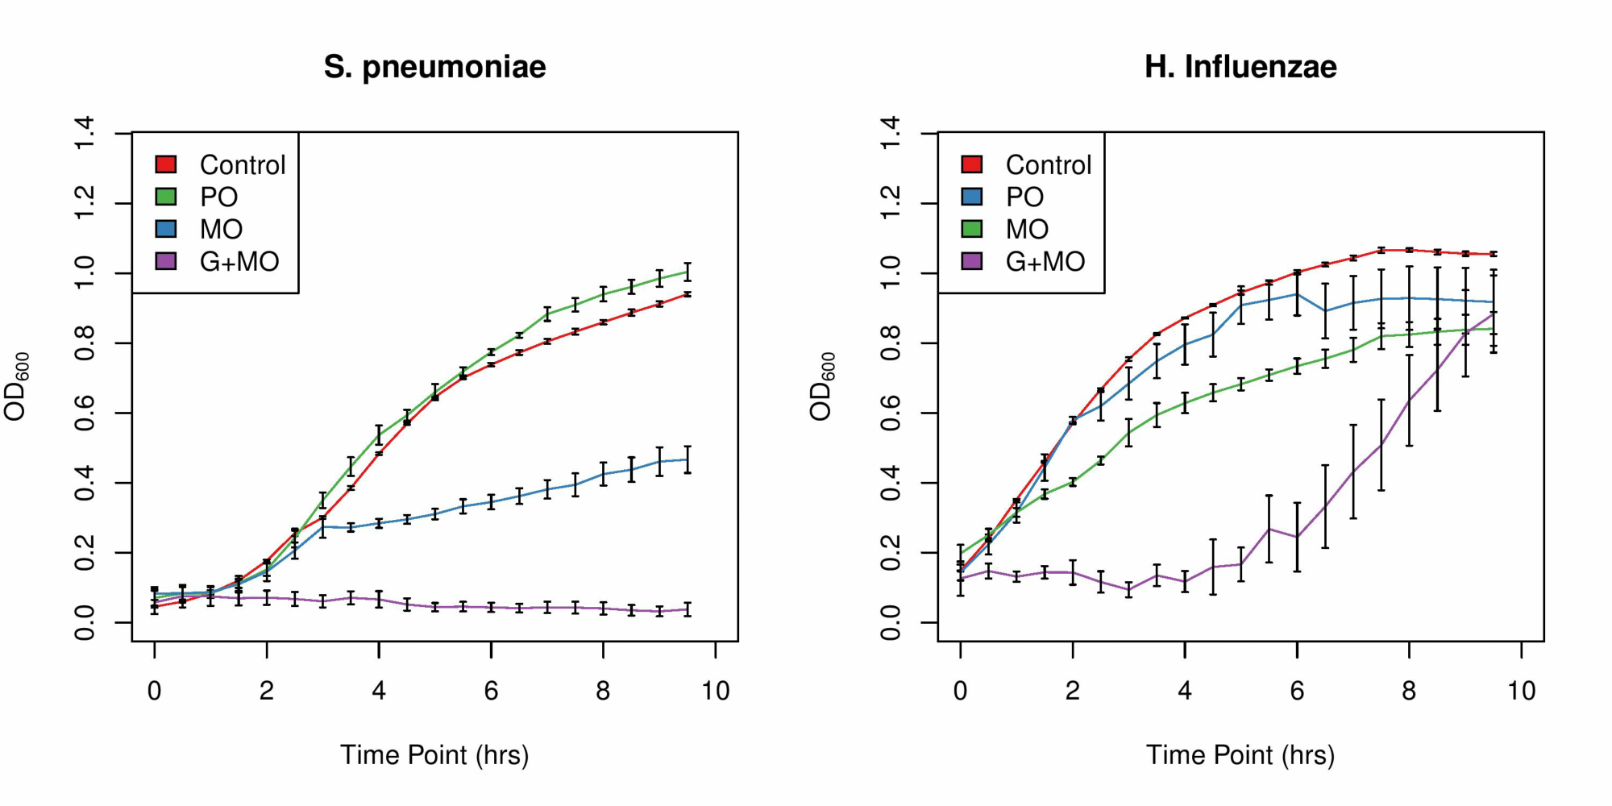

**Fig 1: Inhibitory effects of peanut oil, mustard oil, and garlic dissolved in mustard oil on the growth of *Streptococcus pneumoniae* and *Haemophilus influenzae***

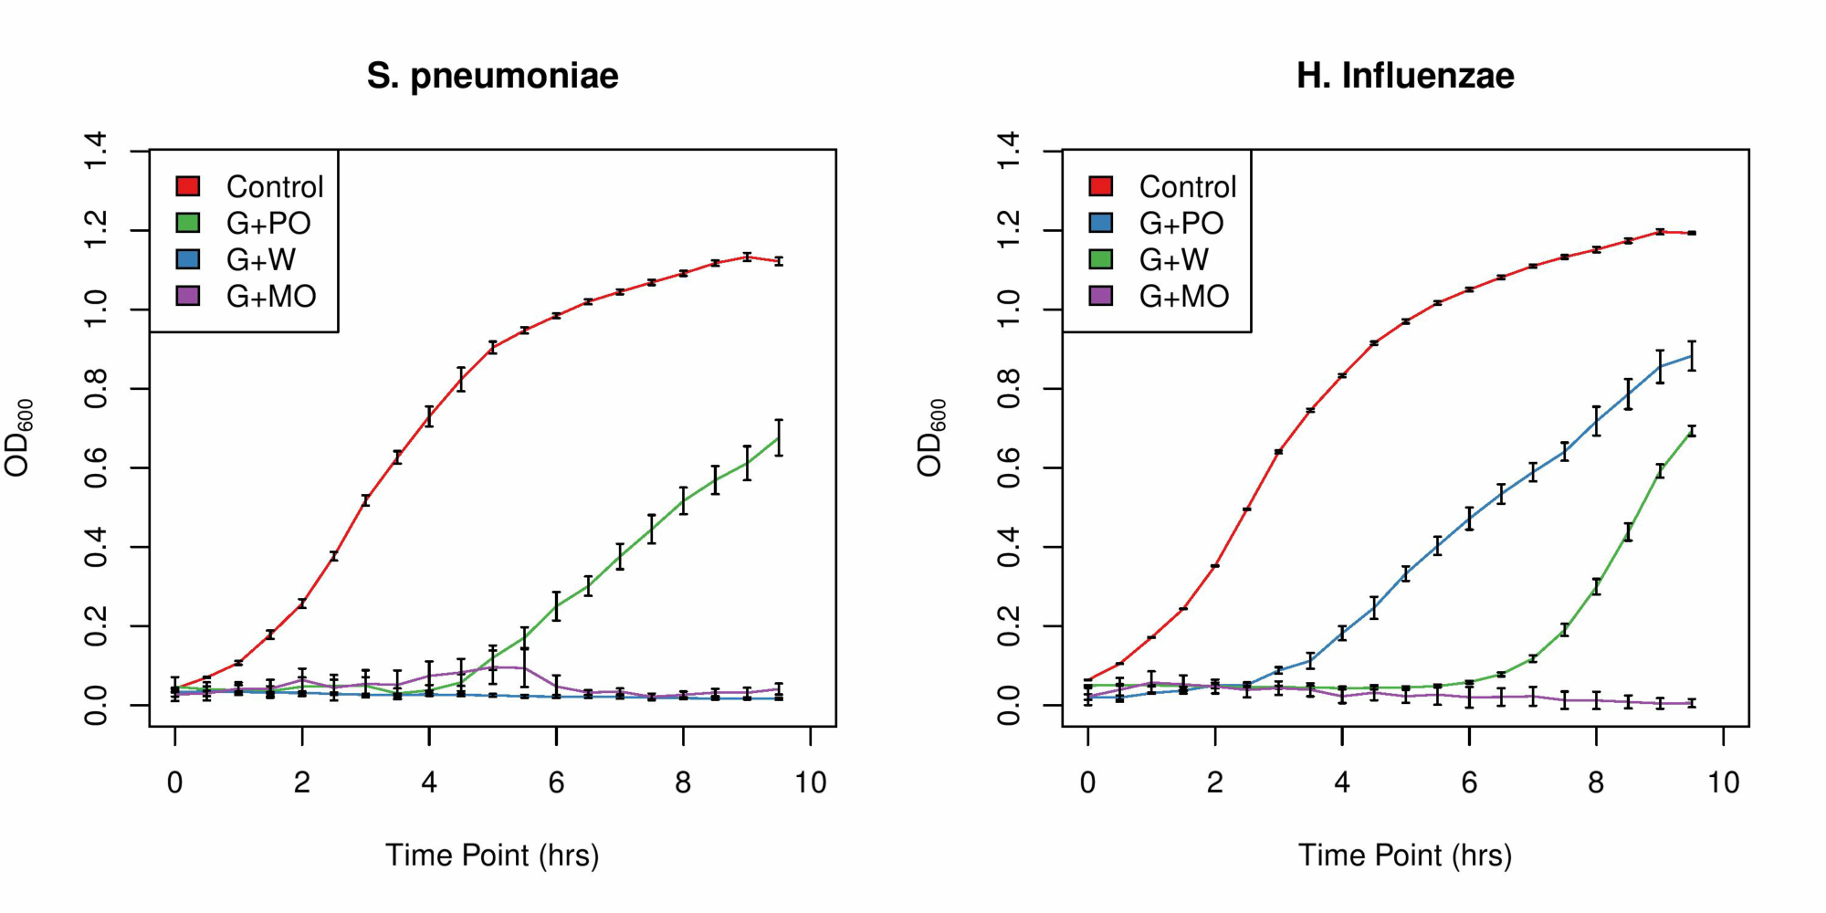

**Fig 2: Inhibitory effects of garlic mixed in peanut oil, water, or mustard oil on the growth of *Streptococcus pneumoniae* and *Haemophilus influenzae***

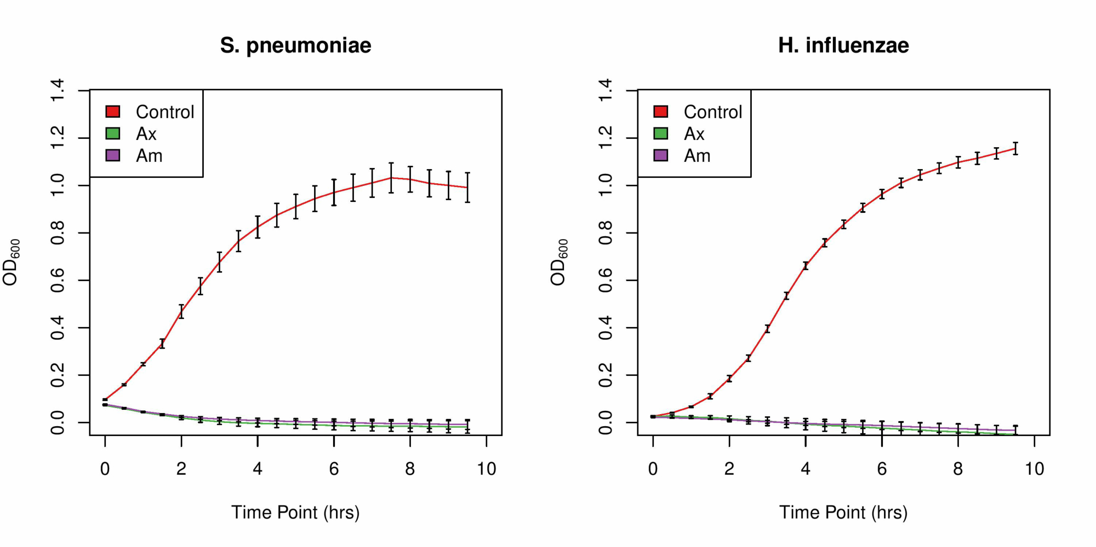

**Fig 3: Inhibitory effects of amoxicillin and ampicillin on the growth of *Streptococcus pneumoniae* and *Haemophilus influenzae***