**COMP804 – ASSESSMENT TASK 3 –ASSIGNMENT 1**

**Report for GIT HUB task 5**

**Step 1: Creation of new repository to store website**

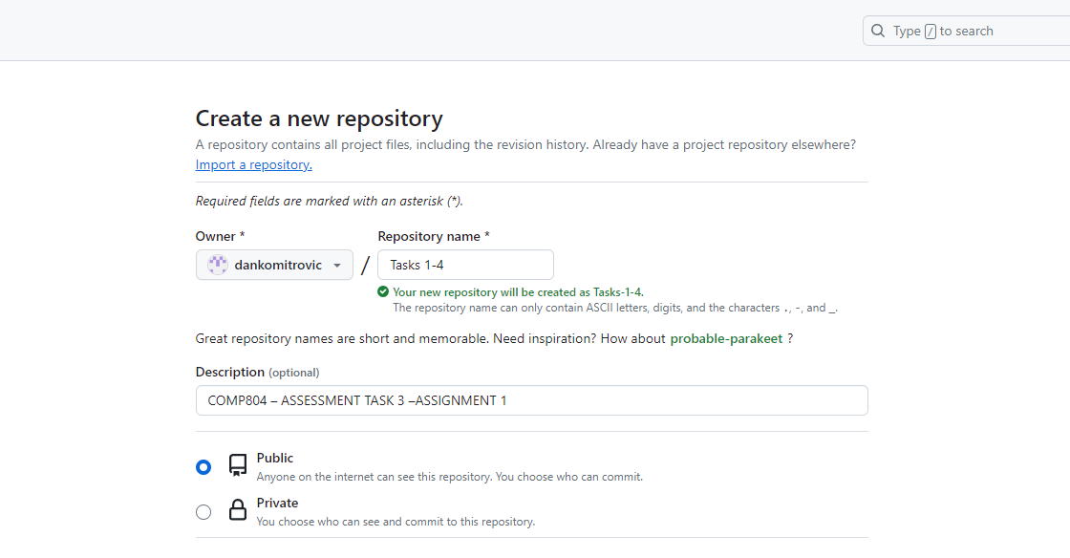

**Step 2: Initialize a Git Repository**

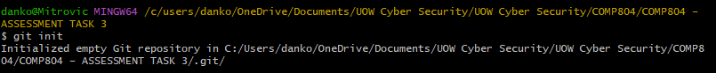

**Step 3: Add the GitHub Repository as Remote**



**Step 4: Add the local website**



**Step 5: Commit the changes**

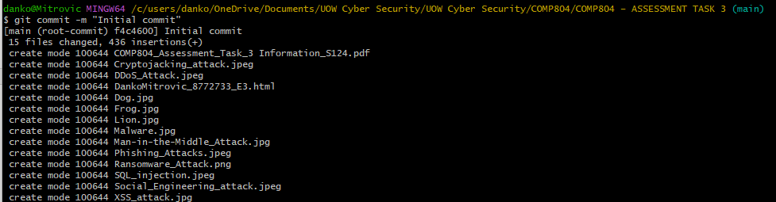

**Step 6: Push the changes to GitHub**

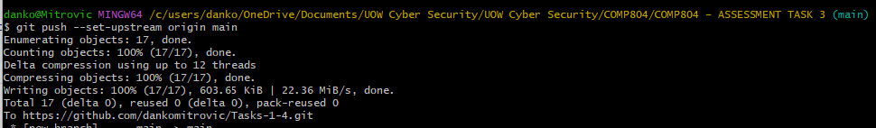

**Link to GitHub Repositort**

<https://dankomitrovic.github.io/Tasks-1-4/>