Covid-19 in Minnesota Data Analysis:

Travis Mattson

Minnesota daily cases and deaths from the New York Times by county.

The daily cases and deaths is shown below:

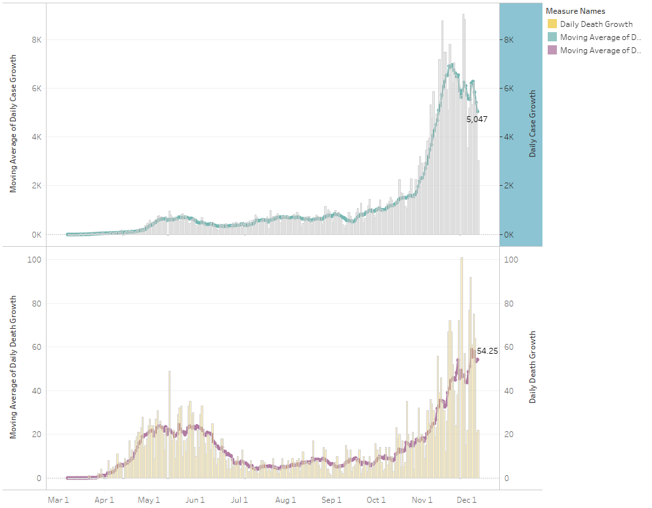

Overall the each MN county reports coronavirus cases and that data made a color coded chart that measured the number of total cases per 100K residents in that county.

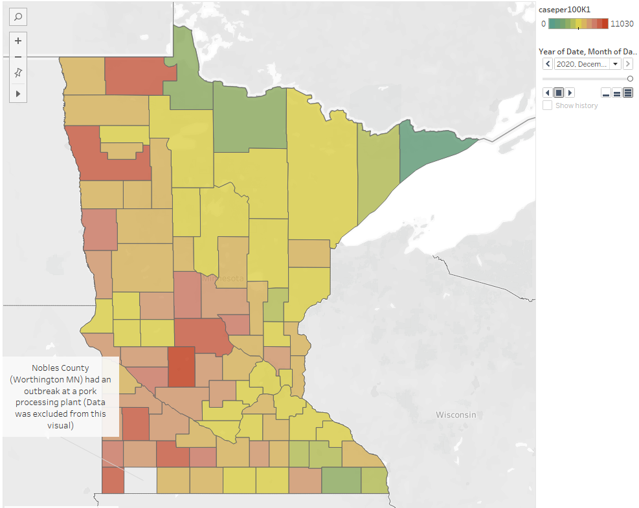

The color coding scheme was thrown off by a relatively large outbreak in Nobles County (Worthington MN) which has a large pork processing plant. This data was excluded as it resulted in 15,000 cases per 100,000 residents. (~500 total)

Then the overall case growth rate. Are we increasing or decreasing in cases?

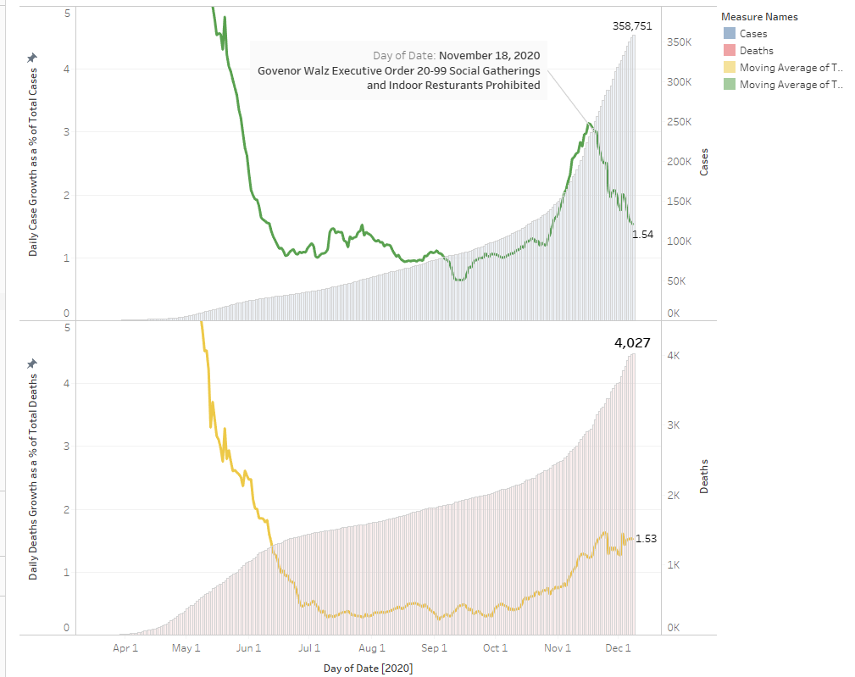

New cases have decreased from a 3% daily growth rate to a 1.5% growth rate after the restrictions on social gatherings and indoor dining. Unfortunately, deaths have increased to a 1.5% daily increase and maintained. Overall MN has ~360,000 total cases and 4,000 deaths from Covid-19.

I next was curious about the growth rate by regions of the state broken down by population. The US census from 2010 defined regions as Urban, Rural and Urban Clusters based on population. This split up the state counties like so.

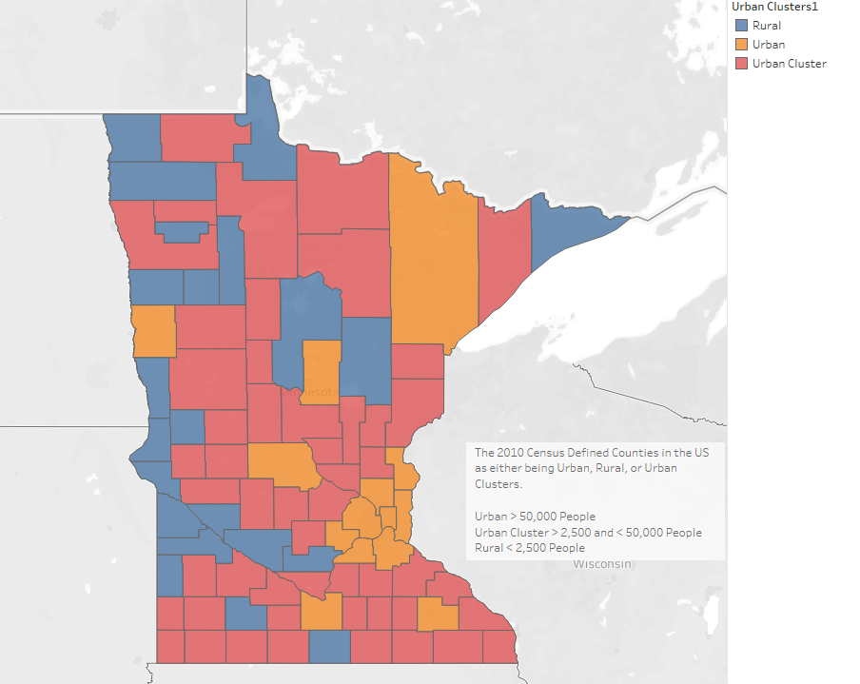

Each of these regions experienced Covid 19 differently. One theory I had heard was that rural areas and potentially urban clusters never saw an initial wave like the urban areas of the US.

New Cases and Deaths by Region of MN

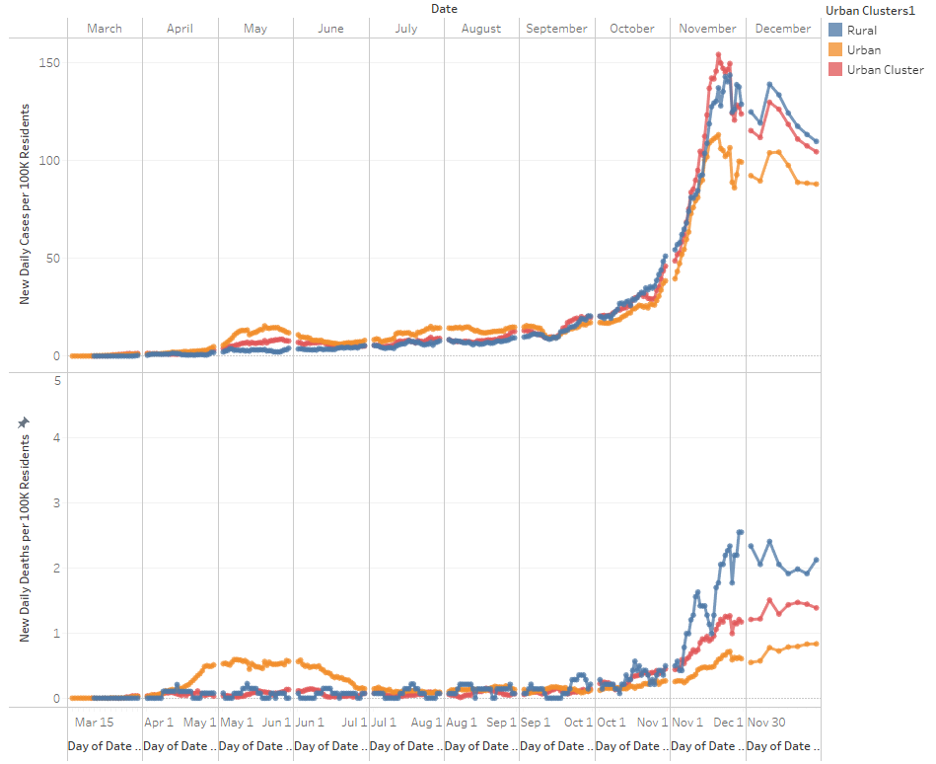

I used daily new cases and deaths per 100k residents to normalize by population size. As a note I removed the Nobles County outbreak from the Urban Cluster Group. What’s fascinating as it appears that the urban counties experienced 2 waves. Whereas Rural and Urban Clusters counties experienced a larger 2nd wave or the 1st wave in October/November. Regardless of how you slice these waves 2nd or 1st or true 1st the increase in October/November was unprecedented to the previous wave.

After that I was curious about mask use and opinions on that. The New York Times gathered 250,000 responses from an online poll between July 2nd and July 14th on mask use. They asked the respondents when within 6’ of someone how often do you wear a mask? (Never, Rarely, Sometimes, Frequently, Always). This was an interesting data set as it does not at all indicate mask use but more so mask enthusiasm. What I mean is we cannot measure actual mask usage. Also, this data set was polled prior to the MN mask mandate on July 24th, which indicates we’ll get peoples true feelings on masks.

The data for polling looked like this by county

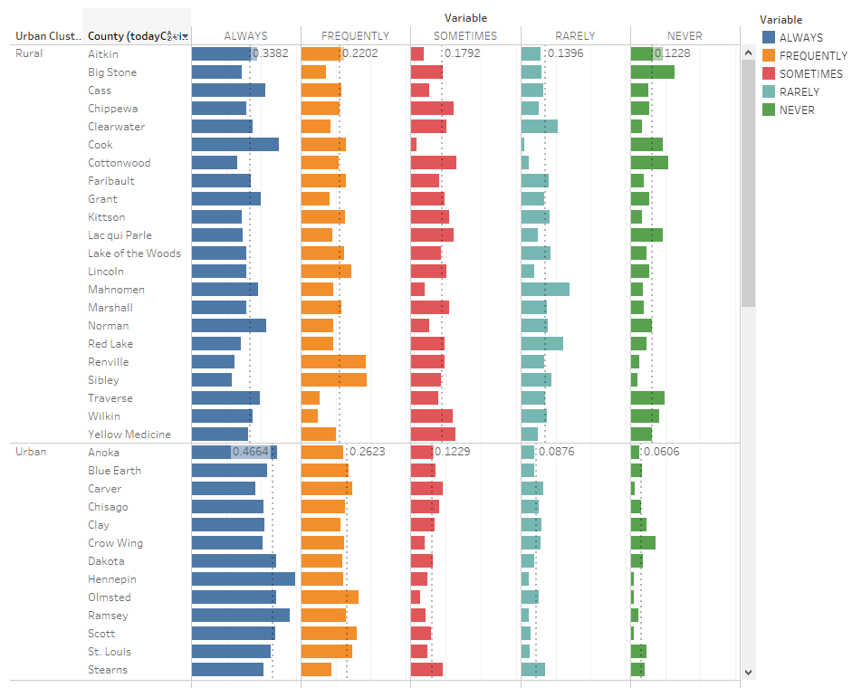

I was curious if I could correlate this mask enthusiasm by regions of the state. I divide into 2 groups the “GOOD” mask uses which were the sum of ALWAYS and FREQUENTLY and the “BAD” mask uses which were the sum of SOMETIMES, RARELY and NEVER. Then I tabulated this split by county and region and made a chart indicating counties where more than 2/3 of the respondents used a mask FREQUENTLY or ALWAYS.

Mask Enthusiasm by County (Green = > 2/3 Red = < 2/3)

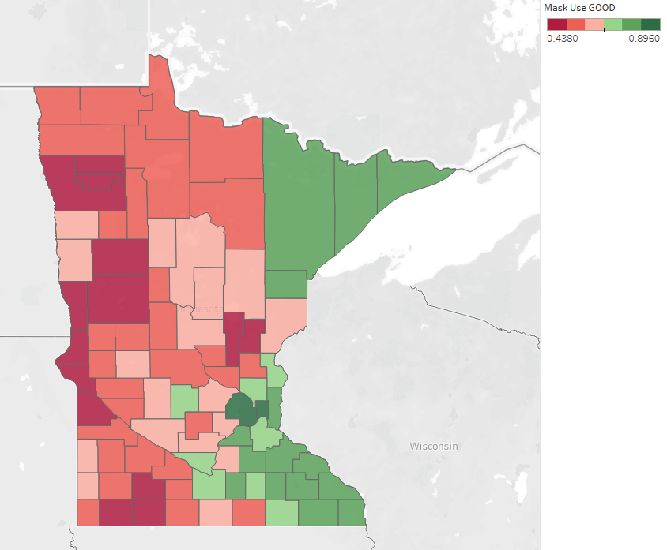

Interestingly there was an east west split between these 2 categories.

Finally, I was curious if the mask enthusiasm correlated to lower total rates of Covid-19.

>2/3 Mask Polling Use <2/3 Mask Polling Use

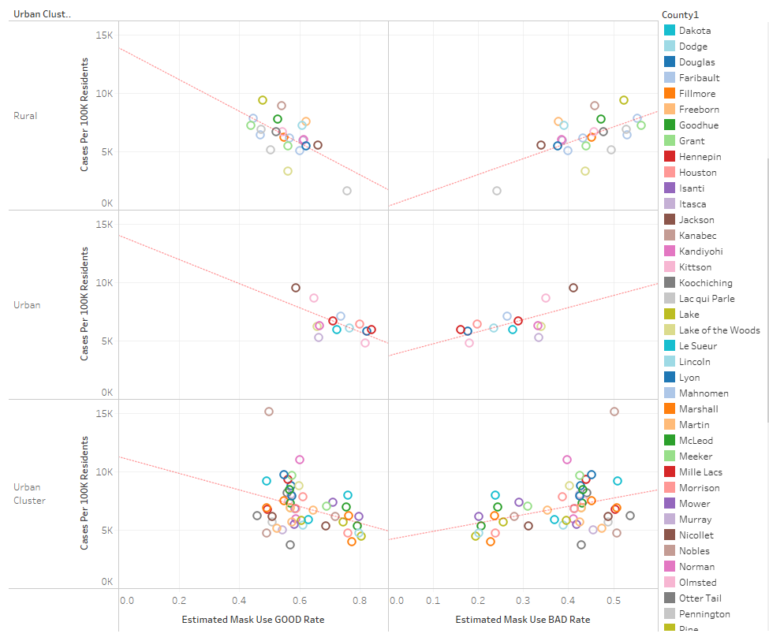

Broken down by region in all 3 cases there was a weak correlation to cases per 100K residents and mask use. In each case it was positive (increase in cases) when bad, and negative(decrease in cases) when good. This data is highly subjective and the correlation is weak (<50% R^2). Regardless this does point to areas that were more enthusiastic about masks so far have experienced less coronavirus cases.

Another thought on this data is looking at the growth rate of covid-19 vs. the case rate per 100k residents. Interestingly when comparing to mask enthusiasm there is an opposite effect or no effect.

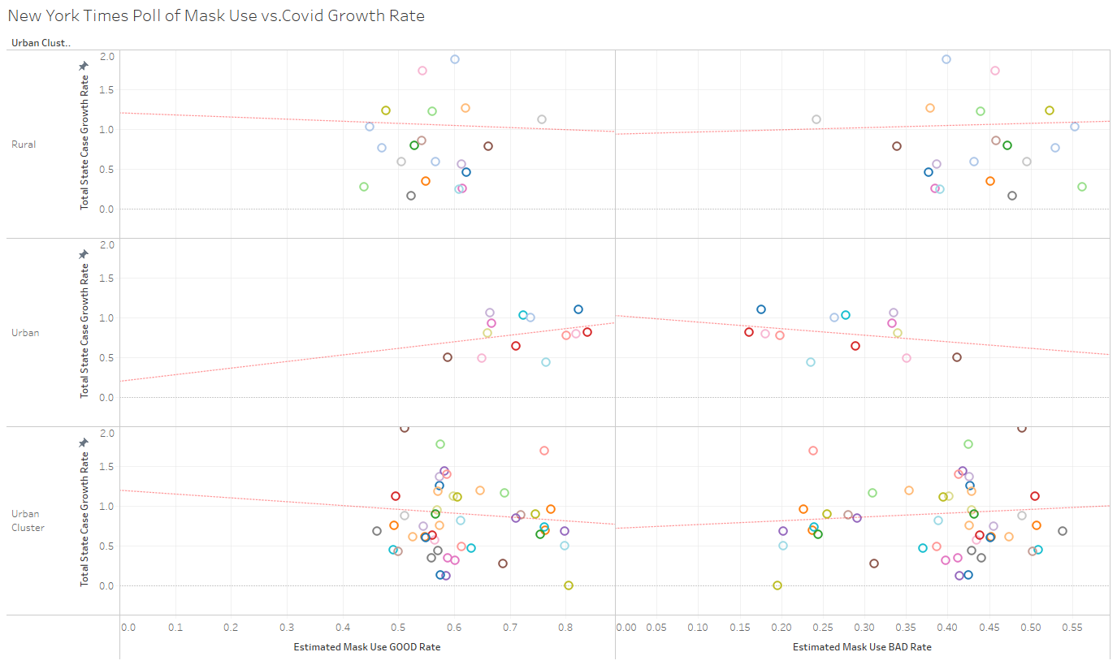

In this case Urban Areas saw a positive correlation with covid 19 growth rate and mask enthusiasm. The opposite was true in rural and urban clusters. My speculation is mask use is reinforced by active covid 19 cases. Urban areas saw a larger first wave and thus people were likely more aware of the virus as opposed to rural areas which didn’t experience this virus until this summer fall. The polling data was taken back in July prior to the October/November outbreak.

**Summary:**

New Daily Cases are decreasing state wide and since the 2nd shutdown.

New Daily Deaths are maintaining unfortunately.

Different regions of the state experience different levels of coronavirus growth.

An online poll of < 1% of the US population estimated mask use.

This poll was divided into two subgroups "Good" and "Bad" based on poll responses

This mask "enthusiasm" could differentiate counties by majority good mask use

The greater the mask "enthusiasm" the less total cases per 100k residents. This is a weak correlation (R^2 ~50%).

The data is interesting, but it is our behaviors that dictate our health. I hope you all found this interesting and I hope you and your families remain safe.