**1. Introduction**

Based on the scenario from Wide World Importer, we need to merge relevant information from it’s newly acquired company “Adventure Works”(AW) into the “Wide World Importers”(WWI) database.

1). Person Table

In order to find combined information of user logon, persons and products, we need to map relevant columns in both datasets. First, we analyzed the WWI database. We found the basic people’s information all included in the application.people table. It includes information like people’s full name, email address, phone number, login information and Personal Identity. WWI As the main company, we need to use its database as the main database, and merge the acquired company database according to the main database template.

However, we compare people’s information in the AW database. The relationship between person and other tables is shown below:

As can be seen from the above ERD of AW, we can get people’s First Name, people’s MiddleName, people’s lastname ,people’s EmailAddress, people’s phonenumber and account’s password. Other information like city’s information we can just use WWI’s database.

Firstly, we Declared a variable, @maxpersonid to store the maximum PersonID and add the maximum value to BusinessEntityID to make sure the data integrity of primary key constraint. And we will use AW’S passwordHash as hashpassword in WWI and after we analyzed the data stored in the WWI database logonname, we thought we could use the email address in the AW personal information as logonname. And we combine first name, middle name and last name in Adventure Works database to match with Application.People. Besides, we set the current system time as the valid start time and using 12/31/9999 23:59:59.9999 as valid end time as WWI do. Leave photo, customerfield, UserPreferences, fax number, OtherLanguages blank to be filled in later.

2) Product Table

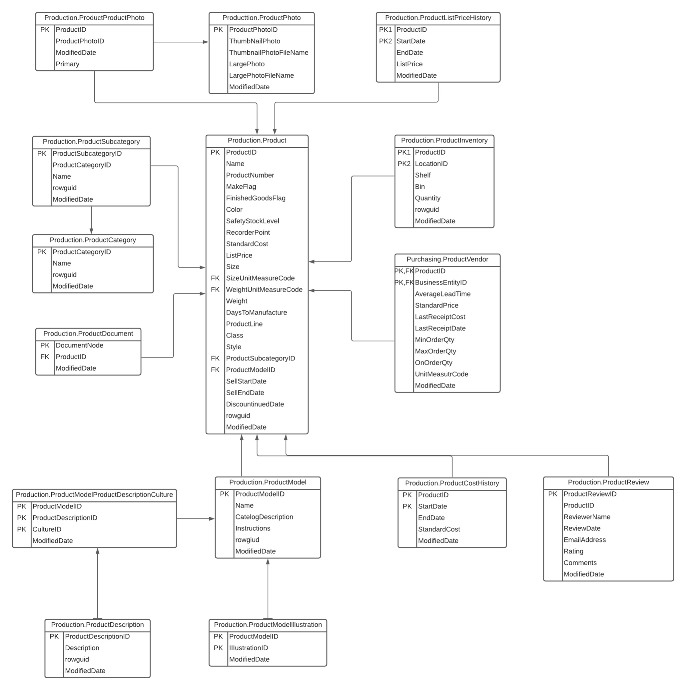

As can be seen from the above ERD, we can get product name, product color, list price, size, categories from AW database. And we can merge this information into the WWI database warehouse.stockitems table. Also, we Declared a variable, @maxid to store the maximum ProductID and add the maximum value to StockItemID to make sure the data integrity of primary key constraint. And we choose product SubcategoryID data as Categories data in WWI database instead of CategoryID since SubcategoryID is a group of parts and CategoryID is a group of bike type. And for supplier part, in AW purchasing.productvendor we can find the detail of supplier, so we generate the information. We set AW purchasing.productvendor’s businessEntityID as suplierID in WWI.

**3. Result**

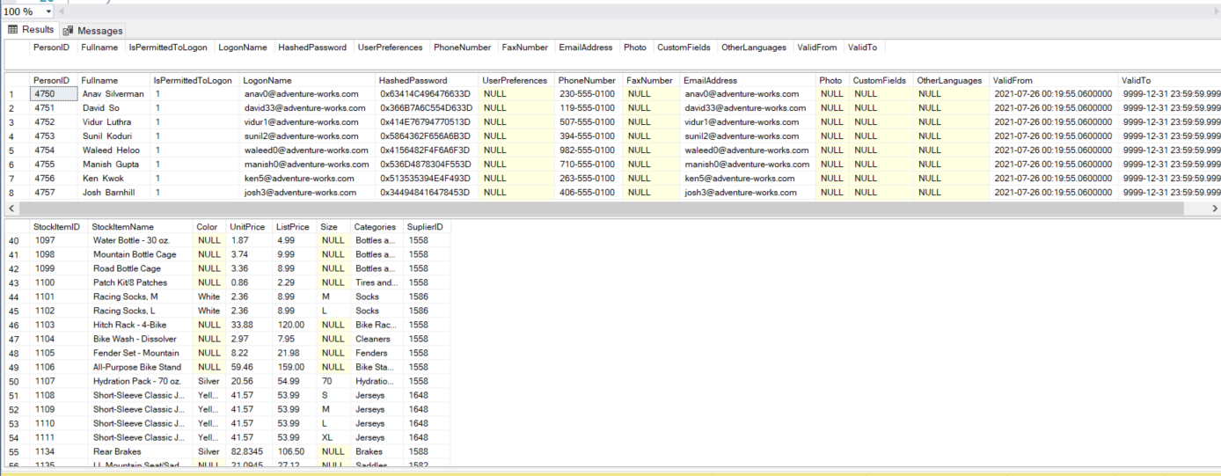

**4. Appendix**

--Create new table contaning logon information and person information--

drop table if exists #PersonNew

go

create table #PersonNew(

PersonID int primary key not null,

Fullname nvarchar(50) not null,

IsPermittedToLogon bit not null,

LogonName nvarchar(50),

HashedPassword varbinary(max),

UserPreferences nvarchar(max),

PhoneNumber nvarchar(20),

FaxNumber nvarchar(20),

EmailAddress nvarchar(256),

Photo varbinary(max),

CustomFields nvarchar(max),

OtherLanguages nvarchar(max),

ValidFrom datetime2(7) not null,

ValidTo datetime2(7) not null

)

go

select * from #PersonNew

use WideWorldImporters

DECLARE @maxpersonid INT;

SELECT @maxpersonid = MAX(p.PersonID)

FROM Application.People p

use AdventureWorks2019

insert into #PersonNew

select ROW_NUMBER() over(order by p.BusinessEntityID) + @maxpersonid as personID,

COALESCE(p.FirstName, '') + ' ' + COALESCE(p.middlename, ' ') + COALESCE(p.lastname, '') as Fullname,

1 as IsPermittedToLogon,

e.EmailAddress as LogonName,

cast(pw.PasswordSalt as varbinary)as HashedPassword,

null as UserPreferences,

pp.PhoneNumber as PhoneNumber,

null as FaxNumber,

e.EmailAddress as EmailAddress,

null as Photo,

null as CustomFields,

null as OtherLanguages,

GETDATE() as ValidFrom,

CAST('12/31/9999 23:59:59.9999' as DATETIME2) as ValidTo

from Person.Person p

join Person.EmailAddress e

on p.BusinessEntityID = e.BusinessEntityID

join Person.PersonPhone pp

on p.BusinessEntityID = pp.BusinessEntityID

join Person.Password pw

on p.BusinessEntityID = pw.BusinessEntityID

go

select * from #personnew

--Create new table containing product information--

drop table if exists #ProductNew

go

use WideWorldImporters

DECLARE @maxproductid INT;

DECLARE @maxsupplierid INT;

SELECT @maxproductid = MAX(si.StockItemID), @maxsupplierid = MAX(si.SupplierID)

FROM Warehouse.StockItems si

use AdventureWorks2019

select

p.ProductID + @maxproductid as StockItemID,

p.Name as StockItemName,

p.Color as Color,

pv.LastReceiptCost as UnitPrice,

p.ListPrice as ListPrice,

p.Size as Size,

ps.Name as Categories,

pv.BusinessEntityId + @maxsupplierid as SuplierID

into #ProductNew

from Production.Product p

join Production.ProductSubcategory ps

on p.ProductSubcategoryID = ps.ProductSubcategoryID

join Purchasing.ProductVendor pv

on p.ProductID = pv.ProductID

go

select * from #ProductNew