Governing Like a River Basin:

Options for Expanded Stakeholder Engagement

in the Colorado River Basin

“Though contentiousness over the Colorado River has only grown more complex, there is no regular means to work out differences, let alone to cooperate in the management of such an important natural resource.
Isn’t it time to bring the states and other interests together around the same table to avoid and solve problems important to all of them?”

David H. Getches, keynote address at Colorado River Conference
Denver, Colorado (July 20, 1992)

A Carpe Diem West Policy Brief

Prepared by the

Center for Natural Resources & Environmental Policy

The University of Montana

Review Draft, 8/23/11

FOR DISCUSSION ON CONFERENCE CALL

SEPTEMBER 1, 2011

PLEASE DO NOT SHARE OR DISTRIBUTE THIS REVIEW DRAFT

Preface: Why This Policy Brief?

In April 2011, Carpe Diem West released an assessment of Colorado River Basin leaders’ perspectives on challenges and opportunities in Colorado River management, Thinking Like a River Basin: Leaders’ Perspectives on Options and Opportunities in Colorado River Management. The goal of that report was to identify any common themes among the opinions of diverse segments of the Colorado Basin water community, with the intent of providing useful information to leaders interested in basin-scale solutions to long-term imbalances in water supply and demand.

The Thinking Like a River Basin report revealed two important themes, each related to governance. First, leaders on all sides described a lack of coordinating leadership to address problems at the basin scale. Second, an equally wide range of leaders acknowledged that a broader range of stakeholders wish to be more meaningfully engaged in river management discussions and decision processes than is currently allowed.

These two issues are related, particularly as the basin moves deeper into the era of climate change. As warmer, drier conditions and decreased river flows become more prevalent across the seven-state area of the Colorado River Basin, the need to resolve competing demands across such a vast area makes it increasingly necessary to coordinate water management at the basin scale. At the same time, a more-inclusive stakeholder process might assist the implementation of basin-scale management in some important practical ways—for example, by resolving conflicts before they lead to litigation, and by broadening public support for potentially controversial solution components such as water storage and delivery infrastructure, ecosystem restoration, and more flexible management regimes. Of course, the prospect of any such benefits would have to be weighed against the potential risks of adding undue complexity to existing governance processes.

Carpe Diem West commissioned the current policy brief in response to these two concerns raised by Colorado Basin leaders in the Thinking Like a River Basin report. In particular, given leaders’ interest in the potential benefits and pitfalls of broadening stakeholder input, we believe the Colorado River Basin water community could benefit from a systematic look at the experience other river basins with a broad range of different stakeholder models, and a discussion of what those models might look like in the unique context of the Colorado River.

- Kimery Wiltshire, Carpe Diem West

Highlights of This Policy Brief

This policy brief, Governing Like A River Basin, responds to a pair of concerns shared by Colorado River Basin leaders on challenges and opportunities in Colorado River management, Thinking Like a River Basin: Leaders’ Perspectives on Options and Opportunities in Colorado River Management. First, leaders expressed a belief that the basin suffers from a lack of coordinating leadership to address problems at the basin scale. Second, many acknowledged that a broader range of stakeholders want to be more meaningfully engaged in river management discussions and decision processes than is currently allowed.

Collaborative initiatives can reduce conflict among competing interests, avoid litigation, create better-informed decisions, provide a strong base of support for funding solutions, and improve chances of successful implementation and environmental gains. They can also be time-consuming, expensive, and frustrating. In short, although a collaborative process does not guarantee a mutually satisfactory outcome, it can provide a preferable alternative to litigation and may produce solutions that otherwise would not have been considered feasible.

Examples from other river basins illustrate a spectrum of possible collaborative approaches to engaging stakeholders in the Colorado River Basin. This policy brief discusses the following options, listed in ascending order from the least formal to the most structured models:

Voluntary networks and linked dialogues provide regular or ad hoc opportunities for stakeholder input and dialogue with public resource managers and/or elected officials, without being convened by government officials—a sort of “parallel process” of public consultation. A Colorado River Basin Consortium might provide a regular and useful means of stakeholder input and informal dialogue with decision makers, an alternative to the “guerilla consultation” that takes place when certain stakeholders find the means of providing input but many do not.

Regional goal-setting collaborative entities offer a forum for all manner of government agencies, elected officials, and stakeholders to develop and articulate shared goals that extend beyond their individual areas of jurisdiction, which they pledge to support but are not legally bound to implement. Something like a Colorado River Basin Forum could engage all levels of government agencies, elected officials, and stakeholders to develop and articulate shared goals for the basin (perhaps in a Colorado River Basin Charter), and to seek implementation through their various areas of influence and jurisdiction.

Advisory groups with appointed stakeholder representatives formally recognize representatives of diverse stakeholder groups and other entities and provide structured opportunities for them to discuss and provide guidance into ongoing public resource decision processes. A Colorado River Basin Advisory Council would respond to those who wish to see a more formal seat at the table for interests affected by but not formally recognized in current decisions. An advisory council could tackle discrete questions, hashing out collaborative solutions for consideration by state and federal decision makers.

Regional governance authorities acquire some level of formal, binding decision-making authority through the mutual agreement of participating governments, such as an interstate compact, and typically commit to a high degree of stakeholder involvement and consultation. Such a basin-wide organization would be a forum for discussion, debate, and even battles over river management—providing an alternative forum for solving problems before resort to litigation. The organization might also develop and distribute credible information, a sustained version of what the Bureau of Reclamation’s Colorado River Basin Water Supply and Demand Study (“the Basin Study”) is accomplishing now.

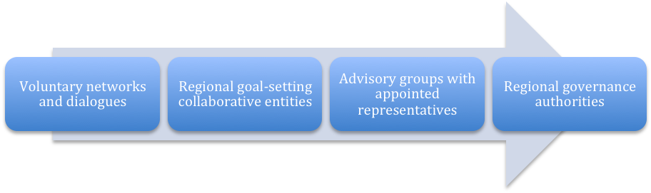

Collaborative stakeholder engagement models, from least to most formal in organization and structure.

Why Consider Expanding Stakeholder Engagement?

“It is a fair criticism that states have left others out of [Colorado River management] decisions until the end.”

“When you’re trying to avoid crisis, you have to limit the number of participants.”

“We need some way to balance or blend the value of inclusive participation . . . and making efficient decisions.”

-Three different views expressed by Colorado Basin leaders in the Carpe Diem West report Thinking Like a River Basin: Leaders’ Perspectives on Options and Opportunities in Colorado River Management

The April 2011 Carpe Diem West report Thinking Like a River Basin: Leaders’ Perspectives on Options and Opportunities in Colorado River Management, revealed two important themes in the opinions of Colorado Basin water leaders, both of which relate to governance. First, leaders on all sides expressed a belief that the basin suffers from a lack of coordinating leadership that can address problems at the basin-wide scale. Second, an equally wide range of leaders acknowledged that a broader range of stakeholders wants to be more meaningfully engaged in river management discussions and decision processes than is currently allowed.

Several leaders expressed strong reservations about the idea of engaging additional stakeholders in any official capacity, and others were concerned that even a less-formal model of cooperation and participation could amount to creating new layers of bureaucracy. Even these individuals, however, recognized increasing public pressure to include a broader range of voices in water governance.

The two broad issues identified by leaders—a lack of basin-wide leadership and the pressure to provide for broader stakeholder involvement—are related, and this relationship is heightened by the effects of climate change. As warmer, drier conditions and decreased river flows become more prevalent across the seven-state area of the Colorado Basin, the need to resolve competing demands across such a vast area makes it increasingly necessary to coordinate water management at the basin scale. Moreover, experience suggests that many of the elements necessary to implement basin-scale management—things like water storage and delivery infrastructure, ecosystem restoration, and more flexible and adaptive management regimes, to name a few—may be developed, funded, and implemented much more quickly and effectively when a full range of stakeholders is involved.

This policy brief focuses primarily on the second of these issues—the rising interest in some form of broader stakeholder engagement. Drawing on models that have been employed in other river basins, it identifies and briefly analyzes a range of options that could be used to respond to concerns about stakeholder engagement expressed by Colorado River Basin leaders and others. Where appropriate, the analysis of these options also touches upon the first issue, a perceived lack of basin-scale leadership. This policy brief does not recommend a particular approach, but instead seeks to spark and inform a discussion of options among diverse basin interests.

The call for improved stakeholder engagement is not unique to the Colorado River Basin. Examples show that efforts to address broad and complex environmental challenges are seldom successful if tackled by a single entity—even a powerful federal agency fortified by the rule of law—unless it engages meaningfully with others who are affected by the problem and have a stake in the outcome. Increasingly, public resource managers find it useful to address complex landscape-scale problems through collaborative approaches. These approaches range from informal efforts to solve problems with diverse partners, to large and formally organized entities with some degree of decision-making authority.

Collaborative initiatives—defined as processes that are inclusive, informed, and deliberative—emerge to fill gaps in governance. Such gaps exist where no single entity has the full range of legal authority and political capital necessary to address difficult boundary-crossing issues. In short, parties participate in such an initiative for the very practical reason that it often leads to better decisions with greater likelihood of implementation than more traditional approaches (notice-and-comment rulemaking, litigation, etc.). More specifically, a collaborative initiative with broad stakeholder engagement can result in:

1. Reduced conflict among competing interests.
- Collaborative initiatives provide a means to involve stakeholders at an early stage, and to engage in a sustained exploration of their values and concerns through interactive processes. This can be a much more effective way to resolve competing concerns than more traditional methods such as public comment or litigation.

2. Better-informed decisions.
- Collaborative initiatives give decision makers access to information sources that otherwise might not be available or easily accessible, including experts working for other agencies, databases or models maintained by NGOs, emerging scholarship from academic institutions, and the practical experience of individual stakeholders.
- All participants benefit from the ability to share information and learning through a more open and inclusive decision process, which can lead to fewer interagency and public misunderstandings and broader public education about the scope of the problems. In some cases, collaborative initiatives engage stakeholders through joint fact-finding processes, a mutual learning exercise that can lead to better agreement about the facts underlying scientific uncertainty.

3. Better chances of successful implementation.
- Participants who share in the development of a management plan tend to develop a sense of ownership, built from trust and common effort. They are more likely to support it through the sometimes-stormy public review phase, and less likely to resort to litigation.
- Participants also share responsibility for implementation, with defined responsibilities and regular communication. Federal agencies are able to share workforce resources with state and tribal agencies, local watershed groups, and NGOs, thus leveraging resources to get more done.
- Where implementation requires action from political bodies – such as funding for infrastructure or amendments to laws that constrain water management – the support of a broad spectrum of stakeholders can be a powerful tool for persuading elected officials to take the necessary actions.
- During implementation, collaborative initiatives can be a highly effective tool for adaptive management. They enable learning through monitoring for specific indicators of success, followed by adjustments in management practices to adapt to unexpected outcomes. The practice of adaptive management is well supported by a foundation of shared information and regular communication among participants in a collaborative initiative, though measures of success must be clearly articulated and scientifically justified.

The governance gap that prompts this sort of initiative cannot be closed merely applying scientific or technical knowledge to address economic, social, or environmental concerns. Nor is closing the gap simply about managing land or resources more effectively and efficiently. At its core, this is a sociopolitical challenge, seeking to integrate the interests and concerns of multiple jurisdictions, government agencies, and public and private stakeholders to address complex regional or issues.

There is also no guarantee that a collaborative initiative that involves many stakeholders will achieve resource management goals such as ecosystem restoration or water supply security. One need only look at the ongoing challenges in the California Bay-Delta to see the many ways that genuinely good intentions for broad engagement can be sidetracked by wicked political conflicts joined with deeply conflicting resource management goals in a challenging physical environment. Even in such cases, however, collaborative initiatives arguably provide a more effective means of integrating the diverse social, economic, and environmental values that define natural resource issues than more conventional approaches to decision making.

In short, there is no silver bullet for addressing the many sources of competition and conflict in the Colorado River Basin, but it is worthwhile to consider options for engaging stakeholders in a more inclusive, basin-wide approach to Colorado River planning and management decisions.
Examples of Collaborative Initiatives That Include Significant Stakeholder Engagement

Over the past several decades, the number of regional collaborative initiatives has grown dramatically. Ranging from local watershed-focused restoration projects to large, interstate river basin governance bodies, the range of examples underscores that there is no single “ideal” model for coordinating management and engaging stakeholders across a large physical and political landscape in a meaningful way.

The examples featured here include regional, river basin-focused collaborative initiatives involving federal agencies, states, tribes, and local governments. All emphasize opportunities for a variety of stakeholders to participate in substantive discussions, though the levels of formal involvement vary considerably.

As illustrated in the figure, these examples present a spectrum of possible approaches, ranging from the least formal to the most structured models. Each of the examples mentioned here is described in more detail in the pages that follow.

- Voluntary networks and linked dialogues provide regular or ad hoc opportunities for stakeholder input and dialogue with public resource managers and/or elected officials, without being convened by government officials—a sort of “parallel process” of public consultation.
  - Example: Universities Consortium on Columbia River Governance

- Regional goal-setting collaborative entities offer a forum for all manner of government agencies, elected officials, and stakeholders to develop and articulate shared goals that extend beyond their individual areas of jurisdiction, which they sign a pledge to support but are not legally bound to implement.
  - Example: Ecosystem Charter for the Great Lakes-St. Lawrence Basin

- Advisory groups with appointed stakeholder representatives formally recognize representatives of diverse stakeholder groups and other entities and provide structured opportunities for them to discuss and provide guidance into ongoing public resource decision processes.
  - Example: Missouri River Recovery Implementation Committee

- Regional governance authorities acquire some level of formal, binding decision-making authority through the mutual agreement of participating governments, such as an interstate compact, and typically commit to a high degree of stakeholder involvement and consultation.
  - Example: Northwest Power and Conservation Council

Collaborative stakeholder engagement models, from least to most formal in organization and structure.

Although these approaches vary widely in terms of structure and approach, all of them raise some threshold design questions:

- Who participates – will the process be open only to certain individuals representing selected interests, or can anyone be involved?
- What is the purpose and expected outcomes of the process?
- How is the agenda set?
- What information is brought to the table, how is it related to formal decision-making and implementing systems?
- To what extent are agreements reached by the group binding upon participants (a key element that determines how much incentive there is for people and organizations to participate)?

These questions should be considered in fine-tuning any chosen approach to engaging stakeholders through a collaborative initiative.

Universities Consortium on Columbia River Governance

Informal network provides “parallel process” to support and inform cross-border treaty discussions.

Summary: A 1964 treaty between the U.S. and Canada governs joint international operation of the Columbia River for the purposes of hydropower production and flood control. Certain of the flood control provisions expire in 2024, and either country must provide ten years’ notice (by 2014) should it seek to terminate the treaty. A variety of official and informal efforts are underway to understand and predict changes within the basin and to determine whether those changes warrant modification of the treaty. The government entities engaged in dam operation and thus directly involved in the treaty discussions include Bonneville Power, BC Hydro, and the U.S. Army Corps of Engineers. Recognizing the need for a regional dialogue involving tribes, stakeholders, government, and researchers throughout the basin, public universities in each state and province in the basin joined together in 2008 to offer a neutral, inclusive forum to help support this conversation. The Universities Consortium on Columbia Basin Governance includes the University of British Columbia, the University of Idaho, the University of Montana, Oregon State University, and the University of Washington. The Consortium has initiated a series of annual symposia to help inform the process and determine some of the scenarios and outcomes that might influence Columbia River Basin decisions:
- The 2009 symposium explored how to design and implement governance of international watercourses in face of uncertainty.
- The 2010 symposium addressed needs and benefits, participatory processes, and transboundary governance mechanisms.
- The upcoming 2011 symposium will focus on a transboundary group discussion of alternative scenarios for the Columbia River Treaty and related questions and considerations for treaty discussions.

Participants: The Consortium includes representatives of each of the participating universities. The symposium steering committee includes representatives from
the universities, the Columbia Basin Trust (CBT), the Northwest Power & Conservation Council (NPCC), the government entities involved in dam operations and treaty discussions, and the First Nations/Tribes on both sides of the border. Symposium participants include all of these parties and a broad range of stakeholders, NGOs, and academics.

Financial Support: There is no sustained central source of support for this consortium. The CBT and the NPCC each provide approximately $10,000 in support for the annual symposia, as well as many hours of in-kind professional services. Consortium members work with their own universities’ funding sources to participate in the symposia and related discussions.

Accomplishments: The symposia have been well-attended and by all accounts are providing a valuable supplement to the formal discussions underway among government entities and sovereigns, providing a sort of “parallel process” that opens the door to a wider range of stakeholders who otherwise would not have a seat at the table. In addition, since the Consortium is university-based, there is a practical educational component as well. In preparation for the 2011 symposium, students at many of the universities represented in the consortium, under the direction of the faculty representatives, are reviewing the relevant literature, researching key questions, and interviewing a wide variety of people on both sides of the border. Based on this information, the students will develop a set of scenarios for where the region, the entities, and the nation might take the treaty. The students will also develop and analyze a set of associated questions, such as what can be accomplished without requiring a formal treaty process and what possibilities exist for widening public participation.

Challenges: As a relatively informal network, there is no single coordinator or institutional home for the Consortium. Participating members provide their own financial support, and resources for the annual symposia are limited.

Information: http://www.uidaho.edu/law/newsandevents/columbiarivergovernance/Background

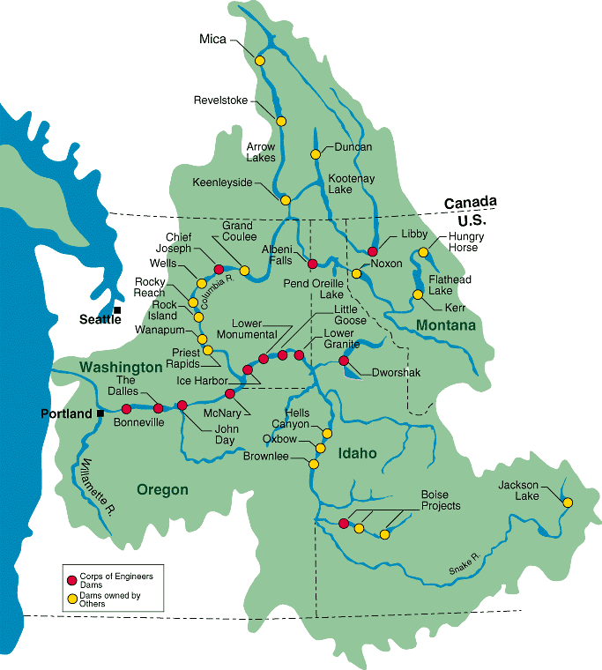

Source: U.S. Army Corps of Engineers

Ecosystem Charter for the Great Lakes-St. Lawrence Basin

Diverse parties sign pledge to support a common vision for the world’s largest freshwater ecosystem.

Summary: Tensions over shared boundary waters between the United States and Canada, and especially the Great Lakes, have prompted a number of significant negotiated inter-governmental agreements, from the 1909 Boundary Waters Treaty to the 2008 Great Lakes-St. Lawrence River Basin Water Resources Compact. Over the years, the Great Basin states (through the Council of Great Lakes Governors) and the two nations (through the Great Lakes Commission and the International Joint Commission) have devised innovative means of coordinating governance and resolving conflicts without litigation. In 1994, this effort broadened to include a wide range of non-governmental entities who joined with diverse government representatives in endorsing the Ecosystem Charter for the Great Lakes-St. Lawrence Basin, pledging to support its principles and work toward a common vision that calls for a clean environment, strong economy, and high quality of life for basin residents. The Charter calls for “cooperative and collaborative relations among [federal, state, provincial, local, and tribal] jurisdictions, in partnership with business and industry, citizen organizations and all other Basin interests,” as well as public processes that ensure “timely, accurate and accessible information; a forum in which to voice concerns; and a mechanism to become involved in policymaking and implementation efforts.” Unlike the Compact and other agreements in place between the nations that share the Great Lakes, this Charter is not legally binding upon its signatories. Nonetheless, those endorsing it are expected to: (1) consider Charter principles as guidance when developing work plans and priorities; (2) communicate and cooperate with one another in pursuing those priorities; and (3) consider the Charter as a means of assessing ongoing work. No signatory is expected to engage in activities beyond its legal mandate in complying with the Charter.

Participants: As of 1995, there were 160 signatories to the Charter, including local conservation districts, NGOs, professional associations, universities, elected officials, and all levels of government agencies. Many provided signatory statements explaining their interests and concerns (see Addendum to the Charter).

Financial and Political Support: The Charter itself is not the source or target of any funding, but it is part of a large and successful campaign to draw political attention and financial support for diverse efforts to restore and protect the Great Lakes, described below in the “Accomplishments” section. Each year, partners gather in Washington, D.C., for Great Lakes Day, a collective effort to make the case for continued federal support for restoration efforts and to raise awareness about threats from invasive species.

Accomplishments: As a non-binding agreement, it is not easy to assess the direct benefits of the Charter, but the collective effort to coordinate management and build political and financial support for Great Lakes issues has clearly been a success. For example, the Great Lakes Legacy Act, signed by President George W. Bush in 2002, provides $270 million over five years to clean up contaminated sediments from the Great Lakes and to educate people about this issue. In May 2004, President Bush signed an Executive Order creating the Great Lakes Interagency Task Force, under the lead of Environmental Protection Agency (EPA). The Task Force brings together 10 federal agency and Cabinet officers to provide strategic direction on federal Great Lakes policy, priorities and programs. The order directs EPA to work with Chairs of the Council of Great Lakes Governors and the Great Lakes Cities Initiative to convene a complementary "Regional Collaboration of National Significance," and a cabinet-level federal Great Lakes Interagency Task Force.

Challenges: The vast size of this region—95,000 square miles, containing 20 percent of the world’s and 95 percent of North America’s fresh surface water—means that water resource and ecosystem restoration challenges are large and tough to address. Despite the admirable cooperation evidenced by the Charter and related institutional agreements, the Great Lakes face threats from climate change, growing demands for water withdrawals, and continued threats from pollution and invasive species. Heavy dependence on federal funding makes this region vulnerable to congressional budget battles; the Interior-EPA spending bill under consideration in July 2011 included a 48 percent reduction—from $475 million to $250 million—to the Great Lakes Restoration Initiative from its spending level in 2010.

Information: http://www.glc.org/ecochart/

[Sidebar to include with this section:]
“Meaningful public participation requires the public to be an active partner in the decision-making process, including the identification and assessment of issues.”
- Ecosystem Charter Principle XVII

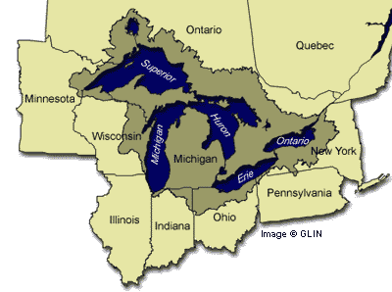

Source of map: Great Lakes Information Network [need permission to reprint]

Missouri River Recovery Implementation Committee

Broadly representative appointed federal advisory body provides formal input and guidance for ecosystem recovery efforts in the nation’s longest river.

Summary: Section 5018 of the Water Resources Development Act of 2007 authorized the U.S. Army Corps of Engineers to establish a broadly representative advisory body to provide guidance to the Corps and affected federal agencies, state agencies, and tribes on a study of the Missouri River and its tributaries to determine the actions required to mitigate losses of aquatic and terrestrial habitat, to recover federally listed species protected under the Endangered Species Act, and to restore the river's ecosystem to prevent further declines among other native species.

Participants: The 70 appointed members of the Missouri River Recovery Implementation Committee (MRRIC, or “Mr. Ric” in shorthand) include representatives of federal agencies (the Corps and the U.S. Fish & Wildlife Service are the lead agencies), eight states, up to 28 tribes, and 16 stakeholder categories (28 total stakeholder members). In September of 2008, the Corps’ Northwest Division made appointments to MRRIC. The group is facilitated and co-chaired by two recognized experts who do not have a stake in the issues being addressed.

Financial and Political Support: Congress allocates funding for the U.S. Army Corps of Engineers’ Missouri River Recovery Program (MRRP). The MRRIC is a line-item in the MRRP budget, with a current operating budget of approximately $1.4 million. Participants report satisfaction with the federal government’s financial and substantive commitment to MRRIC.

Accomplishments: As a relatively new entity, MRRIC focused initially on establishing its membership, organizational structure (there are six work groups), and operating procedures. In 2009, the Committee issued its first substantive recommendations to federal agencies, addressing the endangered pallid sturgeon and the purpose and need for the Corps’ long-term river restoration plan. MRRIC next turned to establishing a third-party neutral science review program, which will examine discrete science questions that rise in the recovery study process. Additionally, MRRIC is setting up formal liaisons to interact with agency teams working on various aspects of the study process.

Challenges: The authorizing legislation forbids reimbursement of members’ travel expenses, which has made it very difficult to ensure participation by sovereign and stakeholder representatives over this large region. MRRIC’s consensus decision rule reflects shared values for a common vision, but may prevent the group from making meaningful recommendations on controversial issues. The process, according to one leader, is frankly “tedious,” due to the numerous meetings and the need to establish procedural guidelines before engaging in substantive work; drafting the group’s charter took 18 months. Finally, the “background noise” of separate processes addressing Missouri River management reminds participants that they are working in a highly charged political context and can be distracting to MRRIC deliberations.

Information: www.mrric.org/

[Sidebar to include with this section:]

“The Committee includes broad stakeholder representation to ensure a comprehensive approach to Missouri River recovery implementation while providing for congressionally authorized Missouri River project purposes and to ensure public values are incorporated into the study and the recovery and mitigation plans.”
-MRRIC Fact Sheet

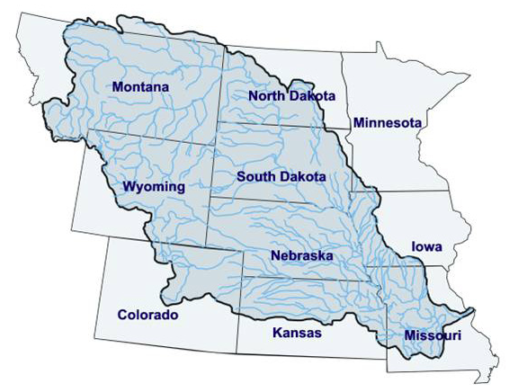

Source of map: MRRIC Fact Sheet

Northwest Power and Conservation Council

Interstate compact agency provides opportunity for states to influence federal actions, with strong emphasis on stakeholder involvement.

Summary: The Pacific Northwest Electric Power Planning and Conservation Act of 1980 (“Northwest Power Act”) authorized the Columbia River Basin states of Idaho, Montana, Oregon, and Washington to form the Pacific Northwest Electric Power and Conservation Planning Council (now known as the Northwest Power and Conservation Council) with two representatives from each state, appointed by the governors. The Council is neither a federal nor state agency; it is an interstate compact agency that has legal authority to adopt plans and programs that guide the actions of federal agencies. Specifically, the Bonneville Power Administration must ensure that its actions are “consistent” with the Council’s plans and programs, and other federal agencies must take the Council’s fish and wildlife program into account “at each relevant stage of decision-making processes to the fullest extent practicable.” The Council also makes recommendations on Bonneville’s annual expenditure of fish and wildlife funds, based on advice of an independent scientific panel. All planning for electric resources and fish protection must involve the public, and the NPCC must seek the recommendations of the region’s tribal, state and federal fish and wildlife agencies in all planning processes.

Participants: Council members are appointed by the governors of the four Columbia River Basin states (two members per state). Although the Council itself lacks formal representation of stakeholder groups and the full range of affected sovereigns, the Council relies on independent scientific review of all fish and wildlife projects proposed for funding, with input from state and tribal agency officials, stakeholder groups, and members of the public. Virtually all business of the Council is conducted in the public eye, with a strong expressed value of broad-based engagement and dialogue.

Financial Support: The Council is funded by wholesale power revenues from the Bonneville Power Administration, the federal agency that markets the electricity generated at federal dams on the Columbia River. The Council’s Columbia River Basin Fish and Wildlife Program directs more than $220 million per year in electricity ratepayer funding to address the impacts of hydropower dams on fish and wildlife from the estuary of the Columbia to its mountain tributaries in the four Pacific Northwest states.

Accomplishments: The NPCC adopted its first power plan in January 1983 and has revised it five times since then. In February 2009, the Council culminated a 15-month public process by approving a revision of its Columbia River Basin Fish and Wildlife Program, the nation’s largest regional effort to protect and enhance fish and wildlife. Through their participation on the Council, basin states have worked together—and with diverse partners including Indian nations, commercial fishing organizations, recreational groups, power customers, and others—to develop and enforce priorities for power production, energy conservation goals, and fish and wildlife habitat restoration. As described above, the Council is now engaged as well in discussions concerning the Columbia River Treaty, supporting a bi-national dialogue to complement and inform official negotiations.

Challenges: Although the funding mechanism for the Council was innovative in 1980 (based on forecasted sales of firm power), it failed to foresee important changes in the electric utility industry, and with regard to fish and wildlife recovery needs in the Pacific Northwest. Thus, over time, funding has not increased at the same rate that the Council’s responsibilities have expanded. The Council has absorbed nearly 36 percent in inflation costs from 1982 to 2010 and has confined its budget growth to less than 3 percent per year since 1998. Moreover, the Council’s authority is limited to influencing (not controlling) federal agencies, and it does not have any legal authority over state and tribal resource decsisions.

Information: http://www.nwcouncil.org/

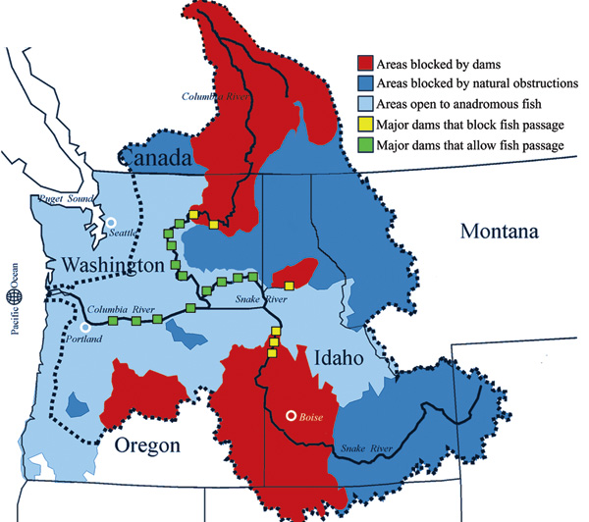

Source: NPCC

What Might This Look Like in the Colorado River Basin?

The examples of collaborative initiatives involving strong stakeholder engagement illustrate that there is no single model for success. Indeed, any such process must be designed around the scale and nature of the particular problem being addressed. Experience with a diverse array of cross-jurisdictional approaches teaches that regional collaboration is more like community organizing than rational planning. Any effort to apply broad general principles requires adaptation to the particular place and the people that live there. Thus, the real work lies in application of these ideas and examples to the particular physical and institutional setting of the Colorado River.

While a detailed description of this setting is beyond the scope of this policy brief (more detail is available in the earlier assessment, Thinking Like a River Basin and in the sources it cites), we offer here some observations to inform the discussion of how different stakeholder models might apply in the Colorado River Basin:

- Virtually all formal water governance at the basin-wide level derives from the 1922 Colorado River Compact, the foundational document that sets forth rights and obligations with regard to the interstate delivery and management of water.

- Formal water governance at the basin-wide level is dominated by the signatories to the 1922 Compact—the governments of the seven basin states and the United States. While these governments are in theory charged with representing the interests of all stakeholders affected by Colorado River water decisions, in practice it is questionable whether agency processes provide a feasible means of simultaneously representing the many diverse perspectives that are affected by water management decisions.

- A wide range of stakeholder groups are affected by water management and allocation decisions in the Colorado River Basin. These include environmental organizations, Native American tribes, cities, farmers, farm workers, and others. While these groups lack formal standing in basin-level governance processes, they can often affect the outcome of those processes—either positively or negatively—through litigation, political organizing, media campaigns, and other means.

- The existing seven-state basin-wide governance process has produced a successful, if limited, track record of collaboration to address specific issues. The states have an established tradition of resolving most disputes through dialogue and negotiation rather than litigation, of which they are justifiably proud. Moreover, during the most recent major governance process—the negotiation of the 2007 Colorado River Accord—certain environmental stakeholder groups were able to effectively participate through an ad hoc process that might best be described as “guerilla consultation.”

- A number of collaborative processes that engage stakeholders to address specific challenges exist in the Colorado River Basin. These include the Glen Canyon Adaptive Management Work Group, which advises the Secretary of the Interior on how to best protect the resources downstream of Glen Canyon Dam, and several endangered species recovery initiatives. However, no existing collaborative process has a sustained presence at the basin scale.

With this background in mind, we suggest here a few observations on how the spectrum of options discussed in this policy brief might respond to the two main governance concerns expressed by Colorado River Basin leaders in the Thinking Like a River Basin report—i.e., basin-wide coordination and broader stakeholder engagement:

A voluntary network or set of linked dialogues could provide for broader stakeholder input in a way that addresses some leaders’ concerns about creating new “bureaucracy” or excessively burdensome consultation. Something like a Colorado River Basin Consortium—whether convened by academic institutions or some other nongovernmental entity—might provide a regular and useful means of stakeholder input and informal dialogue with decision makers, an alternative to the “guerilla consultation” that takes place when certain stakeholders find the means of providing input but many do not. On the other hand, this approach would not answer questions about basin-wide leadership or coordination, and might prove frustrating if stakeholders conclude that they are being shunted off to a side conversation with little import for official decisions.

A regional goal-setting collaborative entity would answer some of the expressed concerns of those who see a lack of leadership or a failure to develop a common vision for the Colorado River Basin. Something like a Colorado River Basin Forum could engage all levels of government agencies, elected officials, and stakeholders to develop and articulate shared goals for the basin (perhaps in a Colorado River Basin Charter), and to seek implementation through their various areas of influence and jurisdiction. Such a regional entity can coexist with and complement the work of states that share water resources through an interstate compact, as is the case in the Great Lakes; that example illustrates how a shared vision can support joint efforts to secure national attention (and funding) for resource protection goals. The Great Lakes entities were motivated to articulate a shared vision in response to a perceived external threat of water exports to distant states or countries. It remains to be seen whether the growing consensus of scientific understanding about climate change impacts on shared water resources in the Colorado River Basin is yet “ripe” as a similar external threat motivating collective action.

An advisory group with appointed stakeholder representatives would elevate the stakeholder participation to an official capacity, for example in the form of a Colorado River Basin Advisory Council. This would limit official participation to those selected as representatives of particular interests and thus would be less inclusive of the broad public, but would respond to those who wish to see a more formal seat at the table for interests affected by but not formally recognized in current processes such as negotiations among the seven basin states. An advisory council could tackle discrete questions, hashing out collaborative solutions for consideration by state and federal decision makers. Their recommendations would not be binding, and the financial and logistical burdens of sustained participation might make it difficult to keep a diverse group engaged over the long run.

A regional governance authority would be the most formal approach to coordinated management in the Colorado River Basin, and would require interstate agreement and Congressional legislation. In the research for the Thinking Like a River Basin report, some leaders expressed the opinion that something like a Colorado River Basin Authority (or Commission) with some level of formal, binding decision-making authority would be the only approach with enough “teeth” to address the challenging issues at hand; others felt it would add undesired complexity to basin water governance. Either way, this is not a new idea: President Herbert Hoover urged creation of a Colorado River Commission when the Compact was negotiated in 1922, and Governors Richard Lamm (Colorado) and Bruce Babbitt (Arizona) both urged formation of a commission in the 1980s, possibly funded by a power surcharge as is the case with the Northwest Power and Conservation Council. Such a basin-wide organization would be a forum for discussion, debate, and even battles over river management—providing an alternative forum for solving problems before resort to litigation. The organization might also develop and distribute credible information, a sustained version of what the Basin Study is accomplishing now. Whether it would improve opportunities for stakeholder engagement would depend entirely upon its design and implementation, drawing lessons from the experience of the NPCC.

It may be worthwhile for the Colorado River Basin Study to incorporate something like this spectrum of approaches into its options analysis phase in the fall of 2011—both considering whether such strategies might respond to issues highlighted thus far in the study process and incorporating as inclusive a stakeholder dialogue process as possible into the analysis itself to model this approach for those who may wish to make it a more regular part of river management planning and decision making.

[sidebar to insert in this section:]

Some questions to ask in selecting a stakeholder engagement process:
- How satisfied are people and organizations likely to be with the outcomes of one process over another?
- How durable will the outcomes be, or will people be compelled to challenge them through litigation or other means?
- What are the transaction costs associated with one option over another?
- What impact will one option have on working relationships relative to the others?

