June 7, 2011 DRAFT
RISK MANAGEMENT STRATEGIES FOR THE
UPPER COLORADO RIVER BASIN

Eric Kuhn, General Manager
Colorado River Water Conservation District

I. INTRODUCTION
The 1922 Colorado River Compact (1922 Compact) divided the Colorado River Basin within the United States into two hydrologic basins, an Upper Basin and a Lower Basin. The 1922 Compact defines the dividing point as Lee Ferry, one mile downstream of the confluence of the Paria River and the Colorado River. The Upper Basin is actually defined as “those parts of the states of Arizona, Colorado, New Mexico, Utah and Wyoming within and from which waters naturally drain into the Colorado River System above Lee Ferry which are now or shall hereafter be beneficially served by water diverted from the system above Lee Ferry.” Approximately 90% of the natural flow of the Colorado River at its mouth originates in the Upper Basin.

Under the 1922 Compact, the States of the Upper Division, which are the four states with primary Upper Basin interests, have certain obligations at Lee Ferry. Article III (d) provides that the States of the Upper Division will not cause the flow of the river at Lee Ferry to be depleted below an aggregate of 75 million acre feet (maf) for any period of ten consecutive years.

Additionally, Article III (c) requires that the Upper and Lower Basin share equally in providing any deficiency in the delivery of water to the Republic of Mexico under the 1944 International Treaty. Whenever necessary, the States of the Upper Division shall deliver their 50% share of the deficiency in addition to the water required under Article III (d). Thus, the obligation of the States of the Upper Division could be as high as 82.5 maf every 10 consecutive years. Since there is currently no agreed-upon procedure or accounting system in place to determine if a deficiency exists and if one exists how such a deficiency is quantified, for the illustrative purposes of this paper, the obligation of the States of the Upper Division at Lee Ferry is assumed to be 75 maf every 10 years.

Article IV of the 1948 Upper Colorado River Basin Compact (1948 Compact) addresses how the Commission, established by Article VIII, would determine each state’s obligation if it is ever necessary to curtail uses in the Upper Basin to meet the obligations of Article III of the 1922 Compact. Curtailment of uses in the States of the Upper Division would likely have a very significant and detrimental impact on the economy of the region and perhaps even threaten the health and safety of the region’s inhabitants dependent upon the Colorado River. This paper explores some of the management strategies and other options available to the States of the Upper Division to first avoid, and if unavoidable, live with the implementation of a curtailment.

II. BACKGROUND AND SETTING
The Colorado River system within the United States drains about 242,000 square miles. The Upper Basin drainage is approximately 110,000 square miles. The Upper Basin is a land of high deserts, plateaus and table mesas and the Rocky Mountains. Most of the river flow originates in the numerous high mountain watersheds located above 9,000’ in elevation. Within each of the States of the Upper Division, the Colorado River not only supplies municipal, industrial and irrigation uses within the Upper Basin, the river’s waters are also exported to adjacent basins to meet similar needs.

The Lower Basin is a land of both low and high deserts and canyons, but with only a handful of mountain watersheds over 9,000’. Like the Upper Basin, Lower Basin Colorado River water is exported out of the basin for use in the Southern California coastal plain.

At the time of the negotiations of the Colorado River Compact, the estimated natural flow of the river at the mouth was in the range of 20 to 22 maf per year and 17 to 18 million maf per year at Lee Ferry. By the 1940s, the estimated natural flow at the mouth was 17.3 maf per year and 15.7 maf per year at Lee Ferry. Today, using tree ring-based long term reconstructions, the estimated long term natural flow at Lee Ferry is in the range of 14.0 to 15.0 maf per year, which would equate to about 15.5 to 16.5 maf per year at the mouth. (See footnote 1.).

Current System Uses
Under the 1968 Colorado River Basin Project Act, the Secretary of the Interior issues a report on consumptive uses and losses in the Colorado River system every 5 years. The first report covered the period of 1971-1975. Based on the most recent information available from the Bureau of Reclamation website, the following two tables summarize current consumptive uses.
Upper Basin Uses (in 1000s acre feet per year)
Average
1996-2000 2001-2005 2006 2007
In-Basin Consumptive Use 2994 3030 2862 2900
Exports from the Basin 723 766 881 706
CRSP Reservoir Evaporation 682 487 444 453
Total Uses 4399 4283 4187 4059
Lower Basin Consumptive Uses (in 1000s acre feet per year)
Average
1996-2000 2001-2005 2006 2007
Mainstem Uses 7988 7713 7411 7454
Lower Basin Tributary Use 2508 2660 not available
Reservoir Evaporation and 1321 1105 1100 1050⁷
System Losses
Total Uses 11,817 11,478 11,061 11,054⁸

As the above two tables show, annual consumptive use for both the Upper Basin and Lower Basin was less in 2006 and 2007 than the average annual use for 1996-2000 or 2001-2005 periods. In the Lower Basin during the 1996-2000 period Lake Mead was full, and surplus water was available. California was using about 5.2 maf per year. The drought of the 2001-2004 period reduced reservoir levels such that California was forced to reduce its use to its normal year apportionment of 4.4 maf. Additionally, as Lake Mead levels have dropped, reservoir evaporation has gone down. Within the Lower Basin, there is considerable controversy over the amount of tributary use. Within the Gila River system, some of the irrigation use attributable to Colorado River is likely groundwater. I believe that current total Lower Basin consumptive use, including mainstem, tributary and reservoir evaporation is in the range of 10.8 to 11.3 maf per year.

Within the Upper Basin, the demand for Colorado River water has been relatively flat since the mid-1990s. Actual annual consumptive use will vary based on local water availability, summer precipitation and water availability in adjacent river basins. I believe that current uses in the Upper Basin, excluding CRSP reservoir evaporation, are in the range of 3.6 to 4.1 maf per year. CRSP reservoir evaporation varies with reservoir levels. Based on recent reservoir levels, .5 maf per year is a good estimate. Thus, total Upper Basin uses are in the range of 4.1 to 4.6 million acre feet per year.

Adding in 1.5 to 1.7 maf per year for Mexico, total Colorado River consumptive use is currently in the range of 16.4 to 17.4 maf per year.

Deliveries at Lee Ferry
The following graph shows the ten-year cumulative flow at Lee Ferry for the last 30 years (1981-2010). Ten-year flows at Lee Ferry have always been well in excess of the minimum requirements under Article III of the 1922 Compact.
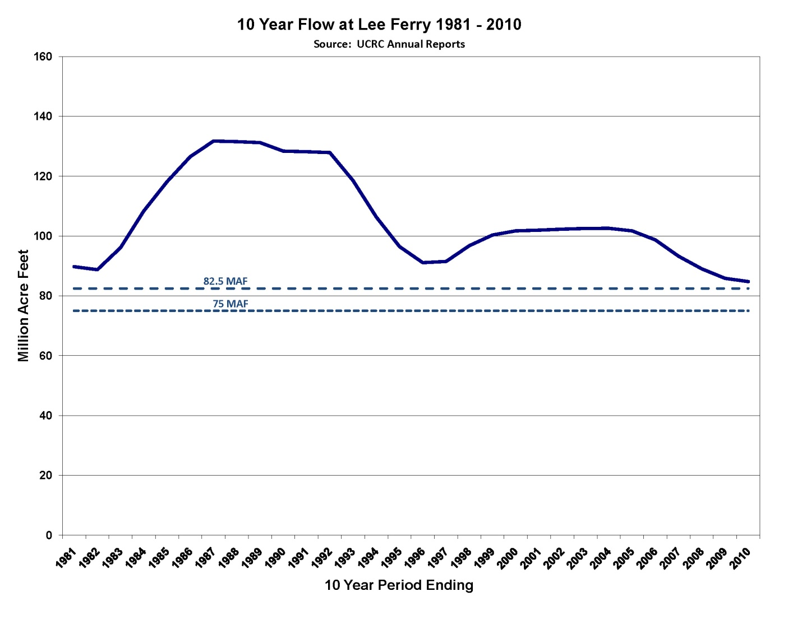
Present Perfected Rights
Article VIII of the 1922 Compact states:
“Present perfected rights to the beneficial use of waters of the Colorado River System are unimpaired by this compact. Whenever storage capacity of 5,000,000 acre-feet shall have been provided on the main Colorado River within or for the benefit of the Lower Basin, then claims of such rights, if any, by appropriators or users of water in the Lower Basin against appropriators or users of water in the Upper Basin shall attach to and be satisfied from water that may be stored not in conflict with Article III.

All other rights to beneficial use of waters of the Colorado River system shall be satisfied solely from the water apportioned to that Basin in which they are situate.”

A common interpretation of this provision in the States of the Upper Division is that water rights that were perfected prior to approval of the compact cannot be curtailed to meet the obligations at Lee Ferry under Article III.

The 1922 Compact minutes suggest that Article VIII was one of the most difficult and contentious provisions in the Compact. There were numerous drafts of this article, and the Commissioners and their advisors spent considerable time and energy wordsmithing this article and discussing how it related to Articles III (d) and III (e). The irony is that the 1922 Compact minutes suggest that there was little or no concern or desire on the part of the Commissioners from the Upper Division to shield or insulate perfected rights from a curtailment under Article III. Rather, the problem was how to address low flows on the Lower Colorado River and to protect upstream rights against a priority claim (call) by downstream senior rights on the Lower Colorado, especially the Imperial Irrigation District.

The Commissioners considered several alternatives including a proposed provision in Article III (d) that would require an annual minimum flow of 4 maf per year at Lee Ferry in addition to the 10-year requirement of 75 maf.

The Commission even considered and rejected a proposal submitted by Imperial Irrigation District that would prohibit any upstream diversions from diverting water in the months of August, September, October and November.

Under the Imperial Irrigation District proposal, the monthly prohibition would have gone away with the construction of at least 5,000,000 acre feet of upstream storage. Obviously, Imperial Irrigation District and the entire California delegation were trying to use the Compact to gain as much political support as possible for the construction of Boulder Canyon Dam (now named Hoover Dam).

However, the States of the Upper Division can find comfort and support for their interpretation based on comments made in the 1922 Compact minutes. During the 25th meeting of the Commission, R.T. McKisick, California’s legal advisor made the following the statement: “The underlying reason for the clause as it now stands is precisely as you have stated it. Assuming that there are rights in the Lower River which must be satisfied, this Commission has no power to impair those rights.”

The Commission fussed and bickered over the wording and intent of the phrase
“present perfected rights.” Chairman Hoover was concerned with “inchoate” rights and “the fact that these rights are likely to be dated as vesting at the time they are filed. We must at least make a declaration about perfected rights.”

Commissioner Davis of New Mexico stated “The very word that has been causing trouble is ‘rights.’ We have been having difficulty with vested rights. We thought by using the word ‘beneficial use’ we would get away from the word rights.”

Commissioner Carpenter of Colorado suggested a broader definition for Article VIII which would include “unperfected rights,” but he did not have any support and dropped the idea.

The definition of “present perfected right” became a disputed issue in Arizona v. California. Section 6. of the Boulder Canyon Project Act (BCPA) states
“the dam and reservoir provided for by section 1 hereof shall be used: First, river regulation, improvement of navigation, and flood control: second, for irrigation and domestic uses and satisfaction of present perfected rights in pursuance of Article VIII of said Colorado River compact.” (Emphasis added).

The disputed issues in Arizona v. California relating to “present perfected rights” are interesting, but not as relevant to this paper as the Court’s definition.

The Special Master’s report and subsequent U.S. Supreme Court decreecontain the following definitions:

(G) “Perfected right” means a water right acquired in accordance with state law, which right has been exercised by the actual diversion of a specific quantity of water that has been applied to a defined area of land or to definite municipal or industrial works, and in addition shall include water rights created by the reservation of mainstream water for the use of federal establishments under federal law whether or not the water has been applied to beneficial use;

(H) “Present perfected rights” means perfected rights, as here defined, existing as of June 25, 1929, the effective date of the Boulder Canyon Project Act;”

It should be recognized that the Supreme Court decision in Arizona v. California was only interpreting the Boulder Canyon Project Act (BCPA), not the 1922 River Compact, thus a future Court decision could possibly adopt a different definition. I personally doubt this would occur. I find the arguments put forth for these definitions in the Report of the Special Master quite compelling and consistent with the intent of the Commission as described in the minutes.

The effective date for present perfected rights is a better example of where the interpretation of the 1922 Compact and the BCPA may differ. The effective date under the BCPA is the date the act was declared effective by President Hoover , June 25, 1929. However, the minutes of the Upper Colorado Basin Compact Commission suggest that some basin officials believed the effective date was intended to be November 24, 1922. This date is incorporated into Article IV of the 1948 Compact.

The following quote from Commissioner Carson of Arizona is from the 7th meeting of the Upper Basin Commission. Mr. Carson is referring to a provision in Article IV of the 1948 Compact.

“but to exclude from the calculation consumptive uses which existed prior to the 24th day of November 1922. That is the date the original compact was signed and it was thought that the then existing uses should be protected and that any curtailment would be made out of subsequent appropriations and uses.”

For the States of the Upper Division, the inclusion of federal reserved rights in the definition of present perfected rights, especially those held in trust by the United States for Indian tribes, raises a number of difficult problems and challenges. A detailed analysis of this matter is beyond the scope of this paper. Clearly, how Indian reserved rights are addressed by the Upper Colorado River Compact Commission in the event of a curtailment is only one of several issues that will have to be resolved in the future.

Assuming the effective date for present perfected rights under the 1922 Compact is November 24, 1922, there could be up to 2.3 maf of consumptive use associated with present perfected rights in the States of the Upper Division. The minutes of the 6th meeting of the Colorado River Commission include a table that shows the amount of water “probably” used on acres irrigated as of 1920:

State Acre Feet
Wyoming 550,500
Colorado 1,110,000
Utah 538,500
New Mexico 68,000
Totals 2,267,000

At least for Colorado, this “guess” was pretty good. In May 2007, then Deputy State Engineer Ken Knox estimated that the average consumptive use for the period of 1975-2002 for rights with priorities senior to November 24, 1922 was 1,027,553 acre feet per year. We often refer to present perfected rights senior to the compact as “pre-1922” and those perfected after the compact as “post-1922.”

Article IV of the 1948 Compact
For the States of the Upper Division, the rules for implementation of curtailment are found in Article IV of the 1948 Compact.

“In the event curtailment of use of water by the States of the Upper Division at any time shall become necessary in order that the flow at Lee Ferry shall not be depleted below that required by Article III of the Colorado River Compact, the extent of curtailment by each State of the consumptive use of water apportioned to it by Article III of this Compact shall be in such quantities and at such times as shall be determined by the Commission upon the application of the following principles:

(a) The extent and times of curtailment shall be such as to assure full compliance with Article III of the Colorado River Compact;

(b) If any State or States of the Upper Division, in the ten years immediately preceding the water year in which curtailment is necessary, shall have consumptively used more water than it was or they were, as the case may be, entitled to use under the apportionment made by Article III of this Compact, such State or States shall be required to supply at Lee Ferry a quantity of water equal to its, or the aggregate of their overdraft of the proportionate part of such overdraft, as may be necessary to assure compliance with Article III of the Colorado River Compact, before demand is made on any other State of the Upper Division;

(c) Except as provided is subparagraph (b) of this Article, the extent of curtailment by each State of the Upper Division of the consumptive use of water apportioned to it by Article III of this Compact shall be such as to result in the delivery at Lee Ferry of a quantity of water which bears the same relation to the total required curtailment of use by the States of the Upper Division as the consumptive use of Upper Colorado River System water which was made by each such State during the water year immediately preceding the year in which the curtailment becomes necessary bears to the total consumptive use of such water in the States of the Upper Division during the same water year; provided that in determining such relation the uses of water under rights perfected prior to November 24, 1922, shall be excluded.”

Except to identify and discuss issues that are relevant to risk and risk management, a detailed analysis of Article IV is not the focus of this paper. From a curtailment risk and risk management perspective, Article IV does not alter or change the probability of a future curtailment. The risk of curtailment is primarily based on the requirements of Article III of the 1922 Compact, the level of upstream depletions, and future hydrology.

However, different interpretations of Article IV divide up the burden of curtailment among the four Upper Division States in different ways. For example, Article IV (b) is often referred to as the “10-year penalty box” provision. The policy intent of this provision is to first put the burden of a curtailment on the state or states that develop beyond its/their apportionments under Article III of the 1948 Compact.

For example, let’s assume that in a 10-year period preceding a curtailment, the State of Colorado had consumed 54% of the aggregate total for the four Upper Division States. Colorado’s apportionment is only 51.75%. Further, let’s assume that the shortage to the Lee Ferry delivery that triggers the curtailment is 1.5 maf, and Colorado’s overuse of 2.25% amounts to 1.75 maf in those last 10 years. Under this scenario, the intent of the ten-year penalty provision would dictate that Colorado would make up 100% of the curtailment because had Colorado not overdeveloped its apportionment, the curtailment would not have occurred and would not have impacted any of the other three states.

An alternative approach to Article IV (b) would be for the Commission to adopt development caps for each of the Upper Division States. Under this approach, each state would have a 10-year cap or perhaps annual cap based on its apportionment and a reasonable assumption of future hydrology. The 10-year cap would be in acre feet of consumptive use, not a percentage. In the event of a curtailment, the ten-year penalty box would only be triggered if an individual state exceeded its approved 10-year cap. The advantage to this approach is that it would provide more certainty for the planning and management of projects within each state.

The downside to this approach is that if a curtailment is to occur, it will almost certainly be caused by hydrology that is drier or the delivery obligation under Article III of the 1922 Compact different than what was assumed by the Commission when it sets the 10-year or annual caps.

A second concern is whether or not this approach is legal under the existing framework of the 1948 Compact. If not, would it require a formal amendment to the Compact?

III. FUTURE RISK OF AND POTENTIAL IMPACTS FROM A CURTAILMENT
Risk of a Curtailment
As previously mentioned, the risk of future curtailment is a function three variables: the actual obligations at Lee Ferry under Article III of the 1922 Compact; the level of future development in each of the States of the Upper Division; and future hydrology within the Basin.

Obligation at Lee Ferry under Article III
Under Article III (d) of the 1922 Compact, the obligation of the States of the Upper Division is to not deplete flow at Lee Ferry below 75 maf over any consecutive 10-year period. The 75 million is not guaranteed because nature, and/or presumably pre-1922 water rights, could deplete the flow below this amount without a violation of Article III (d).

The wild card is how much, if any, is the obligation of the States of the Upper Division under Article III (c) for delivery of water to Mexico. Since the normal year delivery obligation to Mexico is 1.5 maf per year, the Upper Basin’s share could be up to 50% or 750,000 acre feet per year. It could be a little bit more, if the Upper Basin has to make up for transit losses. Thus, if the deficiency over a 10-year period is 7.5 maf, the total obligation under Article III could be as high as 82.5 maf every 10 years. Obviously, the higher the obligation under Article III, the higher the probability of a future curtailment.

Uncertainties with the delivery obligation to Mexico are also a serious problem for the individual States of the Upper Division. For planning purposes, should a state plan on 75 million or 82.5 maf, or something in between? Should a state water project proponent be allowed to proceed with an individual project, if that project’s long term water supply is not available if the Lee Ferry delivery obligation is 82.5 maf every 10 years, but available if the obligation is 75 maf?

The Level of Future Development

Again, the obvious answer is the higher the level of depletions by the States of the Upper Division, the higher the probability of a future curtailment. From the perspective of the Lake Powell and the Lee Ferry’s gage, the impact of an upstream depletion of an acre foot is identical is to a reduction in basin yield of an acre foot. The real questions are related to the level and pace of new development.

Water use in the States of the Upper Division has been relatively consistent since the early 1990s. The following graph shows Upper Basin uses from 1971-2007, less CRSP evaporation. The graph shows actual annual consumptive use, a 10-year moving average and a trend line. The graph clearly shows that from the early 1970s to the early 1990s, consumptive uses were steadily increasing. Since the early 1990s, the trend line is increasing, but at a decreasing rate. It is flattening out. The ten year moving average has essentially been flat for the last decade.
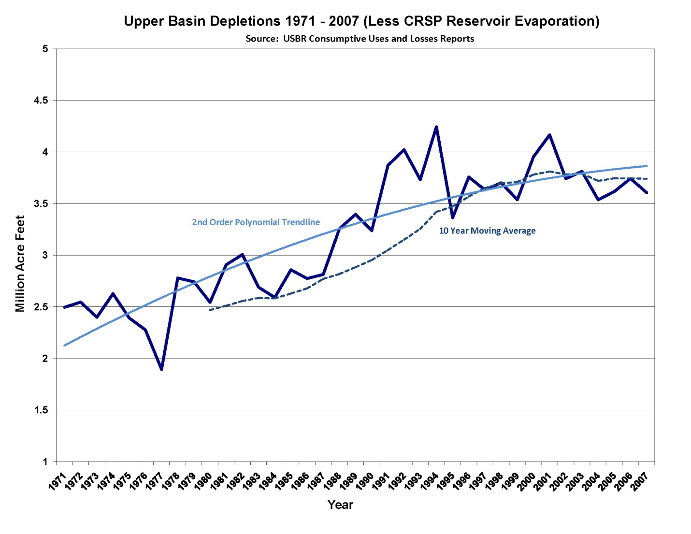
There are probably a variety of reasons for the flattening trend line. The last major transmountain diversions and new irrigation projects were completed in the late 1980s. Within Colorado, the Windy Gap Project was the last new transmountain diversion project. It was completed in 1985, but its use was small until 2001. The last two traditional irrigation projects, the Dallas Creek and Dolores Projects, were completed in the late 1980s and early 1990s.

Within western Colorado, urbanization of the lower valleys and resort growth in the higher mountain valleys may be replacing irrigated agriculture with less consumptive uses. A number of the major municipal providers have implemented successful conservation programs. Finally, I’m a little suspicious that nature helped flatten the trend line. The 1990s, especially the late ‘90s, were relatively wet, with decent summer precipitation. This was followed by the very dry decade of 2000-2010 where consumptive uses were often limited by a lack of local water availability and there was considerable public awareness for the need to conserve water.

There are a number of reasons to believe that this flat trend may be ending, and the consumptive use of Colorado River water within the States of the Upper Division will start growing again. Within Colorado, both Denver Water and the Northern Colorado Water Conservancy District Municipal Subdistrict are in the final stages of completing the permitting of expansions to existing transmountain diversions.

Also within Colorado, there is a statewide water planning/consensus building process underway. Studies show that Colorado may have a large future need for water to meet growth throughout the state, but primarily along the Front Range corridor. While Colorado is a long way away from reaching any public consensus or even identifying candidate projects, one of the primary goals of many of the process participants is to obtain public support for a new transmountain diversion.

The State of Utah is in the process of permitting a pipeline from Lake Powell to the St. George area. This pipeline could divert about 90,000 to 100,000 acre feet per year. From the perspective of the Lee Ferry obligation, the project would be 100% consumptive.

In New Mexico, the focus is on implementation of the water settlement with the Navajo Nation in the San Juan Basin. If funding is available, implementation of the settlement will increase New Mexico’s consumptive use of Colorado River water.

The wild card in Colorado, Utah and possibly Wyoming is the future demand for water by the energy industry, specifically oil shale. The Upper Colorado River Basin is home to large deposits of oil shale. However, after decades of research and development, it is still unclear whether or not oil can be recovered on an economically feasible commercial-scale basis. If such an industry is ever successfully developed, it would require significant amounts of water. The estimates vary based on the type of technology used, but most studies suggest that an industry with a production capacity of a million barrels per day could use in excess of 200,000 acre feet per year. A recent GAO study concluded:
“Water is likely to be available for the initial development of an oil shale industry, but the size of an industry in Colorado or Utah may eventually be limited by water availability. Water limitations may arise from increase in water demand from municipal and industrial users, the potential of reduced water supplies from a warming climate, fulfilling obligations under interstate water compacts, and the need to provide additional water to protect threatened and endangered fishes.”

In addition to oil shale, the Upper Colorado River Basin contains numerous other potential energy sources. The potential demand for water varies from relatively small amounts for natural gas production to over 50,000 acre feet per year for a proposed nuclear power plant near Green River, Utah.

Impact of Climate Change on Future Depletions
Even if there are no additional future projects, climate change could significantly increase the consumptive use associated with existing agriculture, residential lawns and municipal parks and open spaces. As temperatures rise, the growing season will lengthen and evapotranspiration goes up increasing total crop water demands. If sufficient additional water is physically available for the plants, then crop irrigation requirements (CIR) could go up by approximately 20% by 2040.

The phase I report, public draft, of the Colorado River Water Availability Study (CRWAS), included an estimate of CIR under different climate models for 2040 and 2070. This report estimates that by 2040 the additional CIR for the Colorado River Basin in Colorado is in the range of 136,000 to 506,000 acre feet per year with an average of 350,000 acre feet per year by 2040.

Due to comments on the draft report, similar numbers for 2070 are under review and may be revised. The preliminary results show that the 20% increase in CIR in 2040 could go up to 31% by 2070. This implies that the average increase in CIR, again if the water is available, in the Colorado River Basin within Colorado, could be over 500,000 acre feet per year.

The implications of the CRWAS results on future depletions in the Upper Basin are staggering. Assuming that Colorado’s irrigation use is about one-half of the total for the Upper Basin depletions, by 2040, the total increase in Upper Basin depletions due to increasing temperatures on existing irrigation could be in the range of 250,000 to 1,000,000 acre feet per year and 400,000 to 1,500,000 acre feet per year by 2070.

There are a number of reasons that may discount or mitigate this potential increase. The projected temperature increases may be overstated. Even if the temperature increase does occur, the irrigation water may not be physically available. Late season irrigation water may not be available because reservoirs designed for shorter growing seasons will be insufficient. And finally, population growth will continue to displace agricultural lands throughout the Upper Basin.

Future Hydrology

At the time of the 1922 Compact was being negotiated, the negotiators had a very limited and crude understanding of the hydrology of the Colorado River. The first true gages were not installed until the 1890s. The gage at Lee Ferry was not installed until late 1921.
The hydrology data as of 1922 were based on a very short period-of-record and only a few gauges. As luck would have it, the available data covered what we now recognize as a period of unusual wetness.

By the 1940s, Reclamation and the USGS had installed more gages and sufficient hydrology work had been done so that the negotiators of the 1948 Compact had a little better understanding of the river hydrology. Additional gages have now been installed throughout the basin by federal, state and local entities.

In the 1970s, through the use of tree ring-based techniques, paleo-hydrologists began expanding the record of flows back to about the 15th century. Since then, a number of additional tree ring-based studies and stream flow chronologies have been published. One recent study extended the Lee Ferry record back to 762 A.D.

These paleo-reconstructions, while not perfect, have given us a much richer picture of the long-term (1,000 year+) history of the Colorado River. I believe that it is fair to conclude that based on the paleo record, the 20th century was relatively wet. The 20-year period prior to the negotiations of the 1922 Compact was very wet. The two most significant droughts of the 20th century, 1931-1940 and 1954-1965 were relatively mild. Finally, it is too soon to make any conclusions concerning the the 11 year dry period from 2000-2010. Natural flow data for 2008-2010 has not been compiled.

There have been numerous studies addressing the potential impact of climate change on the Colorado River System. Most of the studies that I’m familiar with suggest that the Colorado River at Lee Ferry will see a reduction in future flow as the earth warms. The magnitude of the reduction in flow ranges from about 5% to 20% or more by 2070. However, there are a number of cautions. First, there are significant uncertainties in the modeling process, especially with the impact of climate change on precipitation. Second, the resolution of most of the global models is not better than 100x100 kilometers, so we cannot yet fully understand the impact of topography. The models used to downscale
(large area to small area) are rudimentary. Finally, the only study that I’m aware of that considers the reduction in flow due to increased water demand by existing uses is the recent CWCB Colorado River Water Availability Study. (See footnote 28).

From the perspective of the risk of a future curtailment, the conclusions are simple and straightforward. As climate change raises global and regional temperatures, the risk of future curtailment is much higher. The risk in the near future, through about year 2020 or 2025 appears to be relatively low. After 2020 to 2025, the risk increases at an increasing rate.

The following graph shows the concept of the risk increasing out into the future under different scenarios.

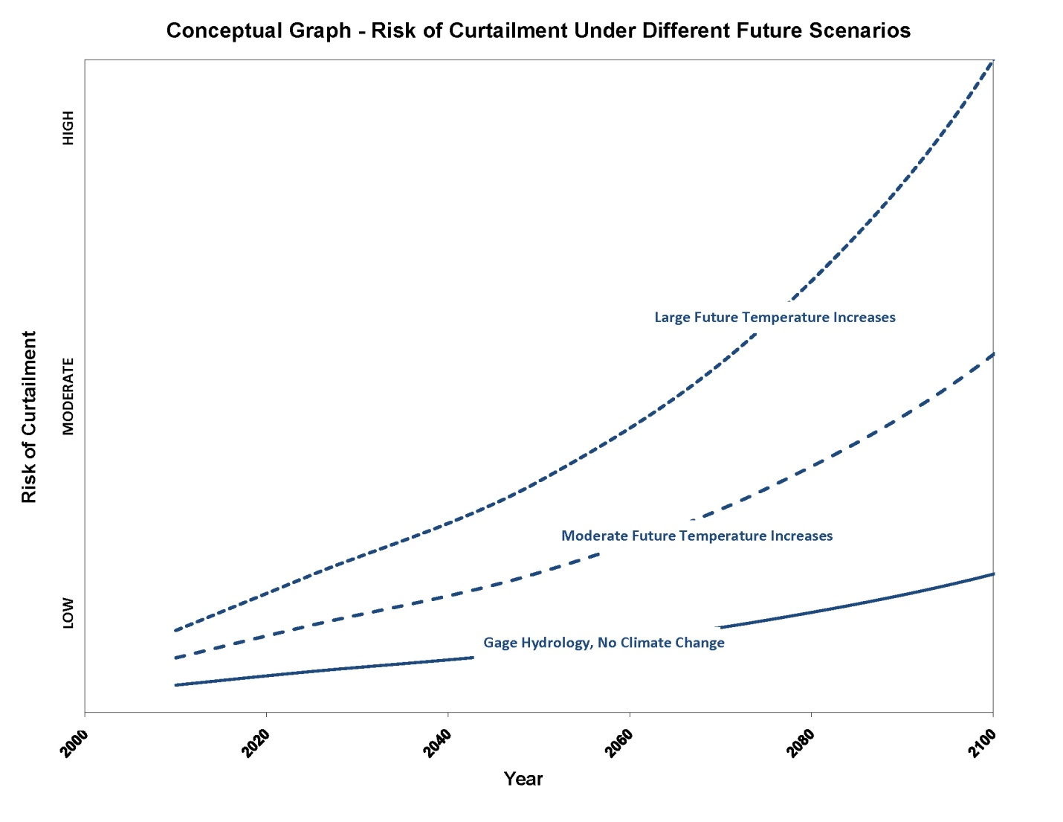
The lower curve shows that there is an increasing risk of curtailment in the future even if future hydrology is similar to 20th century hydrology. The small increase in risk is due to additional Upper Basin depletions.

The middle curve represents a future with moderate increase in temperature or period of reduced flows like the 17th century. The upper curve represents the future under a future with climate change conditions as suggested by most recent studies.

In summary, a high risk scenario for a future curtailment would look like the following:

Obligation at Lee Ferry: 82.5 maf every 10 years.
Future Level of Development: Regional population growth requires significant
new out-of-basin exports and in-basin energy
development requires significant new water supplies.

Climate Change: Increased temperatures reduce available stream
flows AND increases the water requirements for
for existing crops, lawns and parks.

Alternately, a low risk scenario would look like the following:
Obligation at Lee Ferry: 75.0 maf every 10 years.
Future Level of Development: The demand for future out-of basin exports is low.
Oil shale is not economically viable, thus energy
water uses are small.

Climate Change: The next century is similar to the 20th century, no
real change in regional temperatures or hydrology.

Other Hydrologic Issues

There are two other hydrologic factors that could influence the future risk of a curtailment. The first is the impact of dust on the mountain snowpack. The second is the widespread impact of beetle kill on Upper Colorado River watersheds.

The dust on snow study suggests that the reduced system yield caused by dust is in the range of 750,000 acre feet per year. There may be opportunities to improve future Colorado River flows, through dust mitigation strategies. However, I believe mitigation will be difficult to implement. The impact of beetle-devastated forests on the Colorado River system yield is not well understood and needs more study.

Impacts of a Curtailment on the States of the Upper Division

It is important to understand that it would take a significant and prolonged drought period just to get to a possible curtailment. The most likely conditions that would trigger a curtailment are as follows:

- In years 1 through 9 there has been a prolonged dry period in the Upper Basin, the CRSP reservoirs are seriously depleted. Storage at Lake Powell would be below minimum power head, thus no hydroelectric power is being produced. The flow at the Lee Ferry gage for the nine-year period is right at, or perhaps just at or a little bit more than 67.5 maf. The upstream federal and non-federal reservoirs are all seriously depleted. Major municipal water providers throughout the Basin have all been requiring strict conservation for at least the last several years.

- Year 10 is another dry year with forecasted inflow at Lake Powell well below 50% of average. Based on its 24 month study, Reclamation determines the inflow to Lake Powell will be insufficient to maintain the head behind Glen Canyon Dam at the elevation needed to deliver 7.5 maf during year 10. At this point, and assuming all of the legal issues have been settled, the most likely scenario would be that working with data provided by Reclamation, the Upper Colorado River Commission would determine the amount of upstream curtailment necessary to keep the elevation of Lake Powell at sufficient head to deliver the necessary amount through the Glen Canyon bypass tubes. As prescribed by paragraph IV of the 1948 Compact, the Commission would also apportion the curtailment among the states. How the curtailment would actually be handled within each state would vary.

My theory is that it will take a relatively large shortage amount, on the order of 250,000 to 500,000 acre feet or more, to actually force a curtailment. For smaller amounts, the most probable outcome is a negotiated agreement to put off the curtailment for a year.

A significant one-year curtailment could turn into a multi-year curtailment if the hydrology stayed dry. The multi-year curtailment could be aggravated if the year 10 curtailment did not restore 10-year flows to the 75 maf trigger. For example, let’s assume that after a year 10 curtailment the new running total was still 74 maf, and if year 1 delivery (the year that drops out) was 7.5 maf, the States of the Upper Division would have to deliver 8.5 maf in the new year 10 to get back to 75 maf. Continuing dry hydrology could keep deepening the hole.

As previously stated, once the Commission determines the amount each Upper Division State must deliver to Lee Ferry, curtailment of actual water use is the job of the different state water administrators. While each of the States of the Upper Division uses the doctrine of prior appropriation, there are technical and administrative differences among the states.

From a Colorado perspective, there are a number of critical curtailment administrative issues that have not been resolved. One of these issues is how to address post-1922 storage that was carried over into a curtailment year. It raises the difficult junior-junior vs. senior-junior issue.

For example, assume we have a 1940 direct flow right (senior-junior) and a 1970 storage right (junior-junior). In the curtailment year, the 1970 storage right has 50,000 acre feet of water in it that was stored in priority in years 1 through 9. Under a curtailment, should the State of Colorado require the release of the 50,000 acre feet of junior-junior (1970) stored water before curtailing the senior-junior (1940) direct flow right? From my perspective, there is no easy answer to this question. If the state determines that the previously stored water should not be curtailed, it could be denying the senior-junior the benefit of its priority. On the other hand, if it releases water the junior-junior right stored, it may wasting a valuable and flexible drought resource, stored water, downstream.

Impacts of a Curtailment to Water Use

If a large curtailment were to occur, Colorado’s use of Colorado River water would be limited to its pre-1922 rights and perhaps carryover storage. Not counting CRSP reservoir evaporation, Colorado is currently consuming about 1.9 to 2.3 maf per year, thus Colorado would have to get by with about one half of its normal Colorado River water supply. In contrast, Colorado’s consumptive uses in the two worst drought years, 1977 and 2002, were 1.6 maf and 2.1 maf. The task of surviving a curtailment year with only 50% of what was used in 2002 would be an extreme challenge.

The impacts to individual users would vary significantly. For example, a number of West Slope towns such as Glenwood Springs and Grand Junction have significant pre-1922 rights. However, most communities probably have a mix of pre-1922 and post-1922 rights. Within Colorado, almost all of the major transmountain diversions and most newer communities, special districts and industrial plants use post-1922water rights.

For the major transmountain diverters such as Denver Water or Colorado Springs, the situation is more complicated because these cities have water portfolios with both imported Colorado River supplies and in-basin (South Platte or Arkansas River) supplies. The impact of a curtailment in these cities could be mitigated if their in-basin supplies were abundant. The impact could also be aggravated because transmountain sources are reused through exchanges and recycle plants. The safest assumption is that under climactic conditions that would trigger a Colorado River curtailment, local South Platte and Arkansas River supplies would also be severely stressed, and, thus, the impacts of a curtailment would be very serious.

In the other three States of the Upper Division, the impacts of a curtailment would also be serious. There are important transmountain diversions serving Albuquerque, Santa Fe, Cheyenne and the Wasatch Front as well as a number of large thermal power plants and other critical uses that utilize post 1922 rights. The amount of pre-1922 uses varies somewhat. Relative to its current uses, Wyoming’s pre-1922 uses are large, where as New Mexico’s are small (refer to the table on page 10).

Economic Impacts of a Curtailment on the States of the Upper Division

There is not much research available on the economic impacts of a curtailment. The October 1995 Severe and Sustained Drought study included a chapter on the “Hydrologic and Economic Impacts of Drought under Alternative Policy Responses” written by James F. Booker. Although the study covers the entire basin and did not specifically model a curtailment (it did so by assumption), the impacts are still significant. The study suggested a marginal damage of $1,200/acre foot for Colorado Front Range cities. Therefore, a loss of 450,000 acre feet would result in an economic loss of $540 million (in 1992 dollars). Booker also concludes that from an Upper Colorado River Basin perspective, the economic impacts from hydropower and recreation would also be very significant, exceeding $500 million per year (in 1992 dollars).
IV. UPPER BASIN STRATEGIES TO MINIMIZE THE RISK AND IMPACTS OF A CURTAILMENT
There are four basic approaches, all interwoven, that the States of the Upper Division could use to minimize the risk of a curtailment.
1. The first approach would be optimization of the use of the Colorado River Storage Project Act (CRSPA) mainstem storage reservoirs to meet the Article III obligations. This optimization will almost certainly include studying whether or not additional storage, either through the construction of new units, or the expansion of existing units, would be beneficial.
2. The second approach is litigation. The most common answer given to the question “when will the States of the Upper Division face a curtailment,” is “when the Supreme Court tells us we have to.”
It is not the purpose of this paper, nor am I qualified to discuss the legal issues in great detail. I will focus on the policy and management decisions related to the litigation option as a risk management tool. In theory, decisions to litigate will be made by elected officials and policy boards (the clients) with input and advice from the water agency managers, engineers and legal advisors. The issue of litigation risk will be an important decision factor.
3. The third approach is for the individual States of the Upper Division to develop curtailment compliance and contingency plans. I would expect that these plans would first try to avoid a curtailment, but if that was impossible, use each state’s pre-1922 rights and make strategic use of any available storage. One mechanism Colorado is studying is a water bank where the consumptive use from pre-1922 rights could be temporarily leased to post-1922 critical uses.
A remote possibility is that two or more of the Upper Division States could join forces and develop a joint curtailment contingency plan. For this to occur, there would have to be a clear advantage to each of the participating states.
4. The final approach is for the seven basin states and possibly the United States to negotiate and implement alternative institutional arrangements or joint projects that would further reduce the risk of a curtailment on the States of the Upper Division. In fact, the current Interim Guidelines, which expire in 2026, contemplate that negotiations to possibly extend them will commence in 2019. I expect negotiations will actually start much sooner. These alternative arrangements could either be interim in nature or permanent changes to components of the Law of the River.
Use of Storage to Minimize Risk

The development and use of water storage upstream of Lee Ferry is the primary operational tool for managing the obligations of the States of the Upper Division at Lee Ferry, and thus managing risk. The negotiators of the 1922 Compact believed that storage upstream of Lee Ferry would be developed and were aware that a high dam at Glen Canyon was feasible and would be of great value in regulating the flow of the Colorado River at Lee Ferry.

In 1956, Congress passed the Colorado River Storage Project and Participating Projects Act (CRSPA). CRSPA authorized the construction of four major storage reservoirs in the Upper Basin: Glen Canyon Dam and Reservoir (Lake Powell); Flaming Gorge Dam and Reservoir; Navajo Dam and Reservoir; and, Blue Mesa Reservoir. These reservoirs have a combined live storage of over 30 maf.

One of the primary purposes of CRSPA is “making it possible for the States of the Upper Basin (sic) to utilize, consistently with the provisions of the Colorado River Compact, the apportionments made to and among them in the Colorado River Compact and the Upper Colorado River Basin Compact.”

Of the four storage reservoirs, Lake Powell is by far the largest and most important. As a practical matter, Lake Powell is operated to meet the Article III obligations of the States of the Upper Division at Lee Ferry. Two of the three upstream reservoirs, Flaming Gorge and Aspinall, are primarily operated for local river regulation, endangered species recovery needs and power generation. Navajo Reservoir is primarily used to meet downstream water needs in New Mexico.

In the face of a curtailment, the potential role of the three upstream storage reservoirs is not well understood, and there are a number of unresolved issues.

In a curtailment year, carryover storage would be a very valuable resource. To the extent that upstream CRSP storage reservoir have state priorities, the priorities are relatively junior (1950s and 1960s). Thus, in a larger curtailment year, it is unlikely that these reservoirs would be able to store any water, but there could be some water in storage carried over from previous years. Under curtailment conditions, how would the Secretary dispose of this water? If it is under contract, would it be delivered to contract holders or could it be withheld for delivery to Lake Powell and subsequently to Lee Ferry? Should individual water districts or states be allowed to contract for this water with the intent that if a curtailment were to occur, the water would be released for the sole benefit of the contract holder? These are questions that need to be addressed by the individual states, the Upper Colorado River Commission and the Department of the Interior/Bureau of Reclamation.

Section 602 (a) of the Colorado River Basin Act

While the passage of CRSPA resulted in the construction of the four CRSP storage reservoirs, also referred to as storage units, it provided little guidance on the specific operation of the reservoirs, specifically Lake Powell. During the period that the Bureau of Reclamation was completing construction of the Glen Canyon Dam and beginning the slow fill of Lake Powell, the seven Colorado River Basin states were negotiating with each other and Congress for passage of the Colorado River Basin Project Act (CRBPA). Among other things, CRBPA authorized the Central Arizona Project (CAP), a number of participating projects in the Upper Basin, and reauthorized the Dixie Project in Utah. Under Article VI, the CRBPA also provided Congressional direction to the Secretary of the Interior on the coordinated operations of the Colorado River projects developed under all three major development acts: the 1928 BCPA; the 1956 CRSPA, and the 1968 CRBPA.

The Upper Division State representatives were concerned that Lower Basin interests would use Article III (e) of the 1922 Compact to interfere with the storage and operation of Lake Powell. Article III (e) states:

“(e) The States of the Upper Division shall not withhold water, and the States of the Lower Division shall not require the delivery of water, which cannot reasonably be applied to domestic and agricultural uses.”

The concern was that the Lower Basin would claim that Lake Powell storage was “withholding water” that could not be used, thus they insisted on section 602 (a). Section 602 (a) required the Secretary of the Interior to prepare coordinated long range operating criteria, and set priorities for release of water from Lake Powell. Those priorities are as follows:
(1) “releases to supply one-half the deficiency described in article III (c) of the Colorado River Compact, if any such deficiency exists and is chargeable to the States of the Upper Division, but in any event such releases, if any, shall not be required in any year that the Secretary makes the determination and issues the proclamation specified in section 202 of this Act:
(2) releases to comply with article III (d) of the Colorado River Compact, less such quantities of water delivered into the Colorado River below Lee Ferry to the credit of the States of the Upper Division from other sources; and
(3) storage of water not required for the releases specified in clauses (1) and (2) of this subsection to the extent that the Secretary, after consultation with the Upper Colorado River Commission and representatives of the three Lower Division States and taking into consideration all relevant factors (including, but not limited to, historic stream-flows, the most critical period of record, and probabilities of water supply), shall find this to be reasonably necessary to assure deliveries under clauses (1) and (2) without impairment of annual consumptive uses in the upper basin pursuant to the Colorado River Compact: Provided, that water not so required to be stored shall be released from Lake Powell: (i) to the extent it can be reasonably applied in the States of the Lower Division to the uses specified in article III (e) of the Colorado River Compact, but no such releases shall be made when the active storage in Lake Powell is less than the active storage in Lake Mead, (ii) to maintain, as nearly as practicable, active storage in Lake Mead equal to the active storage in Lake Powell, and (iii) to avoid anticipated spills from Lake Powell.”
With paragraph (3), the States of the Upper Division defined the rules for delivery to the Lower Basin under Article III (e).
As a practical matter, 602 (a) (3) set a trigger elevation in Lake Powell. When storage in Lake Powell is below the trigger, the States of the Upper Division are at an elevated risk that there is insufficient water in storage to meet future obligations under Article III (c) and III (d) of the 1922 Compact.
Calculation and Impacts of 602 (a)
The formula for the calculation of 602 (a) levels was included in Appendix A of the “Draft EIS for Colorado River Interim Guidelines for Lower Basin Shortages and Coordinated Operations for Lake Powell and Lake Mead.”
The formula is as follows:
602a = {(UBDepletion + UBEvap)* (1 – percentShort/100) + minObjRel-
criticalPeriodInflow} * 12 + minPowerPoolStorage
where:
602(a) = the 602(a) storage requirement
UBDepletion = the average over the next 12 years of the Upper Basin scheduled depletions
UBEvap = the average annual evaporation loss in the Upper Basin (currently set to 560kaf)
percentShort = the percent shortage that will be applied to Upper Basin depletions during the critical period (currently set to zero)
minObjRel = the minimum objective release to the Lower Basin (currently set to (8.23 maf)
criticalPeriodInflow = average annual natural inflow into the Upper Basin during the critical period (1953-1964) (currently set to 12.18 maf)
minPowerPoolStorage= the amount of minimum power pool to be preserved in Upper Basin reservoirs (currently set to 7.179 maf)
This formula has been in use for several decades. However, neither the Upper Colorado River Commission nor any of the Lower Division States have formally agreed to its use. In 2004, the Secretary of the Interior adopted an interim 602 (a) storage guideline that was set at 14.85 maf in Lake Powell (elevation 3630’ msl) on September 30. This guideline was only effective through 2016. As a part of the adoption of the Interim Guidelines for Lower Basin Shortage Guidelines (Interim Guidelines), the seven states negotiated a table of “equalization” levels. The term “602 (a)” levels was specifically avoided. This table supersedes the 14.85 maf figure and will be used through 2026.
The states avoided the term “602 (a)” because discretion and judgment (and thus disagreement) are necessary to set almost every variable in the 602 (a) formula. For example, should the minimum objective release be 7.48 maf/year, 8.23 maf/year, or something else? Should the critical flow period be based on 1953-1964, 1988-2009, or a paleo-hydrology period? Should climate change be considered?
Should the percent shortage and minimum power pool variables even be included in the formula?
The following graph plots 602 (a) levels against Upper Division depletions under three different critical periods.
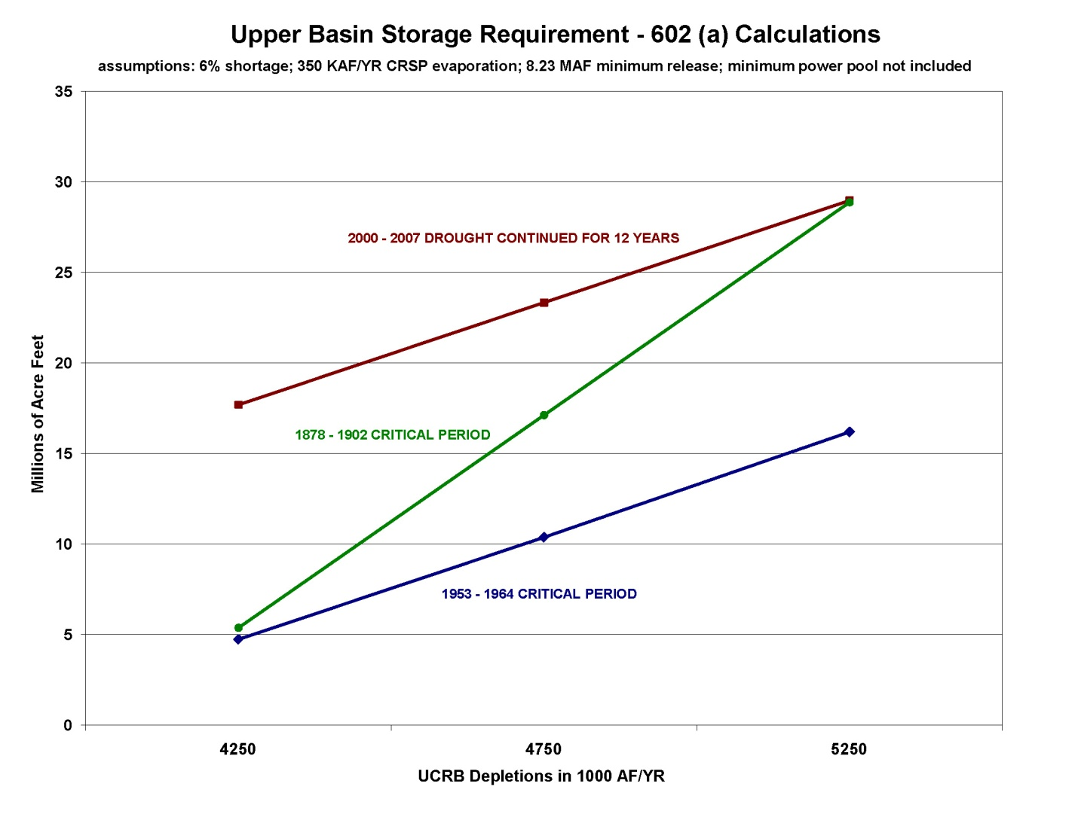
The graph clearly shows that 602 (a) levels go up steeply as depletions increase. From a risk management perspective, the States of the Upper Division want the 602 (a) assumptions to be as conservative as possible. Ironically, the minimum objective release variable runs counter to other interests within each basin. A minimum release of 8.23 maf /year results in a 602 (a) level of about 9 maf more than a release of 7.50 maf/year (based on a 12 year critical period). Yet based on their view of the Mexican Treaty obligation, the States of the Upper Division believe that 8.23 maf is not justified. For the States of the Lower Division, 8.23 maf/year is the appropriate minimum objective release, but using a 7.50 figure in the 602 (a) calculation and the 1953-1964 critical period would result in a very low (or negative) 602 (a) level. Equalization would occur just about every time storage in Lake Powell was greater than Lake Mead.

Future Debate Over 602 (a)
While the Interim Guidelines are in place, the debate between the Upper Division and Lower Division has been temporarily postponed. However, in 2019 or so, when the states resume negotiations, or if the Interim Guidelines agreement implodes, 602 (a) could resurface as a very contentious issue.
The Upper Division States will negotiate to maximize the protection accorded by 602 (a), and the Lower Division States will negotiate for maximum equalization releases.
In the longer run, if depletions in the Upper Division approach or exceed 5 maf per year and/or climate change or natural variability provides a longer and drier critical period, 602 (a) approaches or exceeds the available CRSPA storage capacity. If this were to occur, Lake Powell would either be operated to deliver the required minimum release or (in wet years) to avoid uncontrolled spills. How Reclamation operates Lake Powell to avoid uncontrolled spills becomes a critical issue. Since flooding damaged the Glen Canyon Dam emergency spillways in 1983-1984, Reclamation has been very conservative when operating Lake Powell at elevated storage levels.
Would Additional Storage in the Upper Basin Dedicated to Compact Protection Reduce Risk?
The first question many water and political officials in the Upper Division States ask is “could additional storage reduce the risk of a future curtailment?”
As we move forward, this question has to be studied, and policy makers throughout the basin need to understand the results.
I would split this question into two separate questions: Can existing storage projects be re-operated or modified to provide additional compact curtailment protection? And, would the construction of new storage provide additional compact curtailment protection?

Can Existing Storage Projects be Re-operated or Modified to Provide Additional Protection?
The first task to consider is can the upstream CRSPA storage reservoirs (Navajo, Flaming Gorge and Blue Mesa) be operated in a manner that reduces the risk of a future curtailment to all four Upper Division states? What are the options for operating these projects in a coordinated manner with the operation of Lake Powell to minimize the future risk of a curtailment? To date, the operational focus on the three upstream CRSPA reservoirs has been endangered species and power generation (except Navajo) and local supply issues. To my knowledge, there has been no detailed study on how these reservoirs could be used to manage compact risk.
A second major question is whether or not Glen Canyon Dam might be modified to increase its effective capacity. As mentioned previously, Reclamation operates Glen Canyon very conservatively to avoid uncontrolled spills. This restriction has not been an issue recently for two reasons. First, 602 (a) or “equalization” levels are currently much less than the reservoir capacity. Secondly, actual storage in Lake Powell has not approached 20 maf for over a decade. However, in the future, if Lake Mead and Lake Powell ever refill, or if upstream depletions and/or critical hydrology results in a 602 (a) level that exceeds 22-23 maf, then this conservative operation could limit the compact protection provided by Lake Powell.
As a practical matter, this would involve studying whether or not the spillways can be modified or otherwise operated in a manner where Reclamation is more comfortable operating Lake Powell at higher storage levels. It would also have to consider the impact of uncontrolled spills on the resources downstream of Glen Canyon Dam.
Would the Construction of New Storage Provide Additional Compact Protection?
The question of whether or not additional storage could reduce the risk of a curtailment on the States of the Upper Division has been on the table since the mid 1960s. In 1965, Colorado engineer Royce Tipton prepared a report for the Upper Colorado River Commission where he concluded “The addition of more reservoir capacity than will be provided by the existing and authorized units of the Upper Colorado River Storage Project would not materially increase these (meaning Upper Basin) depletions.”
Mr. Tipton based his conclusion on a hydrologic analysis of the extended dry period of 1930-1964. By today’s standards, the Tipton analysis was relatively crude. So, it may be worthwhile for Reclamation or individual states to redo the analysis. Under climate change scenarios, one of the possible futures is more winter precipitation, especially in the northern ranges of the Upper Colorado River Basin. I expect that we may experience some rare but extremely wet winters.
It also needs to be recognized that even if the study results suggest potential benefits from additional storage, finding an acceptable dam and reservoir site that does not inundate critical endangered fish habitat, a major railroad or an existing community may be problematic. As a practical matter, the options may be limited to off-channel sites or the expansion of existing facilities.
Litigation as a Management Tool to Reduce Risk
In the western United States, interstate litigation between or among states over the enforcement or interpretation of interstate water compacts or decrees is relatively common and has been so for over a century. Indeed, two landmark Supreme Court decisions involving Colorado in the early 1900s, Colorado v. Kansas in 1907, and Colorado v. Wyoming in 1922, led Colorado’s Compact Commissioner, Delph Carpenter, to conclude that an interstate compact on the Colorado River was essential to protecting the ability of the States of the Upper Division to develop future Colorado River water.
While these cases are heard in the United States Supreme Court as the court of original jurisdiction, the court normally assigns a special master. The process can take years, if not decades, and normally the cases are very expensive for the participating states.
On the Colorado River system, there have been four United States Supreme Court cases, all initiated by Arizona. All four of these cases were initiated during the development phase of the Colorado River. The most recent case, decided in 1963 and decreed in 1964, was necessary for Arizona to demonstrate to Congress that a water supply was available from the mainstem of the Colorado River for the Central Arizona Project (CAP). The decision was limited to the interpretation of the intent of Congress under the 1928 Boulder Canyon Project Act, not the 1922 Compact.
From a risk management perspective, the initiation of interstate litigation over the interpretation or enforcement of the 1922 Compact is a potential action, but in my view, one that is just as likely to increase risk to the initiating state and indeed the entire basin. Again, my goal with this paper is to discuss litigation as a management/policy tool, not to analyze litigation strategies or defenses in detail.
From my perspective, litigation on the Colorado River could involve any of the first five paragraphs of Article III: Article III (a), the apportionment to each basin; Article III (b), the additional one maf for the Lower Basin; the interpretation of Article III (c), the Mexican Treaty provision; Article III (e), the “withholding of water” provision; or possibly Article III (d), the 75 maf over 10 years provision. There are also several different possible initiation triggers.
If the 10 year flow at Lee Ferry were to drop below 82.5 maf, it is possible that one of the states of the Lower Division could initiate litigation to force the states of the Upper Division to curtail uses or release more reservoir water to bring the delivery at Lee Ferry up to 82.5 maf. This amount would represent 75 maf for the Lower Basin and 7.5 maf for a 10 year delivery to Mexico (1/2 x 1.5 maf/year x 10 years = 7.5 maf/year).
I believe it is highly unlikely that any of the Upper Division States would curtail any of their existing uses to bring flows at Lee Ferry up to the 82.5 maf/10 year level unless ordered to do so by the United States Supreme Court. Whether or not the Upper Division States would agree to allow additional releases from Lake Powell is also problematic. It would probably depend on water supply conditions and whether or not the Interim Guidelines for the Coordinated Operation of Lake Mead and Lake Powell are still in place.
If the Interim Guidelines are still in place, there is little reason for the Upper Division States to do anything at all. Further, to do so could undermine the value of the Interim Guidelines.
From the perspective of the States of the Lower Division, if 10 year Lee Ferry flow drops below 82.5 maf, and we’re not under the cover of the Interim Guidelines, it will present an interesting management challenge. The downsides of interstate litigation may far outweigh any potential gains, especially for Arizona and Nevada.
Litigation will almost certainly raise the issue of the Lower Basin tributaries and the limitations inherit to Articles III (a) and III (b) of the 1922 Compact. The issue is not whether or not the Lower Basin tributaries have to physically contribute to the delivery of water to Mexico. As a practical matter, because of large channel losses on the Gila River between Phoenix and Yuma, only the Colorado River mainstem can efficiently deliver water to Mexico. The real question is whether or not the consumptive uses on the Lower Basin tributaries count and how they’re counted against the apportionment limit of 8.5 maf per year. Special Master Rifkind in his report on Arizona v. California put it very simply,
“The Compact puts an embargo upon the acquisition of appropriative rights in excess of the limits set by Article III (a) and (b). The first call upon any remaining water goes to supply Mexico.” (Emphasis added).
The Lower Basin is currently consuming about 11 maf per year (see page 4 ). This figure includes mainstem uses, reservoir evaporation and tributary uses. 11 maf per year is 2.5 maf more than the 8.5 maf provided for under Articles III (a) and III (b). Even under shortage conditions, such as a 600,00 a.f. shortage to deliveries from Lake Mead, it is still very likely that the Lower Basin would be consuming more than 8.5 maf/year.
Nevada and Arizona should be concerned that a possible perhaps even probable outcome of litigation is that the Supreme Court could come to the same conclusion as the Special Master and find the first obligation of any Colorado River water beyond the 8.5 maf plus the lesser of the Upper Basin current use or 7.5 maf is for delivery to Mexico. Under current conditions, the Upper Basin is using about 4.5 maf/year (including CRSP evaporation), so it is possible that the first obligation of any system water available over 13.0 maf/year would go to Mexico. This means that in most, but not all years, there would be no deficiency and thus the States of the Upper Division would have no obligation to Mexico under Article III. c.
A pretty good rule of thumb for the operation of Lake Mead is that if Lake Powell releases 8.23 maf/year, Lake Mead will lose about a million acre feet of storage per year. An 8.23 maf/year release from Lake Powell plus about 20 kaf/year of Paria River water, plus 750 kaf/year of tributary inflow between Lee Ferry and Lake Mead results in a total inflow of about 9 maf. Releases of water (and pumping) from Lake Mead for the three Lower Division States (7.5 maf/year), plus deliveries to Mexico (1.5 maf/year), plus evaporation and system losses (1+ maf/year) results in a demand of about 10 maf/year. Thus, the deficit is about one maf/year. To stabilize Lake Mead levels, deliveries to the Lower Division States and Mexico and system evaporation and losses would have to be reduced by that same million acre feet.
Reducing Lake Powell deliveries to 7.48 maf/year would reduce Lake Mead inflows by 750 kaf/year increasing the deficit to about 1.75 maf/year. The actual impacts are more complicated than the rules of thumb. Reducing the minimum release from Lake Powell to 7.48 maf/year would also increase the frequency of equalization releases during wetter periods, and as previously mentioned, there would be years when the Upper Basin owes water under the Mexican Treaty. All of these factors have to be modeled to show actual impacts.
A second possible litigation trigger is if the 10 year flow at Lee Ferry were to drop below 75 maf. First, it is unlikely that flows would approach the 75 maf figure without significant impacts and discourse throughout the basin. I would expect that prior to the flow approaching 75 maf, there will have been several years of Lower Basin mainstem shortages of at least 600,000 acre feet/year. In the Upper Basin, federal and non-federal storage reservoirs would be seriously depleted. Mandatory conservation measures would be common throughout the basin. Frustration levels would be high, tempers short, with attorneys manning their battle stations.
I further expect the Secretary of the Interior would be using all of his/her powers and influence to bring the basin states together to manage the available water in very different ways than the status quo.
If, despite the extraordinary management actions throughout the Basin, 10 year flows at Lee Ferry went below 75 maf and the Upper Basin did not begin curtailing uses, litigation would be a near certainty. I also expect that at least in one of the Upper Division states, there would be political pressure to resist curtailment and litigate. The idea that the 1922 Compact gave the Upper Basin an absolute right to consume 7.5 maf per year is still engrained in the politics of several Upper Basin. The issues would be similar to those mentioned under the 82.5 maf trigger, but the increased risk would be transferred to the Upper Basin. If the court were to agree that the Upper Basin owed additional water to Mexico for past years under Article III (c) in addition to the 75, the result of litigation could turn a small curtailment into a larger and possibly longer multi-year curtailment.
My personal view is that as the 10 year flow at Lee Ferry drops below 82.5 maf, the Upper Basin has the litigation advantage, but as flows approach or drop below 75 maf, that advantage shifts to the Lower Basin. The conventional wisdom is that based on the law of gravity, as opposed to the Law of the River, downstream users are the first to initiate litigation because nature gives the upstream users first access to the water. A reasonable scenario is that at some flow between 75 and 82.5 maf, the Basin would reach an agreement and/or the states of the Upper Division would begin curtailing post 1922 uses.
In summary, interstate litigation may be a political necessity, but from a more focused risk management perspective, and due to the particular facts on the Colorado River, I suggest that most parties would first make extraordinary efforts to avoid litigation.
Development of Curtailment Contingency Plans
The third general approach to managing risk in the Upper Basin is for the States of the Upper Division to either individually, or possibly collectively, develop curtailment contingency plans. I would suggest two basic components. The first component would be to consider approaches to first avoid a curtailment, and if that fails, the second component is having a contingency plan in place that allows critical uses to continue to divert during a curtailment.
Since we can’t foretell the future, developing a strategy to avoid a curtailment is quite a challenge. The potential for changing the hydrologic baseline due to climate change also complicates any strategy to avoid a curtailment. A possible method to avoid a curtailment would be to develop and use a CRSP reservoir storage hydrology model that looks out 10 years and then implements certain actions based on the probability that total CRSP storage would be reduced below identified triggers.
For example, the model would start with current conditions, then using actual hydrology from all years since 1988; determine minimum CRSP storage for the next 10 years. If 2008 is the last year available, this would provide a 21 year database.
I chose 1988 for two reasons; first, consumptive uses since 1988 in the Upper Basin have been relatively constant; and second, if climate change is impacting basin-wide hydrology, the future is more likely to look like the recent past rather than the distant past. The downside to starting with a year like 1988 is the small sample size. It may not be long enough to capture multi-decadal climate oscillations. The modeling effort could be much more sophisticated using a longer record and updating depletions to current levels, and even considering seasonal climate forecasts.
If the model results showed that there was a risk of draining the CRSP reservoirs and possibly result in a curtailment then states would take certain actions. Again, as an example, and just an example, if the model results showed the probability of a curtailment was greater than 20%, then some junior rights would be curtailed. If the probability was greater than 40%, perhaps it curtails more juniors and it starts banking pre-1922 depletions in water bank reservoirs on a space available basis.
The difficult, if not impossible, part of this strategy will be reaching a consensus on the probability levels that would trigger certain actions, agreeing on what those actions would be, and whether or not such a plan would be legal under state law.
The advantage of this approach is that it does something to protect post-1922 rights with relatively senior rights (senior-juniors), while providing an opportunity to divert the water available during wet cycles. An alternative that Colorado will likely avoid is to only allow development up to a traditional firm yield basis. Doing so might protect the senior-juniors, but in wetter periods, a lot of water would be left undeveloped and unused. This water could represent a considerable economic activity. A second problem is that under some hydrologic assumptions, development in Colorado may already be beyond a true “firm” or “safe” yield level.
Developing the second part of the strategy, a curtailment contingency plan will be necessary either if an avoidance strategy is politically or legally impossible to implement or, if one is implemented, but it fails to completely avoid a curtailment.
The concept most commonly discussed for a contingency plan is based on developing a water bank where the consumptive use from a state’s pre-1922 (prior-perfected) water rights would be available to cover critical uses during the curtailment period.
In 2007, the Colorado River Water Conservation District (River District) and Southwestern Water Conservation District (Southwestern) Boards held a joint meeting where they instructed their staffs to work together to develop a curtailment contingency plan. A water bank is one component of this draft plan. Since 2007, the River District and Southwestern have been joined by the Nature Conservancy, the Colorado Water Conservation Board (CWCB) and the Front Range Water Council. At its January 2011 meeting, the CWCB awarded Alternatives to Agriculture Dry Up grant to study the concept in more detail.
What we know is that Colorado has about a million acre feet per year of consumptive uses associated with pre-1922 rights. We also know that most transmountain diversions and many West Slope critical uses, such as water supplies for newer cities, power plants, snowmaking and reservoirs, are post-1922.
We don’t know how much of the million acre feet might be available on a willing lessor basis and what the magnitude of demand of critical uses will be, again on a willing lessee basis. We don’t have a consensus on the definition of “critical use.” We don’t know how a bank would be managed, how it would be administered from a water rights administration standpoint, and whether it would necessarily involve storage or not. We don’t have a good understanding of the economic structure of a bank, and we have not addressed secondary impacts. We plan on addressing all of these issues as a part of the detailed study.
There are a number of basic political and legal assumptions inherent with a bank. The first assumption is that as long as an Upper Division state meets its delivery obligations at Lee Ferry as determined by the UCRC under Article IV of the 1948 compact, what happens within the state is a state matter. Thus, the consumptive use from pre-1922 rights can be used to replace post-1922 depletions.
The second assumption is that owners of post-1922 critical rights would be willing to participate in a bank like an insurance policy. Another critical assumption is that the State of Colorado would be an active enabler of such a bank. If not, the water rights administration and exchange issues could be so complex as to make a bank impractical.
The diverse coalition pursuing the concept of the bank has its advantages and obstacles. The advantages are that it brings broad resources to the table. If we can find consensus, it will make it much easier for enabling legislation and ultimately governance. The obstacles are each of the entities has fundamentally different missions. An example of a fundamental difference is that the River District and Southwestern Boards see a bank as insurance for critical existing uses. Some on the Front Range may see it as a source of new supply.
From what I know, the focus on a curtailment water bank has been centered in Colorado. I believe the other three Upper Division States are interested and are paying close attention. However, due to differences in how water is administered and political culture, I expect the other states will develop their own plans. What ties the four Upper Division States together is how the CRSP reservoirs are operated. If individual state banks are to be operated in conjunction with CRSP storage, it will take cooperation among the states and Bureau of Reclamation.
I believe that it is possible that at some point in the future, two or more of the Upper Division States might consider a cooperative program. However, I expect that this could be quite a few years into the future.
Alternative Institutional Arrangements or Agreements for Managing Risk
The fourth approach is for the seven Colorado River Basin states and the United States to negotiate alternative institutional arrangements, new agreements and/or implement new projects that would reduce the risk of a curtailment on the Upper Basin.
From my perspective, this approach could involve new governance mechanisms, or it could be a continuation of the “incremental adaptation” approach that has always been an integral part of the management of the river.
The issue of new governance mechanisms for the Colorado River has been on the table since at least the early 1980s. At the December 2010 Colorado River Water Users meeting in Las Vegas, Dr. Douglas Kenney of the University of Colorado Natural Resources Law Center presented a paper titled “Rethinking the Future of the Colorado River.” In his presentation, Dr. Kenney argued that incremental reform has been reduced to a point of diminishing returns, and in fact, may be inhibiting different and better futures.
I found Dr. Kenney’s presentation quite thought provoking, but I would also observe that the basin states are not quite ready to discuss new approaches for the broad issues of river governance. Therefore, I will assume that the incremental approach will continue into the foreseeable future.
Whether under old or new governance approaches, the challenges are similar. To reach a successful agreement on the Colorado River among seven states and the United States, each of the individual parties must conclude that it is better off with an agreement than without one. This is a very difficult standard! In certain situations, such as the Interim Shortage Guidelines, the United States, through the Secretary of the Interior, has sufficient power to incentivize an agreement. The Boulder Canyon Project Act and decree in Arizona v. California give the Secretary broad powers on the Colorado River mainstem in and below Lake Mead. These broad powers arguably don’t extend into the Upper Basin or onto the Lower Basin tributaries.
There are several potential agreements that could be used to help reduce or manage the risk of a curtailment on the Upper Division states. These range from the relatively non-controversial to the very controversial. My observation is that as a general rule, the least controversial are the least effective, and unfortunately, those with the potential to be the most effective are the most controversial.
At the relatively non-controversial end of the spectrum, the states could agree to continue to sponsor, help finance, or support the simpler in-basin augmentation strategies, such as phreatophyte control, cloud seeding and dust abatement. Programs to promote cloud seeding and control tamarisk have been underway for a number of years, but at moderate levels. Whether or not these programs can be ramped up to actually make a difference is uncertain. There are several problems. The first is uncertain science. The second is funding. As long as the funding levels are low, there is not much concern with uncertainty on the results. However, if the states were to propose large new Congressional funding or a basin-wide surcharge on federal water deliveries, they will need better science and better consensus that programs actually deliver water.
Dust control is a relatively new issue. Recently published science suggests that dust is reducing Colorado River system flows by as much as 750 kaf per year. Whether or not a basin-wide program can be put into place to reduce dust levels is uncertain, especially the funding. I can also see conflicts between dust control and recreation on public lands and perhaps conflicts with grazing on public and tribal lands.
The next level of controversy involves augmentation plans that would move new water from outside the basin into the basin either by exchange or physical delivery. Examples of these kinds of projects are: a large seawater desalination plant in Mexico or southern California that would provide water to cities like Mexicali, San Diego or other Metropolitan District customers, and a like amount of water would be exchanged back to the Colorado River system. If an Upper Division State or water provider wanted to participate financially in the project, water could be, in theory, exchanged all the way back above Lee Ferry. A second example is a pipeline from the Mississippi River to Navajo Reservoir or the Colorado Front Range. The concept would be that the Mississippi River water would replace current Colorado River diversions, allowing the Colorado River water to be used by the financial sponsors of the pipeline.
There are numerous problems with these large augmentation schemes; enormous costs, high energy use, large environmental footprints, political problems from the exporting regions, etc. The problem from an Upper Basin risk management perspective is that these projects have been primarily proposed to supplement Lower Basin supplies, not Upper Basin supplies. To potential Upper Basin participants, the costs of these projects will likely outweigh the costs of local alternatives.
I expect that a discussion of large scale augmentation will continue to be on the table, but I personally doubt it will do much more than divert our attention from more productive discussions.
The two most controversial kinds of agreements would be those that either change, or bend like crazy, the structure of the 1922 Compact and other components of the Law of the River or that attempt to open the entire Colorado River Basin to market based mechanisms for moving water from one use to another.
Although I personally acknowledge it will be very controversial, I actually believe there is the potential for new understanding on the 1922 Compact that could substantially reduce Upper Basin curtailment while benefiting the Lower Basin as well.
At a seven states meeting in Albuquerque, New Mexico in 2005, participants from Colorado made an informal suggestion that the basin states might want to consider an approach where, under certain conditions, the Upper Division States would not contest the use of water in the Lower Basin beyond the 8.5 maf limits of Articles III (a) and (b), including the full use of the Lower Basin tributaries, if in return, the Lower Basin would never require or severely limit an Upper Basin curtailment under either Article III (c) or III (d). In our discussion we acknowledged that the Upper Basin would have to limit its depletions to something less than the 7.5 maf provided in Article III (a) and most likely less than the 6.0 maf/year then thought to be a reasonable estimate of Upper Basin yield. The concept never took root, perhaps it was before its time. However, a similar concept may make sense in the future.
If such a concept were to be reconsidered, the details and sideboards would get very complicated. To make this work, the Upper Basin would probably have to limit the non-call provision to existing uses or existing uses plus a future development allowance. This kind arrangement would shift some of the climate change risk to the Lower Basin. It would also benefit Arizona and Nevada by providing a long term solution for the Lower Basin overuse and tributary use problems. As a part of any agreement the Basins would have to reach an agreement on the Mexican treaty obligation as well. There are many potential fatal flaws to this concept. One of the most obvious is that California has no Lower Basin tributaries.
The second very controversial institutional arrangement or reform would be to put in place programs that would move the entire Colorado River Basin toward a market-based approach, including both interstate and inter-basin consumptive use transfers. There were several proposals in the 1980s for interstate water marketing, including one by the Chevron Oil Company. One of the problems with these first generation proposals was that the proponents were trying to turn “paper” water into real water. Colorado has conditional water right that preserve a diverter’s place in line, but the diverter has not yet consumed any water. None of the proposals added wet water to the system.
In general, these water marketing proposals were strongly opposed by numerous parties, and in the last 15 years or so, inter-basin water marketing from the Upper Basin to the Lower Basin has received little or no attention.
However, as basin supplies get tighter and tighter and shortages become more prevalent, I expect that there will be considerable pressure to expand water market access to existing water supplies.
The theme of the 2011 Colorado Water Congress winter meeting was a series of presentations by water officials from Australia. Beginning in the 1990s, Australia experienced a severe drought, well beyond what could have been predicted. It fundamentally changed how the country and its states viewed water management. Australia’s solution to address its water problems relies on expanding its use of water markets, subject to significant environmental controls. Australia’s experience is important. Within the United States, our traditional politics strongly encourages market-based solutions.
Although it will be a challenging task, I expect that the Upper Division States will continue to strongly resist efforts to open up inter-basin water marketing. The primary concern is similar to the original motivation for the 1922 Compact. The Lower Basin’s higher value agricultural economy and faster urban growth would command the river. A market-based approach would move water-based economies from rural areas to the Lower Basin and Urban areas. It would impact smaller and rural communities.
From a risk perspective, free-market based water solutions, including interstate and inter-basin access, could reduce the risk of a curtailment on the larger municipal users that have significant financial resources, but could also increase the risk and burden on entities with limited resources.
I expect that one of the reactions to Reclamation’s Colorado River Basin study will be renewed attention to expanded water markets. I expect that federal government officials will generally be neutral (it’s a state matter) and that Lower Basin officials will be open to the concept, but let their political representatives take the lead. If expanded water marketing happens, it will be happen at a very measured pace. Perhaps some combination of a no curtailment agreement and limited water marketing by expanding the lake Mead Intentionally Created Surplus (ICS) into the Upper Basin might be components of a future solution.
Summary of Approaches
The four basic approaches that I have listed are by no means the only solutions. I expect that new approaches and ideas will surface. I also expect that the States of the Upper Division must pursue all basic approaches in parallel. We’ve reached a time where the current demands for Colorado River water exceed the available supply. This gap will continue to grow. Climate change adds uncertainty and new challenges. At the local water provider level, conservation will be a priority, not an afterthought, but even extraordinary conservation will leave shortages. Application of the Law of the River will have consequences.
At the same time, engrained expectations, like the idea that Colorado has a million acre feet of Colorado River water left to develop will confuse and complicate strategies to reduce risk.
Thirty years from now, I expect that the Colorado River Basin will look about the same as it does today, but with more people and a bit less water. Within the Lower Basin, shortages will be common. Within the Upper Basin, risk management of water supplies will be a top priority. Those entities that take this issue seriously today will be the most successful in the future.

Key Sources
House Document 419, Eightieth Congress, First Session, “The Colorado River - A Natural Menace Becomes a National Resource” U.S. Department of the Interior, July 1947.

Colorado River Compact, November 24, 1922.

Upper Colorado River Basin Compact, October 11, 1948.

Minutes and Record of the first 18 sessions, and sessions 19-27 of the Colorado River Commission.

Official Record of the Upper Colorado River Basin Compact Commission.

“Climate Change in Colorado, A Synthesis to Support Water Resources Management and Adaptation,” Colorado Water Conservation Board, 2008

The Colorado River Documents, U.S. Department of the Interior, U.S. Bureau of Reclamation, 2008.

Colorado River Water Availability Study, AECOM, Phase I Report, Public Draft, March 22, 2010.

Report of the Special Master in the Arizona v. California case, 364, U.S. 940, January 16, 1961.

Colorado River Compact Administration, Department of Natural Resources, Division of Water Resources, June 2007.

i.

There are few reliable estimates of the flow of the Colorado River at its mouth. In House Document 419, Eightieth Congress, first session, Reclamation estimated that the “virgin” aka “natural” flow of the Colorado River at Lee Ferry from 1897-1943 was 16.27 maf per year (page 281). The estimated flow at the Colorado River for the same period at the international boundary is 17.72 maf per year. This analysis suggests that 91.8% of natural flow originates above Lee Ferry. The minutes of the 11th meeting of the Colorado River Commission suggest the compact negotiators believed that 86% of the annual flow of the Colorado River originated above Lee Ferry (page 23).
The compact defines the “States of the Upper Division” as Colorado, New Mexico, Utah and Wyoming. The terms “Upper Basin,” “States of the Upper Division,” and “Upper Basin States,” which is not found in either the 1922 or 1948 Compacts, are often used interchangeably. Because of the compact implications, I will not use the term “Upper Basin States,” instead I will use the terms “Upper Basin” and “States of the Upper Division” or “Upper Division States” in their proper context under the compacts.
The actual wording of the 1922 Compact is “such waters shall be supplied first from the waters which are surplus over and above the aggregate of the quantities specified in (a) and (b) and if such surplus shall prove insufficient for this purpose, then the burden of such deficiency shall be equally borne by the Upper Basin and the Lower Basin, and whenever necessary the States of the Upper Division shall deliver at Lee Ferry water to supply one half of the deficiency so recognized in addition to that provided in paragraph (d).”
This will not be an easy calculation, Article III (c) is an annual requirement whereas, Article III (d) is a ten-year requirement. Water users in the Lower Basin may even argue that the obligation could be greater than 82.5 maf in 10 years if the States of the Upper Division have to make up for transit losses to Mexico.
In addition to the Metropolitan Water District’s Colorado River Aqueduct, the All American Canal delivers Colorado River water from near Yuma to Imperial and Coachella Valleys (Salton Sink). Although the Salton Sink does not currently drain to the Colorado River, many geologists consider it a part of the Colorado River Basin. Over the eons, the Colorado River has alternately drained either to the Gulf or into the Salton Sink. Plate tectonics created the rift. The Colorado River filled it with sediment, thus creating what we call today the Salton Sink.
The reports can be found at www.usbr.gov/uc. The latest full report available covers 1996-2000. Data or provisional data are available for 2001-2007.
The information is not yet available. I made these estimates based on 24-month studies.
These estimates assume that Lower Basin tributary use, including storage was 2.5 maf in 2006 and 2007.
Total Lower Basin uses include approximately 27,000 acre feet per year of tributary use in New Mexico and 140,000 acre feet per year of tributary use in Utah, both states of the Upper Division with Lower Basin interests. Similarly, Arizona is a state of the Lower Division with Upper Basin interests. It uses about 37,000 acre feet per year within its portion of the Upper Basin.
The normal year delivery obligation to Mexico is 1.5 maf per year, but with bypasses under Minute 242 and inefficiencies in deliveries, actual deliveries range from 1.5 to 1.7 maf per year. The Drop 2 Reservoir will reduce, but not eliminate, over-deliveries.
Minutes of the 24th meeting of the Colorado River Commission, page 232. The irony is that this proposal would have exempted only one entity, the City of Denver.
Minutes of the 26th meeting of the Lower Colorado River Commission, page 284.
Minutes of the 25th meeting of the Colorado River Commission, page 266.
Minutes of the 25th meeting of the Colorado River Commission, page 267.
Minutes of the 26th meeting of the Colorado River Commission, page 275.
364 U.S. 940, the lawsuit was initiated on August 13, 1952.
The Report of the Special Master is 364. U.S. 940. The Decree is 376.U.S.340.
Official Record of the Upper Colorado River Basin Commission, Volume II, 7th meeting, page 76.
Note (1) under the table states that “All data involve estimation in varying degree. The acre-feet of past use are in the nature of guess.”
The full power point presentation is attached as Appendix A.
The irony is that early in the Upper Colorado River Compact negotiations, the Upper Colorado River Basin Compact Commission decided to apportion water by percentage as opposed to acre feet. They did so because of the uncertainty in the available water supply. See Official Record of the Upper Colorado River Commission meeting 5, pages 72-85.
I used the term normal year, because the treaty with Mexico provides for a delivery of up to 1.7 million acre feet per year under surplus conditions, and to deliver less than 1.5 million acre feet per year under extraordinary drought and other emergency conditions.
Article III (c.) is confusing. Each basin shares equally in the deficiency. This would imply that it includes Arizona’s share of the Upper Basin, but the additional delivery obligation at Lee Ferry is limited to the States of the Upper Division.
C.R.S. 37-75-101, “Colorado Water for the 21st Century Act,” AKA, “the Colorado Roundtable/IBCC process.”
The most recent study is by the GAO, “Energy-Water Nexus A Better and Coordinated Understanding of Water Resources Could Help Mitigate the Impacts of a Potential Oil Shale Development.” GAO-11-35, October 2010. The table on page 35 suggests that a 1,000,000 barrel per day industry would use an average of 235,000 acre feet per year.
Ibid. “What GAO Found,” cover page.
“Water Grab for Proposed Green River Nuclear Power Plant Raises Eyebrows” by David O. Williams, October 21, 2009. Accessed on www.thecoloradoindpendent.com on December 10, 2010.
Colorado River Water Availability Study, DRAFT Phase I Report, March 22, 2010, AECOM, prepared for the Colorado Water Conservation Board. Table 3-4, page 3-13.
Ibid. Table 3-5, page 3-17.
Ibid. The 2070 issue with the study centers on whether or not the five individual GCM models used for the 2070 analysis skew the 2070 results toward the dry end. See pages 2-26 through 2-28 of the study for more details.
Ibid. Table-C2, page 3-17.
Because the models show that the future temperature increases are greater in the southern part of the Upper Basin than the northern, determining the increase in CIR for the entire Upper Basin is much more complicated than just doubling the numbers for Colorado. This is only a very crude approximation.
I believe that it is probably true that we’ve oversold what climate models can tell us about future climate conditions in the Colorado River Basin. Unfortunately, most of the uncertainty is related to future precipitation. There is much more confidence in the model results for future temperatures.
The first comprehensive report was published by Charles Stocton and Gordon Jacoby, “Long Term Surface-Water supply and Stream Flow Trends in the Upper Colorado River Basin, Lake Powell Research Project,” Bulletin #18 in 1976.
Meko, D.M., C.A. Woodhouse, C.A. Baisan, T. Knight, J.J. Lukas, M.K. Hughs, and M.W. Salazar. “Medieval drought in the Upper Colorado River Basin.” Geophysical Research Letters 2007 34(5). For a comprehensive list of reconstructions, see http://treeflow.info
Executive Summary, Climate Change in Colorado, A Synthesis to Support Water Resources. A report for the Colorado Water Conservation Board, Western Water Assessment and the University of Colorado at Boulder 2008.
Ibid. Table 5-1, page 37.
Ibid, page 16.
This graph is patterned after specific graphs shown in “Water Supply Risk on the Colorado River: Can Management Mitigate?” Rajagopalan, et.al. Water Resources Research, June 2009.
“Response of the Colorado River runoff to dust radiative forcing in snow.” Thomas H. Painter, Jeffery S. Deems, Jayne Belnap, Alan F. Hamlet, Christopher C. Landry and Bradley Udall, Proceedings of the National Academies of Science, September 2010.
To make 7.5 million acre feet per year requires a flow of 625,000 acre feet per month, which for a 30 day month, is approximately 10,500 cfs.
This is not the only scenario. The states might insist that Reclamation alter the dam to increase its discharge capacity (where is Dr. Ingebretson when we need him?).
In my view, the effort and brain damage, including dangerous litigation necessary to force and then implement a curtailment would politically outweigh the benefit of a small scale curtailment.
It is possible that year 1 could have been more or less than 7.5 maf. If year 1 was greater than 7.5 million, it would be more painful. However, Lake Powell tends to stabilize annual flows.
In early 2011, the Colorado Water Conservation Board (CWCB) and State Engineer’s Office are expected to being a Colorado River Compact Compliance Study. Because of the future potential for litigation, I would expect that portions of this study will not be public.
This is only one of a number of thorny junior-junior vs. senior-junior issues. I expect that eventually either the Colorado Legislature or the Supreme Court may have the final say (at least in Colorado).
The consumptive use number for 2002 is somewhat misleading, to survive 2002, reservoirs were drawn down throughout the state.
“Severe and Sustained Drought in the American Southwest,” Water Resources Bulletin American Water Resources Association, October, 1995.
Ibid, page 897.
Ibid, page 898.
Russell Martin, “A Story that Stands Like a Dam,” 1989. See Chapter Two
70 Stat. 105 (1956).
61st Annual Report of the Upper Colorado River Commission, page 30. Under Reclamation terminology, live storage is the amount of water above the outlet tubes. Active storage is the amount of water above the minimum power intake. Active storage is less than live storage.
82 Stat. 885 (1968).
The coordinated operation for Lake Powell and Lake Mead put forth an interim operation of the two reservoirs that was much more sophisticated than previous operations or the intent of section 602 (a). These interim guideline interim criteria sunsets in 2026.
The releases for Glen Canyon Dam are set at 7.48 maf or 8.23 maf because the assumption is that the Paria River, an Upper Basin tributary, will provide 20,000 acre feet – making the total 7.50 or 8.25 maf.
See footnote 72.
“Water Supplies of the Colorado River”, Tipton and Kalmbach, Inc., July 1965, prepared for the Upper Colorado River Commission.
Indeed, if the Murray-Darling River system in Australia can be seen as a proxy for the Colorado River Basin under climate change scenarios, we need to consider both the extreme drought conditions experienced beginning in the 1990s and the more recent record wet period. 2011 will be a very high flow year.
Carpenter concluded that absent an interstate compact, the application of the prior appropriation doctrine on the Colorado River system wide would favor the Lower Basin because it was destined to develop at a faster pace than the Upper Basin.
As a practical matter, I’m not qualified for this task. There are a number of papers available on the subject. I recommend “Contrary Views of the Law of the Colorado River: An Examination of Rivalries Between the Upper and Lower Basins“by John U. Carlson and Alan E. Bowles, 1986.
One of the purposes of the Interim Guidelines is to put in place a more efficient operation of Lake Mead and Lake Powell as a unit rather than as two separate reservoirs. The modeling suggests that the coordinated operation is a benefit to both of the basins, but the modeling also shows that the price of the coordinated operations is occasional lower 10 years flows at Lee Ferry.
Article III (a) apportions in perpetuity, 7.5 maf per annum each to the Upper Basin and Lower Basin. Article III (b) allows the Lower Basin to increase its consumptive use by one million acre feet per annum.
36 U.S. 940, page 196.
This is an oversimplification of the technical issues involved. The court would have to address the issue of whether depletions are charged at the point of diversion or at mouth. Further, the court might have to address where in the basin the surplus is located. My point is to make the case that litigation could add significant risk.
Evaporation losses will be reduced by lowering reservoir elevations, so this is just a thumb rule approximation.
The assumption is the flow at Lee Ferry is 7.50 maf/year, 7.48 from Lake Powell plus 20 kaf from the Paria River.
An interesting question would be now many times the downstream states vs. the upstream states initiate interstate water litigation. In Arizona v. California the states are across the river neighbors.
The legal issues are very difficult. The basic problem is that in states like Colorado, river administration is on an annual real time basis, but as a state of the Upper Division, its obligation at Lee Ferry is on a 10 year basis. Imposing at 10 year compact commitment on water rights administration while preserving the doctrine of prior appropriation will be a difficult challenge.
The Front Range Water Council is an association of the major Front Range transmountain diverters including Denver Water, Northern Colorado Water Conservancy District, the Cities of Aurora, Colorado Springs and Pueblo, and the Southeastern Water Conservancy District.
The Arkansas River Basin and Gunnison River Basin Roundtables are applying for a state grant to study how Aspinall Unit storage might be used as a part of the bank. The CWCB will consider this request at its March 2011 meeting.
By insurance model I mean that the owners of the post-1922 critical uses would contribute financially to the operation of the bank every year, but only use the bank in rare curtailment years. One of my concerns is that some users may only want to participate once a curtailment is certain. Wouldn’t it be wonderful if we could buy fire insurance after the fire?
I believe the incremental adaptation approach started in the mid 1920s after the Arizona Legislature refused to ratify the 1922 Compact. In response, the six remaining states put together a six-state ratification strategy which was made a part of the 1928 Boulder Canyon Project Act.
The report can be found at www.waterpolicy.info
In recent years, the threat of unilateral action by the Secretary is a strong incentive ,at least for the States of the Lower Division, to reach an agreement among themselves.
At the 2009 Colorado River Water Users meeting, a representative of CAP made this suggestion.
I believe that the development of desalination projects will continue, but on a scale of a tens of thousands of acre feet, not the hundreds of thousands of acre feet necessary to affect risk in the Upper Basin.
The participants from the State of Colorado were Scott Balcomb, Rod Kuharich and Ted Kowolski. The Colorado Water User Coalition participants were Jim Lochhead and Eric Kuhn.
This number was determined by the 1988 Hydrologic Determination (HD) prepared by the Secretary of the Interior. Technically, the HD only applies to the federal contracts out of Navajo Reservoir and has no legal meaning for Colorado, Utah and Wyoming.
Currently, the problem is severe flooding, at least in northeast Australia. At the CWC meeting, Brad Udall, Director of the Western Water Assessment, noted that Australia’s water problems, both the highs and the lows, are consistent with what science tells us about climate change.

