Converting legacy Common Public Radio Interface (CPRI) to Enhanced CPRI (eCPRI) is a critical step in migrating 4G Distributed RAN (D-RAN) architectures to 5G Cloud RAN (C-RAN) and O-RAN ecosystems. CPRI relies on a rigid, constant-bit-rate, point-to-point serial connection. eCPRI shifts this to a packet-based Ethernet/UDP transport, allowing statistical multiplexing and lower bandwidth requirements via functional splits.
To bridge legacy Radio Remote Units (RRUs) with modern virtualized Distributed Units (vDUs), operators use a Fronthaul Gateway (FHGW) or an Interworking Function (IWF).
Converting legacy Common Public Radio Interface (CPRI) to Enhanced CPRI (eCPRI) is a critical step in migrating 4G Distributed RAN (D-RAN) architectures to 5G Cloud RAN (C-RAN) and O-RAN ecosystems. CPRI relies on a rigid, constant-bit-rate, point-to-point serial connection. eCPRI shifts this to a packet-based Ethernet/UDP transport, allowing statistical multiplexing and lower bandwidth requirements via functional splits.
To bridge legacy Radio Remote Units (RRUs) with modern virtualized Distributed Units (vDUs), operators use a Fronthaul Gateway (FHGW) or an Interworking Function (IWF).

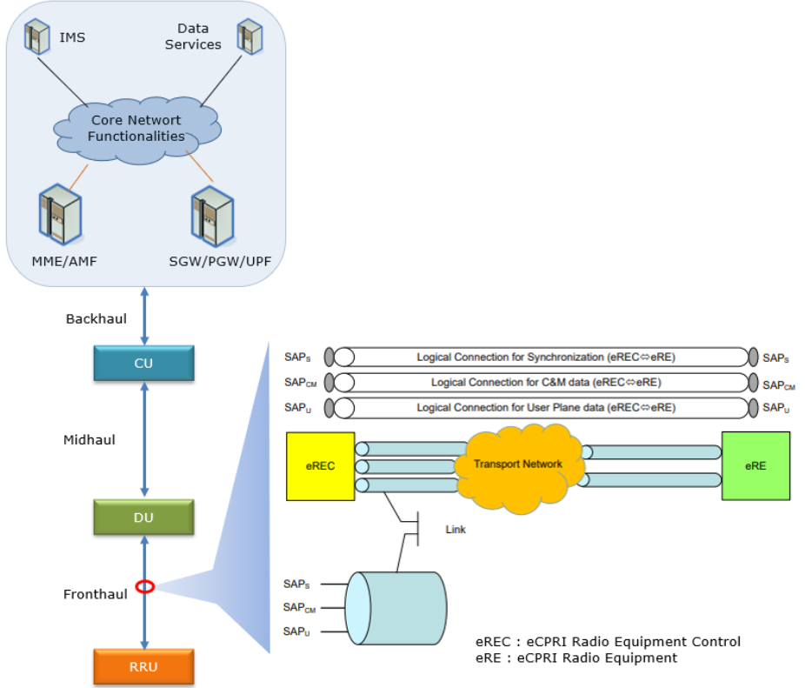
eCPRI Packet-Based Fronthaul Architecture. Source: OpenRAN | ShareTechnote

Here are the primary architectural options for executing this conversion:
1. Tunneling (Radio over Ethernet - RoE)
This is the simplest approach, standardized under IEEE 1914.3. It does not alter the underlying functional split (Split 8); it merely encapsulates the continuous CPRI bitstream into Ethernet packets.
- Mechanism: CPRI frames are mapped directly into Ethernet payloads using either Structure-Agnostic or Structure-Aware mapping.
- Pros: Requires no Digital Signal Processing (DSP); relatively straightforward RTL implementation; protocol agnostic.
- Cons: Does not reduce the massive bandwidth requirements of CPRI. The transport network must still carry raw I/Q samples at the original bit rate.
2. DSP-Based Split Translation (True Conversion)
To realize the ~10x bandwidth reduction promised by eCPRI, the gateway must perform low-PHY layer processing to convert CPRI (Split 8) into an eCPRI functional split (e.g., O-RAN Split 7.2x).
- Mechanism: The gateway terminates the CPRI link, extracts the time-domain I/Q data, and runs it through DSP blocks (handling tasks like FFT/iFFT, cyclic prefix insertion/removal, and digital beamforming). The resulting frequency-domain data is packetized into eCPRI/O-RAN User-Plane messages.
- Pros: Drastically reduces fronthaul transport bandwidth; allows legacy 4G radios to interface directly with an O-RAN vDU.
- Cons: Highly compute-intensive. Requires sophisticated DSP architecture and precise timing alignment.

Hardware Implementation Paths
Approach | Typical Hardware | Best Use Case | Key Characteristics
FPGA / SmartNIC Acceleration | High-end FPGAs | vDU servers (PCIe cards) or edge aggregation nodes | Flexible. IP cores handle SERDES, 8b/10b encoding, CPRI hyperframing, and RoE packetization. DSP blocks handle the FFT for split translation.
Fronthaul Routers (ASIC) | Telecom merchant silicon | Cell site aggregation routers | High throughput. Often relies on hardwired RoE encapsulation to converge legacy traffic onto standard packet networks.
Active WDM with IWF | Optical Transponders | Passive/Active optical networks | Performs CPRI to eCPRI conversion at the optical edge before transmitting over a multiplexed optical network.

Critical Design Considerations
When developing the hardware architecture for a conversion gateway, the two primary hurdles are:
- Synchronization: CPRI embeds timing natively within its constant bit rate. eCPRI operates over asynchronous Ethernet. The conversion node must utilize Precision Time Protocol (PTP / IEEE 1588v2) and SyncE to recover the clock and meet the strict ±1.5 µs time alignment error budget required for TDD and Massive MIMO operations.
- Jitter Management: Packet-switched networks introduce jitter. The gateway requires deep buffering and precise playout algorithms to recreate the continuous CPRI stream on the downlink back to the legacy RRU, ensuring no buffer overruns or underruns occur.

https://www.sharetechnote.com/html/OpenRAN/OR_RU_DU_interface.html#:~:text=*%20Description%3A%20Ensures%20precise%20timing%20alignment%20between,requirement%20of%20%C2%B11.5%20%C2%B5s%20time%20alignment%20error.

What is the high-level RTL architecture and data flow for implementing IEEE 1914.3 Radio over Ethernet (RoE) mapping on an FPGA?

Implementing an IEEE 1914.3 Radio over Ethernet (RoE) mapper requires a deterministic RTL architecture that bridges a synchronous, constant-bit-rate CPRI interface with an asynchronous, packet-switched Ethernet network. The fundamental engineering challenge is tearing down the CPRI framing, moving it across independent clock domains, and reconstructing it on the remote end without violating the radio's strict phase and jitter tolerances.
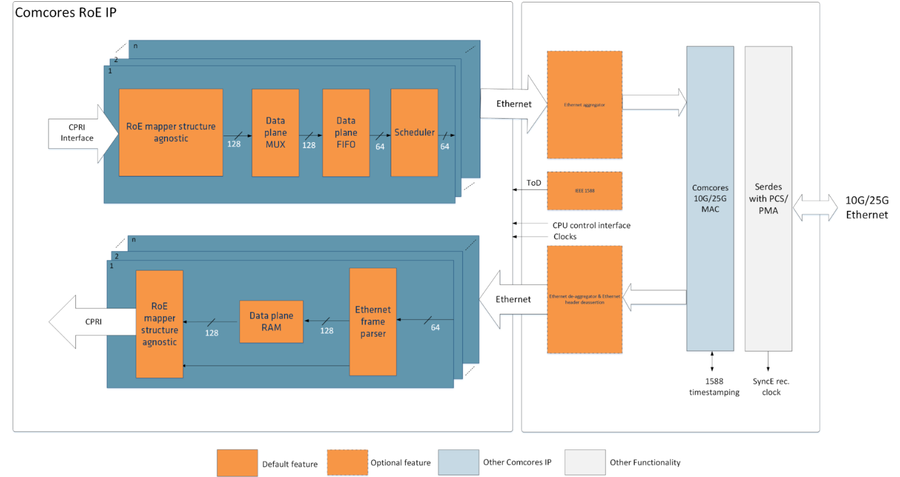
RoE Structure-Agnostic Mapper/Demapper Architecture. Source: Comcores

Data Flow: Ingress (CPRI to Ethernet)
In the uplink path, the RTL pipeline converts the continuous serial stream into packetized bursts. Most modern FPGA implementations utilize an AXI4-Stream (or Avalon-ST) backbone for the internal data path.
- CPRI PCS/PMA: The transceiver recovers the clock from the incoming CPRI stream, performs 8b/10b (or 64b/66b) decoding, and aligns the raw CPRI basic frames.
- RoE Mapper: This is the core encapsulation logic. In Structure-Agnostic mode, the state machine blindly fragments the raw CPRI bitstream into fixed-size payloads. In Structure-Aware mode, it demultiplexes specific Antenna-Carrier (AxC) containers and separates the Control & Management (C&M) channels.
- Header Insertion: The logic appends the IEEE 1914.3 header, injecting the Flow ID, Sequence Number, and a hardware-generated timestamp (derived from the local PTP clock).
- Clock Domain Crossing (CDC) FIFO: An asynchronous dual-clock FIFO safely transitions the packetized data from the recovered CPRI clock domain to the Ethernet MAC clock domain (e.g., 156.25 MHz or 390.625 MHz for 10G/25G).
- Aggregator / Scheduler: A round-robin or strict-priority arbiter multiplexes multiple RoE mapper streams (if aggregating multiple RRUs) and grants access to the MAC.
- Ethernet MAC & PCS/PMA: Encapsulates the RoE payload into standard UDP/IP or raw Ethernet frames (using EtherType 0xFC3D), calculates the Frame Check Sequence (FCS), and transmits out the SERDES.

Data Flow: Egress (Ethernet to CPRI)
The downlink path is significantly more complex because it must absorb network-induced Packet Delay Variation (PDV) and synthesize a perfectly continuous bitstream.
- Ethernet MAC & Parser: The MAC receives the frames, verifies the FCS, strips standard networking headers, and routes packets matching the RoE EtherType to the de-mapper pipeline.
- Classifier: The logic reads the RoE header and routes the packet to the correct processing channel based on its Flow ID.
- Jitter Buffer (Playout FIFO): This is the most critical block in the architecture. It is typically a deep Dual-Port RAM designed to absorb network jitter. The read-pointer operates on a strictly disciplined recovered clock, meaning packets must sit in the buffer just long enough to ensure the buffer never under-runs during network congestion.
- Sequence Checking & Re-framer: The state machine checks sequence numbers. If a packet is lost or arrives too late, the logic must immediately insert dummy data (zeros or Local Fault conditions) to keep the CPRI link alive; otherwise, the legacy radio will drop the connection and trigger system-wide alarms.
- CPRI PCS/PMA: The reassembled, continuous bitstream is 8b/10b encoded and serialized out to the RRU.
Critical Architectural Considerations
- Timing Recovery (PTP & SyncE): The entire system relies on highly accurate clock recovery. A dedicated hardware timestamping unit must sit at the Ethernet MAC layer to stamp IEEE 1588v2 Precision Time Protocol (PTP) packets on the fly. An embedded soft-core processor (like MicroBlaze or Nios V) typically runs the PTP servo loop to discipline an external VCTCXO/OCXO, while SyncE recovers the physical layer frequency.
- Buffer Sizing vs. Latency: Deep Jitter Buffers prevent under-runs but introduce latency. Because LTE and 5G have strict round-trip delay budgets (often driven by HARQ timing), the buffer depth must be dynamically configurable, usually managed via control registers accessed over an AXI4-Lite interface.

Walk me through the hardware architecture of a PTP hardware timestamping unit for an FPGA MAC.

A Precision Time Protocol (PTP) hardware timestamping unit—often called a Time Stamp Unit (TSU)—sits precisely at the boundary between the Ethernet MAC and the Physical Layer (PHY). Its sole purpose is to eliminate the unpredictable latency of software stacks and deep FIFOs by capturing the exact nanosecond a packet physically enters or leaves the FPGA.

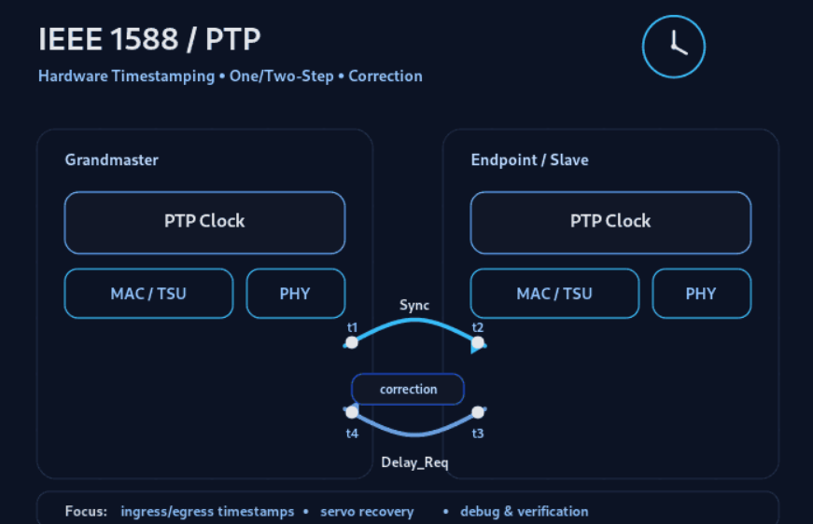

Hardware Timestamping Unit (TSU) at the MAC/PHY boundary. Source: ICNavigator

Here is the RTL architectural breakdown of the primary blocks required to implement a TSU in an FPGA.
1. The Real-Time Clock (RTC) Core
This is the beating heart of the timestamping system. It maintains the local Time-of-Day (ToD), typically formatted as a 64-bit or 96-bit register (seconds and nanoseconds/fractional nanoseconds).
- Driven by: A high-quality oscillator (e.g., an external VCXO).
- Digital Controlled Oscillator (DCO) Logic: Since the FPGA cannot easily change the physical clock frequency, the RTL uses an "addend" register. Every clock cycle, the addend value is accumulated. If the software servo loop determines the local clock is running too slow compared to the Grandmaster, it increases the addend value so the nanosecond counter rolls over slightly faster.
- Time output: The ToD is broadcasted to both the TX and RX capture units.
2. Ingress (RX) Timestamp Capture
When a packet arrives, the RX logic must identify if it is a PTP message and capture the time.
- Start-of-Frame (SOF) Detector: Monitors the MAC-to-PHY interface (e.g., XGMII for 10G). When the Start Frame Delimiter (SFD) crosses the bus, it immediately latches the current ToD from the RTC into a temporary register.
- Packet Parser: A pipelined state machine snoops the incoming AXI4-Stream data. It parses the Ethernet header, VLAN tags, IP header, UDP ports (319/320), and finally the PTP header.
- Action: If the parser confirms the packet is a PTP Event message (like Sync or Delay_Req), it writes the latched SOF timestamp alongside the packet's Sequence ID into an RX Timestamp FIFO. The software stack later reads this FIFO via an AXI4-Lite interface.
3. Egress (TX) Timestamp Capture & Insertion
The TX path is more complex because it must support either 1-Step or 2-Step PTP operations.
Like the RX path, a parser snoops the outbound data and an SOF detector latches the egress time. What happens next depends on the mode:
2-Step Mode (Simpler RTL)
- The hardware latches the exact time the SFD leaves the MAC.
- The parser confirms it was a PTP Sync message.
- The timestamp and Sequence ID are pushed into a TX Timestamp FIFO.
- The FPGA's soft-core processor (or host CPU) reads this FIFO and generates a separate Follow_Up packet containing the timestamp.
1-Step Mode (Complex RTL)
- The hardware must insert the egress timestamp directly into the payload of the packet currently flying through the MAC.
- The Challenge: By the time the SFD hits the PHY and the timestamp is latched, the front of the packet is already leaving the FPGA.
- The Solution: The TX MAC requires a shallow delay line (a small FIFO). The packet is delayed just long enough (e.g., 64 bytes) for the parser to identify the PTP header offset, latch the egress time, and inject the 64-bit timestamp directly into the moving data stream.
- Checksum Recalculation: Because the payload was modified on the fly, the RTL must include a pipeline stage to recalculate the UDP checksum and the Ethernet Frame Check Sequence (FCS) before the packet leaves the PHY.
4. Clock Domain Crossing (CDC)
The RTC usually runs on a dedicated, highly stable clock domain (e.g., 250 MHz from a PLL). The MAC interfaces run on varying clocks depending on the link speed (e.g., 156.25 MHz for 10GbE). The TSU architecture must heavily rely on Gray-coded asynchronous FIFOs and phase-matched registers to safely transfer the wide 96-bit ToD vector from the RTC domain into the RX/TX MAC clock domains without capturing metastable data.

