**CONNECT ODROID AND PIXHAWK SERIAL PORT**

**PIXHAWK SERIAL PORTS:**

|  |  |
| --- | --- |
| Software Serial Port Names | Hardware Serial Port Names |
| UART1 (/dev/ttyS0) | IO DEBUG (RX) |
| UART2 (/dev/ttyS1) | TELEM 1 (TX pin2, RX pin3) (USART1) |
| UART5 (/dev/ttyS2) | TELEM 2 (TX pin2, RX pin3) (USART2) |
| UART6 (/dev/ttyS3) | GPS (UARTX) |
| N/A (/dev/ttyS4) | N/A (UART5, IO Link) |
| N/A (/dev/ttyS5) | SERIAL5 (on SERIAL 4/5 connector, TX pin4, RX pin5) |
| N/A(/dev/ttyS6) | SERIAL4 (on SERIAL 4/5 connector, TX pin2, RX pin3) (UART8) |

TELEM1, TELEM2 and SERIAL4 are general serial ports. TELEM1 defaults is 57600. TELEM2 activated if SYS_COMPANION is set and the only permitted rate is 921600. SERIAL4 is used by some sensor drivers but any code uses it by default.

**ODROID SERIAL PORTS:**

Two options:

* Serial Console for debugging: /dev/ttyS0 in software. Typically used for console access. A special connector is also needed. So we are not going to use this port.
* Serial port in 40pin expansion header: /dev/ttyS2. RX on pin 10, TX on pin 8, GND on pin 6. All pins in expansion header (except analog input signal) are 3.3V.

**CABLE TO CONNECT ODROID TO TELEM1/2:**

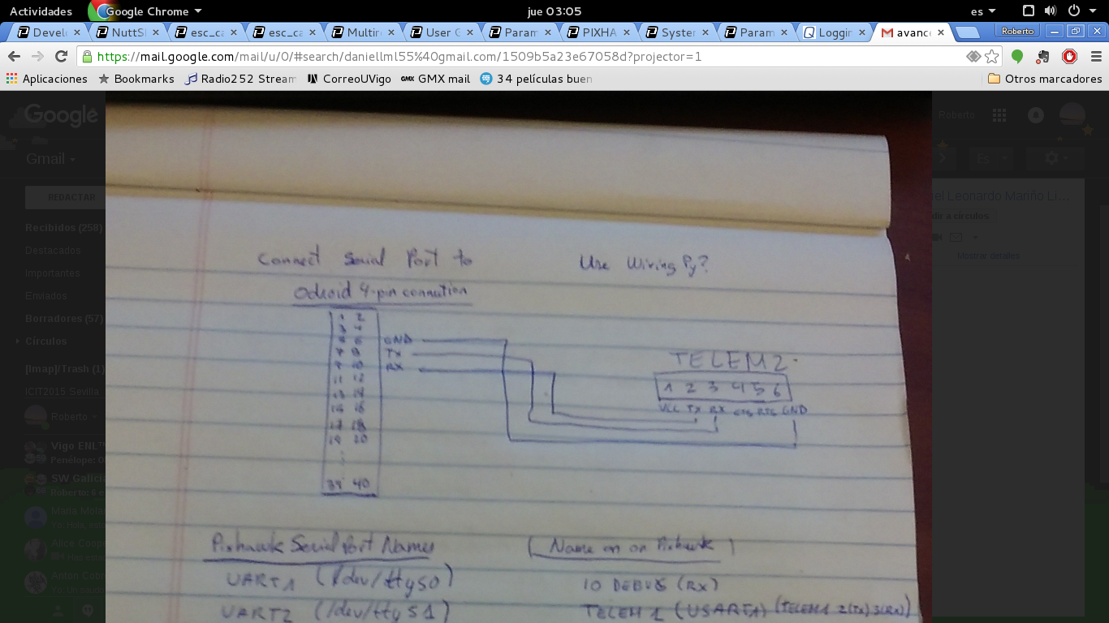

To build a cable for SERIAL4 is easy. Pins for SERIAL 4 in SERIAL 4/5 connector are given above.

**COMMANDS TO OPEN SERIAL PORT IN ODROID:**

**>>sudo apt-get install minicom**

**>>sudo minicom -b 115200 -D /dev/ttyS2**

Fix baud rate depending on the port connected. However if you are doing mavlink in the Pixhawk side baudrate does not affect too much because mavlink sends binary data and you will see strange characters for any baudrate.