PANGASINAN STATE UNIVERSITY
Urdaneta City Campus
College of Engineering and Architecture
Department of Mechanical Engineering
Academic Year 2025–2026, Second Semester
BS Mechanical Engineering
Control Engineering
LABORATORY REPORT
IN CONTROL ENGINEERING

Submitted by:
Dan Mark C. Pastoral

Submitted to:
Engr. Miguel Albert Calizar

LABORATORY ACTIVITY NO. 01
Functional Tests of Sensors
OBJECTIVE
- To be familiar with the functional tests of sensors.
- To identify different types of sensors used in industrial applications.
- To understand the functions and basic principles of each sensor.
- To propose prototype systems utilizing sensors for real-world industrial use cases.

PART I: SENSORS USED IN INDUSTRY
The following are seven (7) sensors commonly used in industrial settings. Each sensor is described with its function and a simple illustration of its operating principle.

# | Sensor Name | Function & Description | Simple Illustration (Block Diagram)
1 | Temperature Sensor (Thermocouple) | Measures temperature by converting thermal energy into an electrical voltage. Widely used in industrial furnaces, HVAC systems, and process control. It operates based on the Seebeck effect — two dissimilar metals joined at one end produce a voltage proportional to the temperature difference. | 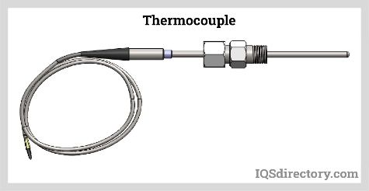
2 | Pressure Sensor (Piezoelectric Sensor) | Converts mechanical pressure into an electrical signal using the piezoelectric effect. Used in hydraulic systems, pneumatic machines, and engine management systems. When pressure is applied, the crystal generates charge proportional to the force. | 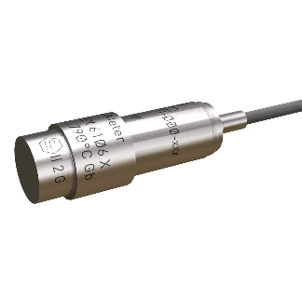
3 | Proximity Sensor (Inductive Type) | Detects the presence or absence of a metallic object without physical contact. Commonly used in automated assembly lines, robotics, and CNC machines. It generates an electromagnetic field and detects changes caused by a nearby metal target. | 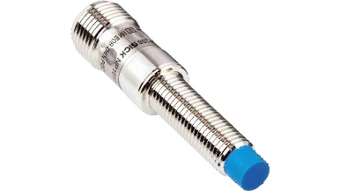
4 | Flow Sensor (Turbine Flow Meter) | Measures the volumetric flow rate of fluids or gases passing through a pipe. Used in water treatment, oil & gas pipelines, and chemical plants. Fluid flow spins a turbine rotor; the rotational speed is proportional to flow rate. | 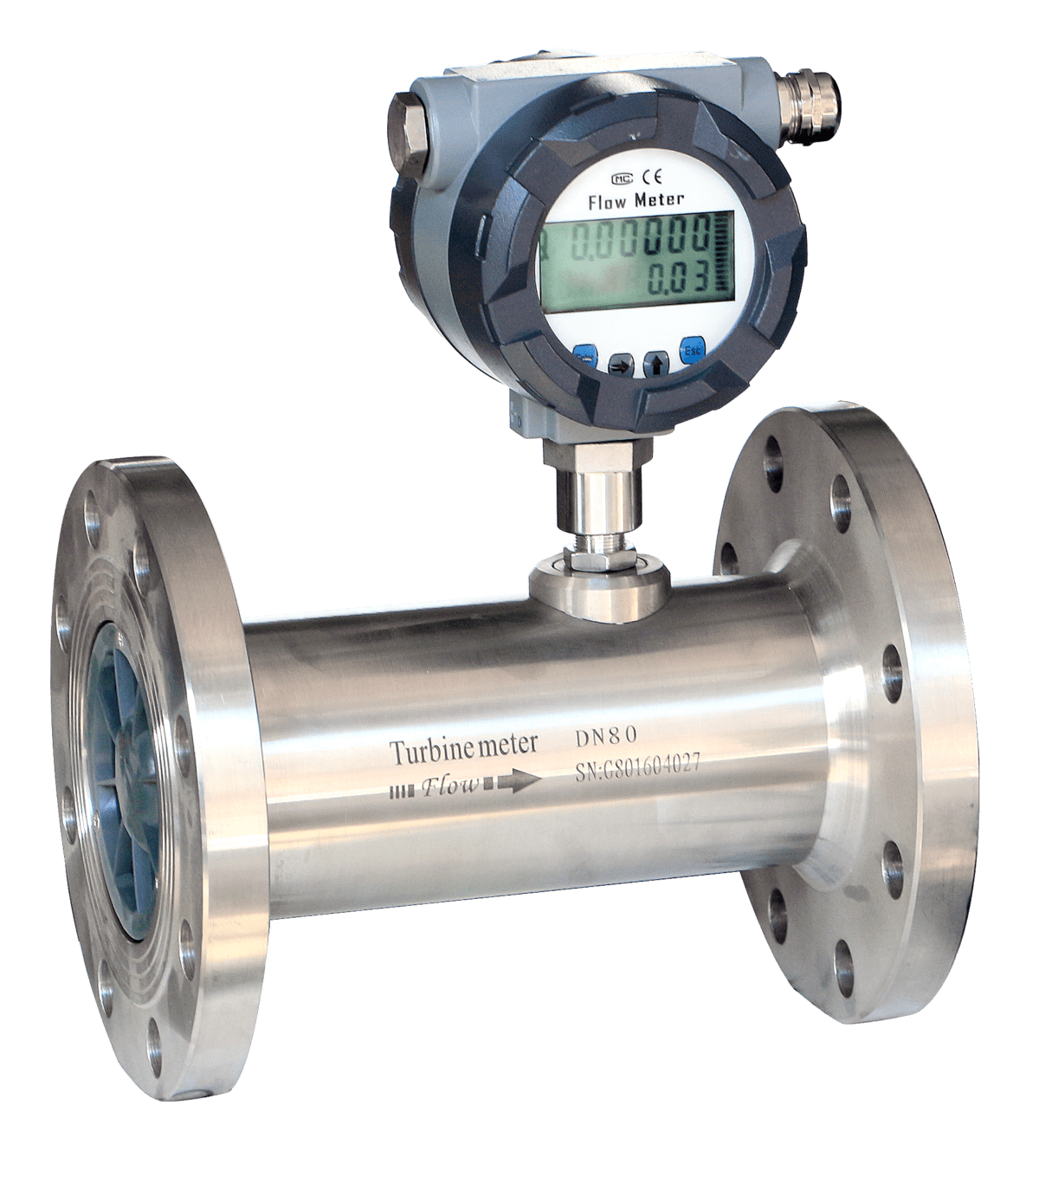
5 | Level Sensor (Ultrasonic Level Sensor) | Measures the level of liquid or solid material in a tank or vessel by emitting ultrasonic pulses and measuring the time for the echo to return. Used in storage tanks, wastewater treatment, and food processing. | 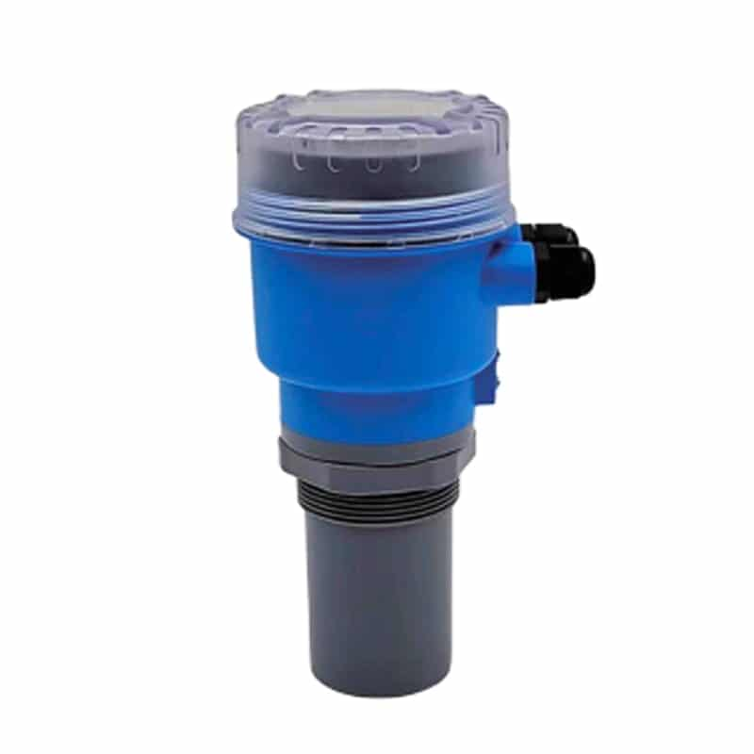
6 | Vibration Sensor (Accelerometer) | Detects vibration, acceleration, and shock in rotating machinery, engines, and structural components. Used for predictive maintenance and condition monitoring. A mass suspended by springs generates a signal when subjected to vibration. | 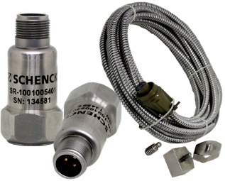
7 | Position Sensor (Rotary Encoder) | Converts the angular position or rotational movement of a shaft into digital pulses. Widely used in servo motors, CNC machine tools, and robotic arms for precise positioning and speed feedback. | 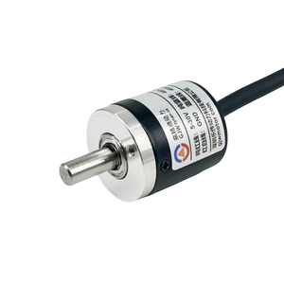

PART II: PROPOSED PROTOTYPE SYSTEMS
The following are three (3) proposed prototype systems that utilize multiple industrial sensors. Each proposal describes the system concept, its application, and the sensors involved.

Proposal 1: Automated Greenhouse Monitoring System
This prototype integrates temperature sensors, humidity sensors, and light intensity sensors (LDR) to automatically monitor and control the internal environment of a greenhouse. The system collects real-time data and triggers actuators such as ventilation fans, irrigation valves, and LED grow lights when parameters fall outside set thresholds. A microcontroller (Arduino/Raspberry Pi) processes sensor inputs and sends alerts to a mobile dashboard, ensuring optimal plant growth conditions with minimal human intervention.
Sensors Used:
- Temperature Sensor – monitors air and soil temperature
- Humidity Sensor – tracks moisture levels
- Light Sensor (LDR/Photodiode) – controls LED grow lights automatically

Proposal 2: Industrial Machine Predictive Maintenance System
This system uses vibration sensors, temperature sensors, and proximity sensors mounted on industrial rotating equipment (motors, pumps, compressors) to continuously monitor their health. Data is streamed to a PLC/SCADA system that applies threshold-based alarms and trend analysis. The system predicts potential failures before they occur, reducing unplanned downtime and maintenance costs, making it highly applicable in manufacturing and power generation plants.
Sensors Used:
- Vibration/Accelerometer Sensor – detects abnormal vibration patterns
- Temperature Sensor (Thermocouple) – monitors bearing/motor heat
- Proximity Sensor – detects misalignment or component wear

Proposal 3: Smart Fluid Tank Management System
Designed for chemical plants and water treatment facilities, this prototype monitors fluid levels, flow rates, pressure, and temperature within storage and processing tanks. Sensors feed data to a central control unit that automates pump operations, valve control, and safety shutdowns. The system prevents overflow, detects leaks, and ensures process fluids remain within safe operating parameters, improving operational efficiency and safety compliance.
Sensors Used:
- Ultrasonic Level Sensor – monitors tank fluid levels continuously
- Turbine Flow Sensor – measures fluid input/output flow rates
- Pressure Sensor – detects overpressure conditions and triggers relief valves
- Temperature Sensor – monitors fluid temperature for process control

CONCLUSION
This laboratory activity provided an in-depth understanding of the various sensors used in industrial settings. Through the identification and analysis of seven industrial sensors — including temperature, pressure, proximity, flow, level, vibration, and position sensors — it is evident that sensors serve as the fundamental building blocks of any control system. Each sensor converts a specific physical quantity into an electrical signal that can be processed and acted upon by a controller.

The three proposed prototype systems further demonstrate how multiple sensors can be integrated to create intelligent, automated systems. Whether it is an automated greenhouse, a predictive maintenance system, or a smart tank management system, the combination of sensors with control hardware enables accurate monitoring, improved safety, and increased operational efficiency. This activity reinforces the critical role of sensor technology in modern mechanical and control engineering applications.

________________________________  Dan Mark C. Pastoral  Student | ________________________________  Engr. Miguel Albert Calizar  Instructor

