M1_BUAD5122
Danni Martin
2025-01-10

Problem 1
This exercise relates to the College data set. It contains a number of variables for 777 different universities and colleges in the US.
The variables are: Private : Public/private indicator Apps : Number of applications received Accept : Number of applicants accepted Enroll : Number of new students enrolled Top10perc : New students from top 10 % of high school class Top25perc : New students from top 25 % of high school class F.Undergrad : Number of full-time undergraduates P.Undergrad : Number of part-time undergraduates Outstate : Out-of-state tuition Room.Board : Room and board costs Books : Estimated book cost Personal : Estimated personal spending PhD : Percent of faculty with Ph.D. Terminal : Percent of faculty with terminal degree S.F.Ratio : Student/faculty ratio perc.alumni : Percent of alumni who donate Expend : Instructional expenditure per student Grad.Rate : Graduation rate

A
Use the read.csv() function to read the data into R. Call the loaded data College. Make sure that you have the directory set to the correct location for the data.
College <- read.csv("College.csv")

B
Look at the data using the View() function. Use rownames() to name the first row of the data as row.names. This rawnames should be the names of the colleges.
View(College)
row.names <- College[,1]
rownames(College) <- row.names
#Remove first column as values are now used as row names.
College <- College[,-1]

C
Use the summary() function to produce a numerical summary of the variables in the data set.
summary(College)
Private Apps Accept Enroll
Length:777 Min. : 81 Min. : 72 Min. : 35
Class :character 1st Qu.: 776 1st Qu.: 604 1st Qu.: 242
Mode :character Median : 1558 Median : 1110 Median : 434
Mean : 3002 Mean : 2019 Mean : 780
3rd Qu.: 3624 3rd Qu.: 2424 3rd Qu.: 902
Max. :48094 Max. :26330 Max. :6392
Top10perc Top25perc F.Undergrad P.Undergrad
Min. : 1.00 Min. : 9.0 Min. : 139 Min. : 1.0
1st Qu.:15.00 1st Qu.: 41.0 1st Qu.: 992 1st Qu.: 95.0
Median :23.00 Median : 54.0 Median : 1707 Median : 353.0
Mean :27.56 Mean : 55.8 Mean : 3700 Mean : 855.3
3rd Qu.:35.00 3rd Qu.: 69.0 3rd Qu.: 4005 3rd Qu.: 967.0
Max. :96.00 Max. :100.0 Max. :31643 Max. :21836.0
Outstate Room.Board Books Personal
Min. : 2340 Min. :1780 Min. : 96.0 Min. : 250
1st Qu.: 7320 1st Qu.:3597 1st Qu.: 470.0 1st Qu.: 850
Median : 9990 Median :4200 Median : 500.0 Median :1200
Mean :10441 Mean :4358 Mean : 549.4 Mean :1341
3rd Qu.:12925 3rd Qu.:5050 3rd Qu.: 600.0 3rd Qu.:1700
Max. :21700 Max. :8124 Max. :2340.0 Max. :6800
PhD Terminal S.F.Ratio perc.alumni
Min. : 8.00 Min. : 24.0 Min. : 2.50 Min. : 0.00
1st Qu.: 62.00 1st Qu.: 71.0 1st Qu.:11.50 1st Qu.:13.00
Median : 75.00 Median : 82.0 Median :13.60 Median :21.00
Mean : 72.66 Mean : 79.7 Mean :14.09 Mean :22.74
3rd Qu.: 85.00 3rd Qu.: 92.0 3rd Qu.:16.50 3rd Qu.:31.00
Max. :103.00 Max. :100.0 Max. :39.80 Max. :64.00
Expend Grad.Rate
Min. : 3186 Min. : 10.00
1st Qu.: 6751 1st Qu.: 53.00
Median : 8377 Median : 65.00
Mean : 9660 Mean : 65.46
3rd Qu.:10830 3rd Qu.: 78.00
Max. :56233 Max. :118.00

D
Use the pairs() function to produce a scatterplot matrix of columns 2-10 or variables of the data. Recall that you can reference the columns of a matrix A using A[,2:10].
pairs(College[,2:10])
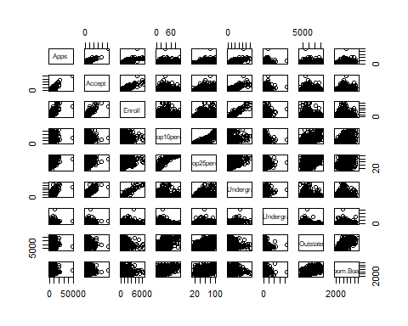

E
Use the plot() or boxplot() function to produce side-by-side boxplots of Outstate versus Private.
#Per boxplot, out-of-state tuition is typically higher for private schools than public universities.
#Outliers exist in for out-of-state costs for private and public universities alike.
boxplot(Outstate ~ Private, data = College)
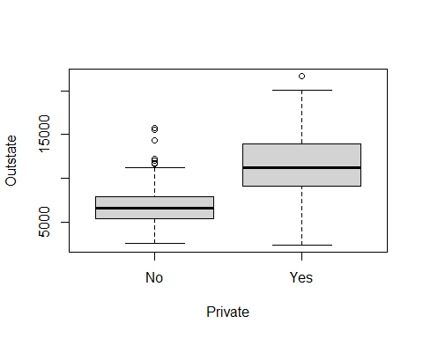

F
Create a new qualitative variable, called Elite, by binning the Top10perc variable. We are going to divide universities into two groups based on whether or not the proportion of students coming from the top 10% of their high school classes exceeds 50%. Use the summary() function to see how many elite universities there are. Now, use the plot() function to produce side-by-side boxplots of Outstate versus Elite.
College$Elite <- ifelse(College$Top10perc >50, "Yes", "No")
College$Elite <- as.factor(College$Elite)
summary(College$Elite)
No Yes
699 78
#Per plot, out-of-state tuition is typically higher for "Elite" colleges than non-Elite colleges.
#A few outliers exist regarding out-of-state tuition cost for non-Elite colleges.
plot(Outstate ~ Elite, data = College)
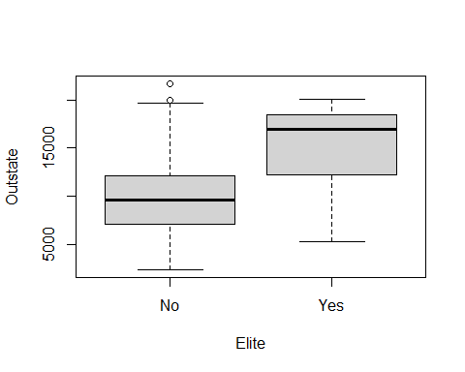

G
Use the hist() function to produce histograms for a few of the quantitative variables: Room.Board : Room and board costs, Books : Estimated book cost, Personal : Estimated personal spending.
#Room.Board histogram is unimodal and slightly right-skewed. Median room and board cost is between $4-4.5k.
hist(College$Room.Board)
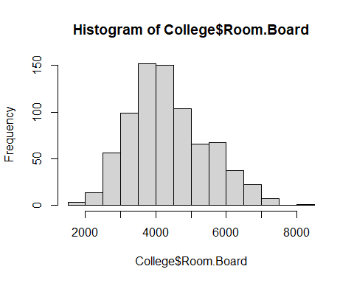
#Books histogram is unimodal and slightly right-skewed. Median book cost is about $500.
hist(College$Books)
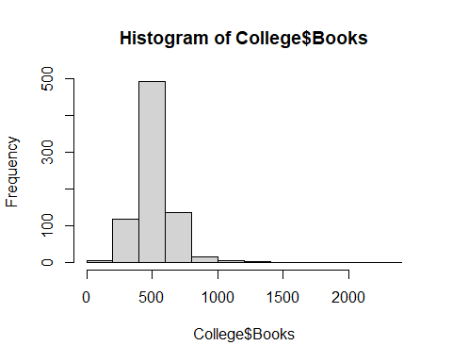
#Personal histogram is unimodal and slightly right-skewed. Median personal cost is about $1200.
hist(College$Personal)
