Overview
The program includes a friend recommendation model for a social network i.e., recommends friends-of-friends. For example, assume you have Joe and Jill who are not connected to each other. However, they may have many mutual connections. Therefore, the model recommends that Joe and Jill connects with each other.
Input:
Below is an excerpt from the input file:
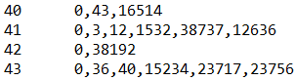
In each line, we have the UserID and a list of the UserIDs they are connected with. Please note there is a tab after the first UserID and the rest is separated by a comma. For example, UserID 40 is connected to UserIDs 0, 43 and 16514. You may want to note that these connections are mutual, meaning that if the connections of UserID 40 includes UserID 43, then the connections for UserID 43 will include UserID 40.
Algorithm:
For each user X, the program recommends 10 users who are not already connected with X, but have the largest number of mutual connections in common with X. It is possible that X may get less than 10 recommendations (or even zero) since you only need to look at mutual connections.
Note: It is possible to solve this question with a single MapReduce job (i.e., one mapper step and one reducer step). But our program has it in two steps.
Output:
The output contains one line per user, starting with the UserID and the connection recommendations for the user. Please note that the recommendations are ordered by the decreasing number of mutual connections.
Below is an excerpt from the output file:
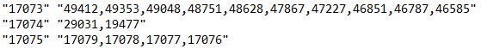
For example, the model suggests that UserID 17074 may know and should connect with UserID 29031 and UserID 19477.

