MT5 Balance Event Plugin Documentation

Contents

1. Application expected behavior 3

2. Application parameters 4

2.1 MT5 Server inputs 4

2.2 Configure the plugin 4

2.3 POST Message 4

3. Given When Then (GWT) 5

2.1 GWT Plugin Setup with * as User login. 5

2.2 GWT Plugin Setup with list of User logins. 5

# 1. Application expected behavior

The application will connect to MT5 server via Manager API and request the chart bars for a given time. It will perform all the above functionality at present and if needed enhancement is required later.

This MT5 server plugin will intercepts the balance operations in server and notify using POST message based on the given parameter.

* For every balance operation in MT5 server it will send the POST message notification.
* POST message notification will send to designated URL based on the given server parameter.
* User can do filter based on the login or “*”, which means it will send POST notification only for the mentioned login names.

The server plugin need three minimum parameters to operate.

# 2. Application parameters

## 2.1 MT5 Server inputs

Please extract Balance_Event_Plugin.zip in any suitable location and copy the dll into server plugin folder.

## 2.2 Configure the plugin

It needs at least three parameters to start.

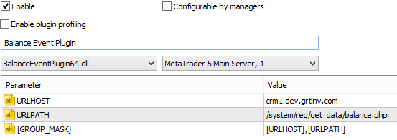

## 2.3 POST Message

As per the requirement, the POST message will contain (-/+) Balance Change, Account Source, Deal or Trade ID, Time stamp and operational comment.

# 3. Given When Then (GWT)

## 2.1 GWT Plugin Setup with * as User login.

|  |  |
| --- | --- |
| **GIVEN** |  |
| **WHEN** | Click OK |
| **THEN** | Plugin Enabled with two parameters.  POST message will be sending to given URL (crm1.dev.grtinv.com/system/reg/get_data/balance.php).  POST message will be sending to given URL for all the login account’s balance operation. |

## 2.2 GWT Plugin Setup with list of User logins.

|  |  |
| --- | --- |
| **GIVEN** |  |
| **WHEN** | Click OK |
| **THEN** | Plugin Enabled with two mandatory parameters and two other parameters contains group mask and its corresponding POST URL.  POST message will be sending to given URL (crm1.dev.grtinv.com/system/reg/get_data/balance.php).  POST message will be sending to corresponding URL based on login’s user group mask. |