MT5 Trade Copier Plugin Documentation

Contents

1. Application expected behavior 3

2. Application parameters 4

2.1 Configure the plugin 4

3. Given When Then (GWT) 5

2.1 GWT Plugin Setup with single setting per Symbol. 5

2.2 GWT Plugin Setup with more than one setting per Symbol. 6

# 1. Application expected behavior

Plugin will copy the trades based on the criteria given in parameters. In the parameter each line meaning one settings/ criteria. The order of filtering the trades against given criteria are as follows.

1. Match it first with given symbol mask.
2. Then match it against user group mask.
3. Then try to find a match against the given login mask.

Note that each login mask must have only one target login. One group setting can have multiple sets of login mask and target login. One symbol setting can have multiple group mask settings but vice versa is not true.

# 2. Application parameters

## 2.1 Configure the plugin

It needs at least two parameters to start. “ManagerLogin” meaning login of a dealer, on whose behalf the request is performed. Other parameters are the Symbol settings.

Example:

Parameter Name: *EURUSD|demo* [ SymbolMask|GroupMask ]

Parameter Value: *,!1005|1004 [ LoginMask|TargetLogin ]

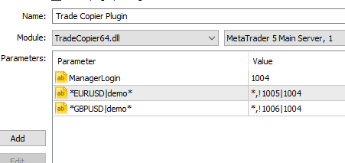

# 3. Given When Then (GWT)

## 2.1 GWT Plugin Setup with single setting per Symbol.

|  |  |
| --- | --- |
| **GIVEN** |  |
| **WHEN** | Click OK |
| **THEN** | Plugin Enabled with three parameters.  First parameter is mandatory which is manager login.  Trade belongs to EURUSD and GBPUSD group will be filtered for client group demo*. If the trade belongs to login other than 1005 for EURUSD and 1006 for GBPUSD will be copied to target account 1004. |

## 2.2 GWT Plugin Setup with more than one setting per Symbol.

|  |  |
| --- | --- |
| **GIVEN** |  |
| **WHEN** | Click OK |
| **THEN** | In this example for one Symbol group there could be multiple client group settings.   1. EURUSD trade under demo* group except 1005 login will be copied to 1004 account. 2. EURUSD trade for 1005 login will be copied to 1006 account. |