DMSF

Document Management System “Features”
User's guide

1.4.9 Karel Pičman 2014

CONTENTS
1 Introduction 3
2 Features 3
3 Requirements 3
4 Installation 3
5 Rake tasks 4
5.1 Convert documents 4
5.2 Alert approvals 4
6 Administration 4
6.1 Plugins 4
6.2 Custom fields 5
6.3 Roles and permissions 5
6.4 Approval workflows 5
7 Project settings 5
7.1 Modules 5
7.2 DMSF 5
7.3 Approval Workflows 6
8 DMSF module 6
8.1 Documents 6
8.1.1 Documents management 6
8.1.2 New folder 6
8.1.3 List of folders 8
8.1.4 Filtering 8
8.1.5 Tagging 8
8.1.6 Download 8
8.1.7 E-mail 8
8.1.8 Delete folder 9
8.1.9 Add documents 9
8.1.10 Documents links 10
8.1.11 List of documents 11
8.1.12 Document details 12
8.1.13 Notifications 13
8.1.14 Approval workflow 13
8.1.15 Trash bin 15
9 Activity module 16
10 WebDAV 16

Introduction
Document Management System “Features” - DMSF is a plugin for Redmine issue tracking system. It is aimed to replace current Redmine's Documents module.
Redmine DMSF now comes bundled with WebDAV functionality: if switched on within plugin settings this will be accessible from /dmsf/webdav. WebDAV functionality is provided through DAV4Rack gem.
Initial development was for Kontron AG R&D department and it is released as open source thanks to their generosity.
Redmine Document Management System "Features" plugin is distributed under GNU General Public License v2 (GPL).
Redmine is a flexible project management web application, released under the terms of the GNU General Public License v2 (GPL) at http://www.redmine.org/
Further information about the GPL license can be found at http://www.gnu.org/licenses/old-licenses/gpl-2.0.html#SEC1

Syntax
In this document the following syntax is used:
Italics – name of a company or product
Bold italics – links, click-able items
Bold – names of tabs, or fields you can fill in
Courier – commands

Features
- Directory structure
- Document versioning / revision history
- Email notifications for directories and/or documents
- Document locking
- Multi (drag/drop depending on browser) upload/download
- Multi download via zip
- Direct document or document link sending via email
- Configurable document approval workflow
- Document access auditing
- Integration with Redmine's activity feed
- Wiki macros for quick content linking
- Full read/write webdav functionality
- Optional document content fulltext search
- Documents and files symbolic links
- Document tagging
- Trash bin
- Compatible with Redmine 2.5.x

Requirements
Redmine 2.3.x or higher
Xapian for full-text search support (optional)

Installation
Nothing special. Just follow common steps for Redmine plugins installation. Please see the README.md file in the root folder of the plugin.

Rake tasks

Convert documents
Convert project documents from the original Redmine Documents module to DMSF folder/file structure. Converted project must have Documents and may not have DMSF module activated.

Available options:
project => id or identifier of project (defaults to all projects)
dry => true or false (default false) to perform just check without any conversion
invalid=replace => to perform document title invalid characters replacement for '-'

Example:
rake redmine:dmsf_convert_documents project=test RAILS_ENV="production"

Alert approvals
Alert all users who are expected to do an approval in the current approval steps.

Example:
rake redmine:dmsf_alert_approvals RAILS_ENV="production"

Administration

Plugins
There in the Redmine Administration under Plugins you can see something like that:
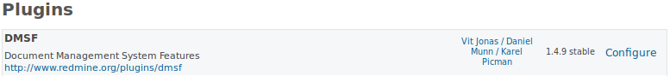
The plugin configuration is available by clicking on Configure. Available options are as follows (the default value in square brackets):

Maximum files upload [0] Limits maximum number of files uploaded at once. 0 means unlimited.
Maximum files download [0] Limits maximum number of files downloaded in zip or sent via email. 0 means unlimited.
Maximum email attachment size [0] Limits maximum file size that can be sent via email. 0 means unlimited. Number is in MB.
Maximum file size upload-able via AJAX [100] Maximum file size upload-able via AJAX
File storage directory [/files/dmsf] Where the uploaded files will be physically stored.
Physical file delete [No] Whether files are physically deleted after their deletion in the web interface.
File default notification [Deactivated] Allows set notifications per project.
Display notified recipients [Deactivated] When activated the user will be informed about all recipients of just sent the email notification.
WebDAV [Activated] WebDAV once enabled can be found at http://.../dmsf/webdav/[project identifier]
Webdav strategy [Read-only] Enables the administrator to decide if WebDAV is a read-only or read-write platform for end users.
Directory containing Xapian databases [files/dmsf_index] A location of Xapian full-text searching database.
Stemming Language [english] A language used for stemming.
Stem strategy [Stem none] This controls how the query parser will apply the stemming algorithm. The default value is STEM_NONE. The possible values are:
STEM_NONE: Don't perform any stemming.
STEM_SOME: Search for stemmed forms of terms except for those which start with a capital letter, or are followed by certain characters, or are used with operators which need positional information. Stemmed terms are prefixed with 'Z'.
STEM_ALL: Search for stemmed forms of all words (note: no 'Z' prefix is added).
Note that the stemming algorithm is only applied to words in probabilistic fields - boolean filter terms are never stemmed.

Custom fields
Custom fields can be applied on documents and folders. There in the Redmine Administration is an item Custom field. If New custom field from the command toolbar is selected there is a new DMSF type available. Then there is a common New custom field form where can be specified the new custom field parameters.
In order to use Documents tagging feature let's add a new DMSF custom field named Tag as a list with possible values specified according to your requirements.

Roles and permissions
Available permissions:
Browse documents
User preferences DMSF tab is enabled in the project settings
View documents Documents can be downloaded, emailed, copied and moved. Approval workflow is available.
Folder manipulation Folders can be created, deleted, edited, locked, unlocked. Email notification can be switched on/off.
File manipulation Documents can be uploaded, locked, unlocked. Email notification can be switched on/off. Approval workflows can be applied. Symbolic links can be created/deleted.
Delete documents It allows enter the Trash bin and delete/restore documents.
Manage workflows Approval workflow tab is enabled in the project settings. Members are allowed to define approval workflows of the project.
Force file unlock A member is allowed to unlock a document locked by someone else.

Approval workflows
The last Administration item related to DMSF is Approval workflows. Here can be defined global approval workflows available in all projects.

Project settings

Modules
I order to be DMSF available it is necessary to have checked the corresponding module in the Modules tab.

DMSF
Each project member with corresponding permissions can set email notifications related to DMSF documents and folders of the project.

Approval Workflows
Definition of approval workflows of the project.
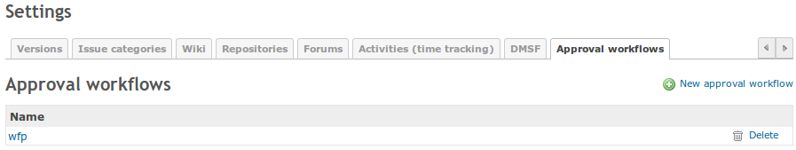
The main view consists of a list of already defined approval workflows. They can be edited by clicking on their names or deleted by clicking on the corresponding trash icon. A new approval workflow can be defined by clicking on the New approval workflow item in the command toolbar.
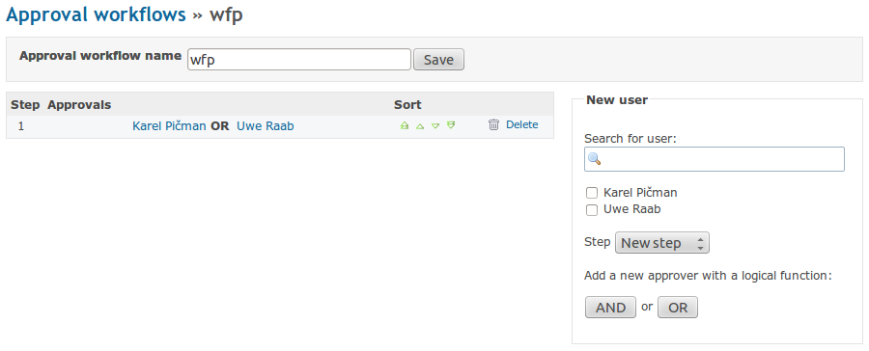
Firstly fill in the approval workflow name. Secondly define the approval workflow steps by selecting approvers, step and logical function.

DMSF module

Documents
The Documents module allows you to store all documentation relevant to a project at one place, sorted into folders. You can switch on the Documents module by going to the project Settings → Modules tab. Check the check box in front of the DMSF item, which is the Document Management System Feature.
At the screen you find two major areas: folder and files tree in the upper part of the screen, and an area for uploading files in the lower part of the screen.

Documents management
The documents are stored in folders, which should have such a structure that provides an easy orientation within the topic.
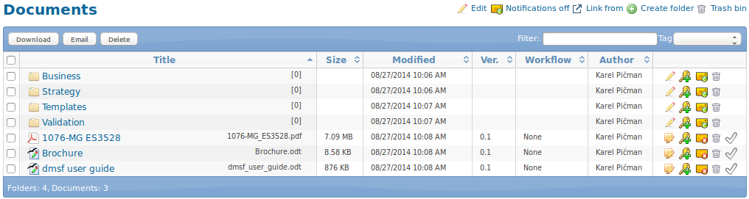

New folder
You can create a new folder by clicking the green plus sign in the right upper corner. This takes you to the following screen:

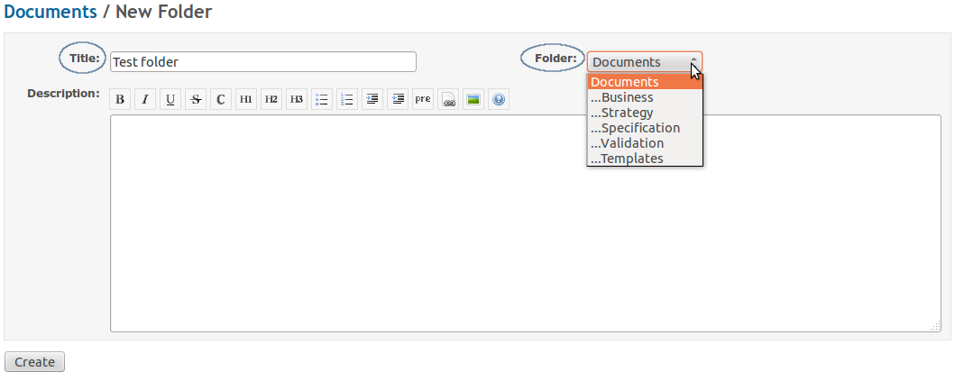
Type the new folder Title and select which already existing Folder it should belong to (the new folder will become a sub-folder of the selected folder). You can add a description of the folder. You can use various types of text formatting, such as headings, lists, links to web pages, documents etc. If you need help with the text formatting, click the Help tool button and you are provided with a list of commands, including examples.
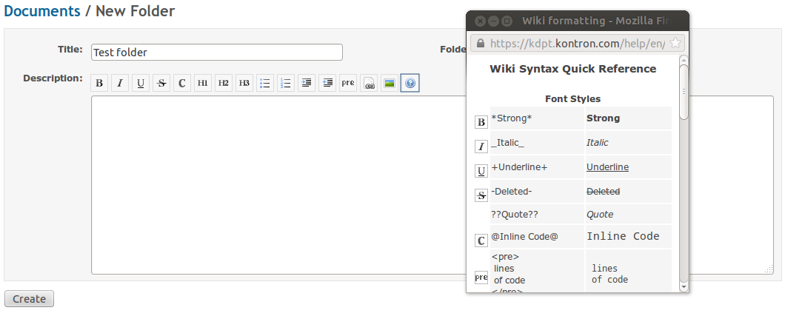
When you are satisfied with the settings, click the Create button.

A new folder can be also created by copying an existing folder. Go to the folder you wish to create a copy of, and click the Edit icon:

Or click the edit button directly in the main view:

On the folder edit page click the Copy icon:
Select the Target project and Target folder. Click the Copy button.

List of folders
Each line of the folder list contains:
- the folder name
- number of files the folder contains
- folder size, date of creation, version, author
- folder edit tools
- possibility to erase a folder
- notification flag or

The editing tool uses the same form as is used for creating a new folder. You can change the folder title and description here and make it a sub-folder of a different folder.
You can sort the folders in the alphabetical or reversed alphabetical order. You achieve this by clicking the sign of arrow right from the column name (unsorted, alphabetical order, reversed alphabetical order):

Filtering
If you are unsure of what the name of the folder is, you can try applying a key word. Go to the Filter field, located in the right upper corner, and begin to type the key word.
Only those folders with titles that contain the given sequence of letters will be displayed. As you continue typing, less folders remain.

Tagging
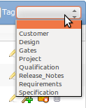
There is a pre-defined list of tags. If you select a tag from the list, there will be displayed documents and folders marked with that tag only. To clear the tag filter and to display all documents and folders again just select the empty item on the list.

Download
Let's say you want to download all contents of a folder called “Training”. Check the check box in front of the folder title and then click the Download button (in the left upper corner):
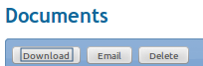

The whole content of the folder will be zipped into one file and saved on your hard-drive.

E-mail
You can e-mail the folder content to your partner. Check the check box in front of the folder title and then click the Email button.
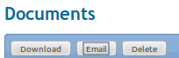

All contents of the folder will be zipped into one file. You will be asked to fill in the recipient's e-mail address, subject and you can add a piece of text explaining what are you sending. The zipped files are included automatically. However, be careful with sending the whole content of a folder as its size can exceed the e-mailing limits and your e-mail may not be delivered!
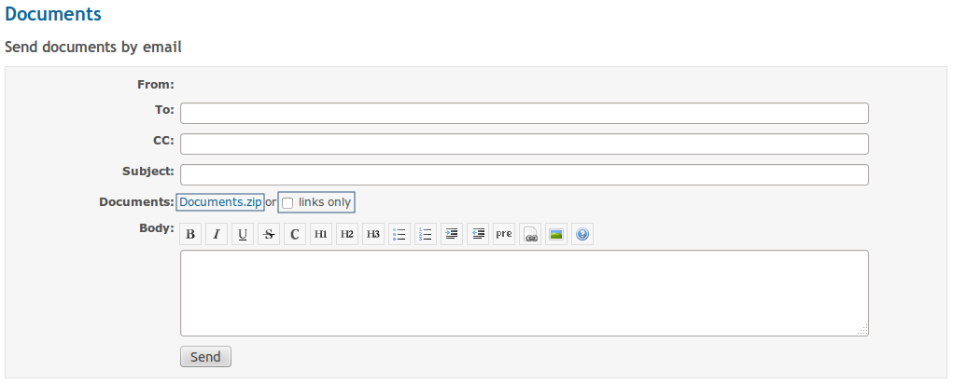
Before sending you can check the attachment by clicking on the URL link Documents.zip. If the checkbox links only is checked, URL links of attached documents will be append to the email body instead.

Delete folder
You can erase a folder in two ways:
- click the red cross that is located at the end of the line containing the folder title
- check the check box in front of the folder title, then click the Delete button
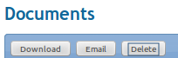

Add documents
Once you have your folder structure set up, you can start filling it with files. You can, of course, add a new folder any time later.
New files can be added in two ways:
- using drag & drop method – you drag & drop the files you wish to add into the area called Upload; only for files with size < 100MB; does not work for Internet Explorer, it opens the document instead of adding it into the list
- click the Add Files button, located left under the update area, then browse for the file.
You see a list of all ready-to-be-added files. Each line contains:
- the name of the file,
- status,
- file size,
- possibility to remove the file from the list .
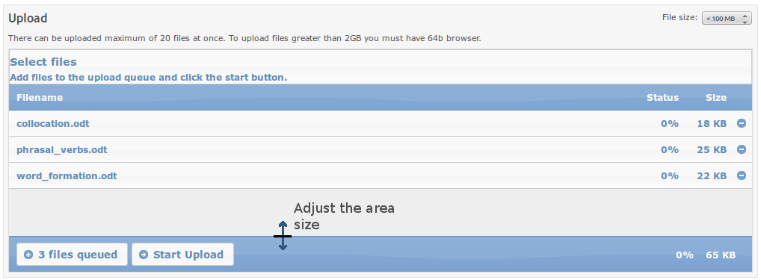
Adjust the area size
You can add up to 20 files within one upload. For files over 2GB you need to have a 64b browser. If you don't have a 64b browser, use you archiving tool such as ZIP or RAR and compress and then split your original file into more smaller archives before uploading. When all the files are ready for upload into the folder, click the Start Upload button. You will see the upload status changing. If needed, you can stop the upload by clicking the Stop Upload button.
You can adjust the area size by dragging the bottom line up and down.
When the files are uploaded, a similar screen appears:
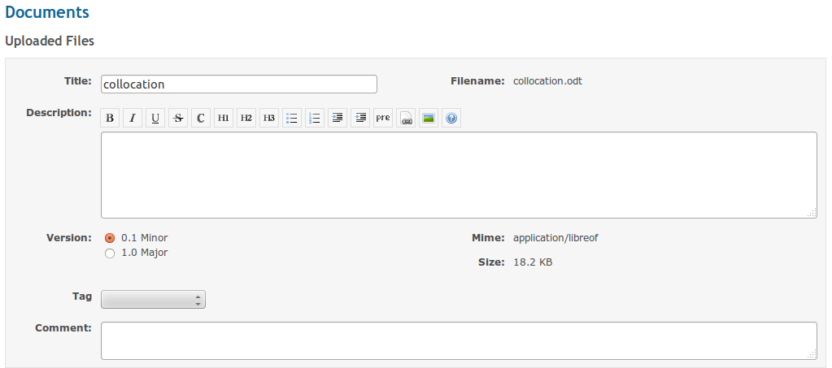
Here you can change the file title, add description and comment and assign an appropriate version. You can also select a corresponding tag from the pre-defined list. When satisfied, click the Commit button.
If a document of the same file name already exists in the current folder you are offered with a new revision of the document automatically.

Documents links
There is possible to create a link to another document or folder from the same or another folder of the same or another project. Links behave as if operating directly on the target document or folder. It means for example that if you download or email a link, the referenced file is sent to the user.
If the target document is going to be removed or moved the user will be warn about existing links and these links will be automatically removed.
Create a link in the current location to another file or folder
There is a command in the command toolbar in the document or folder details form. After a click on that icon a new form New document link appears. The user is expected to choose a source project, folder and optionally document as the target of the link just being created.
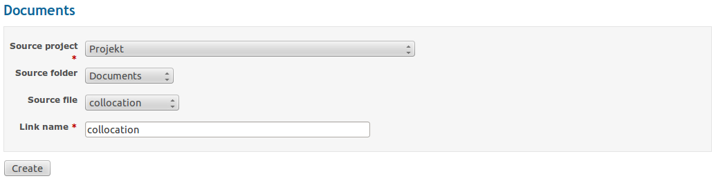
Create a link from the current file or folder to another folder
There will be a new command in the command toolbar of the main view. After a click on that icon a new form New document link appears. The user is expected to choose a target project and folder where the link just being created will be located.
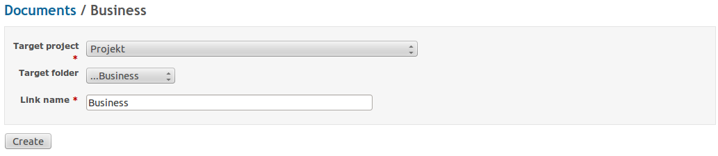

List of documents
Your files are added into the folder:

You see the file titles and names, their size, last modification date, version, workflow state and who added them (the author). You can sort the list according to the individual columns by clicking the arrow next to their name (Title, Size, Modified, Ver., Workflow, Author). Furthermore, you can lock or delete files.
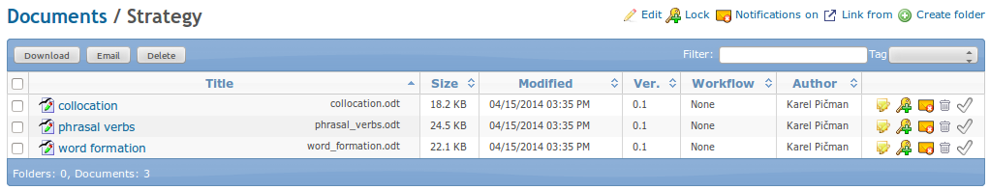
Symbols and their meaning:
- file details
- lock to prevent changes for other members
- unlock to allow changes for other members
- delete file
- locked file
- notifications not active: activate (Project Manager or Administrator only)
- notifications active: deactivate (Project Manager or Administrator only)
- approval workflow not assigned: assign
            - approval workflow assigned: start
      - waiting for approval: approve
      - document approved
      - document rejected

Document details
If you click the symbol, you get to the page with detailed information about the file.
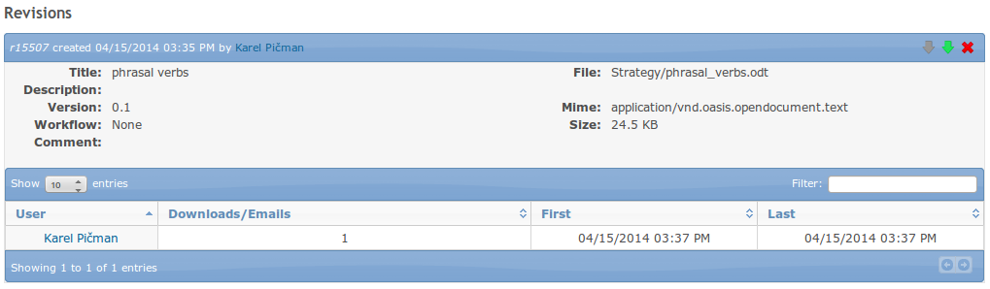
You see the file history, its versions and workflow. You can download older revisions by clicking the corresponding sign. You can show/hide download and email entries by clicking the icon. You can delete a particular revision by clicking on icon . The file can be copied or moved to another folder or even project by clicking on icon. Then you are expected to select a target folder and project. The file is copied or moved by a click on a corresponding button Copy or Move.

As a project manager you also see statistics about who, when and how many times has downloaded individual versions.
You can add new revision by clicking the plus + sign next to the New Revision title at the top of the page. Following screen appears:
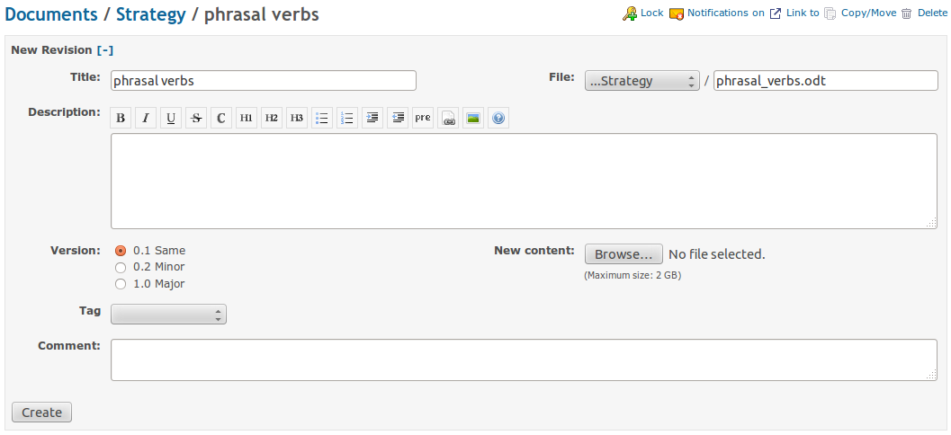
You can change the title, description and add a new comment. If you add a new file (New content), a new version will be automatically assigned to it. It can be either a minor version (if the previous version was x.1, the new version will be x.2; usually for minor changes in the document), or a major version (if the previous version was 1.x, the new version will be 2.0; usually for extensive changes in the document).
When you finished all document settings, click the Create button and a new revision is added.

Notifications
It is possible for the Project Manager or the Administrator to enable/disable notifications for each document or document folder. If the notification flag is on, a notification e-mail is sent to all e-mail recipients after the document state has changed (creation, change, approval). The e-mail recipients are taken from the list of the project members. E-mail notification settings of individual users are taken in account.
If the notification flag is set on a folder, notification e-mails are sent if any document state changed within the folder sub-hierarchy.

Approval workflow
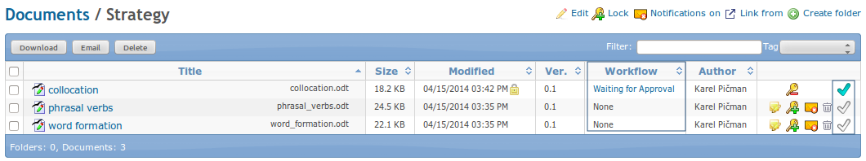
The approval workflow state is indicated by workflow status in the Workflow column and by corresponding icon on the very right side. The initial state is None as it is shown by the second document on the picture above. If you move your mouse cursor over an icon or text, a help text in a bubble is displayed. In case of the command icon it is the action represented by the icon state. In case of the workflow state there are listed next approvers.
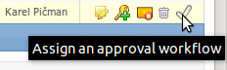
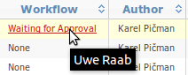

Approval workflow process
The process itself is clearly described on the diagram below.
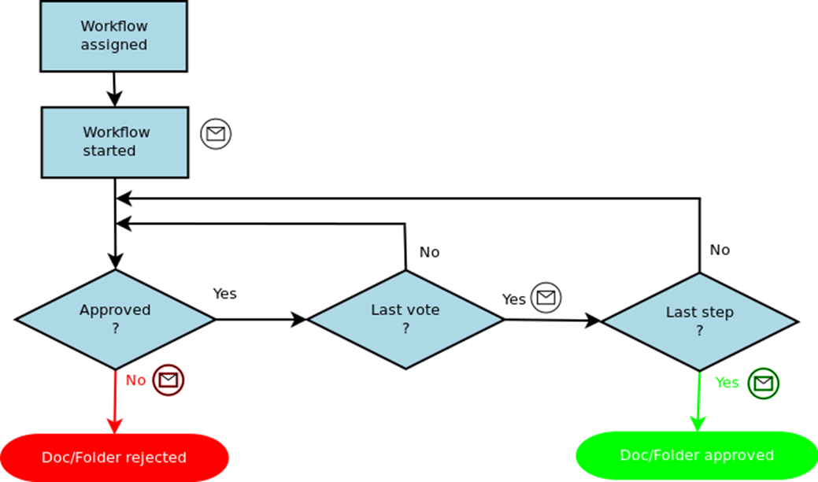

And now step by step:
1. Assign an existing approval workflow to the selected document by clicking on the icon .Then a workflow assignment form appears:
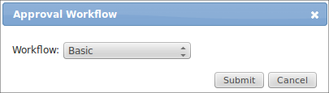

All project and global approval workflows are selectable. Select a workflow and click on Submit button. The selected workflow is assigned to the document. The icon has changed to .
2. In the next step the assigned workflow must be started by clicking icon.
3. When the workflow is started, all approvers in particular steps are expected to do an approval. The icon is changed to and the document is locked to prevent all changes.
If you are one of the approvers of the current approval step, the icon is click-able and you can do an approval by clicking on it. Then the approval form appears:
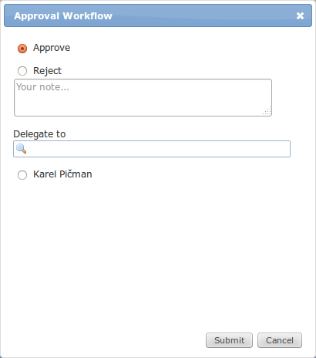

You have three options here, either approve, reject or delegate the current approval step. In case of rejection or delegation you are obliged to comment it in the text field “Your note...”. Only members of the project are offered for delegation. Your decision will be confirmed by clicking the Submit button.
4. If you has just approved the document and you are the last person of the approval chain. The document is approved as a consequence of your approval. The icon is changed to and the status is changed to “Approved”.
5. If you has just rejected the document. The approval chain is finished immediately and the document is in the state Rejected. The icon is changed to
6. If you approve it and you are not the last approver or you delegate your approval to someone else, the workflow approval continues.
Log
All workflow approvals are stored and are available in the log window. You can open the window by clicking the workflow status text:
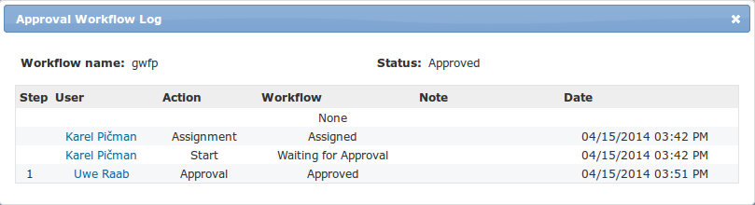

Email notifications
Email notifications are sent according to the table as follows:
Event | Receiver(s)
The approval workflow is started | All approvers of the first step
An approval workflow step is finished | All approvers of the next step and workflow owner
The document has been approved | All members of the project
The document has been rejected | All participants of the workflow and the workflow owner
An approval step has been delegated | The delegate
Due date has been reached | All approvers in the given step who haven't approved yet. These notifications are resent every working day.

Trash bin
If documents or folders are deleted by a user, they are moved into the Trash bin only in fact and can be restored again or definitively removed from the Trash bin with Delete documents permission.
The Trash bin is available from the main DMSF menu:
The user interface of the Trash bin is very similar to the documents view except command icons. New command icons for restore and delete a folder or document are next to the deleted folders a documents. Once a document or folder is deleted from the Trash bin there is no way back!
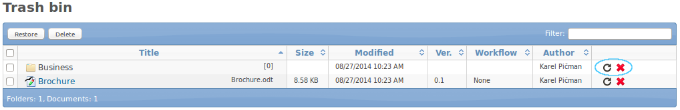

Activity module
All changes related to a file revision are recorded as activities.
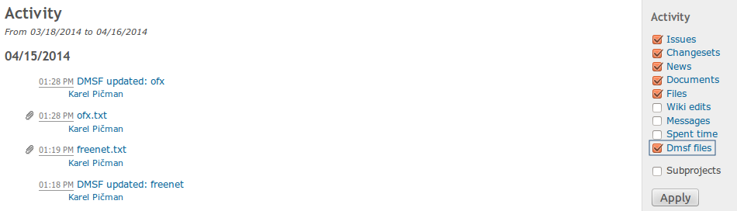

WebDAV
The document module of the project can be mounted as a web folder. In a mounted folder is available a complete document and folder structure then. When a user does an operation such as download/upload a document or creating a new folder it is automatically recorded in DMSF and it has the same effect as the operation would be done in the web interface of DMSF.
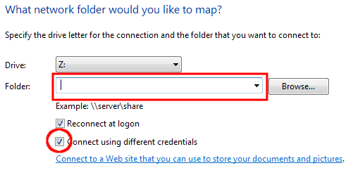
In order to mount a project documents in MS Windows system open Documents, right click on the Computer item in the tree and select Mount network drive. Fill-in URL of the project documents module in the following format: https://[your domain]/dmsf/webdav/[project identifier].
In the next step you are asked to login and in case of a successful login a new folder with the project documents appears.
